# Education

**ENGINEERING | (2018-2022)**

**INTERMEDIATE | (2016-2018)**

**SSC| (2016)**

Mohammed Tanveer Hussain

[hussainitb83@gmail.com](mailto:hussainitb83@gmail.com)

+91 8247368380

Hyderabad, Telangana, 500034

# Organization

**Certificates**

# Skills

TECHNICAL SKILLS

* **Programming Languages:**
* **Data Structure, OOP.**
* **Cloud Computing (Azure).**
* **Web Technologies:**
* **Application Development:**
* **Database:**
* **Softwares/Tools:**

Desktop Publishing:

# Projects

**GitHub Profile Link : https://github.com/Hussain-786 Web Development Projects :**

**App Development Projects :**

# Personal Details

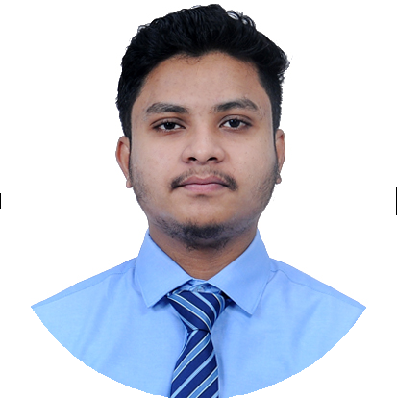

**OpenCV Projects**

**Major Project**