Erste Graphiken

Jan-Philipp Kolb

### Erste Graphiken

<http://cran.r-project.org/web/views/Graphics.html>

library(mlmRev)

## Warning: package 'mlmRev' was built under R version 3.1.3

## Loading required package: lme4

## Warning: package 'lme4' was built under R version 3.1.3

## Loading required package: Matrix  
## Loading required package: Rcpp

library(datasets)  
library(lattice)  
library(vioplot)

## Loading required package: sm  
## Package 'sm', version 2.2-5.4: type help(sm) for summary information

head(Chem97)

## lea school student score gender age gcsescore gcsecnt  
## 1 1 1 1 4 F 3 6.625 0.3393157  
## 2 1 1 2 10 F -3 7.625 1.3393157  
## 3 1 1 3 10 F -4 7.250 0.9643157  
## 4 1 1 4 10 F -2 7.500 1.2143157  
## 5 1 1 5 8 F -1 6.444 0.1583157  
## 6 1 1 6 10 F 4 7.750 1.4643157

? Chem97

## starting httpd help server ... done

# Histogram

# Histogramm  
?hist  
hist(Chem97$gcsescore)

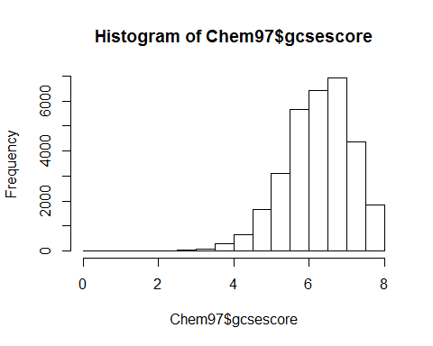

hist(Chem97$gcsescore,col="blue",  
 main="Hallo Welt",ylab="y-Werte",  
 xlab="x-Werte")

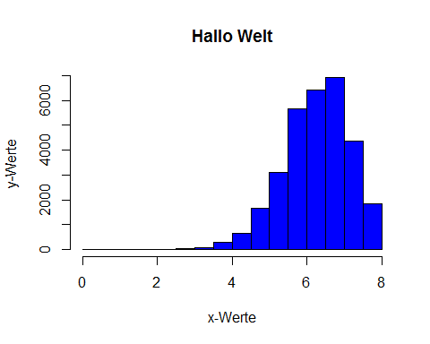

# Barplot

Der Befehl rgb

tabScore <- table(Chem97$score)  
barplot(tabScore)

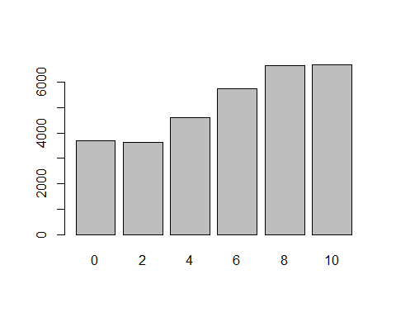

barplot(tabScore,col=rgb(0,0,1))

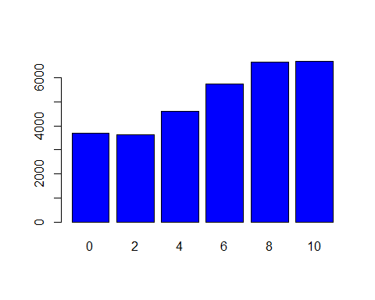

barplot(tabScore,col=rgb(0,1,0))

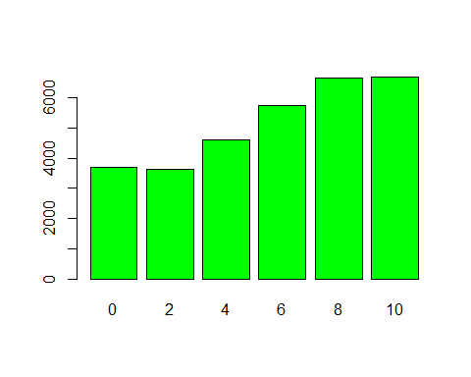

barplot(tabScore,col=rgb(1,0,0,.3))

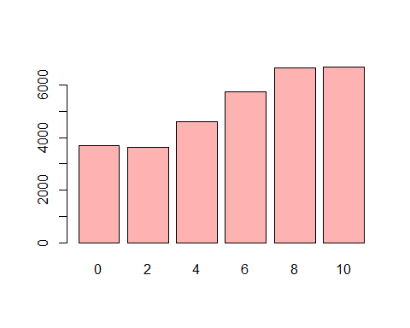

weitere Barplots

barplot(table(Chem97$lea))

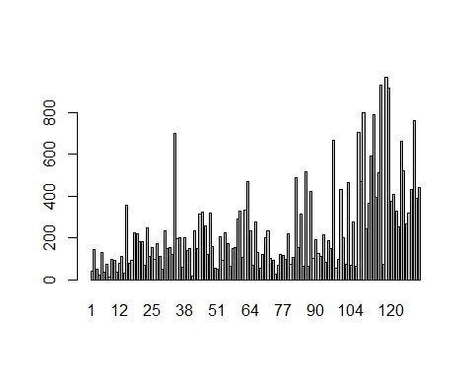

# Boxplot

<http://edoc.hu-berlin.de/dissertationen/gruenwald-andreas-2005-01-17/HTML/chapter2.html>

boxplot(Chem97$gcsescore,horizontal=TRUE)

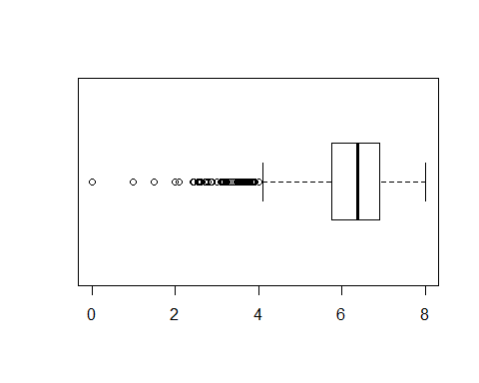

boxplot(Chem97$gcsescore~Chem97$gender)

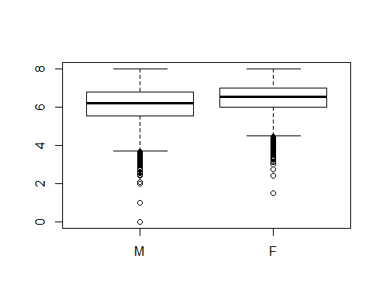

# vioplot

vioplot(Chem97$gcsescore,col="royalblue")

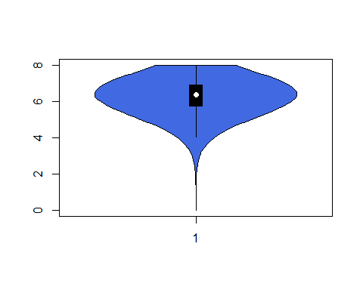

# Scatterplot

plot(Chem97$gcsescore,Chem97$gcsecnt,xlab="gcsescore",  
 ylab="gcsecnt",pch=15,col="royalblue",cex=3)

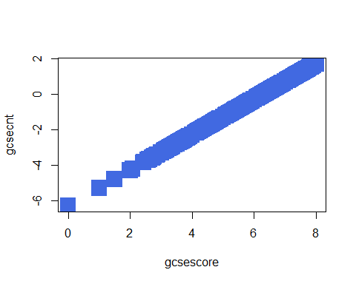

Hier geht es weiter mit Zusammenhang:

<https://github.com/Japhilko/IntroR/blob/master/2015/H_Zusammenhang.Rmd>