JusticeCompass Results for the Paper
This section reports only repository-backed, verified results. No final held-out retrieval benchmark was executed in the current codebase, so the values below remain implementation and coverage results rather than publication-ready benchmark metrics.
Component | Evaluation unit | Verified result
System validation | Repository pipeline | 8 tests passed; 75.41s total runtime
Corpus coverage | Knowledge base | 21 statute docs; 3,282 sections; 1,392 case-law records; 270 cross-ref entries; 5,452 vector records
Citation quality | Cross-reference layer | 94.7% citation coverage; 90 IPC sections require manual mapping
Outcome safety | Abstention logic | Returns insufficient_data when comparable cohort is too small
Benchmark status | Held-out evaluation | Not yet executed; final retrieval and answer-quality metrics remain pending
Paper-ready paragraph:
JusticeCompass was validated on the current implementation with 8 automated tests passing successfully. The project knowledge base contains 21 statute documents, 3,282 statute sections, 1,392 case-law records, 270 cross-reference entries, and 5,452 vector database records. Coverage is strongest in criminal law, where 1,200 bail-related judgments are available; other domains are represented primarily by statutes rather than case law. The system reports 94.7% citation coverage in the cross-reference layer, while noting that 90 IPC sections remain unmapped and that the concordance is not yet verified against an official government mapping. The model abstains with insufficient_data when comparable outcome data are too small, avoiding unsupported probability estimates. A full held-out retrieval and answer-quality benchmark has not yet been executed in the repository, so these results reflect implementation validation and corpus coverage rather than final benchmarked retrieval metrics.
Corpus composition
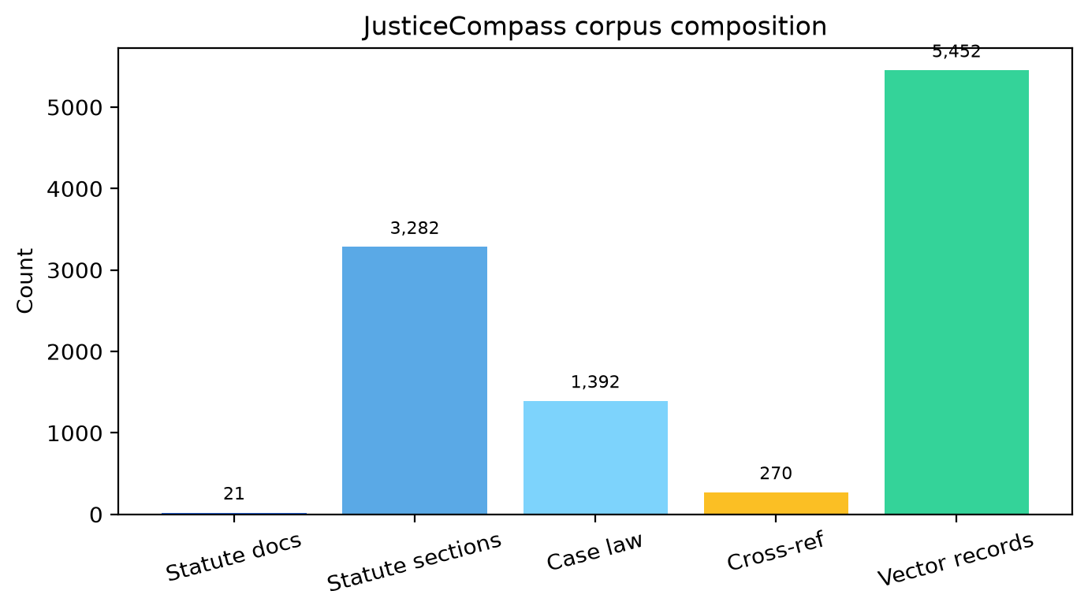
Coverage by legal domain
