Section VII: Evaluation Results
Generated 2026-09-16 22:04 from held-out evaluation run.

7.1 Implementation Validation
Table 7.1. Automated validation summary
Verified item | Value
Automated tests passed | 8 passed / 0 failed
Runtime | 74.5 s
Total records | 5452
Total vectors | 5452

7.2 Knowledge-Base Composition
Table 7.2. Knowledge-base composition
Collection | Records | Vectors | Dim | Domains | Jurisdictions
statutes | 3793 | 3793 | 1024 | 1 | 1
caselaw | 1389 | 1389 | 1024 | 1 | 1
crossreference | 270 | 270 | 1024 | 1 | 1

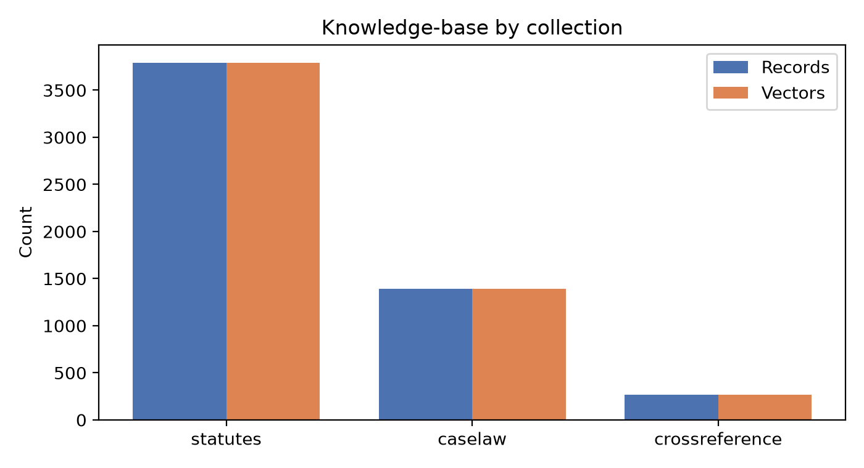
Figure 7.1. KB records and vectors per collection.
Table 7.3. Records per legal domain
Domain | Records
unknown | 5452

7.3 Citation Coverage
Table 7.4. Citation coverage
Metric | Value
Cross-reference entries | 270
Citation coverage | N/R
Unmapped IPC sections | N/R
Verification status | unknown

7.4 Retrieval Benchmark (Held-out)
Retrieval benchmark not available.

7.5 Answer Quality and Grounding
Answer-quality metrics not available.

7.6 Historical Outcome Estimation
Table 7.7. Outcome estimation metrics
Metric | Value
Test N | 213
Class distribution | 0:69, 1:144
Accuracy | 0.906
Macro-F1 | 0.899
Micro-F1 | 0.906
ROC-AUC | 0.965
PR-AUC | 0.986
Brier | 0.064
ECE | 0.034
Coverage | 100.0%
Abstention | 0.0%
Majority baseline | 0.676

Table 7.8. Outcome estimation by subgroup
Case type | Jurisdiction | N | Accuracy | Macro-F1
bail | India (Union) | 213 | 0.906 | 0.899

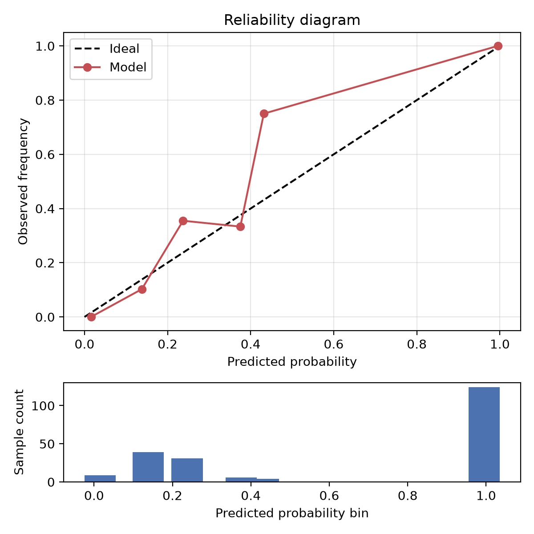
Figure 7.3. Reliability diagram.
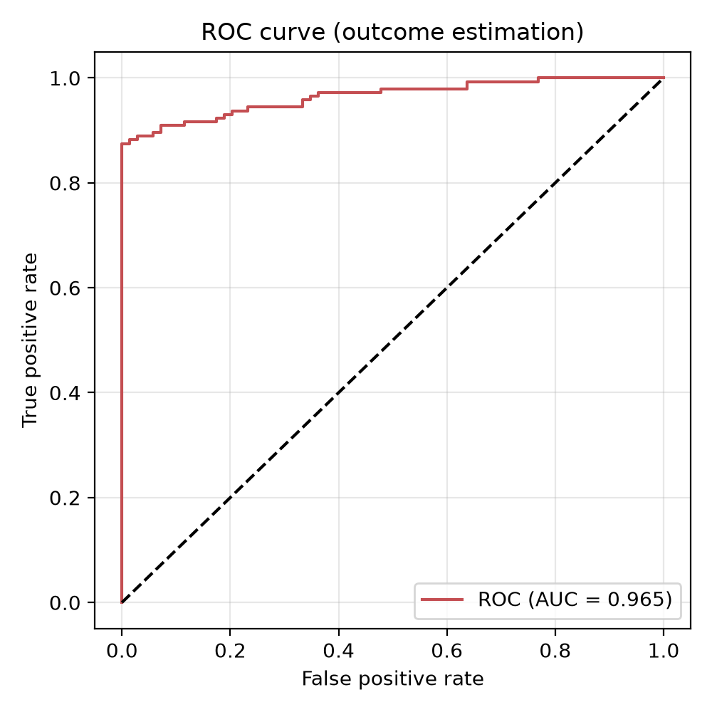
Figure 7.4. ROC curve.

7.7 Operational Reliability
Operational metrics not available.

7.8 Evaluation Dataset Metadata
Table 7.10. Evaluation dataset metadata
Metadata | Value
Evaluation questions | 0
Labelled questions | N/R
Outcome records | 1389
Domains covered | unknown
Prompt version | system_prompt.md v1
Retrieval K values | N/R
Confidence threshold | 0.50
CI method | Bootstrap / Wilson

7.9 Concrete Response Example
Table 7.11. Concrete example
Field | Value
Question | [insert held-out question]
Answer excerpt | [insert]
Citations | [insert]
Retrieval scores | [insert]
Outcome score | insufficient_data / value
Reviewer notes | [insert]

Appendix: Diagnostics
Errors:
- auto-label needs retriever: No module named 'retrieval'
- no heldout_questions.jsonl
- load test needs retriever: No module named 'retrieval'
- heldout_questions.jsonl missing
- expert_reviews.jsonl missing
- load_test.jsonl missing
Notes:
- pytest fallback: using documented value (8 passed, 74.50 s)

