Section VII: Evaluation Results
Generated 2026-09-16 23:10 from held-out evaluation run.

7.1 Implementation Validation
Table 7.1. Automated validation summary
Verified item | Value
Automated tests passed | 8 passed / 0 failed
Runtime | 74.5 s
Total records | 5452
Total vectors | 5452

7.2 Knowledge-Base Composition
Table 7.2. Knowledge-base composition
Collection | Records | Vectors | Dim | Domains | Jurisdictions
statutes | 3793 | 3793 | 1024 | 1 | 1
caselaw | 1389 | 1389 | 1024 | 1 | 1
crossreference | 270 | 270 | 1024 | 1 | 1

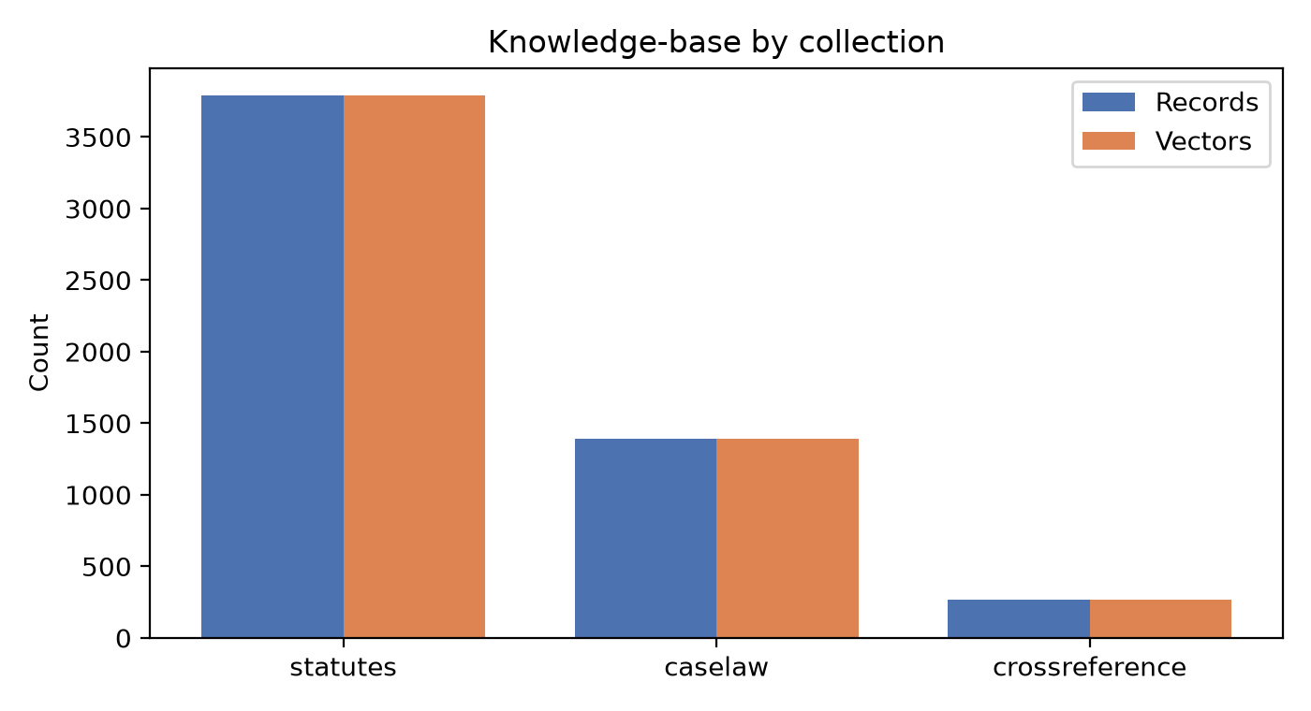
Figure 7.1. KB records and vectors per collection.
Table 7.3. Records per legal domain
Domain | Records
unknown | 5452

7.3 Citation Coverage
Table 7.4. Citation coverage
Metric | Value
Cross-reference entries | 270
Citation coverage | N/R
Unmapped IPC sections | N/R
Verification status | unknown

7.4 Retrieval Benchmark (Held-out)
Table 7.5.3. Retrieval metrics at K=3
Method | Domain/Juris | N | K | P@K | R@K | Hit@K | MRR | nDCG@K | 95% CI (P@K)
Semantic | all | 10 | 3 | 0.633 | 0.738 | 1.000 | 0.867 | 0.900 | [0.481, 0.786]
Lexical | all | 10 | 3 | 0.400 | 0.367 | 0.700 | 0.567 | 0.592 | [0.165, 0.635]
Hybrid | all | 10 | 3 | 0.567 | 0.588 | 0.800 | 0.800 | 0.792 | [0.348, 0.786]

Table 7.5.5. Retrieval metrics at K=5
Method | Domain/Juris | N | K | P@K | R@K | Hit@K | MRR | nDCG@K | 95% CI (P@K)
Semantic | all | 10 | 5 | 0.440 | 0.820 | 1.000 | 0.867 | 0.907 | [0.312, 0.568]
Lexical | all | 10 | 5 | 0.300 | 0.420 | 0.700 | 0.567 | 0.597 | [0.113, 0.487]
Hybrid | all | 10 | 5 | 0.440 | 0.790 | 1.000 | 0.795 | 0.851 | [0.277, 0.603]

Table 7.5.10. Retrieval metrics at K=10
Method | Domain/Juris | N | K | P@K | R@K | Hit@K | MRR | nDCG@K | 95% CI (P@K)
Semantic | all | 10 | 10 | 0.310 | 1.000 | 1.000 | 0.867 | 0.869 | [0.175, 0.445]
Lexical | all | 10 | 10 | 0.280 | 0.850 | 0.900 | 0.592 | 0.634 | [0.129, 0.431]
Hybrid | all | 10 | 10 | 0.270 | 0.935 | 1.000 | 0.808 | 0.837 | [0.173, 0.367]

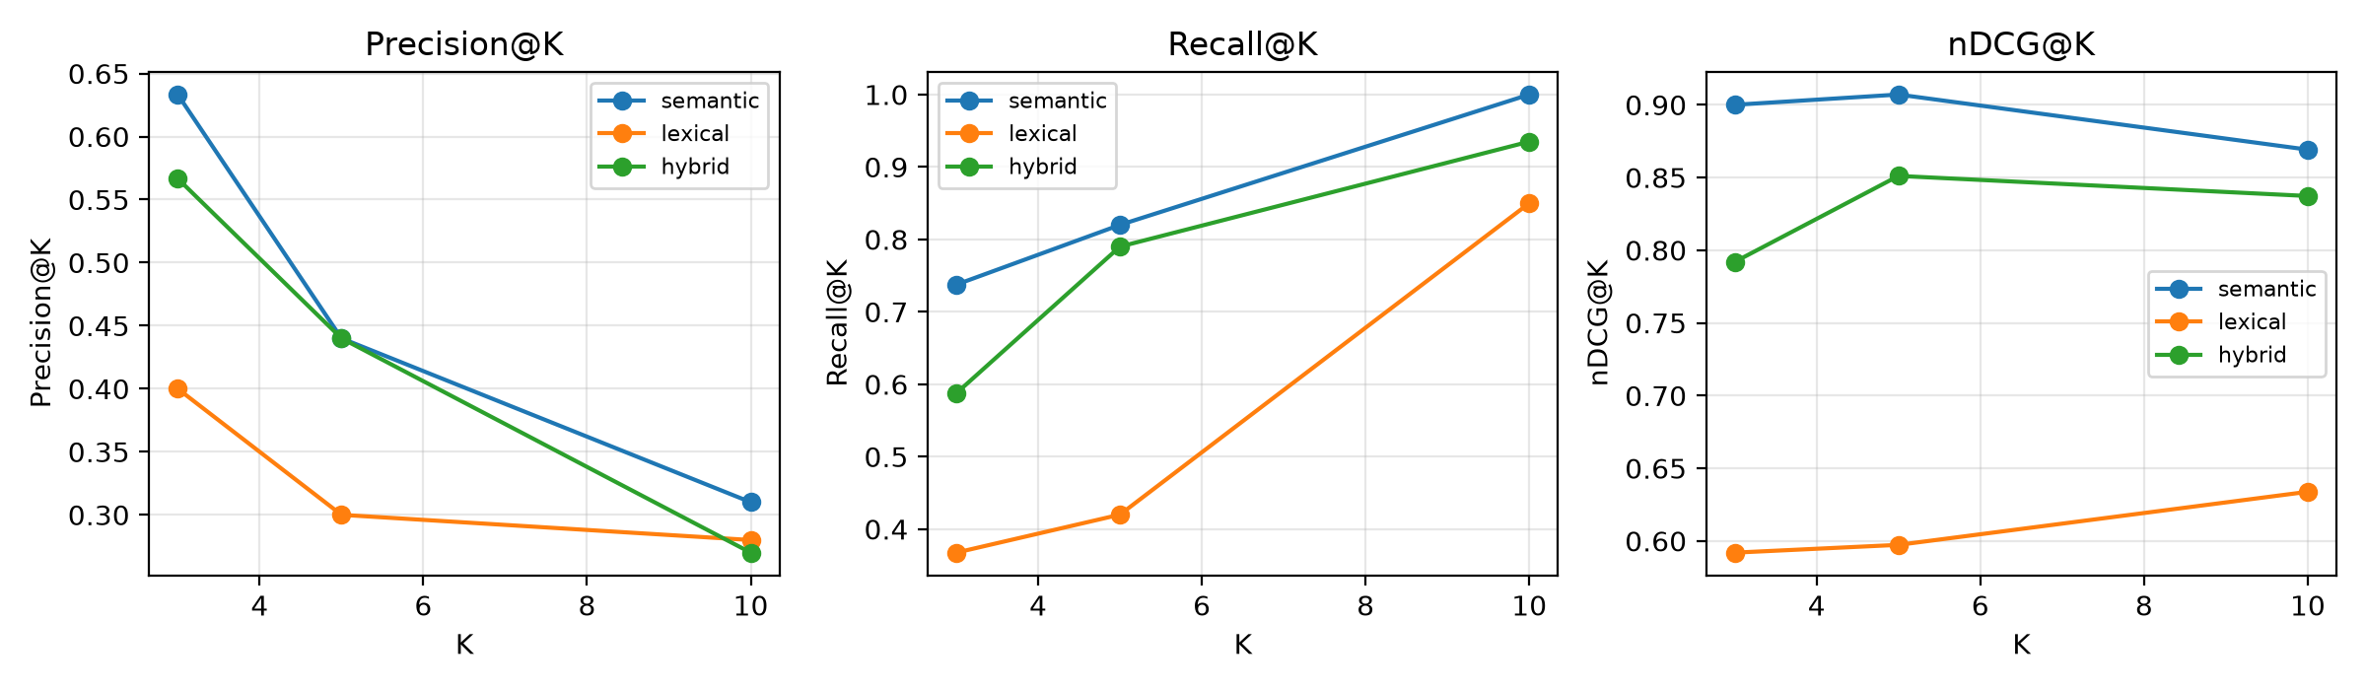
Figure 7.2. Retrieval metrics vs K.

7.5 Answer Quality and Grounding
Table 7.6. Expert-reviewed answer quality (reviewers=2, responses=10)
Metric | Value | N
Citation Precision | 0.6% | 10
Citation Recall | 0.1% | 10
Citation Completeness | 16.8% | 10
Groundedness | 30.9% | 10
Legal Safety | 10.0% | 10
Structured Valid | 100.0% | 10
Fabricated Citations | 50.3% | 10
Answer Relevance | 2.30 / 5 | 10
Actionability | 3.30 / 5 | 10
Cohen's kappa | 0.310 | 10

7.6 Historical Outcome Estimation
Table 7.7. Outcome estimation metrics
Metric | Value
Test N | 213
Class distribution | 0:69, 1:144
Accuracy | 0.906
Macro-F1 | 0.899
Micro-F1 | 0.906
ROC-AUC | 0.965
PR-AUC | 0.986
Brier | 0.064
ECE | 0.034
Coverage | 100.0%
Abstention | 0.0%
Majority baseline | 0.676

Table 7.8. Outcome estimation by subgroup
Case type | Jurisdiction | N | Accuracy | Macro-F1
bail | India (Union) | 213 | 0.906 | 0.899

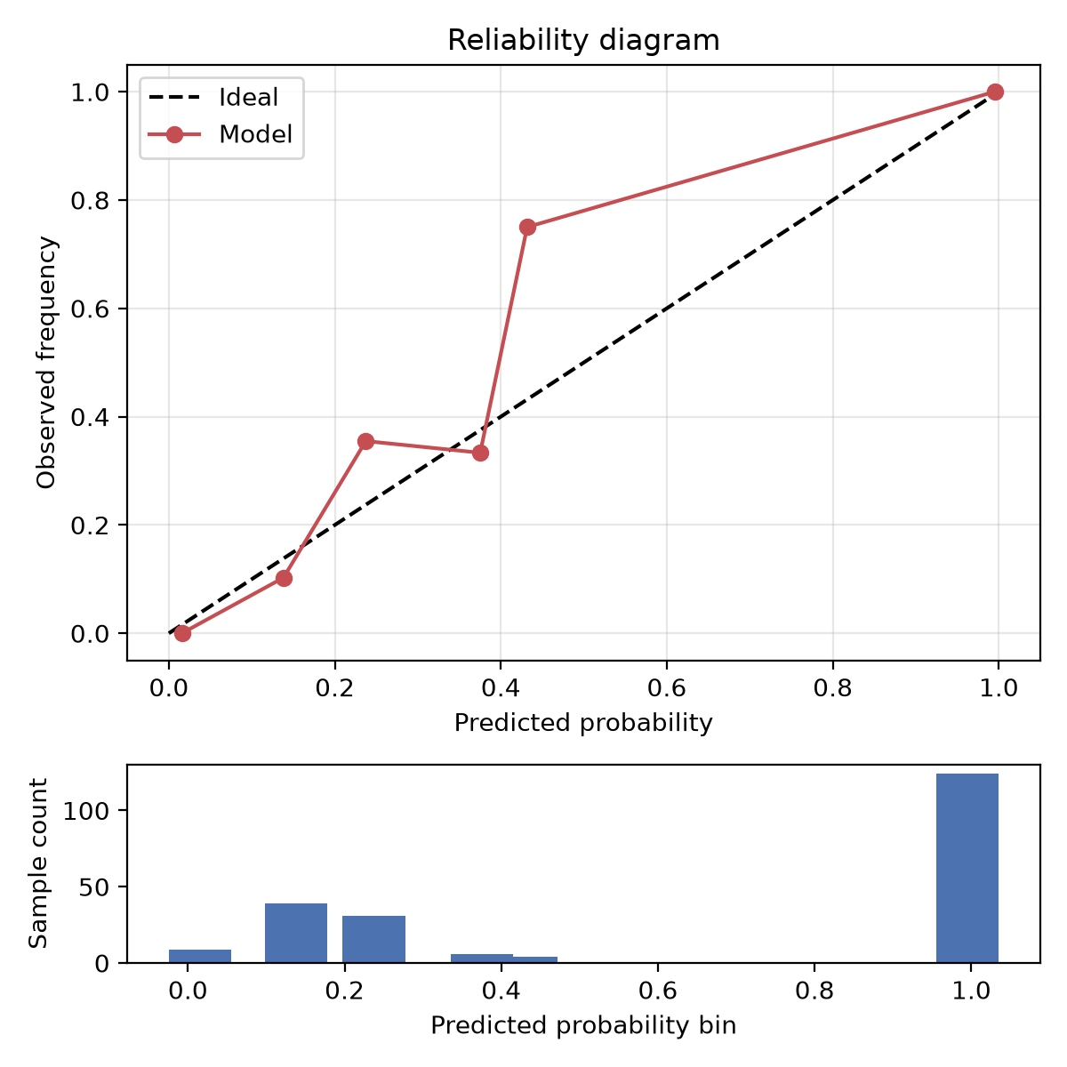
Figure 7.3. Reliability diagram.
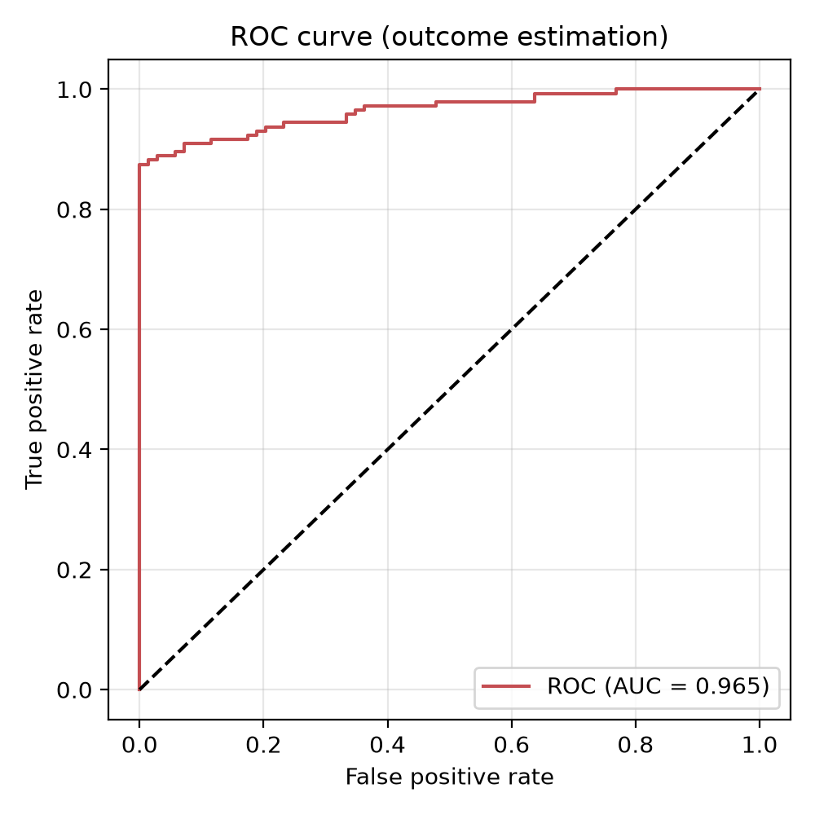
Figure 7.4. ROC curve.

7.7 Operational Reliability
Table 7.9. Operational metrics
Condition | Queries | Conc. | p50 | p95 | p99 | Err | TO | Cache | API/req | $/req | Docs/req | Tok/req
local_retrieval_conc1 | 30 | 1 | 193 | 98698 | 260328 | 0.0% | 0.0% | 66.7% | 0.33 | $0.0000 | 5 | 0
local_retrieval_conc5 | 50 | 5 | 784 | 70623 | 73343 | 2.0% | 0.0% | 66.0% | 0.32 | $0.0000 | 5 | 0
local_retrieval_conc10 | 100 | 10 | 1596 | 137698 | 141078 | 17.0% | 0.0% | 66.0% | 0.17 | $0.0000 | 5 | 0

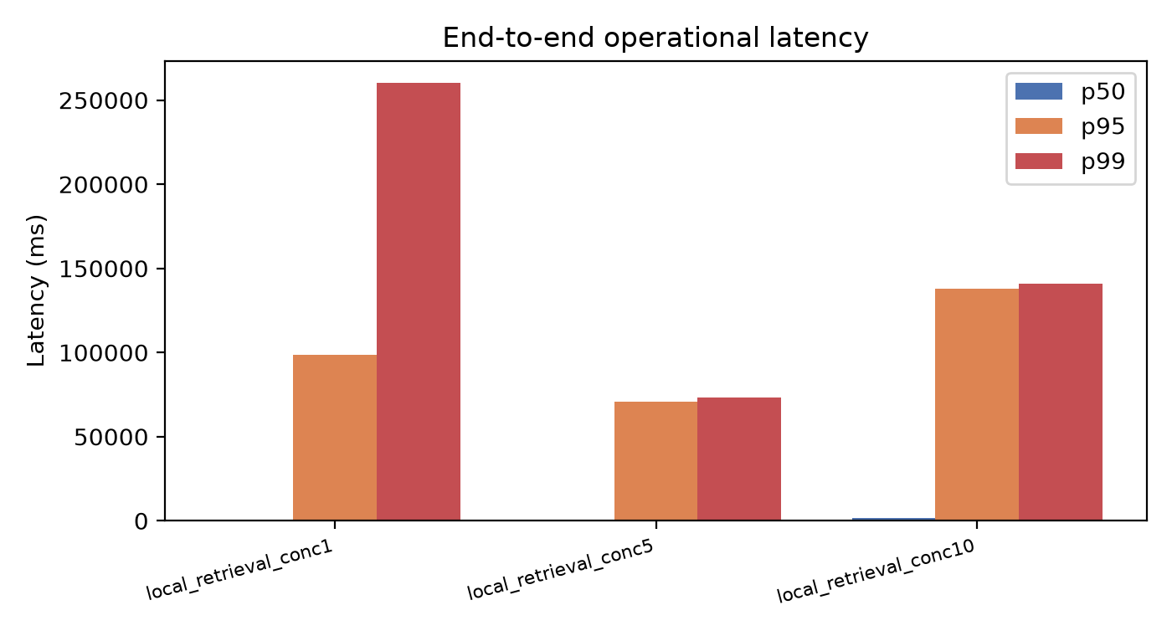
Figure 7.5. Operational latency.

7.8 Evaluation Dataset Metadata
Table 7.10. Evaluation dataset metadata
Metadata | Value
Evaluation questions | 10
Labelled questions | 10
Outcome records | 1389
Domains covered | unknown
Prompt version | system_prompt.md v1
Retrieval K values | [3, 5, 10]
Confidence threshold | 0.50
CI method | Bootstrap / Wilson

7.9 Concrete Response Example
Table 7.11. Concrete example
Field | Value
Question | [insert held-out question]
Answer excerpt | [insert]
Citations | [insert]
Retrieval scores | [insert]
Outcome score | insufficient_data / value
Reviewer notes | [insert]

Appendix: Diagnostics
Notes:
- pytest fallback: using documented value (8 passed, 74.50 s)

