LOGISTICS DATA ANALYST
INTERNSHIP PROJECT
TASK 4 PROJECT REPORT
Predictive Modeling and Optimization in Logistics Systems

Prepared by | Role | Organization | Reporting Period
Japkirat Kaur | Logistics Data Analyst Intern | Yuva Intern | September 2026

Project focus: forecasting shipment delivery time using supervised machine learning and translating validated predictions into logistics decision-support and optimization strategies.

Executive Summary
This project develops an end-to-end predictive modeling framework for forecasting shipment delivery time in a hypothetical logistics environment. The workflow covers problem definition, data simulation, exploratory analysis, preprocessing, baseline benchmarking, multiple regression models, 5-fold cross-validation, hyperparameter tuning, diagnostic analysis, feature interpretation, scenario-based optimization, and implementation recommendations.
Final KPI | Result | Meaning
Dataset | 2,000 shipments; 11 variables | Complete simulated modeling dataset with no missing values or duplicate rows
Selected model | Tuned Random Forest Regressor | Selected after test comparison, cross-validation and grid-search tuning
Test MAE | 2.83 hours | Average absolute prediction error on the held-out test set
Test RMSE | 3.57 hours | Penalizes larger errors more heavily than MAE
Test R² | 0.968 | 96.8% of test-set variation explained relative to the mean-prediction reference
5-fold CV MAE | 3.04 hours after tuning | Stable internal validation across multiple training/validation partitions
Tuning gain | 1.99% CV MAE improvement | Measurable but modest improvement over the untuned Random Forest
Leading model driver | Distance: 56.61% importance | Largest impurity-based predictive contribution in the fitted ensemble
The model substantially outperforms the mean baseline (MAE 16.61 hours). However, the report does not treat high simulated accuracy as proof of real-world performance. The target was generated from structured relationships in a hypothetical dataset, and all validation is internal to that simulation. The final model is therefore presented as a prototype decision-support component requiring external validation before operational deployment.

1. Problem Definition and Business Objective
The prediction problem is to estimate Delivery_Time_Hours before shipment completion using information available during planning. Reliable estimates can support scheduling, service commitments, shipment prioritization, and evaluation of feasible transport alternatives.
Prediction and optimization are deliberately separated. Prediction estimates expected delivery duration under specified shipment characteristics; optimization chooses an operational action subject to objectives and constraints. Because the simulated dataset does not include transportation cost, capacity, route availability, or service penalties, this project demonstrates delivery-time decision support rather than claiming a complete real-world optimization solution.

2. Hypothetical Dataset Design and Validation
Variable | Type | Role
Shipment_ID | Identifier | Unique shipment record
Shipment_Date | Datetime | Simulated shipment date
Region | Categorical | North, South, East, West
Transport_Mode | Categorical | Air, Rail, Road, Sea
Priority | Categorical | Shipment service priority
Distance_km | Numeric | Route distance
Shipment_Volume_kg | Numeric | Shipment weight/volume proxy
Warehouse_Processing_Hours | Numeric | Pre-dispatch processing duration
Traffic_Level | Categorical | Traffic condition
Weather_Condition | Categorical | Weather condition
Delivery_Time_Hours | Numeric target | Forecast variable
Validation confirmed 2,000 rows, 11 columns, zero missing values, zero duplicate rows, and zero duplicate shipment IDs. Shipment_Date was stored as a datetime variable, numerical predictors used numeric dtypes, and categorical predictors used object/string representations. This provides a clean simulated basis for modeling while the production pipeline still includes imputers to remain robust to future missing values.

3. Exploratory Data Analysis
Metric | Mean | Median | Std. Dev. | Min | Max
Distance (km) | 1,525.85 | 1,522.00 | 854.08 | 50.00 | 3,000.00
Shipment Volume (kg) | 287.50 | 246.29 | 190.91 | 20.00 | 1,253.39
Warehouse Processing (h) | 3.74 | 3.30 | 2.39 | 0.50 | 15.00
Delivery Time (h) | 34.99 | 31.26 | 19.62 | 2.39 | 105.35
Delivery time has a mean of 34.99 hours and median of 31.26 hours, with values extending to 105.35 hours. The higher mean than median and the long upper range indicate a longer-duration tail. This matters for evaluation because average performance can conceal larger errors on operationally important long-duration shipments.
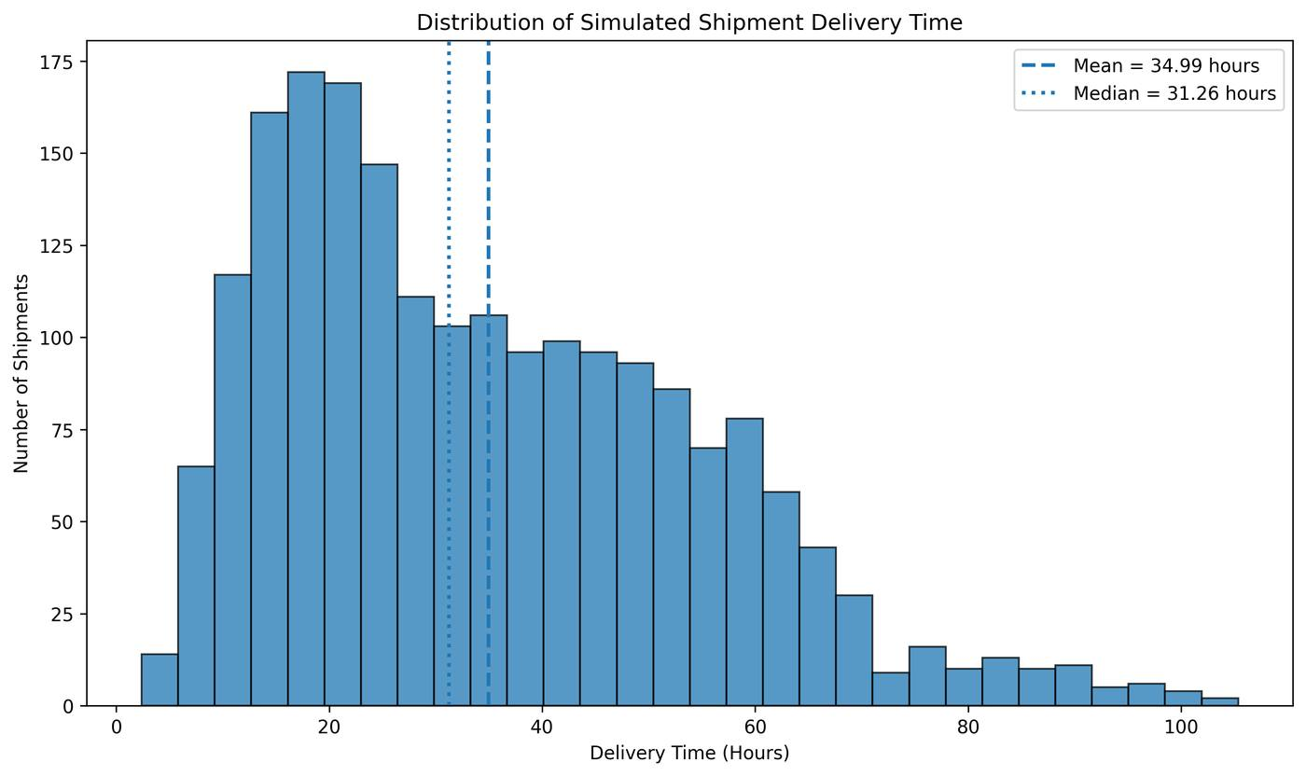
Figure 1. Distribution of simulated shipment delivery time. A histogram is appropriate for examining the target distribution, central tendency and tail behavior.
Visualization interpretation: the histogram makes distribution shape visible in a way that summary statistics alone cannot. The mean and median reference lines support the conclusion that the target is not perfectly symmetric. Operationally, the long-duration tail motivates both robust error metrics and later residual diagnostics.

4. Relationships and Visualization Rationale
Pearson correlation was used for numerical pairwise linear relationships. Distance_km has a correlation of 0.712 with Delivery_Time_Hours, while Warehouse_Processing_Hours is 0.084 and Shipment_Volume_kg is 0.001. Correlation is descriptive, not causal, and cannot directly represent categorical variables such as transport mode.
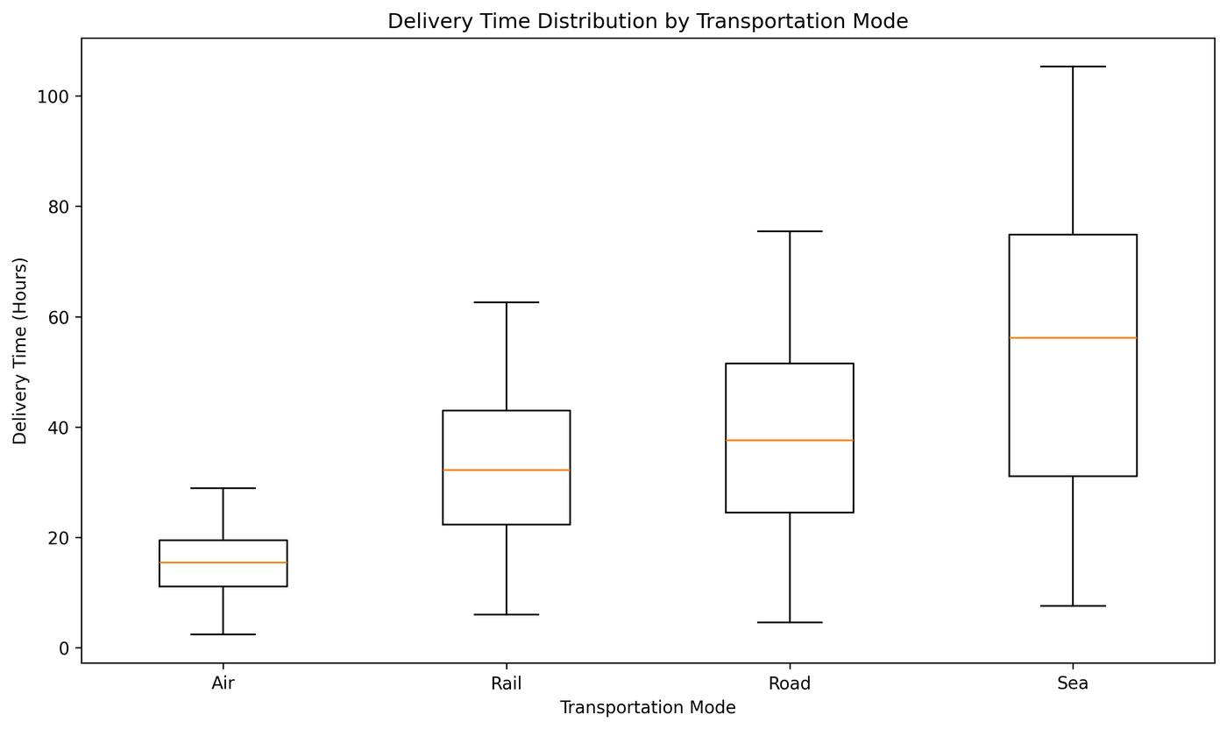
Figure 2. Delivery-time distribution by transportation mode. A box plot is appropriate because it compares medians, spread and range across categorical groups.
Mode | Shipments | Mean Delivery (h) | Median (h) | Std. Dev. (h) | Min | Max
Air | 378 | 15.36 | 15.42 | 5.32 | 2.39 | 28.95
Rail | 401 | 32.58 | 32.18 | 12.75 | 6.03 | 62.58
Road | 931 | 37.90 | 37.56 | 16.35 | 4.59 | 75.45
Sea | 290 | 54.54 | 56.18 | 24.85 | 7.55 | 105.35
The box plot shows substantial mode-specific differences that a single overall average would hide. Air has the shortest mean simulated delivery time (15.36 h), while Sea has the longest (54.54 h). These are simulated associations and should not be read as causal estimates for real transport networks.

5. Data Preparation and Leakage Control
The 2,000 observations were split into 1,600 training and 400 testing observations. Eight predictor variables were used: Distance_km, Shipment_Volume_kg, Warehouse_Processing_Hours, Region, Transport_Mode, Priority, Traffic_Level, and Weather_Condition. Delivery_Time_Hours is the target.
Numerical features use median imputation and standardization. Categorical features use most-frequent imputation and one-hot encoding. These transformations are embedded inside scikit-learn pipelines so that preprocessing is learned only from the training portion of each fit. Keeping preprocessing inside cross-validation also reduces leakage from validation folds.
numerical_transformer = Pipeline([('imputer', SimpleImputer(strategy='median')), ('scaler', StandardScaler())])
categorical_transformer = Pipeline([('imputer', SimpleImputer(strategy='most_frequent')), ('onehot', OneHotEncoder(handle_unknown='ignore'))])

6. Model Selection and Comparative Performance
Four models were evaluated on the same held-out test set: a mean baseline, Linear Regression, Decision Tree Regression, and Random Forest Regression. The baseline establishes whether machine learning provides useful shipment-specific information rather than merely reproducing the target average.
Model | MAE (h) | RMSE (h) | R² | MAE Improvement vs Baseline | RMSE Improvement vs Baseline
Baseline Mean | 16.61 | 19.97 | ≈0 | 0.00% | 0.00%
Linear Regression | 5.10 | 7.22 | 0.869 | 69.29% | 63.86%
Decision Tree | 4.18 | 5.32 | 0.929 | 74.86% | 73.37%
Random Forest | 2.85 | 3.61 | 0.967 | 82.82% | 81.93%
MAE is emphasized because it expresses typical prediction error directly in hours. RMSE is included because it penalizes larger errors more strongly, and R² describes variation explained relative to a mean-based reference. The consistent ranking across all three metrics strengthens the comparison, but a single split is not sufficient for final model selection.

7. Cross-Validation and Model Stability
Model | Mean 5-fold CV MAE | Std. Dev. | Best Fold | Worst Fold
Linear Regression | 5.05 h | 0.27 h | 4.74 h | 5.51 h
Decision Tree | 4.24 h | 0.18 h | 4.00 h | 4.41 h
Random Forest | 3.10 h | 0.11 h | 2.91 h | 3.22 h
Random Forest has both the lowest mean validation MAE and the smallest fold-to-fold standard deviation. Its 3.10-hour cross-validation MAE is also close to the 2.85-hour initial test MAE, providing evidence that strong performance is not confined to one test partition. These folds still come from the same simulated data-generating process, so this is internal rather than external validation.
scores = -cross_val_score(model, X_train, y_train, cv=5, scoring='neg_mean_absolute_error', n_jobs=-1)

8. Hyperparameter Tuning and Final Model
GridSearchCV systematically evaluated Random Forest settings for number of trees, maximum depth, minimum samples per leaf, and feature sampling. The search used 5-fold cross-validation with negative MAE as the scoring objective, while the held-out test set remained untouched until final evaluation.
Tuning Element | Selected Value
n_estimators | 250
max_depth | None
min_samples_leaf | 1
max_features | 0.8
Untuned CV MAE | 3.10 h
Tuned CV MAE | 3.04 h
CV MAE improvement | 1.99%
The tuning gain is measurable but modest. This is reported explicitly because additional model complexity and computation should be justified by practical benefit. The tuned configuration is retained because it provides the strongest validated performance, not because tuning itself produced a dramatic improvement.
Final Test Metric | Tuned Random Forest
MAE | 2.83 hours
RMSE | 3.57 hours
R² | 0.968
The final MAE means predictions differ from actual simulated delivery times by about 2.83 hours on average in absolute terms. R² = 0.968 does not mean 96.8% of individual predictions are correct; it describes explained variation relative to the mean-prediction reference on this held-out simulated test set.

9. Final Model Diagnostics
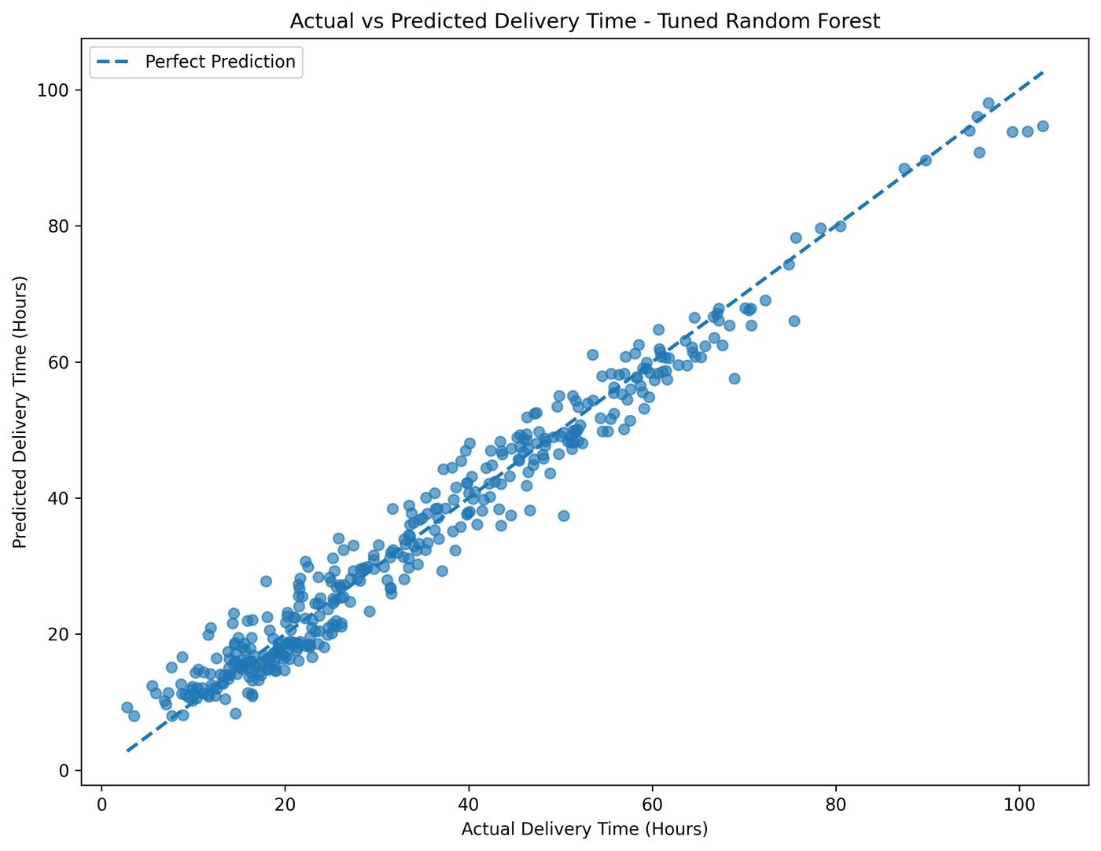
Figure 3. Actual vs predicted delivery time. The 45-degree reference line makes agreement and range-specific deviations directly visible.
Most observations lie close to the perfect-prediction line, consistent with the strong aggregate metrics. Some of the longest-duration shipments fall below the line, suggesting possible underprediction toward the upper end. This matters operationally because underestimating a long shipment can create optimistic schedules or service commitments.
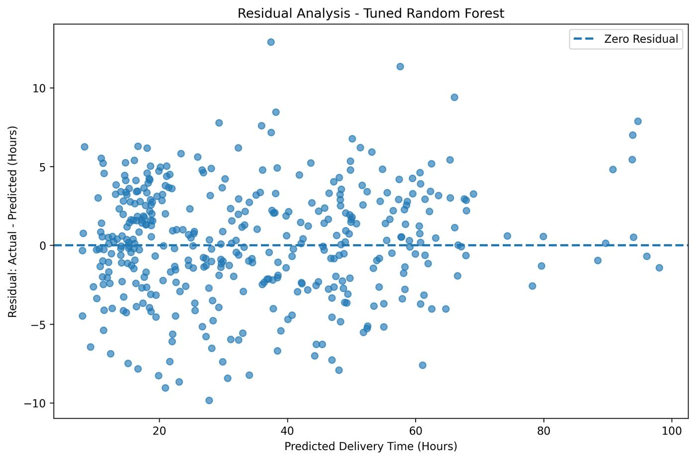
Figure 4. Residuals (Actual - Predicted) versus predicted delivery time. A residual plot is appropriate for detecting directional bias and error patterns hidden by aggregate metrics.
Residual Statistic | Value
Mean | 0.21 h
Median | 0.31 h
Standard deviation | 3.57 h
Minimum | -9.84 h
Maximum | 12.91 h
Residuals appear on both sides of zero and the mean residual is only +0.21 hours, indicating little overall directional bias. However, individual errors remain meaningful: the range from -9.84 to +12.91 hours shows why a near-zero mean residual cannot be interpreted as error-free prediction. Positive residuals represent underprediction because residual = Actual - Predicted.

10. Feature Importance and Interpretation
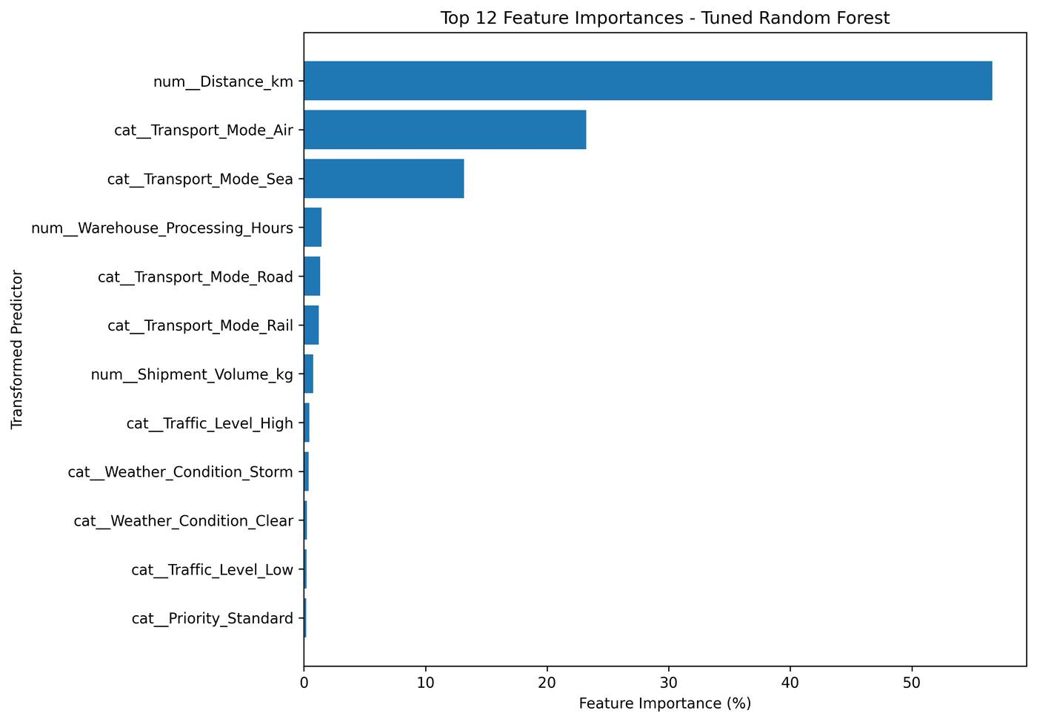
Figure 5. Top transformed Random Forest feature importances. Horizontal bars improve readability for one-hot-encoded feature names and support direct relative comparison.
Transformed Feature | Importance
Distance_km | 56.61%
Transport_Mode_Air | 23.23%
Transport_Mode_Sea | 13.16%
Warehouse_Processing_Hours | 1.45%
Transport_Mode_Road | 1.33%
Transport_Mode_Rail | 1.24%
Shipment_Volume_kg | 0.76%
Traffic_Level_High | 0.44%
Weather_Condition_Storm | 0.41%
Weather_Condition_Clear | 0.25%
Traffic_Level_Low | 0.21%
Priority_Standard | 0.19%
Distance is the dominant individual feature and is consistent with its Pearson correlation of 0.712. Transportation mode is also important, although one-hot category importances should not be treated as a complete ranking of the underlying modes. Warehouse processing has weak pairwise correlation (0.084) yet still contributes to the nonlinear ensemble, illustrating that correlation and model-based importance answer different questions.
These values are impurity-based importances. They describe predictive use within the fitted forest, not causation, direction of effect, or guaranteed stability across datasets. In a production study, permutation importance or SHAP analysis could provide complementary interpretation.

11. Scenario-Based Logistics Optimization
The final model is used for controlled what-if analysis. These scenarios change one operational input while holding the others fixed, allowing consistent comparison of model outputs. They are decision-support demonstrations, not causal experiments.
Mode Scenario | Predicted Delivery Time
Air | 13.87 h
Rail | 28.81 h
Road | 34.36 h
Sea | 54.08 h
For a 1,500 km, 300 kg shipment with 4 hours warehouse processing, North region, Standard priority, Medium traffic and Clear weather, Air is predicted 20.49 hours shorter than Road, while Rail is 5.55 hours shorter than Road. Sea is 19.72 hours longer than Road. If delivery time were the only objective and all modes were feasible, Air would have the shortest predicted duration in this scenario. A real choice must also consider cost, capacity, availability, route constraints, environmental considerations and service requirements.
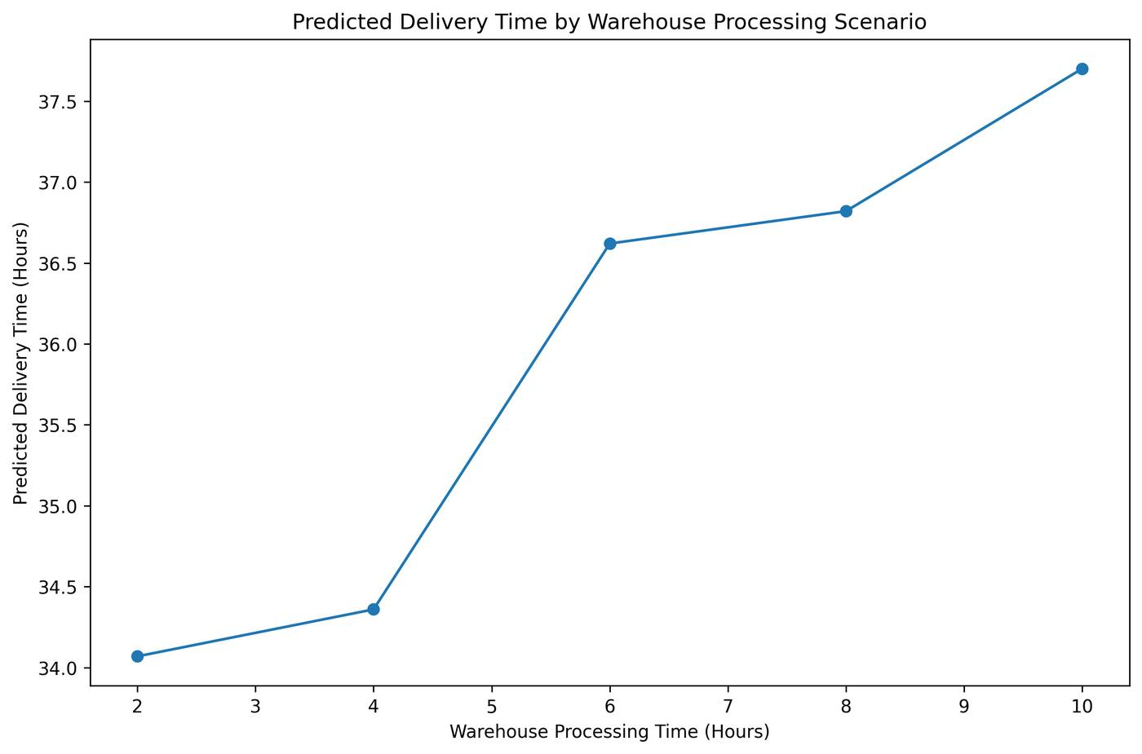
Figure 6. Predicted delivery time across warehouse-processing scenarios. A line chart is appropriate because the input is ordered numeric and the purpose is to show how model predictions change across increasing processing times.
Warehouse Processing | Predicted Delivery Time
2 h | 34.07 h
4 h | 34.36 h
6 h | 36.62 h
8 h | 36.82 h
10 h | 37.70 h
Across the controlled Road scenario, increasing warehouse processing from 2 to 10 hours is associated with a 3.63-hour increase in predicted total delivery time. The response is not perfectly linear, which is consistent with Random Forest predictions based on tree partitions rather than a constant coefficient. The result should not be interpreted as a guaranteed causal saving from a warehouse intervention.

12. Actionable Optimization Recommendations
Pre-shipment prediction: Use predicted delivery time as a planning KPI and flag unusually long predicted shipments for review. The recommendation is supported by the final test MAE of 2.83 h, while residual extremes show that predictions should not be treated as guarantees.
Service-constrained mode evaluation: Estimate delivery time under each feasible mode, remove alternatives that miss the service deadline, then evaluate the remaining options using cost, capacity and availability. This follows directly from the controlled mode scenario.
Distance-sensitive planning: Give long-distance shipments additional planning attention because distance contributes 56.61% of model importance and correlates 0.712 with simulated delivery time.
Targeted warehouse improvement: Prioritize processing-time reduction where service benefits justify additional resources. The controlled scenario shows a 3.63-hour predicted difference across the 2-to-10-hour processing range.
Risk-based human review: Escalate high-risk shipments because residuals range from -9.84 to +12.91 h despite strong average performance.
Model monitoring: Track MAE, RMSE, residual patterns, segment performance and input-distribution changes. Retrain and revalidate when business-defined thresholds are breached.
Extend to multi-objective optimization: Add transportation cost, capacity, route availability, fuel/energy, service deadlines, warehouse capacity and labor constraints. These variables are necessary before claiming full cost-and-service optimization.

13. Optimization Decision Framework
A practical operational workflow is: Predict expected delivery duration -> Identify high-risk or deadline-sensitive shipments -> Evaluate feasible alternatives -> Apply cost, capacity and service constraints -> Select an operational action -> Monitor the completed outcome. This keeps the predictive model in a decision-support role while preserving human oversight for constraints that are absent from the dataset.

14. Consolidated Analytical Findings
Analytical Area | Evidence | Operational Meaning
Target distribution | Mean 34.99 h; median 31.26 h; max 105.35 h | Long-duration tail requires attention beyond average performance
Distance relationship | r = 0.712; importance = 56.61% | Major planning input in the simulated system
Mode differences | Air 15.36 h mean; Sea 54.54 h mean | Mode is important for forecasting and scenario planning
Baseline vs final | MAE 16.61 h -> 2.83 h | Large improvement over mean-only prediction
Cross-validation | Random Forest 3.10 ± 0.11 h MAE | Strong performance is stable across five internal folds
Tuning | 3.10 -> 3.04 h CV MAE | Only a modest 1.99% incremental gain
Residual risk | -9.84 to +12.91 h | Individual errors remain operationally relevant
Mode scenario | 13.87 to 54.08 h | Predictions can screen alternatives against service requirements
Warehouse scenario | 34.07 to 37.70 h | Processing improvement may matter for selected shipments

15. Feasibility, Limitations, and Real-World Implementation
Technical feasibility: The prototype uses standard Python and scikit-learn pipelines and could technically be integrated with shipment-planning systems if the required predictors are available at prediction time.
Simulated data: All observations are hypothetical. Strong model performance partly reflects relationships intentionally embedded in the data-generation process and must not be generalized directly to real operations.
Internal validation only: Train-test evaluation and cross-validation use observations from the same simulated process. External validation on independent historical logistics data is required before deployment.
Incomplete optimization variables: Cost, capacity, route availability, labor, fuel/energy and service penalties are absent. Therefore, the project demonstrates delivery-time decision support rather than full mathematical optimization.
Changing operating conditions: Routes, carriers, demand, warehouse processes and external conditions can shift. Production monitoring and periodic retraining would be required.
Human oversight: Operational planners should retain responsibility for unusual events, contractual constraints, urgent customer needs and other factors not represented in the model.

16. Python Tools and Reproducibility
The notebook uses pandas and NumPy for data handling, Matplotlib for visualization, and scikit-learn for preprocessing, model training, evaluation, cross-validation and GridSearchCV. Random seeds are used where applicable to support reproducibility. The full notebook accompanies this report.
grid_search = GridSearchCV(estimator=tuning_pipeline, param_grid=param_grid, scoring='neg_mean_absolute_error', cv=5, n_jobs=-1, refit=True)
grid_search.fit(X_train, y_train)
tuned_predictions = grid_search.best_estimator_.predict(X_test)

17. Conclusion and Reflection
This project demonstrates a complete predictive analytics workflow for logistics delivery-time forecasting. The tuned Random Forest achieves MAE 2.83 hours, RMSE 3.57 hours and R² 0.968 on the held-out simulated test set, with 5-fold tuned CV MAE of 3.04 hours. The analysis combines model comparison, validation, diagnostics and interpretation rather than relying on a single accuracy figure.
The optimization scenarios show how forecasts can inform transport-mode evaluation and warehouse planning while preserving the distinction between prediction and optimization. The strongest practical lesson is that model outputs should be combined with service requirements, feasibility constraints, cost information, monitoring and human judgment. The project is therefore best understood as a rigorously evaluated prototype for predictive logistics decision support, not as a production-ready autonomous optimization system.

Appendix A. Key Deliverables
Artifact | Purpose
Task 4 DOC report | Comprehensive methodology, results, visualizations, interpretations and recommendations
Python notebook (.ipynb) | Reproducible code, model training, validation, tuning and scenario analysis
Hypothetical logistics dataset (.csv) | 2,000-row simulated source dataset
Charts folder | Six exported visualization outputs used in the analysis

