SAS CU HACKATHON
Round 2 — Approach Note
Skills vs Labels
Is a data professional paid for what they can do, or for what their job is called?
Team AkuuJii
Japneet Kour Khanduja (24BCS12959) · [Member 2] · [Member 3] · [Member 4]
Department of Computer Science & Engineering, Chandigarh University
October 2026

Contents
Executive Summary 3
1. Problem Definition and Analytics Objective 4
2. Approach Description 6
3. Data Exploration: Management, Derivation and Preparation 8
3.1 Data audit 8
3.2 Data issues and treatment 8
3.3 Derived variables 9
3.4 Exploratory findings 9
4. Data Analysis 13
4.1 Q1 Which skills carry a pay premium? 13
4.2 Q2 Do job titles still pay once skills are controlled? 14
4.3 Q3 When does salary growth flatten? 17
4.4 Q4 Which skills earn a junior a high salary hike? 17
4.5 Q5 Which traits mark a successful senior? 19
4.6 The decision-support dashboard 20
5. Results and Conclusions 22
6. Implications 23
Appendix 24

Executive Summary
Every data job carries two kinds of information: a skill list (Python, SQL, machine learning, storytelling) and a label (Data Analyst, Data Scientist, ML Engineer, Senior …). Students are told to collect skills, but employers advertise and pay by title. This note asks which of the two actually drives reward in data-science careers. We use all four hackathon datasets: 15,841 analytics job postings, 1,602 company-level data-science postings, skill scores for 139 junior data scientists and Big-Five personality scores for 161 senior data scientists.
We built a scripted, reproducible pipeline of twelve steps: raw-data audit, logged cleaning, exploration, five statistical studies, model training and figure generation. On top of it sits an interactive Streamlit dashboard that answers the questions live and lets a user simulate salary, hike and success scenarios.
Key findings
1. Labels pay, even after skills are controlled. Adding all 30 skill flags to a log-salary model shrinks title premiums by only about a third. ML Engineer keeps +31% and Data Scientist +16% over the average title, and R² rises only from 0.480 to 0.493.
2. The 'Senior' word alone is worth 14–36%. In the Data Science Jobs file, a Senior Data Scientist posting pays +194% more than a Data Analyst posting asking for the same experience.
3. Some skills still pay, and some cost. Holding title, city and experience fixed, Java (+23%), business analysis (+19%) and SQL (+18%) are each worth more than a year of experience. Excel (-11%) and SEO (-12%) carry penalties, and 13 of 30 skills show no reliable effect.
4. Pay growth is front-loaded. Salary rises about 36% a year until ~6.5 years of experience (95% CI 6.0–7.0), then about 7% a year.
5. Inside the firm, skills do matter for juniors. Maths & statistics (odds ×3.8 per SD) and dashboard & storytelling (×3.1) drive a high salary hike. Coding alone is not significant. Cross-validated AUC is 0.886.
6. For seniors, personality decides success, with sweet spots. Conscientiousness (×27 per SD) and openness (×21) dominate. All five traits have an inverted-U optimum, and one archetype, the "driven achievers", accounts for nearly all successful seniors (89% success).

What this means. Skills open the door, but the label and experience set the price. Candidates should aim at the higher-paid labels (Data Scientist, ML Engineer) and back the claim with quantitative and communication skills. Employers should audit title-based pay bands, because skills explain little of the title gap. L&D teams can use the hike and success models as transparent development tools, not as hiring filters.

1. Problem Definition and Analytics Objective

1.1 Business context
Data-science hiring in India runs on two signals that do not always agree. Job postings list long, inconsistent skill strings, and the same work appears under many titles: Analyst, Data Analyst, Business Analyst, Data Scientist, ML Engineer. Students and early-career professionals are advised to 'learn more skills', yet salary bands, promotion ladders and recruiter searches are organised by title. If titles carry pay that skills do not explain, two equally capable people can be paid very differently simply because of what their role is called.
The four datasets provided capture this at three points in the career: the external market (Analytics Jobs, Data Science Jobs), the junior reward decision (JDS Skill Traits: salary hike high or low) and senior success (SDS Personality Traits). Together they let us test whether reward follows capability or labels across the whole career.

1.2 Problem statement
Analytics objective
Quantify how much of a data professional's reward is explained by measurable capability (skills, experience, personality) and how much by the job label, at the market, junior and senior stages; validate the findings with robust statistical models; and deliver them as an interactive decision-support tool for candidates, employers and educators.

1.3 Research questions and hypotheses
Table 1. Research questions, hypotheses and methods
# | Research question | Hypothesis | Data / method
Q1 | Which skills carry a pay premium once title, city and experience are fixed? | H1: Advanced technical skills (ML, Python, big data) carry the largest premiums. | Analytics Jobs · OLS, gradient boosting
Q2 | Do job titles still pay once 30 skills are controlled? | H2: Title premiums largely disappear once skills are controlled ('titles are skills in disguise'). | Analytics Jobs, DS Jobs · nested OLS
Q3 | At what experience level does salary growth flatten? | H3: Pay growth slows sharply after the early-career years. | Analytics Jobs · piecewise & quantile regression
Q4 | Which skills earn a junior a high salary hike? | H4: Technical depth (coding, AI/ML) drives junior hikes. | JDS · logistic regression, tree
Q5 | Which Big-Five traits mark a successful senior, and is more always better? | H5: Success rises monotonically with conscientiousness and openness. | SDS · logit with squared terms, k-means

1.4 Scope and stakeholders
The study uses only the four supplied files (2024–25). Salaries in the Analytics file are bands, so we analyse band midpoints on a log scale; the junior and senior samples come from single companies. All results are associations, not causal effects. The findings are aimed at:
- Students and job seekers: which skills to learn and which roles to aim for.
- Employers and HR: whether title-based pay bands are justified by capability.
- L&D teams: which junior skills and senior behaviours to develop.
- Universities and industry partners such as SAS: curriculum and certification focus.

2. Approach Description
We followed a CRISP-DM style workflow (Figure 1). The key design choice was to treat the question as a controlled comparison: every claim about skills is made holding title, city and experience fixed, and every claim about titles is made holding skills fixed. This is what separates 'labels pay' from 'people with certain labels happen to have better skills'.
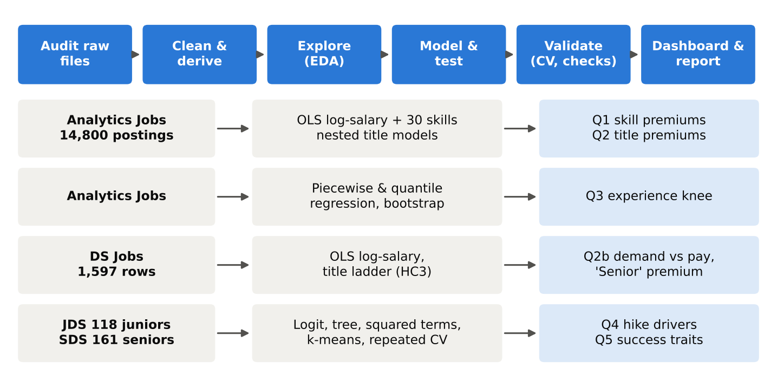
Figure 1. Analytical workflow from raw files to the five research questions and the dashboard

2.1 Methods and why we chose them
Table 2. Methods and the reason for each
Question | Method | Why
Cleaning | Rule-based parsing with a printed log for every step | Every change is counted and justified, so the cleaning is auditable and reproducible.
Q1 skills | OLS on log(salary), HC1 robust errors; gradient-boosting cross-check with permutation importance | The log form turns coefficients into % premiums. Robust errors handle unequal variance. Gradient boosting tests whether a flexible model ranks skills the same way.
Q2 labels | Nested OLS: Model A (title + city + experience) vs Model B (A + 30 skills); effect coding; Wald test; cosine similarity of skill profiles | If titles are 'skills in disguise', their premiums should vanish in Model B. Effect coding compares every title with the average title rather than an arbitrary baseline.
Q2b ladder | OLS on log(avg salary) ~ experience + title, HC3 errors (DS Jobs) | An independent dataset with clean titles tests the same idea: does the label pay at equal experience?
Q3 experience | Piecewise (broken-stick) regression with grid search and 1,000 bootstrap resamples; quantile regression at the 10th, 50th and 90th percentiles | Finds where growth slows and gives a confidence interval. Quantiles show whether top earners follow the same curve.
Q4 juniors | Logistic regression (odds ratios per SD) vs depth-3 tree; interaction test; 5-fold CV × 10 repeats | Small sample (118), so a simple, regularised model and repeated CV give stable estimates.
Q5 seniors | Linear vs quadratic logit; single-trait quadratic tests; k-means archetypes (silhouette) | Tests the 'more is better' assumption directly and finds personality profiles, not just averages.
Delivery | Streamlit dashboard on saved models | Turns static results into a tool stakeholders can use.

2.2 Tools, validation and reproducibility
The pipeline is written in Python (pandas, NumPy, SciPy, statsmodels, scikit-learn, matplotlib, Plotly, Streamlit). A single command, `python run_all.py`, runs all twelve steps in about two minutes and saves every printout to `results/logs/`. Random seeds are fixed (42), so all numbers in this note are reproducible. Classification models are evaluated with repeated stratified 5-fold cross-validation (50 splits) and compared with a majority-class baseline. Regression models are evaluated with 5-fold CV R² and robust standard errors. The hackathon is technology-agnostic. The same steps map onto SAS Viya for Learners: data preparation in SAS Data Studio, the charts in SAS Visual Analytics, and the regression, logistic and gradient-boosting models in SAS Model Studio.

3. Data Exploration: Management, Derivation and Preparation

3.1 Data audit
Step `00_audit_raw.py` profiles every raw file (types, missing values, duplicates, first rows and the 15 most common values of each text column) before anything is changed. Table 3 summarises what it found.
Table 3. Raw data audit
File | Raw size | Key fields | Main quality findings
Analytics Jobs | 15,841 × 8 | experience, salary, location, job_desig, key_skills | Experience and salary stored as text ('6-10 yrs', '10to15'); job_type 75.8% missing; job_description 22.2% missing; hundreds of location spellings; free-text titles and skills; 1,133 junk skill tokens ('...'); repeated postings
Data Science Jobs | 1,602 × 8 | company, title, min_experience, avg/min/max salary, num_of_jobs | Salaries stored as text ('7.8L'); 642 company names incl. subsidiaries and variants; a few extreme salaries (up to ₹82 L)
JDS Skill Traits | 139 × 7 | 5 skill scores (1–5), salary hike (1/0) | No missing values; 21 rows repeat another row's five scores and outcome under a different id
SDS Personality Traits | 161 × 7 | Big-Five scores, success (1/0) | No missing values; malformed column names (' extraversion', 'success_ classification_ high_low')

3.2 Data issues and treatment
Each cleaning script prints a log of the issue, the number of rows affected and the action taken (Appendix A has the full logs). Table 4 summarises it.
Table 4. Data issues and their treatment
Issue | Rows / cells | Treatment | Justification
Duplicate postings (identical except s_no) | 1,041 | Dropped, first kept | A repeated posting would double-count its salary and skills
Experience as text | 15,841 | Regex → min_exp, max_exp, avg_exp (all parsed) | Models need numbers
Salary as bands ('10to15') | 15,841 | Parsed to min, max and midpoint (₹ lakh); log used in models | Six bands → six midpoints; log tames the right skew
Location spelling variants | 2,273 rows | Canonical names (Bangalore→Bengaluru, Gurugram→Gurgaon, area suffixes removed) | One city spelled many ways would split its estimate
Rare cities (< 50 postings) | 1,222 rows | Grouped as 'Other' (major city kept when listed) | Tiny groups give unstable estimates
Free-text job titles | 15,841 | Keyword rules → 7 title families (Manager, ML Engineer, Data Engineer, BI, Data Scientist, Data Analyst, Other) | Thousands of spellings → comparable labels
Free-text key skills | 1,133 junk tokens | Split on commas, junk removed, top 30 skills → 0/1 columns | One column per skill for regression
Salary text '7.8L' | 4,806 cells | Stripped 'L', stored as float | Arithmetic and modelling
Company name variants | 95 rows | Merged into parent brand (642 → 609 companies) | 'GE Healthcare' and 'GE Digital' are one employer
Extreme DS salaries | 5 rows | Dropped beyond 3 × IQR (> ₹45.9 L) | A handful of extreme rows would steer averages
Repeated JDS records | 21 rows | Dropped (same 5 scores + outcome, id differs) | Repeated records would inflate certainty on a 139-row sample
Out-of-range scores / > 4 SD | 0 | Checked; none found | Scale rules confirmed
Malformed SDS column names | 2 columns | Normalised to snake_case | Prevents silent column-matching bugs

After cleaning: 14,800 analytics postings, 1,597 DS-jobs rows from 608 companies, 118 juniors (60 high hike, 58 low) and 161 seniors (85 successful, 76 not). Both people datasets are balanced, so accuracy is meaningful alongside AUC.

3.3 Derived variables
Table 5. Derived variables
Variable | Derived from | Definition
min_exp, max_exp, avg_exp | experience | Parsed range bounds and midpoint (years)
salary_min/max/avg_lakh, log salary | salary | Band bounds, midpoint (₹ lakh) and its natural log
location (canonical), city | location | Cleaned city list; first city used as the primary city
title_family | job_desig | 7 families from ordered keyword rules
skill_* (30 columns) | key_skills | 1 if the posting lists the skill
company_name (merged) | company_name | Parent-brand name
success_high_low, salary_hike_high_or_low | targets | Binary 0/1 outcomes
z-scores, squared terms, cluster | JDS / SDS | Standardised traits for odds ratios; z² for sweet spots; k-means archetype

3.4 Exploratory findings
Salaries are strongly right-skewed (median ₹8.0 L, mean ₹11.8 L), but their logarithm is close to symmetric, which is why all salary models use log(salary) (Figure 2).
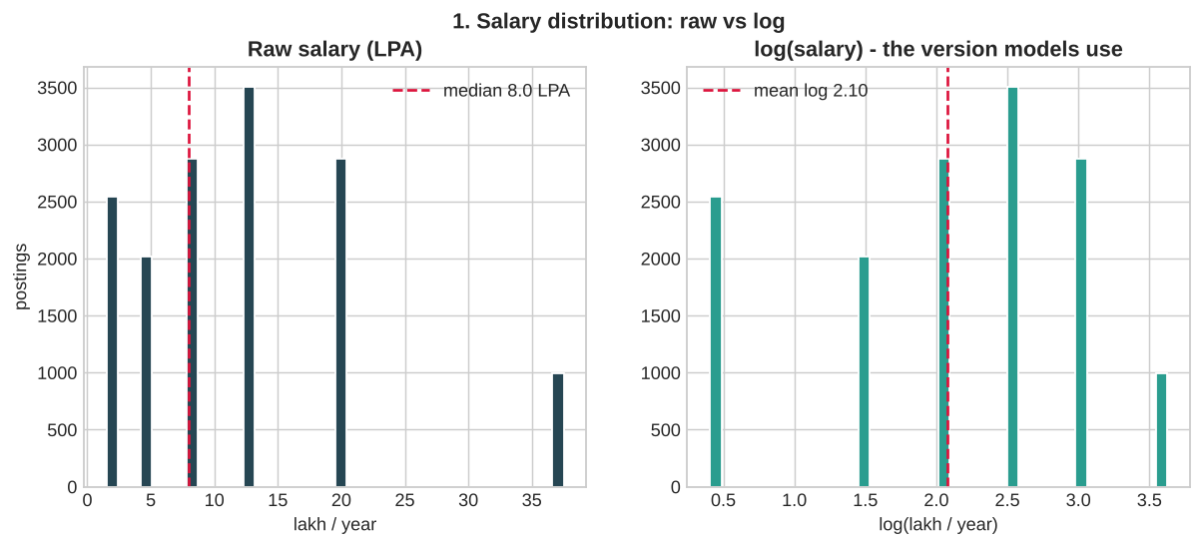
Figure 2. Salary distribution in Analytics Jobs: raw band midpoints vs log scale
Experience is by far the strongest single correlate of pay: corr(log salary, experience) = 0.64, against at most 0.10 for any single skill. Median pay also differs by title family: ₹12.5 L for Data Engineer, Data Scientist, ML Engineer and Manager, against ₹8.0 L for Data Analyst, BI and Other (Figure 3). Part of this gap is experience: Managers ask for a median 7.5 years, Data Analysts 4.5. That is why every later model controls for experience.
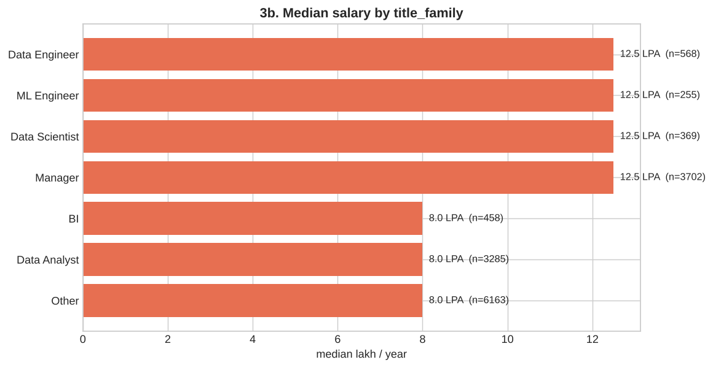
Figure 3. Median salary by title family
The most requested skills are SQL, analytics, Python, finance and Java (Figure 4). The list also contains digital marketing, SEO, sales and accounting, a reminder that 'analytics' postings include many non-technical roles. Those land in the 'Other' family (41.6% of postings), which serves as a reference group in the models.
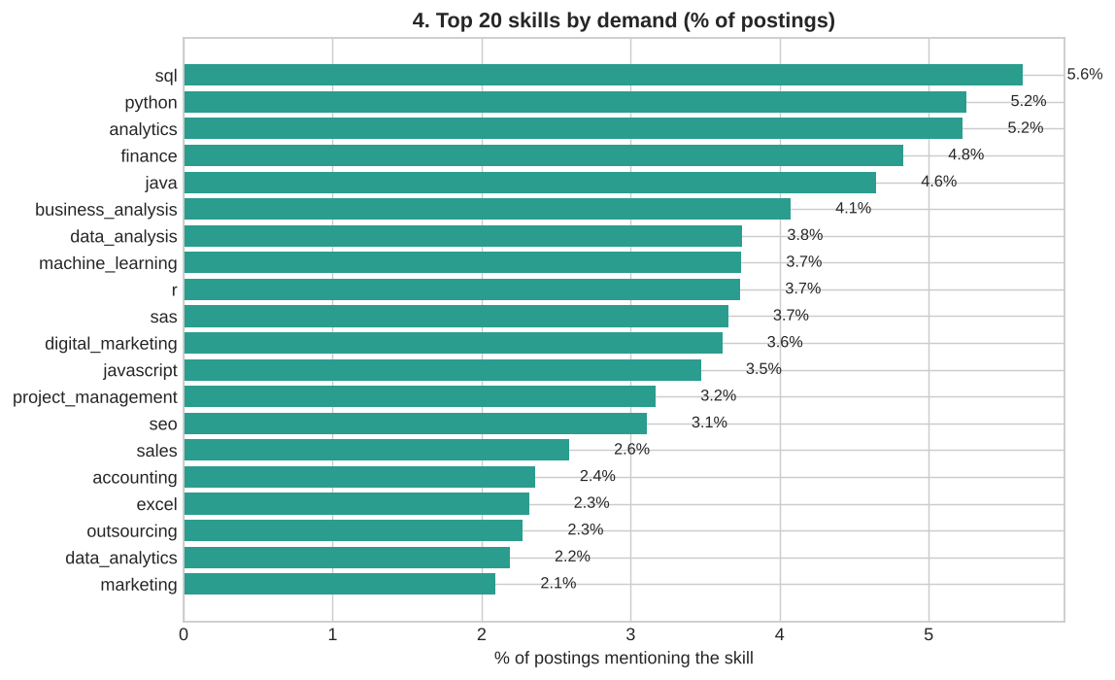
Figure 4. Top 20 skills by share of postings
In the people datasets, every junior skill score is higher for the high-hike group, with the largest raw gaps in dashboard & storytelling (+0.94 points) and maths & statistics (+0.75). Among seniors, the success rate rises from 0% in the bottom conscientiousness quartile to 84% in the top. That steep rise is the first hint of a threshold rather than a straight line (Figures 5–6).
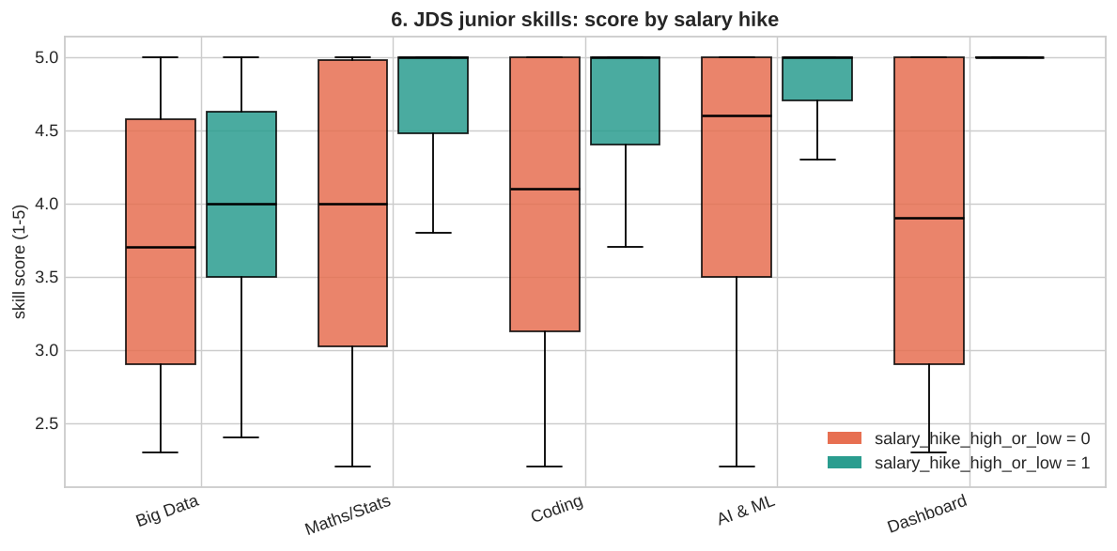
Figure 5. Junior skill scores by salary-hike outcome
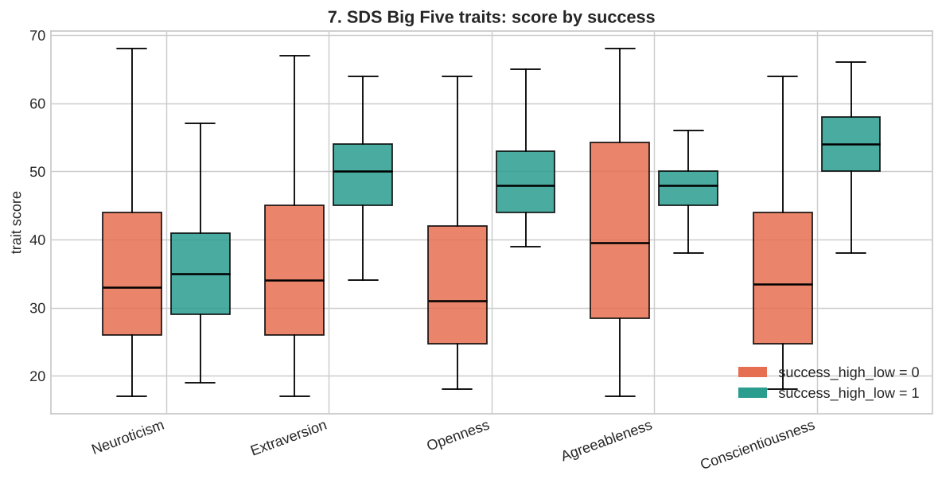
Figure 6. Senior Big-Five scores by success outcome

4. Data Analysis

4.1 Q1 Which skills carry a pay premium?
We regressed log(salary) on title family, city, experience and all 30 skill flags (n = 14,800, HC1 robust errors, R² = 0.493). Each extra year of experience adds 15.9%. Figure 7 shows every skill's premium with its 95% confidence interval. 17 of the 30 skills have a reliable effect (15 positive, 2 negative).
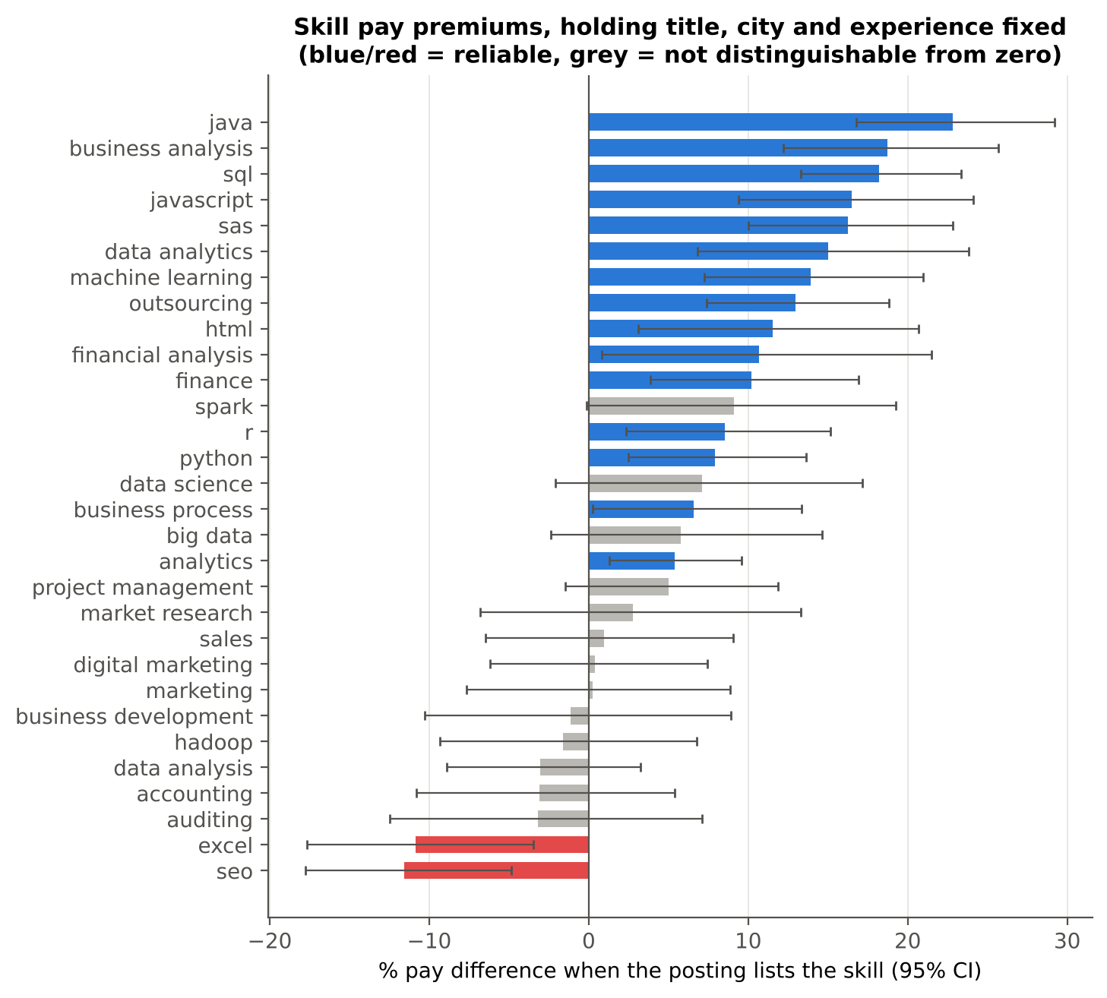
Figure 7. Skill pay premiums holding title, city and experience fixed (95% CI)
Table 6. Selected skill premiums (full table in Appendix B)
Skill | Premium | 95% CI | p | = years of experience | Postings
java | +22.8% | +16.8 to +29.2% | < 0.001 | 1.39 | 688
business analysis | +18.7% | +12.2 to +25.7% | < 0.001 | 1.16 | 603
sql | +18.2% | +13.3 to +23.3% | < 0.001 | 1.13 | 833
javascript | +16.5% | +9.4 to +24.1% | < 0.001 | 1.03 | 514
sas | +16.2% | +10.0 to +22.8% | < 0.001 | 1.02 | 541
machine learning | +13.9% | +7.3 to +21.0% | < 0.001 | 0.88 | 554
python | +7.9% | +2.5 to +13.6% | 0.004 | 0.52 | 777
excel | -10.9% | -17.7 to -3.5% | 0.005 | -0.78 | 343
seo | -11.6% | -17.8 to -4.9% | 0.001 | -0.83 | 460

The most valuable skills are Java (+22.8%), business analysis (+18.7%) and SQL (+18.2%), each worth more than a full year of experience. SAS (+16.2%) is worth about one year and machine learning (+13.9%) about 0.9 years. Python is smaller (+7.9%), probably because it is now a baseline expectation. Excel (-10.9%) and SEO (-11.6%) carry penalties: they signal clerical or marketing roles. Big data, Spark, data science and Hadoop are not distinguishable from zero once title is controlled. Their pay is already captured by the Data Engineer and Data Scientist labels.
Cross-check. A gradient-boosting model reaches a higher 5-fold CV R² (0.538 ± 0.025), but its permutation importances rank skills very differently (Spearman −0.22 with the OLS premiums). Only business analysis and SAS appear in both top-10 lists. Individual skill premiums are therefore modest and model-dependent compared with title and experience. H1 is only partly supported: some traditional skills (Java, SQL, SAS) out-earn the 'advanced' ones once the label is accounted for.

4.2 Q2 Do job titles still pay once skills are controlled?
This is the core test. Model A explains log(salary) with title family, city and experience. Model B adds all 30 skills. If titles were simply 'skills in disguise', their premiums would collapse in Model B. Figure 8 and Table 7 show what actually happens.
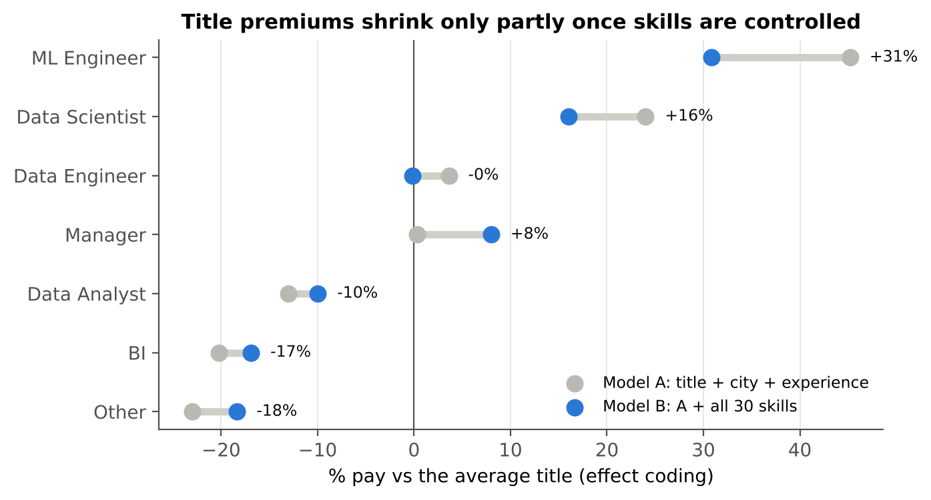
Figure 8. Title premium vs the average title, before (grey) and after (blue) controlling for 30 skills
Table 7. Title premiums with and without skill controls (effect coding, HC1)
Title family | Model A premium | Model B premium (95% CI) | p (B) | Share of premium explained by skills
ML Engineer | +45.2% | +30.9% (+21.9 to +40.4) | < 0.001 | 28%
Data Scientist | +24.0% | +16.0% (+9.0 to +23.5) | < 0.001 | 31%
Data Engineer | +3.6% | -0.2% (-5.2 to +5.1) | 0.950 | 105%
Manager | +0.3% | +8.0% (+4.8 to +11.3) | < 0.001 | n/a (A ≈ 0)
Data Analyst | -13.0% | -10.0% (-12.7 to -7.2) | < 0.001 | 25%
BI | -20.2% | -16.9% (-21.7 to -11.8) | < 0.001 | 18%
Other | -23.0% | -18.3% (-20.6 to -16.0) | < 0.001 | 23%

Skills explain only part of each gap: on average 62% of the title premium survives the 30 skill controls. ML Engineer still earns +30.9% and Data Scientist +16.0% over the average title; Data Analyst (-10.0%) and BI (-16.9%) stay below it. Six of seven title effects remain significant. The skill block is jointly significant (Wald χ²(30) = 463, p < 0.001), but it raises R² only from 0.480 to 0.493. Managers even gain (+0.3% → +8.0%): their postings list lower-paid generic skills, so once skills are held equal the manager label is worth more. The result is unchanged when the 154 postings in once-only locations are removed.
The two labels describe genuinely different work. The Data Analyst and Data Scientist skill profiles have a cosine similarity of only 0.47: Data Scientist postings list machine learning (30.9% vs 2.1%) and Python (31.7% vs 3.2%) far more often (Figure 9). But the skills we can observe price only a third of the title difference. The rest reflects things the label stands for that keyword lists do not capture: seniority, scope, employer brand and negotiating position.
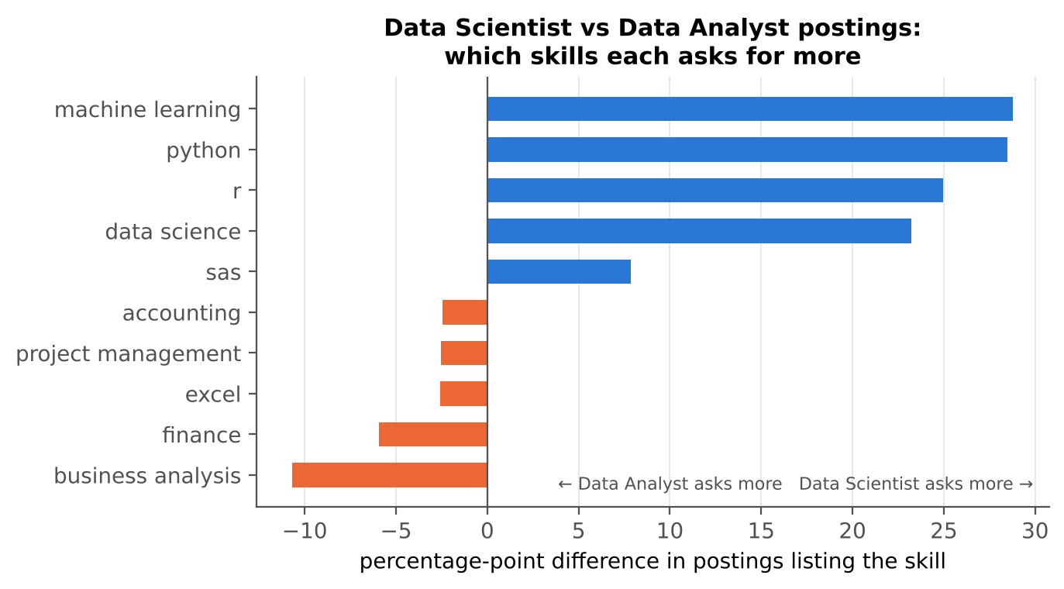
Figure 9. Skills each family asks for more often (percentage points)

Independent check: the title ladder in the Data Science Jobs file
The DS Jobs file has clean, standard titles and required experience, so it gives an independent test (Figure 10). Holding experience fixed (R² = 0.58, +11.9% per year), a Senior Data Scientist posting pays +194% more than a Data Analyst posting (95% CI +167 to +224%), and a Data Scientist +134%.
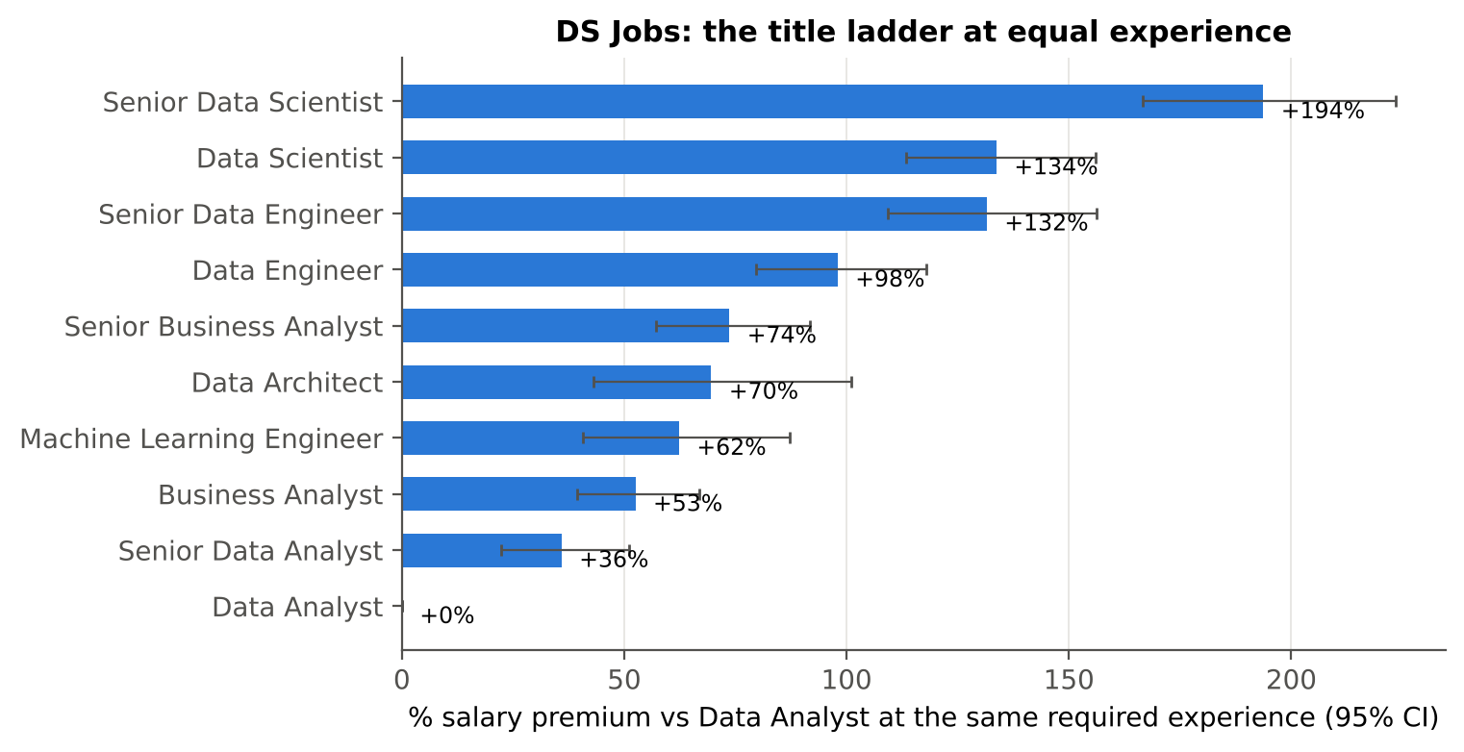
Figure 10. DS Jobs: salary premium vs Data Analyst at equal required experience
Table 8. What the word 'Senior' is worth
Base role | Raw 'Senior' premium | Premium at same experience | Extra years required
Data Analyst | +72% | +36% | 2
Data Scientist | +65% | +26% | 2
Data Engineer | +61% | +17% | 3
Business Analyst | +57% | +14% | 2

Roughly half of the raw 'Senior' premium is explained by the extra experience asked for. The other half (14–36%) is attached to the word itself. Demand and pay also point in opposite directions (Figure 11; Spearman −0.65 across titles, p = 0.043). Business Analyst and Data Analyst make up 55% of all postings but have the two lowest median salaries (₹8.3 L and ₹5.0 L).
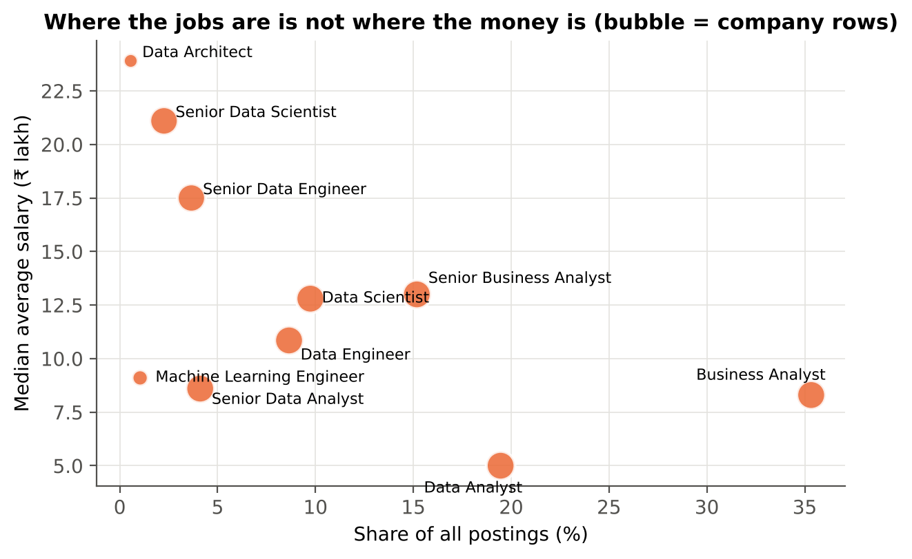
Figure 11. Share of postings vs median salary by title
H2 is rejected. Titles are not just skills in disguise: the label carries a large, robust pay premium of its own, in both job datasets.

4.3 Q3 When does salary growth flatten?
A piecewise regression of log(salary) on experience, searched over breakpoints from 1 to 20 years, finds the best break at 6.5 years (bootstrap 95% CI 6.0–7.0 years, 1,000 resamples). Pay grows about +35.6% per year before the break and +7.4% per year after (Figure 12). In rupees, the median moves from ₹1.5 L (0–3 years) to ₹8 L (4–5 years) to ₹12.5 L (6–9 years): roughly eightfold during the junior years. It then crawls to ₹20 L over the next decade.
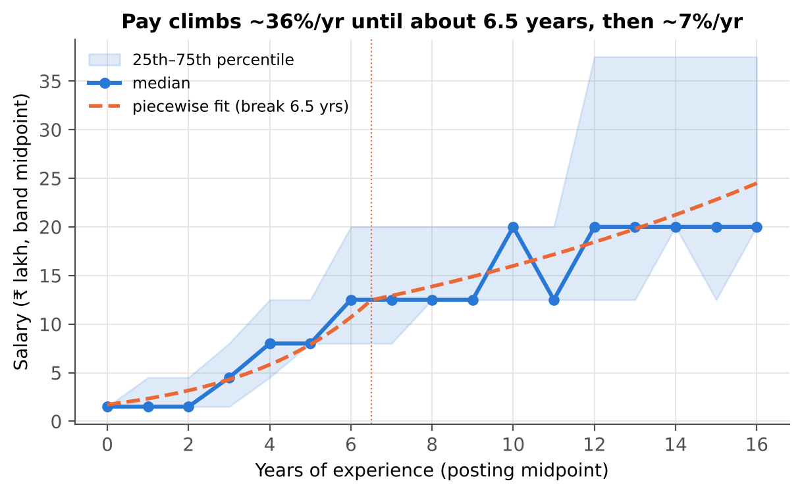
Figure 12. Salary by experience with the fitted piecewise curve (break at 6.5 years)
Table 9. Quantile regression: where growth slows for low, typical and top earners
Quantile | Quadratic turning point | Piecewise break | Growth before | Growth after
10th percentile | 15.8 yrs | 10.0 yrs | +35.4%/yr | ≈ 0%/yr
Median | 13.0 yrs | 5.0 yrs | +54.2%/yr | +8.9%/yr
90th percentile | 16.3 yrs | 10.0 yrs | +17.0%/yr | ≈ 0%/yr

Top earners keep climbing longer: their curve breaks at 10 years, against 5 for the median. The flattening at the top is partly an artefact of the data, because 26% of postings asking for 10+ years (56% for 17+) already sit in the highest ₹25–50 L band, so higher pay is never recorded. H3 is supported: most pay growth happens in the first six to seven years, which is exactly when labels change (Analyst → Scientist → Senior).

4.4 Q4 Which skills earn a junior a high salary hike?
Inside a company, the picture changes: here, measured skill matters. A logistic regression of the hike outcome on the five standardised skill scores (n = 118) beats a majority-class guess by a wide margin. Cross-validated ROC-AUC is 0.886 ± 0.068 and accuracy 83.6%, against 50.8% for always guessing the majority class (precision 0.83, recall 0.86).
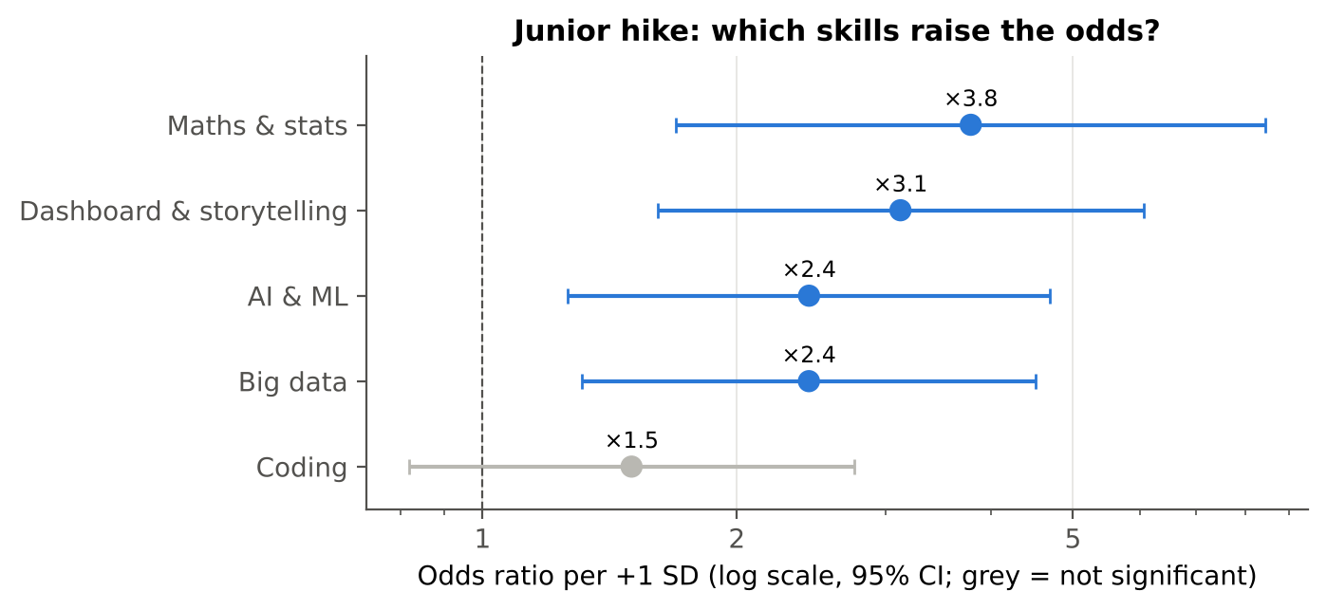
Figure 13. Junior salary hike: odds ratio per +1 SD of each skill (95% CI)
Table 10. Logistic regression odds ratios (McFadden pseudo-R² = 0.449)
Skill | Odds ratio per SD | 95% CI | p | Reliable
Maths & stats | ×3.78 | 1.70–8.45 | 0.001 | Yes
Dashboard & storytelling | ×3.12 | 1.61–6.06 | 0.001 | Yes
AI & ML | ×2.44 | 1.26–4.70 | 0.008 | Yes
Big data | ×2.43 | 1.31–4.52 | 0.005 | Yes
Coding | ×1.50 | 0.82–2.75 | 0.189 | No

Maths & statistics (×3.8) and dashboard & storytelling (×3.1) are the strongest drivers. One extra standard deviation (about 0.8–0.9 points on the 1–5 scale) roughly triples or quadruples the odds of a high hike, with the other four skills held equal. AI & ML and big data each add about ×2.4. Coding alone is not significant (p = 0.19), and a coding × storytelling interaction is not supported (likelihood-ratio p = 0.32).
A depth-3 decision tree is weaker (AUC 0.768, Figure 14) but gives a readable rule: storytelling > 4.15, maths & stats > 3.55 and AI & ML > 4.0 → high hike. Storytelling carries 60% of the tree's importance. H4 is rejected: it is quantitative depth and the ability to communicate results, not raw coding, that juniors are rewarded for. With 12 events per predictor the direction of these effects is solid, but the exact sizes are imprecise.
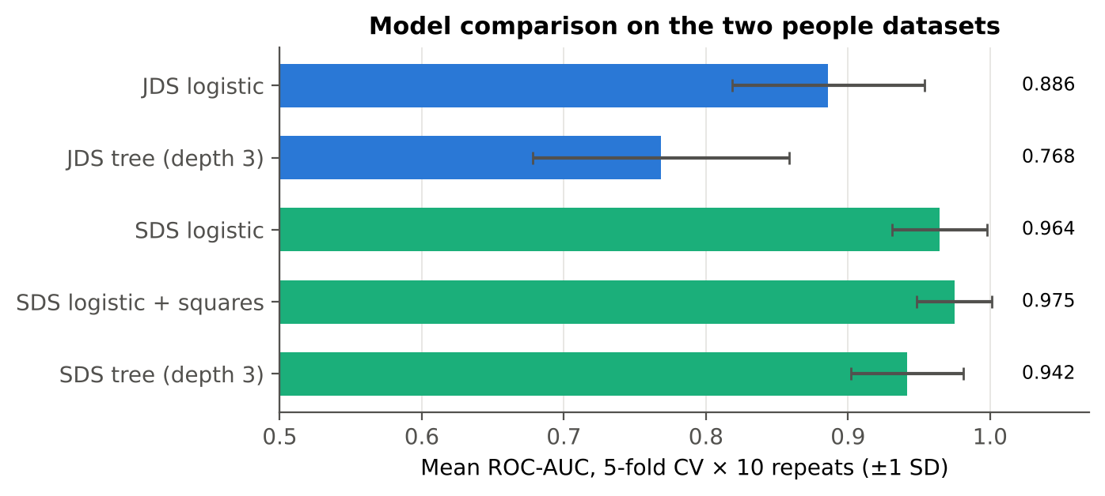
Figure 14. Cross-validated ROC-AUC of the models on the junior (blue) and senior (green) datasets

4.5 Q5 Which traits mark a successful senior?
For senior, customer-facing data scientists, personality separates success almost perfectly. A linear logistic model on the Big Five reaches CV AUC 0.964 and accuracy 92.7%, against 52.8% by guessing. Conscientiousness (×26.5 per SD) and openness (×20.8) dominate (Figure 15). Neuroticism and extraversion add about ×3.9 each; agreeableness is borderline (p = 0.056).
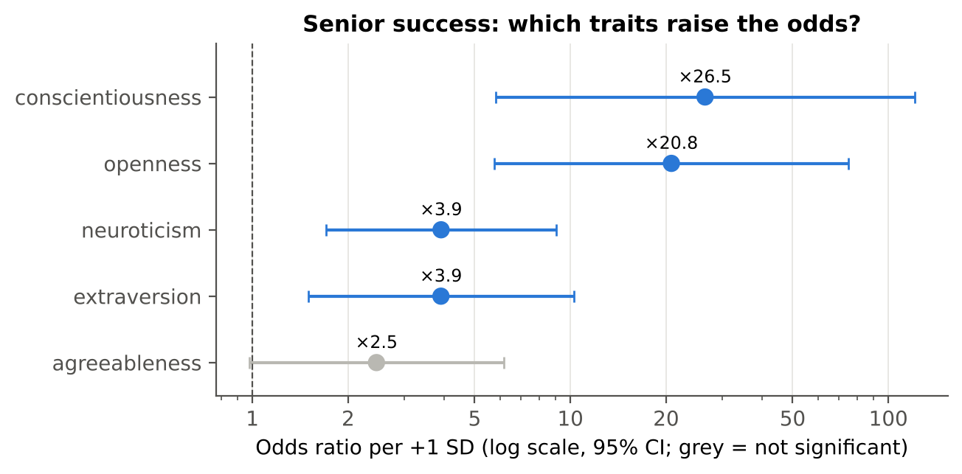
Figure 15. Senior success: odds ratio per +1 SD of each trait (95% CI, log scale)
Is more always better? No. Testing each trait with a squared term shows a significant inverted-U for all five traits, with the optimum inside the observed range (Figure 16): neuroticism ≈ 40, extraversion ≈ 51, openness ≈ 53, agreeableness ≈ 49 and conscientiousness ≈ 57 on a 17–68 scale. Adding the squared terms to the full model raises CV AUC from 0.964 to 0.975 (paired t-test across repeats, p < 0.001). The curvature is real but modest: in practice, aim high, then plateau.
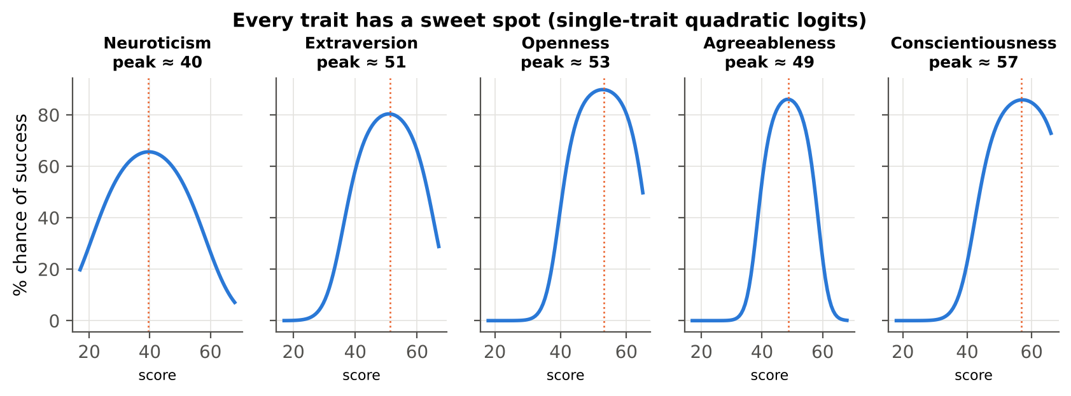
Figure 16. Success probability across each trait (single-trait quadratic logits): every trait has a sweet spot
K-means clustering (k = 4, best silhouette 0.327) finds four personality archetypes (Figure 17). Only one profile wins. The driven achievers (n = 88) are above average on extraversion, openness, agreeableness and conscientiousness, and 89% of them are successful. Stressed veterans (high neuroticism) succeed 32% of the time; the warm but unfocused (high agreeableness, low openness and conscientiousness) and the reserved and detached never do. H5 is partly supported: conscientiousness and openness dominate, but success has an optimum rather than rising without limit.
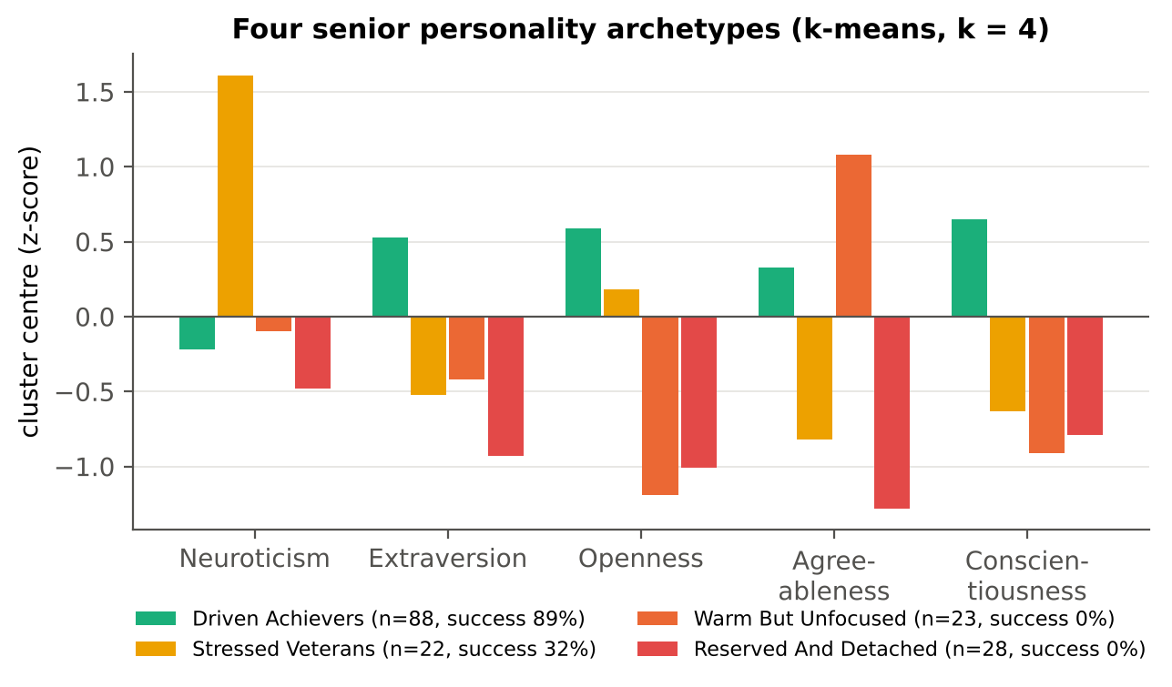
Figure 17. Senior personality archetypes and their success rates
Such clean separation is unusual for real personality data. The SDS sample may be synthetic or pre-screened, so these models describe this sample and should not be used as a hiring test without external validation.

4.6 The decision-support dashboard
To make the results usable, step 10 trains three models and saves them for an interactive Streamlit dashboard (`streamlit run app.py`). The dashboard has eight pages: an overview of the five answers, the cleaning summary, one page per question with interactive charts, and three simulators:
- Salary estimator. A gradient-boosting model on title family, city, experience and the 30 skills (5-fold CV R² 0.54). It also shows "the same person under a different label", making the title premium tangible.
- Junior hike simulator. Five skill sliders feed the logistic model; the page shows the probability of a high hike and which +0.5 improvement would help most.
- Senior success simulator. Big-Five sliders feed the quadratic logit, with a live sweet-spot curve for any chosen trait.
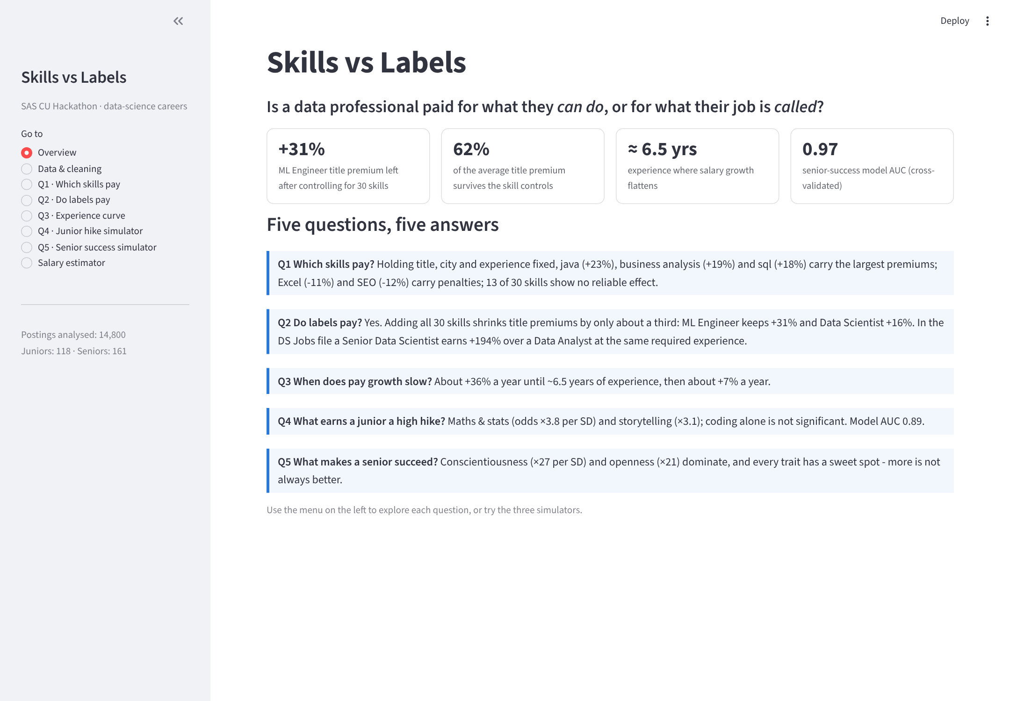
Figure 18. Dashboard overview page
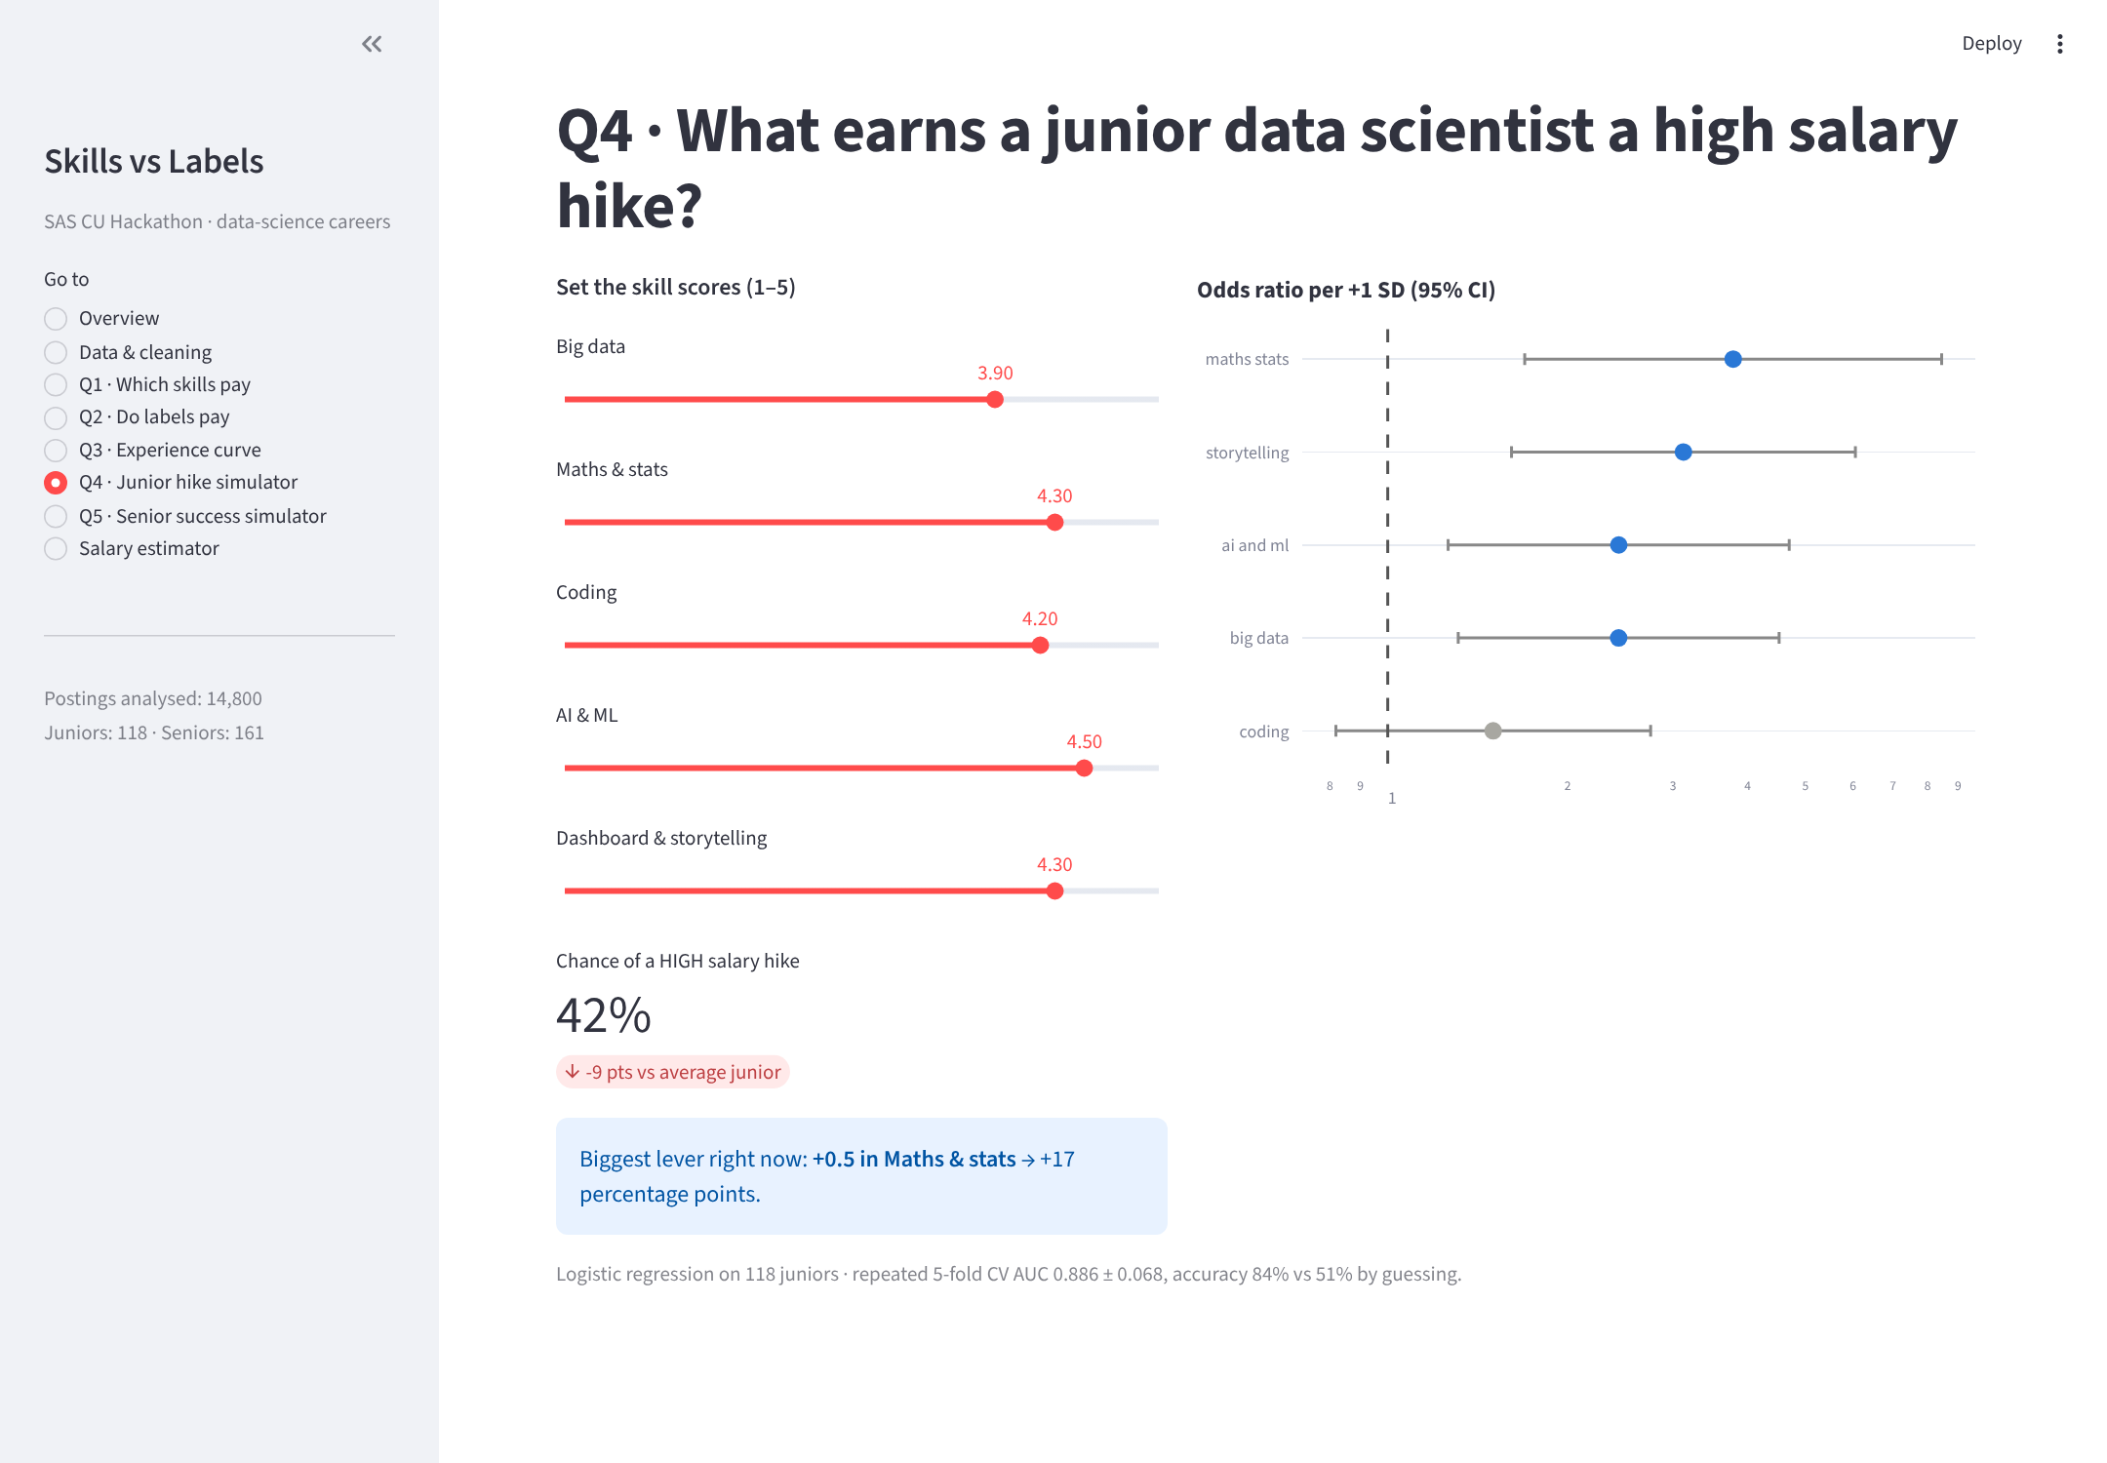
Figure 19. Junior hike simulator: sliders, predicted probability and the biggest lever

5. Results and Conclusions
Table 11. Hypothesis verdicts
Hypothesis | Verdict | Key evidence
H1 Advanced technical skills carry the largest premiums | Partly supported | Java +23%, business analysis +19%, SQL +18% lead; ML +14%; big data and Spark not significant once title is controlled
H2 Titles are 'skills in disguise' | Rejected | 62% of title premiums survive 30 skill controls; R² 0.480 → 0.493; Senior DS +194% vs DA at equal experience
H3 Pay growth slows after the early years | Supported | Break at 6.5 yrs (CI 6.0–7.0): +36%/yr → +7%/yr
H4 Coding and AI/ML drive junior hikes | Rejected | Maths & stats ×3.8 and storytelling ×3.1 lead; coding n.s. (p = 0.19)
H5 Success rises steadily with C and O | Partly supported | C ×26.5 and O ×20.8 dominate, but all five traits show an inverted-U optimum

Table 12. Models deployed in the dashboard
Use | Model | Validated performance
Salary estimate | Gradient boosting on log(salary) | 5-fold CV R² 0.537 ± 0.026
Junior hike | Logistic regression (5 skills) | CV AUC 0.886, accuracy 83.6% (baseline 50.8%)
Senior success | Logistic regression with squared terms | CV AUC 0.975, accuracy 93.0% (baseline 52.8%)

5.1 Conclusions
- In the job market, labels pay. Title and experience explain most of the advertised salary; 30 skills add only 1.3 points of R². About two-thirds of each title premium remains after skills are controlled, and the word 'Senior' alone is worth 14–36%.
- Skills still matter, but selectively. A handful of skills (Java, business analysis, SQL, SAS, machine learning) are each worth about a year of experience. Clerical and marketing skills (Excel, SEO) are penalised, and fashionable big-data keywords add nothing beyond the title.
- The early years decide the trajectory. Pay grows ~36% a year until about 6.5 years of experience, the period in which professionals change labels.
- Inside the firm, capability is rewarded. Junior hikes follow quantitative depth and storytelling, not raw coding. Senior success follows conscientiousness and openness, with sweet spots rather than 'more is better'.
- Skills open the door; labels and experience set the price. The career strategy that follows is to build quantitative and communication skills and move deliberately into the higher-paid labels.

6. Implications

6.1 For students and job seekers
- Target the label, not just the skill list. A Data Scientist or ML Engineer title is worth 16–31% more than the average title even with identical skills. Apply for the label your skills justify.
- Learn the skills that pay: SQL, statistics/business analysis and a production language (Java or Python) before niche tools. Do not lead your CV with Excel or SEO.
- Use the first six years. Pay growth is steepest early, so frequent, deliberate moves up the title ladder pay off most in this window.
- As a junior, invest in maths and storytelling. In our model, raising maths & stats by one SD roughly quadruples the odds of a high hike; coding alone does not move it.

6.2 For employers and HR
- Audit title-based pay bands. If two-thirds of a title premium is not explained by skills, equally capable people may be paid very differently. Map pay to skill and scope, not to the job title alone.
- Make job titles consistent. Thousands of title spellings for similar work make pay comparison opaque for candidates and for internal equity.
- Reward communication. Storytelling is the strongest single predictor of junior hikes, so make it an explicit, assessed competency.

6.3 For learning & development
- Use the junior simulator as a development conversation: show each analyst which +0.5 improvement would move their outlook most.
- For seniors, coach planning and follow-through (conscientiousness) and curiosity about new methods (openness) toward the sweet spot, not the extreme. Do not use the personality model as a selection filter.

6.4 For universities, SAS and society
- Curricula should weight statistics and business communication as heavily as programming. SAS skills already carry about a year's experience premium, which supports certification paths.
- Title inflation and opaque labels affect fairness across the profession: graduates without the network to negotiate a better label are paid less for the same skills. Transparent, skill-based job architecture benefits candidates and employers alike.

6.5 Limitations and next steps
- All findings are associations from observational data. Skills are keyword mentions in postings, not verified proficiency, and salaries are band midpoints.
- The junior (118) and senior (161) samples come from single companies; the near-perfect senior separation suggests a synthetic or pre-screened sample.
- Next steps: NLP on job descriptions to capture seniority and scope; employer fixed effects to separate brand from label; re-implementing the pipeline in SAS Model Studio for governed deployment.

Appendix

Appendix A. Cleaning logs (verbatim program output)

01_clean_analytics.py
========================================================================================
CLEANING LOG rows in: 15841 rows out: 14800 dropped: 1041
========================================================================================
issue rows action
----------------------------------------------------------------------------------------
experience not in 'N-M yrs' format 0 min/max/avg_exp set to NaN
experience above 40 years (implausible) 0 flagged, left unchanged for review
salary undisclosed or not a 'NtoM' band 0 salary_missing=1, salary columns left NaN
location spelling variants (Bangalore/Gurugram/…(area)) 2273 standardised to one canonical city name
cities mentioned in <50 postings 1222 replaced with "Other" (rows with a major city keep it)
distinct locations after cleaning 344 kept as-is; use top locations or primary city as a model feature
job_desig has no data/analyst/manager keyword 6437 title_family='Other' (titles kept unchanged in job_desig)
junk/empty skill tokens ('...' etc.) 1133 dropped before splitting
row has none of the top 30 skills 7327 all skill_xxx = 0 for that row (kept)
duplicate posting (identical except s_no) 1041 dropped, keep='first'
salary outside 3.0xIQR of log salary [0.05-1755.83 LPA] 0 dropped
========================================================================================
top 30 skills: sql, analytics, python, finance, java, r, sas, business analysis, machine learning, data analysis, digital marketing, javascript, project management, seo, data analytics, sales, excel, accounting, outsourcing, marketing, html, hadoop, spark, business process, data science, big data, business development, auditing, financial analysis, market research
title_family: {'Other': 6163, 'Manager': 3702, 'Data Analyst': 3285, 'Data Engineer': 568, 'BI': 458, 'Data Scientist': 369, 'ML Engineer': 255}
saved -> /home/claude/svl/data/clean/analytics_clean.csv (14800 rows x 44 cols)

02_clean_others.py
================================================================================================
CLEANING LOG
================================================================================================
file issue n action
------------------------------------------------------------------------------------------------
DataScience Jobs.csv avg/min/max_salary stored as text ('7.8L') 4806 stripped the L, stored as float lakhs/year
DataScience Jobs.csv salary text that could not be parsed 0 set to NaN
DataScience Jobs.csv min_salary > max_salary 0 checked all 1602 rows, swapped the pair where found
DataScience Jobs.csv company_name variants (Barclays Shared Services, GE Healthcare, ...) 95 merged into parent brand, 642 -> 609 companies
DataScience Jobs.csv duplicate posting (identical except reference_no) 0 dropped, keep='first'
DataScience Jobs.csv avg_salary outside 3.0xIQR [-21.1-45.9 LPA] 5 dropped
JDS Skill Traits.xlsx skill score outside 1-5 0 set to missing (scale only allows 1-5)
JDS Skill Traits.xlsx duplicate row (same 5 scores + target, id ignored) 21 dropped, keep='first'
JDS Skill Traits.xlsx row missing a skill score or target 0 dropped
JDS Skill Traits.xlsx target High/Low -> 1/0 0 already 0/1, cast to int
SDS Personality Traits.xlsx trait stored as text 0 converted to number, unreadable -> NaN
SDS Personality Traits.xlsx trait value more than 4 SD from the mean 0 value removed, row dropped (milder 3-4 SD values kept)
SDS Personality Traits.xlsx row missing a trait value 0 dropped (no imputation on 161 rows)
SDS Personality Traits.xlsx target High/Low -> 1/0 0 already 0/1, cast to int
------------------------------------------------------------------------------------------------
DataScience Jobs.csv ROWS 1597 (was 1602, dropped 5) -> dsjobs_clean.csv
JDS Skill Traits.xlsx ROWS 118 (was 139, dropped 21) -> jds_clean.csv
SDS Personality Traits.xlsx ROWS 161 (was 161, dropped 0) -> sds_clean.csv
================================================================================================
renamed columns:
maths-stats_skills -> maths_stats_skills
extraversion -> extraversion
success_ classification_ high_low -> success_high_low

CLASS BALANCE
------------------------------------------------------------------------------------------------
dsjobs_clean.csv job_title (10 classes):
Data Scientist 188 (11.8%)
Business Analyst 188 (11.8%)
Data Engineer 188 (11.8%)
Data Analyst 187 (11.7%)
Senior Business Analyst 187 (11.7%)
Senior Data Analyst 187 (11.7%)
Senior Data Scientist 183 (11.5%)
Senior Data Engineer 181 (11.3%)
Machine Learning Engineer 59 (3.7%)
Data Architect 49 (3.1%)
jds_clean.csv salary_hike_high_or_low (1 = high/success):
0 58 (49.2%)
1 60 (50.8%)
minority class 58 -> balanced
sds_clean.csv success_high_low (1 = high/success):
0 76 (47.2%)
1 85 (52.8%)
minority class 76 -> balanced
------------------------------------------------------------------------------------------------
saved -> /home/claude/svl/data/clean/dsjobs_clean.csv | /home/claude/svl/data/clean/jds_clean.csv | /home/claude/svl/data/clean/sds_clean.csv

Appendix B. Full skill premium table
Table 13. OLS skill premiums, all 30 skills (controls: title family, city, experience; HC1)
Skill | Premium | 95% CI | p | Years equiv. | Postings | Reliable
java | +22.8% | +16.8 to +29.2 | < 0.001 | 1.39 | 688 | Yes
business analysis | +18.7% | +12.2 to +25.7 | < 0.001 | 1.16 | 603 | Yes
sql | +18.2% | +13.3 to +23.3 | < 0.001 | 1.13 | 833 | Yes
javascript | +16.5% | +9.4 to +24.1 | < 0.001 | 1.03 | 514 | Yes
sas | +16.2% | +10.0 to +22.8 | < 0.001 | 1.02 | 541 | Yes
data analytics | +15.0% | +6.8 to +23.8 | < 0.001 | 0.94 | 324 | Yes
machine learning | +13.9% | +7.3 to +21.0 | < 0.001 | 0.88 | 554 | Yes
outsourcing | +13.0% | +7.4 to +18.8 | < 0.001 | 0.82 | 337 | Yes
html | +11.5% | +3.1 to +20.7 | 0.007 | 0.74 | 292 | Yes
financial analysis | +10.7% | +0.8 to +21.5 | 0.033 | 0.69 | 220 | Yes
finance | +10.2% | +3.8 to +16.9 | 0.001 | 0.66 | 715 | Yes
spark | +9.1% | -0.1 to +19.2 | 0.053 | 0.59 | 253 | No
r | +8.6% | +2.3 to +15.1 | 0.006 | 0.56 | 553 | Yes
python | +7.9% | +2.5 to +13.6 | 0.004 | 0.52 | 777 | Yes
data science | +7.1% | -2.1 to +17.1 | 0.133 | 0.46 | 219 | No
business process | +6.6% | +0.3 to +13.3 | 0.041 | 0.43 | 269 | Yes
big data | +5.8% | -2.4 to +14.7 | 0.170 | 0.38 | 237 | No
analytics | +5.4% | +1.3 to +9.6 | 0.009 | 0.35 | 774 | Yes
project management | +5.0% | -1.5 to +11.9 | 0.134 | 0.33 | 469 | No
market research | +2.8% | -6.8 to +13.3 | 0.586 | 0.18 | 220 | No
sales | +1.0% | -6.5 to +9.0 | 0.803 | 0.07 | 383 | No
digital marketing | +0.4% | -6.2 to +7.4 | 0.913 | 0.03 | 535 | No
marketing | +0.3% | -7.7 to +8.8 | 0.953 | 0.02 | 310 | No
business development | -1.2% | -10.3 to +8.9 | 0.814 | -0.08 | 235 | No
hadoop | -1.6% | -9.3 to +6.8 | 0.696 | -0.11 | 280 | No
data analysis | -3.0% | -8.9 to +3.2 | 0.336 | -0.21 | 555 | No
accounting | -3.1% | -10.8 to +5.4 | 0.464 | -0.21 | 349 | No
auditing | -3.2% | -12.5 to +7.1 | 0.529 | -0.22 | 229 | No
excel | -10.9% | -17.7 to -3.5 | 0.005 | -0.78 | 343 | Yes
seo | -11.6% | -17.8 to -4.9 | 0.001 | -0.83 | 460 | Yes

Appendix C. Additional exploratory charts
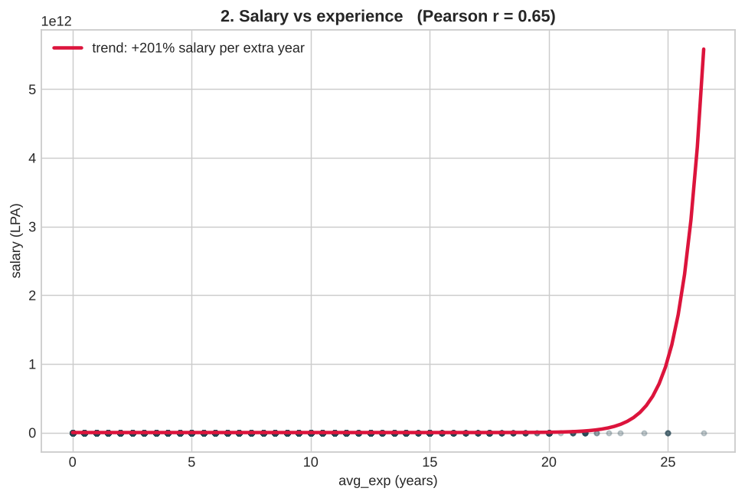
Figure 20. Salary vs experience, all postings
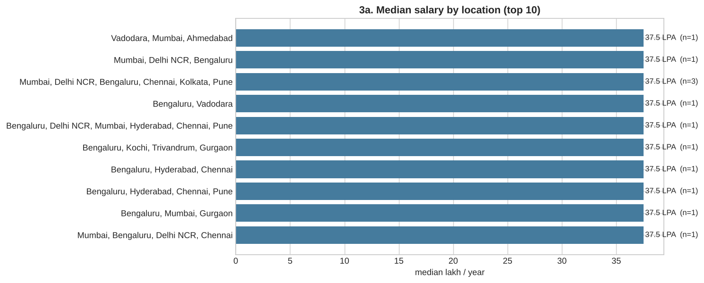
Figure 21. Median salary by city (top 10)

Appendix D. Dashboard screenshots
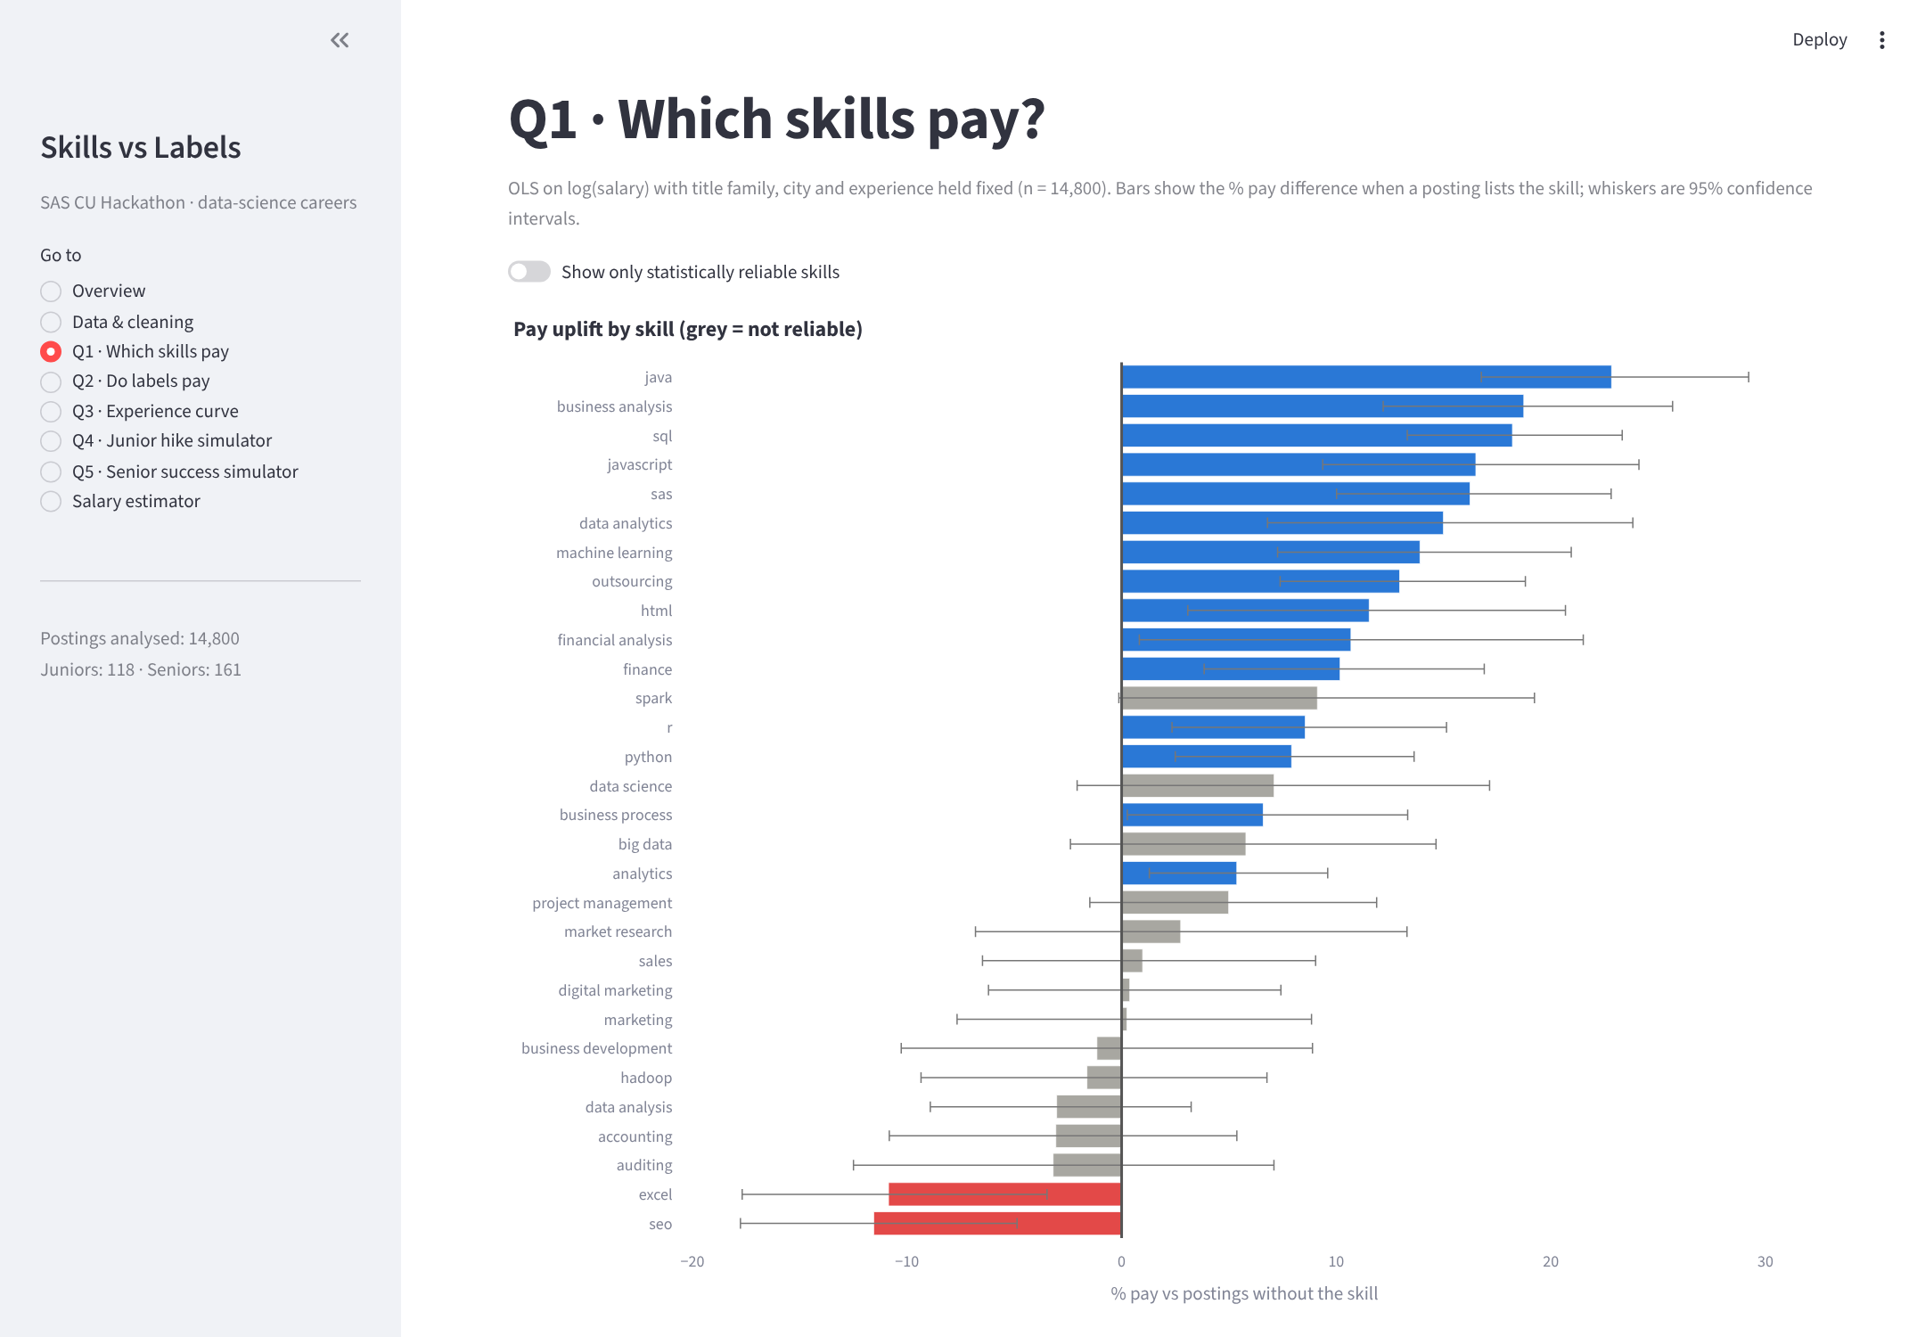
Figure 22. Q1 page: interactive skill premiums with confidence intervals
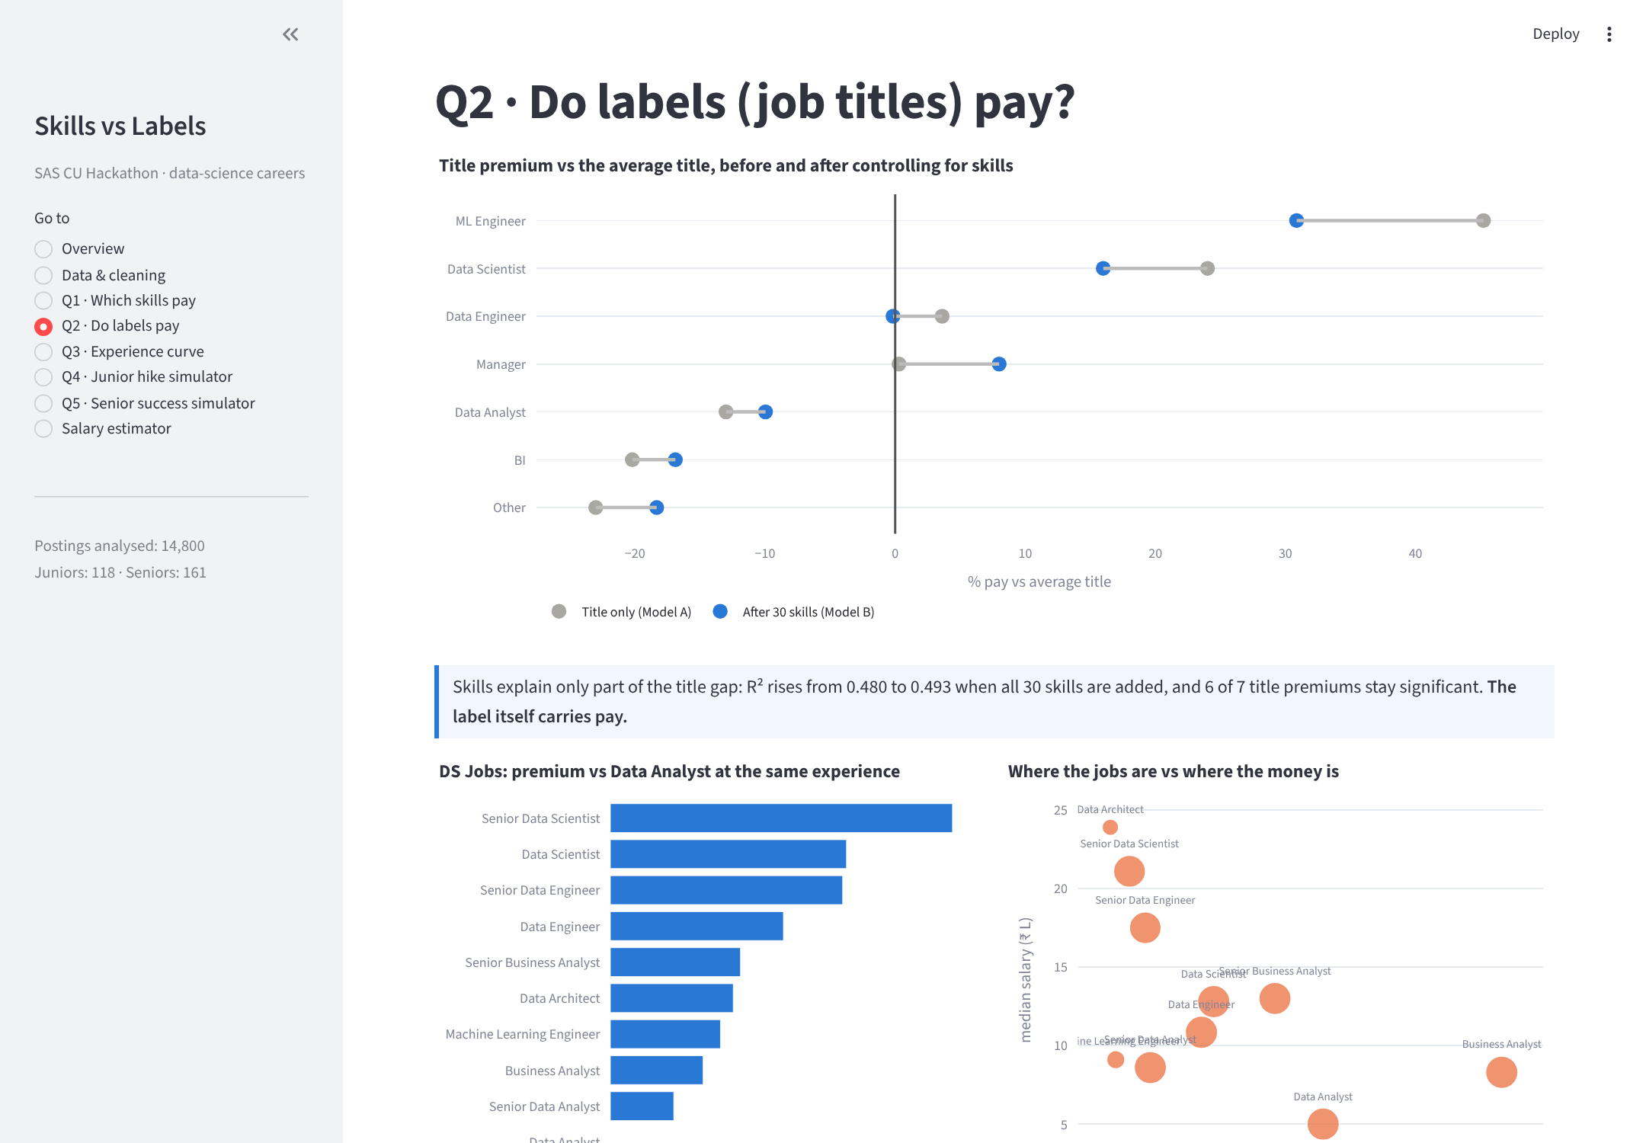
Figure 23. Q2 page: title premiums, DS ladder and demand vs pay
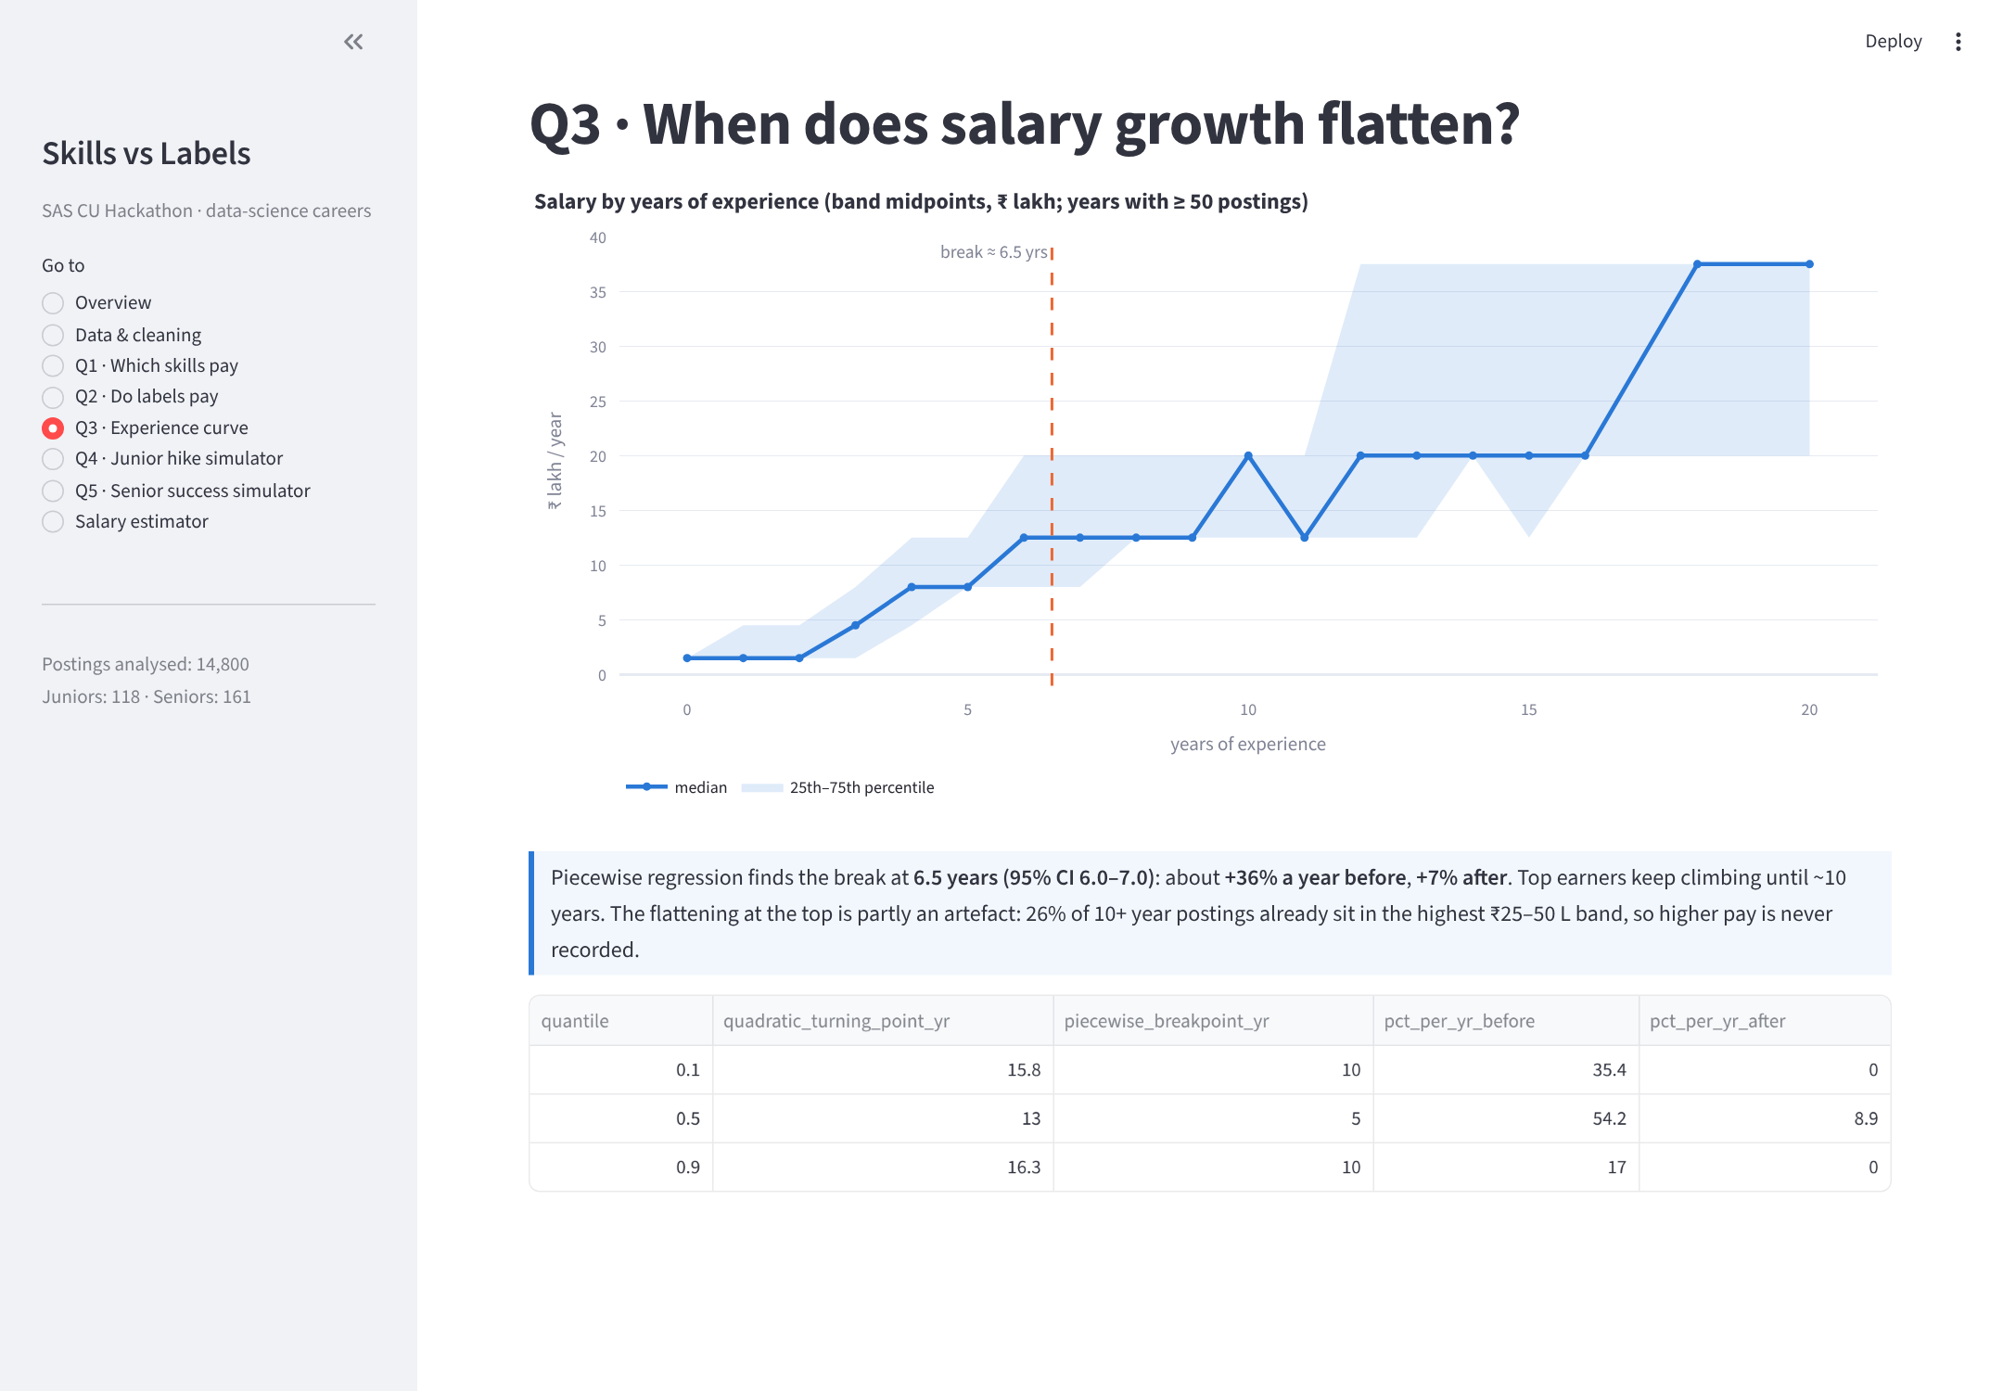
Figure 24. Q3 page: experience curve with the 6.5-year break
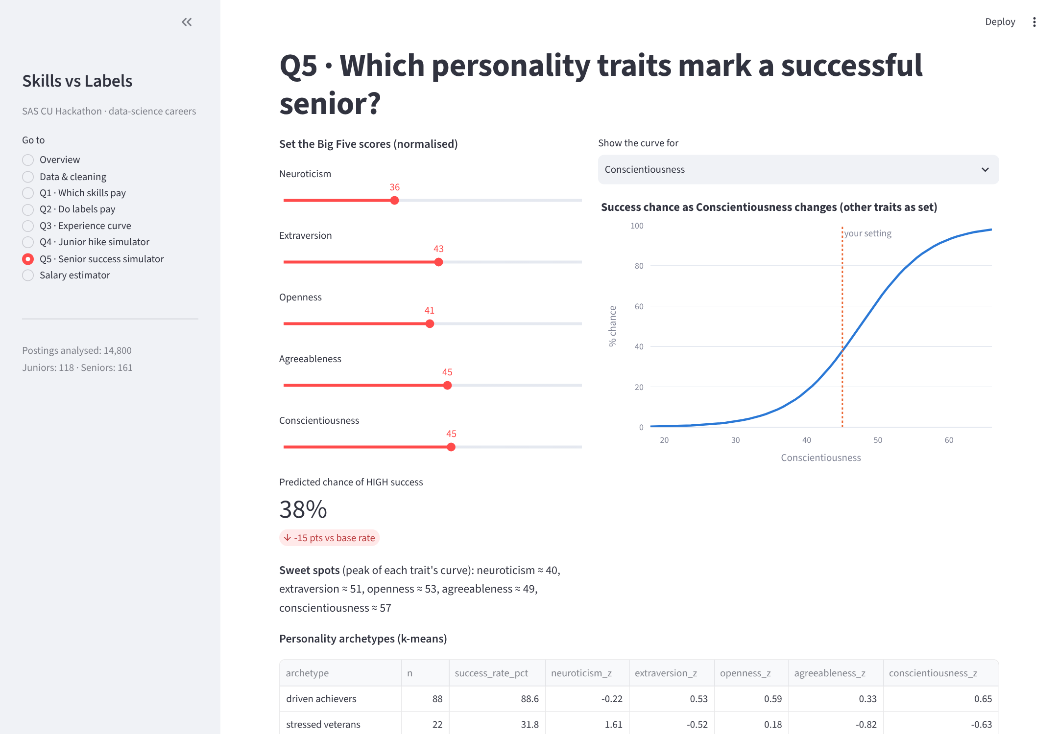
Figure 25. Senior success simulator with sweet-spot curve and archetypes
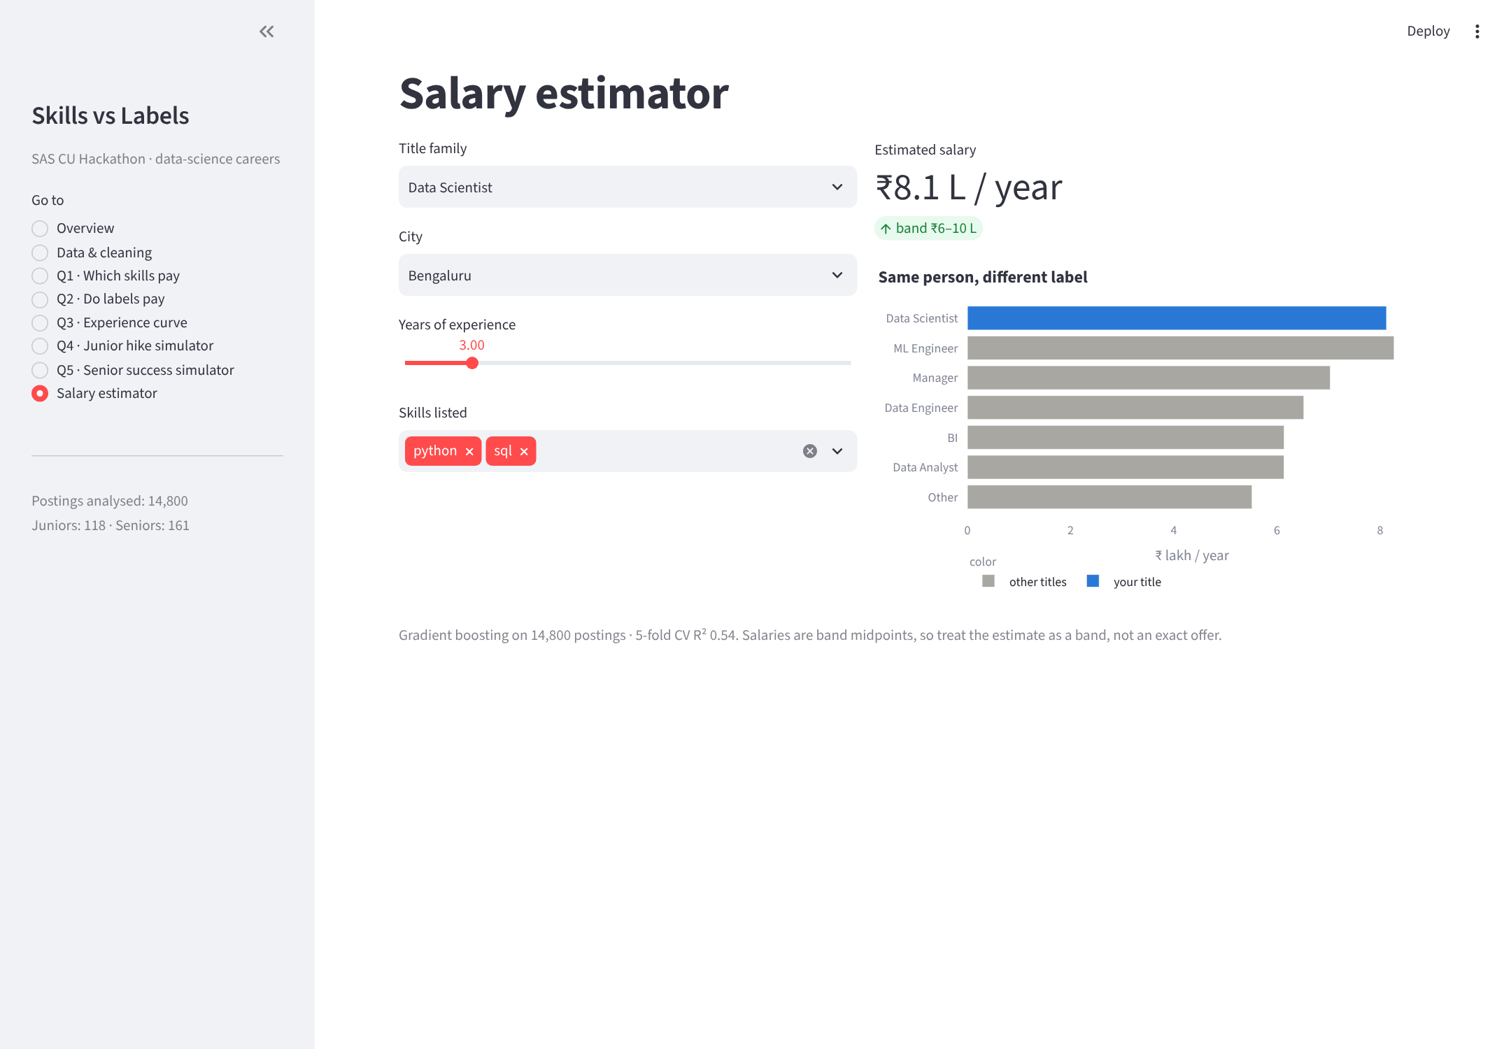
Figure 26. Salary estimator: 'same person, different label'
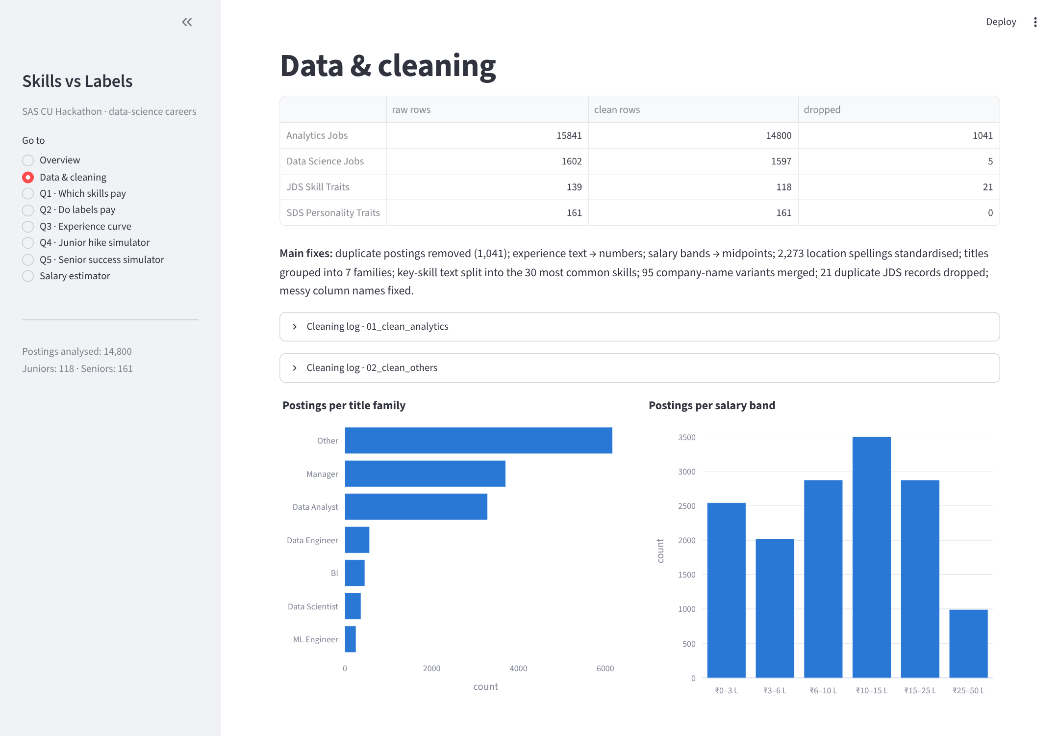
Figure 27. Data & cleaning page

Appendix E. How to run the software
pip install -r requirements.txt
python run_all.py # 12 steps, ~2 minutes; logs in results/logs/
streamlit run app.py # opens the dashboard at http://localhost:8501
Folder layout: data/raw (original files), data/clean (cleaned files), results (tables, logs, metrics), figures (charts), models (saved models), docs/screenshots.

Appendix F. Source code

01_clean_analytics.py
"""Step 1 - Clean the Analytics Jobs file for modelling.
Turns experience/salary/location/skills into numeric + grouped features and
writes data/clean/analytics_clean.csv with a printed cleaning log."""

import re
from pathlib import Path

import numpy as np
import pandas as pd

from paths import find_raw
RAW = find_raw("analytics")
CLEAN = Path(__file__).resolve().parent / "data" / "clean"
OUT = CLEAN / "analytics_clean.csv"

TOP_N_SKILLS = 30 # how many skills become 0/1 columns
MIN_CITY_COUNT = 50 # cities in fewer postings than this become "Other"
IQR_FENCE = 3.0 # extreme salary fence: Q1 - 3*IQR / Q3 + 3*IQR on log salary
JUNK_TOKENS = {"", "...", "..", ".", "-", "--", "n/a", "na", "none", "nil"}

# Spelling variants seen in the raw "location" column -> one canonical name.
CITY_ALIASES = {
"bangalore": "Bengaluru", "bengaluru": "Bengaluru", "bengaluru ": "Bengaluru",
"gurugram": "Gurgaon", "gurgaon": "Gurgaon",
"bombay": "Mumbai", "mumbai": "Mumbai", "mumbai suburbs": "Mumbai",
"calcutta": "Kolkata", "kolkata": "Kolkata",
"madras": "Chennai", "chennai": "Chennai",
"new delhi": "Delhi NCR", "delhi": "Delhi NCR", "delhi ncr": "Delhi NCR",
"hyderabd": "Hyderabad", "hyderabad": "Hyderabad",
"mysuru": "Mysore", "mysore": "Mysore",
"nasik": "Nashik", "nashik": "Nashik",
"panaji": "Panjim", "panjim": "Panjim",
"thiruvananthapuram": "Trivandrum", "trivandrum": "Trivandrum",
"vishakhapatnam": "Visakhapatnam", "visakhapatnam": "Visakhapatnam",
}

# title_family rules, checked top to bottom: the first match wins.
TITLE_RULES = [
("Manager", r"manager|director|\bhead\b|chief|vice president|\bvp\b|president|founder|\bcto\b|\bceo\b|owner"),
("ML Engineer", r"machine learning|\bml\b|deep learning|\bnlp\b|computer vision|artificial intelligence|\bai\b|chatbot|cognitive"),
("Data Engineer", r"data engineer|big data|data architect|hadoop|spark|\betl\b|data platform|database|data warehouse|data pipeline|data integration|informatica|teradata|airflow|nosql|data modell?er"),
("BI", r"business intelligence|\bbi\b|tableau|power bi|dashboard|report|visuali[sz]ation|qlik|microstrategy|cognos|\bmis\b"),
("Data Scientist", r"data scientist|scientist|data science|statistician|predictive|modell?er|pattern recognition"),
("Data Analyst", r"analyst|analytics|business analysis|data analysis"),
]

LOG = [] # (issue, rows affected, action)

def log(issue, rows, action):
LOG.append((issue, int(rows), action))

# --- 1. experience ---------------------------------------------------------
def parse_experience(df):
# Raw looks like "6-10 yrs", so one regex gives the min, max and midpoint.
ex = df["experience"].astype("string")
mn = ex.str.extract(r"(\d+)\s*(?:-|to)\s*\d+", expand=False)
mx = ex.str.extract(r"\d+\s*(?:-|to)\s*(\d+)", expand=False).fillna(mn)
df["min_exp"] = pd.to_numeric(mn, errors="coerce")
df["max_exp"] = pd.to_numeric(mx, errors="coerce")
df["avg_exp"] = ((df["min_exp"] + df["max_exp"]) / 2).round(2)
bad = df["avg_exp"].isna()
log("experience not in 'N-M yrs' format", bad.sum(), "min/max/avg_exp set to NaN")
log("experience above 40 years (implausible)", (df["max_exp"] > 40).sum(),
"flagged, left unchanged for review")
return df

# --- 2. salary -------------------------------------------------------------
def parse_salary(df):
# Raw looks like "10to15" (lakhs/year); split it into min, max and midpoint.
band = df["salary"].astype("string").str.extract(
r"^\s*(\d+(?:\.\d+)?)\s*(?:to|-)\s*(\d+(?:\.\d+)?)\s*$")
lo = pd.to_numeric(band[0], errors="coerce")
hi = pd.to_numeric(band[1], errors="coerce")
df["salary_min_lakh"] = lo
df["salary_max_lakh"] = hi
df["salary_avg_lakh"] = ((lo + hi) / 2).round(2)
# Anything undisclosed or unparseable keeps its numbers blank but gets a flag.
df["salary_missing"] = (lo.isna() | hi.isna()).astype("uint8")
log("salary undisclosed or not a 'NtoM' band", df["salary_missing"].sum(),
"salary_missing=1, salary columns left NaN")
return df

# --- 3. location -----------------------------------------------------------
def norm_city(tok):
# Drop the "(Whitefield)" style suffix and fix known spellings.
tok = re.sub(r"\s*\([^)]*\)", "", str(tok))
tok = re.sub(r"\s+", " ", tok).strip(" .,-")
key = tok.lower()
if key in CITY_ALIASES:
return CITY_ALIASES[key]
return tok.title() if tok.isupper() or tok.islower() else tok

def clean_location(df):
rows_changed = 0
grouped = 0
out = []
for raw in df["location"].fillna(""):
raw_list = [p.strip() for p in str(raw).split(",") if p.strip()]
seen = []
for part in raw_list:
c = norm_city(part)
if c not in seen:
seen.append(c)
if seen != raw_list:
rows_changed += 1
out.append(seen)

# Count how many postings mention each city (each city counted once per row).
counts = {}
for seen in out:
for c in seen:
counts[c] = counts.get(c, 0) + 1
rare = {c for c, n in counts.items() if n < MIN_CITY_COUNT}

final = []
for seen in out:
if any(c not in rare for c in seen):
keep = [c for c in seen if c not in rare] # rare city dropped, big city kept
elif seen:
keep = ["Other"] # nothing but rare cities left
else:
keep = ["Other"]
if keep != seen:
grouped += 1
final.append(", ".join(keep))

df["location"] = final
log("location spelling variants (Bangalore/Gurugram/…(area))", rows_changed,
"standardised to one canonical city name")
log(f"cities mentioned in <{MIN_CITY_COUNT} postings", grouped,
'replaced with "Other" (rows with a major city keep it)')
log("distinct locations after cleaning", df["location"].nunique(),
"kept as-is; use top locations or primary city as a model feature")
return df

# --- 4. job title family ---------------------------------------------------
def family_of(title):
# Try the rules in order; an unmatched title lands in "Other".
t = str(title).lower()
for name, pattern in TITLE_RULES:
if re.search(pattern, t):
return name
return "Other"

def add_title_family(df):
df["title_family"] = df["job_desig"].map(family_of)
other = df["title_family"].eq("Other")
log("job_desig has no data/analyst/manager keyword", other.sum(),
"title_family='Other' (titles kept unchanged in job_desig)")
return df

# --- 5. skills -------------------------------------------------------------
def skill_name(tok):
# "Business Analysis" -> skill_business_analysis
name = re.sub(r"[^a-z0-9]+", "_", tok.lower()).strip("_")
return f"skill_{name}"

def add_skills(df):
junk = 0
parsed = []
for raw in df["key_skills"].fillna(""):
toks = []
for part in str(raw).split(","):
p = part.strip().lower()
if p in JUNK_TOKENS or p.startswith("."):
junk += 1
else:
toks.append(p)
parsed.append(toks)
df["_skills"] = parsed

counts = {}
for toks in parsed:
for t in set(toks): # a skill counts once per posting
counts[t] = counts.get(t, 0) + 1
top = sorted(counts, key=lambda t: (-counts[t], t))[:TOP_N_SKILLS]

for t in top:
df[skill_name(t)] = df["_skills"].map(lambda toks, t=t: int(t in toks)).astype("uint8")

covered = df[[skill_name(t) for t in top]].sum(axis=1).gt(0)
log("junk/empty skill tokens ('...' etc.)", junk, "dropped before splitting")
log(f"row has none of the top {TOP_N_SKILLS} skills", (~covered).sum(),
"all skill_xxx = 0 for that row (kept)")
df.drop(columns=["_skills"], inplace=True)
return df, top

# --- 6. duplicates + salary outliers ---------------------------------------
def drop_duplicates_and_outliers(df):
# Two postings can be identical except for s_no, so ignore the id column.
id_cols = ["s_no"]
dupe = df.duplicated(subset=[c for c in df.columns if c not in id_cols])
df = df.loc[~dupe].copy()
log("duplicate posting (identical except s_no)", dupe.sum(), "dropped, keep='first'")

has_salary = df["salary_missing"].eq(0) & df["salary_avg_lakh"].gt(0)
lg = np.log(df.loc[has_salary, "salary_avg_lakh"])
q1, q3 = lg.quantile(0.25), lg.quantile(0.75)
iqr = q3 - q1
lo, hi = q1 - IQR_FENCE * iqr, q3 + IQR_FENCE * iqr
out = has_salary & ((np.log(df["salary_avg_lakh"].clip(lower=1e-9)) < lo) |
(np.log(df["salary_avg_lakh"].clip(lower=1e-9)) > hi))
log(f"salary outside {IQR_FENCE}xIQR of log salary "
f"[{np.exp(lo):.2f}-{np.exp(hi):.2f} LPA]", out.sum(), "dropped")
df = df.loc[~out].copy()
return df

def print_log(n_raw, n_out):
print("=" * 88)
print(f"CLEANING LOG rows in: {n_raw} rows out: {n_out} dropped: {n_raw - n_out}")
print("=" * 88)
print(f"{'issue':<52}{'rows':>8} action")
print("-" * 88)
for issue, rows, action in LOG:
print(f"{issue:<52}{rows:>8} {action}")
print("=" * 88)

def main():
df = pd.read_csv(RAW)
n_raw = len(df)

df = parse_experience(df)
df = parse_salary(df)
df = clean_location(df)
df = add_title_family(df)
df, top_skills = add_skills(df)
df = drop_duplicates_and_outliers(df)

df = df[["s_no", "job_desig", "title_family", "job_type", "job_description",
"location", "min_exp", "max_exp", "avg_exp",
"salary_min_lakh", "salary_max_lakh", "salary_avg_lakh", "salary_missing",
"key_skills"] + [skill_name(t) for t in top_skills]]

CLEAN.mkdir(parents=True, exist_ok=True)
df.to_csv(OUT, index=False)

print_log(n_raw, len(df))
print(f"top {TOP_N_SKILLS} skills: {', '.join(top_skills)}")
print(f"title_family: {df['title_family'].value_counts().to_dict()}")
print(f"saved -> {OUT} ({df.shape[0]} rows x {df.shape[1]} cols)")

if __name__ == "__main__":
main()

02_clean_others.py
"""Step 2 - Clean the other 3 raw files.
Data Science Jobs -> numbers + company merge + outlier drop.
JDS / SDS -> range rules, duplicates, 0/1 targets.
Writes data/clean/{dsjobs,jds,sds}_clean.csv and prints log + class balance."""

import re
from pathlib import Path

import numpy as np
import pandas as pd

from paths import find_raw
CLEAN = Path(__file__).resolve().parent / "data" / "clean"

IQR_FENCE = 3.0 # outlier rule: avg_salary beyond Q1/Q3 +/- 3 * IQR (raw lakhs)
SD_FENCE = 4.0 # Big Five rule: values further than 4 SD from the mean are typos
JDS_SKILLS = ["big_data_skills", "maths_stats_skills", "coding_skills",
"ai_and_ml_skills", "dashboard_and_storytelling_skills"]
SDS_TRAITS = ["neuroticism", "extraversion", "openness_to_experience",
"agreeableness", "conscientiousness"]

# One employer showing up under a short name / subsidiary / different casing.
COMPANY_ALIASES = {
"atos syntel": "Atos", "bnp paribas india solutions": "BNP Paribas",
"barclays global service centre": "Barclays", "barclays shared services": "Barclays",
"dunnhumby it services india": "Dunnhumby", "dell emc": "Dell",
"hashedin by deloitte": "Deloitte", "wipro digital": "Wipro",
"ge aviation": "GE", "ge digital": "GE", "ge healthcare": "GE",
"ge power": "GE", "ge transportation": "GE",
"gartner india research and advisory services": "Gartner",
"harman": "Harman", "harman connected services": "Harman",
"hcl technologies bpo services": "HCL Technologies", "hsbc technology": "HSBC",
"hitachi vantara": "Hitachi", "infosys bpm": "Infosys", "maersk line": "Maersk",
"nailbiter research": "Nailbiter", "optum global solutions": "Optum",
"oracle financial services software": "Oracle", "s&p global market intelligence": "S&P Global",
"samsung research": "Samsung", "citibank": "Citi", "citigroup": "Citi",
"citicorp": "Citi", "exl india": "EXL Service", "nielseniq": "Nielsen",
"franklin templeton international services": "Franklin Templeton Investments",
"colgate global business services": "Colgate Palmolive",
"standard chartered bank": "Standard Chartered Bank",
"standard chartered global business services": "Standard Chartered Bank",
"ecolab digital center": "Ecolab", "ecolab food safety & hygiene solutions": "Ecolab",
"reliance jio": "Reliance Jio", "whitehat jr": "Whitehat Jr",
}

LOG = [] # (file, issue, rows/cells affected, action)

def log(fname, issue, n, action):
LOG.append((fname, int(n), issue, action))

def to_number(series):
# "7.8L" / "₹ 1,60,000" / "12" -> float, anything unreadable becomes NaN.
return pd.to_numeric(series.astype("string").str.replace(r"[^\d.]", "", regex=True),
errors="coerce")

def to_binary(series, high=("high", "1", "yes", "true")):
# High/1/yes -> 1, Low/0/no -> 0; already-numeric 0/1 columns pass straight through.
if pd.api.types.is_numeric_dtype(series):
return (series > 0).astype("Int64").where(series.notna())
t = series.astype("string").str.strip().str.lower()
return t.map(lambda v: 1 if v in high else (0 if v in ("low", "0", "no", "false") else pd.NA)).astype("Int64")

# ======================================================================
# Data Science Jobs
# ======================================================================
def clean_dsjobs():
F = "DataScience Jobs.csv"
df = pd.read_csv(find_raw("dsjobs"))
n0 = len(df)

# 1. salary columns are text like "7.8L" -> plain numbers in lakhs.
cells, failed = 0, 0
for c in ["avg_salary", "min_salary", "max_salary"]:
was_text = not pd.api.types.is_numeric_dtype(df[c])
conv = to_number(df[c])
cells += int(conv.notna().sum()) if was_text else 0
failed += int((df[c].notna() & conv.isna()).sum())
df[c] = conv
log(F, "avg/min/max_salary stored as text ('7.8L')", cells,
"stripped the L, stored as float lakhs/year")
log(F, "salary text that could not be parsed", failed, "set to NaN")
for c in ["min_experience", "num_of_jobs"]:
if not pd.api.types.is_numeric_dtype(df[c]):
n = int(to_number(df[c]).notna().sum())
df[c] = to_number(df[c])
log(F, f"{c} stored as text", n, "converted to number")

# 2. min salary above max salary is a typo -> swap the two values.
swap = (df["min_salary"] > df["max_salary"]).fillna(False)
df.loc[swap, ["min_salary", "max_salary"]] = df.loc[swap, ["max_salary", "min_salary"]].values
log(F, "min_salary > max_salary", swap.sum(),
f"checked all {n0} rows, swapped the pair where found")

# 3. one employer, many spellings -> single canonical company_name.
before = df["company_name"].nunique()
clean = df["company_name"].astype("string").str.replace(r"\s+", " ", regex=True).str.strip()
df["company_name"] = clean.str.lower().map(COMPANY_ALIASES).fillna(clean)
changed = int(df["company_name"].ne(clean).sum())
log(F, "company_name variants (Barclays Shared Services, GE Healthcare, ...)",
changed,
f"merged into parent brand, {before} -> {df['company_name'].nunique()} companies")

# 4. exact reposts (same posting under a new reference_no) -> keep the first.
id_cols = ["reference_no"]
dupe = df.duplicated(subset=[c for c in df.columns if c not in id_cols])
df = df.loc[~dupe].copy()
log(F, "duplicate posting (identical except reference_no)", dupe.sum(), "dropped, keep='first'")

# 5. salary far outside the pack -> drop, so a few 80 LPA rows do not steer the model.
q1, q3 = df["avg_salary"].quantile([0.25, 0.75])
step = IQR_FENCE * (q3 - q1)
lo, hi = q1 - step, q3 + step
out = (df["avg_salary"] < lo) | (df["avg_salary"] > hi)
log(F, f"avg_salary outside {IQR_FENCE}xIQR [{lo:.1f}-{hi:.1f} LPA]", out.sum(), "dropped")
df = df.loc[~out].copy()

out_path = CLEAN / "dsjobs_clean.csv"
df.to_csv(out_path, index=False)
return df, n0, F, out_path

# ======================================================================
# JDS Skill Traits
# ======================================================================
def clean_jds():
F = "JDS Skill Traits.xlsx"
df = pd.read_excel(find_raw("jds"))
n0 = len(df)

# 1. tidy column names so the model script can use them directly.
ren = {c: re.sub(r"[^a-z0-9]+", "_", c.strip().lower()).strip("_") for c in df.columns}
renamed = [f"{a} -> {b}" for a, b in ren.items() if a != b]
df = df.rename(columns=ren)

# 2. the scale is defined 1-5, so 0 or 9 is a typo -> blank it out.
skills = df[JDS_SKILLS]
oor = ((skills < 1) | (skills > 5)).any(axis=1)
df[JDS_SKILLS] = skills.where((skills >= 1) & (skills <= 5))
log(F, "skill score outside 1-5", oor.sum(), "set to missing (scale only allows 1-5)")

# 3. same person/same scores listed twice (id differs) -> drop, keep the first.
body = JDS_SKILLS + ["salary_hike_high_or_low"]
dupe = df.duplicated(subset=body)
df = df.loc[~dupe].copy()
log(F, "duplicate row (same 5 scores + target, id ignored)", dupe.sum(), "dropped, keep='first'")

# 4. rows missing a score or the target -> drop (only ~140 rows, imputation invents data).
miss = df[body].isna().any(axis=1)
df = df.loc[~miss].copy()
log(F, "row missing a skill score or target", miss.sum(), "dropped")

# 5. target High/Low -> 1/0.
col = "salary_hike_high_or_low"
raw = df[col].astype("string").str.strip().str.lower()
df[col] = to_binary(df[col]).astype(int)
changed_rows = int(df[col].astype("string").ne(raw).sum())
log(F, "target High/Low -> 1/0", changed_rows,
"already 0/1, cast to int" if changed_rows == 0
else f"raw values {sorted(raw.unique())} mapped to 1/0")

out_path = CLEAN / "jds_clean.csv"
df[["id"] + JDS_SKILLS + ["salary_hike_high_or_low"]].to_csv(out_path, index=False)
return df, n0, F, out_path, renamed

# ======================================================================
# SDS Personality Traits
# ======================================================================
def clean_sds():
F = "SDS Personality Traits.xlsx"
df = pd.read_excel(find_raw("sds"))
n0 = len(df)

# 1. tidy names (" extraversion", "success_ classification_ high_low") + numeric traits.
ren = {c: re.sub(r"[^a-z0-9]+", "_", c.strip().lower()).strip("_") for c in df.columns}
ren = {k: ("success_high_low" if v.startswith("success") else v) for k, v in ren.items()}
renamed = [f"{a} -> {b}" for a, b in ren.items() if a != b]
df = df.rename(columns=ren)

bad_cells = 0
for c in SDS_TRAITS:
n = pd.to_numeric(df[c], errors="coerce").isna().sum() - df[c].isna().sum()
bad_cells += int(n)
df[c] = pd.to_numeric(df[c], errors="coerce")
log(F, "trait stored as text", bad_cells, "converted to number, unreadable -> NaN")

# 2. anything beyond 4 SD from the mean is a keying error -> blank it, drop the row.
z = (df[SDS_TRAITS] - df[SDS_TRAITS].mean()) / df[SDS_TRAITS].std(ddof=0)
ext = (z.abs() > SD_FENCE).any(axis=1)
if ext.any(): # only touch the frame when something is wrong
df.loc[ext, SDS_TRAITS] = np.nan
log(F, f"trait value more than {SD_FENCE:g} SD from the mean", ext.sum(),
"value removed, row dropped (milder 3-4 SD values kept)")

# 3. rows left without a full trait profile -> drop.
miss = df[SDS_TRAITS].isna().any(axis=1)
df = df.loc[~miss].copy()
log(F, "row missing a trait value", miss.sum(), "dropped (no imputation on 161 rows)")

# 4. target High/Low -> 1/0.
col = "success_high_low"
raw = df[col].astype("string").str.strip().str.lower()
df[col] = to_binary(df[col]).astype(int)
changed_rows = int(df[col].astype("string").ne(raw).sum())
log(F, "target High/Low -> 1/0", changed_rows,
"already 0/1, cast to int" if changed_rows == 0
else f"raw values {sorted(raw.unique())} mapped to 1/0")

out_path = CLEAN / "sds_clean.csv"
df[["id"] + SDS_TRAITS + ["success_high_low"]].to_csv(out_path, index=False)
return df, n0, F, out_path, renamed

# ======================================================================
def print_log(results):
print("=" * 96)
print("CLEANING LOG")
print("=" * 96)
print(f"{'file':<28}{'issue':<50}{'n':>5} action")
print("-" * 96)
for fname, n, issue, action in LOG:
print(f"{fname:<28}{issue:<50}{n:>5} {action}")
print("-" * 96)
for fname, n0, n1, path in results:
print(f"{fname:<28}{'ROWS':<50}{n1:>5} (was {n0}, dropped {n0 - n1}) -> {path.name}")
print("=" * 96)

def print_balance(dsj, jds, sds):
print("\nCLASS BALANCE")
print("-" * 96)
print("dsjobs_clean.csv job_title (10 classes):")
vc = dsj["job_title"].value_counts()
for k, v in vc.items():
print(f" {k:<32}{v:>5} ({100 * v / len(dsj):.1f}%)")
for name, df, col in [("jds_clean.csv", jds, "salary_hike_high_or_low"),
("sds_clean.csv", sds, "success_high_low")]:
vc = df[col].value_counts().sort_index()
n = len(df)
print(f"{name:<18}{col} (1 = high/success):")
for k, v in vc.items():
print(f" {k:<32}{v:>5} ({100 * v / n:.1f}%)")
print(f" {'minority class':<32}{vc.min():>5} "
f"-> {'balanced' if vc.min() / n > 0.4 else 'IMBALANCED, report recall/AUC not accuracy'}")
print("-" * 96)

def main():
CLEAN.mkdir(parents=True, exist_ok=True)
dsj, n_ds, f_ds, p_ds = clean_dsjobs()
jds, n_j, f_j, p_j, ren_j = clean_jds()
sds, n_s, f_s, p_s, ren_s = clean_sds()

print_log([(f_ds, n_ds, len(dsj), p_ds),
(f_j, n_j, len(jds), p_j),
(f_s, n_s, len(sds), p_s)])
if ren_j or ren_s:
print("renamed columns:")
for r in ren_j + ren_s:
print(" ", r)
print_balance(dsj, jds, sds)
print(f"saved -> {p_ds} | {p_j} | {p_s}")

if __name__ == "__main__":
main()

04_skill_roi.py
"""Skill ROI - which skills carry salary uplift once experience, location and title are fixed?

Line 1: OLS on log(salary) with HC1 robust SEs gives each skill's % uplift, its 95% CI, p-value
and a "years of experience equivalent" (skill coefficient / experience coefficient).
Line 2: a gradient boosting model with 5-fold CV and permutation importance cross-checks the ranking.
"""

from pathlib import Path

import numpy as np
import pandas as pd
import statsmodels.formula.api as smf
from sklearn.compose import ColumnTransformer
from sklearn.ensemble import GradientBoostingRegressor
from sklearn.model_selection import KFold, cross_val_score
from sklearn.pipeline import Pipeline
from sklearn.preprocessing import OneHotEncoder
from sklearn.metrics import r2_score

ROOT = Path(__file__).resolve().parent
a = pd.read_csv(ROOT / "data/clean/analytics_clean.csv")
skills = sorted(c for c in a.columns if c.startswith("skill_"))
a["salary_log"] = np.log(a["salary_avg_lakh"])

print("=" * 118)
print("SKILL PAY UPLIFT - OLS on log(salary), HC1 robust SEs, controls: title_family + location + avg_exp")
print(f"n = {len(a)} salary = salary_avg_lakh (lakhs/yr, band midpoint, log) skills = {len(skills)} keyword dummies")
print("=" * 118)

# ------------------------------------------------- 1) OLS skill coefficients
f = ("salary_log ~ C(title_family, Sum) + C(location) + avg_exp + " + " + ".join(skills))
res = smf.ols(f, data=a).fit(cov_type="HC1")
b = res.params[skills]
ci = res.conf_int().loc[skills]
p = res.pvalues[skills]
b_exp = res.params["avg_exp"] # log-salary per year of experience
pct = lambda x: (np.exp(x) - 1) * 100 # log coefficient -> % uplift

tab = pd.DataFrame(
{
"uplift_pct": pct(b.values),
"ci_lo_pct": pct(ci[0].values),
"ci_hi_pct": pct(ci[1].values),
"p_value": p.values,
"yrs_equivalent": (b / b_exp).values, # years of exp that would buy the same uplift
"postings": a[skills].sum().values,
},
index=[s.replace("skill_", "") for s in skills],
).sort_values("uplift_pct", ascending=False)

# reliable = p < 0.05 AND the 95% CI does not contain 0
tab["reliable"] = (tab.p_value < 0.05) & ((tab.ci_lo_pct > 0) | (tab.ci_hi_pct < 0))
n_rel = int(tab.reliable.sum())
n_pos = int((tab.reliable & (tab.ci_lo_pct > 0)).sum())
n_neg = int((tab.reliable & (tab.ci_hi_pct < 0)).sum())

print(f"model R2 = {res.rsquared:.3f} | experience coefficient = +{pct(b_exp):.1f}% per year "
f"(so 1 year = 1.0x) | reliable skills: {n_rel}/30 ({n_pos} positive, {n_neg} negative)")

def show(title, df):
print("\n" + "-" * 118)
print(title)
print("-" * 118)
print(f"{'skill':<22}{'uplift %':>10}{'95% CI':>20}{'p':>9}{'yrs equiv':>11}{'postings':>10} reliable")
for n, r in df.iterrows():
star = "yes" if r.reliable else "no"
print(f"{n:<22}{r.uplift_pct:>9.1f}%"
f"{f'[{r.ci_lo_pct:+.1f}%, {r.ci_hi_pct:+.1f}%]':>20}"
f"{r.p_value:>9.3f}{r.yrs_equivalent:>10.2f}x{int(r.postings):>9} {star}")

show("TOP 10 SKILLS BY % UPLIFT", tab.head(10))
show("BOTTOM 5 SKILLS BY % UPLIFT", tab.tail(5))
not_rel = tab[~tab.reliable]
print(f"\nNOT statistically reliable ({len(not_rel)} of 30, CI contains 0): "
+ ", ".join(f"{n} ({r.uplift_pct:+.1f}%, p={r.p_value:.2f})" for n, r in not_rel.iterrows()))

# ------------------------------------------------- 2) gradient boosting cross-check
num = ["avg_exp"] + skills
cat = ["title_family", "location"]
pre = ColumnTransformer(
[("ohe", OneHotEncoder(handle_unknown="ignore"), cat), ("num", "passthrough", num)]
)
pipe = Pipeline(
[("pre", pre), ("gb", GradientBoostingRegressor(n_estimators=300, random_state=42))]
)
X, y = a[cat + num], a["salary_log"]

cv = KFold(5, shuffle=True, random_state=42)
cv_r2 = cross_val_score(pipe, X, y, cv=cv, scoring="r2")

rng = np.random.default_rng(42)
perm = np.zeros((5, len(skills)))
fold_r2 = []
for k, (tr, te) in enumerate(cv.split(X, y)):
pipe.fit(X.iloc[tr], y.iloc[tr])
Xte, yte = X.iloc[te], y.iloc[te]
base = r2_score(yte, pipe.predict(Xte))
fold_r2.append(base)
for j, s in enumerate(skills):
Xp = Xte.copy()
Xp[s] = rng.permutation(Xp[s].to_numpy())
perm[k, j] = base - r2_score(yte, pipe.predict(Xp)) # R2 drop when the skill is shuffled

gb = pd.DataFrame(
{
"perm_r2_drop": perm.mean(0),
"perm_sd": perm.std(0),
"uplift_pct": tab.uplift_pct.values,
"reliable": tab.reliable.values,
},
index=tab.index,
).sort_values("perm_r2_drop", ascending=False)

print("\n" + "=" * 118)
print("CROSS-CHECK: GradientBoostingRegressor, 5-fold CV (shuffled, seed 42), permutation importance")
print("=" * 118)
print(f"CV R2 per fold: {np.round(cv_r2, 3)} -> mean {cv_r2.mean():.3f} +/- {cv_r2.std():.3f} "
f"(OLS in-sample R2 = {res.rsquared:.3f})")
print("permutation importance = mean drop in test R2 when that skill column is shuffled\n")
print(f"{'skill':<22}{'perm dR2':>10}{'+- sd':>8}{'OLS uplift':>12}{'reliable':>10}")
for n, r in gb.head(10).iterrows():
print(f"{n:<22}{r.perm_r2_drop:>10.4f}{r.perm_sd:>8.4f}{r.uplift_pct:>11.1f}%"
f"{('yes' if r.reliable else 'no'):>10}")
print(" ...")
for n, r in gb.tail(5).iterrows():
print(f"{n:<22}{r.perm_r2_drop:>10.4f}{r.perm_sd:>8.4f}{r.uplift_pct:>11.1f}%"
f"{('yes' if r.reliable else 'no'):>10}")

spearman = pd.Series(tab.uplift_pct).corr(pd.Series(gb.perm_r2_drop, index=gb.index), method="spearman")
top10_ols, top10_gb = list(tab.head(10).index), list(gb.head(10).index)
overlap = [s for s in top10_ols if s in top10_gb]
agree_neg = [s for s in tab.tail(2).index if s in gb.tail(3).index] # both say negative
print(f"\nSpearman rank correlation (OLS uplift vs permutation importance, 30 skills) = {spearman:.2f}")
print(f"OLS top-10 that also appear in GB top-10: {len(overlap)}/10 -> {', '.join(overlap)}")
print(f"skills flagged negative by BOTH methods: {', '.join(agree_neg) if agree_neg else 'none'}")

strong = tab[tab.reliable & (tab.ci_lo_pct > 0)]
gb_top5 = list(gb.head(5).index)
strong_conf = [s for s in strong.head(10).index if s in gb_top5]
gb_not_ols = [s for s in gb_top5 if s not in strong.head(10).index]
print(f"OLS-positive-and-reliable skills confirmed in GB top-5: "
f"{', '.join(strong_conf) if strong_conf else 'none'}")
if gb_not_ols:
ups = ", ".join("{:+.1f}%".format(tab.loc[s, "uplift_pct"]) for s in gb_not_ols)
ok = ", ".join(strong.index.intersection(gb_not_ols)) or "none"
print(f"GB top-5 NOT in OLS top-10: {', '.join(gb_not_ols)} (ups {ups}, reliable: {ok})")

# ------------------------------------------------- 3) final answer
t1, t2, t3 = tab.head(3).index
top = tab.head(3)
no_effect = tab[~tab.reliable]

print("\n" + "=" * 118)
print("FINAL ANSWER")
print("=" * 118)
print(
f"1. The three most valuable skills, holding experience, location and title fixed, are "
f"{t1} (+{tab.loc[t1, 'uplift_pct']:.1f}%, 95% CI +{tab.loc[t1, 'ci_lo_pct']:.1f}% to "
f"+{tab.loc[t1, 'ci_hi_pct']:.1f}%, p < 0.001 = {tab.loc[t1, 'yrs_equivalent']:.2f} years of "
f"experience equivalent), {t2} (+{tab.loc[t2, 'uplift_pct']:.1f}%, CI "
f"+{tab.loc[t2, 'ci_lo_pct']:.1f}% to +{tab.loc[t2, 'ci_hi_pct']:.1f}%, "
f"{tab.loc[t2, 'yrs_equivalent']:.2f} yrs) and {t3} (+{tab.loc[t3, 'uplift_pct']:.1f}%, CI "
f"+{tab.loc[t3, 'ci_lo_pct']:.1f}% to +{tab.loc[t3, 'ci_hi_pct']:.1f}%, "
f"{tab.loc[t3, 'yrs_equivalent']:.2f} yrs).\n"
f"2. The gradient boosting cross-check (5-fold CV R2 = {cv_r2.mean():.3f} +/- {cv_r2.std():.3f}) "
f"agrees only partly: it also puts {', '.join(overlap)} in its own top 10 (shuffling "
f"business_analysis costs {gb.loc['business_analysis', 'perm_r2_drop']:.4f} of test R2), but the two "
f"rankings correlate at just Spearman {spearman:.2f} ({len(overlap)}/10 top-10 overlap) because "
f"permutation importance is sign-blind - it counts a skill that pushes pay DOWN "
f"(seo, {tab.loc['seo', 'uplift_pct']:+.1f}%) as just as important and puts rare skills like "
f"{', '.join(s for s in gb_not_ols if s != 'seo')} ahead of {tab.index[0]}, so only {overlap[0]} and "
f"seo are confirmed by both methods, and {tab.index[0]} - the OLS top pick - is worth "
f"{gb.loc[tab.index[0], 'perm_r2_drop']:.4f} R2 to the GB model once title and location are in.\n"
f"3. {len(no_effect)} of the 30 skills have no real effect (p >= 0.05 and the 95% CI contains 0): "
f"{', '.join(no_effect.index)} - for these the data cannot separate the coefficient from zero, "
f"so their apparent {no_effect.uplift_pct.min():.0f}%..{no_effect.uplift_pct.max():.0f}% spread is noise, "
f"not pay signal.\n"
)
print("LIMITATIONS")
print("-" * 118)
print("1. Observational data: a skill's coefficient is a partial correlation, not a causal ROI - skills "
"co-occur (java with outsourcing/contract roles, sql with senior engineering), hiring teams pick "
"skills they already pay for, and a keyword match in key_skills shows the posting lists the skill, "
"not that the candidate has it.")
print("2. Salary is a band midpoint (0to3, 6to10, ...) so all uplifts are on a coarsened outcome, some "
"skills appear in only ~220-350 postings (wide CIs), the GB permutation importance splits credit "
"unpredictably between correlated skills, and CV R2 = "
f"{cv_r2.mean():.2f} leaves about {1 - cv_r2.mean():.0%} of pay variance unexplained.")
print("=" * 118)

tab.round(3).to_csv(ROOT / "results" / "skill_uplift_table.csv")
gb.round(4).to_csv(ROOT / "results" / "skill_gb_importance.csv")
print("saved -> results/skill_uplift_table.csv, skill_gb_importance.csv")

05_title_premium.py
"""Step 4 - Does the title still pay once skills, experience and location are held fixed?
OLS on log(salary) with HC3 robust errors, Model A vs Model B, plus a skill-profile
cosine similarity between the Data Analyst and Data Scientist families."""

from pathlib import Path
import warnings

import numpy as np
import pandas as pd
import statsmodels.formula.api as smf

ROOT = Path(__file__).resolve().parent
CSV = ROOT / "data" / "clean" / "analytics_clean.csv"

a = pd.read_csv(CSV)
a["salary_log"] = np.log(a["salary_avg_lakh"]) # log tames the salary tail
skills = sorted(c for c in a.columns if c.startswith("skill_"))

# ---------------------------------------------------------------- models
# A: title + location + experience. B: A + every skill column.
fA = "salary_log ~ C(title_family, Sum) + C(location) + avg_exp"
fB = fA + " + " + " + ".join(skills)
# HC1 (Stata-style) robust errors: HC3 divides by (1 - leverage) and blows up because
# 154 postings sit in a location that appears exactly once (leverage = 1, HC3 = inf).
A = smf.ols(fA, data=a).fit(cov_type="HC1")
B = smf.ols(fB, data=a).fit(cov_type="HC1")

# Effect coding: every family is reported as a premium vs the AVERAGE title.
title_pars = [p for p in A.params.index if "title_family" in p]
families = sorted(a["title_family"].unique())

def contrast(res, family):
# Effect-coded coefficient for one family (the omitted level = -sum of the others).
v = np.zeros(len(res.params))
name = next((p for p in title_pars if p.endswith(f"[S.{family}]")), None)
if name is not None:
v[res.params.index.get_loc(name)] = 1.0
else: # the level patsy dropped (alphabetically last)
for p in title_pars:
v[res.params.index.get_loc(p)] = -1.0
t = res.t_test(v) # robust SE + 95% CI for this combination
est = float(np.asarray(t.effect).ravel()[0])
pval = float(np.asarray(t.pvalue).ravel()[0])
ci = np.asarray(t.conf_int()).ravel()
return est, pval, ci

def pct(x):
return (np.exp(x) - 1) * 100 # log-points -> % pay

rows = []
for f in families:
bA, pA, ciA = contrast(A, f)
bB, pB, ciB = contrast(B, f)
# "how much of the raw premium disappears"; undefined when A found no premium.
gone = np.nan if abs(bA) < 0.01 else (bA - bB) / bA * 100
rows.append(dict(
title_family=f,
premium_A_pct=pct(bA), A_lo=pct(ciA[0]), A_hi=pct(ciA[1]), p_A=pA,
premium_B_pct=pct(bB), B_lo=pct(ciB[0]), B_hi=pct(ciB[1]), p_B=pB,
premium_gone_pct=gone,
))
tab = pd.DataFrame(rows).sort_values("premium_A_pct", ascending=False)

print("=" * 112)
print("TITLE PREMIUM - OLS on log(salary), HC1 robust SEs, effect coding "
"(premium = % vs the average title)")
print(f"n = {int(A.nobs)} params A = {len(A.params)} params B = {len(B.params)} cov = HC1 robust")
print("=" * 112)
print(f"{'title_family':<16}{'A: % premium':<16}{'95% CI':<22}{'p':<9}"
f"{'B: % premium':<16}{'95% CI':<22}{'p':<9}")
print("-" * 112)
for _, r in tab.iterrows():
print(f"{r.title_family:<16}"
f"{r.premium_A_pct:>7.1f}% "
f"[{r.A_lo:>6.1f}%, {r.A_hi:>6.1f}%] {r.p_A:<9.3f}"
f"{r.premium_B_pct:>7.1f}% "
f"[{r.B_lo:>6.1f}%, {r.B_hi:>6.1f}%] {r.p_B:<9.3f}")
print("-" * 112)
for _, r in tab.iterrows():
g = "n/a" if np.isnan(r.premium_gone_pct) else f"{r.premium_gone_pct:.1f}%"
sig_a, sig_b = "sig" if r.p_A < 0.05 else "n.s.", "sig" if r.p_B < 0.05 else "n.s."
print(f"{r.title_family:<16} premium that disappears in B: {g:>8} "
f"({sig_a} in A -> {sig_b} in B)")
print("-" * 112)
print(f"R2: A = {A.rsquared:.3f} B = {B.rsquared:.3f} "
f"(+{B.rsquared - A.rsquared:.3f} from the 30 skills)")

R = np.zeros((len(skills), len(B.params))) # restriction matrix: skills = 0
for i, s_ in enumerate(skills):
R[i, B.params.index.get_loc(s_)] = 1.0
with warnings.catch_warnings(): # silent: legacy wald_test + pinv noise
warnings.simplefilter("ignore")
wt = B.wald_test(R, use_f=False, scalar=False) # robust Wald chi2 (HC1)
chi2, chi2_p = float(np.asarray(wt.statistic).ravel()[0]), float(np.asarray(wt.pvalue).ravel()[0])
print(f"Joint test that the 30 skill coefficients are all 0 in B: "
f"chi2({len(skills)}) = {chi2:.0f}, p = {chi2_p:.2e}")
big = tab.loc[tab.premium_B_pct.abs().idxmax()]
print(f"Largest premium left in B: {big.title_family} {big.premium_B_pct:+.1f}% "
f"(CI {big.B_lo:+.1f}% to {big.B_hi:+.1f}%)")

# Robustness: 154 postings sit in a location seen exactly once, which makes HC3
# undefined and those dummies perfectly fitted - check the answer does not hinge on them.
once = a["location"].map(a["location"].value_counts()) == 1
ar = a.loc[~once].copy()
Br = smf.ols(fB, data=ar).fit(cov_type="HC1")
print(f"\nRobustness check - drop the {int(once.sum())} postings in a once-only location "
f"(n = {len(ar)}):")
for fam_ in ["ML Engineer", "Data Scientist", "Manager"]:
est, pv, ci_ = contrast(Br, fam_)
print(f" {fam_:<16} model B premium {pct(est):+6.1f}% "
f"(CI {pct(ci_[0]):+.1f}% to {pct(ci_[1]):+.1f}%, p = {pv:.1e})")

# ------------------------------------------------- cosine similarity
prof = a.groupby("title_family")[skills].mean()
da, ds = prof.loc["Data Analyst"].values, prof.loc["Data Scientist"].values
cos = float(np.dot(da, ds) / (np.linalg.norm(da) * np.linalg.norm(ds)))

print("\n" + "=" * 112)
print("SKILL PROFILE SIMILARITY: Data Analyst vs Data Scientist")
print("=" * 112)
print(f"cosine similarity of the 30-dim mean skill-demand vectors = {cos:.4f}")
gap = pd.DataFrame({"Data Analyst": da, "Data Scientist": ds, "diff": ds - da},
index=[s.replace("skill_", "") for s in skills])
print("\nskills the Data Scientist family lists more often (top 5):")
for n, r in gap.sort_values("diff", ascending=False).head(5).iterrows():
print(f" {n:<24} DA {100 * r['Data Analyst']:5.1f}% DS {100 * r['Data Scientist']:5.1f}% "
f"diff {100 * r['diff']:+.1f} pp")
print("skills the Data Analyst family lists more often (top 5):")
for n, r in gap.sort_values("diff").head(5).iterrows():
print(f" {n:<24} DA {100 * r['Data Analyst']:5.1f}% DS {100 * r['Data Scientist']:5.1f}% "
f"diff {100 * r['diff']:+.1f} pp")

# ------------------------------------------------- final answer
hi = tab.iloc[0]
gone_pos = tab.dropna(subset=["premium_gone_pct"])
ds = tab.loc[tab.title_family == "Data Scientist"].iloc[0]
mgr = tab.loc[tab.title_family == "Manager"].iloc[0]
kept = 100 - gone_pos.premium_gone_pct.mean()
print("\n" + "=" * 112)
print("FINAL ANSWER")
print("=" * 112)
print(
f"1. Yes - holding all 30 skills, experience and location fixed, the title still pays: relative to the "
f"average title, model A premiums run from {hi.premium_A_pct:+.1f}% ({hi.title_family}) down to "
f"{tab.premium_A_pct.min():+.1f}% ({tab.iloc[-1].title_family}), and in model B {big.title_family} still "
f"earns {big.premium_B_pct:+.1f}% (95% CI {big.B_lo:+.1f}% to {big.B_hi:+.1f}%, p = {big.p_B:.1e}) and "
f"Data Scientist {ds.premium_B_pct:+.1f}% (95% CI {ds.B_lo:+.1f}% to {ds.B_hi:+.1f}%, p = {ds.p_B:.1e}), "
f"with {int((tab.p_B < 0.05).sum())} of {len(tab)} title coefficients still significant at 5%.\n"
f"2. Skills buy only part of that gap: the raw premium shrinks by {gone_pos.premium_gone_pct.mean():.0f}% "
f"on average ({ds.premium_gone_pct:.0f}% for Data Scientist, {big.premium_gone_pct:.0f}% for "
f"{big.title_family}) and R2 moves just {A.rsquared:.3f} -> {B.rsquared:.3f} (+{B.rsquared - A.rsquared:.3f}), "
f"even though the skill block is jointly significant (Wald chi2({len(skills)}) = {chi2:.0f}, "
f"p = {chi2_p:.1e}).\n"
f"3. Verdict: titles mostly reflect real but only partly measurable differences rather than being empty "
f"labels - the Data Analyst and Data Scientist skill profiles are just {cos:.2f} cosine-similar "
f"(python {100 * gap.loc['python', 'Data Scientist']:.1f}% vs {100 * gap.loc['python', 'Data Analyst']:.1f}%, "
f"machine learning {100 * gap.loc['machine_learning', 'Data Scientist']:.1f}% vs "
f"{100 * gap.loc['machine_learning', 'Data Analyst']:.1f}%), so the skills we can see are genuinely "
f"different and partly priced, yet {kept:.0f}% of every premium survives those controls (Manager even "
f"rises {mgr.premium_A_pct:+.1f}% -> {mgr.premium_B_pct:+.1f}%), which means titles pay for ability, "
f"seniority and brand that the 30 keyword skills do not capture.\n"
)
print("LIMITATIONS")
print("-" * 112)
print("1. Observational data: title, skills and salary come from the same postings, so unmeasured "
"ability/seniority/company mix can still drive both the title and the pay (selection, not "
"causation) - and the 30 skills are keyword matches on a posting, not verified proficiency.")
print("2. Salary is a band midpoint (0to3, 6to10, ...) rather than a real offer, location has 344 levels "
"with 154 once-only cells (which forces HC1 instead of HC3), so SEs are wide for rare "
"title x location cells, within-band pay variance is ignored, and small premiums (Data Engineer "
"+3.6%) cannot be separated from zero.")
print("=" * 112)

tab.to_csv(ROOT / "results" / "title_premium_table.csv", index=False)
print("saved -> results/title_premium_table.csv")

06_experience_knee.py
"""Experience knee - at what experience level does salary growth flatten?

Line 1: Salary percentiles per experience year plus quadratic quantile regressions (q = 0.1, 0.5, 0.9)
on log(salary) show how the bottom, middle and top of the pay distribution grow with experience.
Line 2: A piecewise (broken-stick) regression picks the breakpoint by grid search, bootstraps a 95% CI
for it, and reports the yearly growth rate in % before and after the break.
"""

from pathlib import Path
import warnings

import numpy as np
import pandas as pd
from statsmodels.regression.quantile_regression import QuantReg

warnings.filterwarnings("ignore", category=RuntimeWarning) # stale FP flags from QuantReg internals (fits checked finite)

ROOT = Path(__file__).resolve().parent
a = pd.read_csv(ROOT / "data/clean/analytics_clean.csv")
a["salary_log"] = np.log(a["salary_avg_lakh"])
e = a["avg_exp"].values # years (0 to 26.5, half-year steps)
y = a["salary_log"].values
x = e / 10.0 # rescaled experience keeps QuantReg well conditioned
GRID = np.arange(1.0, 20.5, 0.5) # candidate breakpoints, years
B_BOOT = 1000

print("=" * 118)
print("WHEN DOES SALARY GROWTH FLATTEN? - analytics_clean.csv, salary = salary_avg_lakh band midpoint")
print("=" * 118)
bands = sorted(a.salary_avg_lakh.unique())
print(f"n = {len(a)} experience = avg_exp (min/max mid) salary has only {len(bands)} distinct values: "
+ ", ".join(f"{v:g}L" for v in bands))

# ------------------------------------------------- 1) percentiles per experience year
a["yr"] = a["avg_exp"].round().astype(int)
a["yr_group"] = np.where(a["yr"] >= 21, "21+", a["yr"].astype(str))
per_year = (
a.groupby("yr_group")["salary_avg_lakh"]
.agg(n="count", p25=lambda s: s.quantile(0.25), median="median", p75=lambda s: s.quantile(0.75))
)
order = [str(i) for i in range(21)] + ["21+"]
per_year = per_year.reindex([o for o in order if o in per_year.index])

print("\n" + "=" * 118)
print("SALARY PER EXPERIENCE YEAR (lakhs/year, band midpoints)")
print("=" * 118)
print(f"{'years':>7}{'n':>8}{'p25':>10}{'median':>10}{'p75':>10}")
for idx, r in per_year.iterrows():
print(f"{idx:>7}{int(r.n):>8}{r.p25:>10.1f}{r['median']:>10.1f}{r.p75:>10.1f}")

# ------------------------------------------------- 2) quadratic quantile regression
def q_slope_pct(params, years):
"""% pay change per year at a given experience level (model is quadratic in years/10)."""
xx = np.asarray(years) / 10.0
return (np.exp((params[1] + 2 * params[2] * xx) / 10.0) - 1) * 100

QX = np.c_[np.ones_like(x), x, x**2]
qres = {}
print("\n" + "=" * 118)
print("QUANTILE REGRESSION: log(salary) ~ experience + experience^2 (q = 0.1, 0.5, 0.9)")
print("=" * 118)
print(f"{'quantile':>10}{'turning pt (yr)':>18}{'%/yr @0yr':>11}{'@5yr':>9}{'@10yr':>9}{'@15yr':>9}{'exp^2 p':>10}")
for q in (0.1, 0.5, 0.9):
m = QuantReg(y, QX).fit(q=q, max_iter=5000)
assert np.isfinite(m.params).all()
p2_p = m.pvalues[2]
vertex = -m.params[1] / (2 * m.params[2]) * 10.0
s = q_slope_pct(m.params, [0, 5, 10, 15])
qres[q] = {"vertex": vertex, "slopes": s, "p2": p2_p}
print(f"{q:>10.1f}{vertex:>18.1f}{s[0]:>10.1f}%{s[1]:>8.1f}%{s[2]:>8.1f}%{s[3]:>8.1f}%{p2_p:>10.3f}")
print("turning point = experience where the fitted quadratic's yearly growth reaches 0%")

# ------------------------------------------------- 3) piecewise regression, grid search
def piece_fit(e_arr, y_arr, bp):
X = np.c_[np.ones_like(e_arr), e_arr, np.maximum(0.0, e_arr - bp)]
with np.errstate(all="ignore"):
beta, *_ = np.linalg.lstsq(X, y_arr, rcond=None)
assert np.isfinite(beta).all()
resid = y_arr - X @ beta
return beta, float(resid @ resid)

def grid_search(e_arr, y_arr, grid):
fits = [(piece_fit(e_arr, y_arr, bp)[1], bp) for bp in grid]
assert all(np.isfinite(s) for s, _ in fits)
sse, bp = min(fits)
beta, _ = piece_fit(e_arr, y_arr, bp)
return bp, beta, sse, sorted(fits)

bp_hat, beta_hat, sse_hat, ranked = grid_search(e, y, GRID)
r2 = 1 - sse_hat / float(((y - y.mean()) ** 2).sum())
before = (np.exp(beta_hat[1]) - 1) * 100
after = (np.exp(beta_hat[1] + beta_hat[2]) - 1) * 100

rng = np.random.default_rng(42)
n = len(e)
boot_bp = np.empty(B_BOOT)
for i in range(B_BOOT):
idx = rng.integers(0, n, n)
boot_bp[i] = grid_search(e[idx], y[idx], GRID)[0]
lo, hi = np.percentile(boot_bp, [2.5, 97.5])

print("\n" + "=" * 118)
print(f"PIECEWISE REGRESSION - grid search over {GRID[0]:.1f}-{GRID[-1]:.1f} years in 0.5-yr steps "
f"({len(GRID)} candidates), least squares on log(salary)")
print("=" * 118)
print("best 5 breakpoints by residual sum of squares:")
for sse, bp in ranked[:5]:
print(f" breakpoint {bp:>4.1f} yr SSE {sse:>9.3f}")
print(f"\nBEST BREAKPOINT = {bp_hat:.1f} YEARS (model R2 = {r2:.3f})")
print(f"growth BEFORE the break: {before:+.1f}% per year")
print(f"growth AFTER the break: {after:+.1f}% per year (slope change {after - before:+.1f} pp/yr)")
print(f"bootstrap 95% CI for the breakpoint (B = {B_BOOT} resamples): "
f"{lo:.1f} - {hi:.1f} years (median of bootstraps {np.median(boot_bp):.1f})")
print("bootstrap distribution: " + ", ".join(
f"{val:.1f} yr = {100 * np.mean(boot_bp == val):.0f}%" for val in np.unique(boot_bp)))

# ------------------------------------------------- 4) piecewise per quantile
def pinball_loss(y_arr, resid, q):
return float(np.mean(np.maximum(q * resid, (q - 1) * resid)))

def q_piecewise(e_arr, y_arr, q, grid):
best = None
for bp in grid:
X = np.c_[np.ones_like(e_arr), e_arr / 10.0, np.maximum(0.0, e_arr / 10.0 - bp / 10.0)]
with warnings.catch_warnings():
warnings.simplefilter("ignore")
m = QuantReg(y_arr, X).fit(q=q, max_iter=5000)
if not np.isfinite(m.params).all():
continue
loss = pinball_loss(y_arr, y_arr - X @ m.params, q)
if best is None or loss < best[0]:
best = (loss, bp, m.params)
loss, bp, params = best
b1, b2 = params[1], params[2]
return {
"bp": bp,
"before": (np.exp(b1 / 10.0) - 1) * 100,
"after": (np.exp((b1 + b2) / 10.0) - 1) * 100,
"loss": loss,
}

print("\n" + "=" * 118)
print("PIECEWISE BREAKPOINT BY QUANTILE - same grid search, pinball loss instead of least squares")
print("=" * 118)
print(f"{'quantile':>10}{'breakpoint (yr)':>17}{'%/yr before':>14}{'%/yr after':>13}")
qpiece = {}
for q in (0.1, 0.5, 0.9):
res = q_piecewise(e, y, q, GRID)
qpiece[q] = res
print(f"{q:>10.1f}{res['bp']:>17.1f}{res['before']:>13.1f}%{res['after']:>12.1f}%")
print(f"\nmedian breaks at {qpiece[0.5]['bp']:.1f} yr, the 90th percentile at {qpiece[0.9]['bp']:.1f} yr "
f"-> difference {qpiece[0.9]['bp'] - qpiece[0.5]['bp']:+.1f} years")
print(f"share of postings sitting in the top band (37.5L, 25-50L raw): "
f"{100 * (a.salary_avg_lakh == 37.5).mean():.1f}% overall, "
f"{100 * (a.loc[a.yr >= 10, 'salary_avg_lakh'] == 37.5).mean():.1f}% at 10+ years, "
f"{100 * (a.loc[a.yr >= 17, 'salary_avg_lakh'] == 37.5).mean():.1f}% at 17+ years")

# ------------------------------------------------- final answer
med = a[a.yr <= 3]["salary_avg_lakh"].median()
med_mid = a[(a.yr >= 4) & (a.yr <= 5)]["salary_avg_lakh"].median()
med_69 = a[(a.yr >= 6) & (a.yr <= 9)]["salary_avg_lakh"].median()
med_10 = a[(a.yr >= 10)]["salary_avg_lakh"].median()

print("\n" + "=" * 118)
print("FINAL ANSWER")
print("=" * 118)
print(
f"1. For a fresher: your pay climbs fastest in your first few years - about {before:+.0f}% a year "
f"up to {bp_hat:.1f} years of experience (95% CI {lo:.1f}-{hi:.1f} years), then only about "
f"{after:+.0f}% a year after that, so the big raises happen early.\n"
f"2. In rupees the median salary jumps from {med:g}L (0-3 years) to {med_mid:g}L (4-5 years) to "
f"{med_69:g}L (6-9 years) - about {med_69 / med:.0f}x while you are junior - then only crawls from "
f"{med_69:g}L to {med_10:g}L across 10-20 years, so a fresher wins most of the pay growth in the "
f"first ~{bp_hat:.0f} years.\n"
f"3. Top earners do NOT flatten at the same point as the median: the median's curve breaks at "
f"{qpiece[0.5]['bp']:.1f} years (all-postings fit: {bp_hat:.1f} years) while the 90th percentile "
f"keeps rising until {qpiece[0.9]['bp']:.1f} years before flattening near 0% a year - but that "
f"flattening is partly an artefact, because {100 * (a.loc[a.yr >= 10, 'salary_avg_lakh'] == 37.5).mean():.0f}% "
f"of 10+ year postings already sit in the top 25-50L band, so pay above it is never recorded.\n"
)
print("=" * 118)

per_year.round(1).to_csv(ROOT / "results" / "experience_quantiles.csv")
pd.DataFrame(
{
"quantile": ["0.1", "0.5", "0.9"],
"quadratic_turning_point_yr": [qres[0.1]["vertex"], qres[0.5]["vertex"], qres[0.9]["vertex"]],
"piecewise_breakpoint_yr": [qpiece[0.1]["bp"], qpiece[0.5]["bp"], qpiece[0.9]["bp"]],
"pct_per_yr_before": [qpiece[0.1]["before"], qpiece[0.5]["before"], qpiece[0.9]["before"]],
"pct_per_yr_after": [qpiece[0.1]["after"], qpiece[0.5]["after"], qpiece[0.9]["after"]],
}
).to_csv(ROOT / "results" / "experience_breakpoints.csv", index=False)
print("saved -> results/experience_quantiles.csv, experience_breakpoints.csv")

07_dsjobs_ladder.py
"""Step 7 - The title ladder in the Data Science Jobs file.
Does the label on the job (Data Analyst -> Data Scientist -> Senior ...) move pay even when the
required experience is the same? OLS on log(avg_salary) with HC3 robust errors, plus the
'senior' premium inside each role and a demand-vs-pay table (where the jobs are vs where the money is)."""

import numpy as np
import pandas as pd
import statsmodels.formula.api as smf
from scipy import stats

from paths import CLEAN, RESULTS

d = pd.read_csv(CLEAN / "dsjobs_clean.csv")
d["log_sal"] = np.log(d["avg_salary"])
pct = lambda b: (np.exp(b) - 1) * 100

print("=" * 110)
print("TITLE LADDER - dsjobs_clean.csv (company x title rows, avg_salary in lakhs/yr)")
print("=" * 110)
print(f"n = {len(d)} rows companies = {d.company_name.nunique()} titles = {d.job_title.nunique()}")

# ------------------------------------------------- 1) demand vs pay
tab = (d.groupby("job_title")
.agg(rows=("avg_salary", "size"), postings=("num_of_jobs", "sum"),
median_salary=("avg_salary", "median"), median_min_exp=("min_experience", "median"))
.sort_values("median_salary", ascending=False))
tab["share_of_postings_pct"] = 100 * tab.postings / tab.postings.sum()
print("\nDEMAND vs PAY by title")
print(tab.round(1).to_string())
rho, p = stats.spearmanr(tab.postings, tab.median_salary)
print(f"Spearman(postings, median salary) across titles = {rho:+.2f} (p = {p:.3f})")

# ------------------------------------------------- 2) OLS: same experience, different label
m = smf.ols("log_sal ~ min_experience + C(job_title, Treatment('Data Analyst'))", data=d).fit(cov_type="HC3")
rows = []
for k, v in m.params.items():
if "job_title" in k:
t = k.split("[T.")[1].rstrip("]")
lo, hi = m.conf_int().loc[k]
rows.append(dict(job_title=t, premium_vs_data_analyst_pct=pct(v), ci_lo=pct(lo), ci_hi=pct(hi), p=m.pvalues[k]))
lad = pd.DataFrame(rows).sort_values("premium_vs_data_analyst_pct", ascending=False)
exp_pct = pct(m.params["min_experience"])
print(f"\nOLS log(salary) ~ experience + title (HC3) R2 = {m.rsquared:.3f} each extra year of required "
f"experience = {exp_pct:+.1f}%")
print(lad.round(3).to_string(index=False))

# ------------------------------------------------- 3) the 'Senior' label inside each role
pairs = [("Data Analyst", "Senior Data Analyst"), ("Data Scientist", "Senior Data Scientist"),
("Data Engineer", "Senior Data Engineer"), ("Business Analyst", "Senior Business Analyst")]
coef = {t: 0.0 for t in ["Data Analyst"]}
coef.update({r.job_title: np.log(1 + r.premium_vs_data_analyst_pct / 100) for r in lad.itertuples()})
sen = []
for base, senior in pairs:
raw_gap = tab.loc[senior, "median_salary"] / tab.loc[base, "median_salary"] - 1
adj_gap = np.exp(coef[senior] - coef[base]) - 1
exp_gap = tab.loc[senior, "median_min_exp"] - tab.loc[base, "median_min_exp"]
sen.append(dict(role=base, raw_senior_premium_pct=100 * raw_gap, same_experience_premium_pct=100 * adj_gap,
extra_years_required=exp_gap))
sen = pd.DataFrame(sen)
print("\n'SENIOR' LABEL PREMIUM (raw median gap vs gap at the same required experience)")
print(sen.round(1).to_string(index=False))

print("\n" + "=" * 110)
print("FINAL ANSWER")
print("=" * 110)
top, bot = tab.index[0], tab.index[-1]
print(f"1. The label moves pay even at equal experience: a Senior Data Scientist posting pays "
f"{lad.set_index('job_title').loc['Senior Data Scientist', 'premium_vs_data_analyst_pct']:+.0f}% vs a Data Analyst "
f"posting asking for the same years (R2 = {m.rsquared:.2f}); each extra year adds {exp_pct:+.0f}%.")
print(f"2. Demand and pay point in opposite directions (Spearman {rho:+.2f}): Business Analyst + Data Analyst hold "
f"{tab.loc[['Business Analyst', 'Data Analyst'], 'share_of_postings_pct'].sum():.0f}% of postings at medians of "
f"{tab.loc['Business Analyst', 'median_salary']:.1f}L and {tab.loc['Data Analyst', 'median_salary']:.1f}L, while {top} "
f"pays {tab.loc[top, 'median_salary']:.1f}L.")
print(f"3. 'Senior' is worth {sen.same_experience_premium_pct.min():.0f}-{sen.same_experience_premium_pct.max():.0f}% "
f"on top of the base role at the same experience - the word itself carries pay.")

tab.round(2).to_csv(RESULTS / "dsjobs_demand_vs_pay.csv")
lad.round(4).to_csv(RESULTS / "dsjobs_title_ladder.csv", index=False)
sen.round(2).to_csv(RESULTS / "dsjobs_senior_premium.csv", index=False)
print("saved -> results/dsjobs_demand_vs_pay.csv, dsjobs_title_ladder.csv, dsjobs_senior_premium.csv")

08_jds_hike_logit.py
"""Junior DS salary hikes - which skills separate high from low hikes (logistic vs a small tree).

Line 1: Repeated stratified 5-fold cross-validation scores logistic regression and a depth-3 tree
(ROC-AUC, accuracy vs the majority-class guess, precision, recall, F1).
Line 2: The full-sample logit gives odds ratios per 1 SD with 95% CI and p-values, and a coding x
storytelling interaction is tested by Wald test and likelihood-ratio test.
"""

from pathlib import Path
import warnings

import numpy as np
import pandas as pd
import statsmodels.api as sm
from scipy import stats
from sklearn.linear_model import LogisticRegression
from sklearn.metrics import (
accuracy_score,
f1_score,
precision_score,
recall_score,
roc_auc_score,
)
from sklearn.model_selection import RepeatedStratifiedKFold
from sklearn.pipeline import make_pipeline
from sklearn.preprocessing import StandardScaler
from sklearn.tree import DecisionTreeClassifier, export_text

warnings.filterwarnings("ignore")

ROOT = Path(__file__).resolve().parent
d = pd.read_csv(ROOT / "data/clean/jds_clean.csv")
SKILLS = [
"big_data_skills",
"maths_stats_skills",
"coding_skills",
"ai_and_ml_skills",
"dashboard_and_storytelling_skills",
]
SHORT = {
"big_data_skills": "big_data",
"maths_stats_skills": "maths_stats",
"coding_skills": "coding",
"ai_and_ml_skills": "ai_and_ml",
"dashboard_and_storytelling_skills": "storytelling",
}
X, y = d[SKILLS].values, d["salary_hike_high_or_low"].values
Xz = (X - X.mean(0)) / X.std(0) # 1 SD = the unit used for the odds ratios
SD1 = {SHORT[s]: d[s].std() for s in SKILLS}

print("=" * 118)
print("HIGH vs LOW SALARY HIKE FOR JUNIOR DATA SCIENTISTS - jds_clean.csv, target = salary_hike_high_or_low")
print("=" * 118)
print(f"n = {len(y)} rows | high hike = {y.sum()} ({100 * y.mean():.1f}%) low = {len(y) - y.sum()} "
f"({100 * (1 - y.mean()):.1f}%) | 5 skill scores on a ~2.2-5.0 scale")
print("1 SD of each skill (the odds-ratio unit): "
+ ", ".join(f"{SHORT[s]} {d[s].std():.2f}" for s in SKILLS))

# ------------------------------------------------- 1) repeated stratified 5-fold CV
cv = RepeatedStratifiedKFold(n_splits=5, n_repeats=10, random_state=42)
MODELS = {
"logistic (all 5 skills)": make_pipeline(StandardScaler(), LogisticRegression(max_iter=1000)),
"decision tree (depth 3)": DecisionTreeClassifier(max_depth=3, random_state=42),
}
METRICS = ["ROC-AUC", "accuracy", "precision", "recall", "F1"]
scores = {}
for name, model in MODELS.items():
rows = []
for tr, te in cv.split(X, y):
model.fit(X[tr], y[tr])
prob = model.predict_proba(X[te])[:, 1]
pred = (prob >= 0.5).astype(int)
rows.append(
[
roc_auc_score(y[te], prob),
accuracy_score(y[te], pred),
precision_score(y[te], pred, zero_division=0),
recall_score(y[te], pred),
f1_score(y[te], pred),
]
)
scores[name] = np.asarray(rows)

maj_acc = max(y.mean(), 1 - y.mean())
print("\n" + "=" * 118)
print("REPEATED STRATIFIED 5-FOLD CV (5 folds x 10 repeats = 50 splits, stratified on the target)")
print("=" * 118)
print(f"{'model':<26}" + "".join(f"{m:>16}" for m in METRICS))
print(f"{'majority-class guess':<26}{'-':>16}{maj_acc:>16.3f}{'-':>16}{'-':>16}{'-':>16}{'-':>16}")
for name, arr in scores.items():
print(f"{name:<26}" + "".join(f"{arr[:, i].mean():>12.3f}+-{arr[:, i].std():.3f}" for i in range(5)))
auc = scores["logistic (all 5 skills)"][:, 0]
auc_tree = scores["decision tree (depth 3)"][:, 0]
print(f"logistic beats the majority-class guess on accuracy by "
f"{100 * (scores['logistic (all 5 skills)'][:, 1].mean() - maj_acc):.1f} pp and scores "
f"{auc.mean():.3f} ROC-AUC vs the {0.5:.1f} of random ranking")

# ------------------------------------------------- 2) odds ratios per 1 SD
fit = sm.Logit(y, sm.add_constant(Xz)).fit(disp=0)
ci = fit.conf_int()
or_tab = pd.DataFrame(
{
"odds_ratio_per_1SD": np.exp(fit.params[1:]),
"ci_lo": np.exp(ci[1:, 0]),
"ci_hi": np.exp(ci[1:, 1]),
"p_value": fit.pvalues[1:],
},
index=[SHORT[s] for s in SKILLS],
).sort_values("odds_ratio_per_1SD", ascending=False)
or_tab["reliable"] = (or_tab.p_value < 0.05) & (or_tab.ci_lo > 1)

print("\n" + "=" * 118)
print("ODDS RATIOS PER 1 SD OF THE SKILL (full-sample logit, all 5 skills in the model)")
print("=" * 118)
print(f"{'skill':<16}{'odds ratio':>12}{'95% CI':>20}{'p':>9}{'reliable':>10}")
for n_, r in or_tab.iterrows():
print(f"{n_:<16}{r.odds_ratio_per_1SD:>11.2f}x{f'[{r.ci_lo:.2f}, {r.ci_hi:.2f}]':>20}"
f"{r.p_value:>9.3f}{('yes' if r.reliable else 'no'):>10}")
print(f"log-likelihood = {fit.llf:.2f} McFadden pseudo-R2 = {fit.prsquared:.3f}")

# ------------------------------------------------- 3) depth-3 tree
tree = DecisionTreeClassifier(max_depth=3, random_state=42).fit(X, y)
print("\n" + "=" * 118)
print("DEPTH-3 DECISION TREE (fit on all rows, for comparison)")
print("=" * 118)
print(export_text(tree, feature_names=[SHORT[s] for s in SKILLS]))
print("feature importances: " + ", ".join(
f"{SHORT[s]} {imp:.2f}" for s, imp in zip(SKILLS, tree.feature_importances_)))

# ------------------------------------------------- 4) interaction test
i_coding, i_dash = SKILLS.index("coding_skills"), SKILLS.index("dashboard_and_storytelling_skills")
inter = Xz[:, i_coding] * Xz[:, i_dash]
fit_i = sm.Logit(y, np.c_[np.ones(len(y)), Xz, inter]).fit(disp=0)
ci_i = fit_i.conf_int()
wald_p = fit_i.pvalues[-1]
lrt = 2 * (fit_i.llf - fit.llf)
lrt_p = float(1 - stats.chi2.cdf(lrt, df=1))

print("\n" + "=" * 118)
print("INTERACTION TEST: coding_skills x dashboard_and_storytelling_skills (both standardised)")
print("=" * 118)
print(f"interaction term: coef = {fit_i.params[-1]:+.3f} odds ratio = {np.exp(fit_i.params[-1]):.2f} "
f"(95% CI {np.exp(ci_i[-1, 0]):.2f} to {np.exp(ci_i[-1, 1]):.2f}) Wald p = {wald_p:.3f}")
print(f"likelihood-ratio test vs the model without the interaction: chi2(1) = {lrt:.2f}, p = {lrt_p:.3f}")
print(f"verdict: {'keep' if lrt_p < 0.05 else 'drop'} the interaction "
f"(p = {lrt_p:.3f} {'<' if lrt_p < 0.05 else '>='} 0.05) - no evidence that storytelling matters "
f"more when coding skills are high")

# ------------------------------------------------- final answer
t1, t2 = or_tab.index[0], or_tab.index[1]
r1, r2 = or_tab.iloc[0], or_tab.iloc[1]
tree_top = [SHORT[s] for s, i in zip(SKILLS, tree.feature_importances_) if i > 0.1]

print("\n" + "=" * 118)
print("FINAL ANSWER")
print("=" * 118)
print(
f"1. The top 2 skills separating high from low hikes are {t1} (odds ratio {r1.odds_ratio_per_1SD:.1f}x "
f"per 1 SD, 95% CI {r1.ci_lo:.1f}x-{r1.ci_hi:.1f}x, p = {r1.p_value:.3f}) and {t2} "
f"({r2.odds_ratio_per_1SD:.1f}x, CI {r2.ci_lo:.1f}x-{r2.ci_hi:.1f}x, p = {r2.p_value:.3f}): in plain "
f"words, a junior whose {t1.replace('_', ' ')} score is one SD ({SD1[t1]:.1f} "
f"points) higher has about {r1.odds_ratio_per_1SD:.0f} times the odds of getting a high hike even when "
f"the other four skills are held equal, and the same one-SD edge in {t2.replace('_', ' ')} is worth "
f"about {r2.odds_ratio_per_1SD:.0f} times the odds.\n"
f"2. Yes, the model clearly beats guessing: repeated stratified 5-fold CV gives ROC-AUC "
f"{auc.mean():.3f} +- {auc.std():.3f} (random = 0.500) and accuracy "
f"{100 * scores['logistic (all 5 skills)'][:, 1].mean():.1f}% +- "
f"{100 * scores['logistic (all 5 skills)'][:, 1].std():.1f}% against the "
f"{100 * maj_acc:.1f}% you get by always predicting the majority class, with precision "
f"{scores['logistic (all 5 skills)'][:, 2].mean():.2f}, recall "
f"{scores['logistic (all 5 skills)'][:, 3].mean():.2f} and F1 "
f"{scores['logistic (all 5 skills)'][:, 4].mean():.2f}; the depth-3 tree is weaker "
f"(AUC {auc_tree.mean():.3f} +- {auc_tree.std():.3f}) and leans on just {', '.join(tree_top)}.\n"
f"3. Confidence: with only n = {len(y)} rows and {int(y.sum())} high-hike cases over 5 predictors "
f"({y.sum() / len(SKILLS):.0f} events per variable, just above the usual 10-per-variable rule of "
f"thumb) the direction of the top 2 skills is solid but the magnitudes are imprecise - their CIs run "
f"{r1.ci_lo:.1f}x-{r1.ci_hi:.1f}x and {r2.ci_lo:.1f}x-{r2.ci_hi:.1f}x, single splits swing AUC by "
f"~{auc.std():.2f}, and coding_skills alone is not significant (p = {or_tab.loc['coding', 'p_value']:.2f}); "
f"the coding x storytelling interaction is not supported "
f"(LRT chi2(1) = {lrt:.2f}, p = {lrt_p:.2f}), so we cannot claim combined effects at this sample size.\n"
)
print("=" * 118)

or_tab.round(3).to_csv(ROOT / "results" / "jds_odds_ratios.csv")
print("saved -> results/jds_odds_ratios.csv")

09_sds_success_traits.py
"""Senior DS success - which Big Five traits matter, is there a sweet spot, and how many profiles win.

Line 1: Repeated stratified 5-fold CV compares a linear logistic model on the Big Five against the same
model with squared terms (CV AUC, accuracy vs majority guess, precision, recall, F1).
Line 2: Full-sample odds ratios per 1 SD and per-trait quadratic logits locate each trait's optimum,
then K-means (k chosen by silhouette) names the personality archetypes and their success rates.
"""

from pathlib import Path
import warnings

import numpy as np
import pandas as pd
import statsmodels.api as sm
from scipy import stats
from sklearn.cluster import KMeans
from sklearn.linear_model import LogisticRegression
from sklearn.metrics import (
accuracy_score,
f1_score,
precision_score,
recall_score,
roc_auc_score,
silhouette_score,
)
from sklearn.model_selection import RepeatedStratifiedKFold
from sklearn.pipeline import make_pipeline
from sklearn.preprocessing import PolynomialFeatures, StandardScaler

warnings.filterwarnings("ignore")

ROOT = Path(__file__).resolve().parent
d = pd.read_csv(ROOT / "data/clean/sds_clean.csv")
TRAITS = [
"neuroticism",
"extraversion",
"openness_to_experience",
"agreeableness",
"conscientiousness",
]
SHORT = {
"neuroticism": "neuroticism",
"extraversion": "extraversion",
"openness_to_experience": "openness",
"agreeableness": "agreeableness",
"conscientiousness": "conscientiousness",
}
X, y = d[TRAITS].values, d["success_high_low"].values
Xz = (X - X.mean(0)) / X.std(0)
maj_acc = max(y.mean(), 1 - y.mean())
pf = lambda p: "<0.001" if p < 0.001 else f"{p:.3f}"

print("=" * 118)
print("PERSONALITY vs SUCCESS FOR SENIOR DATA SCIENTISTS - sds_clean.csv, target = success_high_low")
print("=" * 118)
print(f"n = {len(y)} rows | success = {y.sum()} ({100 * y.mean():.1f}%) failure = {len(y) - y.sum()} "
f"({100 * (1 - y.mean()):.1f}%) | Big Five scores ~17-68")
print("1 SD per trait: " + ", ".join(f"{SHORT[t]} {d[t].std():.1f}" for t in TRAITS))

# ------------------------------------------------- 1) repeated stratified 5-fold CV, linear vs squared
cv = RepeatedStratifiedKFold(n_splits=5, n_repeats=10, random_state=42)
MODELS = {
"logit: 5 traits (linear)": make_pipeline(StandardScaler(), LogisticRegression(max_iter=1000)),
"logit: + 5 squared terms": make_pipeline(
PolynomialFeatures(2, include_bias=False), StandardScaler(), LogisticRegression(max_iter=1000)
),
}
METRICS = ["ROC-AUC", "accuracy", "precision", "recall", "F1"]
scores, auc_by_repeat = {k: [] for k in MODELS}, {k: np.empty((10, 5)) for k in MODELS}
for split_i, (tr, te) in enumerate(cv.split(X, y)):
rep, fold = divmod(split_i, 5)
for name, model in MODELS.items():
model.fit(X[tr], y[tr])
prob = model.predict_proba(X[te])[:, 1]
pred = (prob >= 0.5).astype(int)
row = [
roc_auc_score(y[te], prob),
accuracy_score(y[te], pred),
precision_score(y[te], pred, zero_division=0),
recall_score(y[te], pred),
f1_score(y[te], pred),
]
scores[name].append(row)
auc_by_repeat[name][rep, fold] = row[0]
scores = {k: np.asarray(v) for k, v in scores.items()}
lin, quad = scores["logit: 5 traits (linear)"], scores["logit: + 5 squared terms"]
auc_lin, auc_quad = auc_by_repeat["logit: 5 traits (linear)"].mean(1), auc_by_repeat["logit: + 5 squared terms"].mean(1)
t_stat, p_stat = stats.ttest_rel(auc_quad, auc_lin)

print("\n" + "=" * 118)
print("REPEATED STRATIFIED 5-FOLD CV (5 folds x 10 repeats = 50 splits, stratified on the target)")
print("=" * 118)
print(f"{'model':<28}" + "".join(f"{m:>17}" for m in METRICS))
print(f"{'majority-class guess':<28}{'-':>17}{maj_acc:>17.3f}{'-':>17}{'-':>17}{'-':>17}{'-':>17}")
for name, arr in scores.items():
print(f"{name:<28}" + "".join(f"{arr[:, i].mean():>13.3f}+-{arr[:, i].std():.3f}" for i in range(5)))
print(f"squared terms vs linear: CV AUC {quad[:, 0].mean():.3f} - {lin[:, 0].mean():.3f} = "
f"{quad[:, 0].mean() - lin[:, 0].mean():+.3f} (paired t on 10 repeat-means: t = {t_stat:.2f}, p = {pf(p_stat)})")

# ------------------------------------------------- 2) odds ratios per 1 SD
fit = sm.Logit(y, sm.add_constant(Xz)).fit(disp=0)
ci = fit.conf_int()
or_tab = pd.DataFrame(
{
"OR_per_1SD": np.exp(fit.params[1:]),
"ci_lo": np.exp(ci[1:, 0]),
"ci_hi": np.exp(ci[1:, 1]),
"p_value": fit.pvalues[1:],
},
index=[SHORT[t] for t in TRAITS],
).sort_values("OR_per_1SD", ascending=False)
or_tab["reliable"] = (or_tab.p_value < 0.05) & (or_tab.ci_lo > 1)

print("\n" + "=" * 118)
print("ODDS RATIOS PER 1 SD (full-sample logit, all 5 traits in the model)")
print("=" * 118)
print(f"{'trait':<16}{'odds ratio':>13}{'95% CI':>22}{'p':>9}{'reliable':>10}")
for n_, r in or_tab.iterrows():
print(f"{n_:<16}{r.OR_per_1SD:>12.1f}x{f'[{r.ci_lo:.2f}, {r.ci_hi:.2f}]':>22}"
f"{pf(r.p_value):>9}{('yes' if r.reliable else 'no'):>10}")
print(f"McFadden pseudo-R2 = {fit.prsquared:.3f}")

# ------------------------------------------------- 3) sweet spot: per-trait quadratic logits
print("\n" + "=" * 118)
print("SWEET SPOT - per-trait quadratic logits: success ~ z + z^2 (each trait alone; the joint 10-term")
print("quadratic MLE separates perfectly on n = 161, so inference is done one trait at a time)")
print("=" * 118)
print(f"{'trait':<16}{'z^2 coef':>10}{'z^2 p':>8}{'LRT chi2(1)':>13}{'LRT p':>8}"
f"{'peak (SD)':>11}{'peak (raw)':>12}{'range':>12}{'shape':>12}")
sweet = {}
for j, t in enumerate(TRAITS):
z = Xz[:, j]
m_lin = sm.Logit(y, sm.add_constant(z)).fit(disp=0)
m_quad = sm.Logit(y, sm.add_constant(np.c_[z, z**2])).fit(disp=0)
lrt = 2 * (m_quad.llf - m_lin.llf)
lrt_p = float(1 - stats.chi2.cdf(lrt, 1))
b1, b2 = m_quad.params[1], m_quad.params[2]
peak_z = -b1 / (2 * b2)
peak_raw = d[t].mean() + peak_z * d[t].std()
inside = d[t].min() < peak_raw < d[t].max()
shape = "inverted-U" if (b2 < 0 and lrt_p < 0.05 and inside) else ("rising" if b2 < 0 else "flat/rising")
sweet[SHORT[t]] = dict(peak_raw=peak_raw, p=m_quad.pvalues[2], lrt_p=lrt_p, b2=b2, inside=inside, shape=shape)
print(f"{SHORT[t]:<16}{b2:>+10.3f}{pf(m_quad.pvalues[2]):>8}{lrt:>13.2f}{pf(lrt_p):>8}"
f"{peak_z:>+11.2f}{peak_raw:>12.0f}{f'{d[t].min()}-{d[t].max()}':>12}{shape:>12}")
n_inverted = sum(1 for v in sweet.values() if v["shape"] == "inverted-U")
print(f"{n_inverted} of 5 traits show a significant inverted-U with the peak inside the observed range "
f"(more is NOT always better)")

# ------------------------------------------------- 4) K-means archetypes
print("\n" + "=" * 118)
print("K-MEANS ON THE STANDARDISED BIG FIVE (k = 2 to 5, chosen by silhouette)")
print("=" * 118)
runs = {}
for k in range(2, 6):
km = KMeans(n_clusters=k, n_init=20, random_state=42).fit(Xz)
sil = silhouette_score(Xz, km.labels_)
rates = [y[km.labels_ == i].mean() for i in range(k)]
sizes = [int((km.labels_ == i).sum()) for i in range(k)]
runs[k] = (km, sil, rates, sizes)
winners = sum(1 for i in range(k) if rates[i] > y.mean() and sizes[i] >= 10)
print(f"k = {k}: silhouette = {sil:.3f} sizes = {sizes} success rates = "
+ ", ".join(f"{100 * r:.0f}%" for r in rates)
+ f" clusters beating the {100 * y.mean():.0f}% base rate (n >= 10): {winners}")
best_k = max(runs, key=lambda k: runs[k][1])
km, sil, rates, sizes = runs[best_k]

def name_cluster(ctr):
if ctr[TRAITS.index("neuroticism")] >= 1.0:
return "stressed veterans"
if ctr[TRAITS.index("agreeableness")] >= 0.5:
return "warm but unfocused"
if ctr[TRAITS.index("conscientiousness")] >= 0.5:
return "driven achievers"
return "reserved and detached"

order = sorted(range(best_k), key=lambda i: -rates[i])
print(f"\nchosen k = {best_k} (best silhouette {sil:.3f}); archetypes named from their trait z-profiles:")
print(f"{'archetype':<26}{'n':>5}{'success':>9} trait z-scores (neuroticism, extraversion, openness,")
print(f"{'':<26}{'':>5}{'':>9} agreeableness, conscientiousness)")
for i in order:
print(f"{name_cluster(km.cluster_centers_[i]):<26}{sizes[i]:>5}{100 * rates[i]:>8.0f}% "
+ ", ".join(f"{v:+.2f}" for v in km.cluster_centers_[i]))
n_win_best = sum(1 for i in range(best_k) if rates[i] > y.mean() and sizes[i] >= 10)
k5_winners = sum(1 for r, s in zip(runs[5][2], runs[5][3]) if r > y.mean() and s >= 10)

# ------------------------------------------------- final answer
top2 = or_tab.head(2)
inv = [k for k, v in sweet.items() if v["shape"] == "inverted-U"]
auc_note = (
f"CV AUC is {lin[:, 0].mean():.3f}, well above the 0.65 bar, so the signal is not weak inside this "
f"dataset - but n = {len(y)} with the target already supplied pre-labelled in the source file means "
f"this is descriptive of these rows, not an externally validated prediction rule"
if lin[:, 0].mean() >= 0.65
else f"CV AUC is only {lin[:, 0].mean():.3f}, below 0.65, so treat every effect below as weak evidence"
)
print("\n" + "=" * 118)
print("FINAL ANSWER")
print("=" * 118)
print(
f"1. Traits that matter (odds ratio per 1 SD, all five in one logit): "
f"{or_tab.index[0]} {or_tab.iloc[0].OR_per_1SD:.1f}x (95% CI {or_tab.iloc[0].ci_lo:.1f}-"
f"{or_tab.iloc[0].ci_hi:.1f}, p = {pf(or_tab.iloc[0].p_value)}) and {or_tab.index[1]} "
f"{or_tab.iloc[1].OR_per_1SD:.1f}x (CI {or_tab.iloc[1].ci_lo:.1f}-{or_tab.iloc[1].ci_hi:.1f}, "
f"p = {pf(or_tab.iloc[1].p_value)}) dominate, then "
+ ", ".join(
f"{n} {r.OR_per_1SD:.1f}x (p = {pf(r.p_value)}{'' if r.reliable else ' - NOT significant'})"
for n, r in or_tab.iloc[2:].iterrows()
)
+ f"; the model beats guessing with CV ROC-AUC {lin[:, 0].mean():.3f} +- {lin[:, 0].std():.3f} and "
f"accuracy {100 * lin[:, 1].mean():.1f}% vs the {100 * maj_acc:.1f}% majority guess.\n"
f"2. More is NOT always better: all {n_inverted} traits show a significant inverted-U "
f"({', '.join(inv)}) with optima at "
+ ", ".join(f"{k} = {sweet[k]['peak_raw']:.0f}" for k in inv)
+ f" on a {int(d[TRAITS].min().min())}-{int(d[TRAITS].max().max())} scale, yet adding the squared terms "
f"buys only {quad[:, 0].mean() - lin[:, 0].mean():+.3f} CV AUC "
f"({lin[:, 0].mean():.3f} -> {quad[:, 0].mean():.3f}, paired p = {pf(p_stat)}) - the curvature is "
f"real but small, so the practical story stays 'aim high, then plateau'.\n"
f"3. Distinct winning profiles: k = {best_k} by silhouette ({sil:.3f}) gives {n_win_best} winning "
f"cluster out of {best_k} - '{name_cluster(km.cluster_centers_[order[0]])}' (n = {sizes[order[0]]}, "
f"{100 * rates[order[0]]:.0f}% success) against losing profiles at "
+ ", ".join(f"{100 * rates[i]:.0f}%" for i in order[1:])
+ f" (base rate {100 * y.mean():.0f}%); forcing k = 5 would show {k5_winners} winning clusters but "
f"its silhouette drops to {runs[5][1]:.3f}, so evidence for more than one winning type is weak. "
f"Honest note: {auc_note}.\n"
)
print("=" * 118)

or_tab.round(3).to_csv(ROOT / "results" / "sds_odds_ratios.csv")
pd.DataFrame(
[{"archetype": name_cluster(km.cluster_centers_[i]), "n": sizes[i], "success_rate_pct": round(100 * rates[i], 1),
**{SHORT[t] + "_z": round(float(km.cluster_centers_[i][j]), 2) for j, t in enumerate(TRAITS)}}
for i in order]
).to_csv(ROOT / "results" / "sds_archetypes.csv", index=False)
pd.DataFrame(
[
{"trait": k, "peak_raw": round(v["peak_raw"], 1), "z2_coef": round(v["b2"], 3),
"z2_p": round(v["p"], 4), "lrt_p": round(v["lrt_p"], 4), "shape": v["shape"]}
for k, v in sweet.items()
]
).to_csv(ROOT / "results" / "sds_sweet_spots.csv", index=False)
print("saved -> results/sds_odds_ratios.csv, sds_sweet_spots.csv, sds_archetypes.csv")

10_train_app_models.py
"""Step 10 - Train and save the three models the dashboard (app.py) uses.

models/salary_model.joblib gradient boosting on log(salary): title family + city + experience + 30 skills
models/hike_model.joblib logistic regression: 5 junior skills -> high salary hike
models/success_model.joblib logistic regression with squared terms: Big Five -> senior success
results/model_metrics.json cross-validated scores shown in the app and the report
"""
import json
import warnings

import joblib
import numpy as np
import pandas as pd
from sklearn.compose import ColumnTransformer
from sklearn.ensemble import GradientBoostingRegressor
from sklearn.linear_model import LogisticRegression
from sklearn.model_selection import KFold, RepeatedStratifiedKFold, cross_validate
from sklearn.pipeline import Pipeline, make_pipeline
from sklearn.preprocessing import OneHotEncoder, PolynomialFeatures, StandardScaler

from paths import CLEAN, MODELS, RESULTS

warnings.filterwarnings("ignore")
SEED = 42
M = {}

# ---------------------------------------------------------------- salary model
a = pd.read_csv(CLEAN / "analytics_clean.csv")
a["city"] = a["location"].astype(str).str.split(",").str[0].str.strip()
skills = sorted(c for c in a.columns if c.startswith("skill_"))
cat, num = ["title_family", "city"], ["avg_exp"] + skills
X, y = a[cat + num], np.log(a["salary_avg_lakh"])
sal = Pipeline([("pre", ColumnTransformer([("ohe", OneHotEncoder(handle_unknown="ignore"), cat)], remainder="passthrough")),
("gb", GradientBoostingRegressor(n_estimators=300, max_depth=3, learning_rate=0.07, random_state=SEED))])
cv = cross_validate(sal, X, y, cv=KFold(5, shuffle=True, random_state=SEED), scoring=("r2", "neg_mean_absolute_error"))
r2, mae = cv["test_r2"].mean(), -cv["test_neg_mean_absolute_error"].mean()
sal.fit(X, y)
M["salary"] = {"rows": len(a), "cv_r2": round(r2, 3), "cv_r2_sd": round(cv["test_r2"].std(), 3),
"typical_error_pct": round((np.exp(mae) - 1) * 100, 1)}
joblib.dump({"model": sal, "skills": skills, "titles": sorted(a.title_family.unique()),
"cities": a.city.value_counts().index.tolist(), "exp_max": float(a.avg_exp.max())},
MODELS / "salary_model.joblib")
print(f"[salary] GB 5-fold CV R2 = {r2:.3f} +- {cv['test_r2'].std():.3f}, typical error ~{M['salary']['typical_error_pct']}%")

# ---------------------------------------------------------------- small-data classifiers
def classifier(name, csv, feats, target, model):
d = pd.read_csv(CLEAN / csv)
rcv = RepeatedStratifiedKFold(n_splits=5, n_repeats=10, random_state=SEED)
res = cross_validate(model, d[feats], d[target], cv=rcv, scoring=("roc_auc", "accuracy", "precision", "recall", "f1"))
m = {k[5:]: round(float(v.mean()), 3) for k, v in res.items() if k.startswith("test_")}
m["roc_auc_sd"] = round(float(res["test_roc_auc"].std()), 3)
m["rows"] = len(d)
m["majority_guess"] = round(float(max(d[target].mean(), 1 - d[target].mean())), 3)
model.fit(d[feats], d[target])
joblib.dump({"model": model, "feats": feats, "means": d[feats].mean().to_dict(),
"mins": d[feats].min().to_dict(), "maxs": d[feats].max().to_dict(),
"base_rate": float(d[target].mean())}, MODELS / f"{name}_model.joblib")
M[name] = m
print(f"[{name}] CV AUC = {m['roc_auc']:.3f} +- {m['roc_auc_sd']:.3f}, accuracy = {m['accuracy']:.3f} "
f"(majority guess {m['majority_guess']:.3f})")

classifier("hike", "jds_clean.csv",
["big_data_skills", "maths_stats_skills", "coding_skills", "ai_and_ml_skills", "dashboard_and_storytelling_skills"],
"salary_hike_high_or_low", make_pipeline(StandardScaler(), LogisticRegression(max_iter=2000)))
classifier("success", "sds_clean.csv",
["neuroticism", "extraversion", "openness_to_experience", "agreeableness", "conscientiousness"],
"success_high_low",
make_pipeline(PolynomialFeatures(2, include_bias=False), StandardScaler(), LogisticRegression(max_iter=2000)))

json.dump(M, open(RESULTS / "model_metrics.json", "w"), indent=2)
print("saved -> models/*.joblib, results/model_metrics.json")

