**Journal Workflows and submission Trends: Portal and Detailed Analytics and Reporting of the Research Department System at Minsu Calapan Campus**

An

Application Development Project

Presented to the Faculty of

**Mindoro State University Calapan City Campus**

Masipit, Calapan City

Oriental Mindoro

In Partial Fulfillment

of the Requirements for the Degree

Bachelor of Science in Information Technology

by:

**ALDEA, MEAN**

**FAJARDO, EVANGEL**

**GOMEZ, PHILIP ANDREW JAKE**

**PANDAPATAN, YASSER**

October 2024

**TABLE OF CONTENTS**

**Title page**

**Table of Contents**

**I: INTRODUCTION**

Project Context

Objectives

Scope and Limitations

Definition of Terms

**II: REQUIREMENTS SPECIFICATIONS**

Hardware and Software Requirements

Functional Requirements

Non-Functional Requirements

Operational Requirements

Performance Requirements

Security Requirements

**III: DESIGN AND DEVELOPMENT METHODOLOGIES**

System Design

Database Design

Architectural Diagram/Block Diagram

DFD Level 0

UML Use-Case Diagram

**LIST OF FIGURES**

Figure 1. Database Design

Figure 2. System Architectural Design of Research Department MinSU – Calapan Campus

Figure 3. Data Flow of the Proposed System

Figure 4. Use case of Unregistered user

Figure 5. Use Case of Editor

Figure 6. Use Case of Admin/Register

Figure 7. Sample Mock-up

Figure 8. Agile Model

Figure 9. Log in page

Figure 10. Registration page

Figure 11. Homepage

Figure 12. Admin page

Figure 13. Researcher profile page

Figure 14. Submission page

Figure 15. Research paper page

**LIST OF TABLES**

Table 1. Component’s Specifications

Table 2. Software Specifications

**LIST OF APPENDICES**

**CHAPTER I**

**INTRODUCTION**

**1.1 Project Context**

As academic institutions continue to expand their research capabilities, managing journal submission workflows and maintaining detailed reporting becomes increasingly critical. The efficiency of research departments relies on how well they can organize, monitor, and analyze the vast amount of submissions and publications. At the Mindoro State University (MinSU) Calapan Campus, the Research Department faces challenges in handling journal workflows, tracking submission trends, and generating precise analytics for reporting purposes. Without a centralized and automated system, managing these processes becomes labor-intensive and prone to errors, potentially hindering research output and institutional performance (Adjei & Yeboah, 2021). As recent studies emphasize the need for digital transformation in academic institutions to improve workflow efficiency and data accuracy (Chen et al., 2023; Sharma & Patel, 2022). By leveraging technology, the Research Department will be able to handle submissions more efficiently and generate insights into publication trends and researcher performance (Thompson & Wright, 2023).

The *Journal WorkFlows and Submission Trends* portal is designed as a comprehensive platform to automate and streamline the submission, tracking, and reporting processes for the Research Department at MinSU Calapan Campus. It will support multiple user roles, including researchers, reviewers, editors, and administrative staff, each with specific access levels and functionalities. Researchers will submit manuscripts via an intuitive submission form that includes fields for the title, abstract, keywords, and file uploads in various formats. The system will perform automated compliance checks, including plagiarism detection, before routing manuscripts to the appropriate editorial team.

The review workflow is engineered for efficiency, allowing editors to assign reviewers based on expertise, and enabling reviewers to submit feedback directly through the portal. Editors will evaluate the reviews to make informed publication decisions, with automated notifications sent to authors regarding the status of their submissions. The portal's robust analytics and reporting features will analyze submission trends over time, identifying patterns such as peak submission periods and popular research topics, while tracking key performance indicators like acceptance rates and review turnaround times. Administrative staff will have the capability to generate custom reports for strategic planning and informed decision-making.

Effective communication is facilitated through automated notifications at various stages of the submission and review process, alongside an internal messaging system for seamless interaction among researchers, reviewers, and editors. The user interface will be clean and intuitive, featuring a personalized dashboard displaying submissions and tasks. Additionally, the portal will be mobile-responsive, ensuring

accessibility from various devices. Data security will be a top priority, with robust measures such as data encryption and multi-factor authentication to protect sensitive information. Ultimately, the *Journal WorkFlows and Submission Trends* portal will enhance the efficiency and effectiveness of the Research Department, empowering it to improve research management and contribute to the university's mission of fostering a vibrant research culture.

**1.2 Objectives**

**1.2.1 General Objectives**

To develop a comprehensive portal featuring a journal workflow submission system that provides a user-friendly digital platform. This platform will streamline the manuscript submission process for researchers, ensuring efficient handling, tracking, and processing of submissions while minimizing administrative overhead and enhancing the overall user experience.

**1.2.2 Specific Objectives**

The project aims to design and implement an intuitive user interface for the manuscript submission portal, simplifying the submission process for researchers while ensuring easy navigation and efficient submission by specific deadlines. It also aims to automate manuscript tracking, providing real-time updates to researchers on the status of their submissions, from initial submission through to editorial decision, with notifications sent within 24 hours of any status change. The system will establish an efficient reviewer assignment process, automatically assigning manuscripts to reviewers based on their expertise and availability, ensuring assignments are completed within hours of submission. The integration of comprehensive analytics tools will generate reports on submission trends, acceptance rates, and review times, enabling the production of monthly reports for departmental review. In addition, the project aims to ensure compliance with data security standards by implementing encryption and user authentication protocols to protect sensitive data, in line with relevant data protection regulations. The portal will also support continuous improvement in research output by monitoring and evaluating effectiveness through feedback mechanisms, aiming for a 100% user satisfaction rate within the first year. Finally, it will align the portal’s functionality with the strategic research objectives of MinSU, targeting an increase in overall publication rates within the next academic year.

**1.3 Scope and Limitations**

This research focuses on developing a digital platform designed to streamline journal submission workflows at Mindoro State University (MinSU) Calapan Campus. The portal aims to simplify the submission process for researchers, reviewers, editors, and administrative staff by supporting different user roles and providing access to features tailored to each role, including manuscript submissions for researchers, feedback for reviewers, and publication decisions for editors. The project seeks to automate key processes, such as manuscript submissions, compliance checks, reviewer assignments, and notifications, to enhance workflow efficiency and minimize manual errors. Additionally, the portal will include tools for analyzing submission trends and key performance indicators, enabling the Research Department to better understand publication patterns and improve research output. However, the research is constrained by time limitations for development and launch, which may impact the thoroughness of testing and refinement. The success of the portal relies heavily on user adoption, as resistance or disengagement from researchers, reviewers, and editors could hinder the achievement of its objectives. Technical challenges, such as integrating with existing systems and addressing limitations in technology, may also affect the portal’s functionality and performance. Although strong security measures will be implemented, complete protection against data breaches or compliance issues cannot be guaranteed, as these are subject to external factors and evolving regulations.

**Definition of Terms**

1. **Journal Submission Workflows**

A structured sequence of processes governing the submission, peer review, and publication of academic manuscripts, ensuring a systematic and efficient evaluation of research contributions at Mindoro State University Calapan Campus.

1. **Portal**

A portal is a centralized digital platform that serves as an entry point for users to access a variety of resources, services, or information. In the context of academic research, a portal is designed to facilitate processes such as manuscript submission, tracking, and reporting.

1. **Review WorkFlow**

The comprehensive process through which submitted manuscripts undergo evaluation by qualified reviewers, facilitating informed editorial decisions based on academic rigor and relevance.

1. **Manuscript**

A written work submitted for publication, typically in the form of a research paper, article, or study that presents original findings or reviews existing literature.

1. **Submission Trends**

Patterns and insights derived from analyzing data related to manuscript submissions, such as peak submission times, common research topics, and the demographics of submitting authors.

1. **Tracking**

Refers to the process of monitoring and recording the status, progress, or movement of items or data over time.

1. **Analytic Tools**

Integrated software features that analyze submission data to generate insightful reports, enabling the identification of trends and performance metrics in research output.

1. **Researchers**

Individuals who conduct systematic investigations to discover new knowledge, analyze existing data, or develop innovative theories and applications. They often hold advanced degrees in their fields and are engaged in academic or scientific work.

1. **Editors**

Professionals responsible for overseeing the manuscript submission and publication process within an academic journal. They review submitted manuscripts, assign them to appropriate reviewers, evaluate feedback, and make final publication decisions based on the quality and relevance of the research.

1. **Administrators**

Individuals who manage the operational aspects of the Journal WorkFlows and Submission Trends portal. They are responsible for overseeing user access, maintaining the system, and ensuring that the portal functions smoothly.

1. **User Interface**

The design and layout of the portal that allows users to navigate and interact with the system effectively, promoting a seamless and intuitive user experience.

1. **Data Security**

Comprehensive measures implemented to protect sensitive research and user information from unauthorized access, loss, or breaches, ensuring compliance with relevant data protection regulations.

1. **Research Department**

The administrative unit within an academic institution responsible for coordinating research activities, supporting faculty and student researchers, and ensuring compliance with research policies and ethical standards

**CHAPTER II**

**REQUIREMENTS SPECIFICATION**

**2.1 Hardware and Software Requirements**

**2.1.1 Hardware Requirements**

This section introduces the hardware components used by researchers and their specifications. The detailed specifications are component type, size, storage capacity and storage space.

| **Hardware Component** | **Minimum Specification** | **Recommended Specifications** |
| --- | --- | --- |
| Processor | 1.00 GHz | 3.3 GHz |
| Internet (LAN/Wi-Fi) | 5.0 Mbps | 25 Mbps |
| Memory (RAM) | 2 GB RAM | 4 GB RAM |
| Storage | 218 GB Solid-State Drive (SSD) or 500 GB Hard Disk Drive (HDD) | 500 GB internal storage |
| Monitor Display | 14” LCD monitor, 1366x768 resolution | 14” LCD monitor, 1600x900 resolution |
| Hard Disk Space | 500 GB | 1 TB |
| Mobile Processor | Quad-core 1.5 GHz | Octa-core 2.0 GHz or higher |
| Mobile RAM | 2 GB RAM | 4 GB RAM |
| Mobile Storage | 16 GB | 64 GB |

**Table 1. Component’s Specifications**

Table 1 shows all the detailed specifications consisting of component type, component size, storage capacity and disk capacity.

**2.1.2 Software Requirements**

The software components play a vital role in data processing, communication, and user interaction. The following software will be utilized:

| **Software Component** | **Minimum Specification** | **Recommended Specifications** |
| --- | --- | --- |
| Operating System | Windows 10 (64-bit) | Windows 11 (64-bit) |
| Development Environment | Node.js | Node.js v18.x |
| Database | MySQL 5.7 (bundled with XAMPP) | MySQL 8.0 (bundled with XAMPP) |
| Programming Language | JavaScript | JavaScript |
| Libraries and Frameworks | Express.js, Vue.js, |  |

**Table 2. Software Specifications**

Table 2 shows the specifications of the software used in this research. Researchers used the latest operating systems and

versions listed above for best results and performance during project development.

**2.2 Functional Requirements**

1. **User (Unregistered)**

Features:

* View publicly accessible documents.
* Access limited read-only content (rules, guidelines).

1. **User (Registered Researcher)**

Features:

* Collaboration:
  + Engage in discussions or collaboration with other registered users.
* File Management:
  + Upload manuscripts or related files.
  + Track the status of uploaded files ("Pending," "Reviewed," "Approved").
* Notification:
  + Receive updates on the status of submissions or collaborations.

1. **Admin**

Features:

* User Management:
  + Approve or reject user registrations.
  + Manage user roles (promote researcher to editor).
* Manuscript Approval:
  + Review and approve/reject submitted manuscripts.
* Reports:
  + Generate system reports (user activity, submission trends, status updates).
* Tracking:
  + Monitor file and manuscript progress.
* System Maintenance:
  + Manage system configurations and settings.

1. **Editors**

Features:

* Manuscript Review:
  + Review manuscripts submitted by researchers.
  + Provide feedback or suggest edits.
* Manuscript Submission:
  + Submit reviewed manuscripts to the admin for final approval.
* Organization:
  + Organize and prioritize manuscripts based on submission deadlines or importance

**2.3 Non-Functional Requirements**

2.3. 1 Operational Requirement

**System Availability:**

* The portal shall be available 24/7 with minimal downtime for maintenance, aiming for 99.9% uptime.

**User Load:**

* The system shall support simultaneous access by a minimum of 500 users without degradation in performance.

**Backup and Recovery:**

* The system shall implement regular backup procedures and data recovery mechanisms to prevent data loss.

2.3.2 **Performance Requirement**

* The portal shall respond to user requests (e.g., submission, status updates) within 2 seconds under normal load condition.
* The system shall process and track submission updates and analytics calculations within 10 seconds.
* The system shall be scalable to accommodate increased user loads and data volume over time, supporting future growth.

2.3.3 **Security Requirement**

* The system shall implement end-to-end encryption for sensitive data, including manuscripts and personal information.
* The portal shall utilize multi-factor authentication for user login to enhance security.
* The system shall enforce role-based access control to restrict user access to functionalities based on their role.
* The system shall comply with relevant data protection regulations (e.g., GDPR, local laws) and institutional policies regarding data privacy

**Chapter III**

**Design and Development Methodologies**

**System Design**

**Database Design**

Relational database management system (DBMS)is a program used to maintain a relational database. Relational database defines database relationships in form of tables. The tables are related to each other-based on data common to each.

| Field | Data Type | Size | Default | Description |
| --- | --- | --- | --- | --- |
| Analytics_id | Int | 11 | None | Analytics id |
| Paper_id | Int | 11 | Null | Paper id |
| Views | Int | 11 |  | Analytics id |
| Download | Int | 11 |  | Analytics download |

**Table 3. Fields for Analytics**

Table 3 above contains the field name, data type, size, default and description of the field in the Analytics table. Here, the id is the Primary Key (PK), while the papers_ID is the Foreign Key (FK).

| Field | Data Type | Size | Default | Description |
| --- | --- | --- | --- | --- |
| Comments_Id | Int | 11 | None | Comments Id |
| Paper_id | Int | 11 | None | Paper id |
| Review_Id | Int | 11 | None | Review id |
| Content | Text |  | None | Comment content |
| Timestamp | Timestamp |  | Current_timestamp | Timestamp |

**T**able 4. Fields for Comments

Table 4 above contains the field name, data type, size, default and description of the field in the Comments table. Here, the id is the Primary Key (PK), while the papers_ID and Review_id is the Foreign Key (FK).

| Field | Data Type | Size | Default | Description |
| --- | --- | --- | --- | --- |
| Co_authors_Id | Int | 11 | None | Co_authors id |
| Paper_id | Int | 11 | None | Paper id |
| User_id | Int | 11 | None | User id |

Table 5. Fields for Co_Authors

Table 5 above contains the field name, data type, size, default and description of the field in the Co_Authors table. Here, the id is the Primary Key (PK), while the papers_ID and User_id is the Foreign Key (FK)

| Field | Data Type | Size | Default | Description |
| --- | --- | --- | --- | --- |
| Papers _Id | Int | 11 | None | Papers id |
| Title | Varchar | 255 | None | Papers title |
| Abstract | Text |  | Null | Papers abstract |
| Keywords | Varchar | 100 | None | Papers keyword |
| Category | Varchar | 255 | None | Papers category |
| File_path | Varchar | 255 | None | File path |
| Submission_date | Timestamp |  | Current_timestamp() | Submission date |
| Status | Enum  ('submitted',  'in_review',  'accepted',  'rejected',  'published') |  | Submitted | Papers status |
| Research_id | Int | 11 | None | Research id |

**T**able 6. Fields for Comments

Table 6 above contains the field name, data type, size, default and description of the field in the Comments table. Here, the id is the Primary Key (PK), while the Research_id is the Foreign Key (FK)

| Field | Data Type | Size | Default | Description |
| --- | --- | --- | --- | --- |
| History_Id | int | 11 | None | Publication history id |
| Paper_id | int | 11 | None | Paper id |
| Publication_date | Timestamp |  | Current_timestap | Publication date |
| Citation_count | Int | 11 |  | Citation count |

**T**able 7. Fields for Publication_history

Table 7 above contains the field name, data type, size, default and description of the field in the Publication_history table. Here, the id is the Primary Key (PK), while the Research_id is the Foreign Key (FK)

| Field | Data Type | Size | Default | Description |
| --- | --- | --- | --- | --- |
| Reviewers_Id | Int | 11 | None | Reviewers id |
| Paper_id | Int | 11 | None | Papers id |
| Editor_id | Int | 11 | None | Editors id |
| Reviewer_deadline | Date |  | Null | Reviewer deadline |
| Status | enum('assigned','reviewed','pending') |  | Pending | Reviewers status |

**T**able 8. Fields for Reviewers

Table 8 above contains the field name, data type, size, default and description of the field in the Reviewers table. Here, the id is the Primary Key (PK), while the Paper_id and Editor_id is the Foreign Key (FK).

| Field | Data Type | Size | Default | Description |
| --- | --- | --- | --- | --- |
| Setting_id | Int | 11 | None | System settings id |
| Setting_name | Varchar | 100 | None | System Setting name |
| Setting_value | Text |  | None | System setting value |

**T**able 9. Fields for Reviewers

Table 9 above contains the field name, data type, size, default and description of the field in the Reviewers table. Here, the id is the Primary Key (PK).

| Field | Data Type | Size | Default | Description |
| --- | --- | --- | --- | --- |
| User_id | Int | 11 | None | Users id |
| Fist_name | Varchar | 50 | None | User firstname |
| Last_name | Varchar | 50 | None | Users lastname |
| Email | Varchar | 100 | None | Users email |
| Password | Varchar | 255 | None | Users password |
| Role | Enum  ('researcher','editor',  'administrator') |  | None | Users role |
| Approval_status | Enum  ('pending',  'approved',  'rejected') |  | Pending | Approval status |
| Created_at | Timestamp |  | Current_timestamp | Time created |

**T**able 10. Fields for Users

Table 10 above contains the field name, data type, size, default and description of the field in the Users table. Here, the id is the Primary Key (PK).

| Field | Data Type | Size | Default | Description |
| --- | --- | --- | --- | --- |
| Approval_id | Int | 11 | None | User approval id |
| User_id | Int | 11 | None | User id |
| Approved_by | Int | 11 | Null | Approved by |
| Approve_date | Timestamp |  | Current_timestamp | Approve date |

**Table 11. Fields for Users**

Table 11 above contains the field name, data type, size, default and description of the field in the Users table. Here, the id is the Primary Key (PK).

| Field | Data Type | Size | Default | Description |
| --- | --- | --- | --- | --- |
| Token_Id | Int | 11 | None | User token id |
| User_id | Int | 11 | None | User id |
| Token | Varchar | 255 | Null | User token |
| Created_at | Timestamp |  | Current_timestamp | Time created |

**Table 12. Fields for Users_token**

Table 12 above contains the field name, data type, size, default and description of the field in the Users_token table. Here, the id is the Primary Key (PK).

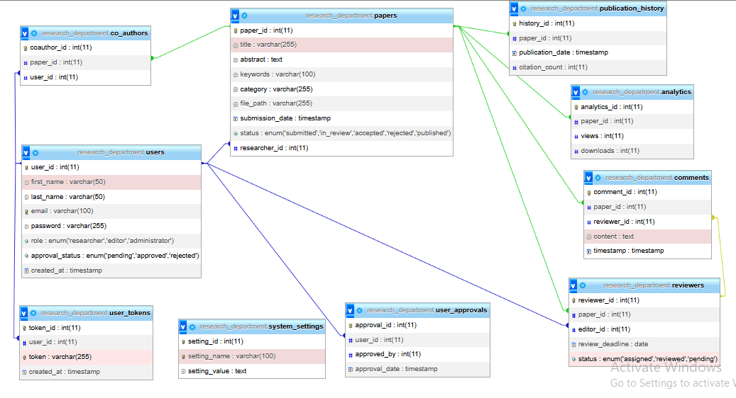

**Figure 1.Database**

The above figure shows the design of database which is the organization of data according to a database model. It divides the information into subject-based tables to reduce the redundant data. This figure provides access with the information it requires to join the information in the tables together as needed.

**Architectural Diagram/ Block Diagram**

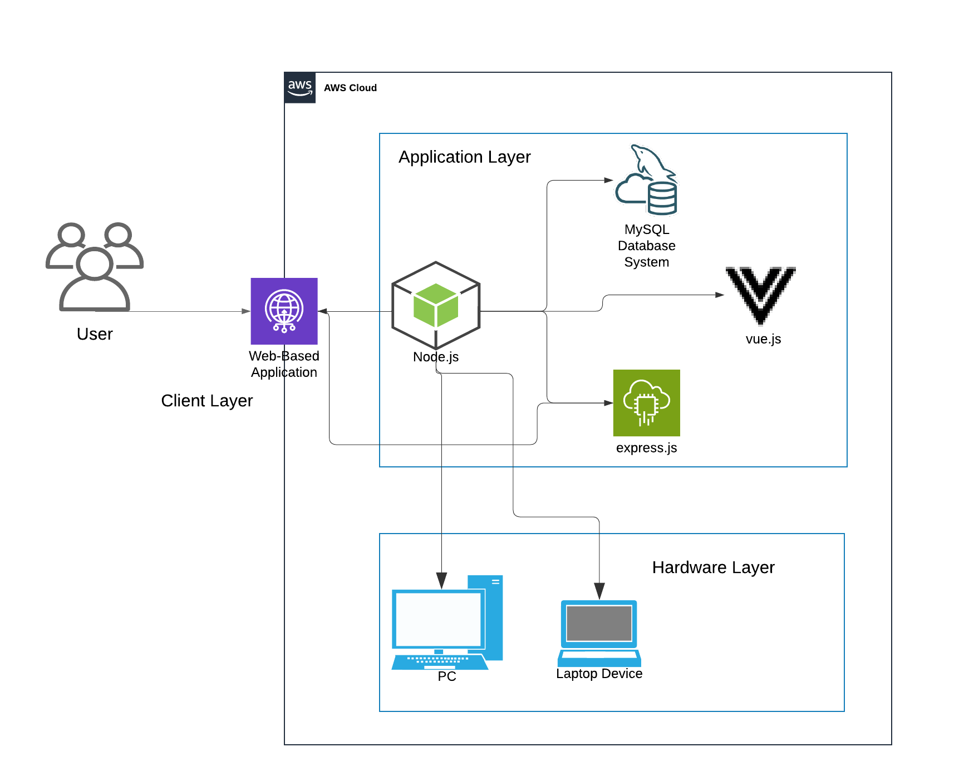

**Figure 2. System Architectural Design of Research Department MinSU – Calapan Campus**

**Figure 2** Illustrates the system architecture of the Research Department website at MinSU – Calapan City Campus, detailing the flow of processes and overall system functionality. Both users and administrators require internet access to interact with the website and perform their respective tasks. Users must first register or log in to access the web portal. Once logged in, users are directed to a dashboard where they can search, upload, and download files. The administrative side has exclusive access to view user information, manage uploaded and submitted files, and oversee the database.

**DFD Level 0**

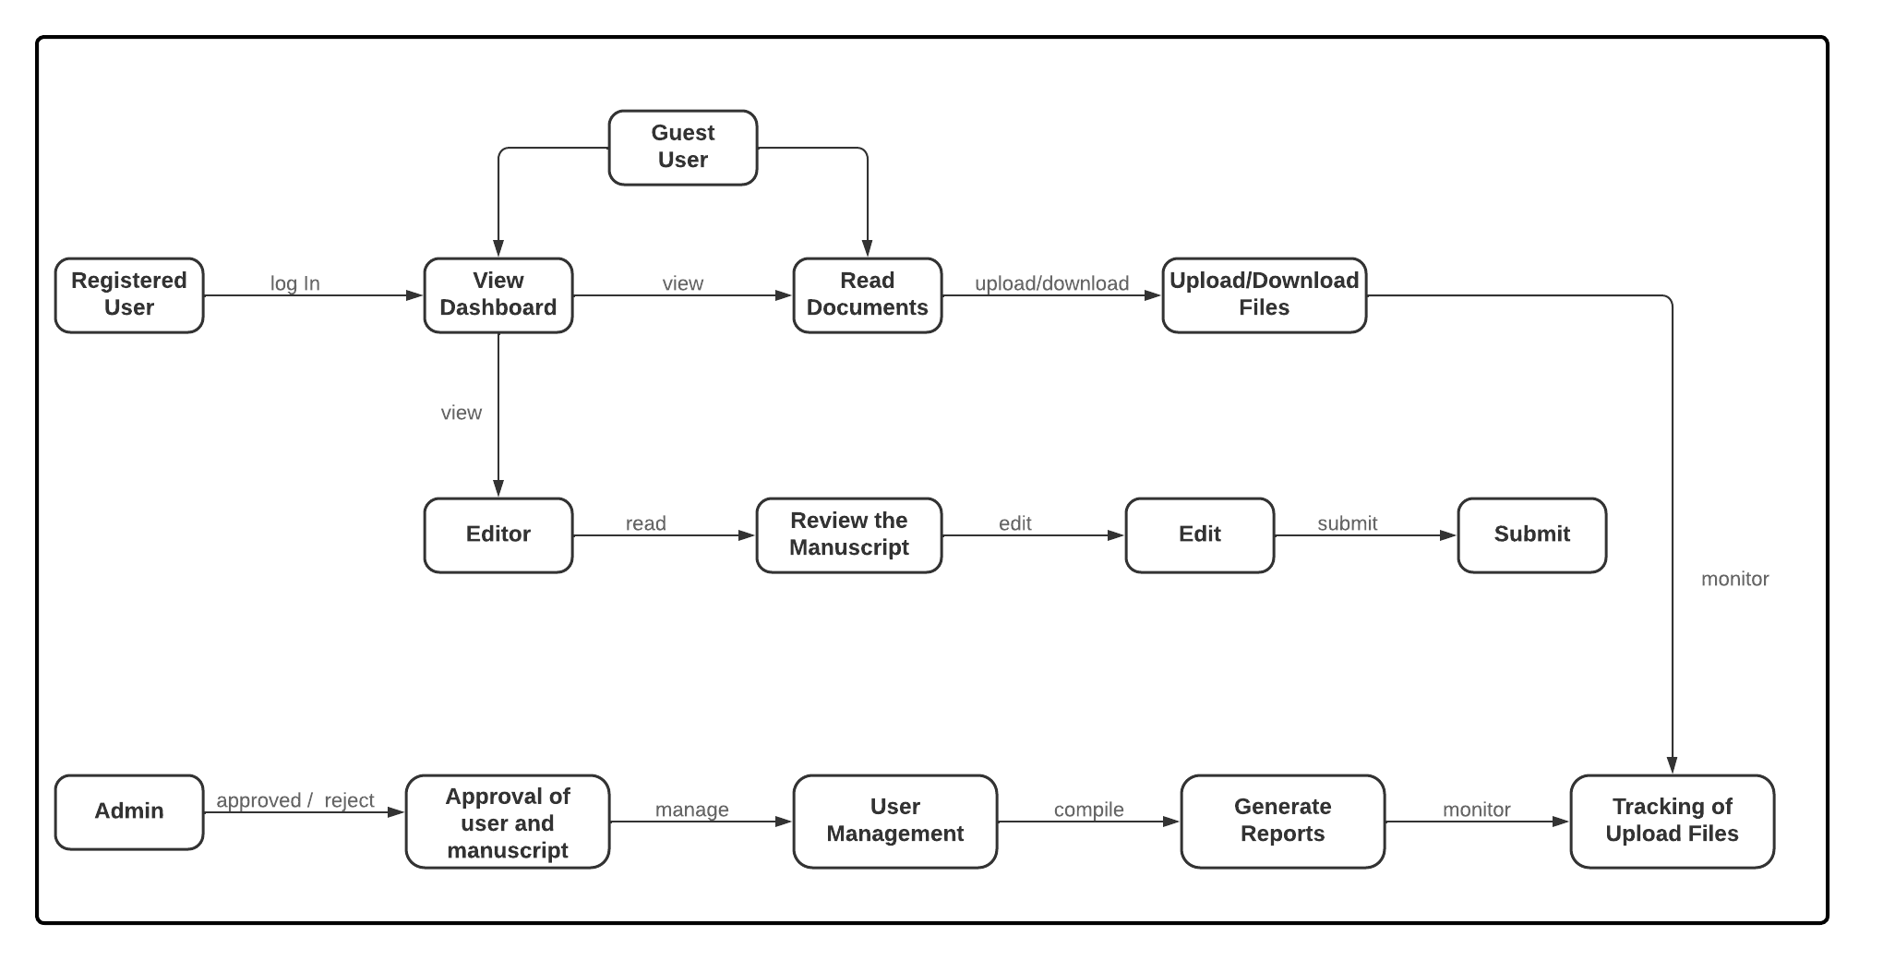

**Figure 3.Data Flow of the Proposed System**

**Figure 3** Illustrates a flowchart outlining the workflow of a system. It showcases the different user roles and their respective permissions. Guest users have limited access, only able to read documents. Registered users have broader functionality, including viewing dashboards, uploading and downloading files, reading documents, and submitting files. Editors specifically review and edit manuscripts. The admin role holds the most extensive permissions, encompassing user and manuscript approval, user management, report generation, and tracking of uploaded files. The flowchart illustrates the system's structure, highlighting how users interact with it and how data flows through its various stages.

**UML Use-case Diagram**

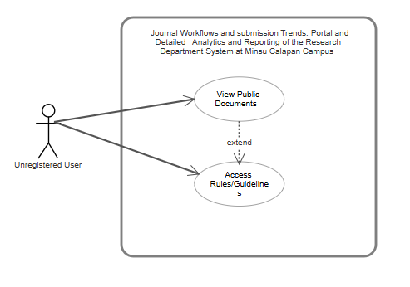

**Figure 4. Use case of Unregistered user**

**Figure 4 illustrates the user-centric view of the website's functionalities, outlining the process flow for accessing public documents and rules/guidelines.**

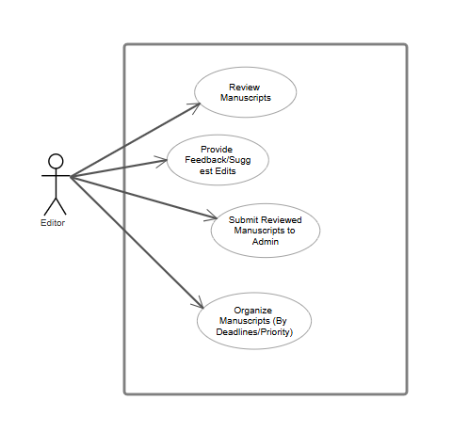

**Figure 5. Use Case of Editor**

The use case diagram depicts the Editor's responsibilities in the manuscript review process, including reviewing manuscripts, providing feedback and suggested edits, submitting reviewed manuscripts to the Admin, and organizing manuscripts based on deadlines or priority.

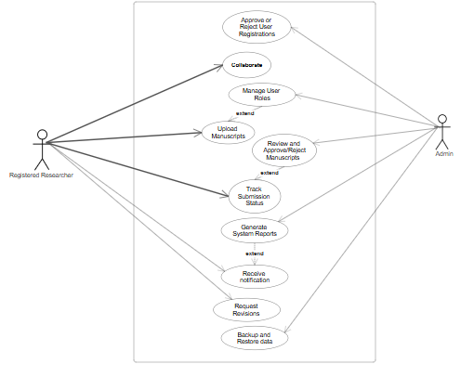

**Figure 6. Use Case of Admin/Register**

The use case diagram depicts the interactions between a Registered Researcher and the Admin within a research manuscript submission and review system.

**Sample Mock-up**

A sample mock-up is a visual representation of a website's design and layout, used to simulate its appearance and functionality before actual development.That the designers and developers can visualize the user experience, identify potential usability issues, and refine the overall design.Ensuring that the final website meets the client's expectations and provides a seamless user experience.



**Figure 7. Homepage**

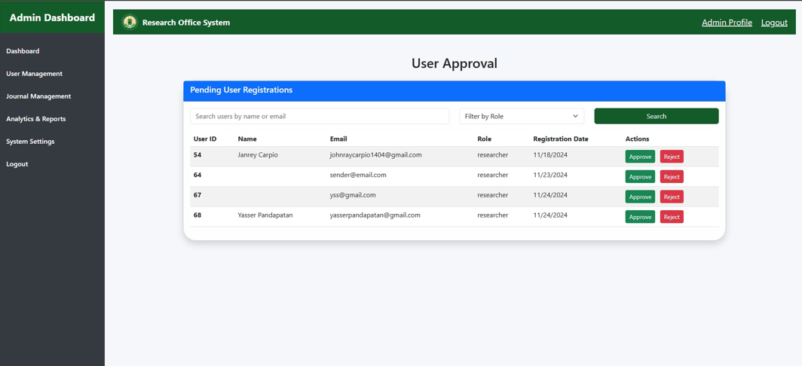

**Figure 8. Admin page**

**Methodology**

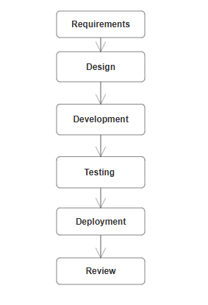

**Figure 9. Agile Model**

Figure 6 shows the future model of the system, Agile method that will guide the research in developing the system. This technique is built on collaborative decision-making between the teams responsible for requirement and those for solutions, as well as a cycle of iterative development that results in usable software. This strategy is more effective and potent make sure that every functional component is given early in the development stage. The agile method makes guarantee that the most important project components are done and delivered firs, so even if time or funding run out, we will still have the essential deliverables finished and operational.

The sequential phases in Agile Model are:

1. **Requirements**

The researcher engages in discussions with the client to identify the primary functions required in the Journal Workflows and Submission Trends: Portal and Detailed Analytics and Reporting of the Research Department System. During these discussions, the researcher carefully documents the client’s suggestions and feedback to ensure that their vision is accurately reflected in the system's design. After collaborating with the client, the researcher begins to map out the key components of the portal. The client provides insights into how the system should operate, including features for tracking manuscript submissions, generating analytics reports, and streamlining workflows. These insights are meticulously noted to guide the system's development. Following the initial discussion, the researcher conducts a detailed study of the specific requirements necessary to develop the proposed system. The client grants the researcher permission to utilize information related to their research processes and workflows, eliminating the need for repeated inquiries. This collaboration ensures that the system aligns with the operational needs of the Research Department at MinSU Calapan Campus while addressing submission trends and enhancing reporting capabilities.

1. **Design**

The researcher meets with the client to review the initial requirements and outline for the Journal Workflows and Submission Trends System. The researcher presents the tentative requirements, sub-requirements, and tools needed for the system, focusing on the system’s core features. As the project is still in the planning phase, discussions on programming languages, frameworks, and other technical details are deferred for later stages.

1. **Development**

After the client approves the plan for developing the Journal Workflows and Submission Trends System, the development phase begins. The team selects an appropriate template and applies it to the chosen framework. They then start adding the required functionalities, such as manuscript submission tracking, analytics, and reporting tools, along with any additional features requested by the client to meet the system’s specific needs.

1. **Testing**

The researcher conducts explanatory testing for the Journal Workflows and Submission Trends System during the testing phase. The testing sessions are recorded so that the researcher can review the footage and identify any errors or areas for improvement. This process helps ensure the system functions as intended, allowing the researcher to fine-tune features like manuscript tracking, analytics, and reporting before final implementation.

1. **Deployment**

Once the Journal Workflows and Submission Trends System is completed, the researcher will deploy the system to the client. The researcher will provide a walkthrough of the system, explaining how it functions, and supervise its operation to ensure there are no bugs and that it runs smoothly. This will transition into the maintenance phase, where the researcher will offer ongoing support to the client, addressing any issues and ensuring the system remains functional over time.

1. **Review**

Once the Journal Workflows and Submission Trends System is completed, the researcher will present a summary of the development process, highlighting the key milestones and features achieved through collaboration with the client. This will include an overview of the system’s functionality, the roles and features integrated, and how the client’s requirements were incorporated into the final product.

**Testing**

1. **Functional Testing**

To verify that all system features work as expected, such as manuscript submissions, status tracking, and reporting tools. This ensures that core functionalities align with client specifications and system requirements.

1. **Usability Testing**

To test the user experience and interface of the system, ensuring it is easy to navigate for users, researchers, admins, and editors. This ensures the system is intuitive and

user-friendly, which is essential for user adoption and efficiency.

1. **Performance Testing**

To assess how well the system handles multiple users and large volumes of data, including manuscript uploads and analytics generation. This ensures that the system remains stable and responsive under load, preventing performance issues during peak usage.

1. **Security Testing**

To evaluate the security features of the system, ensuring that sensitive data, like manuscript content and user information, is protected from unauthorized access. This is important to protect user privacy and comply with security standards.

1. **Compatibility Testing**

To test the system across different browsers, devices, and operating systems. This ensures the system provides a consistent experience for all users, regardless of their preferred platform.

1. **Acceptance Testing**

To verify that the system meets the client's requirements and expectations, and is ready for deployment. This confirms that the system is fully aligned with the client’s vision and needs before going live.

**DDS**

**DESIGN DOCUMENT SPECIFICATION**

 **Figure 10.1 Log in page**

Figure 10.1 shows the Mindoro State University login page is a web page that requires users to input their email address and password to access the university's online portal.

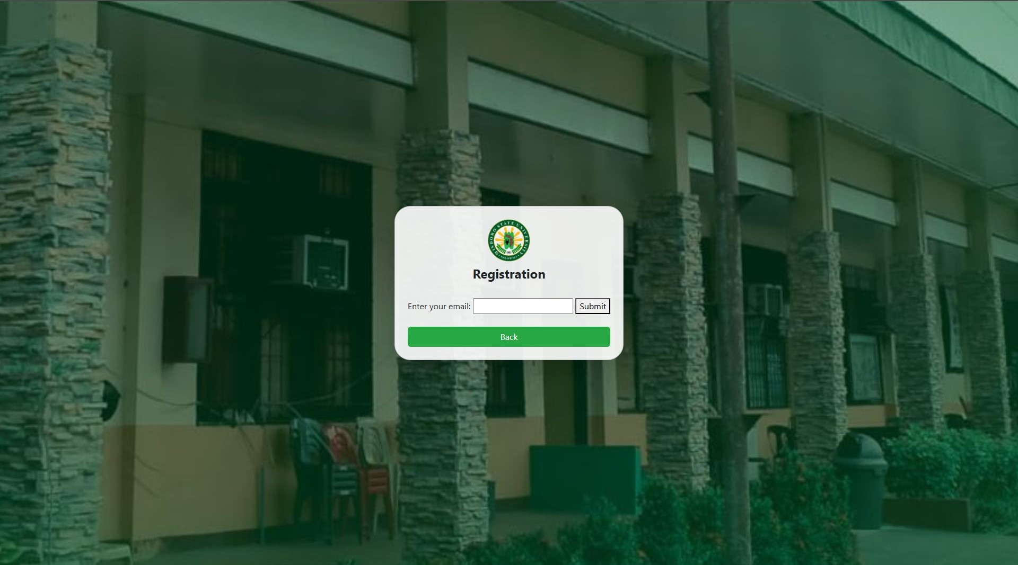

**Figure 10.2 Registration page**

In figure 10.2 shows, that requires users to enter their email address and submit it to proceed with the registration process.



**Figure 10.3 Homepage**

Figure 10.3 shows the Mindoro State University Research Portal homepage welcomes visitors and provides information about its purpose, links to research resources, and researcher testimonials.



**Figure 10.4 Admin page**

In figure 10.4 shows the page allows administrators to review and approve/reject pending user registrations, search users, and filter by role.

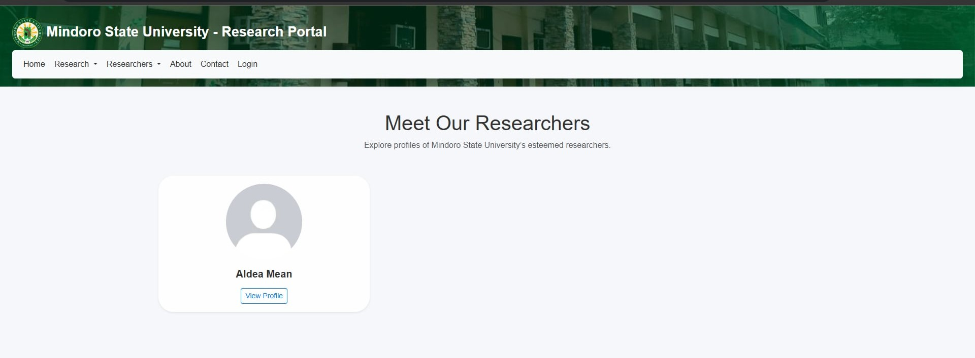

**Figure 10.5 Researcher profile page**

Figure 10.5 shows it displays a profile of a researcher name, with an option to view their full profile.

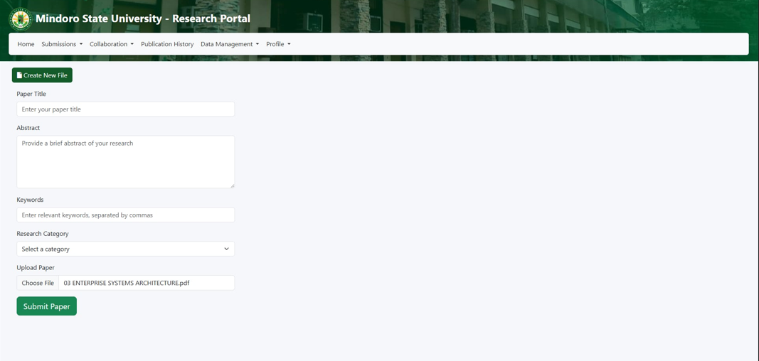

**Figure 10.6 Submit page**

In figure 10.6 shows that allows researchers to submit new research papers by providing fields for the paper title, abstract, keywords, research category, and file upload. Upon completion, researchers can submit the paper for review and potential publication.

**Figure 10.7 Research paper page**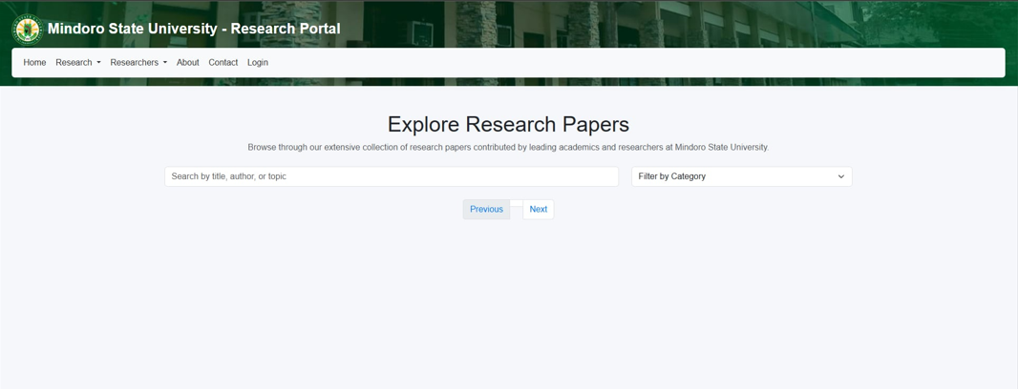

Figure 10.7 shows that it allows users to browse through a collection of research papers contributed by leading academics and researchers at the university. Users can search for papers by title, author, or topic, and filter by category**.**

**CHAPTER IV**

**DEVELOPMENT, TESTING AND EVALUATION RESULT**

**Presentation of the System Output**



**Figure 11.1 Login page**

Figure 11.1 shows the Mindoro State University login page is a web page that requires users to input their email address and password to access the university's online portal.



**Figure 11.2 Registration page**

In figure 11.2 shows, that requires users to enter their email address and submit it to proceed with the registration process.



**Figure 11.3 Homepage**

Figure 11.3 shows the Mindoro State University Research Portal homepage welcomes visitors and provides information about its purpose, links to research resources, and researcher testimonials.



**Figure 11.4 Admin page**

In figure 11.4 shows the page allows administrators to review and approve/reject pending user registrations, search users, and filter by role.



**Figure 11.5 Researcher Profile page**

Figure 11.5 shows it displays a profile of a researcher name, with an option to view their full profile.



**Figure 11.6 Submit page**

In figure 11.6 shows that allows researchers to submit new research papers by providing fields for the paper title, abstract, keywords, research category, and file upload. Upon completion, researchers can submit the paper for review and potential publication.



**Figure 11.7 Researcher profile page**

Figure 11.7 shows that it allows users to browse through a collection of research papers contributed by leading academics and researchers at the university. Users can search for papers by title, author, or topic, and filter by category**.**

**Testing Results**

**ISO 25010 Evaluation Result**

**CHAPTER V**

**CONCLUSION AND RECOMMENDATION**

**Conclusion**

**Recommendation**

**REFERENCES**

**APPENDICES**

**Sample Accomplished ISO 25010 Evaluation Form**

**Picture During Development, Testing & Evaluation**