Imagem escolhida:

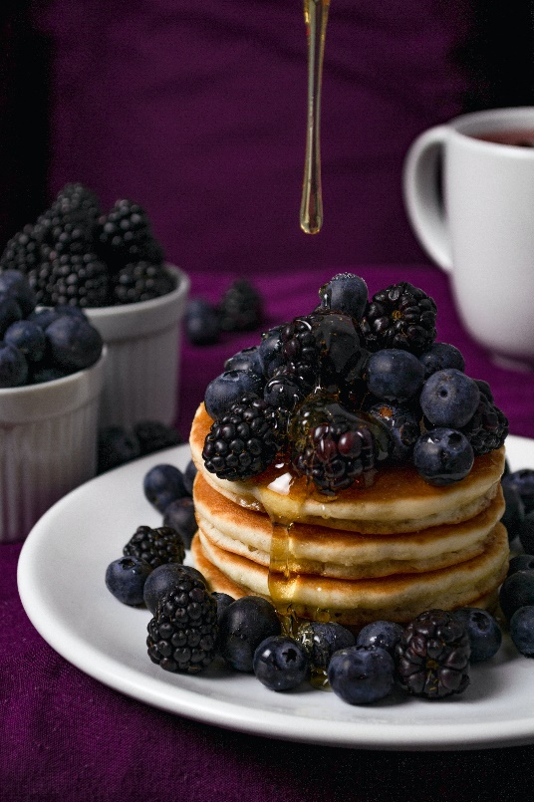

Palheta de cores:

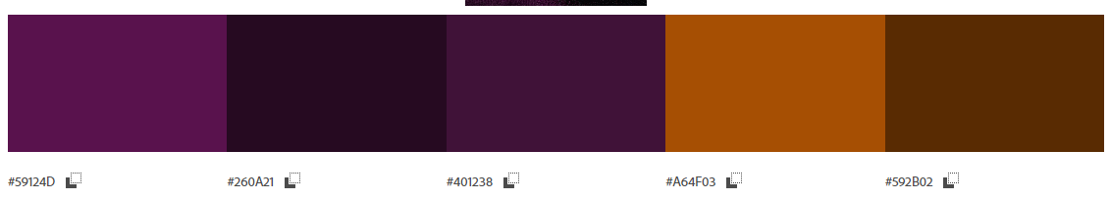

Fonte:

TESTE DE FONTE

Teste de fonte

<link rel="preconnect" href="https://fonts.googleapis.com">  
<link rel="preconnect" href="https://fonts.gstatic.com" crossorigin>  
<link href="https://fonts.googleapis.com/css2?family=**Bebas+Neue**&display=swap" rel="stylesheet">