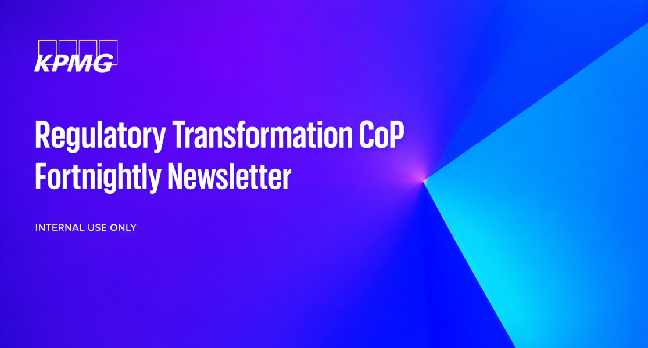

KPMG Regulatory Transformation Fortnightly Brief — 20 May – 2 June 2026
Regulatory Transformation Community of Practice — Fortnightly Brief
02 June 2026
Key messages from Adam
[edit before send] — Adam's 3-sentence key messages will prefill from the dashboard synthesis on the next fortnightly run. Type your replacement here.
Regulators in the news (this fortnight)
No regulator-in-news signal this fortnight — see Themes below.
Our clients in the news
No client-in-news signal this fortnight across any jurisdiction.
Regulatory Transformation: navigating emerging risks, driving AI adoption and reducing regulatory burden
Regulators are facing a shifting operating environment as technology, markets, environmental pressures and societal expectations evolve faster than traditional regulatory frameworks. Fragmented data and limited intelligence continue to make risk prioritisation difficult.
There is a growing opportunity to use advanced analytics to better target regulatory effort. Many regulators are still working to integrate data across systems, uplift analytical capability and embed insights into everyday decision-making.
AI adoption is also becoming a core regulatory transformation issue. Regulators are seeking to balance opportunities for automation and improved risk identification with the need to manage governance, transparency, bias, legal risk, privacy and public confidence.
At the same time, governments are under pressure to reduce red tape, make faster decisions and manage fiscal constraints. This is driving interest in regulatory consolidation, shared-service models and more consistent approaches to regulatory delivery, while maintaining fairness and strong outcomes.
Emerging risks
No emerging risks signal this fortnight.
AI adoption
No ai adoption signal this fortnight.
Regulatory burden
No regulatory burden signal this fortnight.
Training, conferences, webinars & in-person sessions
- VIC Cyber Regulator Industry Briefing — 04 Jun 2026 — Office of the Victorian Information Commissioner · Melbourne
- APRA Financial Risk & Resilience Practitioners Roundtable — Q3 — 12 Jun 2026 — APRA · Online
- 2026 AFR Insurance Summit — 16 Jun 2026 — APRA · Online (Register)
- ABA Banking Conference — 17 Jun 2026 — APRA · Online (Register)
- AFIA Risk Summit — 24 Jun 2026 — APRA · Online (Register)
- ACCC Compliance & Enforcement Forum — 26 Jun 2026 — ACCC · Melbourne
 | Adam Mason-Jefferies  Director  Regulatory Transformation Community of Practice
For internal use only.
© 2026 KPMG, an Australian partnership and a member firm of the KPMG global organisation of independent member firms affiliated with KPMG International Limited, a private English company limited by guarantee. All rights reserved.

