NASA: Dataset Analysis
Meteorite & Bolide Terrestrial Landings
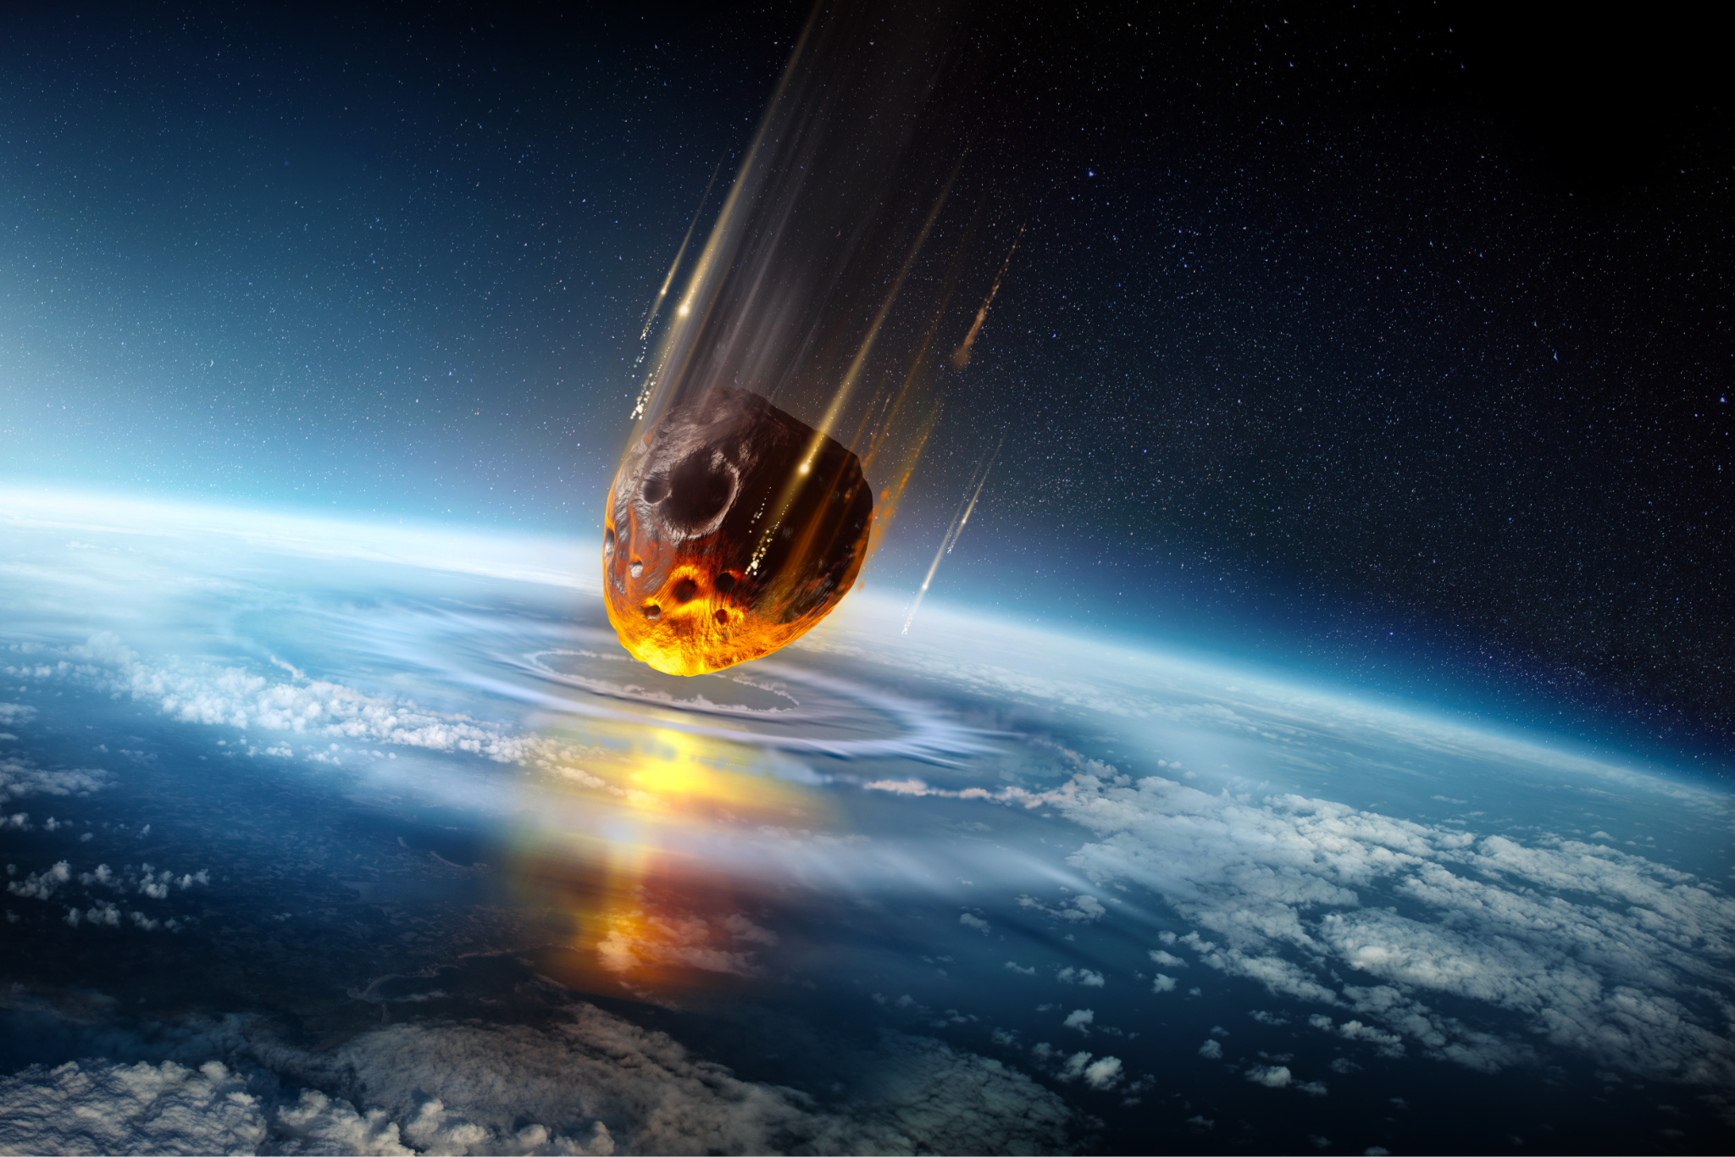
Jaral Arroyo-Jefferson
Period 2
Applied Data Science
Table Of Contents

Background 2
Introduction 2
Dataset Cleaning and Combination 4
Exploratory Data Analysis (EDA): 5
DF2 15
Findings 23
Concluding Thoughts 24
References 24

Background
A meteorite is a fragment of a meteoroid or asteroid that has survived its passage through the Earth's atmosphere and landed on the Earth's surface. Meteoroids are small rocky or metallic bodies in outer space, and when they enter the Earth's atmosphere, they are referred to as meteors or shooting stars. If a meteoroid survives its fiery passage through the atmosphere and lands on Earth, the remaining fragment is called a meteorite.
A bolide or fireball is a bright, exceptionally large meteor that often explodes in the Earth's atmosphere. These events are caused by the entry of a meteoroid or asteroid into the Earth's atmosphere, where it rapidly heats up due to friction with the air. The intense heat causes the object to glow and become visible as a streak of light in the sky.

Introduction
In the vast field of aerospace engineering and space sciences, the exploration of celestial phenomena remains a source of fascination and inquiry. Using the power of data science, this report delves into two compelling datasets sourced from NASA's Open Data Portal: "Meteorite Landings" and "Fireball and Bolide Reports." As an enthusiast of aerospace engineering and space sciences, my aim is to unravel patterns, glean insights, and contribute to a deeper understanding of extraterrestrial events through a data-driven lens.
Meteorite Dataset (DF2)
The Meteorite Landings dataset contains a collection of key attributes, each offering a unique perspective on the celestial visitors. The measured elements include the name, ID, nametype, recclass, mass (g), fall, year, reclat, reclong, and GeoLocation. These parameters collectively provide an understanding of the nature, magnitude, and temporal aspects of these extraordinary events.
• Name: A meteorite's unique identification number that acts as a distinguishing label during our exploration.
• ID: Numerical identification that makes the dataset easier to organize and refer to in a methodical manner.
• Nametype: A designation that indicates the type of meteorite and offers information on classification guidelines.
• Recclass: A description of the meteorite's properties and makeup that advances our knowledge of its formation.
• Mass (g): The meteorite's mass expressed in grams; this is a crucial quantity for determining the size and probable effect of these space visitors.
• Fall: A meteorite's ability to fall may provide information about how it entered Earth's atmosphere and its dynamics.
• Year: Time-related data that shows the exact sequence in which meteorite landings have occurred; this is important for identifying patterns and trends.
• Reclat and Reclong: Geographic coordinates that allow for easier spatial analysis by determining the exact latitude and longitude of each landing.
• GeoLocation: A distilled form of geographic coordinates that captures the spirit of the place on Earth where these space travelers settled.

Bolide Dataset (DF1)
The Fireball and Bolide Reports dataset provides a chronological data summary of events observed by U.S. Government sensors and does not contain all bolides but rather some of the brightest.

• Date/Time - Peak Brightness (UT): The temporal anchor for each event, capturing the precise moment when these celestial luminaries reach their peak brightness in Coordinated Universal Time (UT).
• Latitude (Deg) and Longitude (Deg): Geographical coordinates pinpointing the location of each observed event.
• Altitude (km): The height above Earth's surface at which these fireballs and bolides manifest, offering insights into their atmospheric trajectories.
• Velocity (km/s): The speed at which these cosmic wanderers traverse the heavens, a crucial parameter for understanding their dynamic interactions.
• Velocity Components (km/s): vx, vy, vz: The vector components of velocity, providing a nuanced perspective on the directional dynamics of these celestial entities.
• Total Radiated Energy (J): Quantification of the energy radiated during these luminous displays, offering a glimpse into the scale of their cosmic pyrotechnics.
• Calculated Total Impact Energy (kt): An estimation of the total impact energy, providing context for the potential consequences of these celestial visitors.

Dataset Cleaning and Combination
After importing both datasets into a Google Colab document, data cleaning and preparation for analysis were necessary.
The initial focus was on DF1. Identifying columns with missing values, I filled these gaps with 'NA.' Subsequently, a new column named 'Type' was introduced, with all values set as 'Fireball/Bolide.' This classification aids in distinguishing between entries related to bolides and meteorites. Additionally, a 'GeoLocation' column was appended, utilizing the latitude and longitude values to establish a commonality between the two datasets. To ensure accurate temporal analysis, the 'Date/Time - Peak Brightness (UT)' column was converted to a datetime format. In the case of DF1, cardinal directions present in the latitude and longitude columns were either converted or removed. Specifically, North and East were removed to signify positivity. At the same time, South and West were replaced with negatives and repositioned at the front to indicate negativity, thus facilitating the extraction of numerical values from these geographic coordinates.
Next, I moved onto DF2. Similarly to my process for Df1 I began with filling all missing values with ‘NA’. I then added a Type column to show these rows correspond to Meteorites. Lastly, I converted all columns containing numerical values into integers or floats rather than their original object type.
Finally, I got the point of combining the two datasets into one. In order to merge two datasets into one (DF), I performed an outer merge. This outer merge used the columns GeoLocation, Type, Latitude, and Longitude because they are present in both datasets.

Exploratory Data Analysis (EDA):
At this point, the analysis of the datasets began. The way I divided the analysis is by analyzing DF1 & DF2 individually and then analyzing the combined dataset DF.
DF1
- Frequency of Bolide Appearances Over Time
- 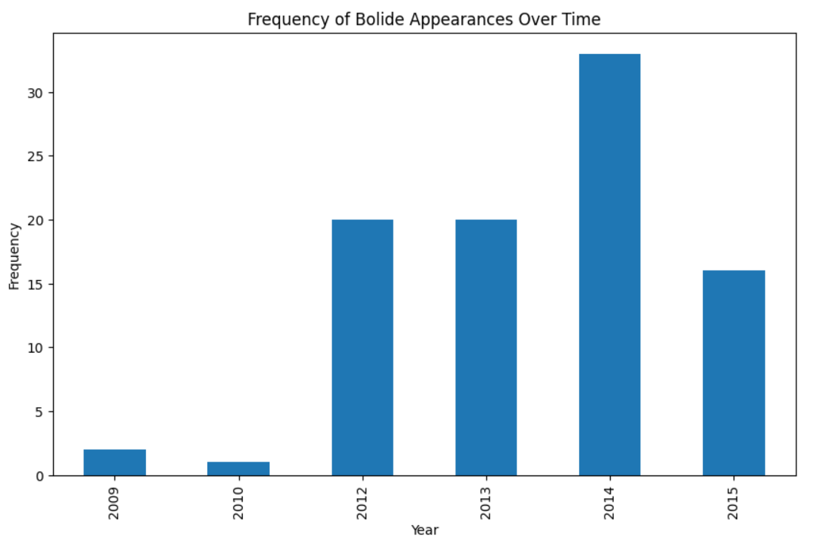
- Velocity Component Comparisons
- 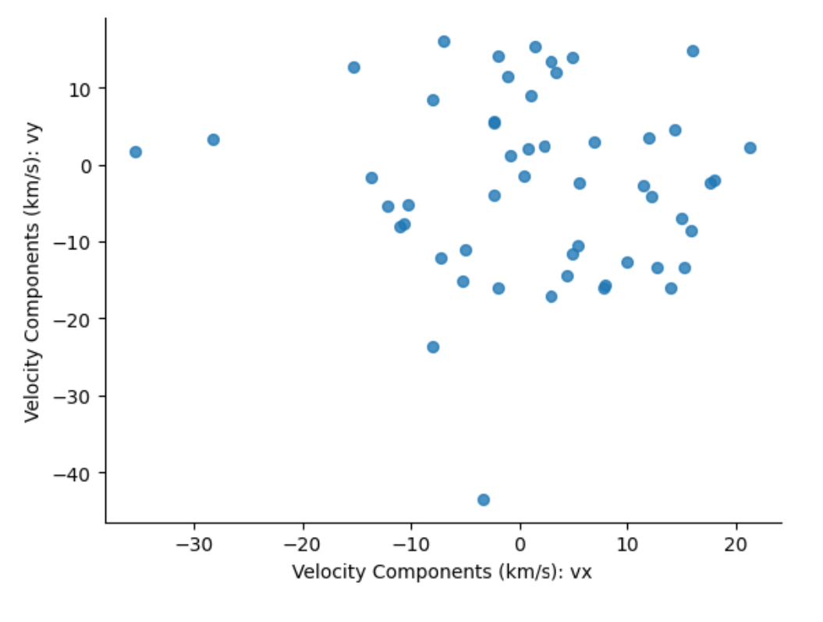
- 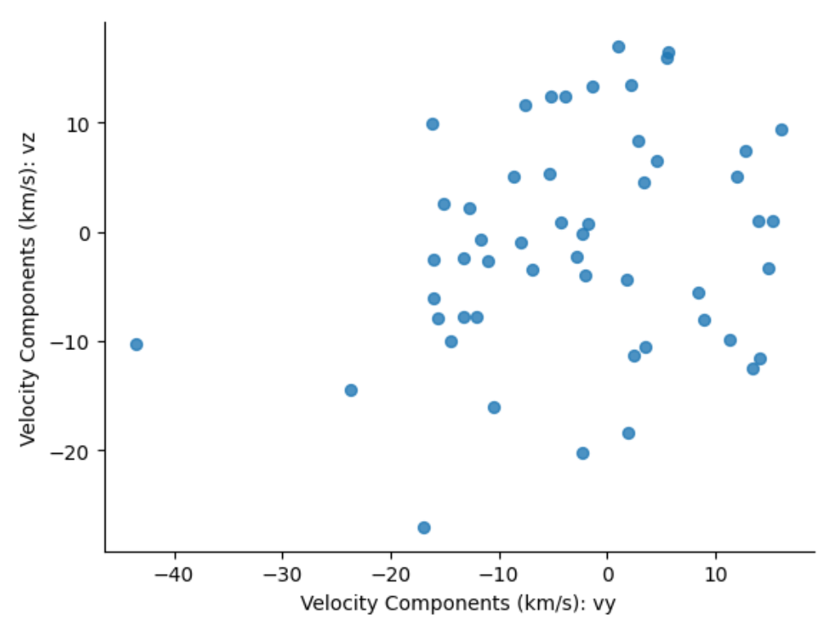
- 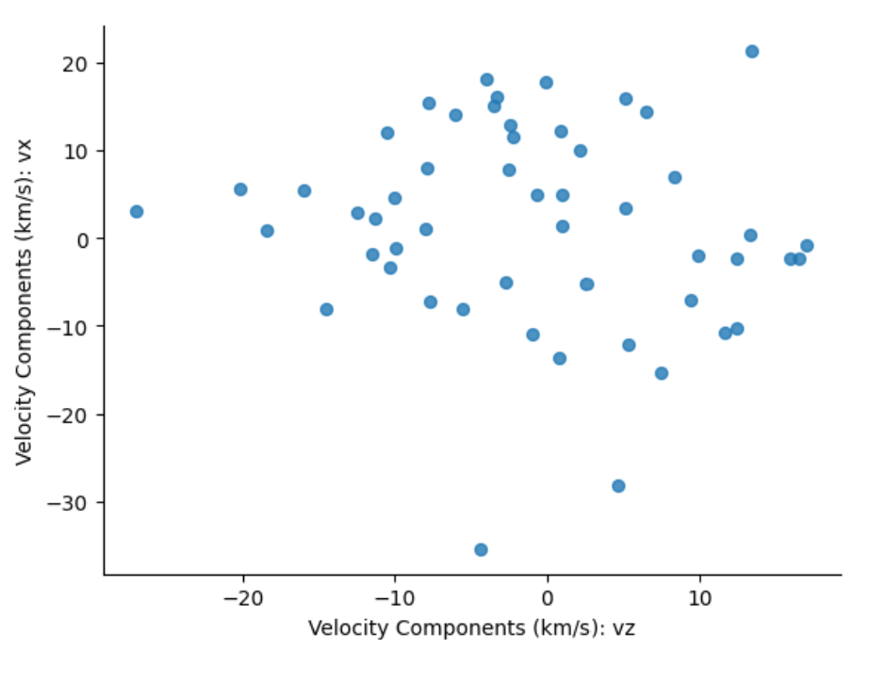
- Velocity Component Frequency
- 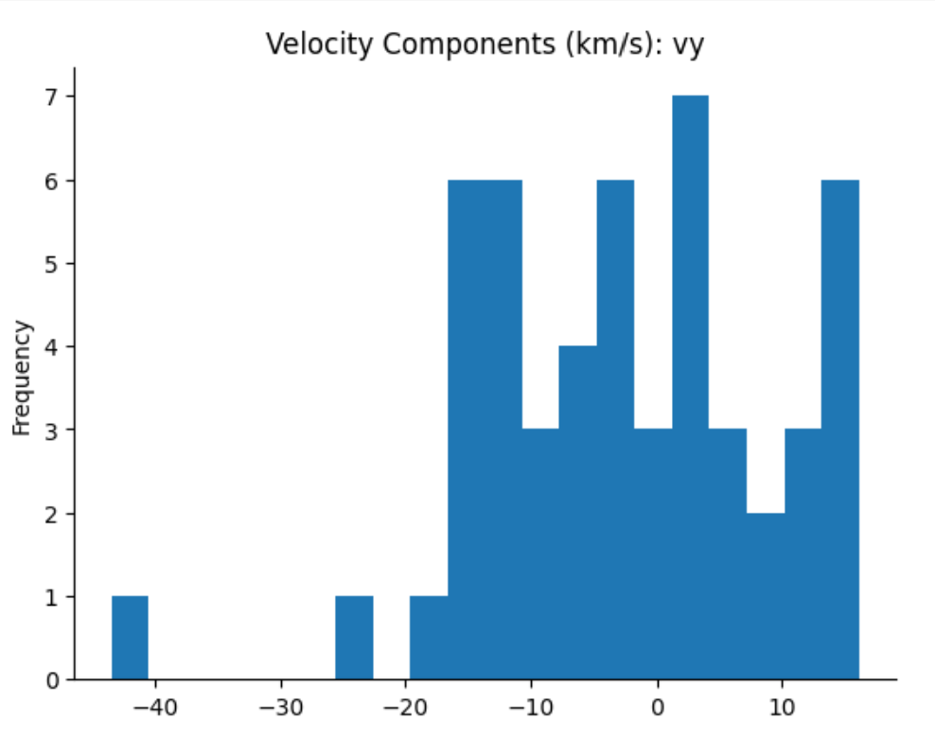
- 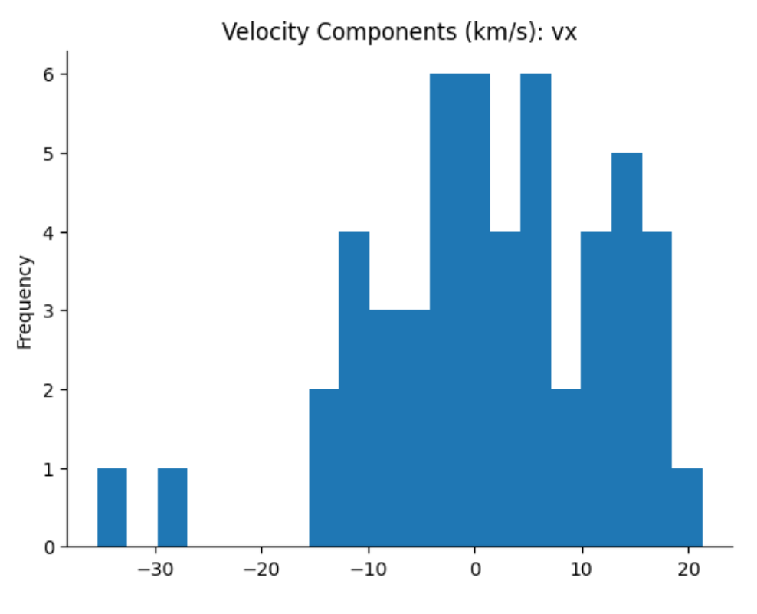
- 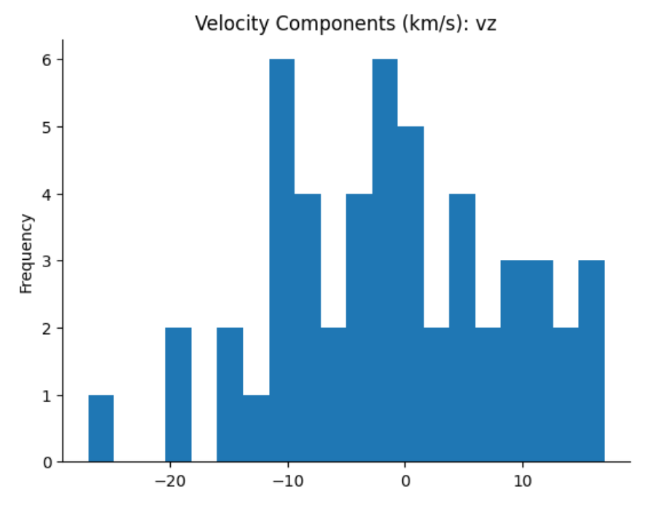
- 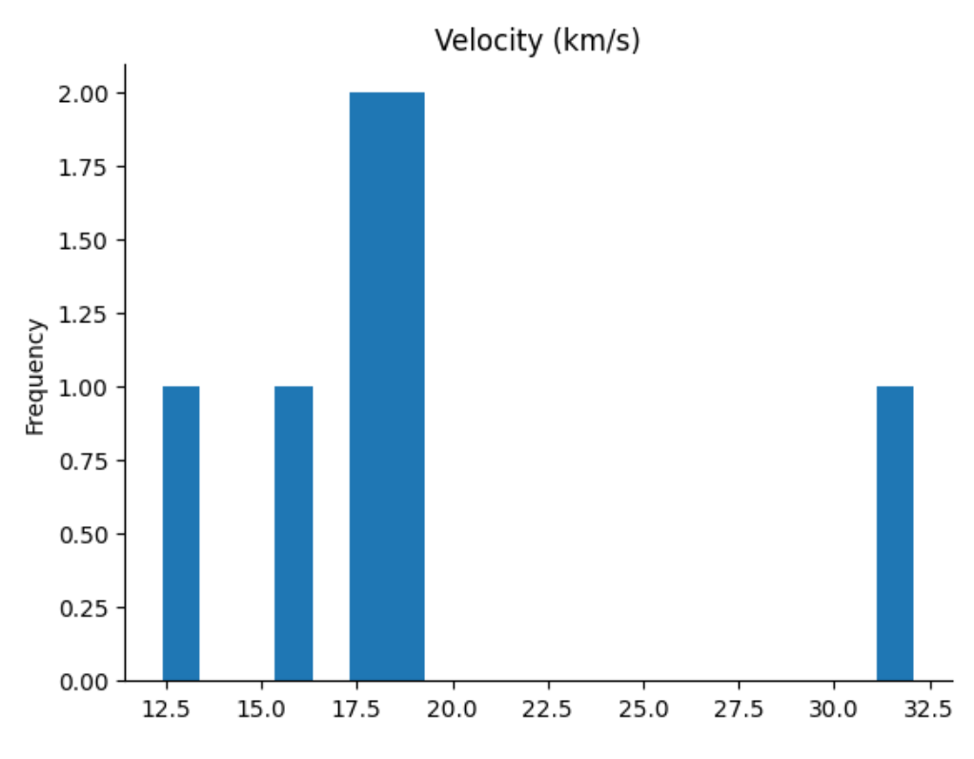
- Altitude Frequency
- 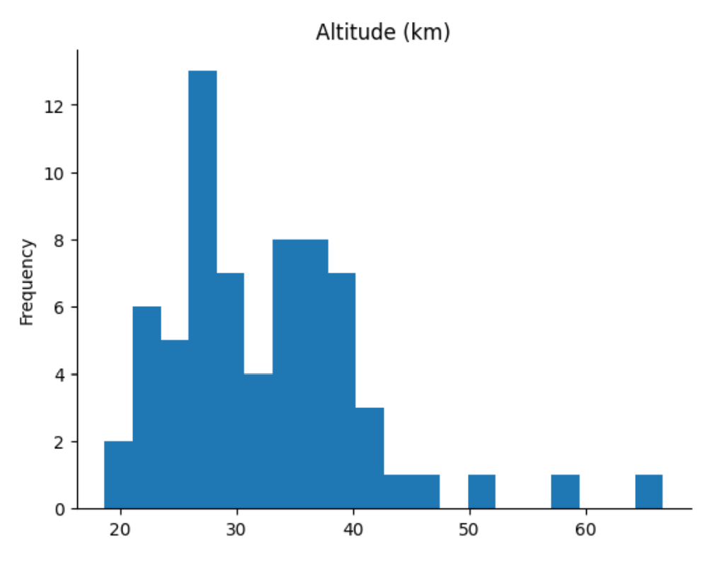
- 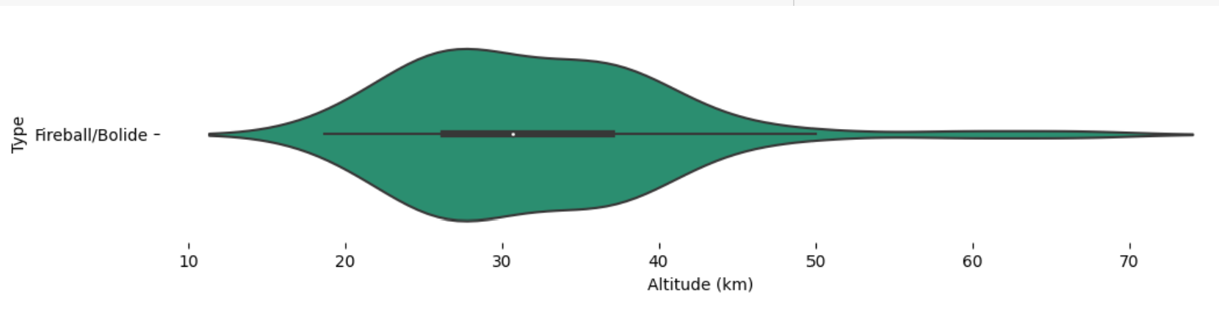
- Energy Correlations
- 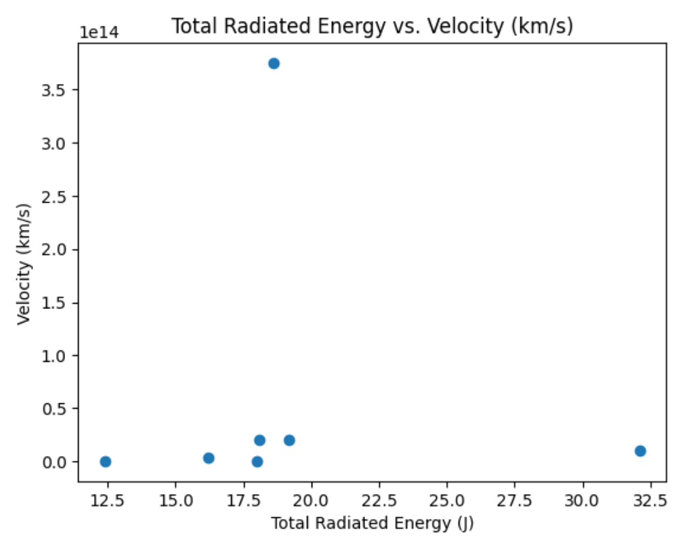
- 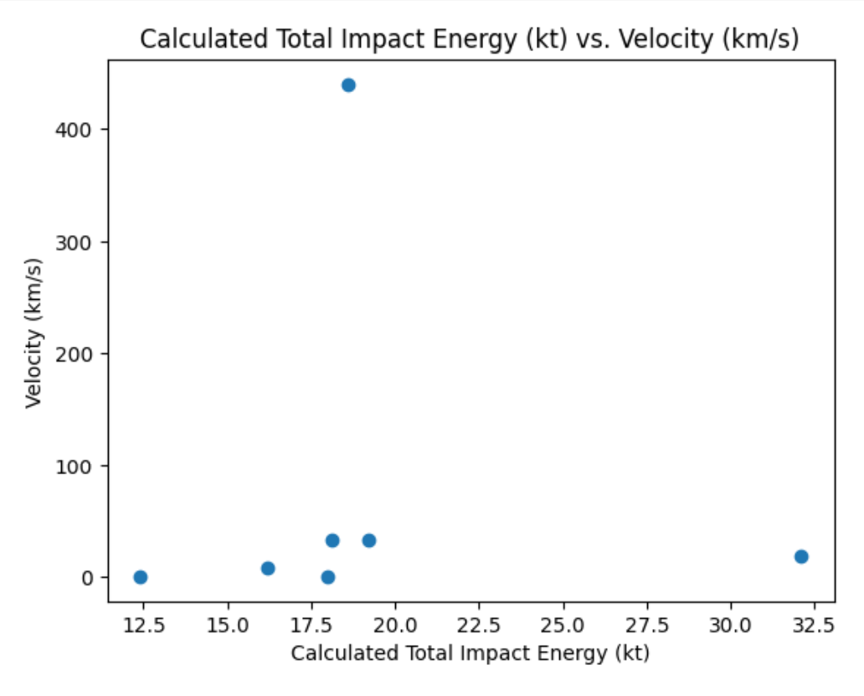
- 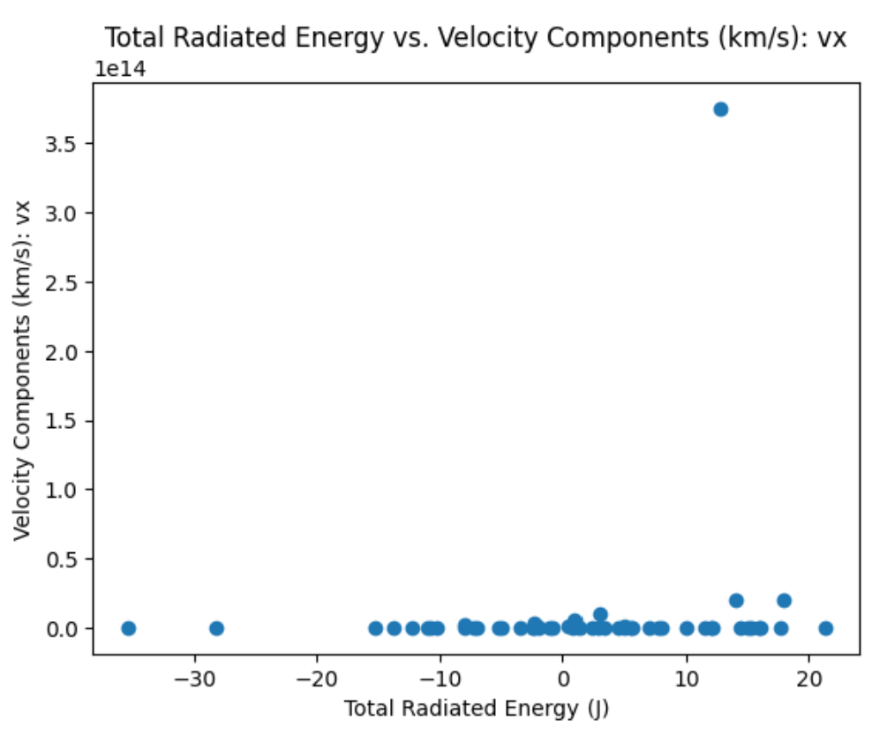
- 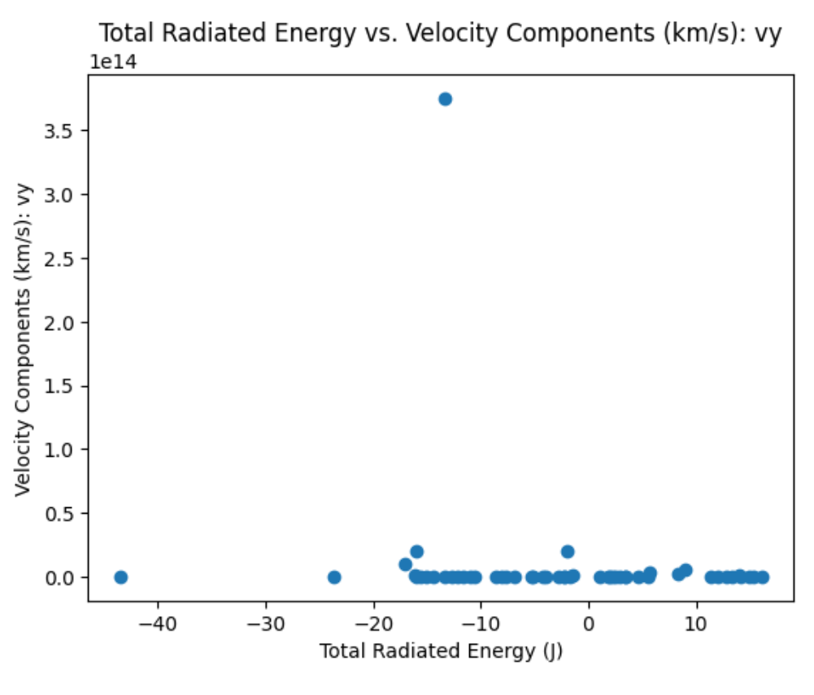
- 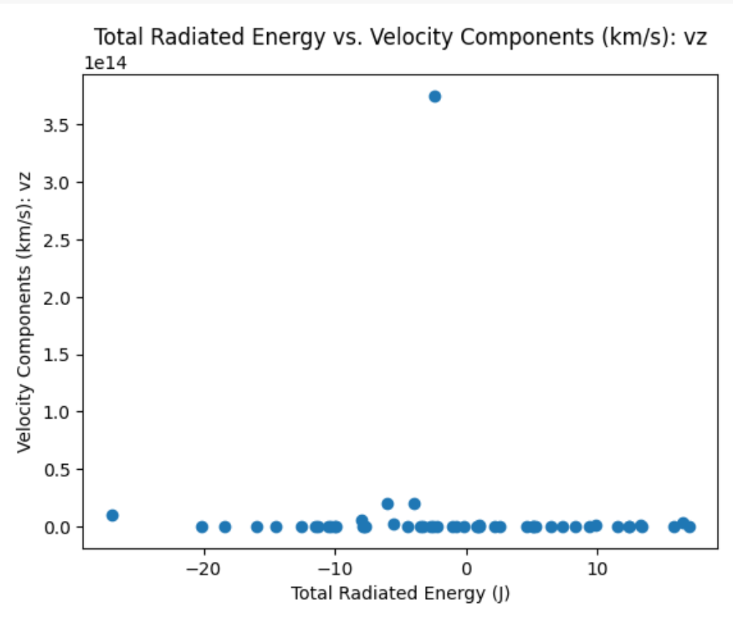
- 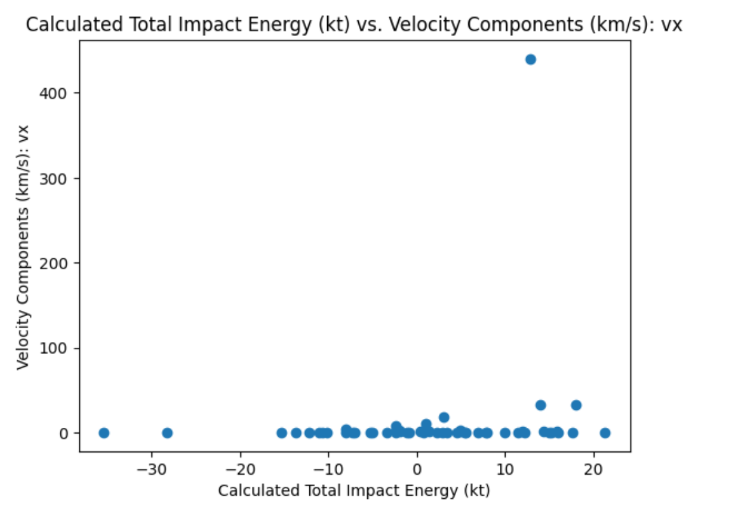
- 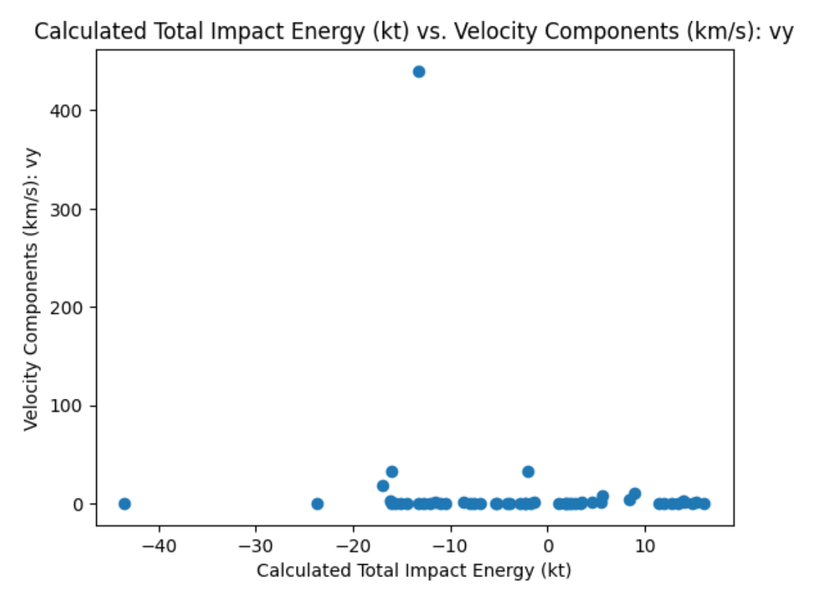
- 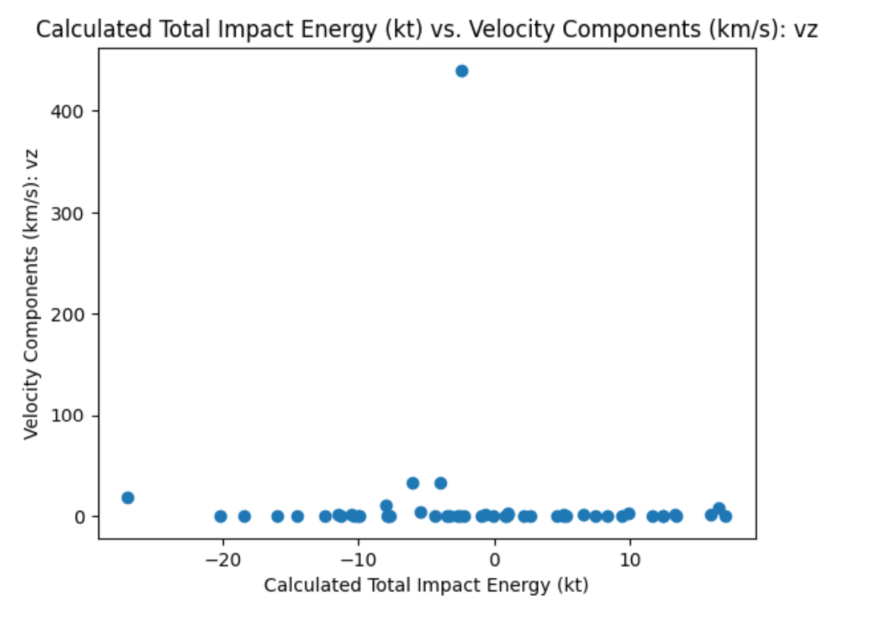
- 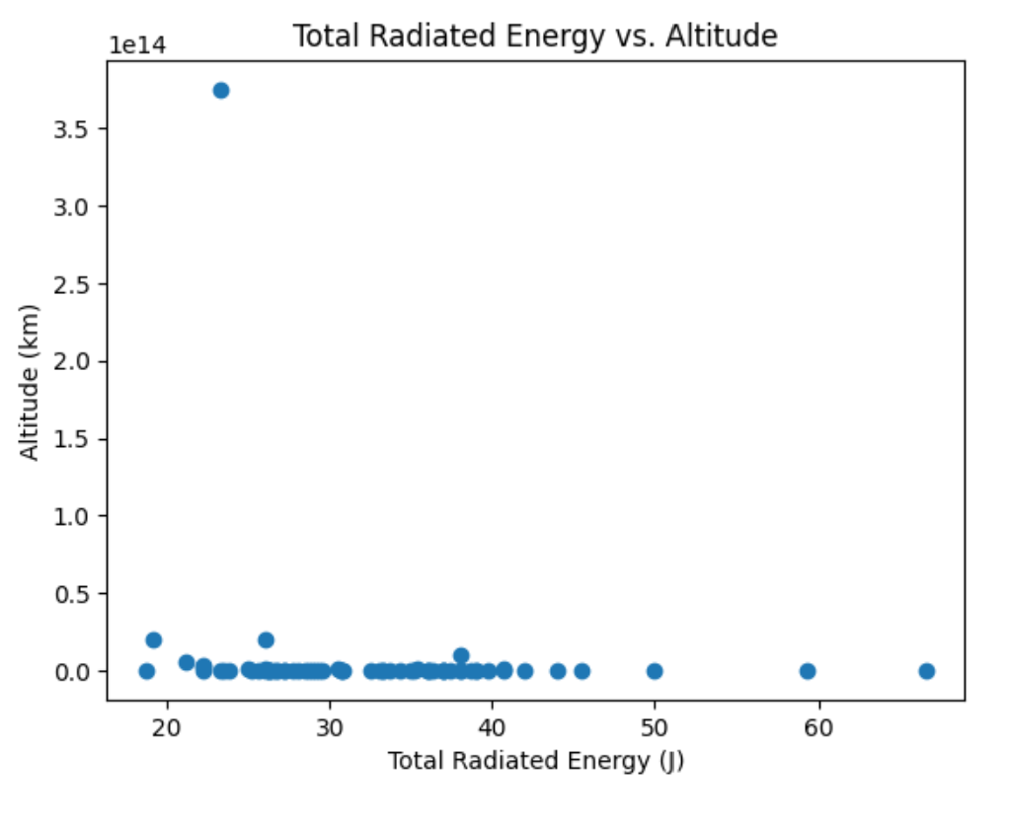
- 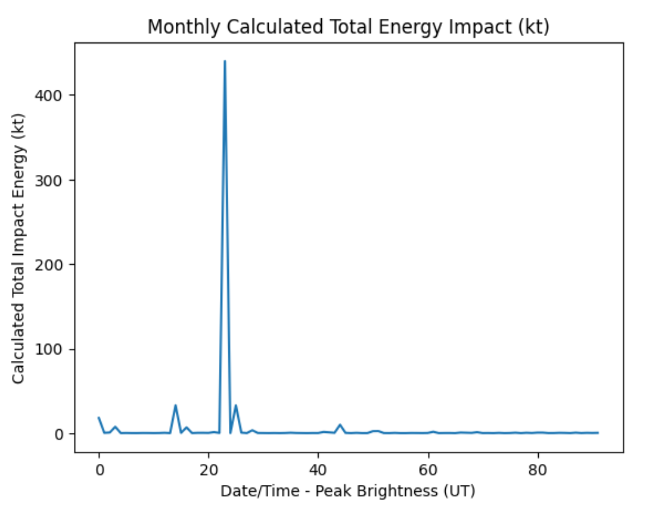
- 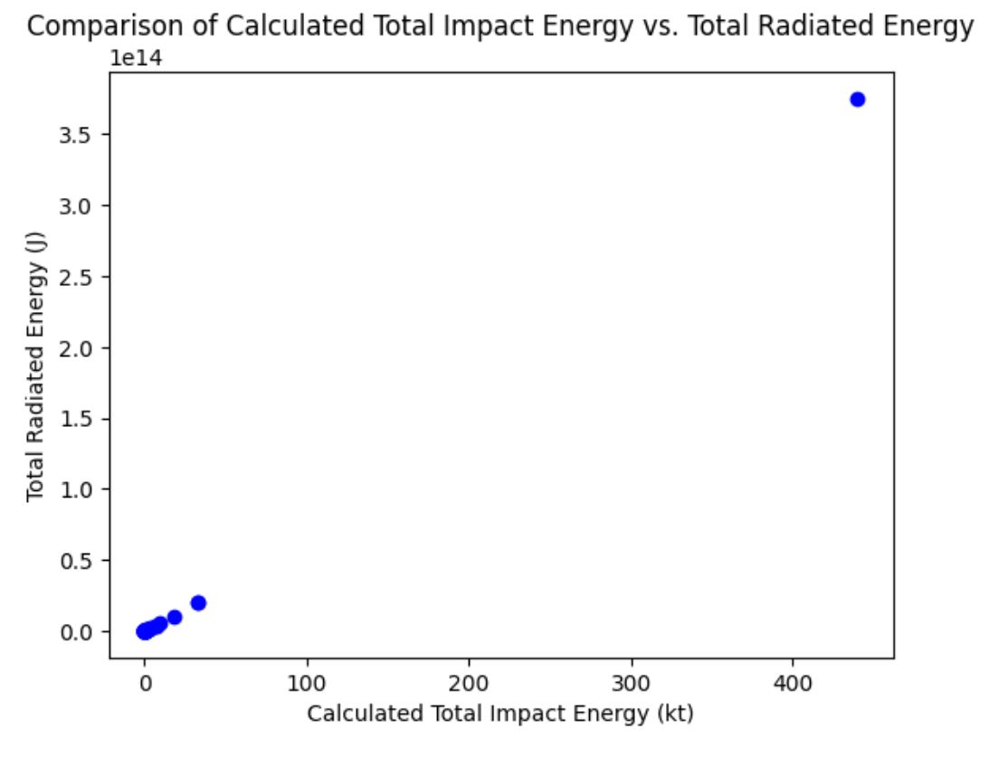
- Map of Bolide Sighting Locations
- 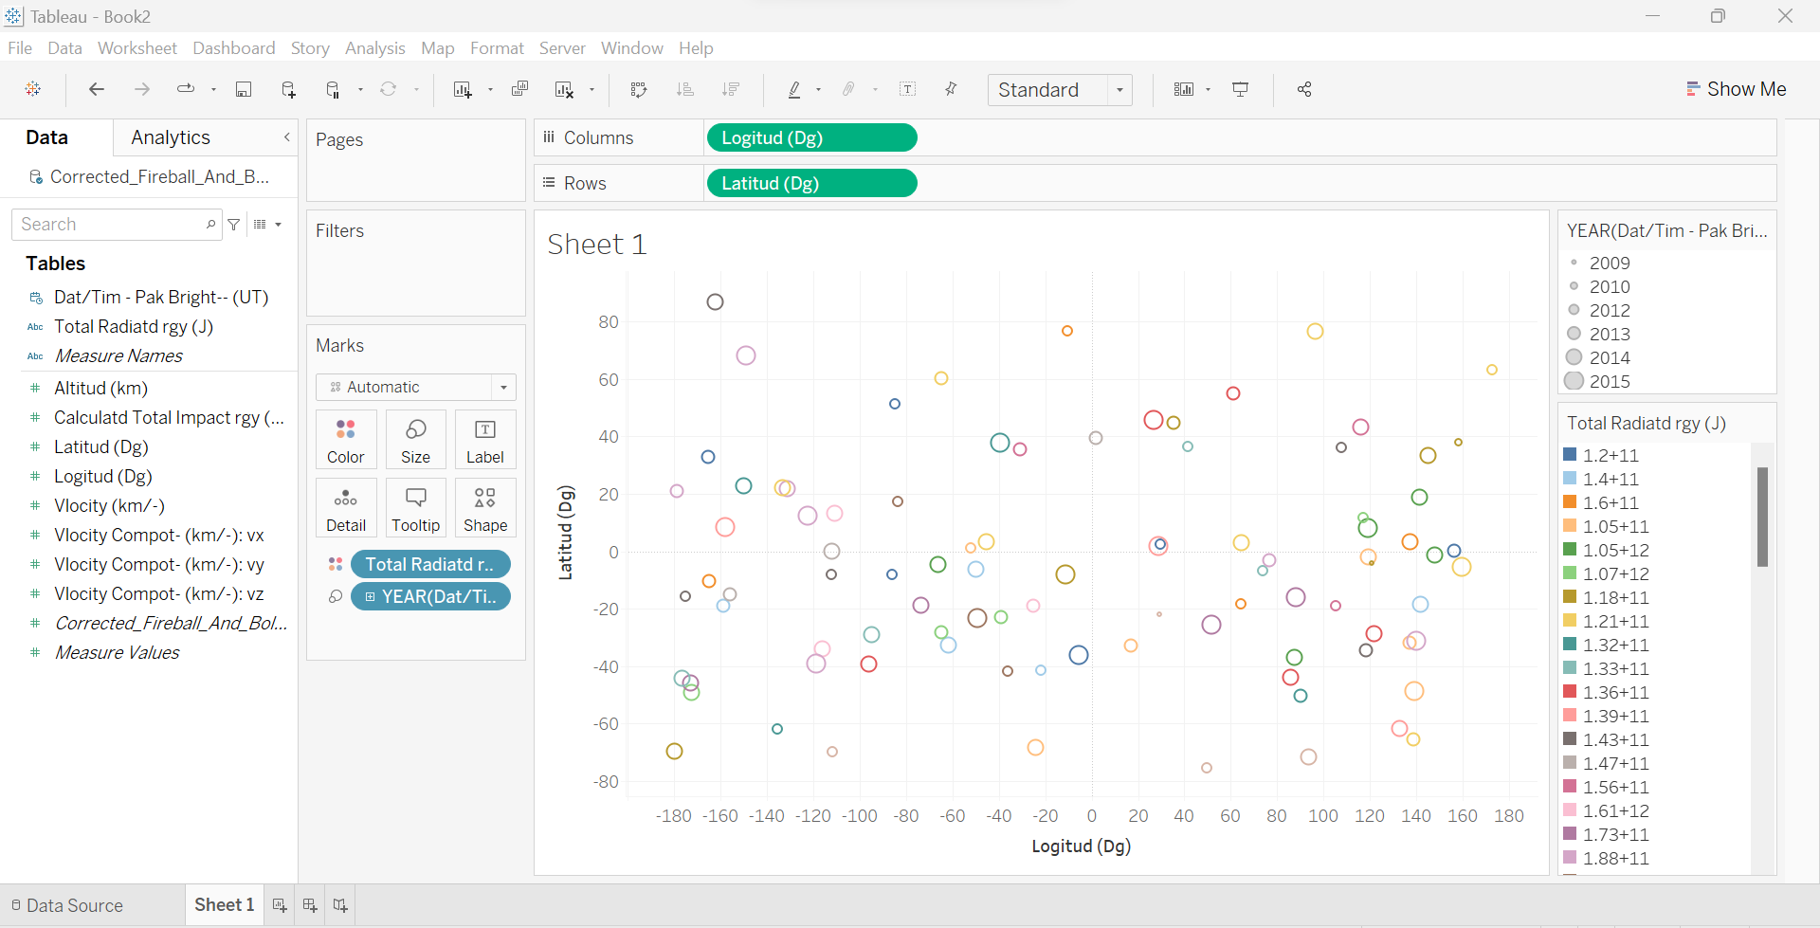

DF2
- Mass Averages
- 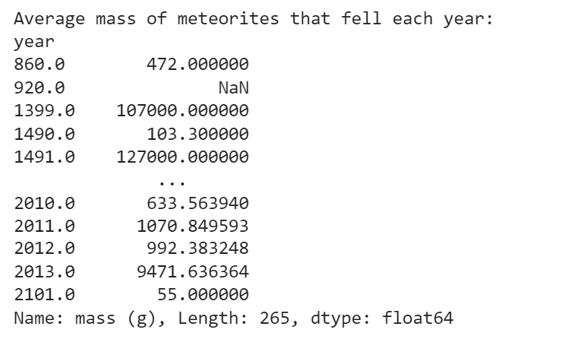
- 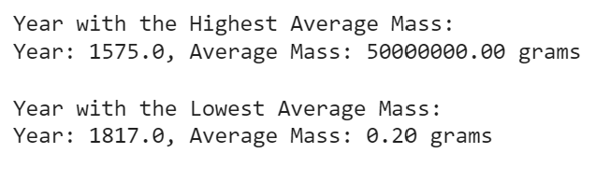
- Year and Lat/Long Relationship
- 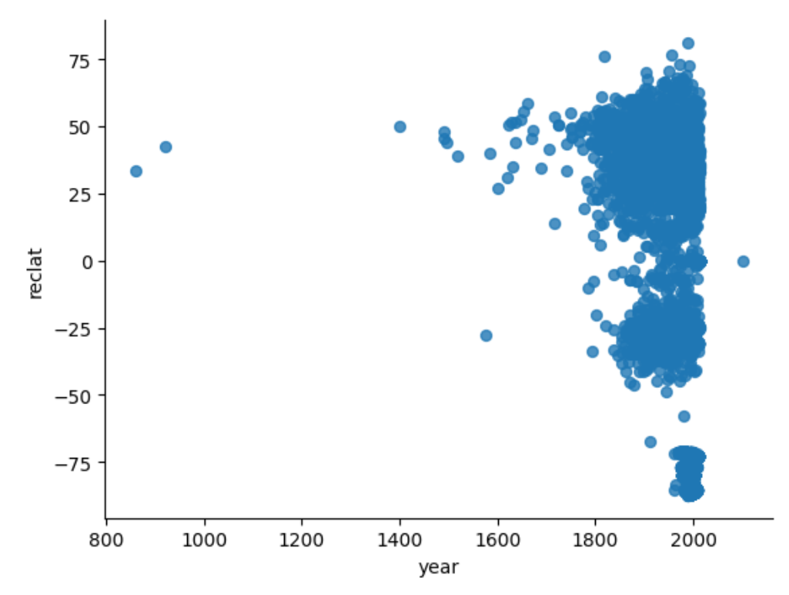
- 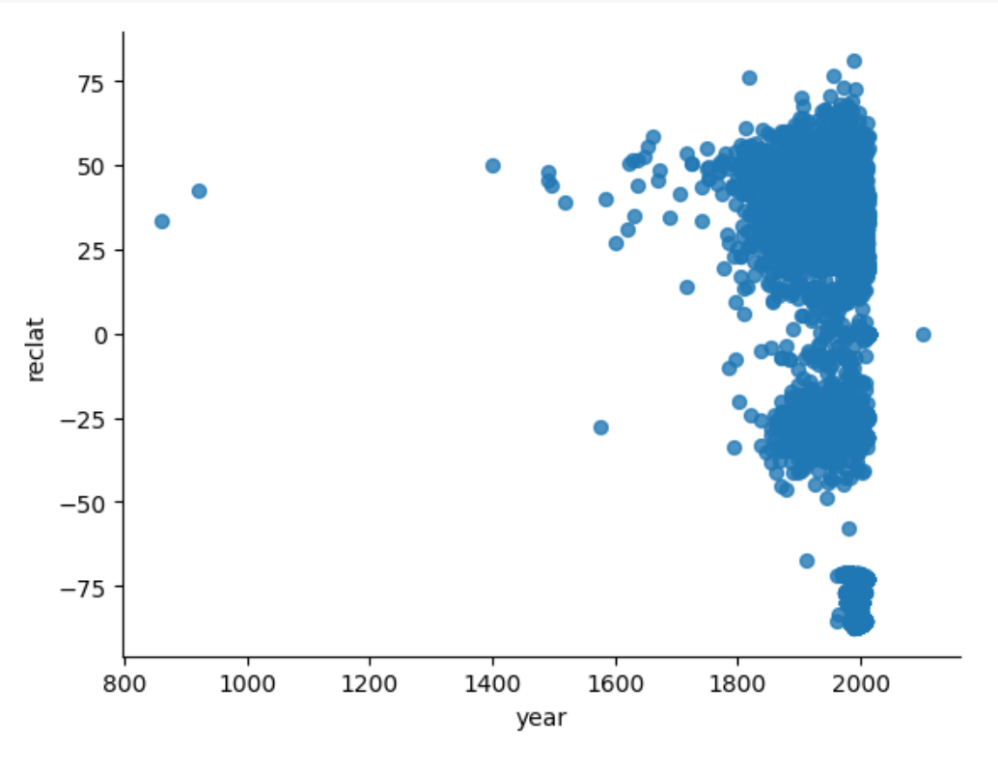
- Discovery Method Distribution
- 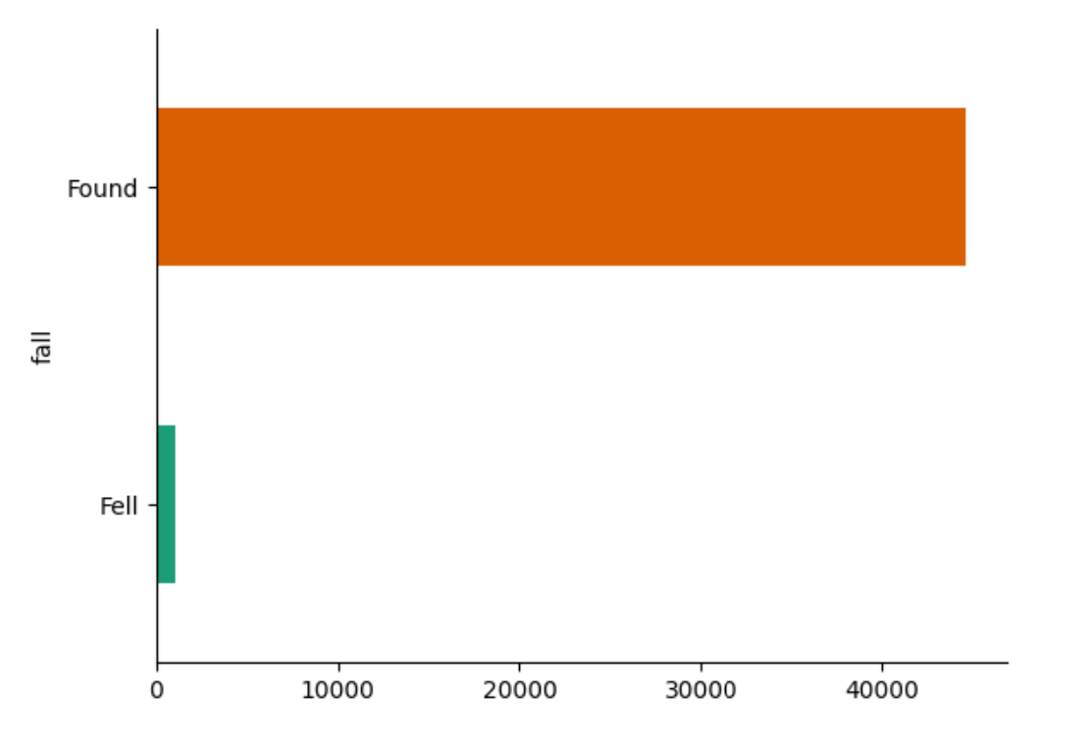
- Lat/Long Frequency
- 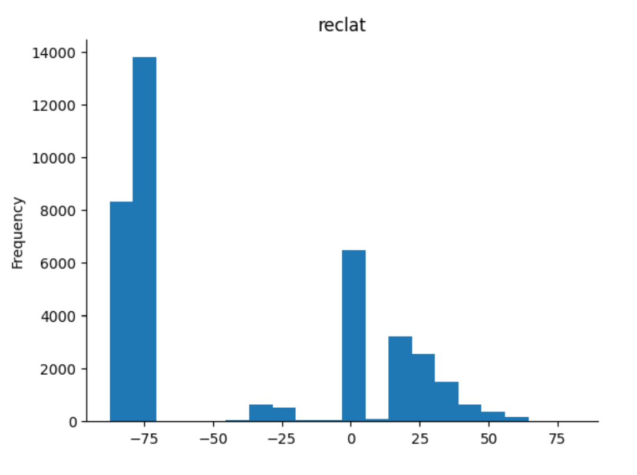
- 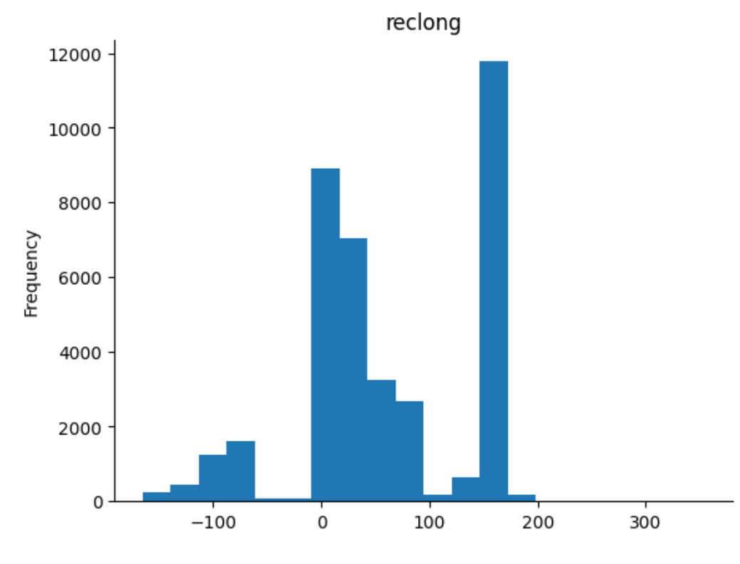
- ID Frequency
- 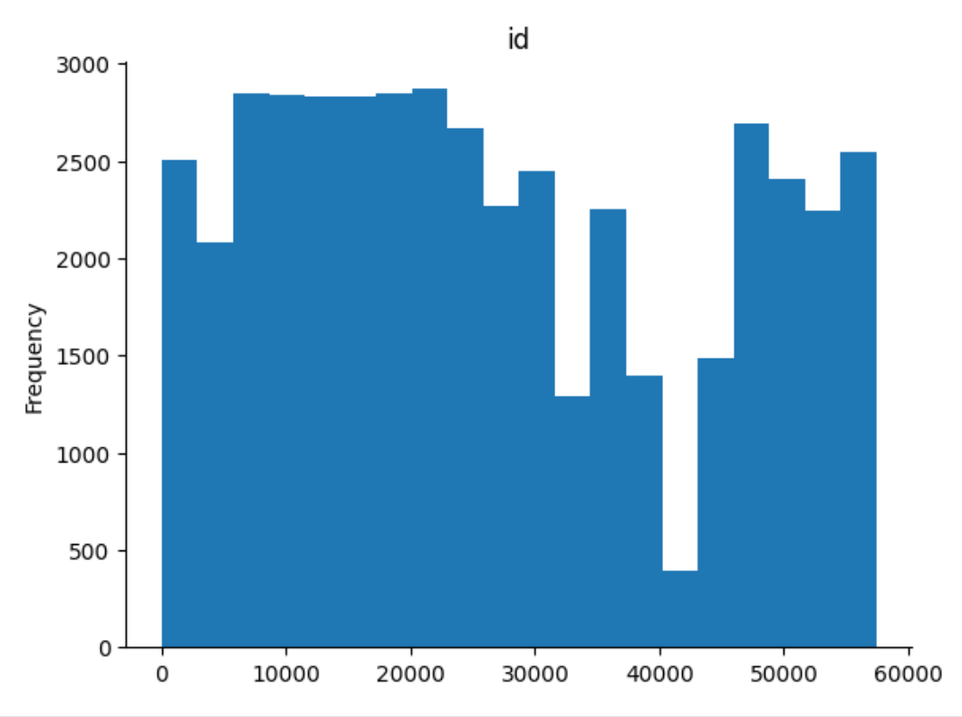
- Meteorite Landings Over Span
- 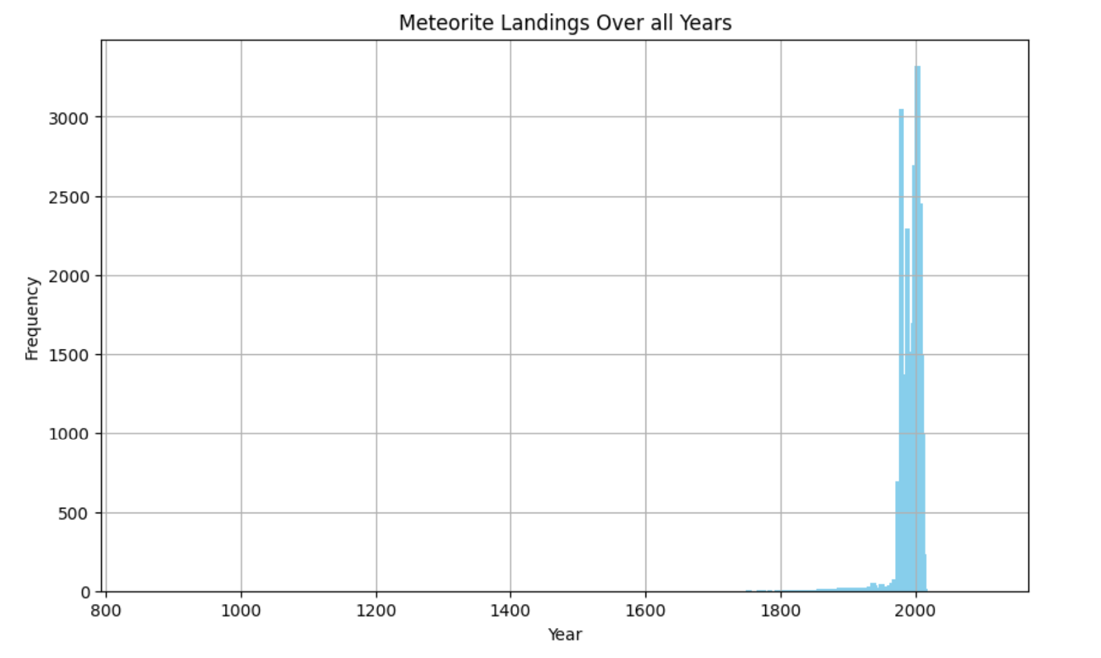
- 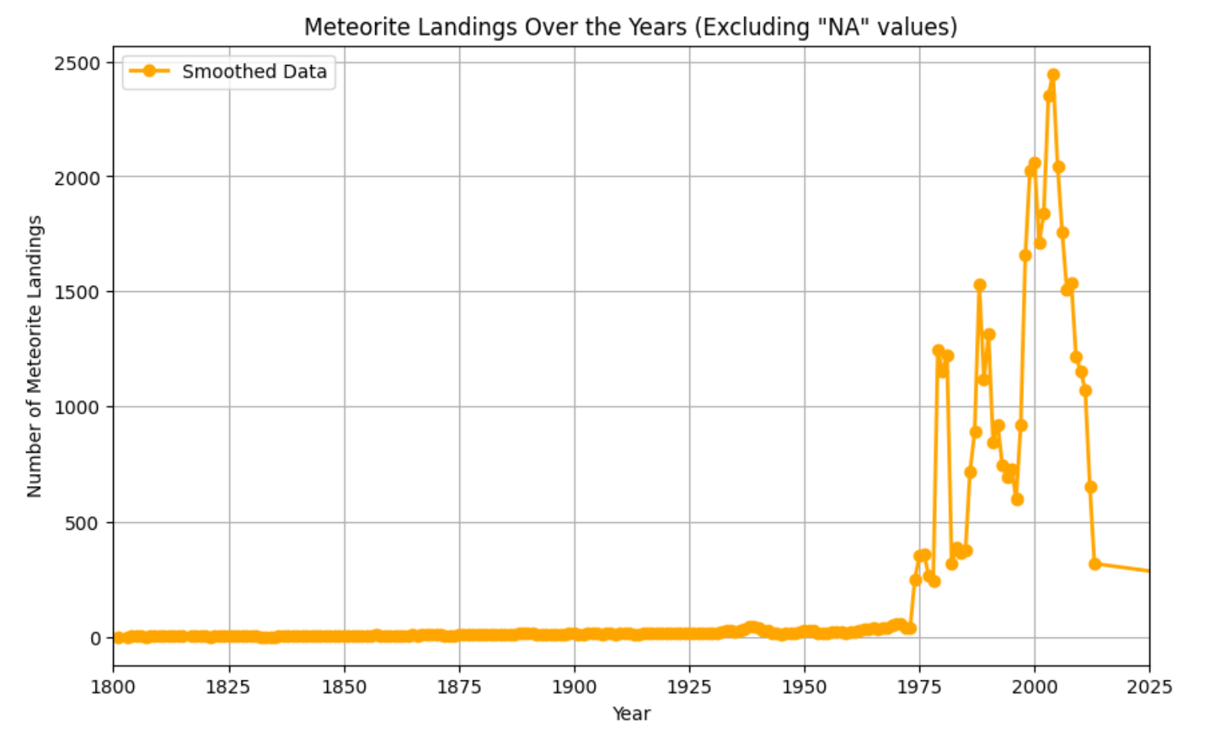
- Recclass Distribution
- 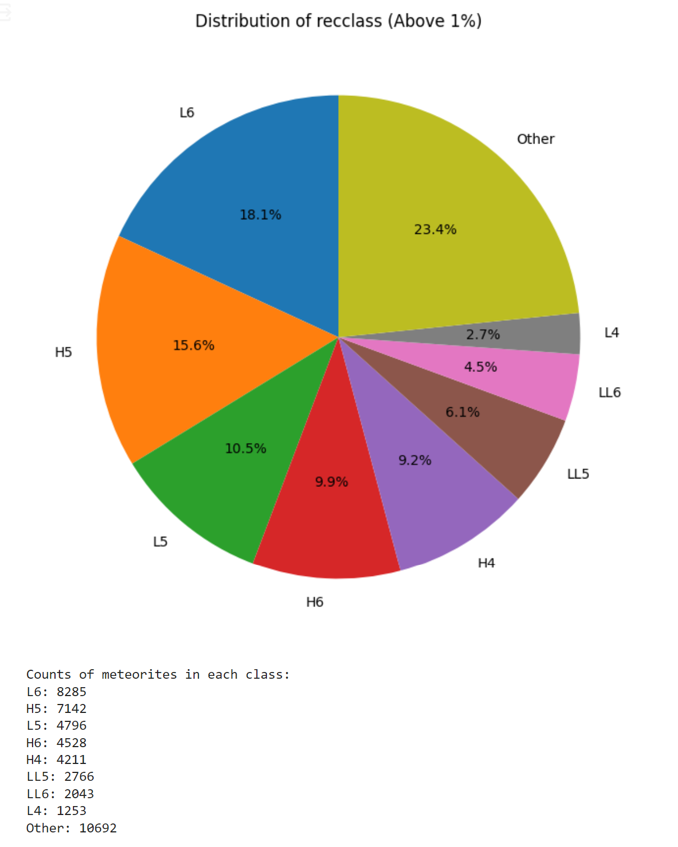
- Total Impact Energy vs Altitude
- 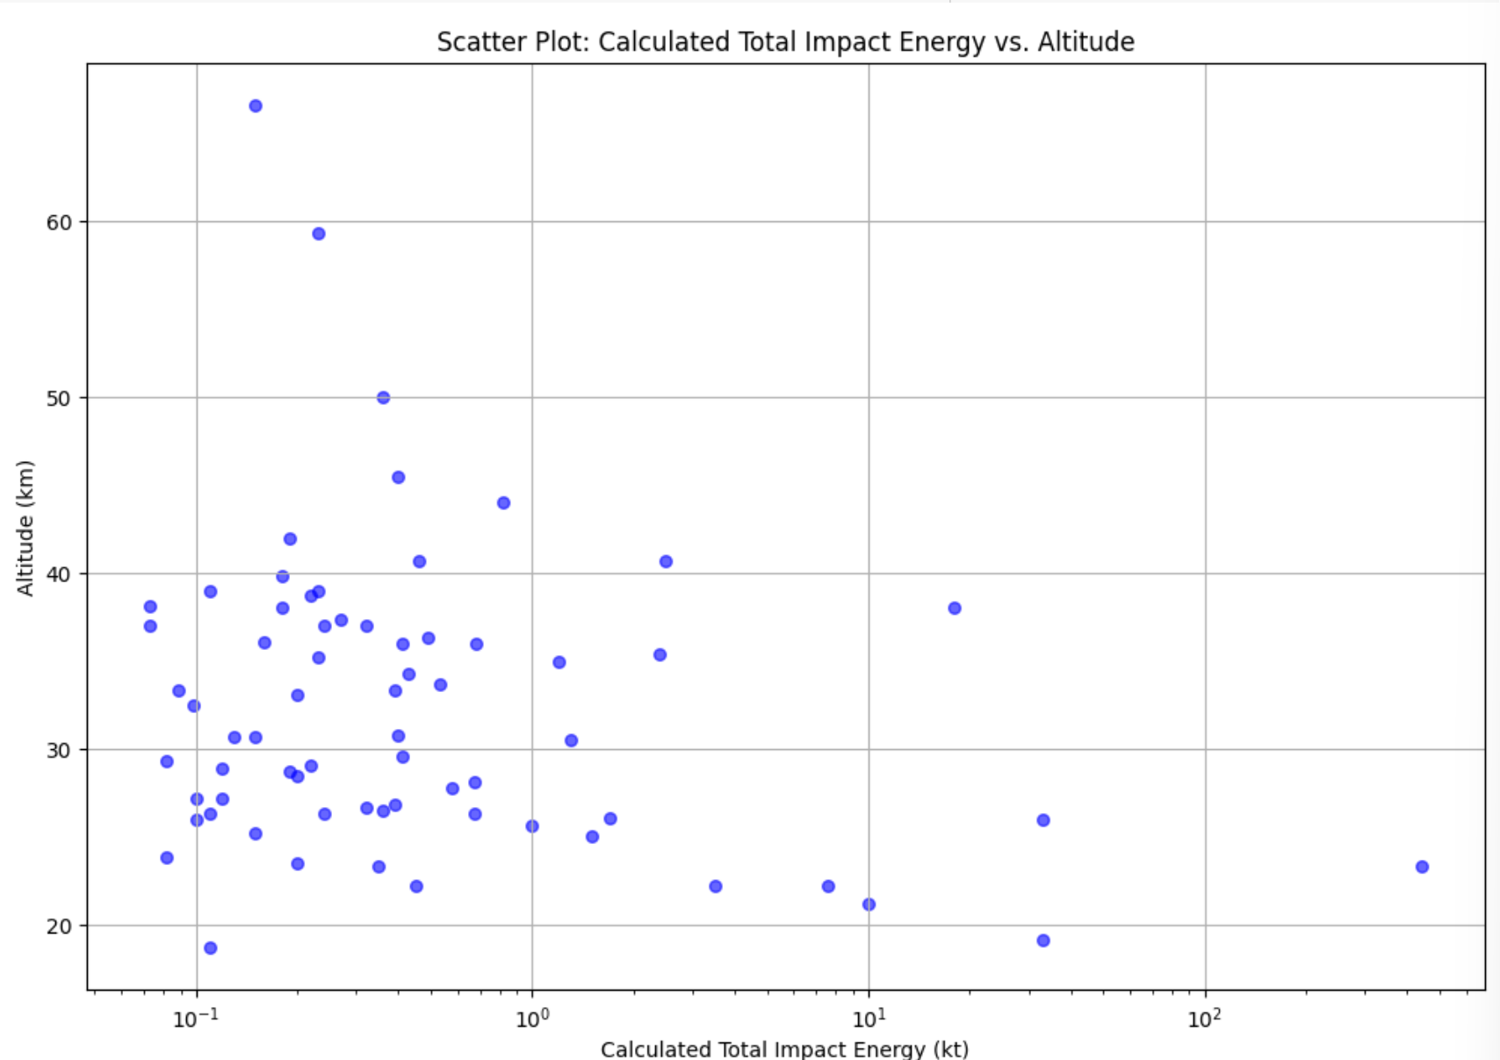
- 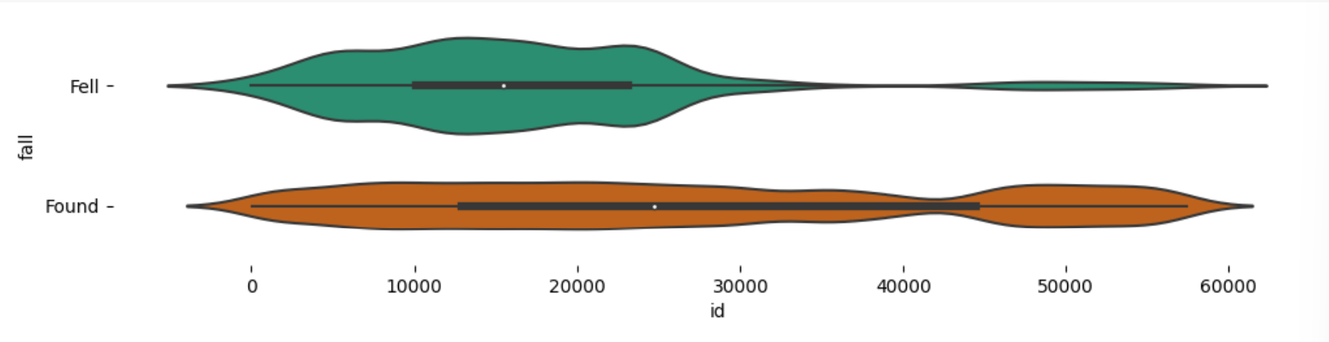
- 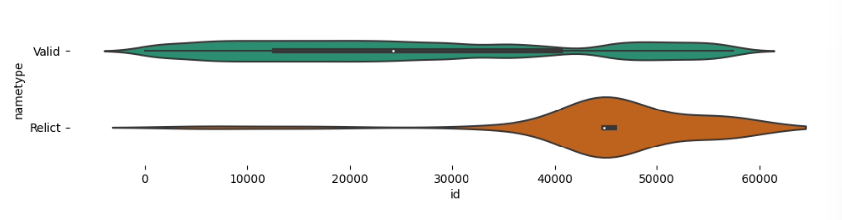
- Meteorite Landings On Map (Showing Date with Color & Mass with Size)
- 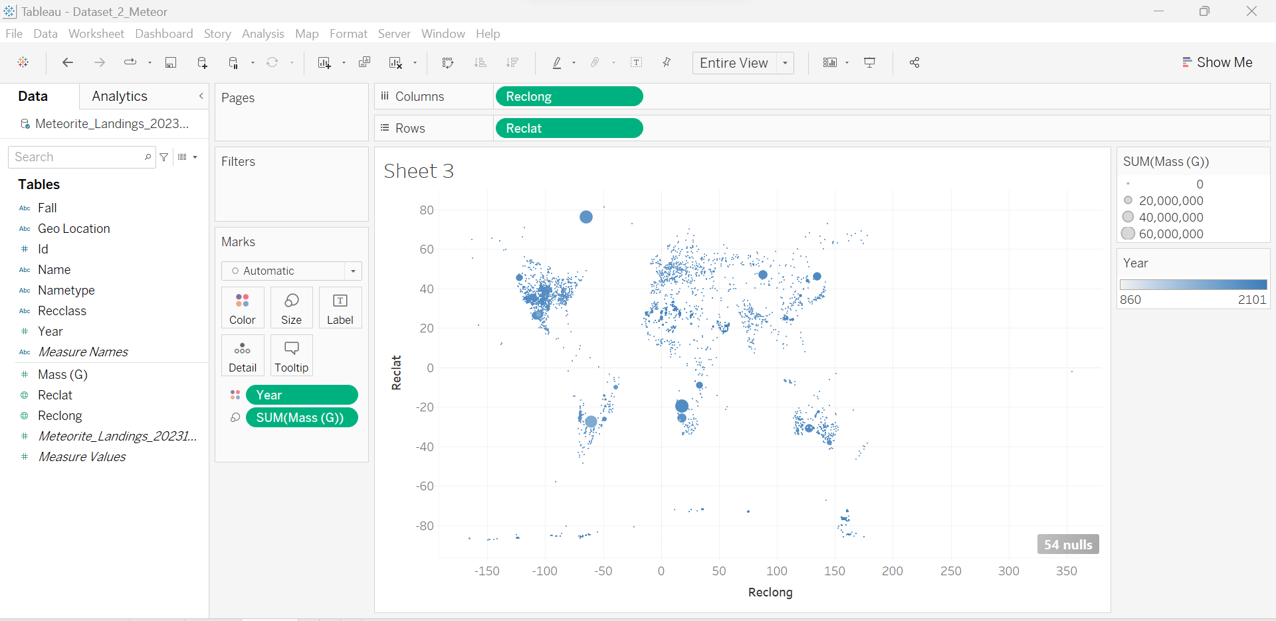

DF (Combined)
- 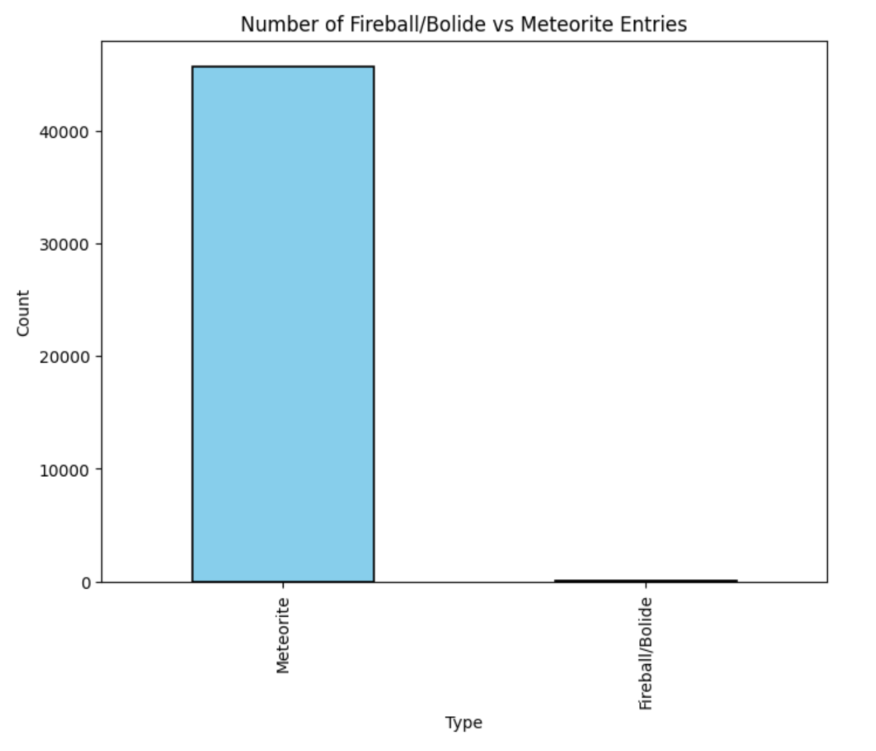
- 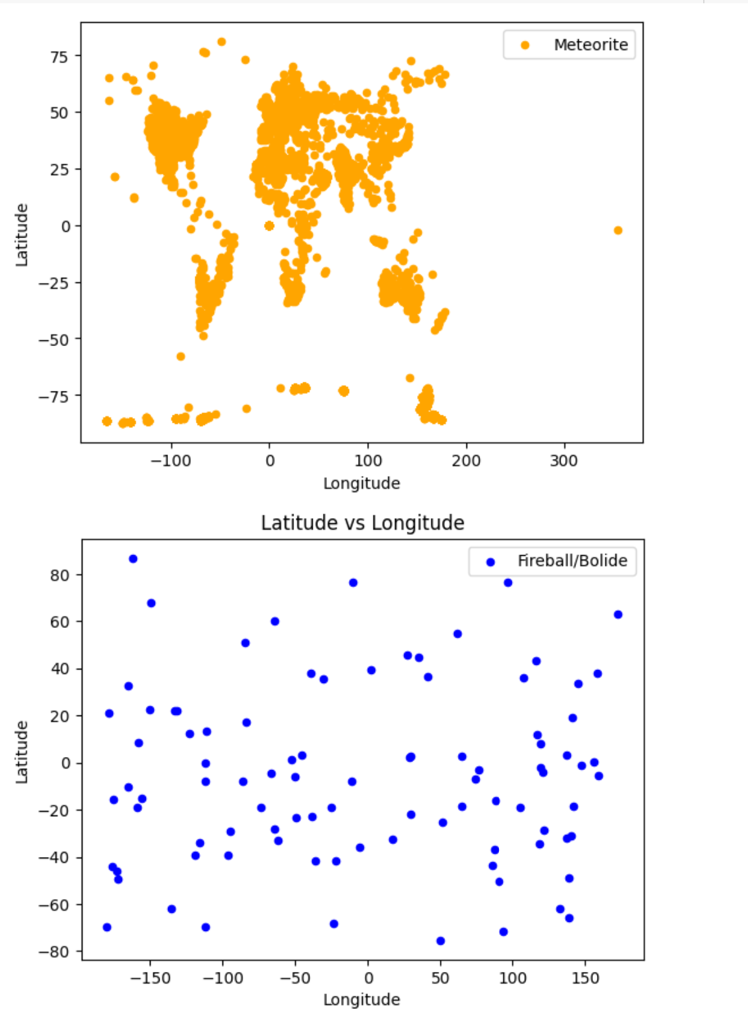
- 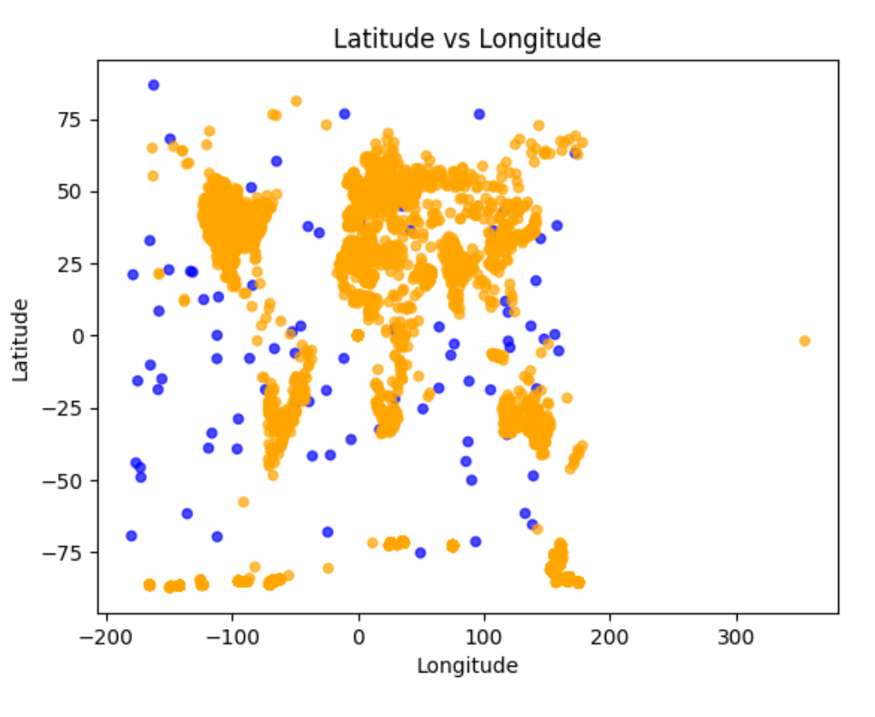
- 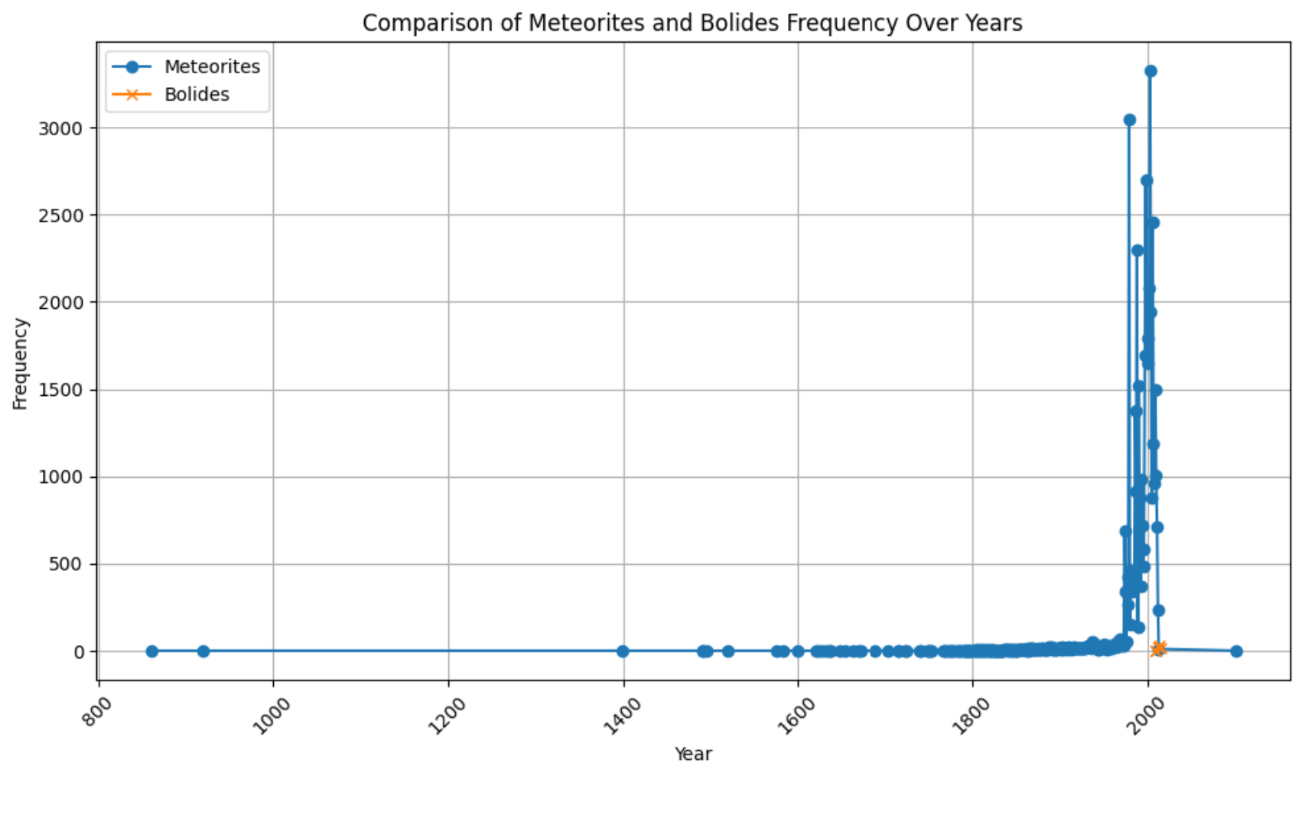

Findings
DF1: According to the Bar Graph depicting the Frequency of Bolide Appearances Over Time, a noteworthy surge in bolide sightings occurred in 2012, with the peak observed in 2014. Further investigation may shed light on the factors contributing to this increase, potentially pointing to an external cosmic event. Analysis of the Velocity Components graph revealed a low positive correlation among velocity axes (x, y, or z). Notably, high velocity in one axis suggests a corresponding elevation in the others. Predominant velocities in the x component range between -20 to 20 km/s, in the y component from -20 to 15 km/s, and in the z component from -17 to 17 km/s. The most common overall velocity hovers around 18.5 km/s. Bolides tend to shine brightest at an altitude of approximately 28 km. Contrary to expectations, the Total Radiated Energy vs. Velocity graph suggests a minimal correlation between component velocities and total radiated energy. This absence of correlation is echoed in Calculated Total Impact Energy (kt) and Altitude in relation to Velocity (km/s). Nevertheless, a Comparison of Calculated Total Impact Energy vs. Total Radiated Energy indicates a clear and direct linear relationship between the two values. Analyzing the Geographical Location Map reveals a global distribution of bolides, dispelling the notion of concentrated appearances in specific regions.
DF2: Several insightful revelations emerge from the dataset. Firstly, the Fall data highlights that the majority of meteorites are found rather than actively witnessed during their descent. This observation aligns logically with the fact that numerous meteorites, dating back millions of years, have landed on Earth and persistently await discovery. Notably, an intriguing pattern surfaces in the Meteorite Landings Over the Years, revealing a substantial increase in meteorite discoveries post-1975. I posit that this surge may be attributed to heightened NASA funding following the Space Race, enabling the agency to undertake extensive exploration and research endeavors. Examining the recclass distribution pie chart, it becomes apparent that a significant portion of discovered meteorites belongs to the L6 class. Defined by The Meteoritical Society, L6 signifies an ordinary chondrite characterized by a moderate degree of alteration and a specific composition featuring a lower quantity of metal. Turning attention to the Scatter Plot depicting Calculated Total Impact Energy vs Altitude, a perceivable but low positive correlation between altitude and impact energy is evident, with a few outliers challenging the trend.
DF: Based on the data I gathered, meteorites exhibit high concentrations in several regions across the globe, including the United States, South Eastern parts of South America (Brazil & Argentina), Europe, Asia, Australia, North West Africa, and South Eastern Africa. Conversely, areas such as Canada, Greenland, and the Northern region of South America have fewer recorded meteorites. Notably, meteorites have also been discovered in oceanic regions, hinting at the likelihood of numerous unobserved instances. It's conceivable that many meteorites might have landed in remote oceanic areas rarely scrutinized, icy regions displaced due to climate changes, or have become obscured over time.
Additionally, we can see that meteorites are far more common than bright and noticeable boldies. This supports outside research I found which explains that boldies typically involve larger celestial objects entering Earth's atmosphere, half are invisible in sunny skies and many occur over the uninhabited ocean.

Concluding Thoughts
It was incredibly enlightening to start the process of finishing a data science project that involved analyzing data from two NASA datasets: Meteorite Landings and the Fireball and Bolide Reports. This project improved my knowledge of cosmic events and sharpened my data science abilities. I improved my capacity to clean, preprocess, and analyze complicated data as I dug deeper into the datasets' minute features. This helped me become more adept at data wrangling and statistical interpretation. The Fireball and Bolide Reports, along with Meteorite Landings datasets, served as windows into the fascinating realm of celestial bodies, offering insights into their frequencies, velocities, and energetic characteristics. Unraveling the patterns within these datasets not only broadened my technical expertise but also sparked a newfound curiosity about the dynamics of bolides and meteorites. Through this project, I not only acquired valuable data science skills but also developed a profound appreciation for the intricate dance of cosmic entities, underscoring the interdisciplinary nature of data science in unraveling the mysteries of the universe.

References
- https://data.nasa.gov/Space-Science/Meteorite-Landings/gh4g-9sfh
- https://data.nasa.gov/Space-Science/Fireball-And-Bolide-Reports/mc52-syum
- https://www.lpi.usra.edu/meteor/metbullclass.php?sea=L6#:~:text=The%20recommended%20classification%20L6%20means,that%20is%20petrologic%20type%206.%22
- https://www.imo.net/observations/fireballs/fireballs/#:~:text=Fireballs%20actually%20occur%20every%20day,very%20few%20times%20per%20lifetime.

