Star Dataset: Report
Machine Learning 6 Star Class Prediction & Analysis
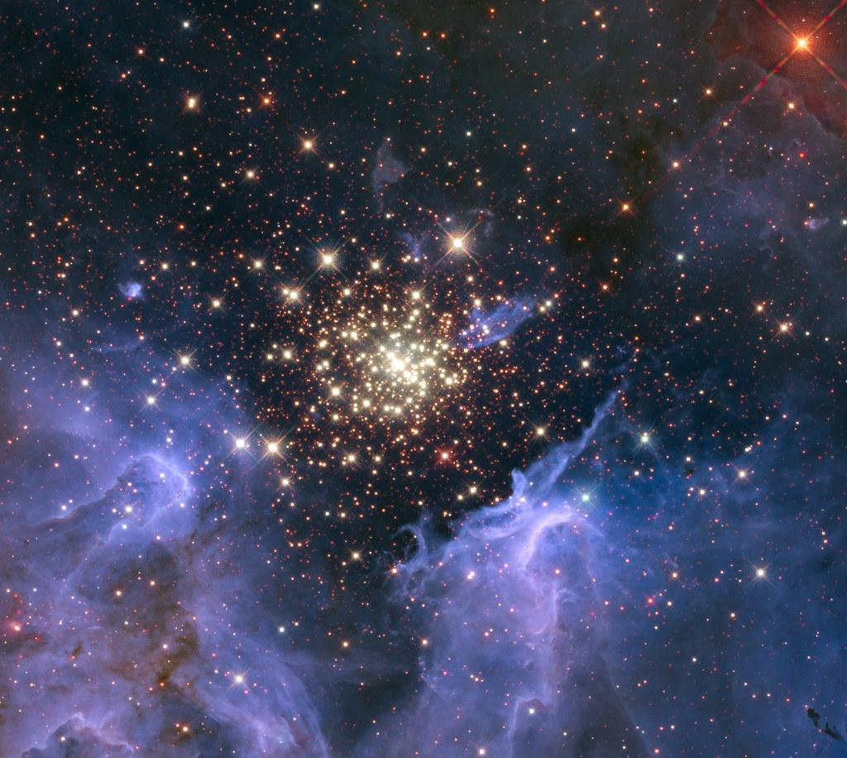
Jaral Arroyo-Jefferson
Period 2
Applied Data Science
Table Of Contents

Research Question 2
Star Dataset (DF) 2
Dataset Cleaning 2
Machine Learning 3
References 12

Research Question
The purpose of making the dataset is to prove that the stars follow a certain graph in the celestial space

Star Dataset (DF)
- Absolute Temperature (in K)
- Relative Luminosity (L/Lo)
- Relative Radius (R/Ro)
- Absolute Magnitude (Mv)
- Star Color (White, Red, Blue, Yellow, yellow-orange, etc.)
- Spectral Class (O, B, A, F, G, K, M)
- Star Type (Red Dwarf, Brown Dwarf, White Dwarf, Main Sequence, SuperGiants, HyperGiants)

Dataset Cleaning
This dataset did not contain any missing values, however, not all the columns were in numerical values so I had to complete the encoding.
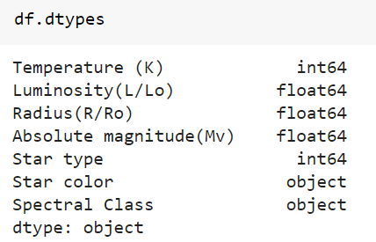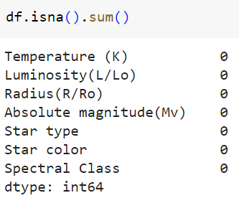
Encoding:
The columns I had to encode were Star Color and Spectral Class. I began by determining the unique values for each column and then mapping each non-numerical value to a number. Then I applied the map to the original column, defining it as a new encoded column. To simplify the colors I mapped them to only those found on roybgiv.
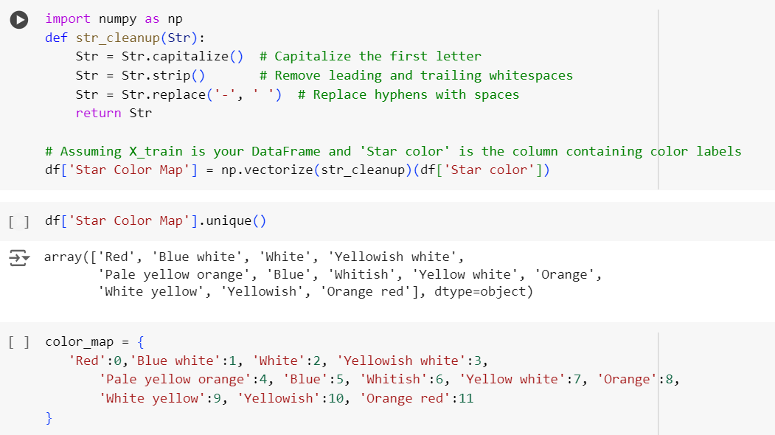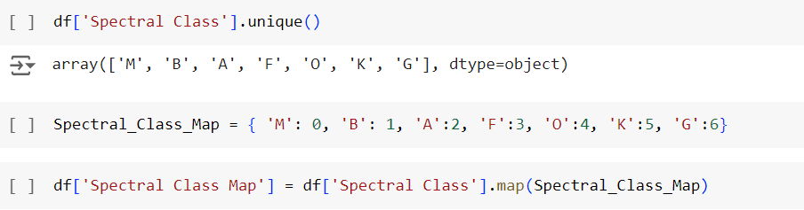
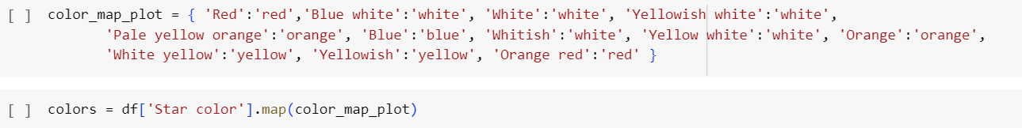

Machine Learning
Although this dataset already contained the Star type predictions I wanted to run my own model and compare my result to the listed value. For my machine learning program, I used the xgboost classification model. For my features, I used 'Temperature (K)', 'Luminosity(L/Lo)', 'Radius(R/Ro)', 'Absolute magnitude(Mv)', and 'Star Color Code'. After fitting the model I compared my model’s predictions to the listed values of the dataset and had a 100% accuracy.
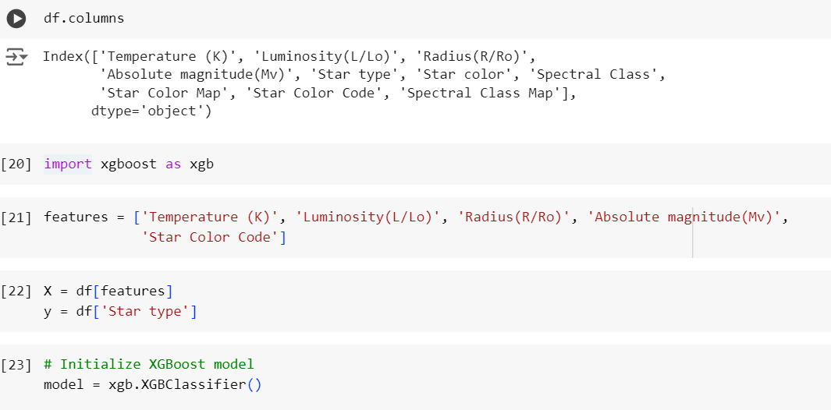
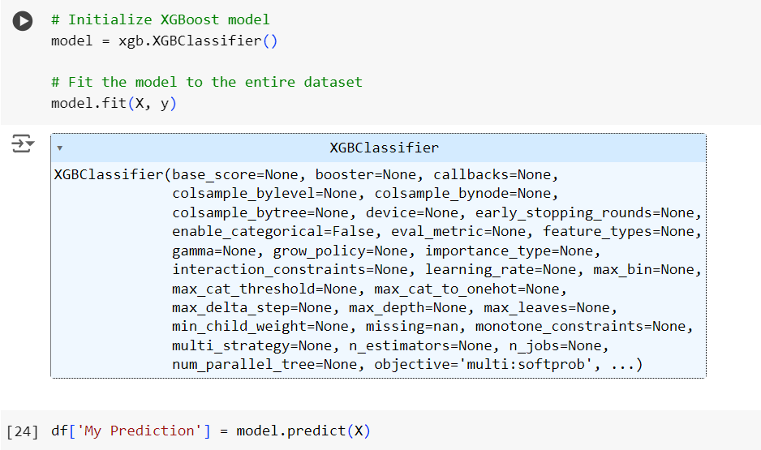
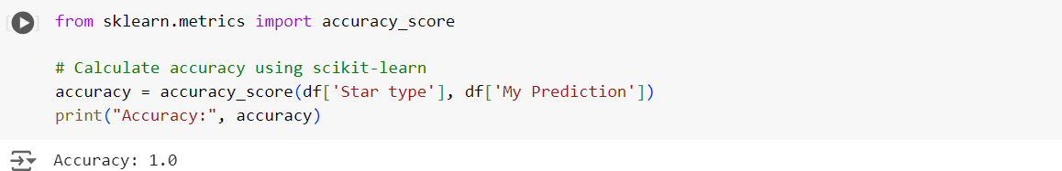
Data Analysis & Visualization
Google Colab:
The goal of my data analysis was to find the defining qualities of various star groups.
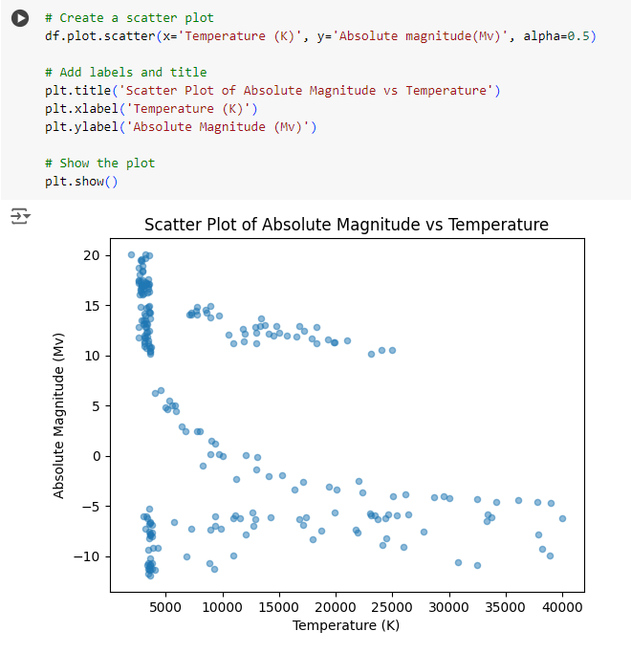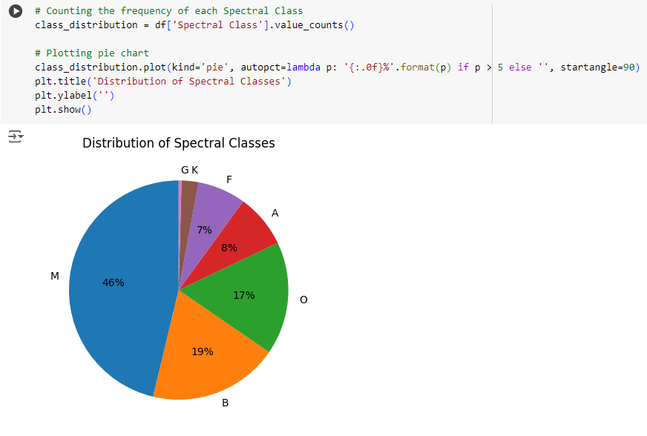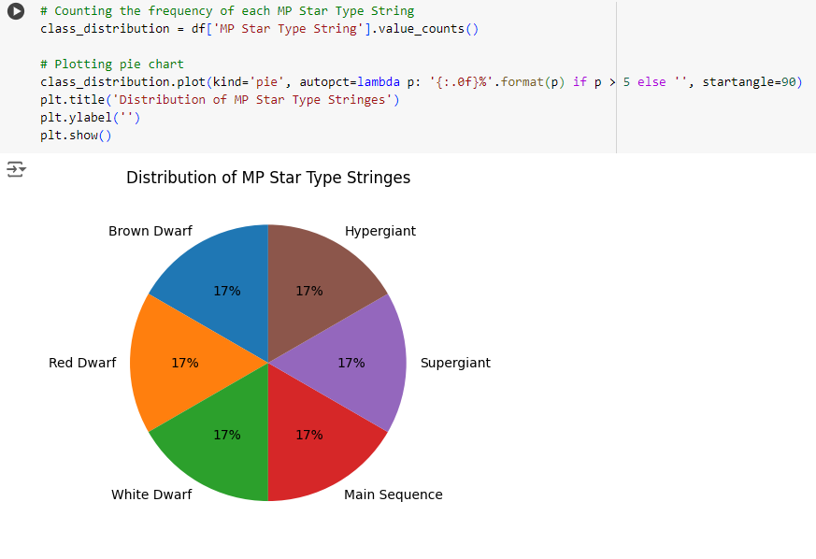

ChatGPT:
ChatGPT is a great resource to be able to quickly develop simple visaulisations for your data. Feeding it a prompt similar to the one below where you explain what you dataset is about, what type of graph you want, and your columns, ChatGPT is able to develop sophisticated graphs and charts. However there are some downsides. For example because I am not able to upload my entire Google Colab document, meaning ChatGPT does not know how the rest of my code looks, there may be issues when you run the generated code. Additionally, when you rely too heavily on ChatGPT for generating the code for the visualization you do not learn how the math plot library actually works and are simply a copy-and-paste bot.
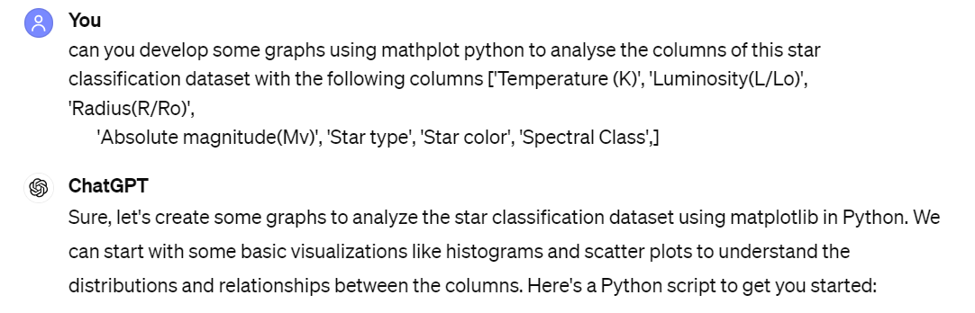
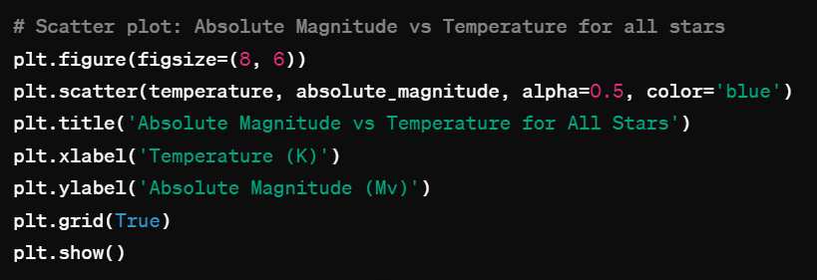
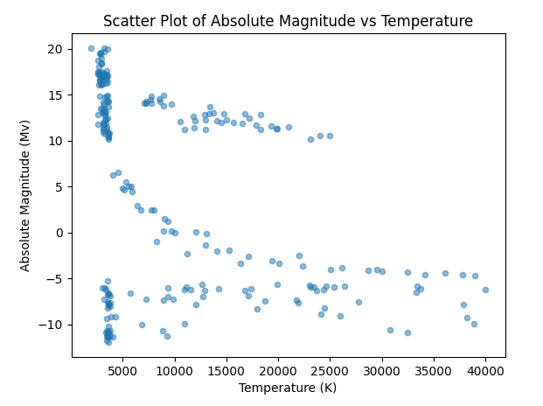

Tableau:
An even more efficient way to make quality data visualizations is using the Tableau software which allows for better customization. Here are some visualizations I made.
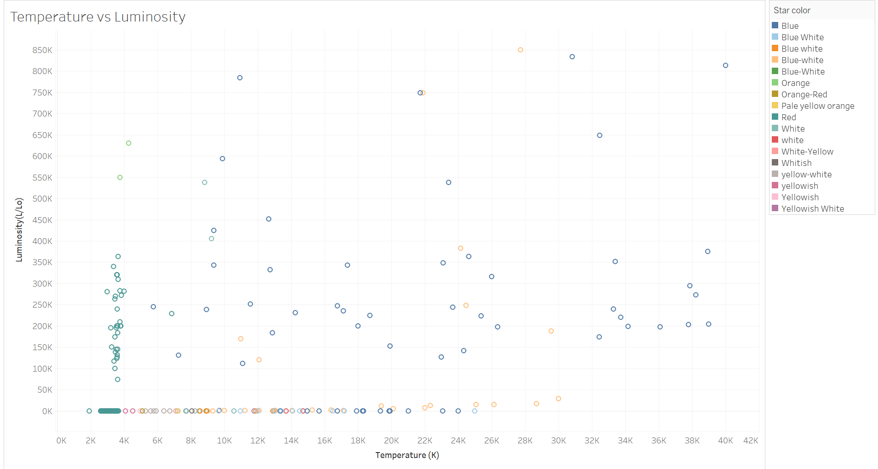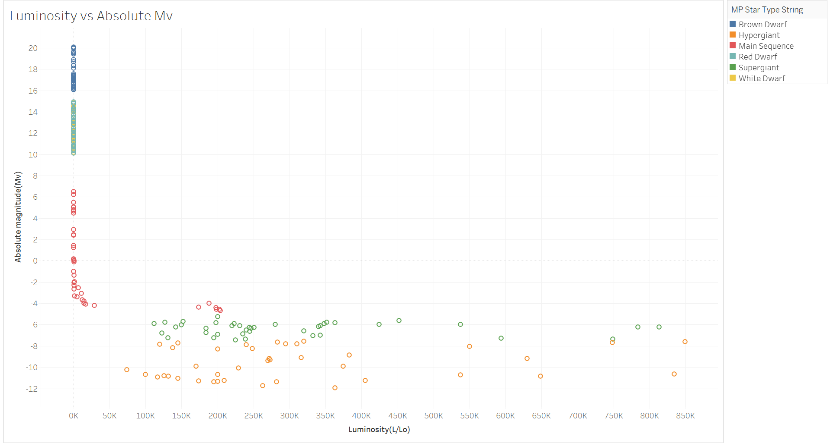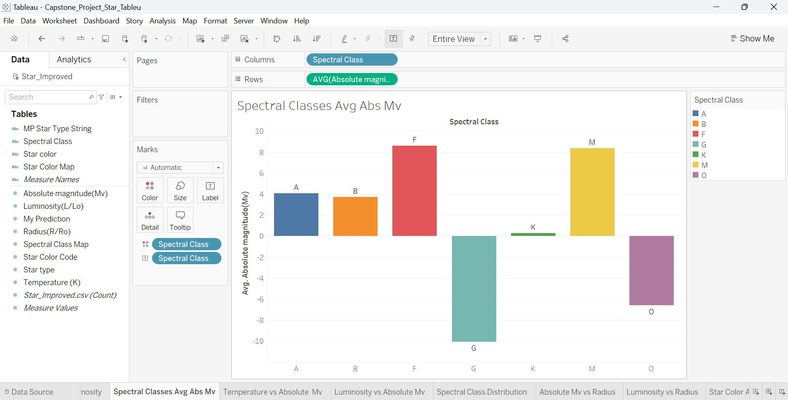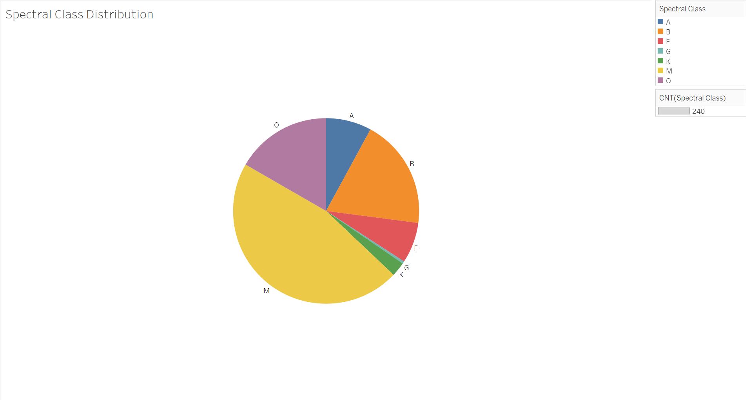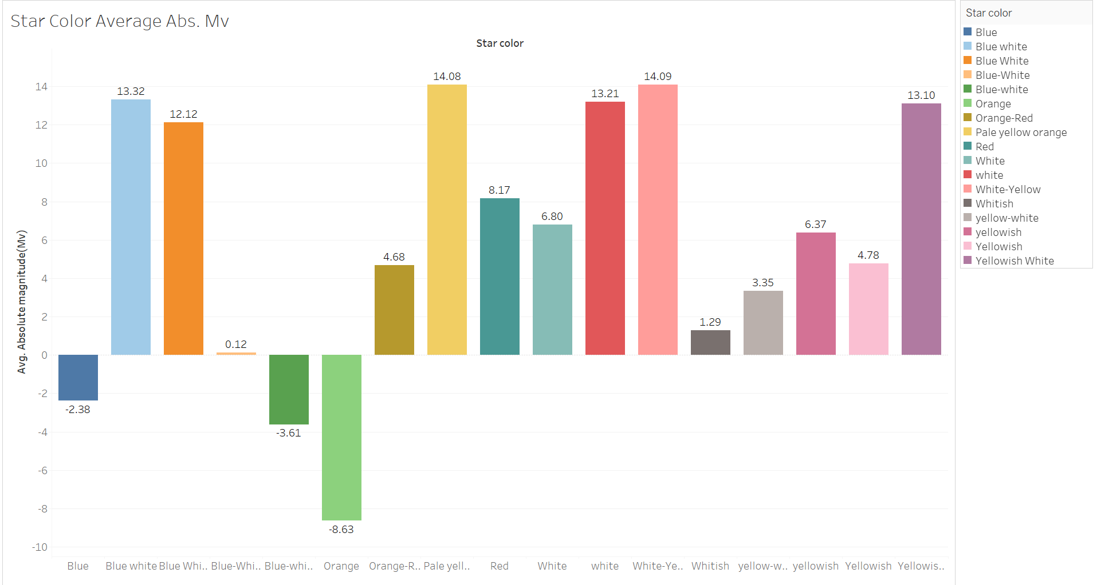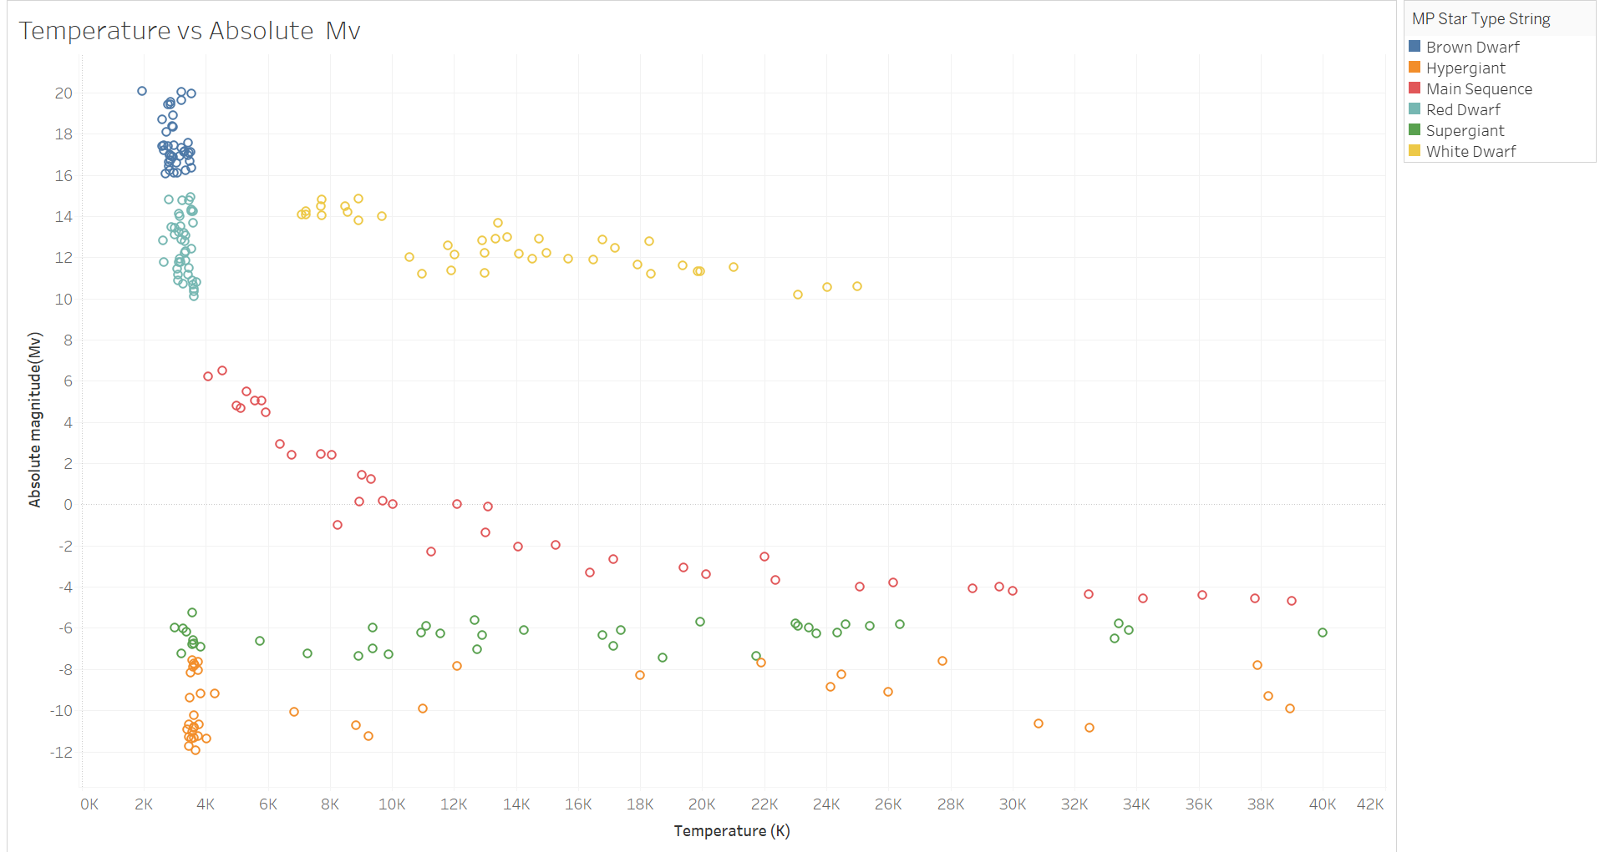
Concluding Thoughts
In this data science journey, I delved into a comprehensive stars dataset to uncover the scientific qualities underpinning star types. My objective was to decipher the intrinsic characteristics that determine the classification of stars, contributing to a deeper understanding of celestial dynamics.

Through analysis and visualization, I explored key attributes such as temperature, luminosity, radius, and absolute magnitude. Leveraging advanced machine learning models, I achieved 100% accuracy in predicting star types, highlighting the predictability and structure inherent in the dataset.

Visualization techniques revealed compelling relationships between luminosity and radius, as well as absolute magnitude and temperature. These insights shed light on the physical properties and evolutionary stages of stars, clarifying the scientific qualities that define their classifications.

Furthermore, the distribution of star types, colors, and spectral classes unveiled intriguing patterns indicative of underlying stellar phenomena. By unraveling these complexities, I have contributed to a deeper understanding of celestial dynamics and the scientific principles governing star classifications.

This study underscores the power of data science in unraveling the mysteries of the universe and advancing our scientific understanding of stellar phenomena.

References
- https://www.kaggle.com/datasets/deepu1109/star-dataset

