**Update on Eurodollar Convexity**

* The Eurodollar futures convexity bias is the result of FRAs having a convex DV01 compared to the fixed $25/bp of a Eurodollar future. In the middle of 2014 the convexity bias hit highs beyond model predictions, while having swung back partially, remain high compared to historical levels. This was likely an early artifact of the CME being flooded with fixed payers combined with OTC clearing margin requirements which more recently manifested themselves in the CME/LCH basis.
* To trade against the bias execute a long ED future combined with payer FRA hedge.

# Background

The convexity benefit of receiving fixed on a forward rate agreement (FRA) compared to a long position in the equivalent Eurodollar (ED) future contract is what is known as Eurodollar futures convexity. An ED future contract has a defined DV01 of $25 per bp while a FRA’s payout will be convex. Both instruments settle on what 3 month LIBOR will be in the future and therefore the valuation of this basis is instrumental in determining where to place your LIBOR risk.

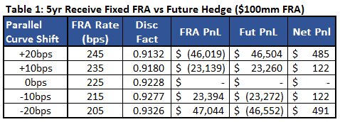Table 1 shows the positive convex profile of a receiver FRA vs a short ED future position starting in 5 years. Assumption made that the FRA and ED rate will move together through parallel shifts and have been struck at the same level. The marketplace prices in this profitable hedge trade by bidding down Eurodollar prices lower then would be expected from implied forwards from swaps. You have to “overpay” for the future hedge to take advantage of the convex nature of the trade.

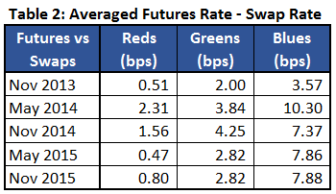Historically the convexity adjustment has been dealt with through models such as ho-lee and hull-white. In May 2014 there was a break to the model implied convexity level which was implying an adjustment lower then seen in the market. Table 2 shows that in May 2014 the convexity bias hit new highs comapred to 2013. The bias did slightly nomralize in the following months but since has remained at elevated levels.

# Causes

Volatility has historically been the driver of movement in the convexity bias. In periods of low volatility there would be little benefit for the trade in table 1 which would push futures closer to the implied forwards from swaps. Table 3 shows the 30 day realized volatility of the reds, greens and blues throughout the past two years. Clearly the increased convexity bias seen here is not explainable by a 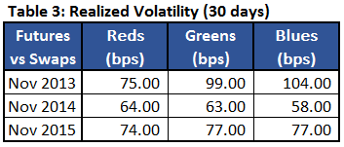systemic shift in vol. This can also be seen in the cap/floor market.

The convexity bias expansion looks to be an early artifact of the fixed payer supply from asset managers seen on the CME. This supply has manifested recently with the CME/LCH basis and it is logical to assume the asset managers would have hit Eurodollar futures first, pushing the prices of EDs down, raising rates further away from the swap curve.

The dealer community is likely having trouble shorting the basis due to two factors. The first, to take advantage of portfolio margining one needs to execute the hedge FRA or swap on the CME but secondly to do so you need to find a counter party willing to receive fixed which is in short supply on the CME, hence the appearance of the CME/LCH basis.

# Mechanics of the Trade

Table 4 walks through the execution, bid/offer and margin requirements of the short convexity bias trade based on a 3yr future and FRA. Note the below points:

* This is a hold to maturity trade, at settlement both sides of this trade converge to spot 3m LIBOR. The expected PnL will be the initial future – FRA spread minus the convexity losses suffered by mismatched hedging throughout the life of the trade. These losses are suffered as one needs to rebalance the futures hedge throughout the life of the trade. For example, when rates move up, discount factors move down which requires selling futures.
* The optimum hedge for the FRA position ($100mm) is not $100mm worth of ED futures due to mismatched DV01. The DV01 of this FRA is roughly $2,400, to delta hedge you would long 96 future contracts. Below shows the hedge ratio with different parallel parallel shifts to the curve:



* CME’s portfolio margining is a requirement here as split margin with LCH will reduce the return but you pay for that right with a ~1bp loss to the CME/LCH basis – which will converge to zero at settlement. FRA margin assumed to be slightly higher than the futures margin.
* The FRA-Future convexity will cause actual loses post day one and reduce PnL. The chart below runs a back test on this trade throughout August and September on the Dec18 futures contract. Note the negative convexity of the payer FRA. For this test I am assuming the bias has not changed during this period which is not guaranteed.
* PnL of this trade, which will be driven by the future-FRA spread, depends on the volatility of the forward rate. Higher volatility will mean less profit as a 50bp move today would equal a loss of roughly $600. This trade is long ED futures, when rates move higher, discount factors move lower and you need to sell part of the hedge at a loss. Table 4 assumes a similar environment as seen the past few months and extrapolates the estimated cost for this position.

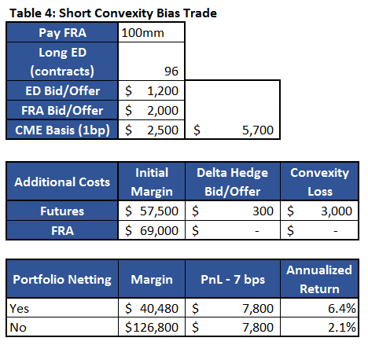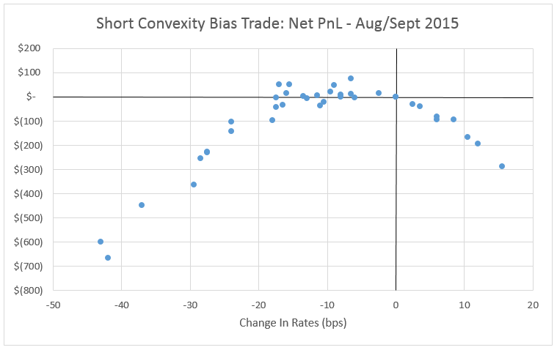

# Conclusion

The convexity bias increase seen in the middle of 2014, though since reduced, looks to be a feature of the marketplace. This is likely driven by the fixed rate payers on the asset management side on the CME and margin requirements for OTC cleared products. The trade here looks at longing an ED future combined with a fixed payer to short the convexity bias. If held to term these two sides will converge to spot 3 month LIBOR. As shown above due to the convexity profile of this trade, there is risk that volatile rates will eat away at the positive time decay profile of this trade. There is also exposure to an expansion of the FRA-futures basis where you will incur MTM losses which will drive up variation margin and lower returns.