Mycroft decides what skill to trigger like this

[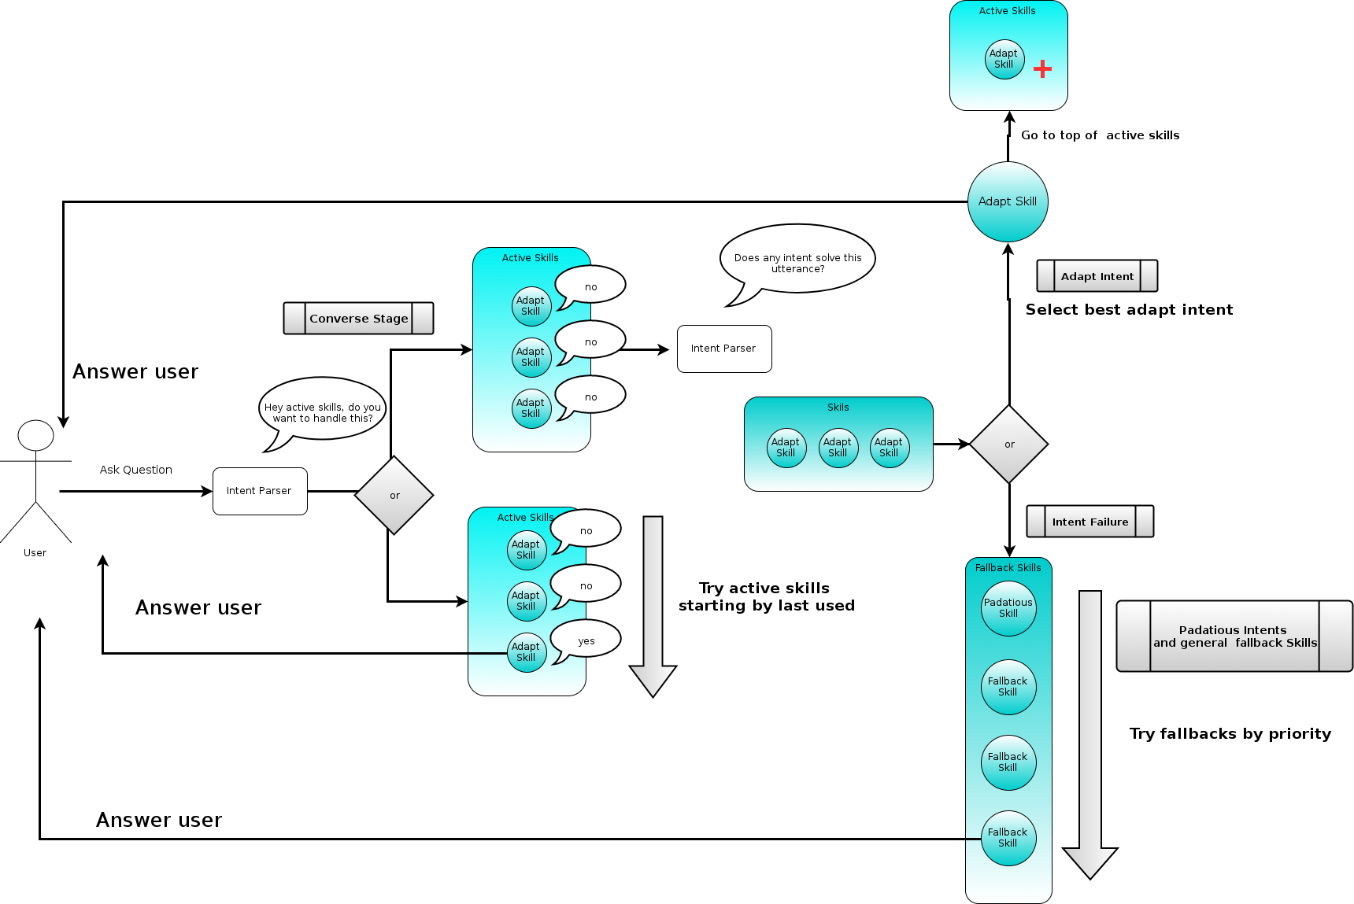](https://raw.githubusercontent.com/JarbasAI/JarbasAI.github.io/master/images/mycroft.png)

Node red skill acts as a bridge between a node red instance and mycroft, it works like a fallback skill

[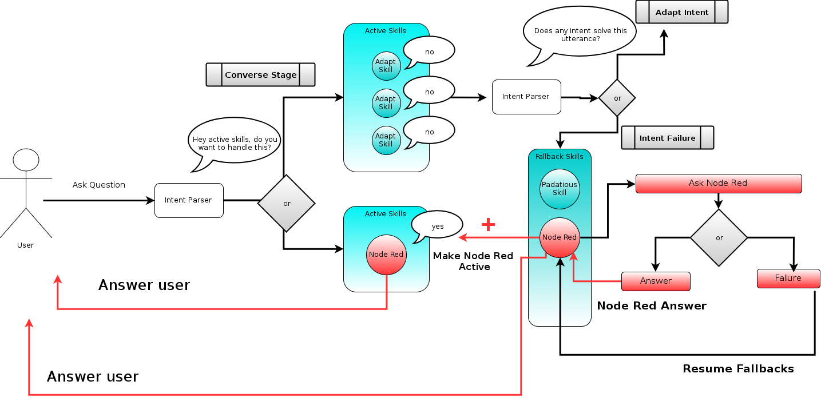](https://raw.githubusercontent.com/JarbasAI/JarbasAI.github.io/master/images/node_fallback.png)

Converse method is now being integrated, you can handle the entire conversation inside node red this way

[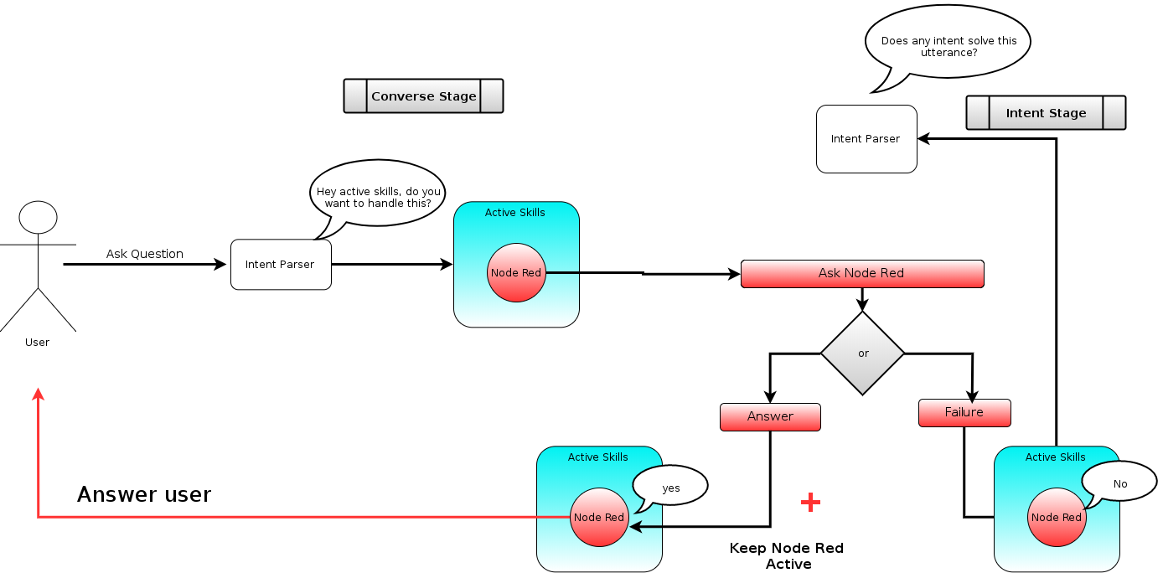](https://raw.githubusercontent.com/JarbasAI/JarbasAI.github.io/master/images/node_converse.png)