|  |  |  |  |  |  |
| --- | --- | --- | --- | --- | --- |
| **Date** | **Accuracy** | **Features** | **Label** | **Library** | **Notes** |
| March 14, 2021 | 13.84% | * Week (circular) | First | Keras | * Numerical order * 200 neurons * Relu and softmax * Categorical_crossentropy * Adam * Epoch = 500 * Batch size = 10 * Kfold splits = 10 |
| March 15, 2021 | 11.1% | * Week (circular) * Day Name (one-hot encoded | First | Tensorflow | * Numerical order * Batch size = 10 * Epoch = 1000 * 20 neurons, 3 layers * Steps = 1000 |
| March 15, 2021 | 7.7% | * Week (circular) | First | Tensorflow | * Numerical order * Batch size = 10 * Epoch = 1000 * 20 neurons, 3 layers * Steps = 1000 |
| March 15, 2021 | 12.49% | * Month (circular) | First | Keras | * Numerical order * 200 neurons * Relu and softmax * Categorical_crossentropy * Adam * Epoch = 500 * Batch size = 10 * Kfold splits = 10 |
| March 15, 2021 | 12.45% | * Day (circular) | First | Keras | * Numerical order * Normalize feature * 200 neurons * Relu and softmax * Categorical_crossentropy * Adam * Epoch = 500 * Batch size = 10 * Kfold splits = 10 |
| March 15, 2021 | 12.12% | * Day (circular) * Week (circular) | First | Keras | * Numerical order * Normalize feature * 200 neurons * Relu and softmax * Categorical_crossentropy * Adam * Epoch = 500 * Batch size = 10 * Kfold splits = 10 |
| March 15, 2021 | 10.74% | * Day (circular) * Week (circular) | First | Keras | * Numerical order * 200 neurons * Relu and softmax * Categorical_crossentropy * Adam * Epoch = 500 * Batch size = 10 * Kfold splits = 10 |
| March 16, 2021 | 14.21% | * Day (circular) * Week (circular) | First | Keras | * Numerical order * Input layer – 20 neurons; relu * 3 hidden layers (500, 250, 125); relu * Output – softmax * Optimizer – Adadelta * Learning rate – 0.001 * Rho – 0.95 * Epsilon – 1e-07 * Loss – Categorical Cross-entropy * Epochs – 2000 * Batch size – 10 * Kfold splits – 10 |
| March 16, 2021 | 14.20% | * Day (circular) * Month (circular) | First | Keras | * Numerical order * Input layer – 20 neurons; relu * 3 hidden layers (500, 250, 125); relu * Output – softmax * Optimizer – Adadelta * Learning rate – 0.001 * Rho – 0.95 * Epsilon – 1e-07 * Loss – Categorical Cross-entropy * Epochs – 2000 * Batch size – 10 * Kfold splits – 10 |
| March 17, 2021 | 14.11% | * Week (circular) * Month (circular) | First | Keras | * Numerical order * Input layer – 20 neurons; relu * 3 hidden layers (500, 250, 125); relu * Output – softmax * Optimizer – Adadelta * Learning rate – 0.001 * Rho – 0.95 * Epsilon – 1e-07 * Loss – Categorical Cross-entropy * Epochs – 2000 * Batch size – 10 * Kfold splits – 10 |
| March 20, 2021 |  | * Week (circular) * Month (circular) | First | Keras | * Numerical order * Min Max scaler * 3 hidden layers (500, 250, 125); relu * Output – softmax * Optimizer – Adadelta * Learning rate – 0.001 * Rho – 0.95 * Epsilon – 1e-07 * Loss – Categorical Cross-entropy * Epochs – 2000 * Batch size – 10 |
| March 20, 2021 |  | * Week (circular) * Month (circular) | First | Keras | * Numerical order * Min Max scaler * 1 hidden layer (17); relu * 1 Dropout – 0.65 * Output – softmax * Optimizer – Adadelta * Learning rate – 0.001 * Rho – 0.95 * Epsilon – 1e-07 * Loss – Categorical Cross-entropy * Epochs – 2000 * Batch size – 10 |
| March 20, 2021 |  | * Week (circular) * Month (circular) | First | Keras | * Numerical order * Min Max scaler * 1 hidden layer (30); relu * 1 Dropout – 0.65 * Output – softmax * Optimizer – Adadelta * Learning rate – 0.001 * Rho – 0.95 * Epsilon – 1e-07 * Loss – Categorical Cross-entropy * Epochs –3000 * Batch size – 10 |
| March 22, 2021 |  | * Week (circular) * Month (circular) | First | Keras | * Numerical order * Min Max scaler * 2 hidden layers (100, 100); relu * 1 Dropout – 0.65 * Output – softmax * Optimizer – Adadelta * Learning rate – 0.001 * Rho – 0.95 * Epsilon – 1e-07 * Loss – Categorical Cross-entropy * Epochs –3000 * Batch size – 10 |
| March 23, 2021 |  | * Week (circular) * Month (circular) | First | Keras | * Numerical order * Min Max scaler * 2 hidden layers (100, 100); relu * 2 Dropouts – 0.5 * Output – softmax * Optimizer – SGD * Learning rate – 0.01 * Loss – Categorical Cross-entropy * Epochs –3000 * Batch size – 10 |
| March 23, 2021 |  | * Week (circular) * Month (circular) | First | Keras | * Numerical order * Min Max scaler * 2 hidden layers (100, 100); relu * 2 Dropouts – 0.5 * Output – softmax * Optimizer – Adadelta * Learning rate – 0.001 * Rho – 0.95 * Epsilon – 1e-07 * Loss – Categorical Cross-entropy * Epochs –3000 * Batch size – 10 |
| March 24, 2021 |  | * Day_Name (OHE) | First | Keras | * Numerical order * Min Max scaler * 1 hidden layer (100); relu * Dropout – 0.5 * Output – softmax * Optimizer – Adadelta * Learning rate – 0.001 * Rho – 0.95 * Epsilon – 1e-07 * Loss – Categorical Cross-entropy * Epochs –3000 |
| March 25, 2021 |  | * Day_Name (OHE) | First | Keras | * Numerical order * Min Max scaler * 1 hidden layer (100); relu * Dropout – 0.5 * Output – softmax * Optimizer – Adadelta * Learning rate – 0.001 * Rho – 0.95 * Epsilon – 1e-07 * Loss – Categorical Cross-entropy * Epochs –3500 |
| March 25, 2021 |  | * Day_Name (OHE) * Month (circular) | First | Keras | * Numerical order * Min Max scaler * 1 hidden layer (100); relu * Dropout – 0.5 * Output – softmax * Optimizer – Adadelta * Learning rate – 0.001 * Rho – 0.95 * Epsilon – 1e-07 * Loss – Categorical Cross-entropy * Epochs –4000 |
| March 25, 2021 |  | * Day_Name (OHE) * Month (circular) | First | Keras | * Numerical order * Min Max scaler * 2 hidden layers (100,100); relu * Dropout – 0.5 * Output – softmax * Optimizer – Adadelta * Learning rate – 0.001 * Rho – 0.95 * Epsilon – 1e-07 * Loss – Categorical Cross-entropy * Epochs –4000 * Batch size – 10 |
| March 25, 2021 |  | * Day_Name (OHE) * Month (circular) | First | Keras | * Numerical order * Min Max scaler * 1 hidden layer (100); relu * Dropout – 0.5 * Output – softmax * Optimizer – Adadelta * Learning rate – 0.001 * Rho – 0.95 * Epsilon – 1e-07 * Loss – Categorical Cross-entropy * Epochs –4500 |
| March 27, 2021 |  | * Day_Name (OHE) * Week (circular) | First | Keras | * Numerical order * Min Max scaler * 1 hidden layer (100); relu * Dropout – 0.5 * Output – softmax * Optimizer – Adadelta * Learning rate – 0.001 * Rho – 0.95 * Epsilon – 1e-07 * Loss – Categorical Cross-entropy * Epochs –4000 |
| March 27, 2021 |  | * Day_Name (OHE) * Week (circular) | First | Keras | * Numerical order * Min Max scaler * 1 hidden layer (100); relu * Dropout – 0.5 * Output – softmax * Optimizer – Adadelta * Learning rate – 0.001 * Rho – 0.95 * Epsilon – 1e-07 * Loss – Categorical Cross-entropy * Epochs –5000 |

**March 20, 2021 – A**

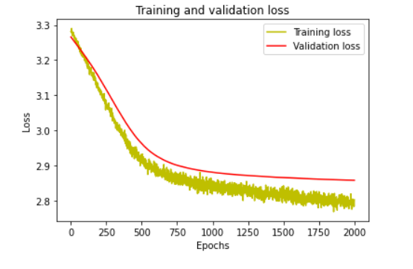

**March 20, 2021 – B**

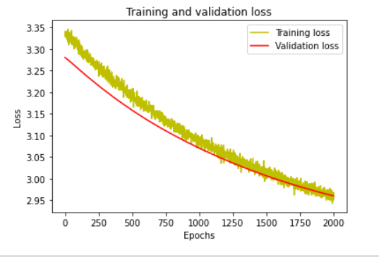

**March 20, 2021 – C**

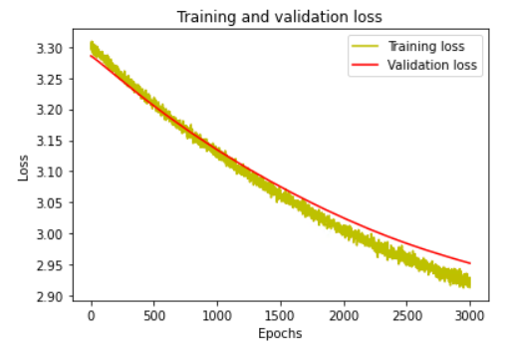

**March 22, 2021**

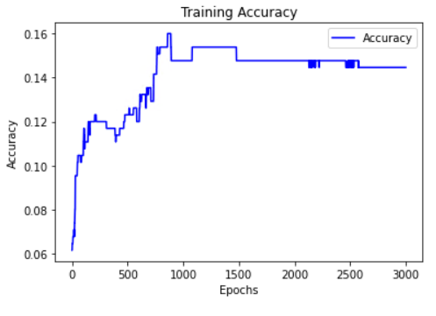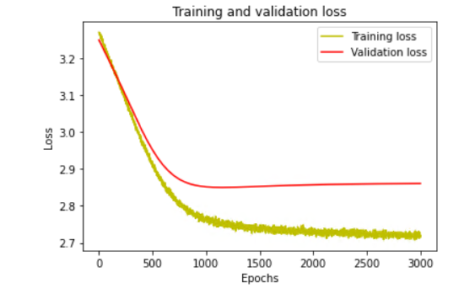

**March 23, 2021 - A**

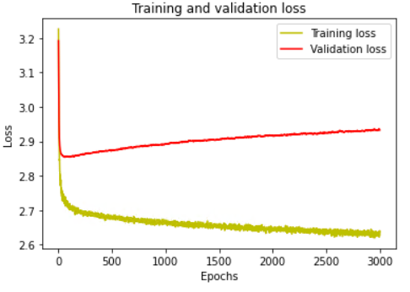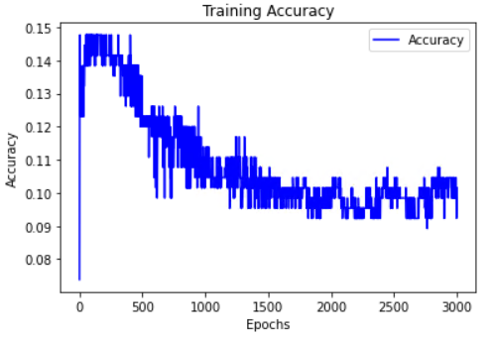

**March 23, 2021 – B**

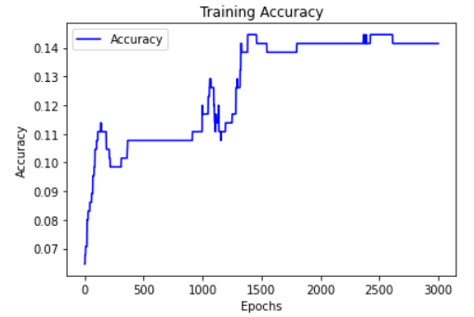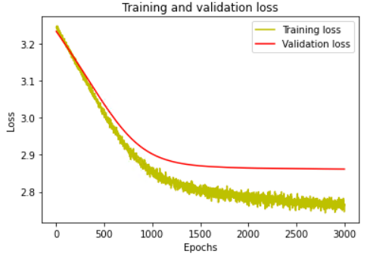

**March 24, 2021**

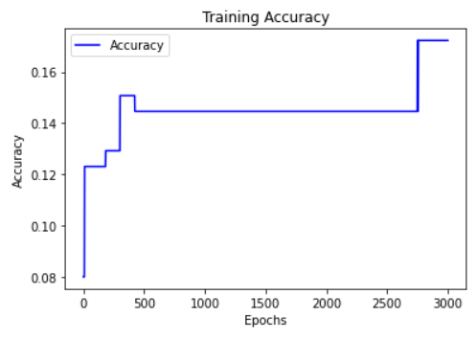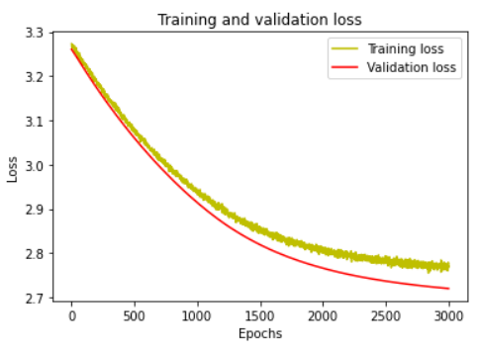

**March 25, 2021 - A**

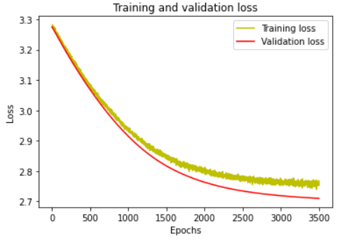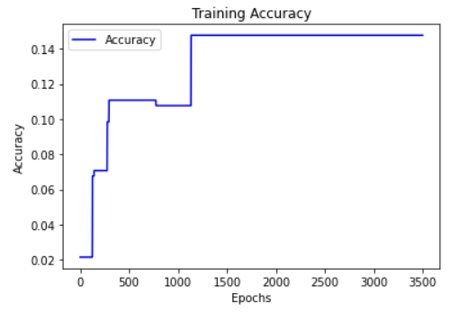

**March 25, 2021 – B**

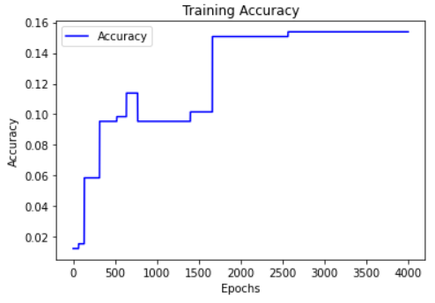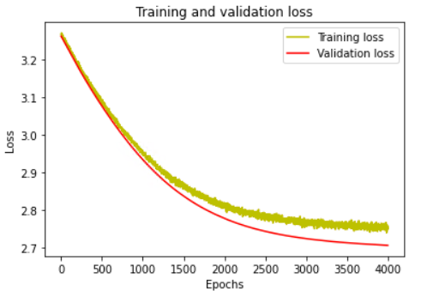

**March 25, 2021 – C**

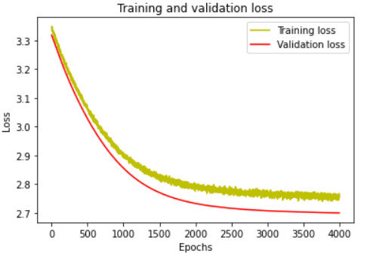 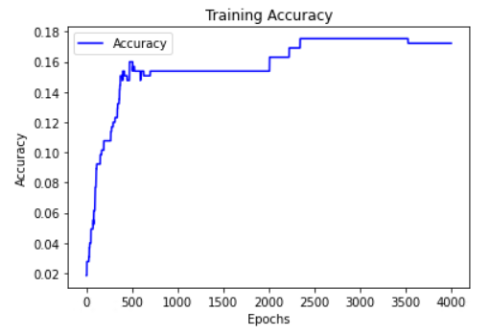

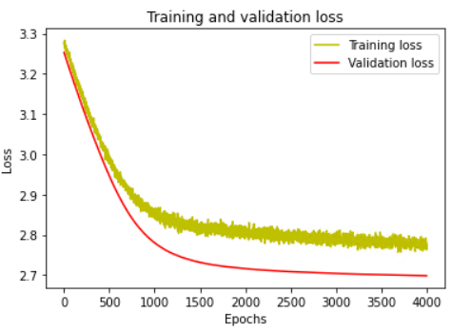**March 25, 2021 – D**

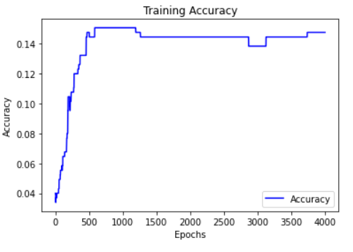

**March 25, 2021 – E**

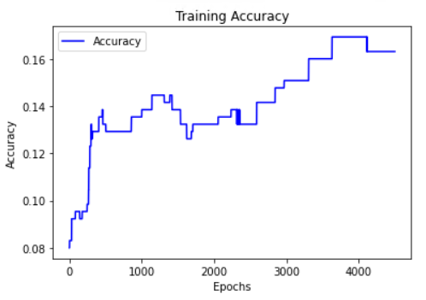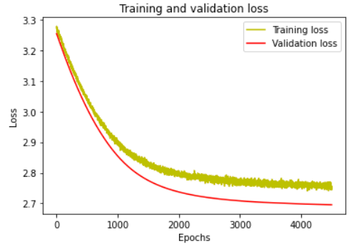

**March 27, 2021 - A**

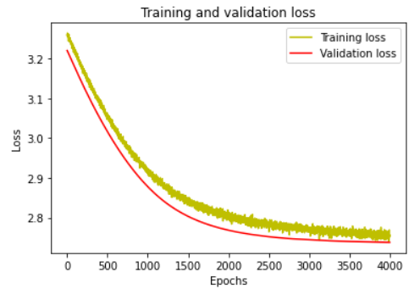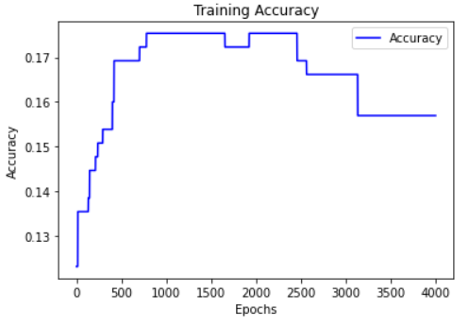

**March 27, 2021 – B**

