|  |  |  |  |  |  |
| --- | --- | --- | --- | --- | --- |
| **Date** | **Accuracy/Loss** | **Features** | **Label** | **Library** | **Notes** |
| April 3, 2021 | 15.64%/2.6542 | * Day_Name (OHE) * Week (circular) | First | Keras | * Numerical order * Min Max scaler * 1 hidden layer (100); relu * Dropout – 0.5 * Output – softmax * Optimizer – Adadelta * Learning rate – 0.001 * Rho – 0.95 * Epsilon – 1e-07 * Loss – Categorical Cross-entropy * Epochs –5000 |
| April 3, 2021 | 14.42%/2.6332 | * Day_Name (OHE) * Week (circular) | First | Keras | * Numerical order * Min Max scaler * 1 hidden layer (100); relu * Dropout – 0.5 * Output – softmax * Optimizer – Adadelta * Learning rate – 0.001 * Rho – 0.95 * Epsilon – 1e-07 * Loss – Categorical Cross-entropy * Epochs –5000 |
| April 6, 2021 | * 15.64%/2.6313 * 7.36%/3.1563 * 5.83%/3.3435 * 5.21%/3.3639 * 6.44%/3.2847 * 9.51%/2.8284 | * Day_Name (OHE) * Week (circular) | * First * Second * Third * Fourth * Fifth * Sixth | Keras | * Numerical order * Min Max scaler * 1 hidden layer (100); relu * Dropout – 0.5 * Output – softmax * Optimizer – Adadelta * Learning rate – 0.001 * Rho – 0.95 * Epsilon – 1e-07 * Loss – Categorical Cross-entropy * Epochs –5000 |
| April 7, 2021 | * 13.19%/2.7446 | * Day_Name (OHE) * Month (circular) | * First | Keras | * Numerical order * Min Max scaler * 1 hidden layer (100); relu * Dropout – 0.5 * Output – softmax * Optimizer – Adadelta * Learning rate – 0.001 * Rho – 0.95 * Epsilon – 1e-07 * Loss – Categorical Cross-entropy * Epochs –4000 |
| April 7, 2021 | * 13.19%/2.7281 | * Day_Name (OHE) * Day (circular) | * First | Keras | * Numerical order * Min Max scaler * 1 hidden layer (100); relu * Dropout – 0.5 * Output – softmax * Optimizer – Adadelta * Learning rate – 0.001 * Rho – 0.95 * Epsilon – 1e-07 * Loss – Categorical Cross-entropy * Epochs –4000 |
| April 7, 2021 | * 15.34%/2.6806 | * Day_Name (OHE) * Day (circular) * Month (circular) | * First | Keras | * Numerical order * Min Max scaler * 1 hidden layer (100); relu * Dropout – 0.5 * Output – softmax * Optimizer – Adadelta * Learning rate – 0.001 * Rho – 0.95 * Epsilon – 1e-07 * Loss – Categorical Cross-entropy * Epochs –4000 |
| April 7, 2021 | * 14.72%/2.6910 | * Day_Name (OHE) * Day (circular) * Week (circular) | * First | Keras | * Numerical order * Min Max scaler * 1 hidden layer (100); relu * Dropout – 0.5 * Output – softmax * Optimizer – Adadelta * Learning rate – 0.001 * Rho – 0.95 * Epsilon – 1e-07 * Loss – Categorical Cross-entropy * Epochs –4000 |
| April 7, 2021 | * 15.34%/2.6842 | * Day_Name (OHE) * Month (circular) * Week (circular) | * First | Keras | * Numerical order * Min Max scaler * 1 hidden layer (100); relu * Dropout – 0.5 * Output – softmax * Optimizer – Adadelta * Learning rate – 0.001 * Rho – 0.95 * Epsilon – 1e-07 * Loss – Categorical Cross-entropy * Epochs –4000 |

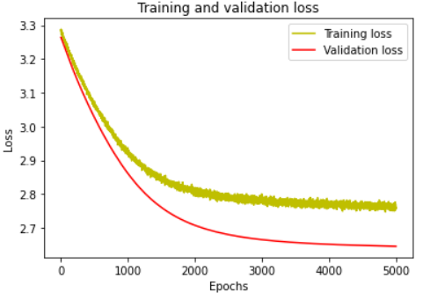**April 3, 2021 – A**

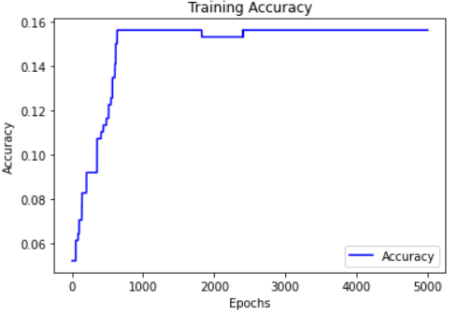

**April 3, 2021 – B**

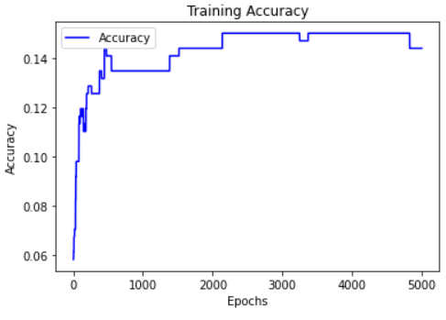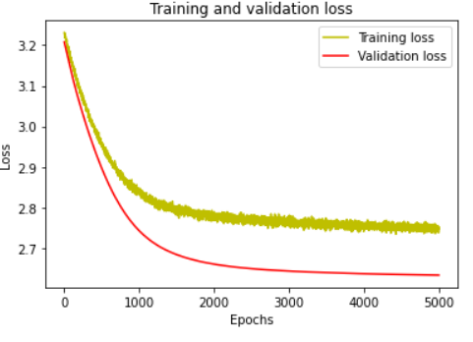

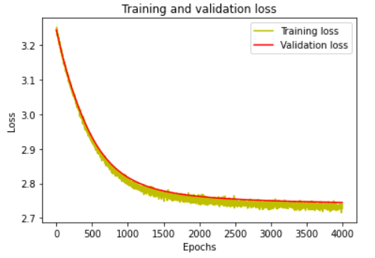**April 7, 2021 - A**

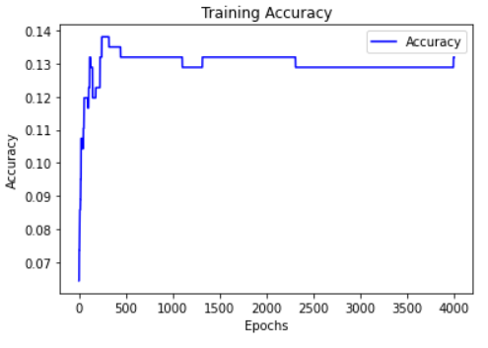

**April 7, 2021 – B**

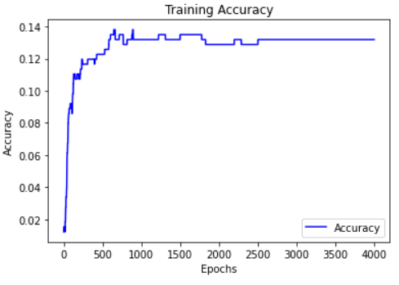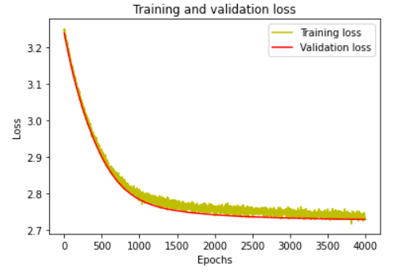

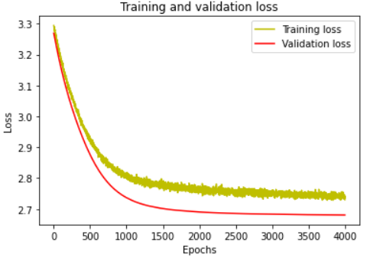**April 13, 2021**

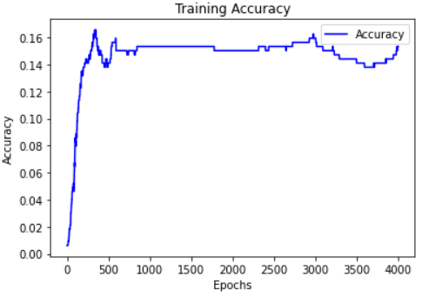

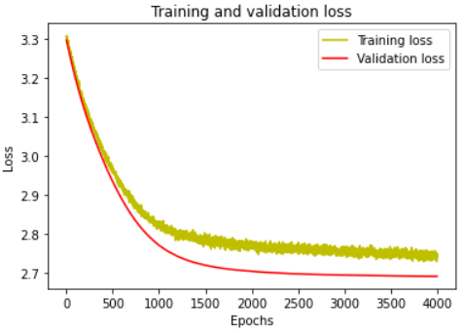**April 13, 2021 – B**

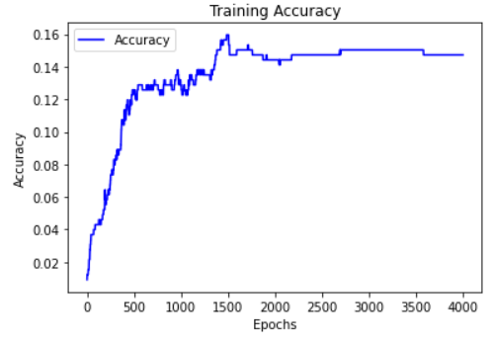

**April 13, 2021 – C**

