

CryptoCrowd Inc

Proposal for Website

Design and Development

Submitted By: Jared Ivory

Table of Contents

1. Website proposal ………………………………………………………………………………………………………………………. 2

2. Site Map ……………………………………………………………………………………………………………………………………. 3

3. Project Schedule …………………………………………………………………………………………………………………………4

**1. Website Proposal**

**Purpose:**

To provide a platform for new and experienced cryptocurrency traders. The site will display the current prices of cryptocurrencies and their price graphs. The daily volumes traded will also be shown per coin. The site will also have recent news of dips and climbs aggregated from other sources to help buyers make educated decisions. Other trading sources will be linked to help teach proper trading techniques and make users better traders.

**Target Audience:**

From beginner to expert, anyone looking to get into the cryptocurrency buying/selling scene. CryptoCrowd Inc appeals to all who want to become more educated in the crypto markets.

**Preliminary Research:**

There are many sites that are already providing cryptocurrency statistics to its users. In the process of creating this site we have analyzed these sites and have incorporated their designs to provide users with a similar experience.

**Design:**

The design of the site will be of minimal design with its content streamlined to the user without much clutter. The site will be heavily based on conventional responsive designs that will allow it to be viewed easily on mobile and desktop. This will be accomplished by using the latest in HTML5, XHTML and CSS technologies. Based on research, the site will have a clean “beginner” view with just simple statistics on each cryptocurrency with an option to change to a “advanced” view with more in-depth stats.

**Project Scope:**

* Logo Assets must be created or obtained with license
* Multiple comprehensive mock-ups must be created
* Find/Create apis to monitor live cryptocurrency statistics

**Summary:**

I, Jared Ivory, am being commissioned to create the custom website “CryptoCrowd”. The site will incorporate designs of other cryptocurrency tracker and will provide Realtime updates to its users.

**2. Site Map**

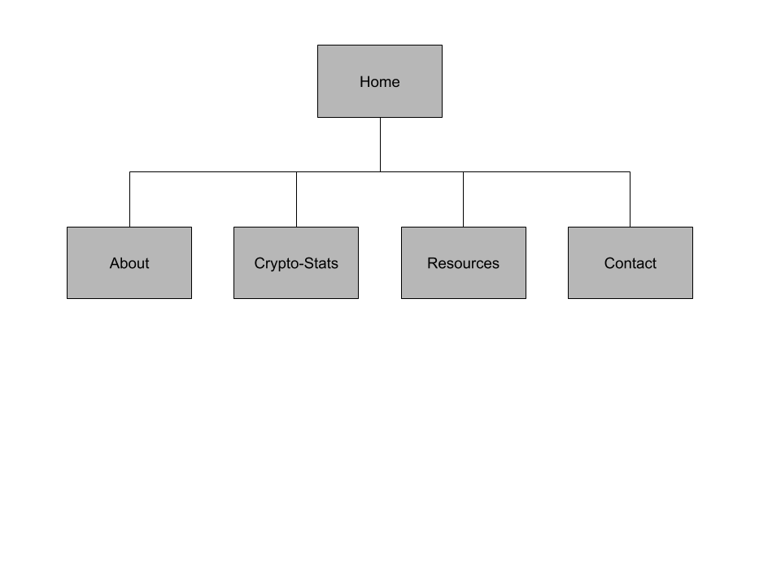

**3. Project Schedule**

**October 29th, 2020:**

Delivery of two comprehensive designs will be submitted for the website. Designs will have concrete definitions for the site structure.

**December 10th, 2020:**

Final draft of the site will be completed.