DRaFF Manual
(Data, Reports and Forms Framework)
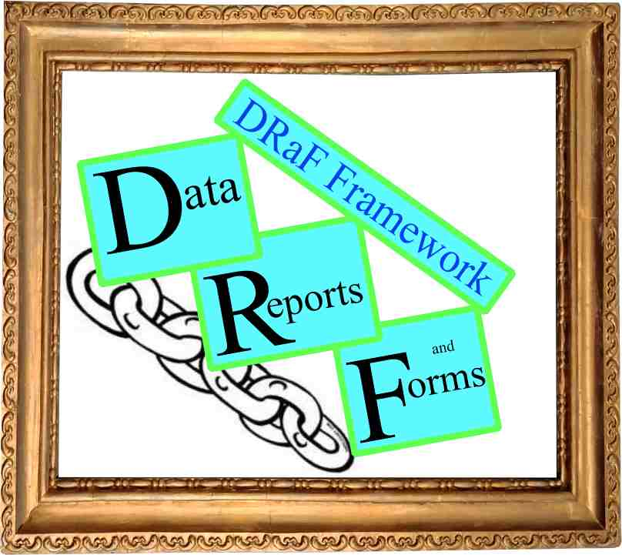
Author: Jared Radin
cat@chessmover.com
Assistance from: Rachel Radin
06/22/2020
Version 020.06.15

Copyright (c) 2020 Jared Radin

As the software is under development and author desires to keep control Permission is hereby granted, to any person obtaining a copy of this software and associated documentation files (the "Software"), to deal in the Software without restriction, including without limitation the rights to use and copy, the Software, and to permit persons to whom the Software is furnished to do so, subject to the following conditions: (1) The above copyright notice and this permission notice shall be included in all copies or substantial portions of the Software. (2) The rights to merge, modify, publish, distribute, sublicense, and/or sell the software is not permitted, subject to change when the software gets more stable.

Note: Names of objects, variables, etc are under development, so at this point need to look at source code to confirm all names. When DRAFF becomes more stable, this documentation will be proof-read to ensure all names are accurate.

draff_chain_sessionData - page 1
Introduction: This class encapsulates the session data that the chain engine uses, including copies of posted data. Other scripts can also use this class. All DRAFF session variables are stored in one array located at $_SESSION ['draff'].

Construct function:
- Function __construct ($pathArray) – finds or creates the array in the $_session variable with the specified path - do not start with 'draff''.
The path will start in $_SESSION ['draff'].

Functions that deal with simple fields in a specific session array.
- Function ses_get ($key, $defaultValue=NULL)
- Function ses_set ( $key, $value) -
- Function ses_exists ($key) – returns TRUE or FALSE
- Function ses_read (&$variable, $key) – This is intended mainly for use in processing posted data. If the $key exists then the &$variable is updated with the value in the (posted) data, otherwise the variable is left alone.
- Function ses_unset ($key)

Functions that deal with the entire array (specific to path in construct).
- Function ses_arrayMerge ($array) – adds this array to existing session data – if identical keys, this array overrides the existing value. This function is useful when copying $_POST into the array that contains posted data from several different forms.
- function ses_arrayIsEmpty.()
- function arrayGet.()
- function arrayGetCount.()
- function ses_arrayClear.()

draff_chain_sessionData - page 2

Example 1 – storing security in $_session:
when logging on:
$securitySession = new draff_chain_sessionData( array('security') );
$userSecuritySession = new draff_sessionData( array('security', 'currentUser') );

if ( $userSecuritySession->ses_arrayIsEmpty()) {
// process login form
// and when this form is submited and validated
// perform this code
$userSecuritySession->ses_set('name',$userName);
$userSecuritySession->ses_set('when', $currentTime );
$userSecuritySession->ses_set('readOnly',TRUE);
}
$userName = $userSecuritySession->ses_get('name');

when logging off:
$userSecuritySession->ses_arrayClear(); // empties the array for user
$securitySession->ses_unset('currentUser'); // eliminates array for user

draff_chain_engine - page 1

Introduction: The chain engine controls the flow of forms and scripts.
- When a script is executed, there should always be a chain-id in it's URL. This ensures that the status of the script is know, and refreshing, back , and forward should work as expected.
  - If the chain-id is unknown it's status is marked as current.
  - If the chain-id is the current chain id then it's a refresh, and fairly normal processing.
  - If the chain-id is known as an older chain id then it's status is retrieved, and the data relaoded from the database with appropiate status message (optional?). Also it's status is marked as current.
- If a url does not have a chain id, before the script generates output, there will be a redirect to this script with the addition of a chain-id. i.e. There is always a chain-id when the url is displayed.
- When a form is submitted several two things can happen
  - The data is valid, and saved. In this case the next visible form will have a new chain-id, whether it's the same script or a new script.
  - There is more processing to be done for this data set – either due to errors or multiple pages before the data is saved. In this case the chain-id is unchanged.

public $chn_posted; // this is data posted by forms – this data is preserved when redirected.
public $chn_shared; // shared between tabs, one value for all tabs and all chain ids– this data is preserved when redirected.
public $chn_status; // this is data status of chain - not posted/form data– this data is preserved when redirected. This is used by rsm, but can also by used by any script (but must not change rsm data ??? need to specify)
function rsmChain_script_continue() { // always same script
function rsmChain_script_execute () { // can be same or new script – new chain id is generated

draff_chain_engine - page 2
I
Example 1 – typical script flow illustrating how chain typically works:

Class appForm_staff_select extends draf_form_object {
// this illustrates how a form object is used
// the chain engine calls the below functions automatically

function appProcess_submit ( $appData, $appGlobals, $appChain ) {
// this is called after this form is submitted
// can check which button was used when submitting
// get any posted data and process it – when ediitng validate it and then save some data to database
// in this case a contact name has been submitted, so now must luanch the form to edit it
if ( $appChain->chn_submit[0] == 'contactId' ) {
$appChain->chn_status->ses_set ( 'contactId' , chn_submit[1] );
$appChain->chn_form_launch ( PAGE_EDIT_CONTACT );
}
}

function appInit_data( $appData, $appGlobals, $appChain ) {
// get data – data which is not chained is usually kept in the appData object
// the data could be kept in this class, but then the form and data are not seperated
// and one of the goals of this framework is to keep data and cosmetics seperated
$appData->contactList = $appData->apd_init_selectMap_contacts( $appGlobals );
}

function appInit_html( $appData, $appGlobals, $appChain, $appEmitter ) {
// init the html page – but do not output it here
// things to initialize include html page title, menus, styles, java-script, etc
// output is not done here, as output can be exported to excell or pdf
// which will still need some, but not all, of the information in the html head
$appEmitter->set_theme( 'theme-select' );
$appEmitter->set_title('Staff List');
}

function appInit_form( $appData, $appGlobals, $appChain ) {
// initialize the fields on this form
foreach ($appData->current_ contactList as $contactId => $contactName ) {
$this->drafForm_define_button( 'contactId_' . $contactId , $contactName );
}
}

// continued on next page

draff_chain_engine - page 3
Example 1 – continues - typical script flow illustrating how chain typically works:

function appOutput_entirePage ( $appData, $appGlobals, $appChain, $appEmitter ) {
// output a page – normal page proccessing can be overridden here
}

function appOutput_headers ( $appData, $appGlobals, $appChain, $appEmitter ) {
// this is the header for the content which will be below
// this area should not be scrollable, and not generally very high
}

function appOutput_content ( $appData, $appGlobals, $appChain, $appEmitter ) {
// output the main content of this form
// this is the only area which is scrollable and will fill as much of the window as possible,
// after outputting the other areas – banners, menus, errors, header, footer, etc
$appEmitter->zone_start('zone-content-scrollable theme-select');
foreach ($appData->current_ contactList as $contactId => $contactName ) {
$appEmitter->content_field('@contactId_' . $contactId);
}
$appEmitter->zone_end();
}

function appOutput_footer ( $appData, $appGlobals, $appChain, $appEmitter ) {
// this is the footer for the content which is above
// this area should not be scrollable, and not generally very high
}

} // end class

$appChain = new draff_chain_engine( $appData, $appGlobals, 'kcmKernel_emitter' );
$appChain->chn_form_register(PAGE_STAFF_SELECT,'appForm_staff_select');
$appChain->chn_form_register(PAGE_STAFF_VIEW,'appForm_staff_view');
$appChain->chn_form_register(PAGE_STAFF_REPORT,'appForm_staff_report');
$appChain->chn_form_launch(); // proceed to current step

?>

