Frad Manual
(Forms, Reports and Data Framework)
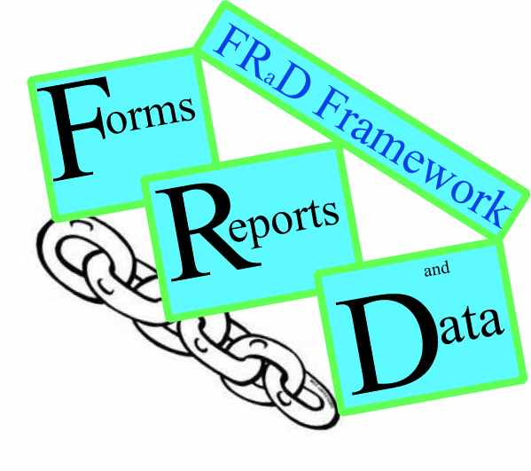
Author: Jared Radin
Assistance from: Rachel Radin
06/22/2020

Copyright (c) 2020 Jared Radin

Permission is hereby granted, free of charge, to any person obtaining a copy
of this software and associated documentation files (the "Software"), to deal
in the Software without restriction, including without limitation the rights
to use, copy, modify, merge, publish, distribute, sublicense, and/or sell
copies of the Software, and to permit persons to whom the Software is
furnished to do so, subject to the following conditions: The above copyright notice and this permission notice shall be included in all copies or substantial portions of the Software.

Contents:

Include Files
frd_chain
frd_form
frd_objects
frd_functions

Objects

Variable Naming Conventions

Variable Naming Conventions

dbRecord_ a database record extended from the rsm_database_record_object.

joinMap – an array which is an array of dbRecords, in which the join property may be another record or array of records

selectMap – a map suitable to generate an html select. Typically the key is the index of a record or option-id and the array element is a string suitable for displaying in a select, This structure is also frequently used to display a button for each element.

Functions to get maps:
getMap_ name of map _ <type of map = 'select' or 'records' or 'joins' >

Database Objects

class rsm_database_engine extends PDO {

There should only be object created for each database
There are two ways of executing a query
- Pass it in as a string with optional bindings
- Pass it in as a query object. A query object makes generating code involving tables easier in many cases.

function __construct( $host, $dbName, $userId, $password, $charset = 'utf8_unicode_ci')
Creates the database engine and connects to the database

function rsmDbe_bindParam( $symbol, $value, $type=NULL )

function rsmDbe_execute( $sqlCommand, $placeholders=NULL) : PDOStatement {
function rsmDbe_execute( rsm_database_query $query ) : PDOStatement {
xxx

There will be additional methods to handle transactions, etc

class rsm_database_query {

Generally speaking, a new object should be created for each query.

function rsmDbq_set($asIsQuery, $bindings=array() ) {

function rsmDbq_selectStart() {

function rsmDbq_selectAddColumns($recordClassName, $options=NULL) {

function rsmDbq_selectAddString($string) {

function rsmDbq_addBinding($arrayOrKey, $value=null ) {

function rsmDbq_start() {

interface rsm_database_record {

static function rsmDbr_getColumnNames($options=NULL);
static function rsmDbr_getInfo();

class rsm_database_record_object {
This

class rsm_database_joiner {
This

Chain Objects

class rsm_chain engine {

The chain engine controls the flow of forms and scripts.
- When a script is executed, there should always be a chain-id in it's URL. This ensures that the status of the script is know, and refreshing, back , and forward should work as expected.
  - If the chain-id is unknown it's status is marked as current.
  - If the chain-id is the current chain id then it's a refresh, and fairly normal processing.
  - If the chain-id is known as an older chain id then it's status is retrieved, and the data relaoded from the database with appropiate status message (optional?). Also it's status is marked as current.
- If a url does not have a chain id, before the script generates output, there will be a redirect to this script with the addition of a chain-id. i.e. There is always a chain-id when the url is displayed.
- When a form is submitted several two things can happen
  - The data is valid, and saved. In this case the next visible form will have a new chain-id, whether it's the same script or a new script.
  - There is more processing to be done for this data set – either due to errors or multiple pages before the data is saved. In this case the chain-id is unchanged.

public $chn_posted; // this is data posted by forms – this data is preserved when redirected.
public $chn_shared; // shared between tabs, one value for all tabs and all chain ids– this data is preserved when redirected.
public $chn_status; // this is data status of chain - not posted/form data– this data is preserved when redirected. This is used by rsm, but can also by used by any script (but must not change rsm data ??? need to specify)
function rsmChain_script_continue() { // always same script
function rsmChain_script_execute () { // can be same or new script – new chain id is generated

