Draft #3

Jared Cheney, Andrew Meraz and Doug Asker

Project 1 – Database Design

**Car-Repair Shop Reservation System: JADautorepair**

**Description**

JADautorepair database is a normalized database designed for car-repair shop reservation system where the customers can request to repair their cars in the shop.

The system stores the information about the customer, car, service, and item. This information is maintained (add, update, delete) by the administrator. One customer can have multiple cars being serviced.

The employee will create the order for the order transaction. The order references to the customer, car. It also stores the request date. Each order has many lines. Each line is for one service such as oil change, brake repair, water pumps…

Each requested service is served by one employee. Each service has the specific price. The requested service can use many item parts such as door control module, battery tray, air intake manifold… Each item has the specific price too.

Assumption

The system does not keep track the payment such as car number…

The car belongs to one customer. Each customer can have one or many cars.

Services Page:

To view services:

Click button to view all services and prices

Customer Page:

To place order:

Enter:

Username

Password

first_name

last_name

phone_number

car_make

car_model

car_year

To view order:

Enter:

Username

Password

Employee Page:

To place order:

Enter:

Username

Password

customer_id

service_id

DBs:

Service

Id, Name, Price

Customer

Id, Username, Password, first_name, last_name, Phonenumber,

Car

Id, car_make, car_model, car_year, customer_Id

Employee

Id, first_name, last_name,Username, Password

Orders

Id, Car_Id, Customer_Id, Service_Id

ERD

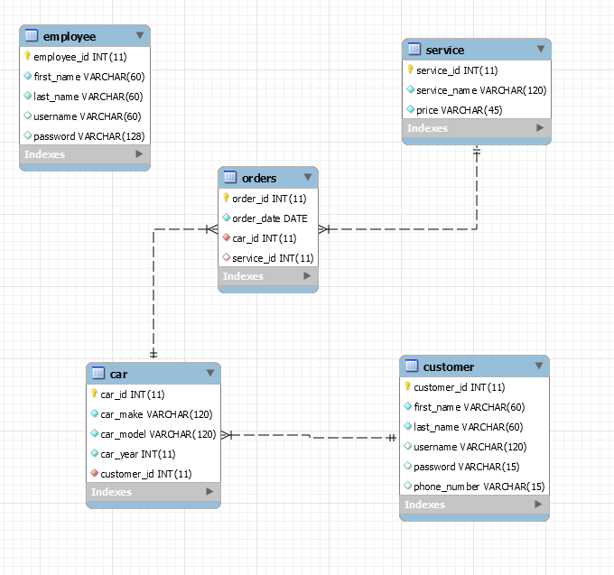

Tables

