Jared Brown  
Exercise 9.4  
WEB 230  
2/11/18

Setting a breakpoint and stepping through a program in Firefox:

1. Open up Firefox and click F12.
2. Choose the Debugger tab.
3. Choose the file you want to debug.
4. Click on a line to set a break point.
5. Execute the JS either by reloading the page, or triggering it through an action.
6. Note the scopes menu on the aside. You can use this to check the value of different variables at this point in execution.
7. Click on the stepover button (F10) to execute the next instructions.

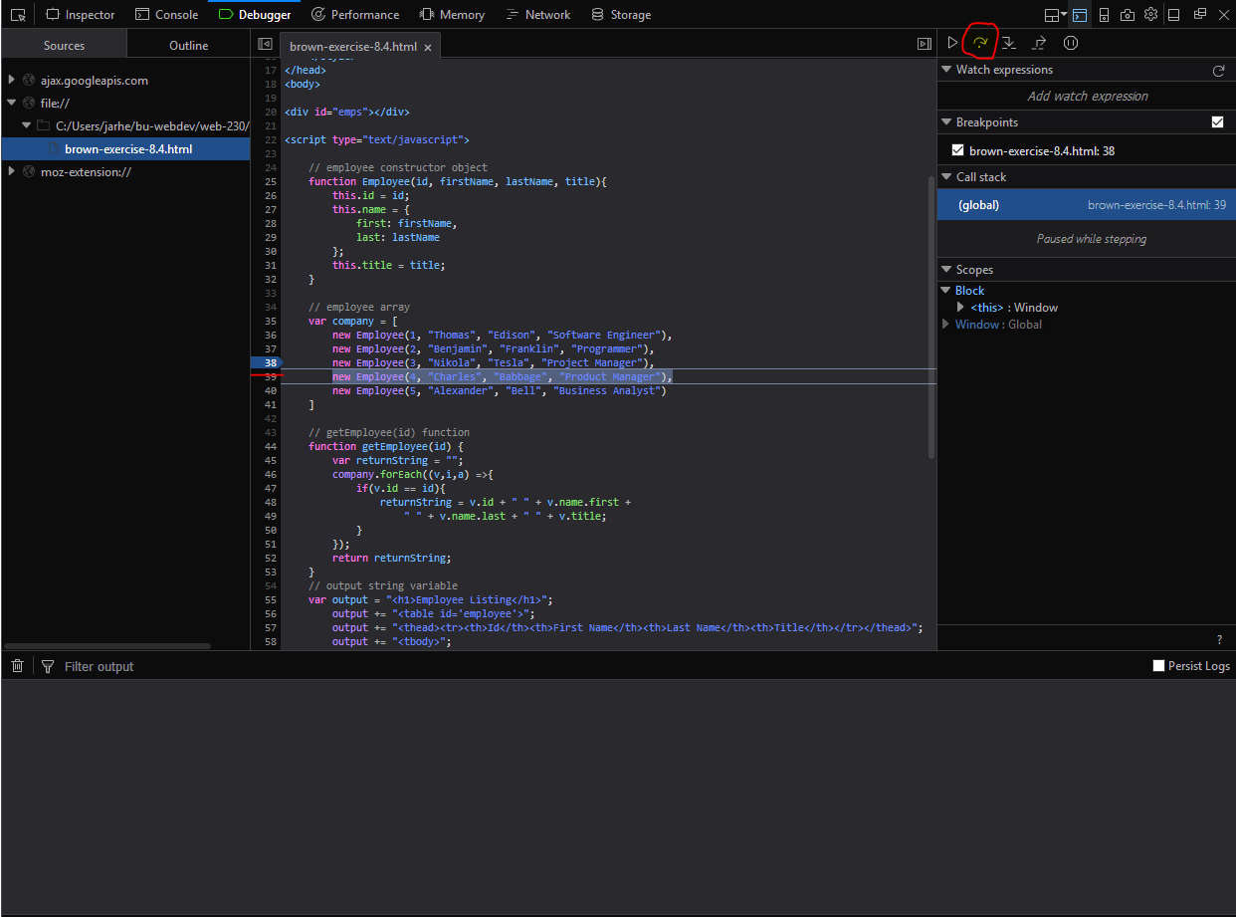

Logging and reading logged messages:

1. You can log messages using console.log(<message>) in your code
2. Anything logged will be logged out to the console which you can access by pressing F12 and then selecting the console tab.
3. You can view where in the code console.log() was called by looking to the right of the message.

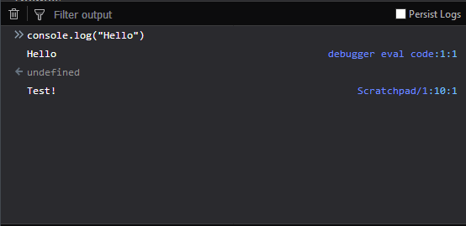Selecting elements within the console:

1. Toggle split console (press Esc or press the button).
2. Make sure you have the inspector up with the console below
3. Select an element
4. Use $0 to denote the currently selected element in the console.
5. 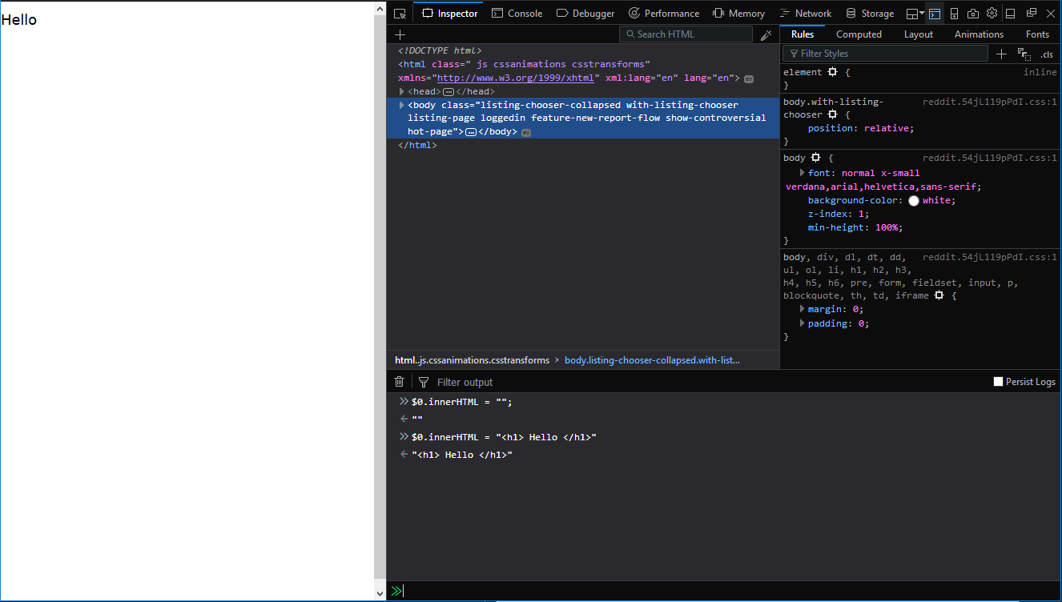See example below

Applying pseudo classes in Firefox developer tools:

1. Open up the dev tools using F12.
2. Select the inspector tab.
3. Select the rules tab.
4. Select the element you wish to apply the pseudo class to.
5. Click on the Toggle-Pseudo Classes button
6. Select the Pseudo class you wish to activate
7. Note the change being applied.

