Jared Brown + Matthew Howard

WEB-320

PETS-R-US GROUP PROJECT

January 2018

GROUP ACTIVITY #1

Product Owner Perspective (Stories chosen by Matthew):

1. As the product owner, I want customers to be able to check-in online so that the appointments can go quickly.
2. As the product owner, I want the site to be simple and intuitive so that we can market the site to as wide of a base as possible.
3. As the product owner, I want the customers to be able to choose their groomers so that the users can feel better about booking their appointments.
4. As the product owner, I want users to be able to pay online so that users will find it more convenient and use the service.
5. As the product owner, I want the users to be able to use make appointments with only a few clicks of the mouse so that users will be more likely to use the service.

UI/Designer Perspective (Stories chosen by Jared):

1. As a User I need to be able to schedule future appointments, so I can have my dog groomed.
2. As a User, I need to be able to change my future appointment so that if something comes up I can get my dog groomed at a later date (or earlier).
3. As a User, I need to be able to view past appointments so that I have a record of them for billing purposes.
4. As a User, I need to be able to contact someone in case I have trouble scheduling an appointment.
5. As a User, I need to be able to add information about my dog so that the staff can prepare for any needs in advance.

|  |  |
| --- | --- |
| # | Story |
| 1 | As the product owner, I want customers to be able to check-in online so that the appointments can go quickly. |
| 2 | As the product owner, I want users to be able to pay online so that users will find it more convenient and use the service. |
| 3 | As the product owner, I want the site to be simple and intuitive so that we can market the site to as wide of a base as possible. |
| 4 | As the product owner, I want the users to be able to use make appointments with only a few clicks of the mouse so that users will be more likely to use the service. |
| 5 | As the product owner, I want the customers to be able to choose their groomers so that the users can feel better about booking their appointments. |
| 6 | As a User, I need to be able to contact support in case I have trouble scheduling an appointment. |
| 7 | As a User, I need to be able to add information about my dog so that the staff can prepare for any needs in advance. |
| 8 | As a User I need to be able to schedule future appointments, so I can have my dog groomed. |
| 9 | As a User, I need to be able to change my future appointment so that if something comes up I can get my dog groomed at a later date (or earlier). |
| 10 | As a User, I need to be able to view past appointments so that I have a record of them for billing purposes |

|  |  |  |  |
| --- | --- | --- | --- |
| Stories | Tasks | Hours | Points |
| Tasks for User Story #1 | Create wireframe for check-in page | 4 | 2 |
| Create user storyboard and flow for check-in page | 2 | 4 |
| Implement DB queries for checking and setting check-in values | 5 | 6 |
| Implement front-end webpage | 4 | 5 |
| Implement client-side code for checking-in | 5 | 5 |
| Implement server-side code for handling check-ins | 7 | 9 |
| **Summary** |  | **27** | **31** |
| Tasks for User Story #2 | Create a wireframe of the payment page | 4 | 2 |
| Create user storyboard for payment page | 2 | 4 |
| Implement front-end for payment page | 5 | 6 |
| Implement client-side code for paying for an appointment | 4 | 6 |
| Implement server-side payment API (such as stripe) | 8 | 9 |
| **Summary** |  | **25** | **27** |
| **Total Summary** |  | **52** | **58** |

GROUP ACTIVITY #2

GROUP ACTIVITY #3

Sketch 1 (Jared Brown):

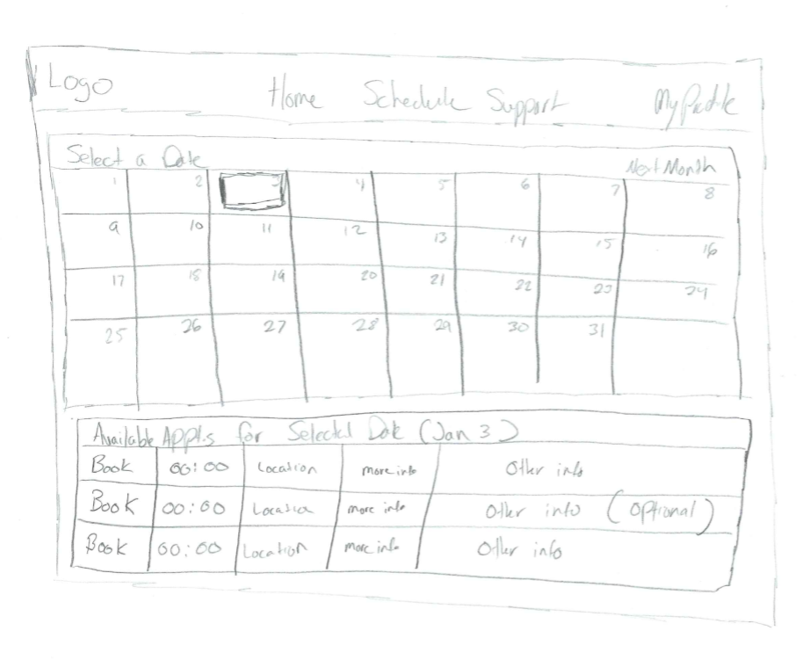

Sketch 2 (Matthew Howard):

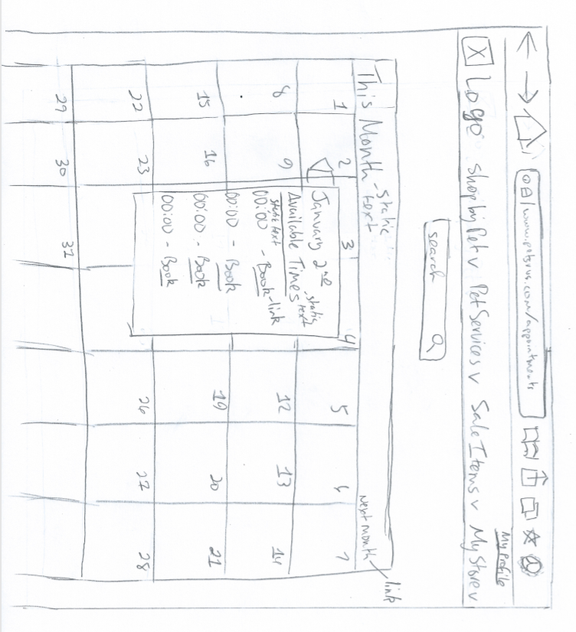

Make any necessary refinements and agree upon the final version of the wireframe to represent the team.

Both of our sketches improve on our previous designs from previous assignments. We also borrowed parts from each other’s designs to create what we thought would best work for this site. Our team will use Jared’s Wireframe to represent the “booking an appointment” functionality for this web app. Jared’s sketch reaches a compromise between the calendar style page and the list/table style as when the user selects a date, a normal table appear below which displays available appointments for that date. Users will be able to understand this best, and implementation of this will be easier to achieve than the other design which is primarily calendar based. Our chosen design will also work better on smaller screens and even some mobile devices.

What challenges did the team face or lessons did the team learn during each this requirement elicitation exercise overall?

The biggest challenges we faced were our different understandings of the project requirements as we each had a differing interpretation of them. We overcame this by talking out each requirement and coming to a consensus on what needed to be done.

Another issue we ran into was our differing experience when it comes to web development. This played out when we used planning poker to assign points and hours to each of the tasks we chose. We were able to work through this by compromising and meeting in the middle in terms of assign points. This is part of the value of planning poker itself.