Jared Brown | 1/28/18 | WEB 320 | Exercise 7.1

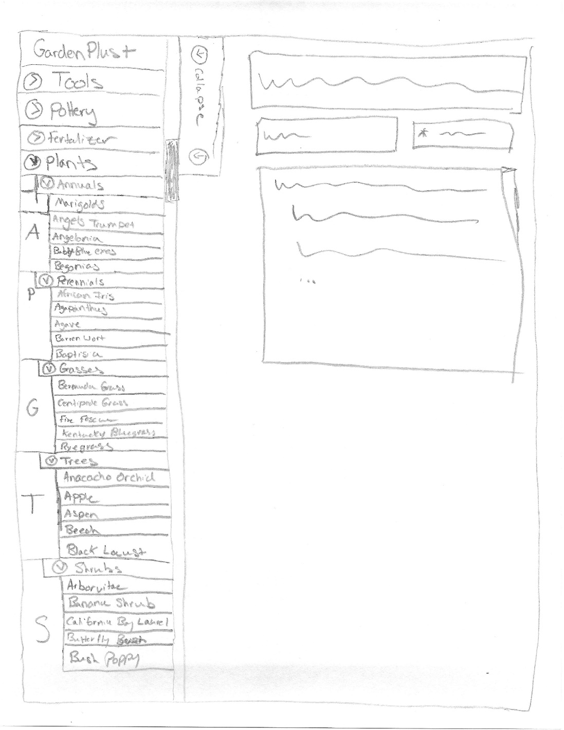

**First Design:** My First Design incorporates a side menu which itself incorporates collapsible categories and item. The advantage is that this can be incorporated on any page in the site, but the disadvantage is that it is cluttered.

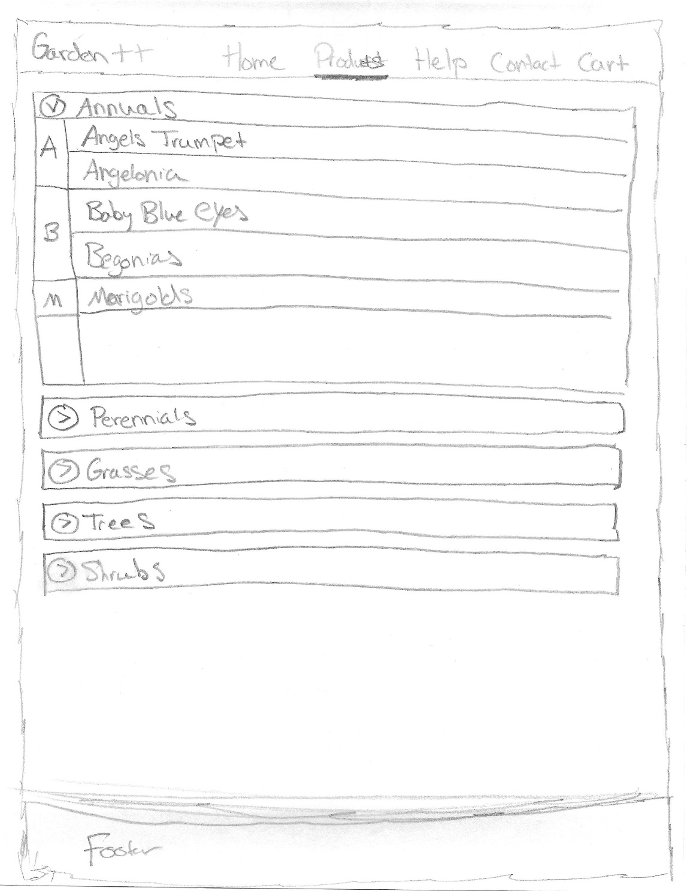

**Second Design:** My Second design utilizes a separate page for the menu system. The advantage is that there is more room for items and there can be bigger text and logos making it easier to navigate. The drawback is that it is its own separate page which needs to be navigated to in order to use it.