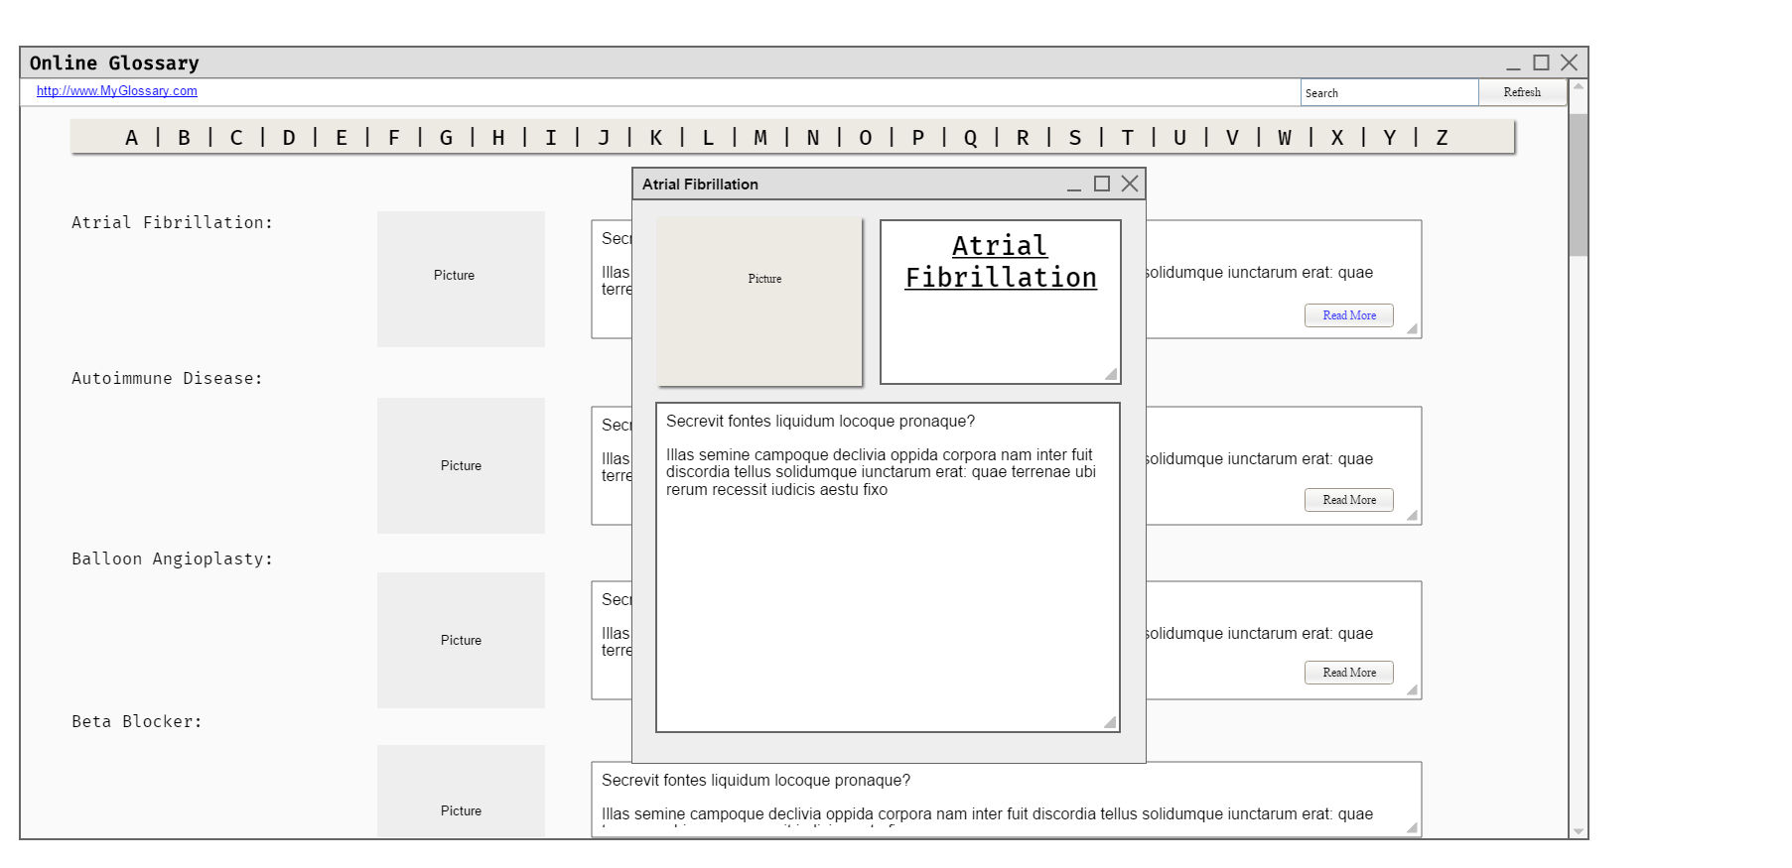

**Design 1:** Design 1 uses a new window which displays when the user clicks the read more button under each entry. A bigger photo and the full text pops up. This design allows for a compact listing of glossary terms to be displayed. The downside is that it will create a new window, which different browsers might handle differently, or not at all.

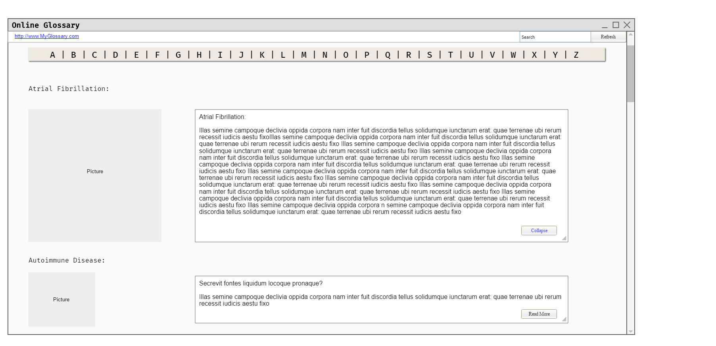

**Design 2:** Design 2 increases the size of the textbox and picture when the user clicks “Read More” displaying the full text. This moves all of the other entries down and out of the way. When the user clicks “Collapse” the entry is changed back to the default size. This allows user to quickly read more about the entry, without the need for popup windows which might be blocked.