Jared Brown  
1/28/18  
WEB-320  
Exercise 7.4

*Chapter 7 | Exercise 1 | Page 165*

For the following groups of items, specify whether a tab control would be appropriate for organizing the items in each group.

* Clothing, Sporting Goods, Hardware, Cosmetics, School Supplies.  
    
  These items would be appropriate to organize into different tabs in a menu system. There is no shared hierarchy between them; they simply represent different categories that could be found on the store’s site.
* Baseball, Football, Basketball, Hockey, Soccer, Standings, Player Statistics  
    
  These items would not be appropriate for grouping. The first four items establish a grouping based on type of sport, while the last two break from that establishment and introduce sports numbers.
* Cars, Trucks, Boats, Airplanes  
    
  These items would be appropriate for grouping into tabs. They all represent a class of vehicle and have established hierarchy.
* Maples, Firs, Pines, Beeches, Walnuts, Oaks, Aspens, Cedars, Spruces, Firs, Lindens, Sycamores, Hickories  
    
  These items would not be appropriate to group together as it contains duplicates (firs) and also includes a hierarchy within by including Beeches and Oaks which belong to the same family (family fagaceae) while other entries are actually their own genus like Hickories (genus Carya).

//Part II (Exercise 1 Page 191) on next page

*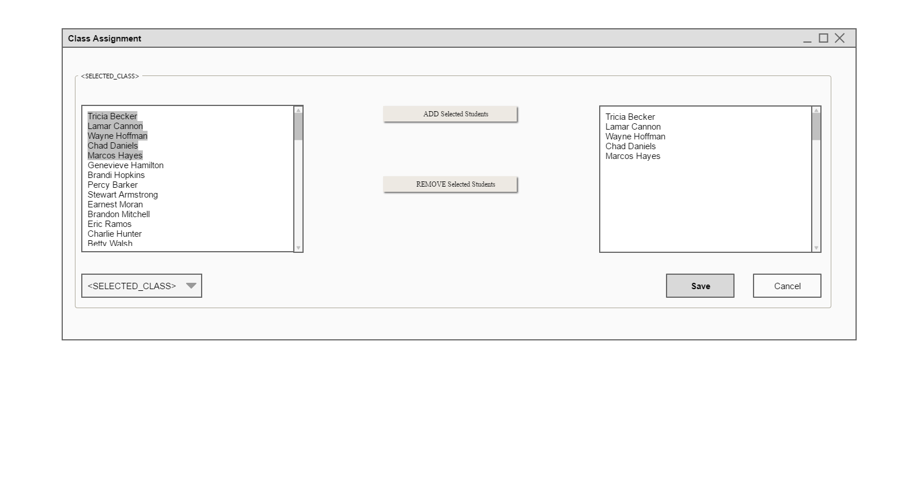Chapter 8 | Exercise 1 | Page 191*