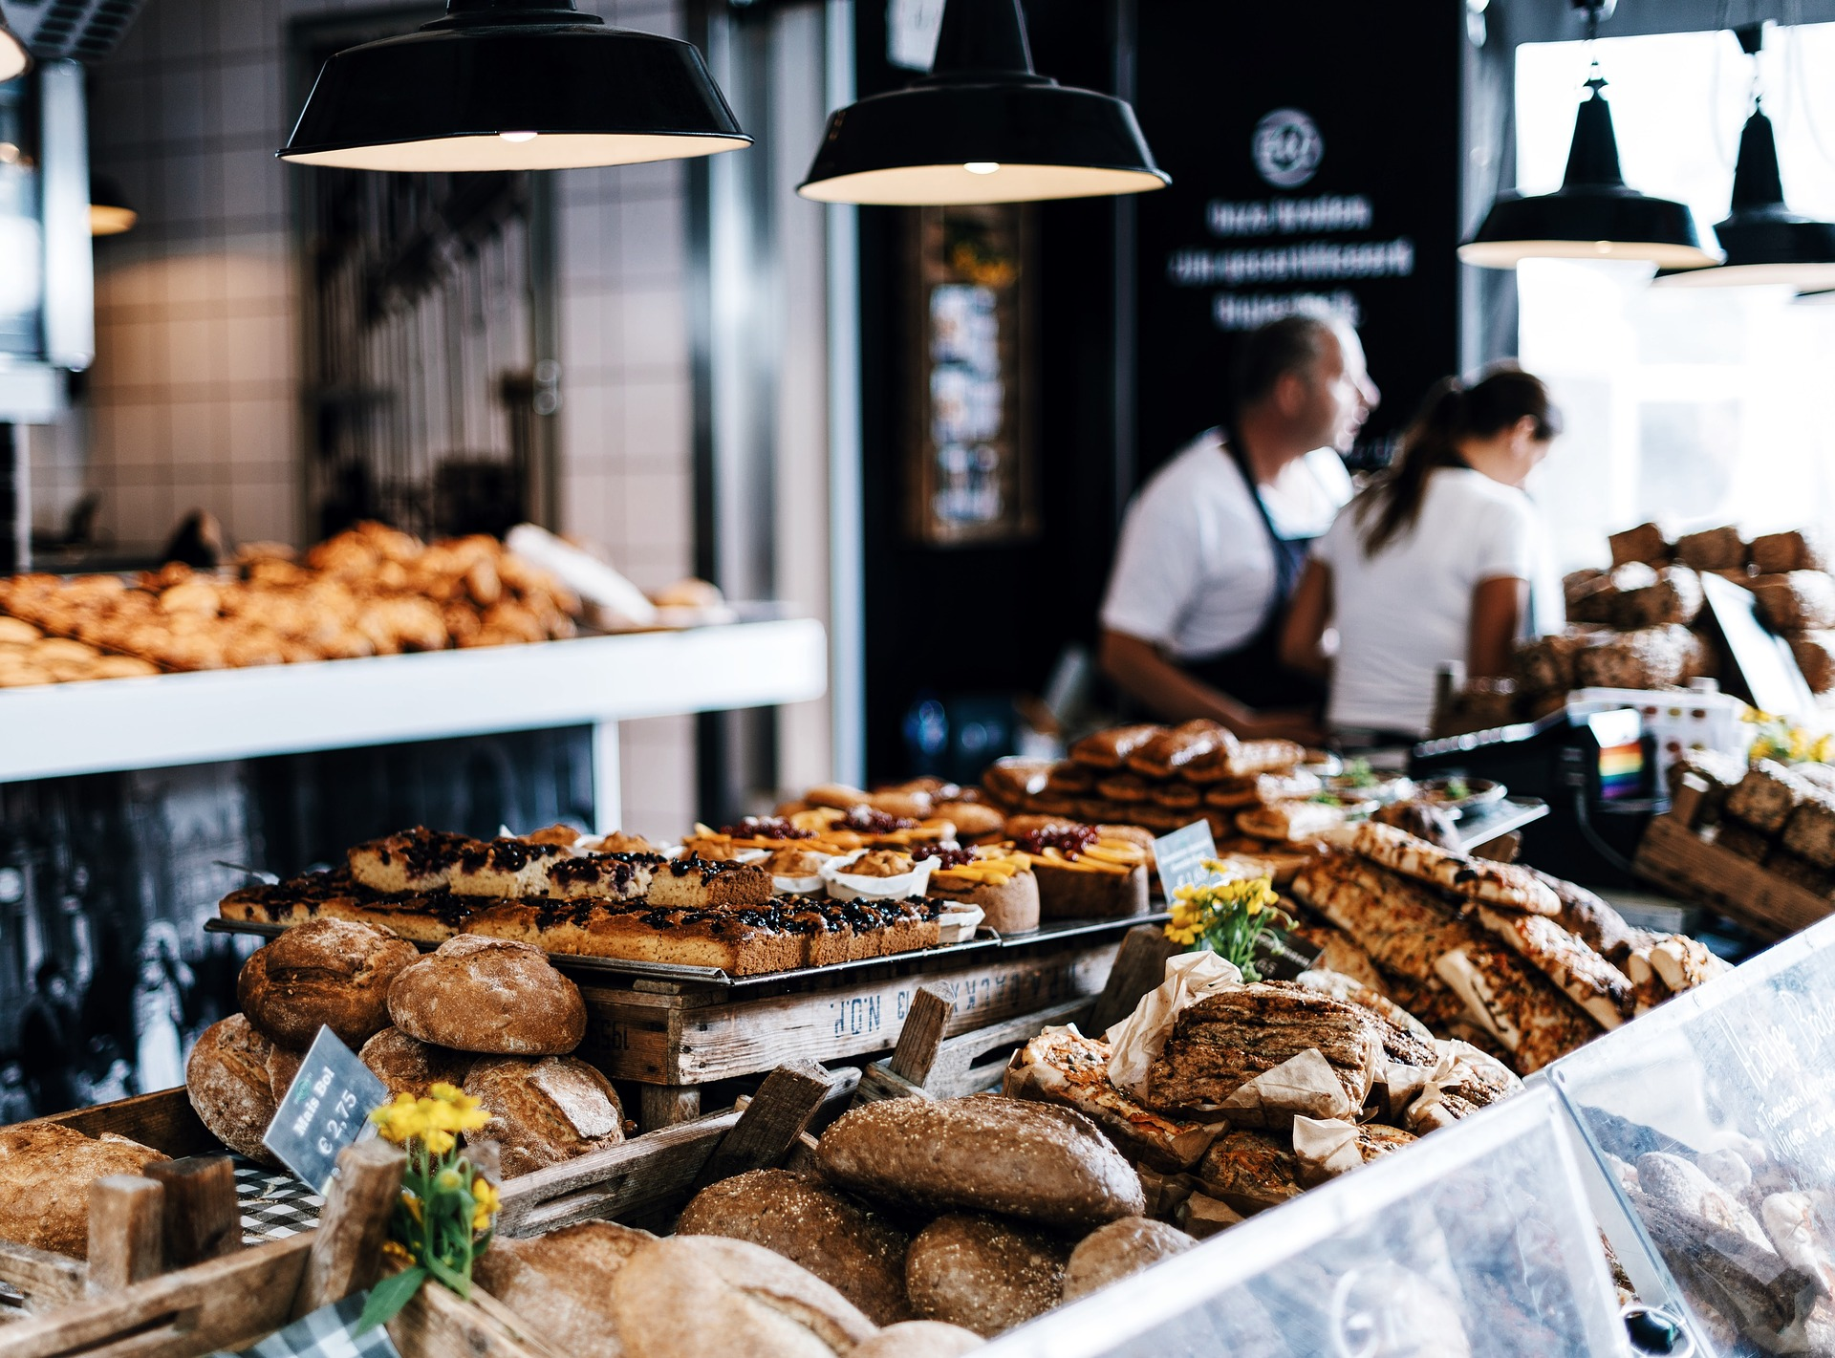

Proposal Response

A Sweet Solution for Bake-Plus’s Tasty Pastry

Jared Brown | WEB 320 | February 11, 2018

# Table of Contents

Table of Contents 2

1. Goals of this Project 3

2. Core Users 3

3. User Personas 3

4. Executive Summary 9

5. Our Proposal 10

6. Product Owner Requirements 12

7. Developer Requirements 12

8. Example Wireframes 13

9. Accessibility 14

10. Made 14

11. Disclaimer 14

12. Links 15

# Goals of this Project

The goal of this project is to provide the customers of Bakery-Plus with the ability to order baked goods from the bakery online. Customers can order online either to have their order ready for pick-up in store or have the order delivered to their home. The site will include design and development considerations outlined in the RFP such as the ability for users to create accounts, viewed featured products, view estimated shipping costs, and more.

# Core Users

1. Regular Customers who want to order ahead to reduce wait times
2. Regular Customers who want their usual order sent to their home
3. Irregular Customers who want to view specials and featured products and may or may not purchase from the bakery.
4. Individuals who have searched for a local bakery and found the site and may or may not purchase from the Bakery.
5. Individuals who live farther away from the bakery and order online as it is the only feasible way to order.

# User Personas

User personas are the personification of different user types. They help us get a better idea of the types of users that will be using the site.

|  |  |
| --- | --- |
| Persona: The Regular Customer (pickup) | |
| Picture | Sunglasses, Beard, Sky, Business, Man, Guy |
| Name | Jerry Miller |
| Distinguishing Characteristics | Loves the bakery and is eager to use the new site to order ahead. |
| Most used features for application | Ordering to Pickup at store |
| Least used features for application | Having his order shipped to his house |
| Needs that application can meet for this user. | Reduce the amount of time it takes to get his order. |
| Computer Skill Level | Average |
| Likely Age Range | 30 – 70 years |
| Time Spent in Application | 10/min a day |
| Devices Used | Likely Mobile |

|  |  |
| --- | --- |
| Persona: The Regular Customer (delivery) | |
| Picture | Grandma, Happy, Family, Grandmother, Senior, Old, Woman |
| Name | Teresa Butler |
| Distinguishing Characteristics | Loves products from the bakery but has a hard time leaving her house. |
| Most used features for application | Delivery of products to her home |
| Least used features for application | Ordering ahead |
| Needs that application can meet for this user. | She will be able to order and have the product shipped to her house, meaning she can order more often and view new products online. |
| Computer Skill Level | Novice |
| Likely Age Range | 50-90 years |
| Time Spent in Application | 30 minutes /day | 1-2 times a week |
| Devices Used | Desktop |

|  |  |
| --- | --- |
| Persona: The Irregular Customer | |
| Picture |  |
| Name | Jonathan King |
| Distinguishing Characteristics | Likes to go to the bakery, but doesn’t go often. |
| Most used features for application | Viewing promotions, new products, and getting coupons/deals |
| Least used features for application | Ordering for home delivery |
| Needs that application can meet for this user. | This user will be able to use the site and application to keep in touch with bakery and see new products and deals. |
| Computer Skill Level | Average to good |
| Likely Age Range | 18 - 60 |
| Time Spent in Application | 15/min a week |
| Devices Used | Laptop/mobile |

|  |  |
| --- | --- |
| Persona: The Searcher | |
| Picture | Young, Sunset, Male, Guy, People, Person, Adult, Man |
| Name | Johnny Phillips |
| Distinguishing Characteristics | Is not familiar with the area, but Googled for a bakery |
| Most used features for application | General information inquiry/ and sometimes ordering ahead |
| Least used features for application | Having his order shipped to his home |
| Needs that application can meet for this user. | He can find information about the bakery and order ahead while in town traveling. |
| Computer Skill Level | Average |
| Likely Age Range | 18 - 50 |
| Time Spent in Application | 5 – 10 min/ once |
| Devices Used | Mobile or laptop |

|  |  |
| --- | --- |
| Persona: The Regular Distance Customer | |
| Picture | Woman, Middle-Aged, Mischievous, Happy |
| Name | Barbara Richardson |
| Distinguishing Characteristics | Used to live nearby and go to the bakery often, but is no longer able to but still wants to order |
| Most used features for application | Having her order shipped to her new home away from the Bakery |
| Least used features for application | Ordering ahead to pickup |
| Needs that application can meet for this user. | She can have her favorites from the bakery shipped to her home |
| Computer Skill Level | Low - Average |
| Likely Age Range | 30 - 60 |
| Time Spent in Application | 15 minutes / week |
| Devices Used | Laptop/Desktop |

# Executive Summary

Modern businesses need to be online, and they need to have functionality which makes shopping easier for customers. This is why Bakery-Plus is looking to launch a new web application which will allow users to order ahead, have their order shipped to their home, and view specials and deals online. Users will also be able to signup for accounts so that their payment information, past orders, and other details will be saved ensuring quick ordering in the future.

Along with this application will come a rewards program for those who have an account. Users will be able to earn rewards towards a future purchase. This increases account participation and will draw more people to the site and subsequently the bakery.

At CompetentDevs Inc. we specialize in creating custom application solutions for small to medium sized retail businesses. We have extensive experience with creating online ordering systems, and we would like to put our expertise to work for Bakery-Plus.

We know choosing the right people for the job is important. All too often, companies end up with clunky, ugly, and outdated online ordering systems after they hired the wrong developers. At CompetentDevs we pride ourselves on delivering top of the line solutions that are smooth, effective, and works of art.

We would love to work on this project with Bakery-Plus. On the next page, you will find the rest of our response to your RFP. It includes things such as an estimated timeframe, cost, and infrastructure for our proposal. Thank you for considering us in this partnership.

# Our Proposal

**Introduction** – Bakery-Plus needs an online ordering system which will allow users to order ahead, and order to their homes. In addition, this system will allow users to create accounts and join a rewards program.

**The Solution** – We will use our proprietary plugin, developed by us, that works in conjunction with WooCommerce, a popular eCommerce program. This plugin will allow you to take advance orders to serve at your store. WooCommerce will then serve as your online store where customers can place orders. We will also create a program that keeps track or rewards points and gives customers coupon codes after they redeem those points.

**Hardware/Software** – We will host the site and application on our own reseller hosting account which ensures we have quick access to it in case of emergencies. We can however, run it on a host of your choice if you would like. The software we use includes WooCommerce, proprietary plugins, Stripe Plugin for WooCommerce and headless Wordpress.

**Methodologies** – We create our own front-end for your site based on a rough template we already have. This doesn’t mean you can customize it; the template is only a rough template which allows us to bootstrap the site. You can customize any part. This front-end serves as the UI, while headless Wordpress serves as the CMS and backend. We pay careful attention to the plugins used in our Wordpress installations and we are always on top of security. The WooCommerce plugin sits on top of Wordpress and acts as the storefront and much of the backend sales and order area. We then run our own proprietary software for advanced orders to be picked up in store and the rewards program.

**Staff/Experience** – Our staff includes three full-time developers and 2 part-time developers. Each of us have extensive experience in Web Development and Design, as well as experience in retail online storefronts and ordering systems.

**Cost** – Our rough estimate for this project is a cost of $17,000. We can offer this low cost as much of the boilerplate we need is already done. We just need to create a front-end to your liking, and then the rewards program application.

|  |  |
| --- | --- |
| Cost Breakdown | |
| Front-end Development | $9,000.00 |
| Back-end Setup | $3,000.00 |
| Rewards Program Development | $4,000.00 |
| Afforded Overrun | $1,000.00 |
| Total | $17,000.00 |

**Schedule** – The project should last 8 weeks. Below is a breakdown of rough schedule.

|  |  |
| --- | --- |
| Rough Schedule | |
| Front-end Development | 3 Weeks |
| Back-end Setup | 2 Weeks |
| Rewards Program Development | 2 Weeks |
| Afforded Overrun | 1 Week |
| Total | 8 Weeks |

# Product Owner Requirements

1. As the product owner I should be able to get periodic reports concerning online sales so that I can get an understanding of what percentage of online traffic uses this feature.
2. As the product owner I should be able to get periodic reports concerning online orders that are picked up in store so that I can get an understanding of what percentage of online traffic uses this feature.
3. As the product owner I should be able to see how many user accounts there are at any given time so that I can get a understanding of the success of the project
4. As the product owner I should be able to see how many Rewards Program Points have been redeemed/issued so that I may see how well the program is working to entice people to spend more.
5. As the product owner I should be able to see how many people view the promotions on the website so that I can get an idea of how wide our audience is on the site.

# Developer Requirements

1. As the developer, I should create functionality which allows the user to order goods online and have them delivered to their home so that the bakery can attract a wider customer base.
2. As the developer, I should create functionality which allow users to order ahead of their visit to the bakery so that their order will be ready when they get there and reduce wait times.
3. As the developer, I should create functionality which allows the customer to input his or her Zipcode and get an estimate of shipping costs so that the customer will have a rough idea of the delivery cost before checkout
4. As the developer, I should create functionality which allows the user to redeem rewards points for free or discounted products so that customers will spend more or be more loyal to this bakery.
5. As the developer, I should create functionality which allow the user to view special deals of the days and then track that view so that we have a better understanding of how many times our deals are clicked on/viewed/used.

# Example Wireframes

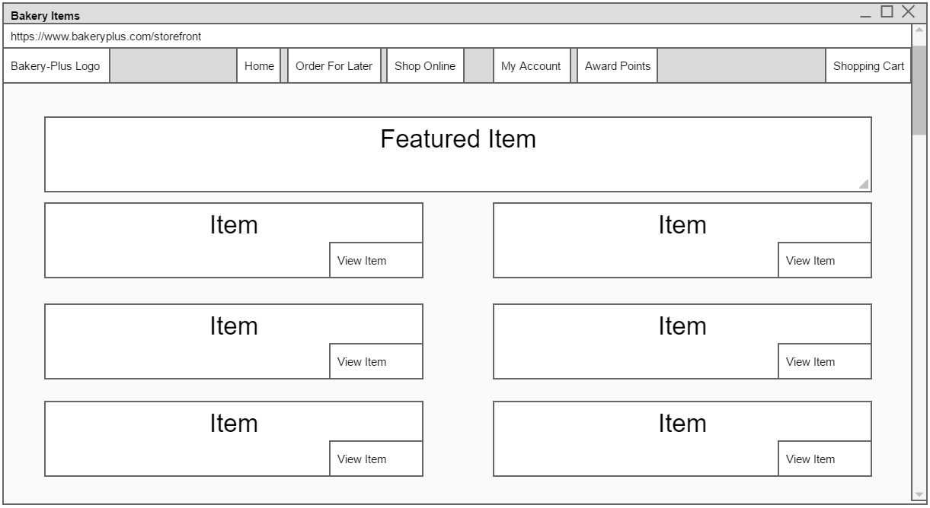

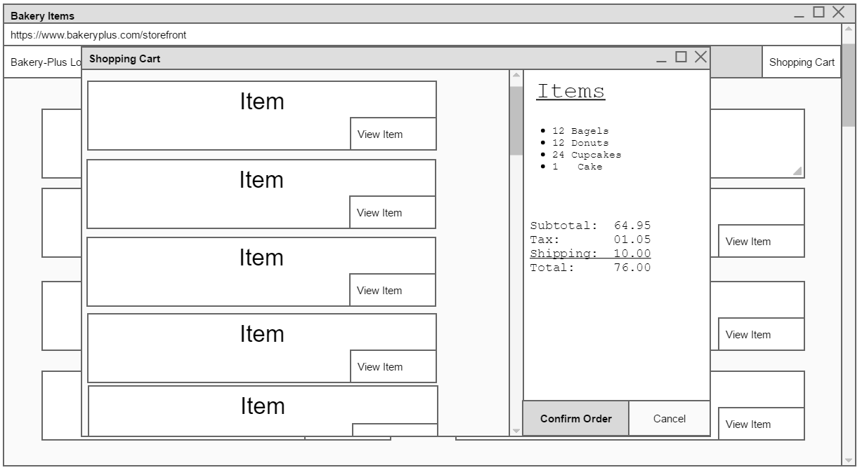

# Accessibility

At CompetentDev, accessibility is a top priority. Although we are not required to comply with federal regulation concerning accessibility, we do our best to follow the guidelines set forth. For all images, we include alternate captions which clearly describe what is in the photo. We design the layout and checkout system for ease of use with only a keyboard using the tab button for navigation. We don’t include any graphics or object which can induce seizures, and we make sure that any videos have synchronized captions.

Not only will this help those who are disabled access your site and use your service, you will be showing everyone that you care about them and their needs.

# Assumptions Made

1. I assumed that users would be able to redeem reward points for Coupons or free items.
2. I assume that the bakery would want customers to be able to schedule orders for the future, and not just immediate pickup when ready. (Like order for tomorrow morning, etc)

# Disclaimer

All images used in this document are licensed under a Creative Commons 0 license and do not require attribution of any kind for any type of use. All images are considered part of the public domain

<https://creativecommons.org/publicdomain/zero/1.0/deed.en>

Regardless, I have supplied direct links to the sources for these images. They can be found below.

# Links

<https://pixabay.com/en/bakery-bread-food-market-pastries-1868925/>

<https://pixabay.com/en/sunglasses-beard-sky-business-man-2562647/>

<https://pixabay.com/en/grandma-happy-family-grandmother-2198060/>

<https://pixabay.com/en/businessman-smile-man-suit-2051664/>

<https://pixabay.com/en/young-sunset-male-guy-people-1508130/>

https://pixabay.com/en/woman-middle-aged-mischievous-happy-797394/