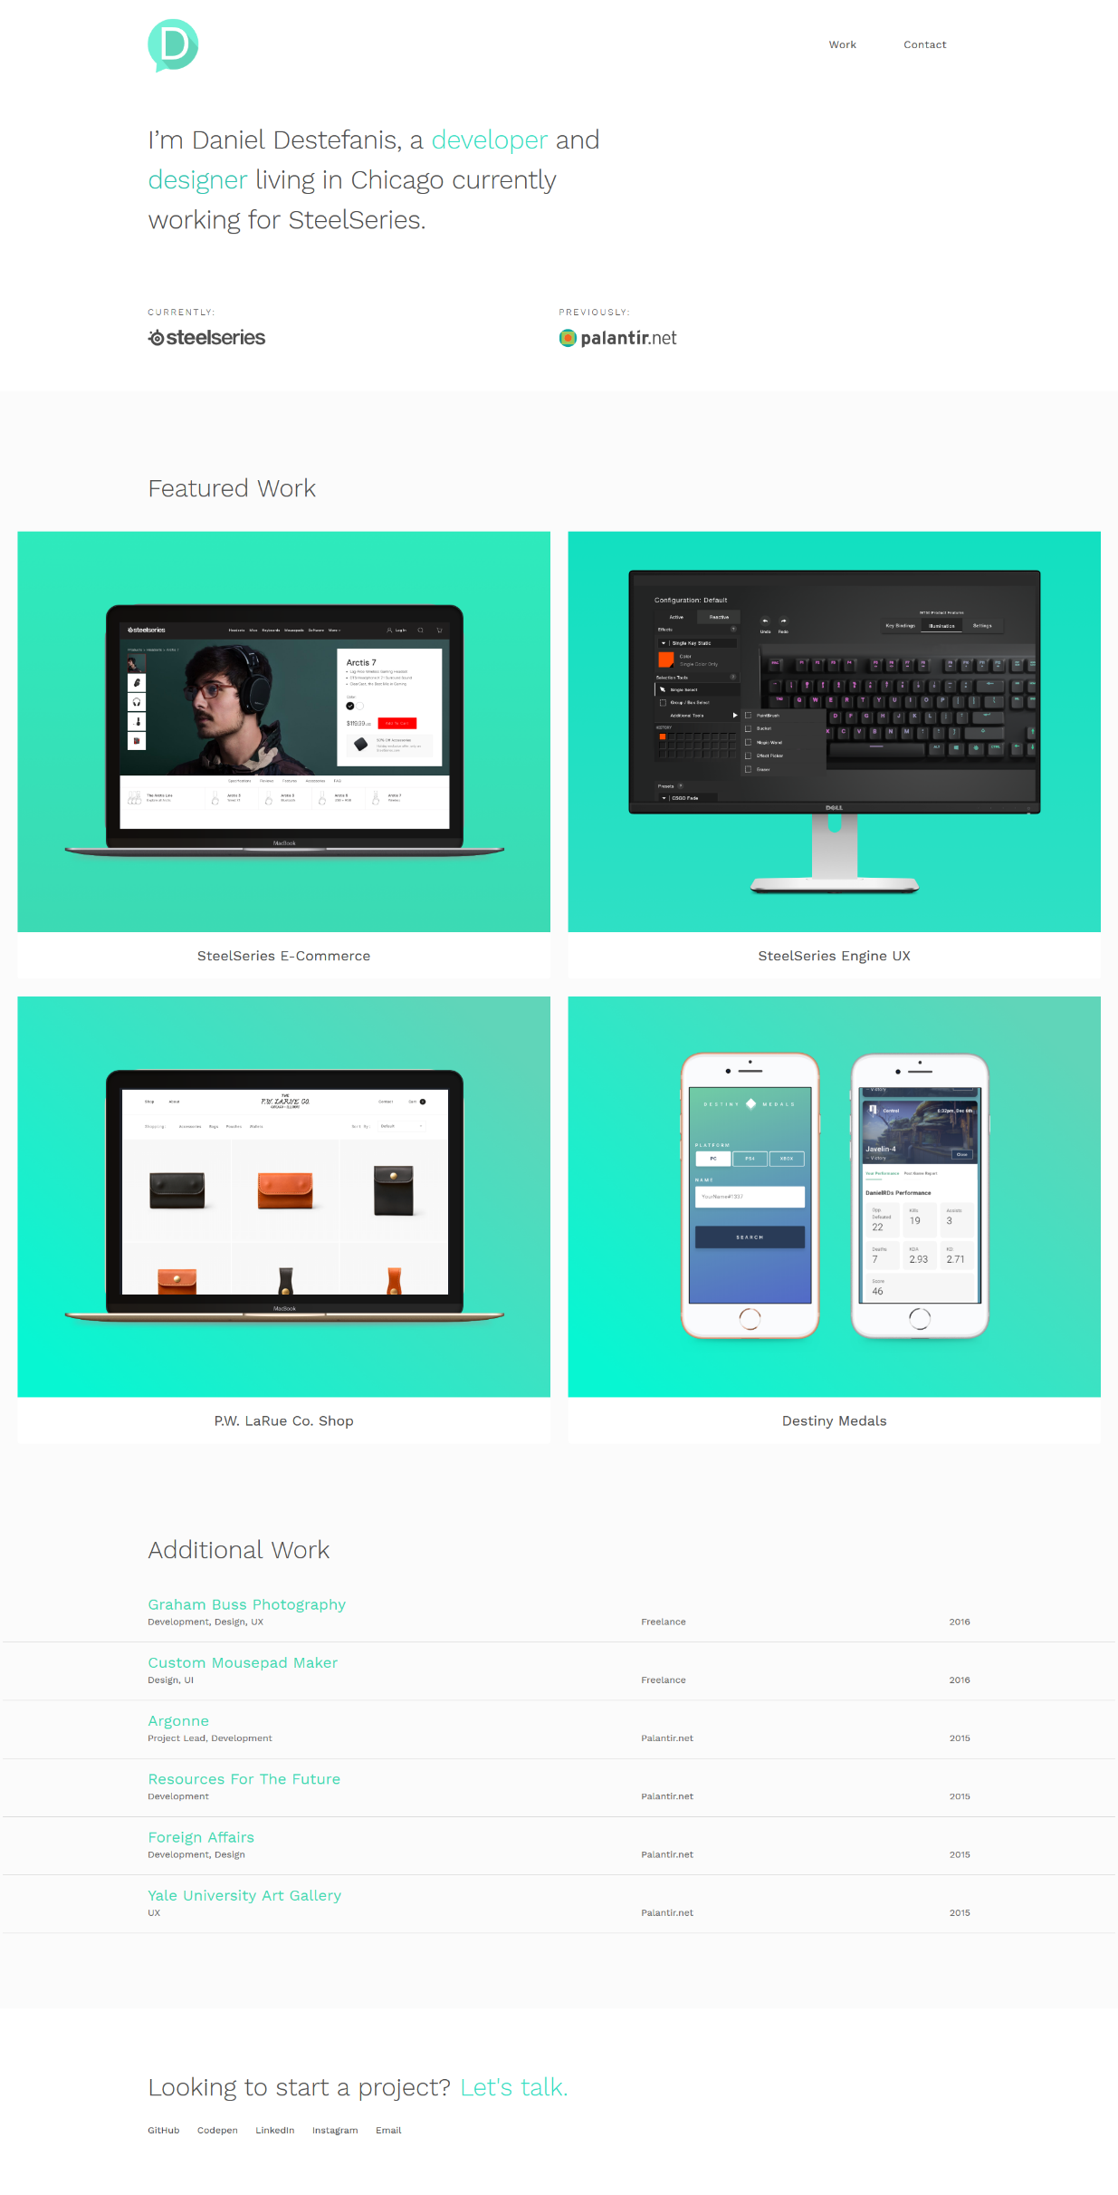

PORTFOLIO ONE

PORTFOLIO ONE: DANIEL DESTEFANIS [HTTP://DANIELRD.COM/](http://danielrd.com/)

Daniel’s portfolio is a simple one, with minimal graphics and a simple layout. It is clean and elegant. The portfolio begins with a very short introduction and then gets right into his work with a 4 panel layout which details his work using images and accompanying captions. He lists additional work below that in a simple list format. At the bottom he lists links to various platforms he is on.

The site implements some interactive design considerations such as styling while hovering over different elements. The flow of the site is also simple and linear which makes it easy for potential employers to go over quickly. The site also uses a consistent color palette.

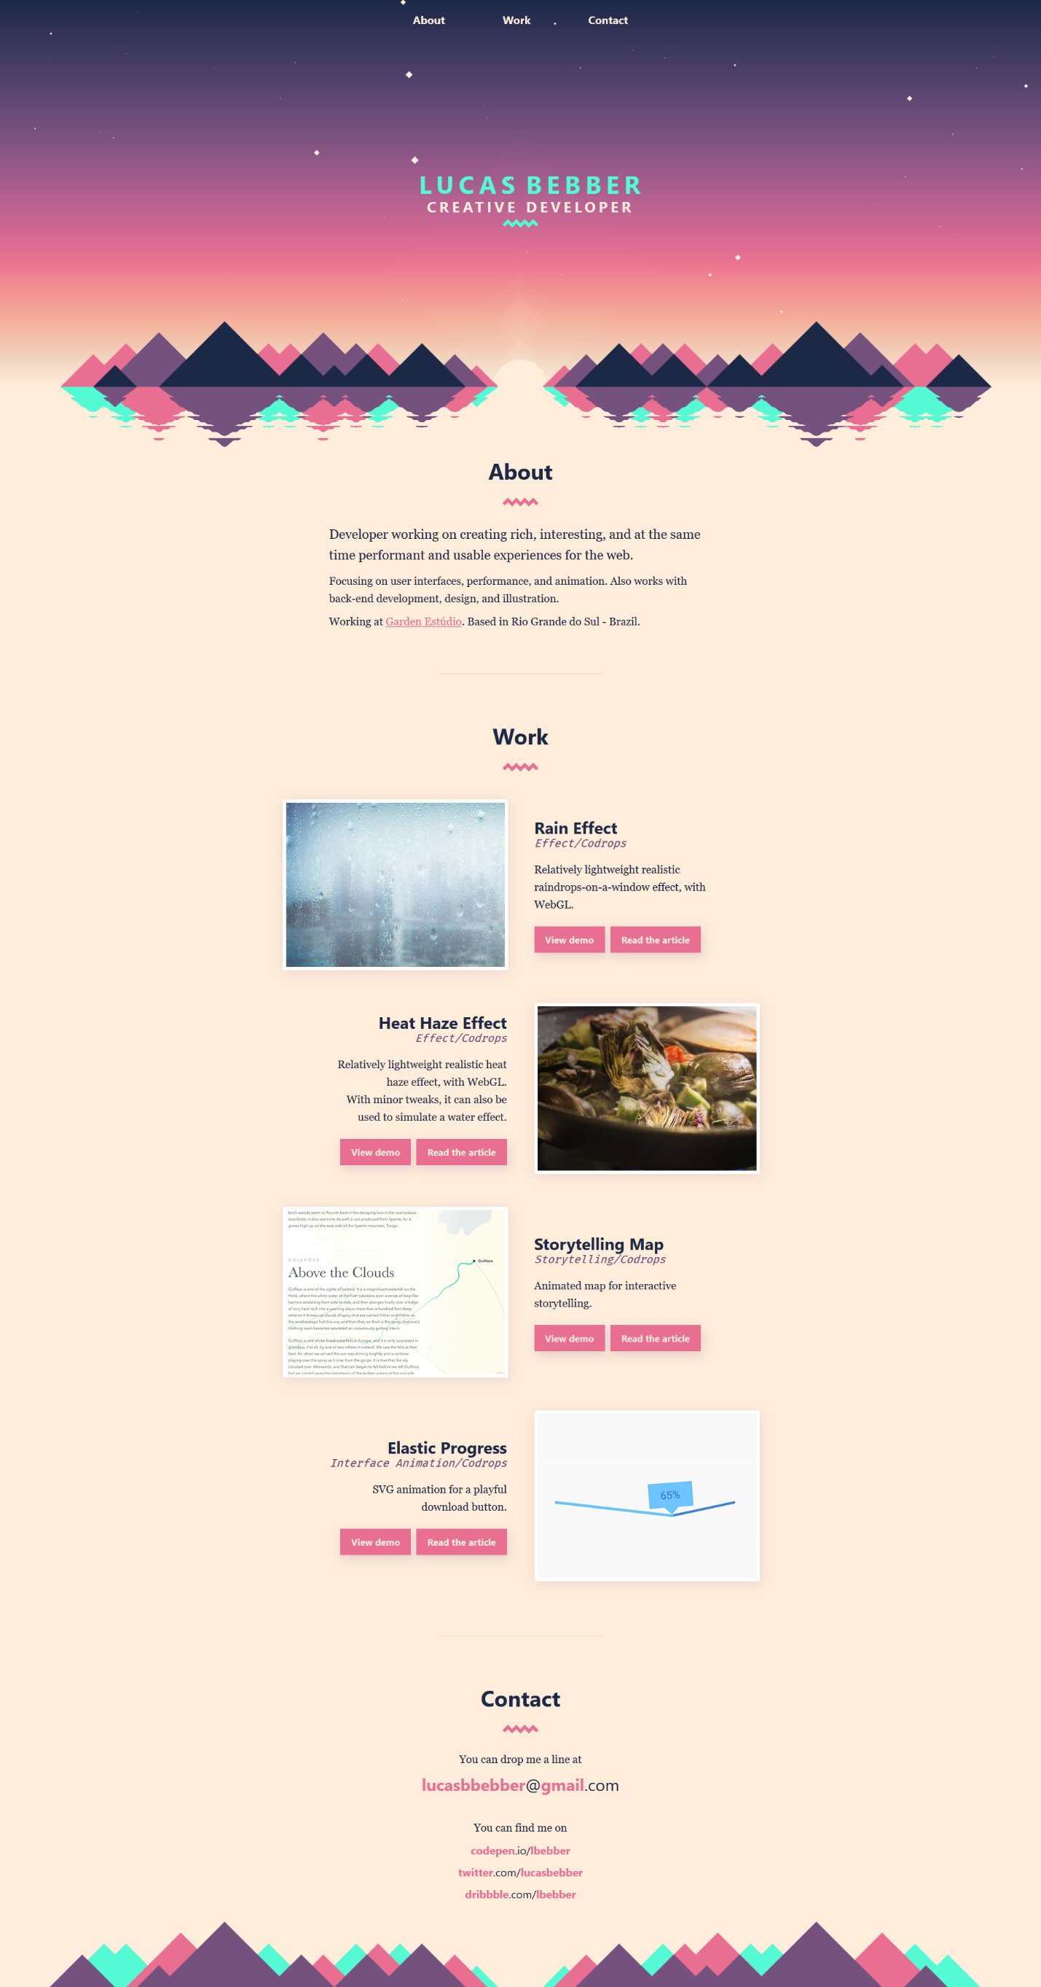

PORTFOLIO TWO

PORTFOLIO TWO: LUCAS BEBBER <HTTP://LBEBBER.GITHUB.IO/>

Lucas’s site is also a relatively simple site but relies on additional design characteristics such as an alternating pattern of images/videos and text as well as header art that flows into the page.

Like the last site, this site is also very linear and easy to quickly skim. I especially like the inclusion of examples of his work in an animated form. The gradient of the page with the inclusion of the header art is also very nice.

Both of these sites include a menu system that links to different parts of the page. The menu items are placed directly onto the page and do not use an intrusive menu bar giving the page a more simple and flat style.

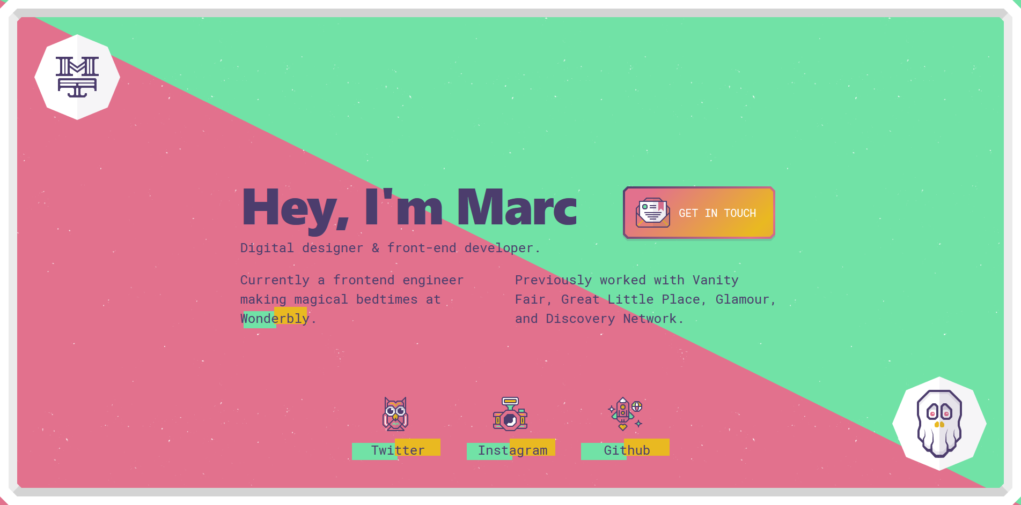

PORTFOLIO

THREE

PORTFOLIO THREE: MARC THOMAS <HTTP://MRCTHMS.COM/>

Marc’s portfolio page is an extremely simple site that acts more as a hub than a portfolio itself. Regardless, the design is very elegant with a great contrast between colors and a tasteful implementation of color gradient in the GET IN TOUCH button (which is also animated). It is, however, somewhat hard to read the text as it goes over from a pink to green background. Like the other pages, this one supplies links to his various platforms so that recruiters or potential employers have easy access.

All three pages show great design which do a lot with very little. I hope to do the same with my own design, including some of the concepts implemented in these designs.