Jared Brown  
5/20/18  
WEB-335  
Exercise 3.3

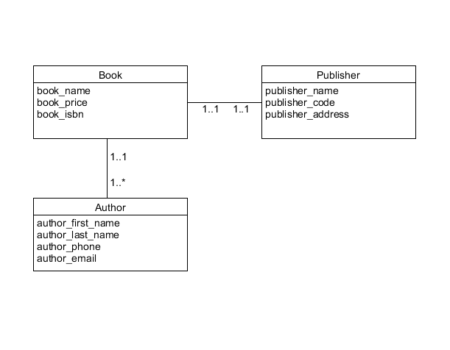

A Book has one Publisher  
A Book can have many Authors

