Bob’s Computer Repair Shop Order System Design Document

Developed by Jared Brown | WEB-425 | Assignment 7.4 | 8/26/18

---- Introduction ----

Purpose:

The purpose of this project is to provide Bob’s Computer Repair shop with an application that can take work orders from customers online. This application should be easy to use and relatively simple. It should include functionality which allows for employees to enter estimated work hours and the cost for parts. Users should be able to view a copy of the work order so that they can save or print it.

Terminology:

Angular – A JavaScript/TypeScript framework which allows for the creation of rich single page applications.

SPA – Single Page Application; an application which does not require the browser to reload the page, but instead relies on code to change the view and asynchronously load resources in the background.

Order – The document generated by a request for services. It is comprised of service information, labor, and parts costs.

Wireframe – A design document which contains basic design information such as structure and placement of elements.

Related Documents:

<https://angular.io/>

<https://material.io/design/material-theming/#>

Document Change Control:

Changes made to the design document must first be approved by the author, Jared Brown. Changes will then be discussed with the product owner. Submit change proposals to: [jatbrown@my365.bellevue.edu](mailto:jatbrown@my365.bellevue.edu)

Changes will be approved or denied within two business days after submission.

Reviewers:

This document will be reviewed and approved by the following individuals:

Jared Brown – Project Leader / Developer / Designer

Robert Ferguson – Product Owner

Richard Krasso – CEO Advanced Development Inc.

Required Skills:

HTML, CSS, JavaScript

TypeScript, Angular

NPM, Git

---- Architecture ----

Physical Architecture:

The physical architecture consists of a SPA which the user will use to submit a work order. The user can select from a list of services with defined prices. They can also submit a request for an estimate for custom work or parts, which will be processed by an employee at the shop. The request will be sent to a backend system which will alert the employee to the request for an estimate. The employee will then fill out the information, and the user can then accept the order and print an invoice out.

*\*In reality, for the purposes of this exercise, the employee portion of the application will be handled by an interface on a delay, which will generate random charges for parts or work hours and prompt the user to accept or decline the estimate.*

Logical Architecture:  
  
User clicks on “Generate Work Order”  
User is taken to Work Order Page  
User can select predefined services

If user only selects defined services  
 Calculate total cost of services  
 Display invoice  
 If user accepts, send work order

If user includes custom work  
 Send request to employees for estimate with parts + manhours  
 Send result of estimate to customer  
 If customer approves work order display work order for printing

---- Process Design ----

Object Relational Diagram:

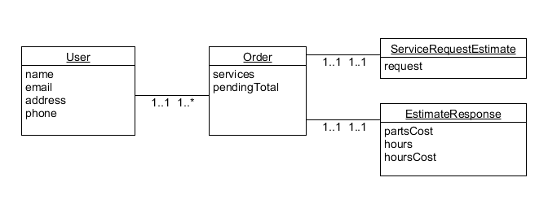

NoSQL Data Structure:

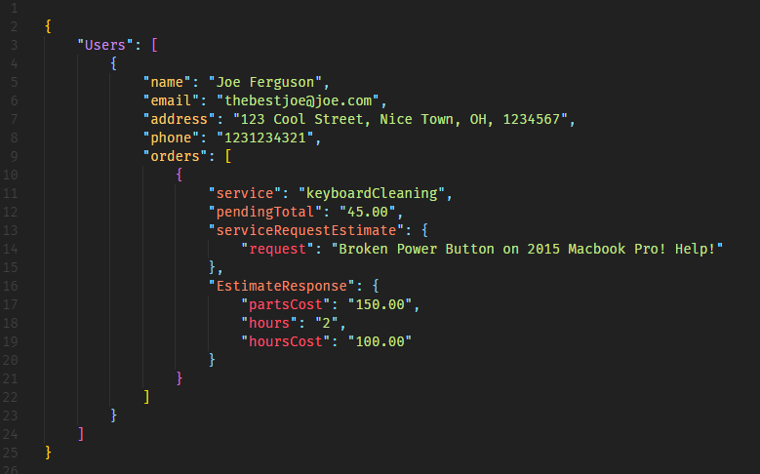

Wireframes:

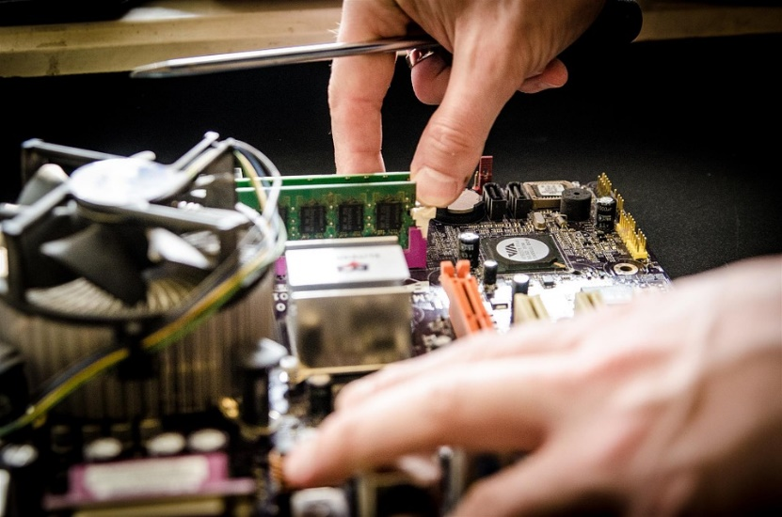

Need Help?

Call Us: 123-421-523

Email Us: [help@bob.co](mailto:help@bob.co)

Bob’s Computer Repair is committed to the best customer service possible. We guarantee our work will be high quality. All of the work we do is covered by a 12-month warranty\*

\*See warranty page for details.

Current Work Orders

Submit Work Order

Home

Bob’s Computer Repair

Bob’s Computer Repair

Simply the Best!

Home page Wireframe



Need Help?

Call Us: 123-421-523

Email Us: [help@bob.co](mailto:help@bob.co)

Bob’s Computer Repair is committed to the best customer service possible. We guarantee our work will be high quality. All of the work we do is covered by a 12-month warranty\*

\*See warranty page for details.

Current Work Orders

Submit Work Order

Home

Bob’s Computer Repair

Services

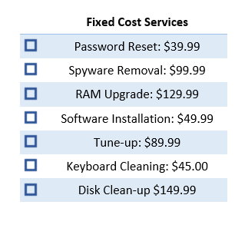

Custom Work Order Details Go Here:

Submit

Submit Work Order Wireframe



Submit Work Order

Home

Current Work Orders

Bob’s Computer Repair

Need Help?

Call Us: 123-421-523

Email Us: [help@bob.co](mailto:help@bob.co)

Bob’s Computer Repair is committed to the best customer service possible. We guarantee our work will be high quality. All of the work we do is covered by a 12-month warranty\*

\*See warranty page for details.



Labor

Parts

Submit Estimate

Work Order Details

Selected Services

Current Work Order Wireframe (employees view)