Jared Brown  
9/9/2018  
Exercise 9.3  
WEB-425  
  
For this project I created an Angular application that allows a user to act as both customer and employee to create and approve work orders. I utilized both Angular routing and services. The services allow me to persist data as the user switches between the customer and employee roles. Obviously, in a real Angular application, these roles would be restricted, and data would be saved to a database, however for the purpose of this exercise the services are adequate.

Home Component:



Role Switcher in navbar (app.component):

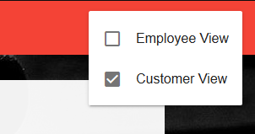

Order Component (Before Submission State):

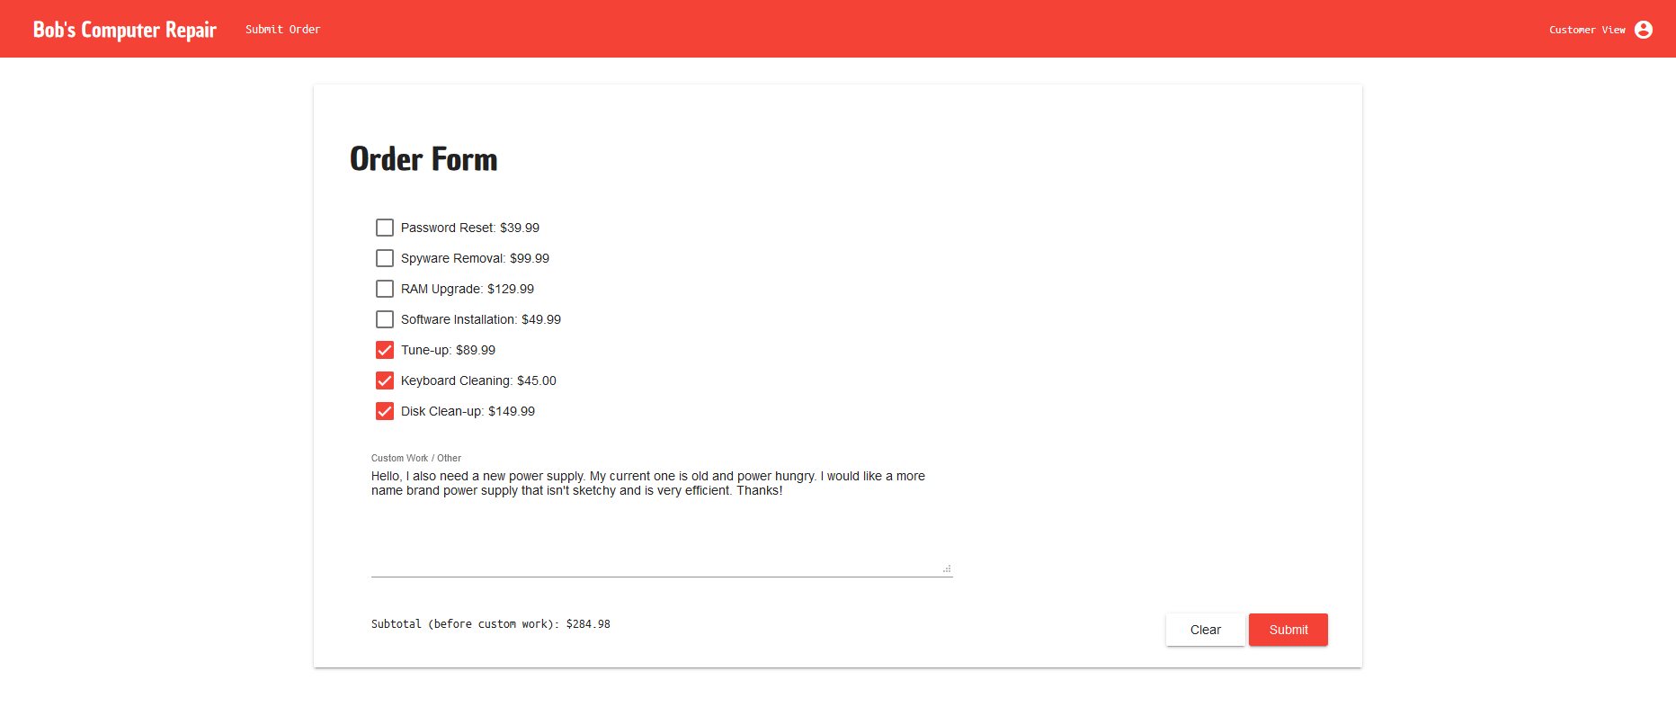

Order Component (After Submission, awaiting approval):

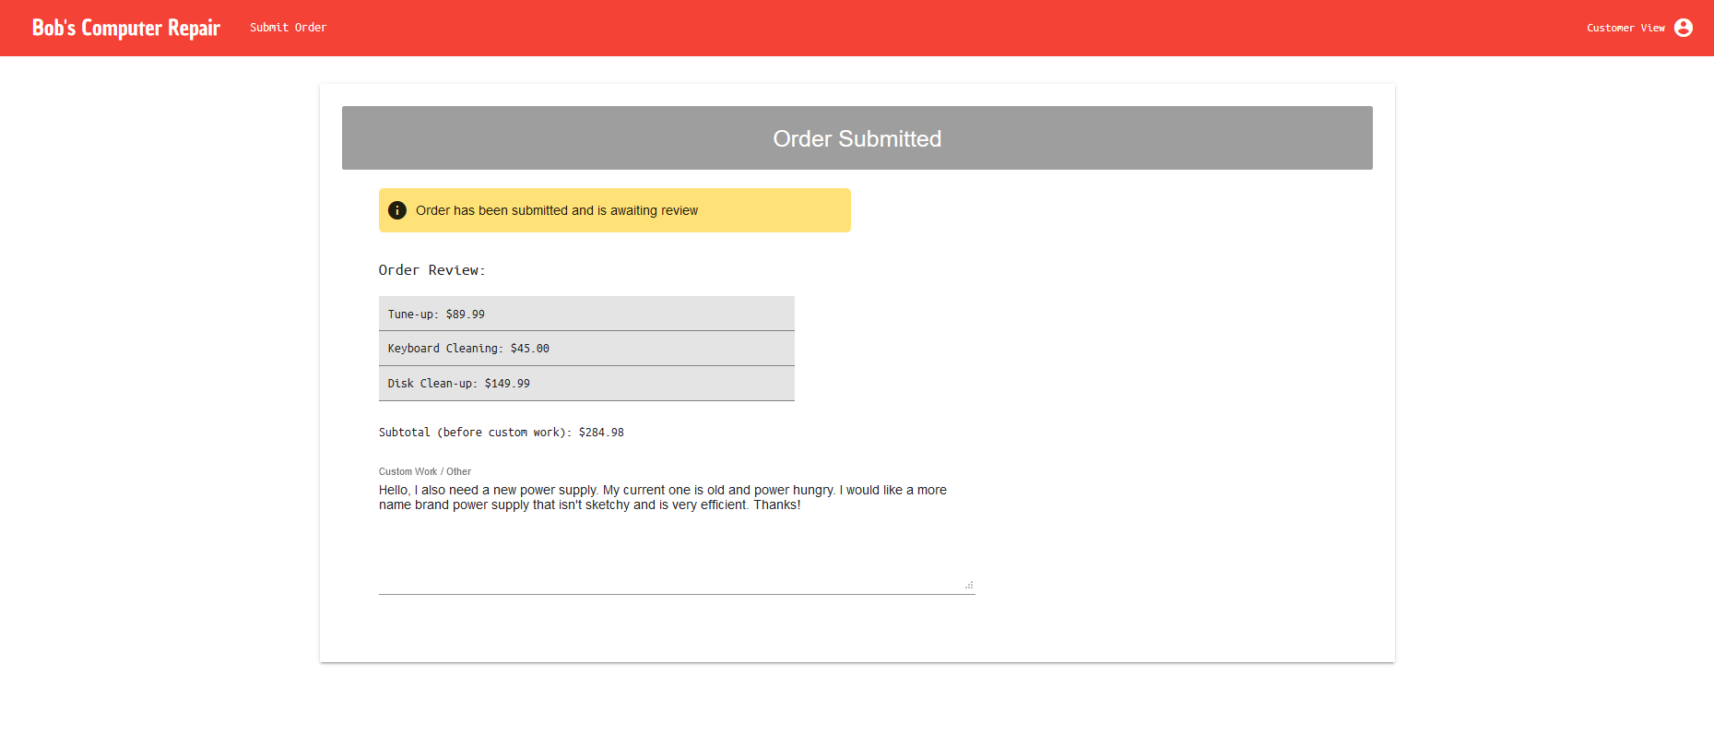

Switched to Employee role (work component):

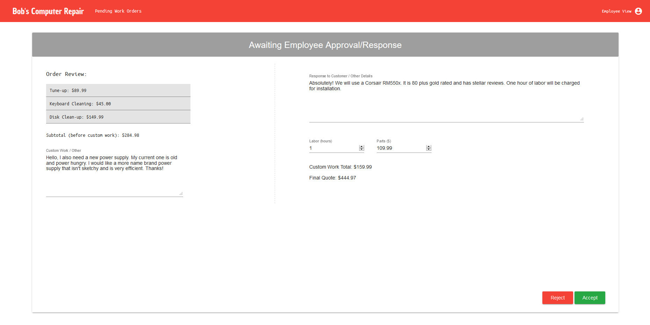

Left side: Read-Only values from the work order request.

Right side: Fields for response, labor, and parts cost as well as a total for final quote.

Work Component (after work order approval)

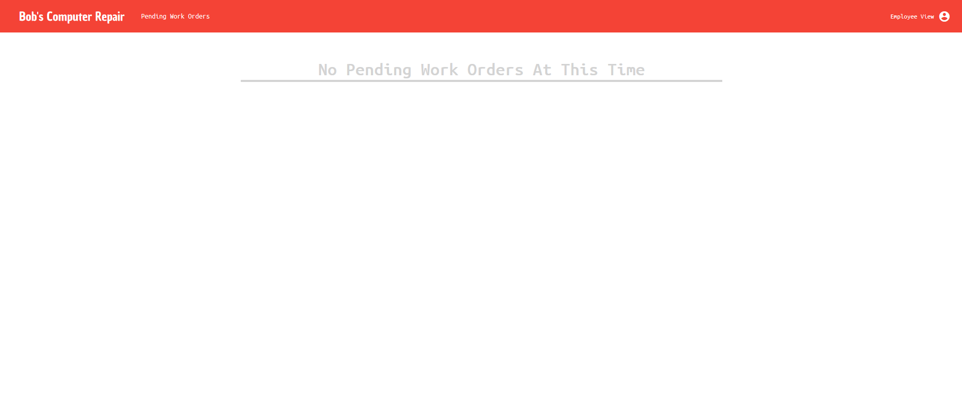

Order Component (Switching back to customer role after employee approval):

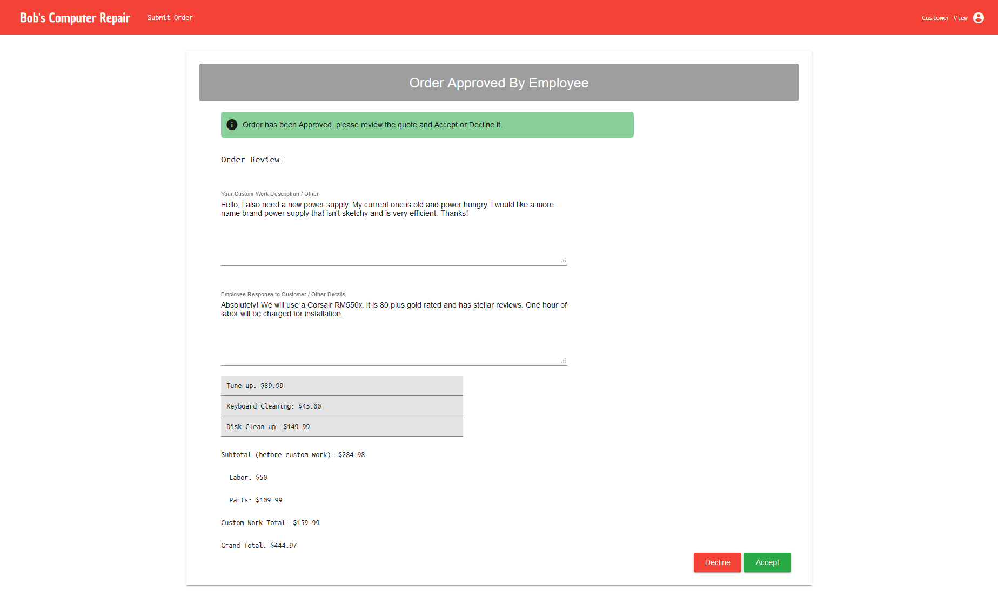

Review Component (opened in new tab/window):

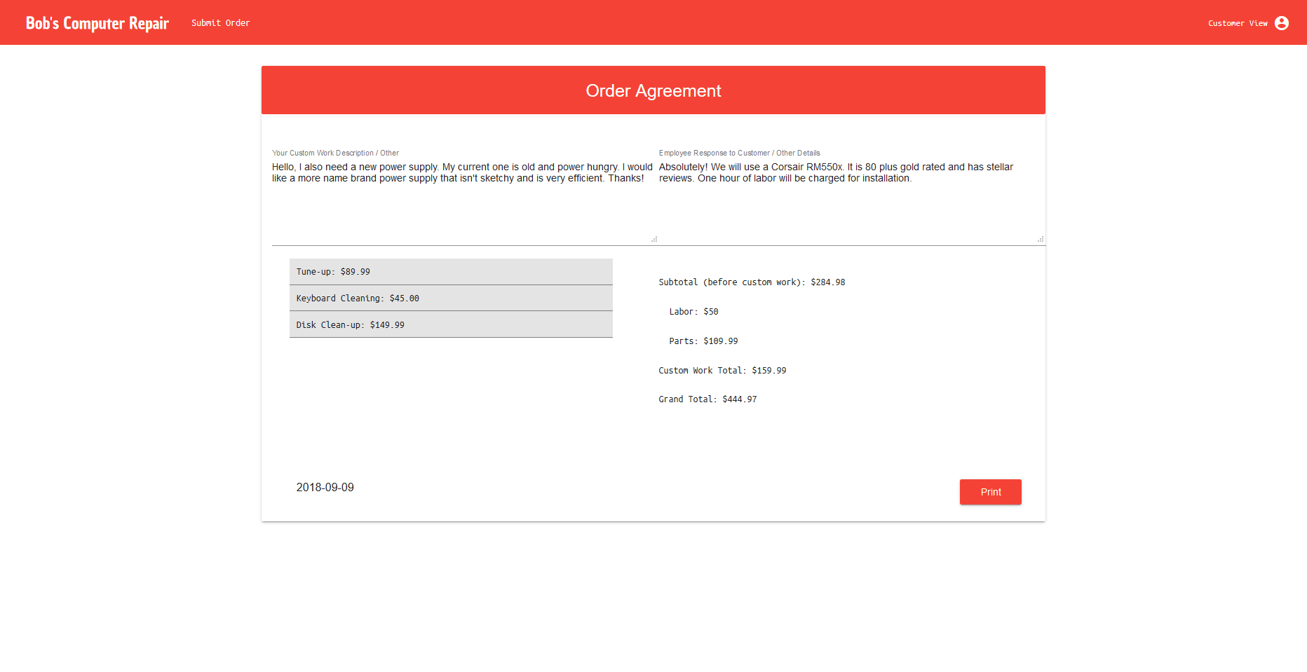

Because this component is opened in a new window/tab I passed the necessary data through the global window object after opening and creating the new window object. Ideally I would use some type of storage plugin, but for the purpose of a quick summary for printing, the window object works fine.