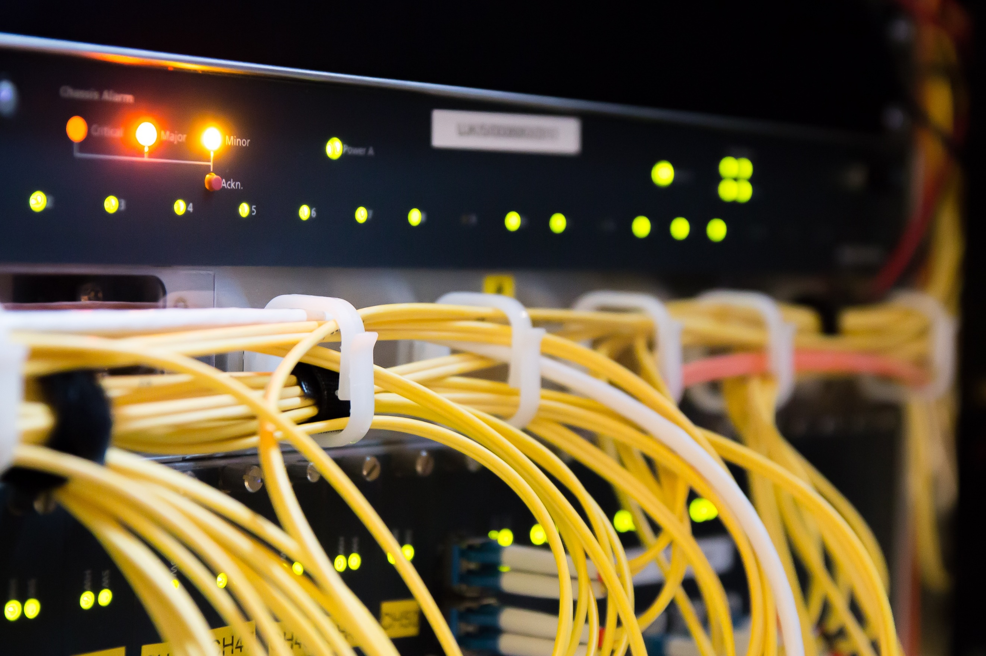

|  |  |
| --- | --- |
|  | NodeQuiz Technical Design Document |
|  |  |
|  | Jared Brown  WEB-450  9/1/18 |

# Technical Design Document Version Control

|  |  |  |  |
| --- | --- | --- | --- |
| Version Number | Version Release Date | Version Notes | Version Resource Link |
| 0.1.0 (this document) | 9/20/18 | Initial Release | - |
|  |  |  |  |
|  |  |  |  |
|  |  |  |  |
|  |  |  |  |
|  |  |  |  |
|  |  |  |  |
|  |  |  |  |

Contents

Technical Design Document Version Control 1

Purpose: 3

# Purpose:

The purpose of this project is to complete an application for NodeQuiz. This application will provide quizzing functionality for internal use at NodeQuiz. This application will hereafter be referred to as NodeQuizzer. NodeQuizzer will also provide a slideshow to accompany each quiz; with each quiz being crafted for it’s slideshow. The results from these quizzes will be saved and each employee will be able to view their scores. Employees will “sign into” the application by providing their employee ID.

# Terminology:

Angular - Angular is a JavaScript framework used in creating single page applications and websites.

NodeJS – NodeJS is a JavaScript runtime (program environment) which allows for the creation of webservers to handle the back-end of a website or API.

MongoDB – MongoDB is a document based database which can store information, in this case it will store the quizzes and results.

Version Control – Version Control refers to the system or process of organizing code or document releases and documenting changes made to them. The purpose of Version control is to keep a record of each version of the item in question and to keep a record of changes made to it so that errors can be undone, or older versions referenced.

# User Personas:

User Personas are the personification of possible but fictional users. They help the development team anticipate the needs of a wide user base with many different traits. User Personas are helpful when creating user stories as it gives the development team a context with which we can express the needs of possible users.

|  |  |
| --- | --- |
| Persona: Power User | |
| Picture | Young, Sunset, Male, Guy, People, Person, Adult, Man |
| Name | Timothy Ferguson |
| Distinguishing Characteristics | Power User / Technically Literate |
| Most used features for application | The actual quizzing and scoring part of the application |
| Least used features for application | Utilizing the Slideshows |
| Needs that application can meet for this user. | He can reaffirm the knowledge he already likely has or new topics. |
| Computer Skill Level | Above Average |
| Likely Age Range | 25 – 60 years |
| Time Spent in Application | 25/min a week |
| Devices Used | Desktop |

|  |  |
| --- | --- |
| Persona: The Eager Learner | |
| Picture | Satisfaction, Peace, Feeling, Happiness, Model, One |
| Name | Michelle McEntire |
| Distinguishing Characteristics | Knowledgeable, Desires to continually learn |
| Most used features for application | Reading the Slideshows and applying that knowledge |
| Least used features for application | Viewing past scores |
| Needs that application can meet for this user. | Allows for continuous learning at the work place |
| Computer Skill Level | Average – Above Average |
| Likely Age Range | 25 – 60 years |
| Time Spent in Application | 45/min a week |
| Devices Used | Desktop / Laptop |

|  |  |
| --- | --- |
| Persona: The Boss | |
| Picture | Entrepreneur, Boss, Man, Businessman, Young |
| Name | Patrick Smith |
| Distinguishing Characteristics | Enthusiastic, Eager to improve the workplace |
| Most used features for application | Viewing Past Scores |
| Least used features for application | Taking a quiz or reading the slideshow |
| Needs that application can meet for this user. | Allows him to see how employees are improving |
| Computer Skill Level | Below Average - Average |
| Likely Age Range | 25 – 60 years |
| Time Spent in Application | 20/min a week |
| Devices Used | Desktop / Laptop / Tablet |