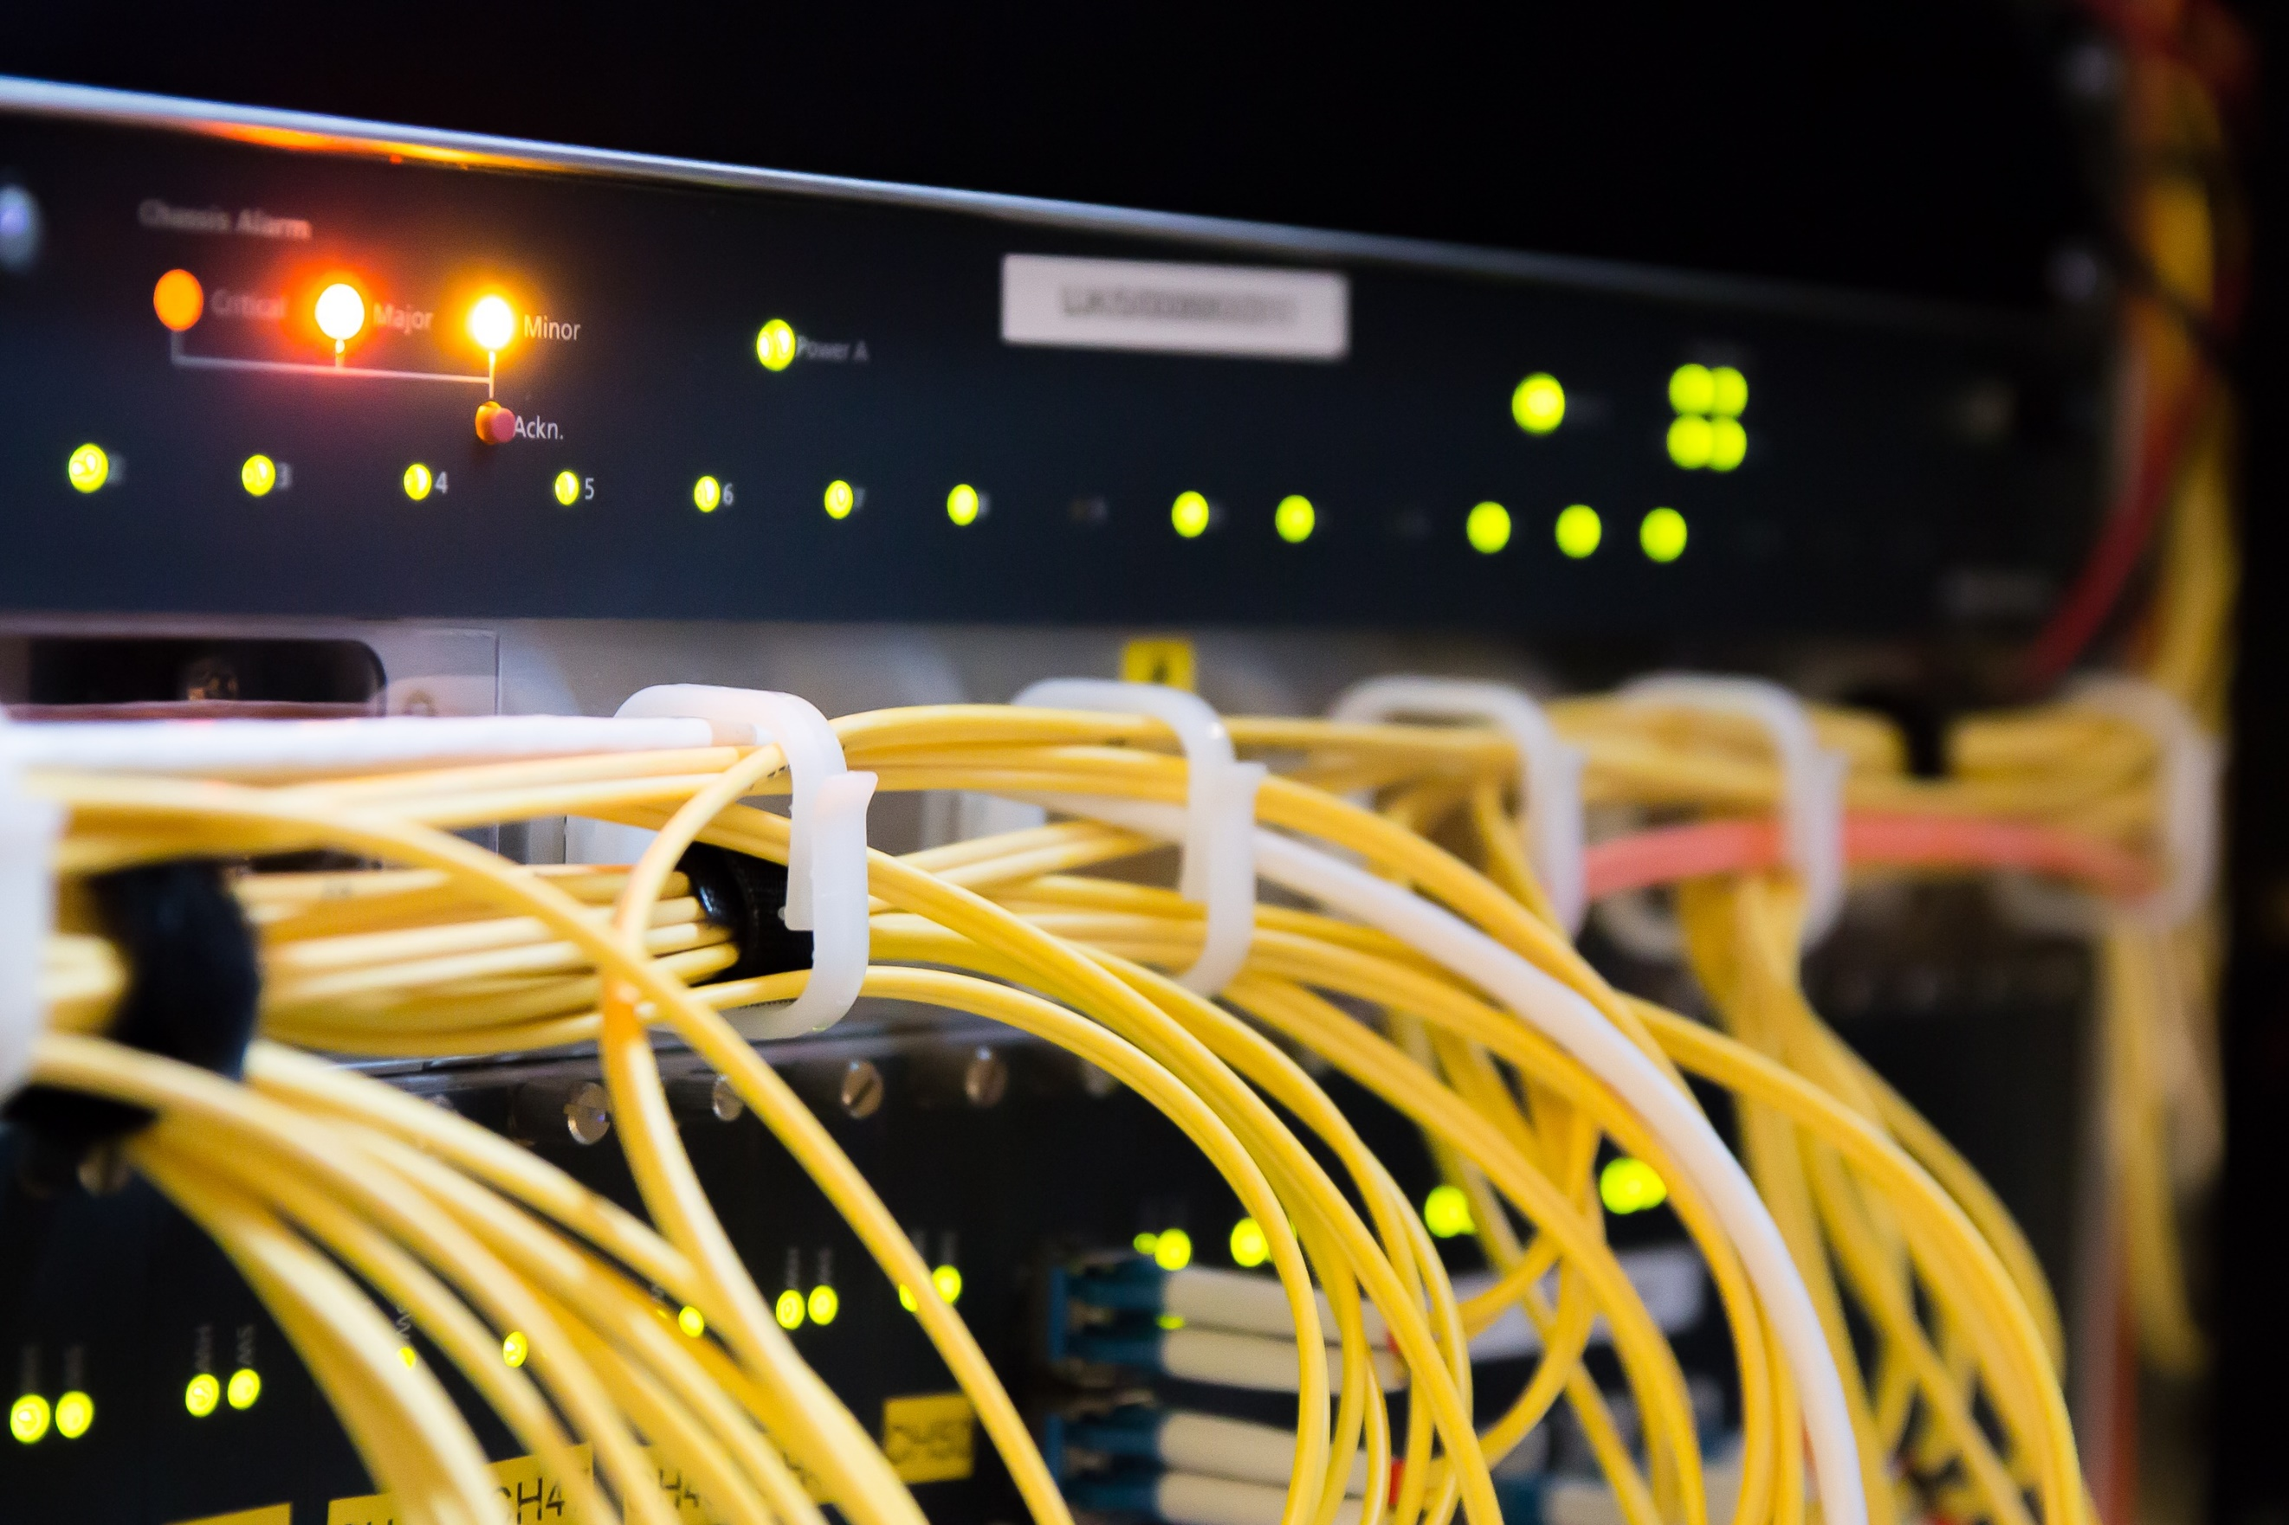

|  |  |
| --- | --- |
|  | NodeQuiz Technical Design Document |
|  |  |
|  | Jared Brown  WEB-450  9/1/18 |

# Technical Design Document Version Control

|  |  |  |  |
| --- | --- | --- | --- |
| Version Number | Version Release Date | Version Notes | Version Resource Link |
| 0.1.0 | 9/20/18 | Initial Release | - |
| 0.2.0 | 9/21/18 | Adding User Stories / Time Estimation |  |
| 0.3.0 | 9/22/18 | Adding Prototypes |  |
| 0.4.0  (this document) | 9/30/18 | Adding ORD, NoSQL Document Diagram, NoSQL Data Structure |  |
|  |  |  |  |
|  |  |  |  |
|  |  |  |  |
|  |  |  |  |

Contents

Technical Design Document Version Control 1

Purpose: 3

Terminology: 3

User Personas: 3

User Stories: 7

Time Estimations: 8

# Purpose:

The purpose of this project is to complete an application for NodeQuiz. This application will provide quizzing functionality for internal use at NodeQuiz. This application will hereafter be referred to as NodeQuizzer. NodeQuizzer will also provide a slideshow to accompany each quiz; with each quiz being crafted for it’s slideshow. The results from these quizzes will be saved and each employee will be able to view their scores. Employees will “sign into” the application by providing their employee ID.

# Terminology:

Angular - Angular is a JavaScript framework used in creating single page applications and websites.

NodeJS – NodeJS is a JavaScript runtime (program environment) which allows for the creation of webservers to handle the back-end of a website or API.

MongoDB – MongoDB is a document based database which can store information, in this case it will store the quizzes and results.

Version Control – Version Control refers to the system or process of organizing code or document releases and documenting changes made to them. The purpose of Version control is to keep a record of each version of the item in question and to keep a record of changes made to it so that errors can be undone, or older versions referenced.

# User Personas:

User Personas are the personification of possible but fictional users. They help the development team anticipate the needs of a wide user base with many different traits. User Personas are helpful when creating user stories as it gives the development team a context with which we can express the needs of possible users.

|  |  |
| --- | --- |
| Persona: Power User | |
| Picture | Young, Sunset, Male, Guy, People, Person, Adult, Man |
| Name | Timothy Ferguson |
| Distinguishing Characteristics | Power User / Technically Literate |
| Most used features for application | The actual quizzing and scoring part of the application |
| Least used features for application | Utilizing the Slideshows |
| Needs that application can meet for this user. | He can reaffirm the knowledge he already likely has or new topics. |
| Computer Skill Level | Above Average |
| Likely Age Range | 25 – 60 years |
| Time Spent in Application | 25/min a week |
| Devices Used | Desktop |

|  |  |
| --- | --- |
| Persona: The Eager Learner | |
| Picture | Satisfaction, Peace, Feeling, Happiness, Model, One |
| Name | Michelle McEntire |
| Distinguishing Characteristics | Knowledgeable, Desires to continually learn |
| Most used features for application | Reading the Slideshows and applying that knowledge |
| Least used features for application | Viewing past scores |
| Needs that application can meet for this user. | Allows for continuous learning at the work place |
| Computer Skill Level | Average – Above Average |
| Likely Age Range | 25 – 60 years |
| Time Spent in Application | 45/min a week |
| Devices Used | Desktop / Laptop |

|  |  |
| --- | --- |
| Persona: The Boss | |
| Picture | Entrepreneur, Boss, Man, Businessman, Young |
| Name | Patrick Smith |
| Distinguishing Characteristics | Enthusiastic, Eager to improve the workplace |
| Most used features for application | Viewing Past Scores |
| Least used features for application | Taking a quiz or reading the slideshow |
| Needs that application can meet for this user. | Allows him to see how employees are improving |
| Computer Skill Level | Below Average - Average |
| Likely Age Range | 25 – 60 years |
| Time Spent in Application | 20/min a week |
| Devices Used | Desktop / Laptop / Tablet |

# User Stories:

User stories are descriptions of actions that a user might need to perform. The development team can then translate these into features for the application. User Stories might be general tasks that will be performed by a user, or they may be based around a need related to a User Persona.

1. As a user I should be able to login into the application using my employee ID so that I can view my data.
2. As a user I should be able to choose from multiple quizzes so that I can take them in any order I wish to.
3. As a user I should be able to view the results from the quiz I just took so that I can see how I did and determine if I need to review the material again.
4. As a user I should be able to view the cumulative results of all the quizzes I have taken so that I can track my progress of continuous learning.
5. As a power user I should be able to elect to take the quiz without having to go through the whole slideshow so that I can get straight to the quiz.
6. As a power user I should be able to easily interact with the application with a mouse so that I can utilize my normal desktop at my cubicle.
7. As an eager learner I should be able to view the slides without taking the quiz so that I can review the material at any time.
8. As a casual user or eager learner, I should be able to use the application with my laptop so that I can use it while I’m away from my desk or away from the office.
9. As the boss I should be able to use the application with my tablet in a mobile browser so that I can use it on the go.
10. As a user I should be able to get to the cumulative score page from my dashboard so that I do not have to take a quiz to get to it.
11. As the boss I should be able to have new quizzes added to the program so that my employees can learn additional content and be quizzed on it.
12. As the boss I should have the ability to view the cumulative scores of employees so I can see how they are progressing.
13. As the boss I should have the ability to view the cumulative score of a single quiz to see how my employees are doing by quiz.
14. As the boss I should be able to view cumulative scores from my dashboard so that I have quick easy access.
15. As the boss I should be able to control certain settings like allowing the retaking of a test without it showing up in a cumulative score count so I can manage the tests more closely.

# Time Estimations:

The time estimations allow the development team to get a sense of the scale of the project and allows for the team to understand what needs special attention.

|  |  |
| --- | --- |
| Front-end Development | 8 Hours |
| Back-end Development | 12 Hours |
| Database Setup / Development | 5 Hours |
| Unit Testing | 4 Hours |
| UI Testing | 2 Hours |
| Total | 31 Hours |
| Cost ($35/hour) | $1,085 |

# Prototypes:

Login Page Prototype

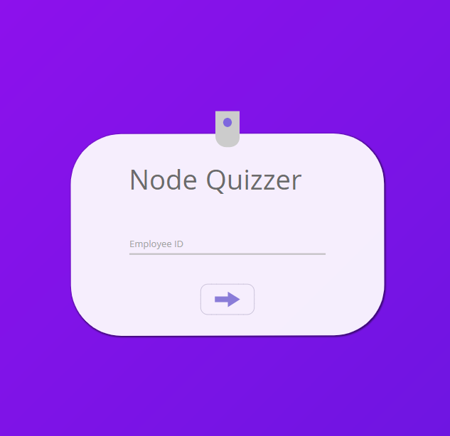

Home Dashboard Prototype:

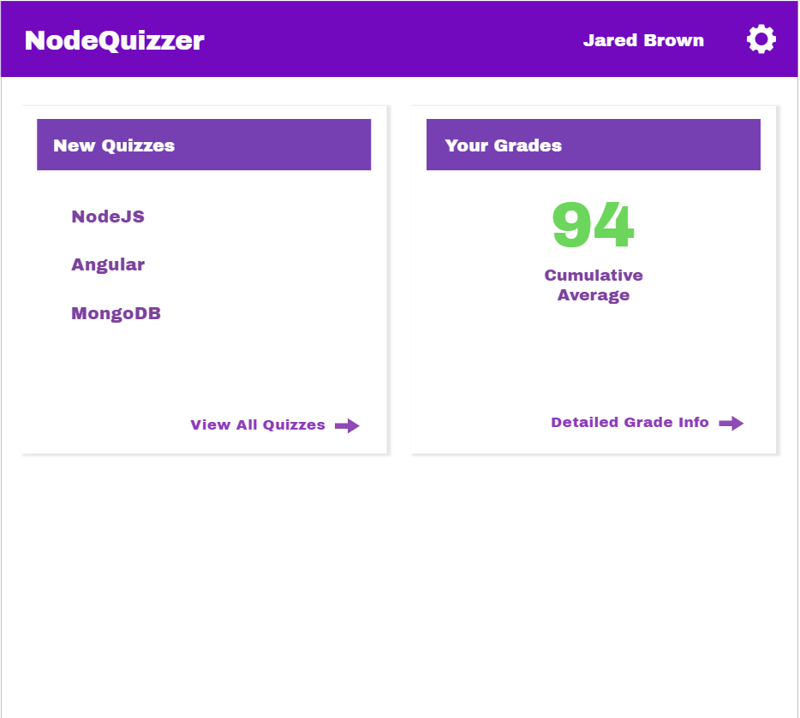

Quizzes Prototype:

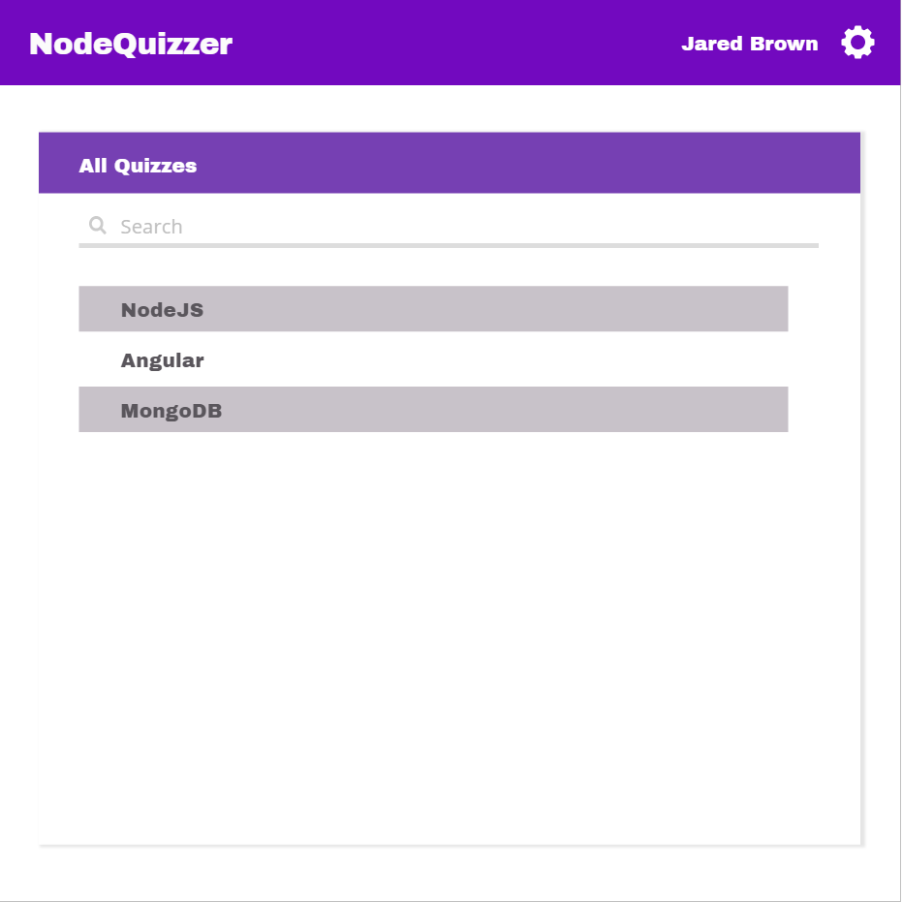

Detailed Grades Page:

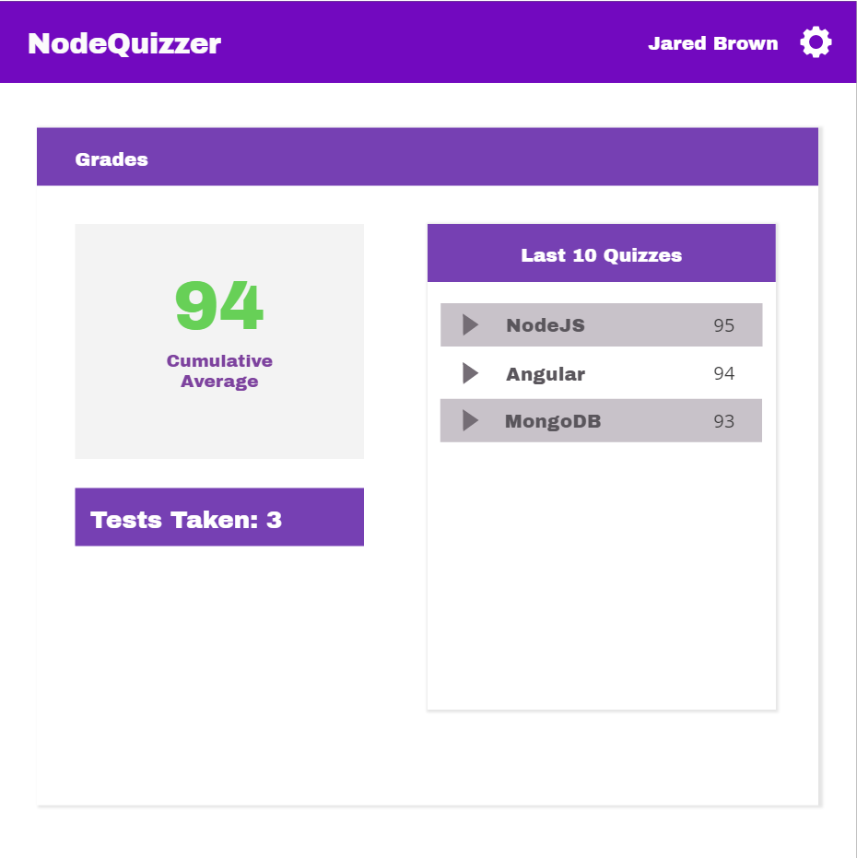

Slide Show Page Prototype:

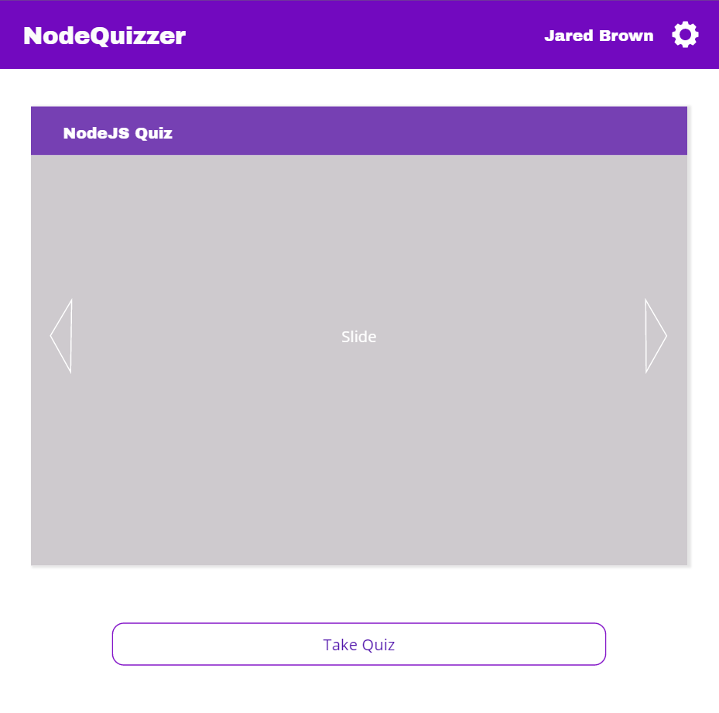

Questions Page Prototype:

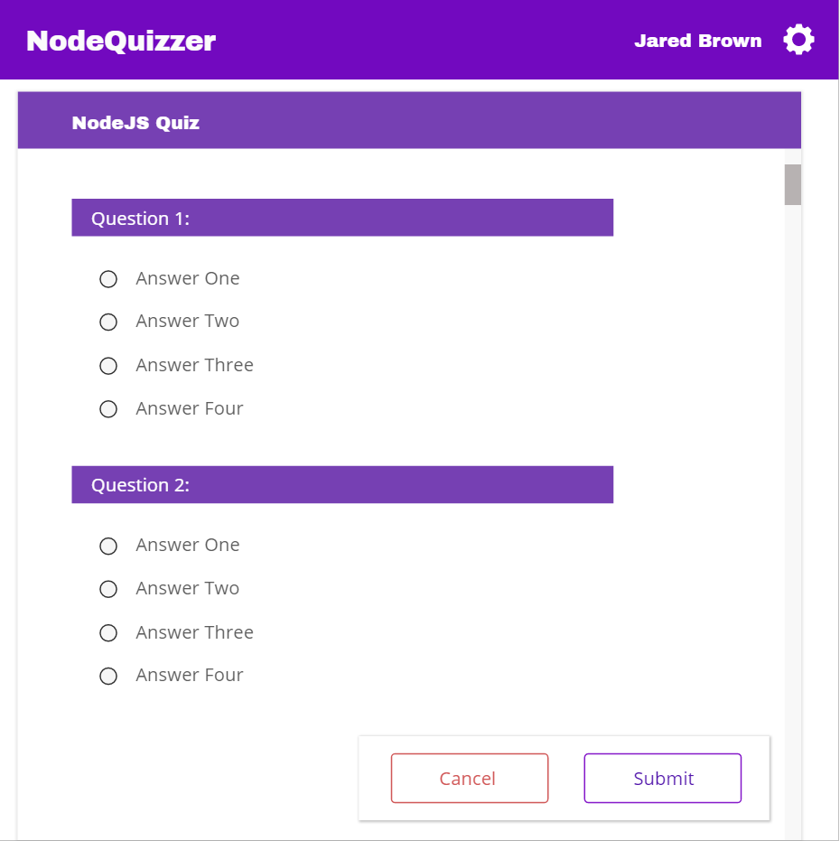

Quiz Results Prototype:

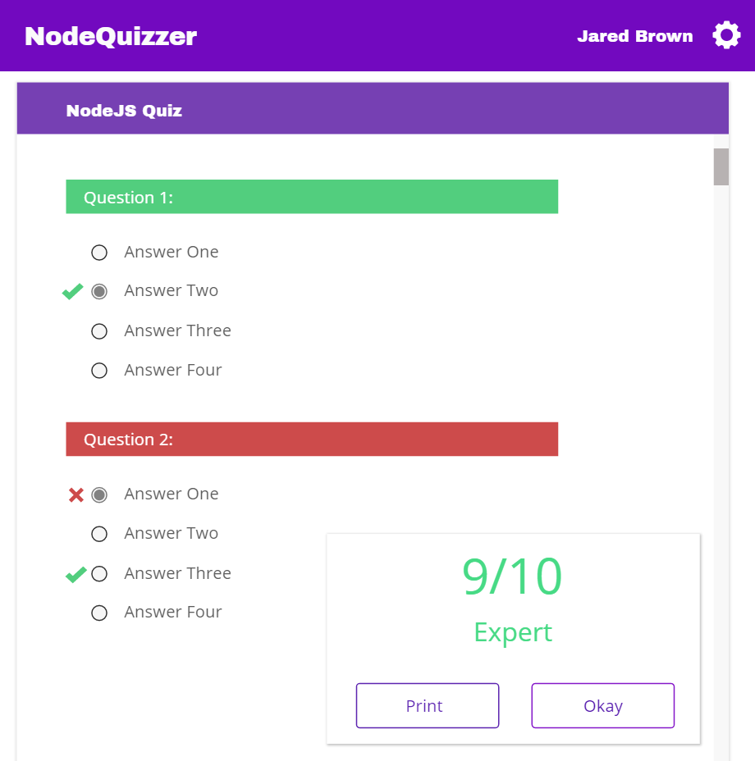

# Object Relational Diagram:

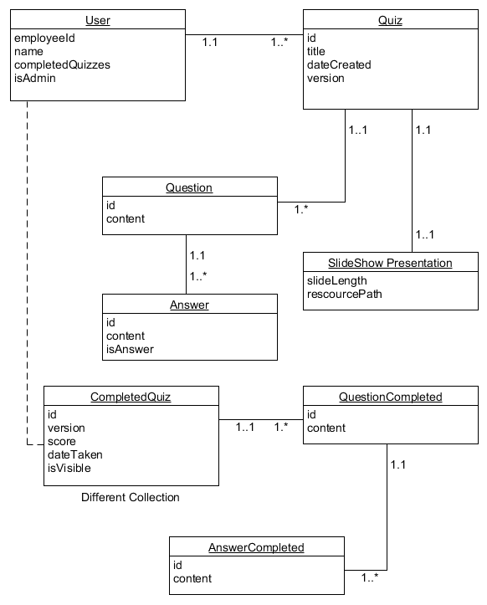

# NoSQL Document Diagram:

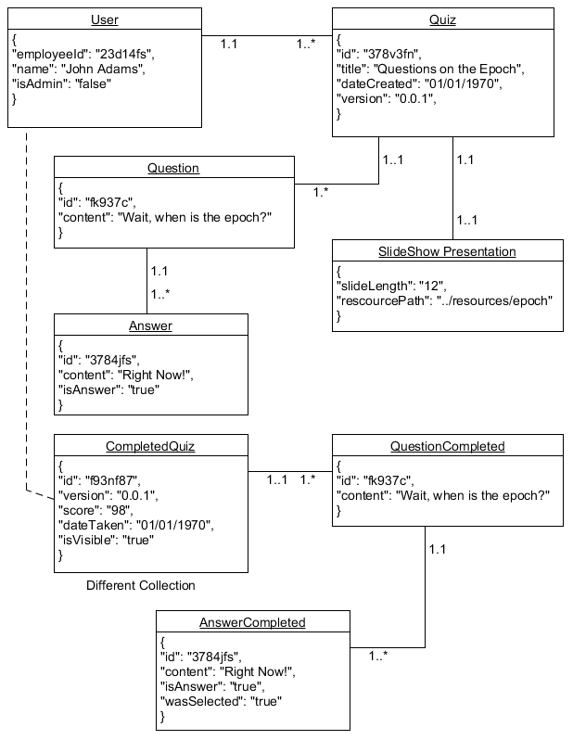

# NoSQL Data Structure (Users Collection):

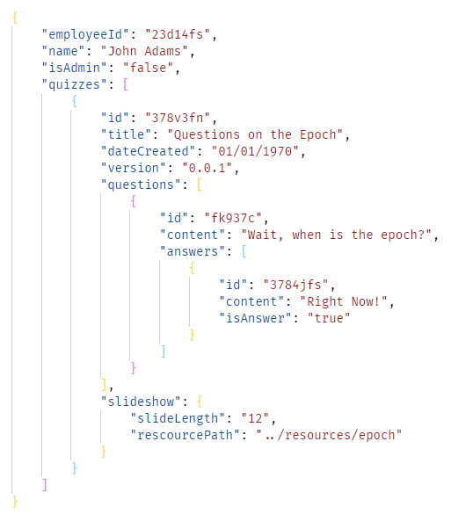

# NoSQL Data Structure (Completed Quizzes Collection):

