Seg (Forgot to name it)

Submarine Fleet Command
An in browser online multiplayer RTS where you and several friends are dropped into a procedurally generated cave system and need to map it out with sonar to capture objectives while trying to sink your opponents.

Game is live at https://butch.sytes.net
To host it yourself, in the deploy directory are instructions to set up to docker container.
No code was touched in the making of this soulless project.

Jared Butcher
Special Thanks to Michel Cook for supplying a max tier Claude subscription

Customizable lobbies and server browser
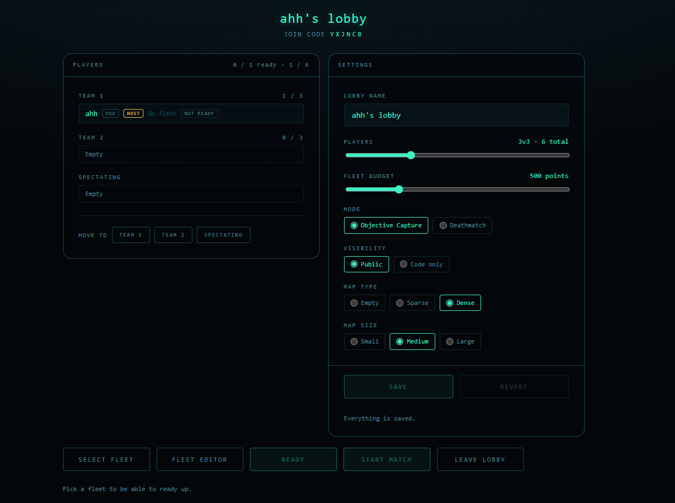
Fleet editor
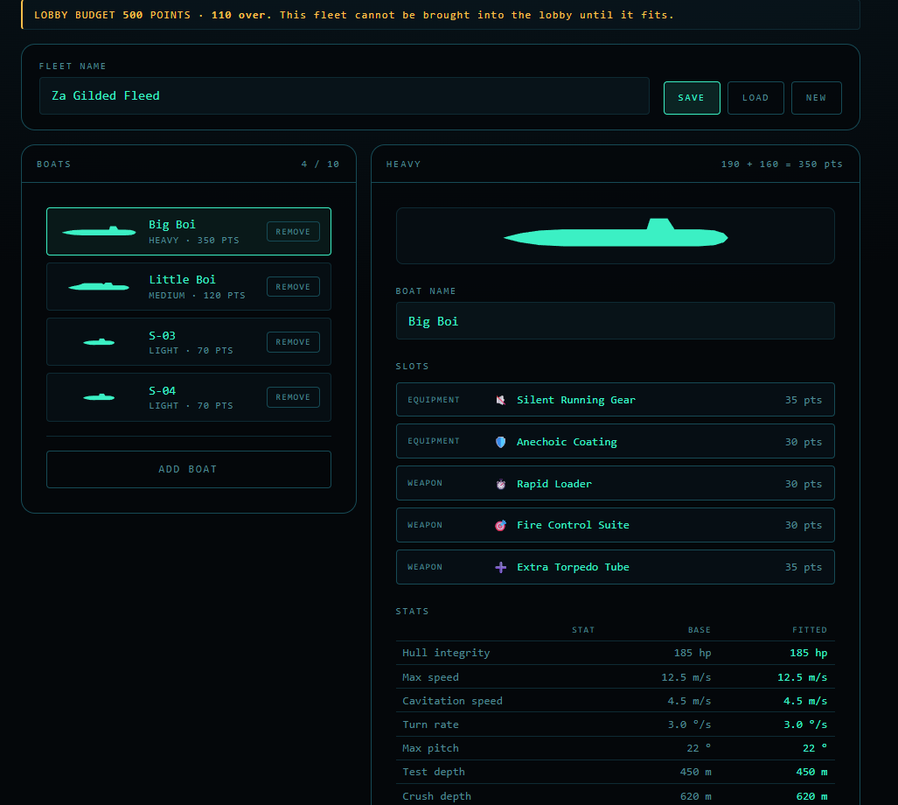
Some gameplay stuff
