SCHOOL OF ENGINEERING, SCIENCE AND TECHNOLOGY
INFORMATION TECHNOLOGY DEPARTMENT
DIPLOMA IN COMPUTER STUDIES &
DIPLOMA IN GAMES TECHNOLOGY
[DMT22114 MOBILE TECHNOLOGY]

[LECTURER: LAI KIM MIN]

ASSIGNMENT: [1]

[APPLICATION 1: FIRST ANDROID APP]

STUDENT NO | NAME | Marks
0193902 | Jared Chew Kah Hong
0192517 | Tay Ho Siang

DUE DATE | : | [27 SEP 2017]
TOTAL MARKS | : | [100 MARKS / 20%]

Assignment Specification (Group Assignment: 2 students per group)

Before working on this or any assignment, you will need to set up the Android Studio IDE on your computer. We suggest that you do this as early as possible, because some students get stuck and need time to get the IDE set up.

This assignment is much more flexible compared to the previous subject DJP2264 (Java Programming). The idea is to encourage you to use your creativity to build something instead of forcing you to produce the exact apps or outcome.

For this first assignment, we'll leave things very open-ended. You can make any Android app you want. We'd prefer to see an app that has the following qualities:

- Your app should be set up as an Android Studio project, so it can easily be opened/run/graded by others.
- Your app should use at least 4 widgets/views on the screen. (Example: Three Buttons and a TextView, ...)
- Your app should use at least 2 different kinds of widgets. (Example: Button, TextView, EditText, ...)
- Your app should respond to at least two different events. (Example: clicks on two different buttons.)
- Your app's design should change at least some aspect of the physical appearance and styling of some widgets. For example, make a text view have a larger or bold font, or make a button appear in a blue color.
- We haven't talked very much about layout yet, so your app can have essentially any layout you want, so long as the various widgets are visible and can be interacted with.

You can do anything you want! Your app does not need to be totally unique; if you have an existing idea that you want to replicate, or if you and a friend want to make the same kind of app, please go ahead but make sure you are not copy each other.

Suggestion:

If you are run out of ideas, perhaps you can consider the following topics:

- Random number guessing game
- Tip Calculator
- Loan Calculator
- Student Grading System
- BMI Calculator
- Memory Game
- Rock-Paper-Scissor
- Hangman
- Math Tutor for Kids

Deliverables
- Program code.
- Layout
- Java files
- Any resources files

- Sample screen shots of your app with appropriate test data.
- Each student is required to write a reflection and evaluation report (e.g. 2 reflection reports for 2 students in a group). The report shall include the following details:
- Your contribution in the whole system development.
- What you have been learnt from the project?
- Your own performance evaluation.
- What problems were encountered during system development? How do you solve it?
- A simple product demonstration during class session.

Marking Rubric for Assignment
The assignment will be marked based on the following criteria. Include this sheet as the last page of your submission.

Criteria | Very Poor | Poor | Good | Expert | Allocated Marks
Program Execution | (0 – 4 marks)  Weak Program execution with major flaws | (5 - 9 marks)  Average Program execution with some flaws | (10 - 14 marks)  Good Program execution with minor flaws | (16 - 20 marks)  Excellent Program execution
Program Correctness (compliant with the specifications stated in assignment) | (0 – 4 marks)  Little coverage of assignments requirements with weak implementation | (5 – 9 marks)  Comply some of the assignment requirements with average or below average implementation | (10 – 14 marks)  Comply with the most of the assignment requirements with good implementation | (16 - 20 marks)  Fully comply with the assignment requirements with excellent implementation
Creativity & Innovative | (0 – 4 mark)  Weak creativity product produced | (5 – 9 marks)  Average product with average creativity | (10 - 14 marks)  Good product with good creativity idea | (16 – 20 marks)  Excellent product which full with creativity and fresh idea
Output & Layout | (0 – 4 mark)  Weak/no output & layout produced | (5 – 9 marks)  Poor/Average output & layout produced | (10 - 14 marks)  Good output & layout produced | (16 – 20 marks)  Excellent output & layout produced
Reflection Report  (* students’ marks will be varied here) | (0 – 3 mark)  Weak report provided with major omission | (3 – 5 marks)  Poor/Average report provided but some aspects are not elaborated in details | (6 – 8 marks)  Good report provided with minor omission in certain aspects | (9 – 10 marks)  Excellent reflection report provided
Presentation  (* students’ marks will be varied here) | (0 – 3 mark)  Weak and unable to demonstration product clearly | (3 – 5 marks)  Poor/Average in overall presentation | (6 – 8 marks)  Good in overall presentation | (9 – 10 marks)  Excellent in overall presentation

Report

(Jared Chew)

I've contributed to the development of the Tic Tac Toe game and the Number Guessing game. When this assignment, I've learnt the use of creating and linking new activity, use of image buttons, TextViews, buttons, mini menu at the top right, and countdown timer. I would say that my performance is on the average side. I didn't face any problems when developing the app as I find it very similar, in fact, easier than Java. The IDE is very powerful that I detects error easily, and is very user friendly.

(Tay Ho Siang)

I contribution to the development of the Memory Challenge game and UI design. When this assignment, I've learnt the design of elements on the location, set the image buttons to have pressed and released mode, use image button, use text view, use buttons, use grid layout, use linear layout, use relative layout, use countdown timer, control the values with until timer done just change or reset it. I have a problem is the image too big system can't handle, but I fixed the problem with use go to change the picture size outside Android studio, after then just copy it inside again, also fix similar, in fact, easier than Java.
Screenshot
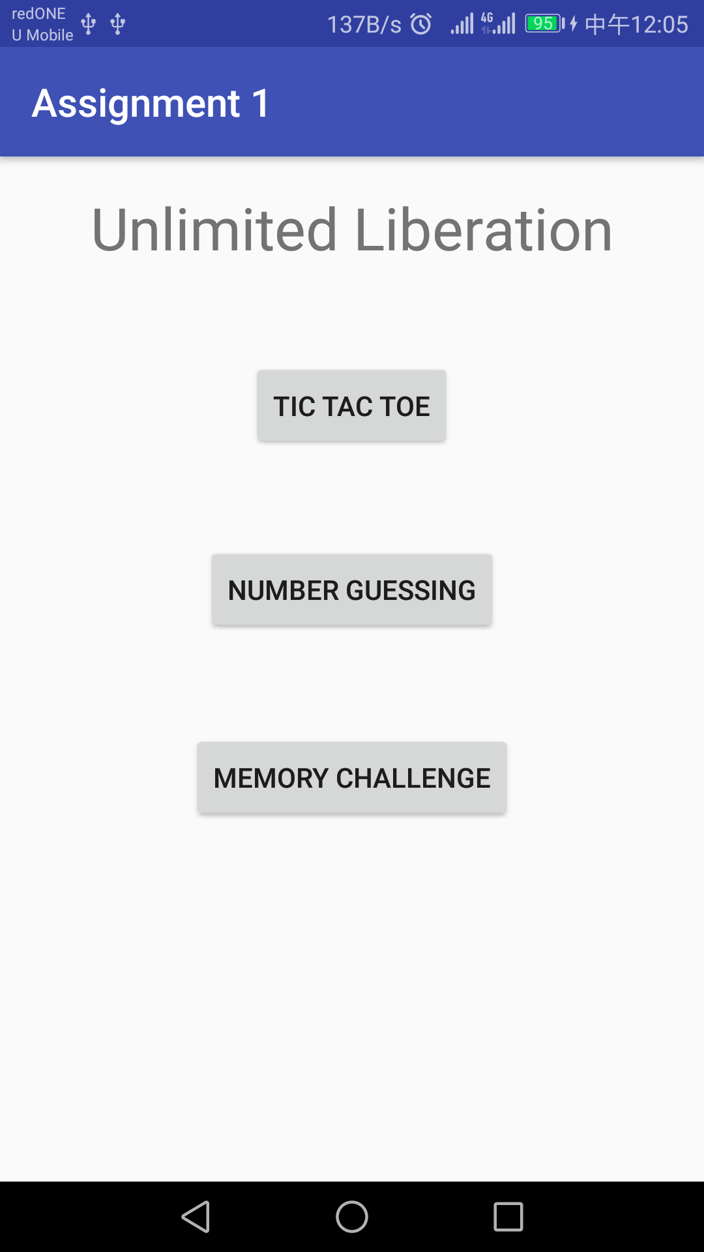

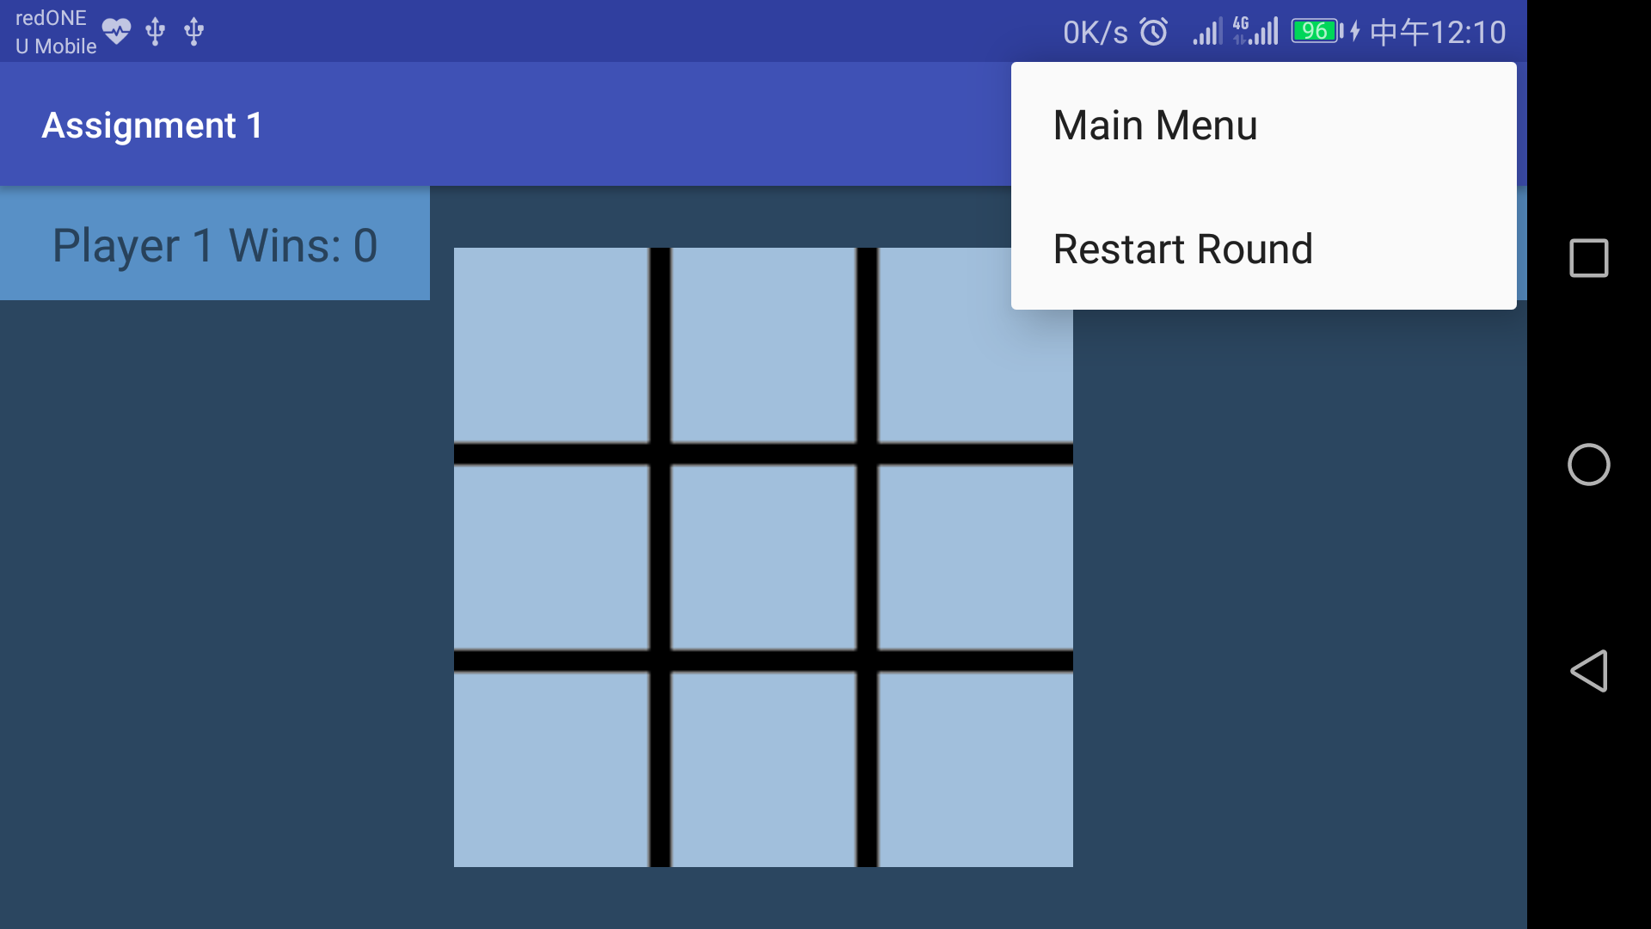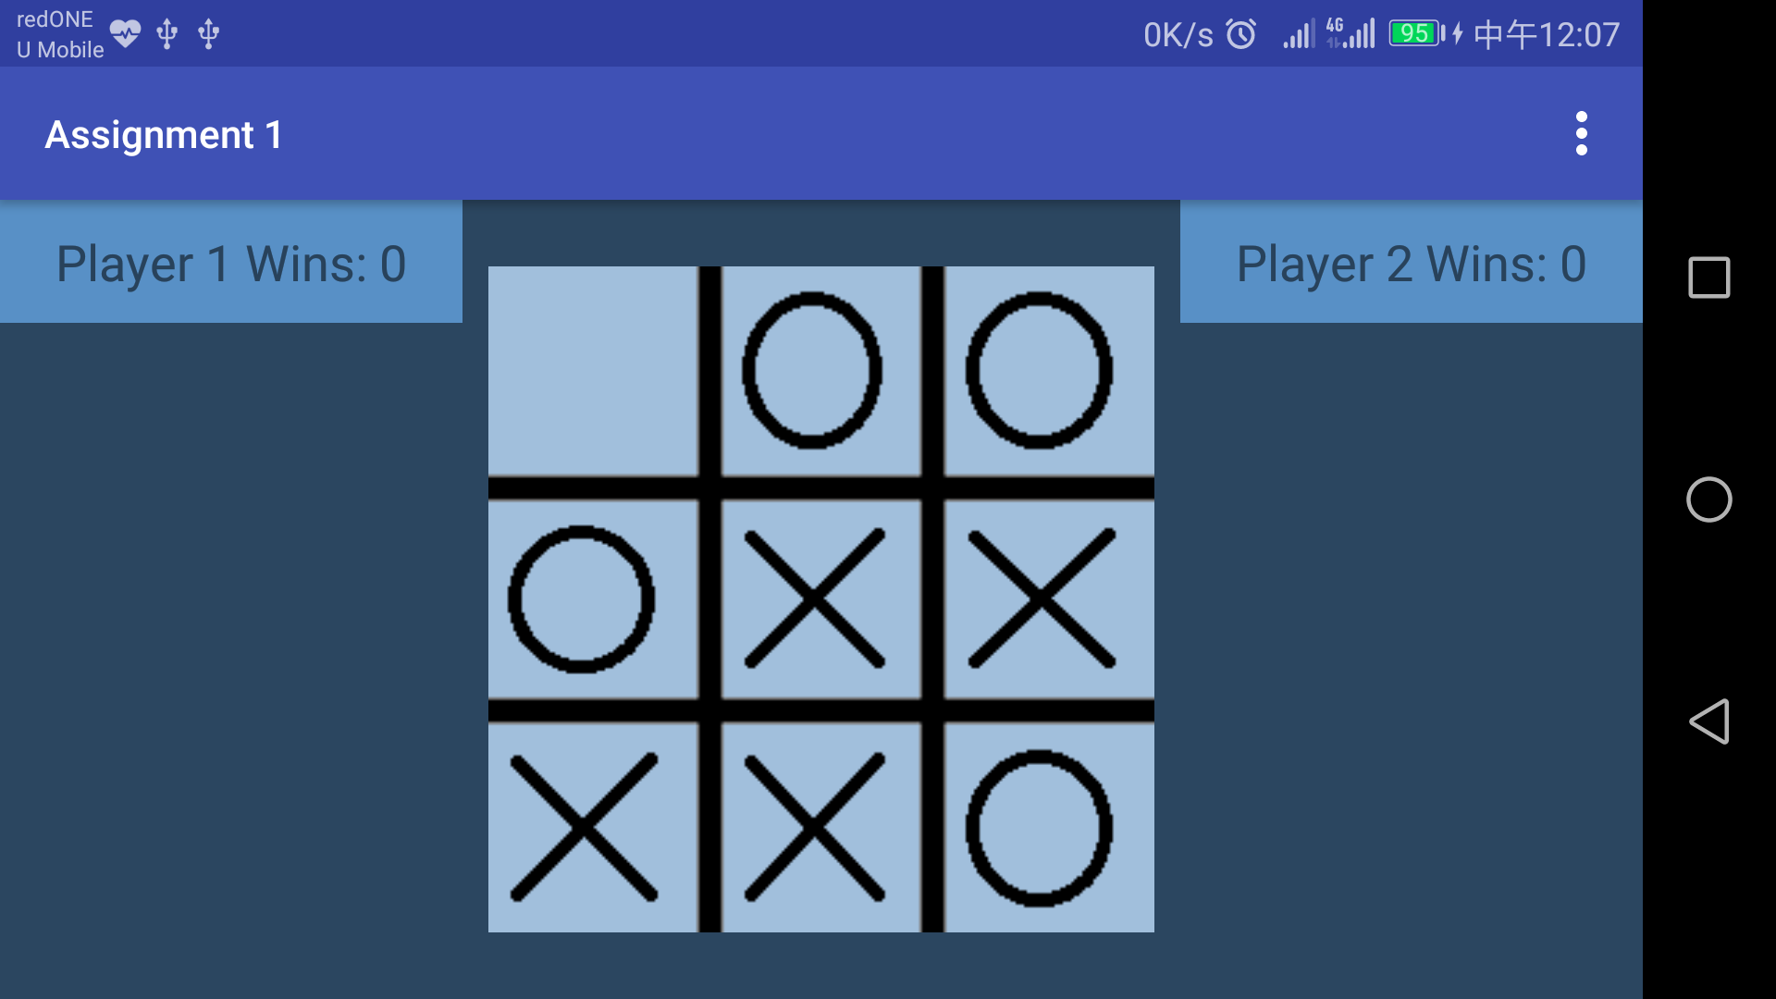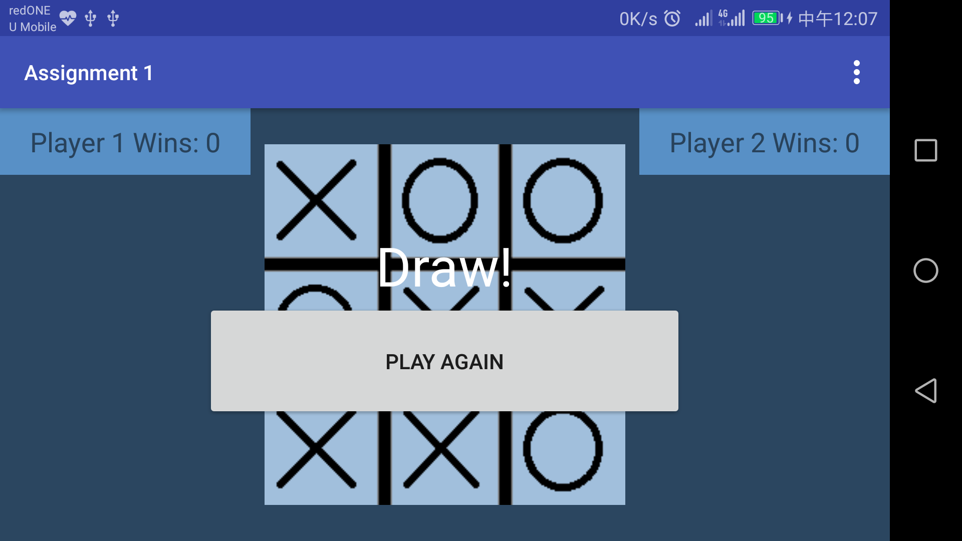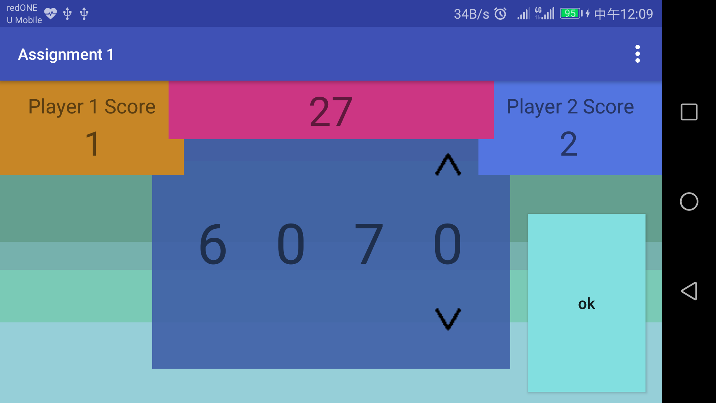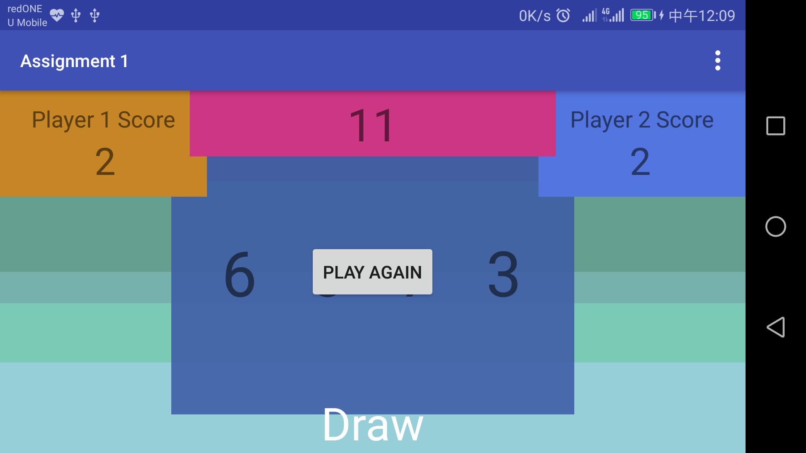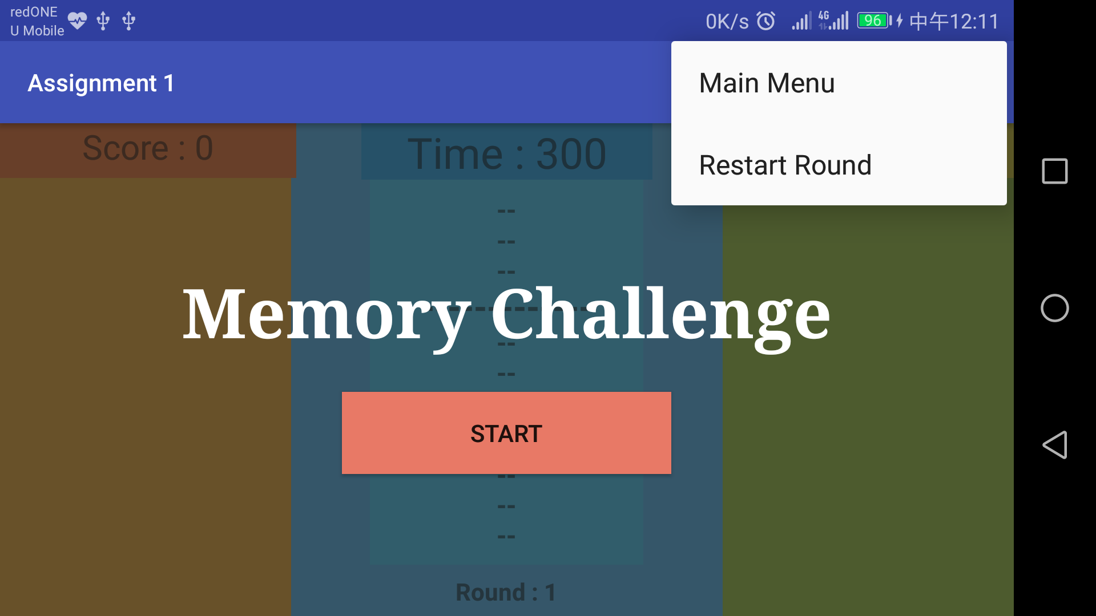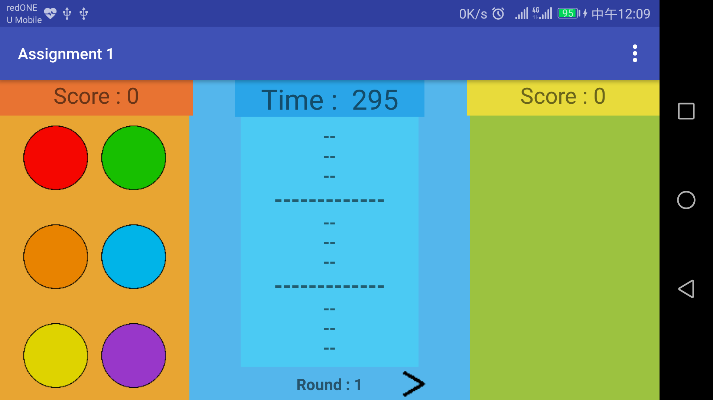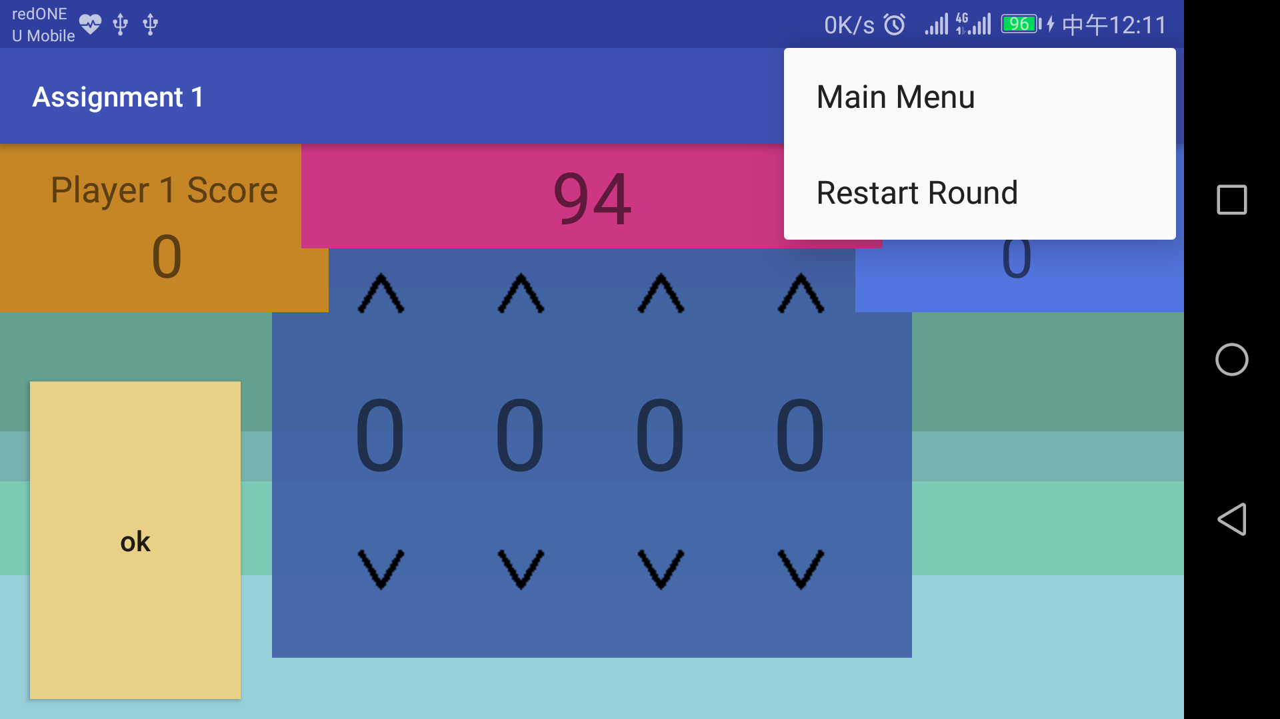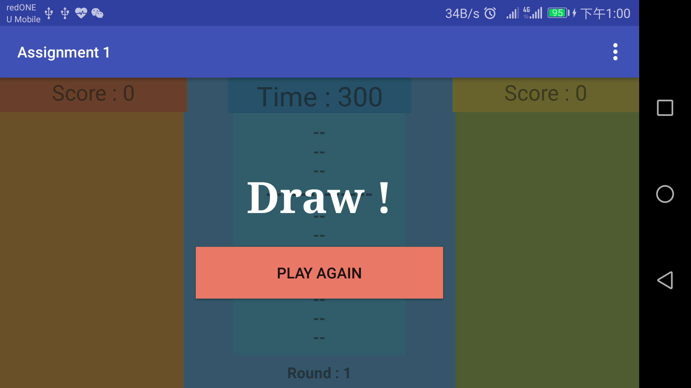
Main Activity XML:
<?xml version="1.0" encoding="utf-8"?>
<LinearLayout xmlns:android="http://schemas.android.com/apk/res/android"
xmlns:tools="http://schemas.android.com/tools"
android:layout_width="match_parent"
android:layout_height="match_parent"
android:orientation="vertical"
android:paddingBottom="@dimen/activity_vertical_margin"
android:paddingLeft="@dimen/activity_horizontal_margin"
android:paddingRight="@dimen/activity_horizontal_margin"
android:paddingTop="@dimen/activity_vertical_margin"
tools:context="com.example.student.assignment1.MainActivity"
android:weightSum="1">
<RelativeLayout
android:layout_width="match_parent"
android:layout_height="match_parent">
<TextView
android:id="@+id/textView"
android:layout_width="match_parent"
android:layout_height="wrap_content"
android:layout_alignParentTop="true"
android:text="@string/title_mainMenu"
android:textAlignment="center"
android:textSize="30sp" />
<Button
android:id="@+id/ticTacTie_Button"
android:layout_width="wrap_content"
android:layout_height="wrap_content"
android:onClick="ticTacToe"
android:tag="pvp"
android:text="@string/ticTacToe_switch"
android:layout_marginTop="47dp"
android:layout_below="@+id/textView"
android:layout_centerHorizontal="true" />
<Button
android:id="@+id/numberGuessing_button"
android:layout_width="wrap_content"
android:layout_height="wrap_content"
android:layout_below="@+id/ticTacTie_Button"
android:layout_centerHorizontal="true"
android:layout_marginTop="46dp"
android:onClick="numberGuessing"
android:text="@string/numberGuessing_switch" />
<Button
android:id="@+id/memoryChallenge_button"
android:layout_width="wrap_content"
android:layout_height="wrap_content"
android:layout_below="@+id/numberGuessing_button"
android:layout_centerHorizontal="true"
android:layout_marginTop="48dp"
android:onClick="memoryChallenge"
android:text="@string/memoryChallenge_switch" />
</RelativeLayout>
</LinearLayout>

Main Activity Java

package com.example.student.assignment1;
import android.content.Intent;
import android.content.pm.ActivityInfo;
import android.support.v7.app.AppCompatActivity;
import android.os.Bundle;
import android.view.View;
public class MainActivity extends AppCompatActivity {
@Override
protected void onCreate(Bundle savedInstanceState) {
setRequestedOrientation(ActivityInfo.SCREEN_ORIENTATION_PORTRAIT);
super.onCreate(savedInstanceState);
setContentView(R.layout.activity_main);
}
protected void ticTacToe(View view) {
Intent myIntent = new Intent(view.getContext(), TicTacToe.class);
this.startActivity(myIntent);
}
protected void numberGuessing(View view) {
Intent myIntent = new Intent(view.getContext(), NumberGuessing.class);
this.startActivity(myIntent);
}
protected void memoryChallenge(View view) {
Intent myIntent = new Intent(view.getContext(), MemoryChallenge.class);
this.startActivity(myIntent);
}
}

Tic Tac Toe XML

<?xml version="1.0" encoding="utf-8"?>
<RelativeLayout xmlns:android="http://schemas.android.com/apk/res/android"
xmlns:app="http://schemas.android.com/apk/res-auto"
xmlns:tools="http://schemas.android.com/tools"
android:layout_width="match_parent"
android:layout_height="match_parent"
android:background="#2B4660"
tools:context="com.example.student.assignment1.MainActivity">
<GridLayout
android:layout_width="wrap_content"
android:layout_height="wrap_content"
android:layout_centerInParent="true"
android:background="#eeAAC8E5">
android:columnCount="3"
android:rowCount="3"
<ImageButton
android:id="@+id/x1y1"
android:layout_width="80dp"
android:layout_height="80dp"
android:layout_column="1"
android:layout_row="1"
android:background="@null"
android:onClick="playerTurn"
android:scaleType="fitXY"
android:tag="0"
app:srcCompat="@drawable/x1y1" />
<ImageButton
android:id="@+id/x2y1"
android:layout_width="80dp"
android:layout_height="80dp"
android:layout_column="2"
android:layout_row="1"
android:background="@null"
android:onClick="playerTurn"
android:scaleType="fitXY"
android:tag="1"
app:srcCompat="@drawable/x2y1" />
<ImageButton
android:id="@+id/x3y1"
android:layout_width="80dp"
android:layout_height="80dp"
android:layout_column="3"
android:layout_row="1"
android:background="@null"
android:onClick="playerTurn"
android:scaleType="fitXY"
android:tag="2"
app:srcCompat="@drawable/x3y1" />
<ImageButton
android:id="@+id/x1y2"
android:layout_width="80dp"
android:layout_height="80dp"
android:layout_column="1"
android:layout_row="2"
android:background="@null"
android:onClick="playerTurn"
android:paddingLeft="0dp"
android:scaleType="fitXY"
android:tag="3"
app:srcCompat="@drawable/x1y2" />
<ImageButton
android:id="@+id/x2y2"
android:layout_width="80dp"
android:layout_height="80dp"
android:layout_column="2"
android:layout_row="2"
android:background="@null"
android:onClick="playerTurn"
android:scaleType="fitXY"
android:tag="4"
app:srcCompat="@drawable/x2y2" />
<ImageButton
android:id="@+id/x3y2"
android:layout_width="80dp"
android:layout_height="80dp"
android:layout_column="3"
android:layout_row="2"
android:background="@null"
android:onClick="playerTurn"
android:scaleType="fitXY"
android:tag="5"
app:srcCompat="@drawable/x3y2" />
<ImageButton
android:id="@+id/x1y3"
android:layout_width="80dp"
android:layout_height="80dp"
android:layout_column="1"
android:layout_row="3"
android:background="@null"
android:onClick="playerTurn"
android:scaleType="fitXY"
android:tag="6"
app:srcCompat="@drawable/x1y3" />
<ImageButton
android:id="@+id/x2y3"
android:layout_width="80dp"
android:layout_height="80dp"
android:layout_column="2"
android:layout_row="3"
android:background="@null"
android:onClick="playerTurn"
android:scaleType="fitXY"
android:tag="7"
app:srcCompat="@drawable/x2y3" />
<ImageButton
android:id="@+id/x3y3"
android:layout_width="80dp"
android:layout_height="80dp"
android:layout_column="3"
android:layout_row="3"
android:background="@null"
android:onClick="playerTurn"
android:scaleType="fitXY"
android:tag="8"
app:srcCompat="@drawable/x3y3" />
</GridLayout>
<TextView
android:id="@+id/player1Score"
android:layout_width="wrap_content"
android:layout_height="wrap_content"
android:layout_alignParentLeft="true"
android:layout_alignParentTop="true"
android:background="#cc63A3E0"
android:paddingBottom="10dp"
android:paddingLeft="20dp"
android:paddingRight="20dp"
android:paddingTop="10dp"
android:text="Player 1 Wins: 0"
android:textSize="18sp" />
<TextView
android:id="@+id/player2Score"
android:layout_width="wrap_content"
android:layout_height="wrap_content"
android:layout_alignParentRight="true"
android:layout_alignParentTop="true"
android:background="#cc63A3E0"
android:paddingBottom="10dp"
android:paddingLeft="20dp"
android:paddingRight="20dp"
android:paddingTop="10dp"
android:text="Player 2 Wins: 0"
android:textSize="18sp" />
<LinearLayout
android:id="@+id/winlose_ui"
android:layout_width="wrap_content"
android:layout_height="wrap_content"
android:layout_centerInParent="true"
android:orientation="vertical"
android:visibility="invisible">
<TextView
android:id="@+id/winLoseDraw"
android:layout_width="match_parent"
android:layout_height="wrap_content"
android:gravity="center_vertical|center_horizontal"
android:textAlignment="center"
android:textColor="@color/mc_ui_gametitle_winner_text_color"
android:textSize="36sp" />
<Button
android:id="@+id/again"
android:layout_width="wrap_content"
android:layout_height="wrap_content"
android:layout_gravity="center"
android:onClick="againButton"
android:paddingBottom="@dimen/ng_ui_size_vertical_padding"
android:paddingLeft="@dimen/ng_ui_size_horizontal_padding"
android:paddingRight="@dimen/ng_ui_size_horizontal_padding"
android:paddingTop="@dimen/ng_ui_size_vertical_padding"
android:text="@string/playAgain_default"
android:visibility="visible" />
</LinearLayout>
</RelativeLayout>
Tic Tac Toe Java

package com.example.student.assignment1;
import android.content.pm.ActivityInfo;
import android.os.Bundle;
import android.support.v7.app.AppCompatActivity;
import android.view.Menu;
import android.view.MenuInflater;
import android.view.MenuItem;
import android.view.View;
import android.widget.Button;
import android.widget.ImageButton;
import android.widget.LinearLayout;
import android.widget.TextView;
public class TicTacToe extends AppCompatActivity {
private boolean gameEnd = false;
private int p1Score = 0;
private int p2Score = 0;
private int turns = 0;
private String player = "Player1";
private char block[] = new char[9];
@Override
protected void onCreate(Bundle savedInstanceState) {
setRequestedOrientation(ActivityInfo.SCREEN_ORIENTATION_LANDSCAPE);
super.onCreate(savedInstanceState);
setContentView(R.layout.activity_tic_tac_toe);
for(int i = 0; i < 9; i++) {
block[i] = 'E';
}
}
private void reset() {
gameEnd = false;
turns = 0;
player = "Player1";
for(int i = 0; i < 9; i++) {
block[i] = 'E';
}
ImageButton x1y1 =(ImageButton) findViewById(R.id.x1y1);
x1y1.setImageResource(R.drawable.x1y1);
ImageButton x2y1 =(ImageButton) findViewById(R.id.x2y1);
x2y1.setImageResource(R.drawable.x2y1);
ImageButton x3y1 =(ImageButton) findViewById(R.id.x3y1);
x3y1.setImageResource(R.drawable.x3y1);
ImageButton x1y2 =(ImageButton) findViewById(R.id.x1y2);
x1y2.setImageResource(R.drawable.x1y2);
ImageButton x2y2 =(ImageButton) findViewById(R.id.x2y2);
x2y2.setImageResource(R.drawable.x2y2);
ImageButton x3y2 =(ImageButton) findViewById(R.id.x3y2);
x3y2.setImageResource(R.drawable.x3y2);
ImageButton x1y3 =(ImageButton) findViewById(R.id.x1y3);
x1y3.setImageResource(R.drawable.x1y3);
ImageButton x2y3 =(ImageButton) findViewById(R.id.x2y3);
x2y3.setImageResource(R.drawable.x2y3);
ImageButton x3y3 =(ImageButton) findViewById(R.id.x3y3);
x3y3.setImageResource(R.drawable.x3y3);
LinearLayout winlose_ll = (LinearLayout) findViewById(R.id.winlose_ui);
winlose_ll.setVisibility(winlose_ll.INVISIBLE);
}
private void setBlockState(int position, char state) {
block[position] = state;
}
private char getBlockState(int position) {
return block[position];
}
public void playerTurn(View view) {
int blockClick = Integer.parseInt(view.getTag().toString());
if(player == "Player1") {
switch (blockClick) {
case 0:
if (getBlockState(0) == 'E' && gameEnd == false) {
ImageButton x1y1 = (ImageButton) findViewById(R.id.x1y1);
x1y1.setImageResource(R.drawable.x1y1x);
setBlockState(0, 'X');
game();
}
break;
case 1:
if (getBlockState(1) == 'E' && gameEnd == false) {
ImageButton x2y1 = (ImageButton) findViewById(R.id.x2y1);
x2y1.setImageResource(R.drawable.x2y1x);
setBlockState(1, 'X');
game();
}
break;
case 2:
if (getBlockState(2) == 'E' && gameEnd == false) {
ImageButton x3y1 = (ImageButton) findViewById(R.id.x3y1);
x3y1.setImageResource(R.drawable.x3y1x);
setBlockState(2, 'X');
game();
}
break;
case 3:
if (getBlockState(3) == 'E' && gameEnd == false) {
ImageButton x1y2 = (ImageButton) findViewById(R.id.x1y2);
x1y2.setImageResource(R.drawable.x1y2x);
setBlockState(3, 'X');
game();
}
break;
case 4:
if (getBlockState(4) == 'E' && gameEnd == false) {
ImageButton x2y2 = (ImageButton) findViewById(R.id.x2y2);
x2y2.setImageResource(R.drawable.x2y2x);
setBlockState(4, 'X');
game();
}
break;
case 5:
if (getBlockState(5) == 'E' && gameEnd == false) {
ImageButton x3y2 = (ImageButton) findViewById(R.id.x3y2);
x3y2.setImageResource(R.drawable.x3y2x);
setBlockState(5, 'X');
game();
}
break;
case 6:
if (getBlockState(6) == 'E' && gameEnd == false) {
ImageButton x1y3 = (ImageButton) findViewById(R.id.x1y3);
x1y3.setImageResource(R.drawable.x1y3x);
setBlockState(6, 'X');
game();
}
break;
case 7:
if (getBlockState(7) == 'E' && gameEnd == false) {
ImageButton x2y3 = (ImageButton) findViewById(R.id.x2y3);
x2y3.setImageResource(R.drawable.x2y3x);
setBlockState(7, 'X');
game();
}
break;
case 8:
if (getBlockState(8) == 'E' && gameEnd == false) {
ImageButton x3y3 = (ImageButton) findViewById(R.id.x3y3);
x3y3.setImageResource(R.drawable.x3y3x);
setBlockState(8, 'X');
game();
}
break;
}
}
else if (player == "Player2") {
switch (blockClick) {
case 0:
if (getBlockState(0) == 'E' && gameEnd == false) {
ImageButton x1y1 = (ImageButton) findViewById(R.id.x1y1);
x1y1.setImageResource(R.drawable.x1y1o);
setBlockState(0, 'O');
game();
}
break;
case 1:
if (getBlockState(1) == 'E' && gameEnd == false) {
ImageButton x2y1 = (ImageButton) findViewById(R.id.x2y1);
x2y1.setImageResource(R.drawable.x2y1o);
setBlockState(1, 'O');
game();
}
break;
case 2:
if (getBlockState(2) == 'E' && gameEnd == false) {
ImageButton x3y1 = (ImageButton) findViewById(R.id.x3y1);
x3y1.setImageResource(R.drawable.x3y1o);
setBlockState(2, 'O');
game();
}
break;
case 3:
if (getBlockState(3) == 'E' && gameEnd == false) {
ImageButton x1y2 = (ImageButton) findViewById(R.id.x1y2);
x1y2.setImageResource(R.drawable.x1y2o);
setBlockState(3, 'O');
game();
}
break;
case 4:
if (getBlockState(4) == 'E' && gameEnd == false) {
ImageButton x2y2 = (ImageButton) findViewById(R.id.x2y2);
x2y2.setImageResource(R.drawable.x2y2o);
setBlockState(4, 'O');
game();
}
break;
case 5:
if (getBlockState(5) == 'E' && gameEnd == false) {
ImageButton x3y2 = (ImageButton) findViewById(R.id.x3y2);
x3y2.setImageResource(R.drawable.x3y2o);
setBlockState(5, 'O');
game();
}
break;
case 6:
if (getBlockState(6) == 'E' && gameEnd == false) {
ImageButton x1y3 = (ImageButton) findViewById(R.id.x1y3);
x1y3.setImageResource(R.drawable.x1y3o);
setBlockState(6, 'O');
game();
}
break;
case 7:
if (getBlockState(7) == 'E' && gameEnd == false) {
ImageButton x2y3 = (ImageButton) findViewById(R.id.x2y3);
x2y3.setImageResource(R.drawable.x2y3o);
setBlockState(7, 'O');
game();
}
break;
case 8:
if (getBlockState(8) == 'E' && gameEnd == false) {
ImageButton x3y3 = (ImageButton) findViewById(R.id.x3y3);
x3y3.setImageResource(R.drawable.x3y3o);
setBlockState(8, 'O');
game();
}
break;
}
}
}
private void game() {
winCheck();
playerSwitch();
}
private void winCheck() {
//Winning mode horizontal
int winCount = 0;
int counter = 0;
for (int i = 0; i < 9; i++) {
if (player == "Player1" && block[i] == 'X') {
winCount++;
}
else if (player == "Player2" && block[i] == 'O') {
winCount++;
}
if (winCount == 3) {
gameEnd = true;
winLose();
return;
}
counter++;
if(counter == 3) {
winCount = 0;
counter = 0;
}
}
////////////////////////////////////////////
//Winning mode vertical
int xPosCounter = 0;
winCount = 0;
counter = 0;
for (int i = 0; xPosCounter < 3; i += 3) {
if (player == "Player1" && block[i] == 'X') {
winCount++;
}
else if (player == "Player2" && block[i] == 'O') {
winCount++;
}
if (winCount == 3) {
gameEnd = true;
winLose();
return;
}
counter++;
if (counter == 3) {
xPosCounter++;
winCount = 0;
counter = 0;
i -= 8;
}
}
////////////////////////////////////////////
//Winning mode diagonal
/* backslash-diagonal */
winCount = 0;
counter = 0;
for (int i = 0; i < 9; i += 4) {
if (player == "Player1" && block[i] == 'X') {
winCount++;
}
else if (player == "Player2" && block[i] == 'O') {
winCount++;
}
if (winCount == 3) {
gameEnd = true;
winLose();
return;
}
counter++;
}
/* forward slash diagonal */
winCount = 0;
counter = 0;
for (int i = 2; i < 7; i += 2) {
if (player == "Player1" && block[i] == 'X') {
winCount++;
}
else if (player == "Player2" && block[i] == 'O') {
winCount++;
}
if (winCount == 3) {
gameEnd = true;
winLose();
return;
}
counter++;
}
////////////////////////////////////////////
//Draw
if(turns == 8) {
player = "Draw";
winLose();
}
}
private void playerSwitch() {
if(player == "Player1") {
player = "Player2";
}
else if(player == "Player2") {
player = "Player1";
}
turns++;
}
private void winLose() {
TextView winLoseDraw = (TextView)findViewById(R.id.winLoseDraw);
LinearLayout winlose_ll = (LinearLayout) findViewById(R.id.winlose_ui);
winlose_ll.setVisibility(winlose_ll.VISIBLE);
if(player == "Player1") {
p1Score++;
TextView player1Score = (TextView) findViewById(R.id.player1Score);
player1Score.setText("Player 1 wins: " + p1Score);
winLoseDraw.setText("Player 1 Win!");
}
else if(player == "Player2") {
p2Score++;
TextView player2Score = (TextView) findViewById(R.id.player2Score);
player2Score.setText("Player 1 wins: " + p2Score);
winLoseDraw.setText("Player 2 Win!");
}
else if (player == "Draw") {
winLoseDraw.setText("Draw!");
}
}
public void againButton(View view) {
TextView winLoseDraw = (TextView)findViewById(R.id.winLoseDraw);
Button playAgain = (Button)findViewById(R.id.again);
winLoseDraw.setVisibility(View.INVISIBLE);
playAgain.setVisibility(View.INVISIBLE);
reset();
}
public boolean onCreateOptionsMenu(Menu menu) {
MenuInflater inflater = getMenuInflater();
inflater.inflate(R.menu.options_menu, menu);
return true;
}
public boolean onOptionsItemSelected(MenuItem item) {
switch (item.getItemId()) {
case R.id.mainMenu:
this.finish();
return true;
case R.id.restart:
reset();
return true;
default:
return super.onOptionsItemSelected(item);
}
}
}

Number Guessing XML

<?xml version="1.0" encoding="utf-8"?>
<RelativeLayout xmlns:android="http://schemas.android.com/apk/res/android"
xmlns:app="http://schemas.android.com/apk/res-auto"
xmlns:tools="http://schemas.android.com/tools"
android:layout_width="match_parent"
android:layout_height="match_parent"
android:background="@color/ng_color_main_background"
tools:context="com.example.student.assignment1.MemoryChallenge">
<TextView
android:id="@+id/background_top"
android:layout_width="match_parent"
android:layout_height="wrap_content"
android:layout_alignParentTop="true"
android:background="@color/ng_color_background_design_top"
android:paddingBottom="@dimen/ng_background_design_top_padding" />
<TextView
android:id="@+id/background_middle"
android:layout_width="match_parent"
android:layout_height="wrap_content"
android:layout_centerVertical="true"
android:background="@color/ng_color_background_design_middle"
android:paddingBottom="@dimen/ng_background_design_middle_padding" />
<TextView
android:id="@+id/background_bottom"
android:layout_width="match_parent"
android:layout_height="wrap_content"
android:layout_alignParentBottom="true"
android:background="@color/ng_color_background_design_bottom"
android:paddingBottom="@dimen/ng_background_design_bottom_padding" />
<GridLayout
android:id="@+id/select_board"
android:layout_width="wrap_content"
android:layout_height="wrap_content"
android:layout_centerInParent="true"
android:background="@color/ng_color_select_board"
android:paddingBottom="@dimen/ng_select_board_vertical_padding"
android:paddingLeft="@dimen/ng_select_board_horizontal_padding"
android:paddingRight="@dimen/ng_select_board_horizontal_padding"
android:paddingTop="@dimen/ng_select_board_vertical_padding">
<ImageButton
android:id="@+id/upBtn1"
android:layout_width="wrap_content"
android:layout_height="wrap_content"
android:layout_column="1"
android:layout_marginBottom="@dimen/ng_sb_element_vertical_margin"
android:layout_marginLeft="@dimen/ng_sb_element_horizontal_margin"
android:layout_marginRight="@dimen/ng_sb_element_horizontal_margin"
android:layout_marginTop="@dimen/ng_sb_element_vertical_margin"
android:layout_row="1"
android:background="@null"
android:contentDescription="@string/buttonUp_desc"
android:onClick="increase_button"
android:padding="@dimen/ng_sb_element_padding"
android:tag="num1"
app:srcCompat="@drawable/arrow_up" />
<TextView
android:id="@+id/num1"
android:layout_width="wrap_content"
android:layout_height="wrap_content"
android:layout_column="1"
android:layout_marginBottom="@dimen/ng_sb_element_vertical_margin"
android:layout_marginLeft="@dimen/ng_sb_element_horizontal_margin"
android:layout_marginRight="@dimen/ng_sb_element_horizontal_margin"
android:layout_marginTop="@dimen/ng_sb_element_vertical_margin"
android:layout_row="2"
android:padding="@dimen/ng_sb_element_padding"
android:text="@string/num1_ng"
android:textSize="@dimen/ng_num1_text_size" />
<ImageButton
android:id="@+id/downBtn1"
android:layout_width="wrap_content"
android:layout_height="wrap_content"
android:layout_column="1"
android:layout_marginBottom="@dimen/ng_sb_element_vertical_margin"
android:layout_marginLeft="@dimen/ng_sb_element_horizontal_margin"
android:layout_marginRight="@dimen/ng_sb_element_horizontal_margin"
android:layout_marginTop="@dimen/ng_sb_element_vertical_margin"
android:layout_row="3"
android:background="@null"
android:contentDescription="@string/buttonDown_desc"
android:onClick="decrease_button"
android:padding="@dimen/ng_sb_element_padding"
android:tag="num1"
app:srcCompat="@drawable/arrow_down" />
<ImageButton
android:id="@+id/upBtn2"
android:layout_width="wrap_content"
android:layout_height="wrap_content"
android:layout_column="2"
android:layout_marginBottom="@dimen/ng_sb_element_vertical_margin"
android:layout_marginLeft="@dimen/ng_sb_element_horizontal_margin"
android:layout_marginRight="@dimen/ng_sb_element_horizontal_margin"
android:layout_marginTop="@dimen/ng_sb_element_vertical_margin"
android:layout_row="1"
android:background="@null"
android:contentDescription="@string/buttonUp_desc"
android:onClick="increase_button"
android:padding="@dimen/ng_sb_element_padding"
android:tag="num2"
app:srcCompat="@drawable/arrow_up" />
<TextView
android:id="@+id/num2"
android:layout_width="wrap_content"
android:layout_height="wrap_content"
android:layout_column="2"
android:layout_marginBottom="@dimen/ng_sb_element_vertical_margin"
android:layout_marginLeft="@dimen/ng_sb_element_horizontal_margin"
android:layout_marginRight="@dimen/ng_sb_element_horizontal_margin"
android:layout_marginTop="@dimen/ng_sb_element_vertical_margin"
android:layout_row="2"
android:padding="@dimen/ng_sb_element_padding"
android:text="@string/num2_ng"
android:textSize="@dimen/ng_num1_text_size" />
<ImageButton
android:id="@+id/downBtn2"
android:layout_width="wrap_content"
android:layout_height="wrap_content"
android:layout_column="2"
android:layout_marginBottom="@dimen/ng_sb_element_vertical_margin"
android:layout_marginLeft="@dimen/ng_sb_element_horizontal_margin"
android:layout_marginRight="@dimen/ng_sb_element_horizontal_margin"
android:layout_marginTop="@dimen/ng_sb_element_vertical_margin"
android:layout_row="3"
android:background="@null"
android:contentDescription="@string/buttonDown_desc"
android:onClick="decrease_button"
android:padding="@dimen/ng_sb_element_padding"
android:tag="num2"
app:srcCompat="@drawable/arrow_down" />
<ImageButton
android:id="@+id/upBtn3"
android:layout_width="wrap_content"
android:layout_height="wrap_content"
android:layout_column="3"
android:layout_marginBottom="@dimen/ng_sb_element_vertical_margin"
android:layout_marginLeft="@dimen/ng_sb_element_horizontal_margin"
android:layout_marginRight="@dimen/ng_sb_element_horizontal_margin"
android:layout_marginTop="@dimen/ng_sb_element_vertical_margin"
android:layout_row="1"
android:background="@null"
android:contentDescription="@string/buttonUp_desc"
android:onClick="increase_button"
android:padding="@dimen/ng_sb_element_padding"
android:tag="num3"
app:srcCompat="@drawable/arrow_up" />
<TextView
android:id="@+id/num3"
android:layout_width="wrap_content"
android:layout_height="wrap_content"
android:layout_column="3"
android:layout_marginBottom="@dimen/ng_sb_element_vertical_margin"
android:layout_marginLeft="@dimen/ng_sb_element_horizontal_margin"
android:layout_marginRight="@dimen/ng_sb_element_horizontal_margin"
android:layout_marginTop="@dimen/ng_sb_element_vertical_margin"
android:layout_row="2"
android:padding="@dimen/ng_sb_element_padding"
android:text="@string/num3_ng"
android:textSize="@dimen/ng_num1_text_size" />
<ImageButton
android:id="@+id/downBtn3"
android:layout_width="wrap_content"
android:layout_height="wrap_content"
android:layout_column="3"
android:layout_marginBottom="@dimen/ng_sb_element_vertical_margin"
android:layout_marginLeft="@dimen/ng_sb_element_horizontal_margin"
android:layout_marginRight="@dimen/ng_sb_element_horizontal_margin"
android:layout_marginTop="@dimen/ng_sb_element_vertical_margin"
android:layout_row="3"
android:background="@null"
android:contentDescription="@string/buttonDown_desc"
android:onClick="decrease_button"
android:padding="@dimen/ng_sb_element_padding"
android:tag="num3"
app:srcCompat="@drawable/arrow_down" />
<ImageButton
android:id="@+id/upBtn4"
android:layout_width="wrap_content"
android:layout_height="wrap_content"
android:layout_column="4"
android:layout_marginBottom="@dimen/ng_sb_element_vertical_margin"
android:layout_marginLeft="@dimen/ng_sb_element_horizontal_margin"
android:layout_marginRight="@dimen/ng_sb_element_horizontal_margin"
android:layout_marginTop="@dimen/ng_sb_element_vertical_margin"
android:layout_row="1"
android:background="@null"
android:contentDescription="@string/buttonUp_desc"
android:onClick="increase_button"
android:padding="@dimen/ng_sb_element_padding"
android:tag="num4"
app:srcCompat="@drawable/arrow_up" />
<TextView
android:id="@+id/num4"
android:layout_width="wrap_content"
android:layout_height="wrap_content"
android:layout_column="4"
android:layout_marginBottom="@dimen/ng_sb_element_vertical_margin"
android:layout_marginLeft="@dimen/ng_sb_element_horizontal_margin"
android:layout_marginRight="@dimen/ng_sb_element_horizontal_margin"
android:layout_marginTop="@dimen/ng_sb_element_vertical_margin"
android:layout_row="2"
android:padding="@dimen/ng_sb_element_padding"
android:text="@string/num4_ng"
android:textSize="@dimen/ng_num1_text_size" />
<ImageButton
android:id="@+id/downBtn4"
android:layout_width="wrap_content"
android:layout_height="wrap_content"
android:layout_column="4"
android:layout_marginBottom="@dimen/ng_sb_element_vertical_margin"
android:layout_marginLeft="@dimen/ng_sb_element_horizontal_margin"
android:layout_marginRight="@dimen/ng_sb_element_horizontal_margin"
android:layout_marginTop="@dimen/ng_sb_element_vertical_margin"
android:layout_row="3"
android:background="@null"
android:contentDescription="@string/buttonDown_desc"
android:onClick="decrease_button"
android:padding="@dimen/ng_sb_element_padding"
android:tag="num4"
app:srcCompat="@drawable/arrow_down" />
</GridLayout>
<TextView
android:id="@+id/player1"
android:layout_width="wrap_content"
android:layout_height="wrap_content"
android:layout_alignParentStart="true"
android:layout_alignParentTop="true"
android:background="@color/ng_player1_mark_text"
android:paddingBottom="@dimen/ng_player1_mark_padding_bottom"
android:paddingLeft="@dimen/ng_player1_mark_horizontal_padding"
android:paddingRight="@dimen/ng_player1_mark_horizontal_padding"
android:paddingTop="@dimen/ng_player1_mark_padding_top"
android:text="@string/player1"
android:textSize="@dimen/ng_player1_mark_text_size" />
<TextView
android:id="@+id/player2"
android:layout_width="wrap_content"
android:layout_height="wrap_content"
android:layout_alignParentEnd="true"
android:layout_alignParentTop="true"
android:background="#5375E0"
android:paddingBottom="50dp"
android:paddingLeft="25dp"
android:paddingRight="25dp"
android:paddingTop="10dp"
android:text="@string/player2"
android:textSize="18sp"
tools:ignore="RelativeOverlap" />
<TextView
android:id="@+id/p1_score"
android:layout_width="wrap_content"
android:layout_height="wrap_content"
android:layout_alignParentStart="true"
android:layout_alignParentTop="true"
android:layout_marginLeft="@dimen/ng_player1_left_and_player_right_margin"
android:layout_marginTop="@dimen/ng_player1_and_player_top_margin"
android:text="@string/score_default"
android:textSize="@dimen/ng_ps_text_size"
tools:ignore="RtlHardcoded" />
<TextView
android:id="@+id/p2_score"
android:layout_width="wrap_content"
android:layout_height="wrap_content"
android:layout_alignParentEnd="true"
android:layout_alignParentTop="true"
android:layout_marginRight="@dimen/ng_player1_left_and_player_right_margin"
android:layout_marginTop="@dimen/ng_player1_and_player_top_margin"
android:text="@string/score_default"
android:textSize="@dimen/ng_ps_text_size"
tools:ignore="RelativeOverlap,RtlHardcoded" />
<TextView
android:id="@+id/time"
android:layout_width="wrap_content"
android:layout_height="wrap_content"
android:layout_alignParentTop="true"
android:layout_centerHorizontal="true"
android:background="@color/ng_time_color"
android:paddingBottom="@dimen/ng_time_vertical_padding"
android:paddingLeft="@dimen/ng_time_horizontal_padding"
android:paddingRight="@dimen/ng_time_horizontal_padding"
android:paddingTop="@dimen/ng_time_vertical_padding"
android:text="@string/time"
android:textAlignment="center"
android:textSize="@dimen/ng_time_text_size"
tools:text="@string/ng_time_text" />
<Button
android:id="@+id/playAgain"
android:layout_width="wrap_content"
android:layout_height="wrap_content"
android:layout_centerInParent="true"
android:onClick="playAgain"
android:text="@string/ng_play_agian_btn_text"
android:visibility="invisible"
tools:text="Play Again" />
<Button
android:id="@+id/okBtn_p1"
android:layout_width="wrap_content"
android:layout_height="wrap_content"
android:layout_alignParentBottom="true"
android:layout_alignParentStart="true"
android:layout_marginBottom="@dimen/ng_btn_p1_and_p2_margin_bottom"
android:layout_marginLeft="@dimen/ng_btn_p1_left_and_p2_right_margin"
android:background="@color/ng_btn_p1_color"
android:onClick="game"
android:paddingBottom="@dimen/ng_btn_p1_and_p2_vertical_padding"
android:paddingLeft="@dimen/ng_btn_p1_and_p2_horizontal_padding"
android:paddingRight="@dimen/ng_btn_p1_and_p2_horizontal_padding"
android:paddingTop="@dimen/ng_btn_p1_and_p2_vertical_padding"
android:tag="p1"
android:text="@string/ok_button"
android:textAllCaps="false"
android:visibility="visible"
tools:ignore="RtlHardcoded" />
<Button
android:id="@+id/okBtn_p2"
android:layout_width="wrap_content"
android:layout_height="wrap_content"
android:layout_alignParentBottom="true"
android:layout_alignParentEnd="true"
android:layout_marginBottom="@dimen/ng_btn_p1_and_p2_margin_bottom"
android:layout_marginRight="@dimen/ng_btn_p1_left_and_p2_right_margin"
android:background="@color/ng_btn_p2_color"
android:onClick="game"
android:paddingBottom="@dimen/ng_btn_p1_and_p2_vertical_padding"
android:paddingLeft="@dimen/ng_btn_p1_and_p2_horizontal_padding"
android:paddingRight="@dimen/ng_btn_p1_and_p2_horizontal_padding"
android:paddingTop="@dimen/ng_btn_p1_and_p2_vertical_padding"
android:tag="p2"
android:text="@string/ok_button"
android:textAllCaps="false"
android:visibility="invisible"
tools:ignore="RelativeOverlap,RtlHardcoded" />
<TextView
android:id="@+id/winLoseDraw"
android:layout_width="wrap_content"
android:layout_height="wrap_content"
android:layout_alignParentBottom="true"
android:layout_centerHorizontal="true"
android:text="TextView"
android:textColor="@color/mc_ui_gametitle_winner_text_color"
android:textSize="36sp"
android:visibility="invisible"
tools:text="@string/winLose_default" />
</RelativeLayout>
Number Guessing Java

package com.example.student.assignment1;
import android.content.pm.ActivityInfo;
import android.os.CountDownTimer;
import android.support.v7.app.AppCompatActivity;
import android.os.Bundle;
import android.view.Menu;
import android.view.MenuInflater;
import android.view.MenuItem;
import android.view.View;
import android.widget.Button;
import android.widget.ImageButton;
import android.widget.TextView;
import java.util.Random;
public class NumberGuessing extends AppCompatActivity {
private CountDownTimer timer = null;
private int num1 = 0;
private int num2 = 0;
private int num3 = 0;
private int num4 = 0;
private boolean winCheck = false;
private String player = "p1";
private String position = "";
@Override
protected void onCreate(Bundle savedInstanceState) {
setRequestedOrientation(ActivityInfo.SCREEN_ORIENTATION_LANDSCAPE);
super.onCreate(savedInstanceState);
setContentView(R.layout.activity_number_guessing);
ranNumGen();
startTimer();
}
private void startTimer() {
timer = new CountDownTimer(100000, 1000) {
public void onTick(long timeRemaining) {
TextView timer_text = (TextView) findViewById(R.id.time);
timer_text.setText("" + timeRemaining / 1000);
}
public void onFinish() {
ImageButton up1 = (ImageButton) findViewById(R.id.upBtn1);
ImageButton up2 = (ImageButton) findViewById(R.id.upBtn2);
ImageButton up3 = (ImageButton) findViewById(R.id.upBtn3);
ImageButton up4 = (ImageButton) findViewById(R.id.upBtn4);
up1.setVisibility(up1.INVISIBLE);
up2.setVisibility(up2.INVISIBLE);
up3.setVisibility(up3.INVISIBLE);
up4.setVisibility(up4.INVISIBLE);
ImageButton down1 = (ImageButton) findViewById(R.id.downBtn1);
ImageButton down2 = (ImageButton) findViewById(R.id.downBtn2);
ImageButton down3 = (ImageButton) findViewById(R.id.downBtn3);
ImageButton down4 = (ImageButton) findViewById(R.id.downBtn4);
down1.setVisibility(up1.INVISIBLE);
down2.setVisibility(up2.INVISIBLE);
down3.setVisibility(up3.INVISIBLE);
down4.setVisibility(up4.INVISIBLE);
gameEnd();
}
};
timer.start();
}
protected void game(View view) {
if(view.getTag().equals(player)) {
if(position.equals("num1")) {
TextView num1_text = (TextView) findViewById(R.id.num1);
if(Integer.parseInt(num1_text.getText().toString()) == num1) {
ImageButton up1 = (ImageButton) findViewById(R.id.upBtn1);
up1.setVisibility(up1.INVISIBLE);
ImageButton down1 = (ImageButton) findViewById(R.id.downBtn1);
down1.setVisibility(down1.INVISIBLE);
num1 = 10;
if(player.equals("p1")) {
TextView p1_score = (TextView) findViewById(R.id.p1_score);
p1_score.setText("" + (Integer.parseInt(p1_score.getText().toString()) + 1));
}
else {
TextView p2_score = (TextView) findViewById(R.id.p2_score);
p2_score.setText("" + (Integer.parseInt(p2_score.getText().toString()) + 1));
}
}
}
else if(position.equals("num2")) {
TextView num2_text = (TextView) findViewById(R.id.num2);
if(Integer.parseInt(num2_text.getText().toString()) == num2) {
ImageButton up2 = (ImageButton) findViewById(R.id.upBtn2);
up2.setVisibility(up2.INVISIBLE);
ImageButton down2 = (ImageButton) findViewById(R.id.downBtn2);
down2.setVisibility(down2.INVISIBLE);
num2 = 10;
if(player.equals("p1")) {
TextView p1_score = (TextView) findViewById(R.id.p1_score);
p1_score.setText("" + (Integer.parseInt(p1_score.getText().toString()) + 1));
}
else {
TextView p2_score = (TextView) findViewById(R.id.p2_score);
p2_score.setText("" + (Integer.parseInt(p2_score.getText().toString()) + 1));
}
}
}
else if(position.equals("num3")) {
TextView num3_text = (TextView) findViewById(R.id.num3);
if(Integer.parseInt(num3_text.getText().toString()) == num3) {
ImageButton up3 = (ImageButton) findViewById(R.id.upBtn3);
up3.setVisibility(up3.INVISIBLE);
ImageButton down3 = (ImageButton) findViewById(R.id.downBtn3);
down3.setVisibility(down3.INVISIBLE);
num3 = 10;
if(player.equals("p1")) {
TextView p1_score = (TextView) findViewById(R.id.p1_score);
p1_score.setText("" + (Integer.parseInt(p1_score.getText().toString()) + 1));
}
else {
TextView p2_score = (TextView) findViewById(R.id.p2_score);
p2_score.setText("" + (Integer.parseInt(p2_score.getText().toString()) + 1));
}
}
}
else if(position.equals("num4")) {
TextView num4_text = (TextView) findViewById(R.id.num4);
if(Integer.parseInt(num4_text.getText().toString()) == num4) {
ImageButton up4 = (ImageButton) findViewById(R.id.upBtn4);
up4.setVisibility(up4.INVISIBLE);
ImageButton down4 = (ImageButton) findViewById(R.id.downBtn4);
down4.setVisibility(down4.INVISIBLE);
num4 = 10;
if(player.equals("p1")) {
TextView p1_score = (TextView) findViewById(R.id.p1_score);
p1_score.setText("" + (Integer.parseInt(p1_score.getText().toString()) + 1));
}
else {
TextView p2_score = (TextView) findViewById(R.id.p2_score);
p2_score.setText("" + (Integer.parseInt(p2_score.getText().toString()) + 1));
}
}
}
if((num1 + num2 + num3 + num4) == 40) { gameEnd(); }
if(player.equals("p1") && winCheck == false) {
player = "p2";
Button p1_ok = (Button) findViewById(R.id.okBtn_p1);
p1_ok.setVisibility(p1_ok.INVISIBLE);
Button p2_ok = (Button) findViewById(R.id.okBtn_p2);
p2_ok.setVisibility(p2_ok.VISIBLE);
}
else if(player.equals("p2") && winCheck == false) {
player = "p1";
Button p2_ok = (Button) findViewById(R.id.okBtn_p2);
p2_ok.setVisibility(p2_ok.INVISIBLE);
Button p1_ok = (Button) findViewById(R.id.okBtn_p1);
p1_ok.setVisibility(p1_ok.VISIBLE);
}
else {
Button p1_ok = (Button) findViewById(R.id.okBtn_p1);
p1_ok.setVisibility(p1_ok.INVISIBLE);
Button p2_ok = (Button) findViewById(R.id.okBtn_p2);
p2_ok.setVisibility(p2_ok.INVISIBLE);
}
scrollReset("");
}
}
private void reset() {
timer.cancel();
ranNumGen();
player = "p1";
position = "";
winCheck = false;
TextView num1_text = (TextView) findViewById(R.id.num1);
TextView num2_text = (TextView) findViewById(R.id.num1);
TextView num3_text = (TextView) findViewById(R.id.num1);
TextView num4_text = (TextView) findViewById(R.id.num1);
num1_text.setText("0");
num2_text.setText("0");
num3_text.setText("0");
num4_text.setText("0");
ImageButton up1 = (ImageButton) findViewById(R.id.upBtn1);
ImageButton up2 = (ImageButton) findViewById(R.id.upBtn2);
ImageButton up3 = (ImageButton) findViewById(R.id.upBtn3);
ImageButton up4 = (ImageButton) findViewById(R.id.upBtn4);
up1.setVisibility(up1.VISIBLE);
up2.setVisibility(up2.VISIBLE);
up3.setVisibility(up3.VISIBLE);
up4.setVisibility(up4.VISIBLE);
ImageButton down1 = (ImageButton) findViewById(R.id.downBtn1);
ImageButton down2 = (ImageButton) findViewById(R.id.downBtn2);
ImageButton down3 = (ImageButton) findViewById(R.id.downBtn3);
ImageButton down4 = (ImageButton) findViewById(R.id.downBtn4);
down1.setVisibility(up1.VISIBLE);
down2.setVisibility(up2.VISIBLE);
down3.setVisibility(up3.VISIBLE);
down4.setVisibility(up4.VISIBLE);
TextView winLoseDraw = (TextView) findViewById(R.id.winLoseDraw);
Button playAgain = (Button) findViewById(R.id.playAgain);
winLoseDraw.setVisibility(winLoseDraw.INVISIBLE);
playAgain.setVisibility(playAgain.INVISIBLE);
scrollReset("");
startTimer();
}
private void scrollReset(String scrollNum) {
TextView num1_text = (TextView) findViewById(R.id.num1);
TextView num2_text = (TextView) findViewById(R.id.num2);
TextView num3_text = (TextView) findViewById(R.id.num3);
TextView num4_text = (TextView) findViewById(R.id.num4);
if(!scrollNum.equals("num1") && num1 != 10) { num1_text.setText("0"); }
if(!scrollNum.equals("num2") && num2 != 10) { num2_text.setText("0"); }
if(!scrollNum.equals("num3") && num3 != 10) { num3_text.setText("0"); }
if(!scrollNum.equals("num4") && num4 != 10) { num4_text.setText("0"); }
}
private void ranNumGen() {
Random rng = new Random();
num1 = rng.nextInt(9);
num2 = rng.nextInt(9);
num3 = rng.nextInt(9);
num4 = rng.nextInt(9);
}
protected void increase_button(View view) {
position = view.getTag().toString();
if(position.equals("num1")) {
TextView num1_text = (TextView) findViewById(R.id.num1);
if(num1_text.getText().equals("9")) {
num1_text.setText("" + 0);
}
else {
num1_text.setText("" + (Integer.parseInt(num1_text.getText().toString()) + 1));
}
scrollReset("num1");
}
else if(position.equals("num2")) {
TextView num2_text = (TextView) findViewById(R.id.num2);
if(num2_text.getText().equals("9")) {
num2_text.setText("" + 0);
}
else {
num2_text.setText("" + (Integer.parseInt(num2_text.getText().toString()) + 1));
}
scrollReset("num2");
}
else if(position.equals("num3")) {
TextView num3_text = (TextView) findViewById(R.id.num3);
if(num3_text.getText().equals("9")) {
num3_text.setText("" + 0);
}
else {
num3_text.setText("" + (Integer.parseInt(num3_text.getText().toString()) + 1));
}
scrollReset("num3");
}
else if(position.equals("num4")) {
TextView num4_text = (TextView) findViewById(R.id.num4);
if(num4_text.getText().equals("9")) {
num4_text.setText("" + 0);
}
else {
num4_text.setText("" + (Integer.parseInt(num4_text.getText().toString()) + 1));
}
scrollReset("num4");
}
}
protected void decrease_button(View view) {
position = view.getTag().toString();
if(position.equals("num1")) {
TextView num1_text = (TextView) findViewById(R.id.num1);
if(num1_text.getText().equals("0")) {
num1_text.setText("" + 9);
}
else {
num1_text.setText("" + (Integer.parseInt(num1_text.getText().toString()) - 1));
}
scrollReset("num1");
}
else if(position.equals("num2")) {
TextView num2_text = (TextView) findViewById(R.id.num2);
if(num2_text.getText().equals("0")) {
num2_text.setText("" + 9);
}
else {
num2_text.setText("" + (Integer.parseInt(num2_text.getText().toString()) - 1));
}
scrollReset("num2");
}
else if(position.equals("num3")) {
TextView num3_text = (TextView) findViewById(R.id.num3);
if(num3_text.getText().equals("0")) {
num3_text.setText("" + 9);
}
else {
num3_text.setText("" + (Integer.parseInt(num3_text.getText().toString()) - 1));
}
scrollReset("num3");
}
else if(position.equals("num4")) {
TextView num4_text = (TextView) findViewById(R.id.num4);
if(num4_text.getText().equals("0")) {
num4_text.setText("" + 9);
}
else {
num4_text.setText("" + (Integer.parseInt(num4_text.getText().toString()) - 1));
}
scrollReset("num4");
}
}
private void gameEnd() {
TextView winLoseDraw = (TextView) findViewById(R.id.winLoseDraw);
TextView p1 = (TextView) findViewById(R.id.p1_score);
TextView p2 = (TextView) findViewById(R.id.p2_score);
Button playAgain = (Button) findViewById(R.id.playAgain);
if(Integer.parseInt(p1.getText().toString()) > Integer.parseInt(p2.getText().toString())) {
winLoseDraw.setText("Player 1 Wins!");
}
else if(Integer.parseInt(p2.getText().toString()) > Integer.parseInt(p1.getText().toString())) {
winLoseDraw.setText("Player 2 Wins!");
}
else {
winLoseDraw.setText("Draw");
}
winLoseDraw.setVisibility(winLoseDraw.VISIBLE);
playAgain.setVisibility(playAgain.VISIBLE);
timer.cancel();
winCheck = true;
}
protected void playAgain(View view) {
reset();
}
public boolean onCreateOptionsMenu(Menu menu) {
MenuInflater inflater = getMenuInflater();
inflater.inflate(R.menu.options_menu, menu);
return true;
}
public boolean onOptionsItemSelected(MenuItem item) {
switch (item.getItemId()) {
case R.id.mainMenu:
this.finish();
return true;
case R.id.restart:
reset();
return true;
default:
return super.onOptionsItemSelected(item);
}
}
}

Memory Challenge XML:

<?xml version="1.0" encoding="utf-8"?>
<RelativeLayout xmlns:android="http://schemas.android.com/apk/res/android"
xmlns:app="http://schemas.android.com/apk/res-auto"
xmlns:tools="http://schemas.android.com/tools"
android:layout_width="match_parent"
android:layout_height="match_parent"
android:background="@color/mc_color_main_background"
tools:context="com.example.student.assignment1.MemoryChallenge">
<GridLayout
android:id="@+id/ply1_btn_place"
android:layout_width="wrap_content"
android:layout_height="match_parent"
android:layout_alignParentBottom="true"
android:layout_alignParentStart="true"
android:layout_marginTop="@dimen/mc_ply_btn_place_top_margin"
android:background="@color/mc_ply1_btn_place_background"
android:paddingBottom="@dimen/mc_ply_btn_place_vertical_padding"
android:paddingLeft="@dimen/mc_ply_btn_place_horizontal_padding"
android:paddingRight="@dimen/mc_ply_btn_place_horizontal_padding"
android:paddingTop="@dimen/mc_ply_btn_place_vertical_padding">
<ImageButton
android:id="@+id/ply1_btn1"
android:layout_width="@dimen/mc_circle_btn_size"
android:layout_height="@dimen/mc_circle_btn_size"
android:layout_column="1"
android:layout_gravity="top"
android:layout_margin="@dimen/mc_circle_button_margin"
android:layout_row="1"
android:background="@null"
android:contentDescription="@string/mc_ply1_cb_red_content_description"
android:onClick="clickPly1_Button"
android:scaleType="fitCenter"
android:tag="p1_red"
android:visibility="invisible"
app:srcCompat="@drawable/circle_red_btn_effect" />
<ImageButton
android:id="@+id/ply1_btn2"
android:layout_width="@dimen/mc_circle_btn_size"
android:layout_height="@dimen/mc_circle_btn_size"
android:layout_column="1"
android:layout_gravity="center_vertical"
android:layout_margin="@dimen/mc_circle_button_margin"
android:layout_row="2"
android:background="@null"
android:contentDescription="@string/mc_ply1_cb_orange_content_description"
android:onClick="clickPly1_Button"
android:scaleType="fitCenter"
android:tag="p1_orange"
android:visibility="invisible"
app:srcCompat="@drawable/circle_orange_btn_effect" />
<ImageButton
android:id="@+id/ply1_btn3"
android:layout_width="@dimen/mc_circle_btn_size"
android:layout_height="@dimen/mc_circle_btn_size"
android:layout_column="1"
android:layout_margin="@dimen/mc_circle_button_margin"
android:layout_row="3"
android:background="@null"
android:contentDescription="@string/mc_ply1_cb_yellow_content_description"
android:onClick="clickPly1_Button"
android:scaleType="fitCenter"
android:tag="p1_yellow"
android:visibility="invisible"
app:srcCompat="@drawable/circle_yellow_btn_effect" />
<ImageButton
android:id="@+id/ply1_btn4"
android:layout_width="@dimen/mc_circle_btn_size"
android:layout_height="@dimen/mc_circle_btn_size"
android:layout_column="2"
android:layout_gravity="top"
android:layout_margin="@dimen/mc_circle_button_margin"
android:layout_row="1"
android:background="@null"
android:contentDescription="@string/mc_ply1_cb_green_content_description"
android:onClick="clickPly1_Button"
android:scaleType="fitCenter"
android:tag="p1_green"
android:visibility="invisible"
app:srcCompat="@drawable/circle_green_btn_effect" />
<ImageButton
android:id="@+id/ply1_btn5"
android:layout_width="@dimen/mc_circle_btn_size"
android:layout_height="@dimen/mc_circle_btn_size"
android:layout_column="2"
android:layout_gravity="center_vertical"
android:layout_margin="@dimen/mc_circle_button_margin"
android:layout_row="2"
android:background="@null"
android:contentDescription="@string/mc_ply1_cb_blue_content_description"
android:onClick="clickPly1_Button"
android:scaleType="fitCenter"
android:tag="p1_blue"
android:visibility="invisible"
app:srcCompat="@drawable/circle_blue_btn_effect" />
<ImageButton
android:id="@+id/ply1_btn6"
android:layout_width="@dimen/mc_circle_btn_size"
android:layout_height="@dimen/mc_circle_btn_size"
android:layout_column="2"
android:layout_margin="@dimen/mc_circle_button_margin"
android:layout_row="3"
android:background="@null"
android:contentDescription="@string/mc_ply1_cb_purple_content_description"
android:onClick="clickPly1_Button"
android:scaleType="fitCenter"
android:tag="p1_purple"
android:visibility="invisible"
app:srcCompat="@drawable/circle_purple_btn_effect" />
</GridLayout>
<GridLayout
android:id="@+id/ply2_btn_place"
android:layout_width="wrap_content"
android:layout_height="match_parent"
android:layout_alignParentBottom="true"
android:layout_alignParentEnd="true"
android:layout_marginTop="@dimen/mc_ply_btn_place_top_margin"
android:background="@color/mc_ply2_btn_place_background"
android:paddingBottom="@dimen/mc_ply_btn_place_vertical_padding"
android:paddingLeft="@dimen/mc_ply_btn_place_horizontal_padding"
android:paddingRight="@dimen/mc_ply_btn_place_horizontal_padding"
android:paddingTop="@dimen/mc_ply_btn_place_vertical_padding">
<ImageButton
android:id="@+id/ply2_btn1"
android:layout_width="@dimen/mc_circle_btn_size"
android:layout_height="@dimen/mc_circle_btn_size"
android:layout_column="2"
android:layout_gravity="top"
android:layout_margin="@dimen/mc_circle_button_margin"
android:layout_row="1"
android:background="@null"
android:contentDescription="@string/mc_ply2_cb_red_content_description"
android:onClick="clickPly2_Button"
android:scaleType="fitCenter"
android:tag="p2_red"
android:visibility="invisible"
app:srcCompat="@drawable/circle_red_btn_effect" />
<ImageButton
android:id="@+id/ply2_btn2"
android:layout_width="@dimen/mc_circle_btn_size"
android:layout_height="@dimen/mc_circle_btn_size"
android:layout_column="2"
android:layout_gravity="center_vertical"
android:layout_margin="@dimen/mc_circle_button_margin"
android:layout_row="2"
android:background="@null"
android:contentDescription="@string/mc_ply2_cb_orange_content_description"
android:onClick="clickPly2_Button"
android:scaleType="fitCenter"
android:tag="p2_orange"
android:visibility="invisible"
app:srcCompat="@drawable/circle_orange_btn_effect" />
<ImageButton
android:id="@+id/ply2_btn3"
android:layout_width="@dimen/mc_circle_btn_size"
android:layout_height="@dimen/mc_circle_btn_size"
android:layout_column="2"
android:layout_margin="@dimen/mc_circle_button_margin"
android:layout_row="3"
android:background="@null"
android:contentDescription="@string/mc_ply2_cb_yellow_content_description"
android:onClick="clickPly2_Button"
android:scaleType="fitCenter"
android:tag="p2_yellow"
android:visibility="invisible"
app:srcCompat="@drawable/circle_yellow_btn_effect" />
<ImageButton
android:id="@+id/ply2_btn4"
android:layout_width="@dimen/mc_circle_btn_size"
android:layout_height="@dimen/mc_circle_btn_size"
android:layout_column="1"
android:layout_gravity="top"
android:layout_margin="@dimen/mc_circle_button_margin"
android:layout_row="1"
android:background="@null"
android:contentDescription="@string/mc_ply2_cb_green_content_description"
android:onClick="clickPly2_Button"
android:scaleType="fitCenter"
android:tag="p2_green"
android:visibility="invisible"
app:srcCompat="@drawable/circle_green_btn_effect" />
<ImageButton
android:id="@+id/ply2_btn5"
android:layout_width="@dimen/mc_circle_btn_size"
android:layout_height="@dimen/mc_circle_btn_size"
android:layout_column="1"
android:layout_gravity="center_vertical"
android:layout_margin="@dimen/mc_circle_button_margin"
android:layout_row="2"
android:background="@null"
android:contentDescription="@string/mc_ply2_cb_blue_content_description"
android:onClick="clickPly2_Button"
android:scaleType="fitCenter"
android:tag="p2_blue"
android:visibility="invisible"
app:srcCompat="@drawable/circle_blue_btn_effect" />
<ImageButton
android:id="@+id/ply2_btn6"
android:layout_width="@dimen/mc_circle_btn_size"
android:layout_height="@dimen/mc_circle_btn_size"
android:layout_column="1"
android:layout_margin="@dimen/mc_circle_button_margin"
android:layout_row="3"
android:background="@null"
android:contentDescription="@string/mc_ply2_cb_purple_content_description"
android:onClick="clickPly2_Button"
android:scaleType="fitCenter"
android:tag="p2_purple"
android:visibility="invisible"
app:srcCompat="@drawable/circle_purple_btn_effect" />
</GridLayout>
<LinearLayout
android:id="@+id/record_place"
android:layout_width="wrap_content"
android:layout_height="wrap_content"
android:layout_centerInParent="true"
android:layout_marginBottom="@dimen/mc_record_view_vertical_margin"
android:layout_marginLeft="@dimen/mc_record_view_horizontal_margin"
android:layout_marginRight="@dimen/mc_record_view_horizontal_margin"
android:layout_marginTop="@dimen/mc_record_view_vertical_margin"
android:background="@color/mc_record_place_background"
android:orientation="vertical"
android:paddingBottom="@dimen/mc_record_view_vertical_padding"
android:paddingLeft="@dimen/mc_record_view_horizontal_padding"
android:paddingRight="@dimen/mc_record_view_horizontal_padding"
android:paddingTop="@dimen/mc_record_view_vertical_padding">
<TextView
android:id="@+id/record1_1"
android:layout_width="match_parent"
android:layout_height="wrap_content"
android:layout_weight="1"
android:text="@string/mc_record_name_null"
android:textAlignment="center"
android:textSize="@dimen/mc_record_text_size"
android:textStyle="bold" />
<TextView
android:id="@+id/record1_2"
android:layout_width="match_parent"
android:layout_height="wrap_content"
android:layout_weight="1"
android:text="@string/mc_record_name_null"
android:textAlignment="center"
android:textSize="@dimen/mc_record_text_size"
android:textStyle="bold" />
<TextView
android:id="@+id/record1_3"
android:layout_width="match_parent"
android:layout_height="wrap_content"
android:layout_weight="1"
android:text="@string/mc_record_name_null"
android:textAlignment="center"
android:textSize="@dimen/mc_record_text_size"
android:textStyle="bold" />
<TextView
android:id="@+id/middle_line_1"
android:layout_width="match_parent"
android:layout_height="wrap_content"
android:layout_weight="1"
android:text="@string/mc_middle_line"
android:textAlignment="center"
android:textSize="@dimen/mc_record_ml_size"
android:textStyle="bold" />
<TextView
android:id="@+id/record2_1"
android:layout_width="match_parent"
android:layout_height="wrap_content"
android:layout_weight="1"
android:text="@string/mc_record_name_null"
android:textAlignment="center"
android:textSize="@dimen/mc_record_text_size"
android:textStyle="bold" />
<TextView
android:id="@+id/record2_2"
android:layout_width="match_parent"
android:layout_height="wrap_content"
android:layout_weight="1"
android:text="@string/mc_record_name_null"
android:textAlignment="center"
android:textSize="@dimen/mc_record_text_size"
android:textStyle="bold" />
<TextView
android:id="@+id/record2_3"
android:layout_width="match_parent"
android:layout_height="wrap_content"
android:layout_weight="1"
android:text="@string/mc_record_name_null"
android:textAlignment="center"
android:textSize="@dimen/mc_record_text_size"
android:textStyle="bold" />
<TextView
android:id="@+id/middle_line_2"
android:layout_width="match_parent"
android:layout_height="wrap_content"
android:layout_weight="1"
android:text="@string/mc_middle_line"
android:textAlignment="center"
android:textSize="@dimen/mc_record_ml_size"
android:textStyle="bold" />
<TextView
android:id="@+id/record3_1"
android:layout_width="match_parent"
android:layout_height="wrap_content"
android:layout_weight="1"
android:text="@string/mc_record_name_null"
android:textAlignment="center"
android:textSize="@dimen/mc_record_text_size"
android:textStyle="bold" />
<TextView
android:id="@+id/record3_2"
android:layout_width="match_parent"
android:layout_height="wrap_content"
android:layout_weight="1"
android:text="@string/mc_record_name_null"
android:textAlignment="center"
android:textSize="@dimen/mc_record_text_size"
android:textStyle="bold" />
<TextView
android:id="@+id/record3_3"
android:layout_width="match_parent"
android:layout_height="wrap_content"
android:layout_weight="1"
android:text="@string/mc_record_name_null"
android:textAlignment="center"
android:textSize="@dimen/mc_record_text_size"
android:textStyle="bold" />
</LinearLayout>
<TextView
android:id="@+id/ply1_mark"
android:layout_width="@dimen/mc_ply_score_horizontal_size"
android:layout_height="@dimen/mc_ply_score_vertical_size"
android:layout_alignParentStart="true"
android:layout_alignParentTop="true"
android:background="@color/mc_ply1_mark_background"
android:text="@string/mc_ply1_default_score"
android:textAlignment="center"
android:textSize="@dimen/mc_ply_score_text_size" />
<TextView
android:id="@+id/time_300s"
android:layout_width="@dimen/mc_time_horizontal_size"
android:layout_height="@dimen/mc_time_vertical_size"
android:layout_alignParentTop="true"
android:layout_centerHorizontal="true"
android:background="@color/mc_time_300s_background"
android:text="@string/mc_default_time_300s"
android:textAlignment="center"
android:textSize="@dimen/mc_time_text_size" />
<TextView
android:id="@+id/ply2_mark"
android:layout_width="@dimen/mc_ply_score_horizontal_size"
android:layout_height="@dimen/mc_ply_score_vertical_size"
android:layout_alignParentEnd="true"
android:layout_alignParentTop="true"
android:background="@color/mc_ply2_mark_background"
android:text="@string/mc_ply2_default_score"
android:textAlignment="center"
android:textSize="@dimen/mc_ply_score_text_size" />
<ImageView
android:id="@+id/ply1_round"
android:layout_width="wrap_content"
android:layout_height="wrap_content"
android:layout_alignParentBottom="true"
android:layout_toStartOf="@+id/rounds"
android:contentDescription="@string/mc_ply1_round_content_description"
android:visibility="invisible"
app:srcCompat="@drawable/arrow_right" />
<TextView
android:id="@+id/rounds"
android:layout_width="wrap_content"
android:layout_height="wrap_content"
android:layout_alignParentBottom="true"
android:layout_centerHorizontal="true"
android:paddingBottom="@dimen/mc_rounds_view_vertical_padding"
android:paddingLeft="@dimen/mc_rounds_view_horizontal_padding"
android:paddingRight="@dimen/mc_rounds_view_horizontal_padding"
android:paddingTop="@dimen/mc_rounds_view_vertical_padding"
android:text="@string/mc_rounds_default"
android:textStyle="bold" />
<ImageView
android:id="@+id/ply2_round"
android:layout_width="wrap_content"
android:layout_height="wrap_content"
android:layout_alignParentBottom="true"
android:layout_toEndOf="@+id/rounds"
android:contentDescription="@string/mc_ply1_round_content_description"
android:visibility="invisible"
app:srcCompat="@drawable/arrow_left" />
<TextView
android:id="@+id/mc_ui_background"
android:layout_width="match_parent"
android:layout_height="match_parent"
android:background="@color/mc_color_ui_background"
android:visibility="visible" />
<TextView
android:id="@+id/prepare_time"
android:layout_width="wrap_content"
android:layout_height="wrap_content"
android:layout_centerInParent="true"
android:text="@string/mc_ui_pt_text"
android:textSize="@dimen/mc_ui_pt_text_size"
android:visibility="invisible" />
<LinearLayout
android:id="@+id/mc_ui_place"
android:layout_width="wrap_content"
android:layout_height="wrap_content"
android:layout_centerInParent="true"
android:orientation="vertical"
android:paddingLeft="@dimen/mc_ui_place_horizontal_padding"
android:paddingRight="@dimen/mc_ui_place_horizontal_padding"
tools:ignore="RelativeOverlap">
<TextView
android:id="@+id/mc_ui_gametitle_winner"
android:layout_width="wrap_content"
android:layout_height="wrap_content"
android:layout_gravity="center_horizontal"
android:layout_margin="@dimen/mc_ui_element_margin"
android:fontFamily="serif"
android:text="@string/mc_ui_gametitle_default"
android:textAlignment="center"
android:textColor="@color/mc_ui_gametitle_winner_text_color"
android:textSize="@dimen/mc_ui_gametitle_winner_text_size"
android:textStyle="bold"
android:visibility="visible" />
<Button
android:id="@+id/mc_ui_gamestart_btn"
android:layout_width="wrap_content"
android:layout_height="wrap_content"
android:layout_gravity="center_horizontal"
android:layout_margin="@dimen/mc_ui_element_margin"
android:background="@color/mc_ui_sb_background"
android:onClick="clickStartButton"
android:paddingBottom="@dimen/mc_ui_gs_btn_vertical_padding"
android:paddingLeft="@dimen/mc_ui_gs_btn_horizontal_padding"
android:paddingRight="@dimen/mc_ui_gs_btn_horizontal_padding"
android:paddingTop="@dimen/mc_ui_gs_btn_vertical_padding"
android:text="@string/mc_ui_sb_text"
android:visibility="visible" />
</LinearLayout>
</RelativeLayout>

Memory Challenge.java

package com.example.student.assignment1;
import android.content.pm.ActivityInfo;
import android.os.CountDownTimer;
import android.support.v7.app.AppCompatActivity;
import android.os.Bundle;
import android.view.Menu;
import android.view.MenuInflater;
import android.view.MenuItem;
import android.view.View;
import android.widget.Button;
import android.widget.ImageView;
import android.widget.LinearLayout;
import android.widget.TextView;
public class MemoryChallenge extends AppCompatActivity {
private int ply1_score = 0;
private int ply2_score = 0;
private CountDownTimer timer_300s = null;
private CountDownTimer prepareTimer = null;
private CountDownTimer showRecordTimer = null;
private String ply1Round = "";
private String ply2Round = "";
private String ply1_record[][] = new String[3][3];
private String ply2_record[][] = new String[3][3];
private int ply1_countRound = 0;
private int ply1_countNo = 0;
private int ply2_countRound = 0;
private int ply2_countNo = 0;
private String plyRecord = "";
@Override
protected void onCreate(Bundle savedInstanceState) {
setRequestedOrientation(ActivityInfo.SCREEN_ORIENTATION_LANDSCAPE);
super.onCreate(savedInstanceState);
setContentView(R.layout.activity_memory_challenge);
}
private void PrepareThreeSeconds() {
prepareTimer = new CountDownTimer(300000, 100) {
TextView prepareTime = (TextView) findViewById(R.id.prepare_time);
public void onTick(long threeSeconds) {
resetScore();
prepareTime.setVisibility(prepareTime.VISIBLE);
prepareTime.setText("" + threeSeconds / 1000);
}
public void onFinish() {
ply1Round = "att";
ply2Round = "def";
resetRound();
ply1Button_Visible();
roundOfPly2_Visible();
ply2Button_Invisible();
roundOfPly1_Invisible();
prepareTime.setVisibility(prepareTime.INVISIBLE);
gameUI_Background_Invisible();
timerStart();
}
};
prepareTimer.start();
}
private void ply1Button_Visible(){
ImageView ply1_btnR =(ImageView) findViewById(R.id.ply1_btn1);
ImageView ply1_btnO =(ImageView) findViewById(R.id.ply1_btn2);
ImageView ply1_btnY =(ImageView) findViewById(R.id.ply1_btn3);
ImageView ply1_btnG =(ImageView) findViewById(R.id.ply1_btn4);
ImageView ply1_btnB =(ImageView) findViewById(R.id.ply1_btn5);
ImageView ply1_btnP =(ImageView) findViewById(R.id.ply1_btn6);
ply1_btnR.setVisibility(ply1_btnR.VISIBLE);
ply1_btnO.setVisibility(ply1_btnO.VISIBLE);
ply1_btnY.setVisibility(ply1_btnY.VISIBLE);
ply1_btnG.setVisibility(ply1_btnG.VISIBLE);
ply1_btnB.setVisibility(ply1_btnB.VISIBLE);
ply1_btnP.setVisibility(ply1_btnP.VISIBLE);
}
private void ply1Button_Invisible(){
ImageView ply1_btnR =(ImageView) findViewById(R.id.ply1_btn1);
ImageView ply1_btnO =(ImageView) findViewById(R.id.ply1_btn2);
ImageView ply1_btnY =(ImageView) findViewById(R.id.ply1_btn3);
ImageView ply1_btnG =(ImageView) findViewById(R.id.ply1_btn4);
ImageView ply1_btnB =(ImageView) findViewById(R.id.ply1_btn5);
ImageView ply1_btnP =(ImageView) findViewById(R.id.ply1_btn6);
ply1_btnR.setVisibility(ply1_btnR.INVISIBLE);
ply1_btnO.setVisibility(ply1_btnO.INVISIBLE);
ply1_btnY.setVisibility(ply1_btnY.INVISIBLE);
ply1_btnG.setVisibility(ply1_btnG.INVISIBLE);
ply1_btnB.setVisibility(ply1_btnB.INVISIBLE);
ply1_btnP.setVisibility(ply1_btnP.INVISIBLE);
}
private void ply2Button_Visible(){
ImageView ply2_btnR =(ImageView) findViewById(R.id.ply2_btn1);
ImageView ply2_btnO =(ImageView) findViewById(R.id.ply2_btn2);
ImageView ply2_btnY =(ImageView) findViewById(R.id.ply2_btn3);
ImageView ply2_btnG =(ImageView) findViewById(R.id.ply2_btn4);
ImageView ply2_btnB =(ImageView) findViewById(R.id.ply2_btn5);
ImageView ply2_btnP =(ImageView) findViewById(R.id.ply2_btn6);
ply2_btnR.setVisibility(ply2_btnR.VISIBLE);
ply2_btnO.setVisibility(ply2_btnO.VISIBLE);
ply2_btnY.setVisibility(ply2_btnY.VISIBLE);
ply2_btnG.setVisibility(ply2_btnG.VISIBLE);
ply2_btnB.setVisibility(ply2_btnB.VISIBLE);
ply2_btnP.setVisibility(ply2_btnP.VISIBLE);
}
private void ply2Button_Invisible(){
ImageView ply2_btnR =(ImageView) findViewById(R.id.ply2_btn1);
ImageView ply2_btnO =(ImageView) findViewById(R.id.ply2_btn2);
ImageView ply2_btnY =(ImageView) findViewById(R.id.ply2_btn3);
ImageView ply2_btnG =(ImageView) findViewById(R.id.ply2_btn4);
ImageView ply2_btnB =(ImageView) findViewById(R.id.ply2_btn5);
ImageView ply2_btnP =(ImageView) findViewById(R.id.ply2_btn6);
ply2_btnR.setVisibility(ply2_btnR.INVISIBLE);
ply2_btnO.setVisibility(ply2_btnO.INVISIBLE);
ply2_btnY.setVisibility(ply2_btnY.INVISIBLE);
ply2_btnG.setVisibility(ply2_btnG.INVISIBLE);
ply2_btnB.setVisibility(ply2_btnB.INVISIBLE);
ply2_btnP.setVisibility(ply2_btnP.INVISIBLE);
}
public void clickPly1_Button(View view) {
plyRecord = view.getTag().toString();
//Player 1
if(ply1Round.equals("att")){
if(ply1_countNo<3) {
//Player 1
if (plyRecord.equals("p1_red")) {
ply1_record[ply1_countRound][ply1_countNo] = "Red";
++ply1_countNo;
} else if (plyRecord.equals("p1_orange")) {
ply1_record[ply1_countRound][ply1_countNo] = "Orange";
++ply1_countNo;
} else if (plyRecord.equals("p1_yellow")) {
ply1_record[ply1_countRound][ply1_countNo] = "Yellow";
++ply1_countNo;
} else if (plyRecord.equals("p1_green")) {
ply1_record[ply1_countRound][ply1_countNo] = "Green";
++ply1_countNo;
} else if (plyRecord.equals("p1_blue")) {
ply1_record[ply1_countRound][ply1_countNo] = "Blue";
++ply1_countNo;
} else if (plyRecord.equals("p1_purple")) {
ply1_record[ply1_countRound][ply1_countNo] = "Purple";
++ply1_countNo;
}
}
if(ply1_countNo == 3){
++ply1_countRound;
ply1_countNo=0;
ply1Button_Invisible();
ply2Button_Visible();
}
}
else if(ply1Round.equals("def")){
if(ply1_countNo<3) {
if (plyRecord.equals("p1_red")) {
ply1_record[ply1_countRound][ply1_countNo] = "Red";
++ply1_countNo;
} else if (plyRecord.equals("p1_orange")) {
ply1_record[ply1_countRound][ply1_countNo] = "Orange";
++ply1_countNo;
} else if (plyRecord.equals("p1_yellow")) {
ply1_record[ply1_countRound][ply1_countNo] = "Yellow";
++ply1_countNo;
} else if (plyRecord.equals("p1_green")) {
ply1_record[ply1_countRound][ply1_countNo] = "Green";
++ply1_countNo;
} else if (plyRecord.equals("p1_blue")) {
ply1_record[ply1_countRound][ply1_countNo] = "Blue";
++ply1_countNo;
} else if (plyRecord.equals("p1_purple")) {
ply1_record[ply1_countRound][ply1_countNo] = "Purple";
++ply1_countNo;
}
}
if(ply1_countNo == 3){
++ply1_countRound;
ply1_countNo=0;
int x = checkColor(ply1_countRound);
switch(x){
case 0:
showRecord(x);
ply1Button_Invisible();
ply2Button_Visible();
ply1_countNo = 0;
ply1_countRound = 0;
setRound(ply2_countRound+1);
if(ply2_countRound==3){
ply1_countRound=3;
}
break;
case 1:
showRecord(x);
ply1Button_Invisible();
ply2Button_Visible();
ply1_countNo = 0;
ply1_countRound = 0;
setRound(ply2_countRound+1);
if(ply2_countRound==3){
ply1_countRound=3;
}
break;
case 2:
showRecord(x);
ply1Button_Invisible();
ply2Button_Visible();
ply1_countNo = 0;
ply1_countRound = 0;
setRound(ply2_countRound+1);
if(ply2_countRound==3){
ply1_countRound=3;
}
break;
case 3:
//win no need show and jump
break;
}
}
if(ply1_countRound == 3){
resetRound();
ply1Button_Visible();
ply2Button_Invisible();
for(int i=0;i<3;i++){
for(int j=0;j<3;j++){
ply1_record[i][j] = null;
ply2_record[i][j] = null;
}
}
ply1_countNo = 0;
ply1_countRound = 0;
ply2_countNo = 0;
ply2_countRound = 0;
// Switch player 1 status
ply1Round = "att";
roundOfPly2_Visible();
// Switch player 2 status
ply2Round = "def";
roundOfPly1_Invisible();
}
else if(ply1_countRound == ply2_countRound){
setRound(ply2_countRound+1);
ply1Button_Invisible();
ply2Button_Visible();
ply1_countNo = 0;
ply1_countRound = 0;
}
}
}
public void clickPly2_Button(View view) {
plyRecord = view.getTag().toString();
//Player 2
if(ply2Round.equals("att")){
if(ply2_countNo<3) {
if (plyRecord.equals("p2_red")) {
ply2_record[ply2_countRound][ply2_countNo] = "Red";
ply2_countNo++;
} else if (plyRecord.equals("p2_orange")) {
ply2_record[ply2_countRound][ply2_countNo] = "Orange";
ply2_countNo++;
} else if (plyRecord.equals("p2_yellow")) {
ply2_record[ply2_countRound][ply2_countNo] = "Yellow";
ply2_countNo++;
} else if (plyRecord.equals("p2_green")) {
ply2_record[ply2_countRound][ply2_countNo] = "Green";
ply2_countNo++;
} else if (plyRecord.equals("p2_blue")) {
ply2_record[ply2_countRound][ply2_countNo] = "Blue";
ply2_countNo++;
} else if (plyRecord.equals("p2_purple")) {
ply2_record[ply2_countRound][ply2_countNo] = "Purple";
ply2_countNo++;
}
}
if(ply2_countNo == 3){
++ply2_countRound;
ply2_countNo=0;
ply2Button_Invisible();
ply1Button_Visible();
}
}
else if(ply2Round.equals("def")){
if(ply2_countNo<3) {
if (plyRecord.equals("p2_red")) {
ply2_record[ply2_countRound][ply2_countNo] = "Red";
++ply2_countNo;
} else if (plyRecord.equals("p2_orange")) {
ply2_record[ply2_countRound][ply2_countNo] = "Orange";
++ply2_countNo;
} else if (plyRecord.equals("p2_yellow")) {
ply2_record[ply2_countRound][ply2_countNo] = "Yellow";
++ply2_countNo;
} else if (plyRecord.equals("p2_green")) {
ply2_record[ply2_countRound][ply2_countNo] = "Green";
++ply2_countNo;
} else if (plyRecord.equals("p2_blue")) {
ply2_record[ply2_countRound][ply2_countNo] = "Blue";
++ply2_countNo;
} else if (plyRecord.equals("p2_purple")) {
ply2_record[ply2_countRound][ply2_countNo] = "Purple";
++ply2_countNo;
}
}
if(ply2_countNo == 3){
++ply2_countRound;
ply2_countNo=0;
int x = checkColor(ply2_countRound);
switch(x){
case 0:
showRecord(x);
ply2Button_Invisible();
ply1Button_Visible();
ply2_countNo = 0;
ply2_countRound = 0;
setRound(ply1_countRound+1);
if(ply1_countRound==3){
ply2_countRound=3;
}
break;
case 1:
showRecord(x);
ply2Button_Invisible();
ply1Button_Visible();
ply2_countNo = 0;
ply2_countRound = 0;
setRound(ply1_countRound+1);
if(ply1_countRound==3){
ply2_countRound=3;
}
break;
case 2:
showRecord(x);
ply2Button_Invisible();
ply1Button_Visible();
ply2_countNo = 0;
ply2_countRound = 0;
setRound(ply1_countRound+1);
if(ply1_countRound==3){
ply2_countRound=3;
}
break;
case 3:
//win no need show and jump
break;
}
}
if(ply2_countRound == 3){
resetRound();
ply2Button_Visible();
ply1Button_Invisible();
for(int i=0;i<3;i++){
for(int j=0;j<3;j++){
ply1_record[i][j] = null;
ply2_record[i][j] = null;
}
}
ply1_countNo = 0;
ply1_countRound = 0;
ply2_countNo = 0;
ply2_countRound = 0;
// Switch player 1 status
ply2Round = "att";
roundOfPly1_Visible();
// Switch player 2 status
ply1Round = "def";
roundOfPly2_Invisible();
}
else if(ply2_countRound == ply1_countRound){
setRound(ply1_countRound+1);
ply2Button_Invisible();
ply1Button_Visible();
ply2_countNo = 0;
ply2_countRound = 0;
}
}
}
private void gameUI_Background_Invisible(){
TextView btnBackground = (TextView) findViewById(R.id.mc_ui_background);
btnBackground.setVisibility(btnBackground.INVISIBLE);
}
private void gameUI_Background_Visible(){
TextView btnBackground = (TextView) findViewById(R.id.mc_ui_background);
btnBackground.setVisibility(btnBackground.VISIBLE);
}
private void gameUI_start_btn_Invisible(){
LinearLayout gameUiPlace = (LinearLayout) findViewById(R.id.mc_ui_place);
gameUiPlace.setVisibility(gameUiPlace.INVISIBLE);
TextView gameTitleWinner = (TextView) findViewById(R.id.mc_ui_gametitle_winner);
gameTitleWinner.setVisibility(gameTitleWinner.INVISIBLE);
Button gamestartBtn = (Button) findViewById(R.id.mc_ui_gamestart_btn);
gamestartBtn.setVisibility(gamestartBtn.INVISIBLE);
}
private void gameUI_start_btn_Visible(){
LinearLayout gameUiPlace = (LinearLayout) findViewById(R.id.mc_ui_place);
gameUiPlace.setVisibility(gameUiPlace.VISIBLE);
TextView gameTitleWinner = (TextView) findViewById(R.id.mc_ui_gametitle_winner);
gameTitleWinner.setVisibility(gameTitleWinner.VISIBLE);
Button gamestartBtn = (Button) findViewById(R.id.mc_ui_gamestart_btn);
gamestartBtn.setVisibility(gamestartBtn.VISIBLE);
}
private void roundOfPly1_Visible(){
ImageView roundOfPly1 = (ImageView) findViewById(R.id.ply1_round);
roundOfPly1.setVisibility(roundOfPly1.VISIBLE);
}
private void roundOfPly1_Invisible(){
ImageView roundOfPly1 = (ImageView) findViewById(R.id.ply1_round);
roundOfPly1.setVisibility(roundOfPly1.INVISIBLE);
}
private void roundOfPly2_Visible(){
ImageView roundOfPly2 = (ImageView) findViewById(R.id.ply2_round);
roundOfPly2.setVisibility(roundOfPly2.VISIBLE);
}
private void roundOfPly2_Invisible(){
ImageView roundOfPly2 = (ImageView) findViewById(R.id.ply2_round);
roundOfPly2.setVisibility(roundOfPly2.INVISIBLE);
}
private void checkScore(){
TextView showWIn = (TextView) findViewById(R.id.mc_ui_gametitle_winner);
Button changeStartBtn = (Button) findViewById(R.id.mc_ui_gamestart_btn);
changeStartBtn.setText("Play again");
if(ply1_score > ply2_score){
showWIn.setText("Player 1 win !");
}
else if(ply2_score > ply1_score){
showWIn.setText("Player 2 win !");
}
else{
showWIn.setText("Draw !");
}
}
private void resetUI(){
TextView showWIn = (TextView) findViewById(R.id.mc_ui_gametitle_winner);
Button changeStartBtn = (Button) findViewById(R.id.mc_ui_gamestart_btn);
changeStartBtn.setText(R.string.mc_ui_sb_text);
showWIn.setText(R.string.mc_ui_gametitle_default);
}
private void setRound(int i){
TextView round = (TextView) findViewById(R.id.rounds);
round.setText("Round : " + i);
}
private void resetRound(){
TextView round = (TextView) findViewById(R.id.rounds);
round.setText(R.string.mc_rounds_default);
}
private void showRecord(int i){
//Round 1
TextView record1_1=(TextView) findViewById(R.id.record1_1);
TextView record1_2=(TextView) findViewById(R.id.record1_2);
TextView record1_3=(TextView) findViewById(R.id.record1_3);
//Round 2
TextView record2_1=(TextView) findViewById(R.id.record2_1);
TextView record2_2=(TextView) findViewById(R.id.record2_2);
TextView record2_3=(TextView) findViewById(R.id.record2_3);
//Round 3
TextView record3_1=(TextView) findViewById(R.id.record3_1);
TextView record3_2=(TextView) findViewById(R.id.record3_2);
TextView record3_3=(TextView) findViewById(R.id.record3_3);
if(ply1Round.equals("def")){
if(i == 0){
record1_1.setText(ply2_record[i][0]);
record1_2.setText(ply2_record[i][1]);
record1_3.setText(ply2_record[i][2]);
}
else if(i == 1){
record2_1.setText(ply2_record[i][0]);
record2_2.setText(ply2_record[i][1]);
record2_3.setText(ply2_record[i][2]);
}
else if(i == 2){
record3_1.setText(ply2_record[i][0]);
record3_2.setText(ply2_record[i][1]);
record3_3.setText(ply2_record[i][2]);
}
}
if(ply2Round.equals("def")){
if(i == 0){
record1_1.setText(ply1_record[i][0]);
record1_2.setText(ply1_record[i][1]);
record1_3.setText(ply1_record[i][2]);
}
else if(i == 1){
record2_1.setText(ply1_record[i][0]);
record2_2.setText(ply1_record[i][1]);
record2_3.setText(ply1_record[i][2]);
}
else if(i == 2){
record3_1.setText(ply1_record[i][0]);
record3_2.setText(ply1_record[i][1]);
record3_3.setText(ply1_record[i][2]);
}
}
//only use to wait 3 seconds
resetRecord();
}
private void resetRecord(){
showRecordTimer = new CountDownTimer(3000,100) {
//Round 1
TextView record1_1=(TextView) findViewById(R.id.record1_1);
TextView record1_2=(TextView) findViewById(R.id.record1_2);
TextView record1_3=(TextView) findViewById(R.id.record1_3);
//Round 2
TextView record2_1=(TextView) findViewById(R.id.record2_1);
TextView record2_2=(TextView) findViewById(R.id.record2_2);
TextView record2_3=(TextView) findViewById(R.id.record2_3);
//Round 3
TextView record3_1=(TextView) findViewById(R.id.record3_1);
TextView record3_2=(TextView) findViewById(R.id.record3_2);
TextView record3_3=(TextView) findViewById(R.id.record3_3);
public void onTick(long l) {
ply1Button_Invisible();
ply2Button_Invisible();
}
public void onFinish() {
if(ply1Round.equals("def")){
ply2Button_Visible();
}
else if(ply2Round.equals("def")){
ply1Button_Visible();
}
record1_1.setText(R.string.mc_record_name_null);
record1_2.setText(R.string.mc_record_name_null);
record1_3.setText(R.string.mc_record_name_null);
record2_1.setText(R.string.mc_record_name_null);
record2_2.setText(R.string.mc_record_name_null);
record2_3.setText(R.string.mc_record_name_null);
record3_1.setText(R.string.mc_record_name_null);
record3_2.setText(R.string.mc_record_name_null);
record3_3.setText(R.string.mc_record_name_null);
}
};
showRecordTimer.start();
}
private void resetScore(){
TextView ply1_score = (TextView) findViewById(R.id.ply1_mark);
TextView ply2_score = (TextView) findViewById(R.id.ply1_mark);
TextView timer_300s = (TextView) findViewById(R.id.time_300s);
ply1_score.setText(R.string.mc_ply1_default_score);
ply2_score.setText(R.string.mc_ply2_default_score);
timer_300s.setText(R.string.mc_default_time_300s);
}
public void clickStartButton(View view){
gameUI_start_btn_Invisible();
PrepareThreeSeconds();
}
private void timerStart(){
timer_300s = new CountDownTimer(3000, 100) {
public void onTick(long l) {
TextView time_300s = (TextView) findViewById(R.id.time_300s);
time_300s.setText("Time : " + l / 1000);
}
public void onFinish() {
checkScore();
resetRound();
resetScore();
for(int i = 0; i < 3; i++){
for(int j = 0; j < 3; j++){
ply1_record[i][j] = null;
ply2_record[i][j] = null;
}
}
ply1_countRound = 0;
ply1_countNo = 0;
ply2_countRound = 0;
ply2_countNo = 0;
ply1Round = "";
ply2Round = "";
ply1Button_Invisible();
ply2Button_Invisible();
roundOfPly1_Invisible();
roundOfPly2_Invisible();
timer_300s.cancel();
prepareTimer.cancel();
if(showRecordTimer != null) {
showRecordTimer.cancel();
}
gameUI_Background_Visible();
gameUI_start_btn_Visible();
}
};
timer_300s.start();
}
private int checkColor(int k){
TextView ply1_mark = (TextView) findViewById(R.id.ply1_mark);
TextView ply2_mark = (TextView) findViewById(R.id.ply2_mark);
int countWin = 0;
for(int i = 0; i<k ;i++) {
for(int j = 0; j < 3; j++) {
if (ply1Round.equals("def")) {
if (ply1_record[i][j].equals(ply2_record[i][j])) {
countWin++;
}
else {
return i;
}
}
else if (ply2Round.equals("def")) {
if (ply2_record[i][j].equals(ply1_record[i][j])) {
countWin++;
}
else {
return i;
}
}
}
if (countWin == (3*(i+1))){
if (ply1Round.equals("def")) {
if(i+1 == ply1_countRound) {
ply1_score += 1 * (i + 1);
ply1_mark.setText("Score : " + ply1_score + " ");
}
}
if (ply2Round.equals("def")) {
if(i+1 == ply2_countRound){
ply2_score += 1 * (i + 1);
ply2_mark.setText("Score : " + ply2_score + " ");
}
}
}
}
return 3;
}
private void reset() {
resetUI();
resetRound();
resetScore();
for(int i = 0; i < 3; i++){
for(int j = 0; j < 3; j++){
ply1_record[i][j] = null;
ply2_record[i][j] = null;
}
}
ply1_countRound = 0;
ply1_countNo = 0;
ply2_countRound = 0;
ply2_countNo = 0;
ply1Round = "";
ply2Round = "";
ply1Button_Invisible();
ply2Button_Invisible();
roundOfPly1_Invisible();
roundOfPly2_Invisible();
timer_300s.cancel();
prepareTimer.cancel();
if(showRecordTimer != null) {
showRecordTimer.cancel();
}
gameUI_Background_Visible();
gameUI_start_btn_Visible();
}
public boolean onCreateOptionsMenu(Menu menu) {
MenuInflater inflater = getMenuInflater();
inflater.inflate(R.menu.options_menu, menu);
return true;
}
public boolean onOptionsItemSelected(MenuItem item) {
switch (item.getItemId()) {
case R.id.mainMenu:
this.finish();
return true;
case R.id.restart:
reset();
return true;
default:
return super.onOptionsItemSelected(item);
}
}
}

Options menu XML:

<menu
xmlns:android="http://schemas.android.com/apk/res/android">
<item android:id="@+id/mainMenu"
android:title="Main Menu"/>
<item android:id="@+id/restart"
android:title="Restart Round"/>
</menu>

Strings XML

<resources>
<string name="app_name">Assignment 1</string>
<string name="title_mainMenu">Unlimited Liberation</string>
<string name="ticTacToe_switch">Tic Tac Toe</string>
<string name="numberGuessing_switch">Number Guessing</string>
<string name="memoryChallenge_switch">Memory Challenge</string>
<string name="highscore_switch">Highscore</string>
<string name="exit">Exit</string>
<string name="player1">Player 1 Score</string>
<string name="player2">Player 2 Score</string>
<string name="time">Time</string>
<string name="score_default">0</string>
<string name="ok_button">ok</string>
<string name="cancel_button">cancel</string>
<string name="playAgain_default">Play Again</string>
<string name="winLose_default">Draw</string>
<string name="num1_ng">0</string>
<string name="num2_ng">0</string>
<string name="num3_ng">0</string>
<string name="num4_ng">0</string>
<string name="buttonUp_desc">Increase number</string>
<string name="buttonDown_desc">Decrease number</string>
<string name="ng_time_text">99</string>
<string name="ng_gamestart_btn_text">Start</string>
<string name="ng_play_agian_btn_text">Play Again</string>
<string name="ng_gametitle_text">Number Guessing</string>
<string name="ng_ply1_round_content_description">ply1Round</string>
<string name="ng_ply2_round_content_description">ply2Round</string>
<string name="mc_record_name_null">--</string>
<string name="mc_middle_line">-------------</string>
<string name="mc_ply1_default_score">Score : 0 </string>
<string name="mc_ply2_default_score">Score : 0 </string>
<string name="mc_default_time_300s">Time : 300</string>
<string name="mc_rounds_default">Round : 1</string>
<string name="mc_ui_gametitle_default">Memory Challenge</string>
<string name="mc_ui_sb_text">Start</string>
<string name="mc_ui_pt_text">3</string>
<string name="mc_ply1_round_content_description">player_1_rounds</string>
<string name="mc_ply2_round_content_description">player_2_rounds</string>
<!--Player 1 circle button content description-->
<string name="mc_ply1_cb_red_content_description">Button_Red</string>
<string name="mc_ply1_cb_orange_content_description">Button_Orange</string>
<string name="mc_ply1_cb_yellow_content_description">Button_Yellow</string>
<string name="mc_ply1_cb_green_content_description">Button_Green</string>
<string name="mc_ply1_cb_blue_content_description">Button_Blue</string>
<string name="mc_ply1_cb_purple_content_description">Button_Purple</string>
<!--Player 2 circle button content description-->
<string name="mc_ply2_cb_red_content_description">Button_Red</string>
<string name="mc_ply2_cb_orange_content_description">Button_Orange</string>
<string name="mc_ply2_cb_yellow_content_description">Button_Yellow</string>
<string name="mc_ply2_cb_green_content_description">Button_Green</string>
<string name="mc_ply2_cb_blue_content_description">Button_Blue</string>
<string name="mc_ply2_cb_purple_content_description">Button_Purple</string>
</resources>

Colors XML

<?xml version="1.0" encoding="utf-8"?>
<resources>
<color name="colorPrimary">#3F51B5</color>
<color name="colorPrimaryDark">#303F9F</color>
<color name="colorAccent">#FF4081</color>
<color name="ng_color_main_background">#B1BCF7</color>
<color name="ng_color_background_design_top">#bb53605C</color>
<color name="ng_color_background_design_middle">#bb61AD92</color>
<color name="ng_color_background_design_bottom">#887EE0BD</color>
<color name="ng_color_select_board">#df3D5BA6</color>
<color name="ng_player1_mark_text">#C78626</color>
<color name="ng_time_color">#CC3683</color>
<color name="ng_btn_p1_color">#E8D086</color>
<color name="ng_btn_p2_color">#82DFE0</color>
<color name="ng_ui_background">#a7242424</color>
<color name="ng_ui_title_color">#ffffff</color>
<color name="ng_ui_gamestart_btn_color">#E87966</color>
<color name="mc_color_main_background">#cc2AA5E8</color>
<color name="mc_ply1_btn_place_background">#E8A532</color>
<color name="mc_ply2_btn_place_background">#9CC240</color>
<color name="mc_record_place_background">#5f3BEDFF</color>
<color name="mc_ply1_mark_background">#E87332</color>
<color name="mc_time_300s_background">#2AA5E8</color>
<color name="mc_ply2_mark_background">#E8DB3B</color>
<color name="mc_color_ui_background">#a7242424</color>
<color name="mc_ui_gametitle_winner_text_color">#ffffff</color>
<color name="mc_ui_sb_background">#E87966</color>
</resources>

Dimens XML:

<?xml version="1.0" encoding="utf-8"?>
<resources>
<dimen name="activity_horizontal_margin">16dp</dimen>
<dimen name="activity_vertical_margin">16dp</dimen>
<dimen name="ng_sb_element_horizontal_margin">15dp</dimen>
<dimen name="ng_sb_element_vertical_margin">5dp</dimen>
<dimen name="ng_sb_element_padding">5dp</dimen>
<dimen name="ng_background_design_top_padding">125dp</dimen>
<dimen name="ng_background_design_middle_padding">125dp</dimen>
<dimen name="ng_background_design_bottom_padding">100dp</dimen>
<dimen name="ng_select_board_horizontal_padding">20dp</dimen>
<dimen name="ng_select_board_vertical_padding">20dp</dimen>
<dimen name="ng_num1_text_size">50sp</dimen>
<dimen name="ng_player1_mark_padding_bottom">50dp</dimen>
<dimen name="ng_player1_mark_horizontal_padding">25dp</dimen>
<dimen name="ng_player1_mark_padding_top">10dp</dimen>
<dimen name="ng_player1_mark_text_size">18sp</dimen>
<dimen name="ng_player1_left_and_player_right_margin">75dp</dimen>
<dimen name="ng_player1_and_player_top_margin">35dp</dimen>
<dimen name="ng_ps_text_size">30sp</dimen>
<dimen name="ng_time_vertical_padding">2dp</dimen>
<dimen name="ng_time_horizontal_padding">125dp</dimen>
<dimen name="ng_time_text_size">36sp</dimen>
<dimen name="ng_btn_p1_and_p2_margin_bottom">10dp</dimen>
<dimen name="ng_btn_p1_left_and_p2_right_margin">15dp</dimen>
<dimen name="ng_btn_p1_and_p2_horizontal_padding">45dp</dimen>
<dimen name="ng_btn_p1_and_p2_vertical_padding">70dp</dimen>
<dimen name="ng_ply1_and_ply2_round_size">50dp</dimen>
<dimen name="ng_ui_place">50dp</dimen>
<dimen name="ng_ui_title_btn_margin">10dp</dimen>
<dimen name="ng_ui_title_text_size">40sp</dimen>
<dimen name="ng_ui_gamestart_btn_horizontal_padding">10sp</dimen>
<dimen name="ng_ui_gamestart_btn_vertical_padding">75sp</dimen>
<dimen name="ng_ui_size_horizontal_padding">120dp</dimen>
<dimen name="ng_ui_size_vertical_padding">30dp</dimen>
<!-- dimen for Memory Challange -->
<dimen name="mc_circle_btn_size">58dip</dimen>
<dimen name="mc_circle_button_margin">6dip</dimen>
<dimen name="mc_record_ml_size">20sp</dimen>
<dimen name="mc_record_text_size">15sp</dimen>
<dimen name="mc_record_view_horizontal_padding">30dp</dimen>
<dimen name="mc_record_view_vertical_padding">10dp</dimen>
<dimen name="mc_record_view_vertical_margin">30dp</dimen>
<dimen name="mc_record_view_horizontal_margin">175dp</dimen>
<dimen name="mc_ply_btn_place_top_margin">30dp</dimen>
<dimen name="mc_ply_btn_place_vertical_padding">5dp</dimen>
<dimen name="mc_ply_btn_place_horizontal_padding">15dp</dimen>
<dimen name="mc_ply_score_horizontal_size">173dp</dimen>
<dimen name="mc_ply_score_vertical_size">32dp</dimen>
<dimen name="mc_time_horizontal_size">170dp</dimen>
<dimen name="mc_time_vertical_size">33dp</dimen>
<dimen name="mc_time_text_size">25sp</dimen>
<dimen name="mc_ply_score_text_size">20sp</dimen>
<dimen name="mc_rounds_view_horizontal_padding">30dp</dimen>
<dimen name="mc_rounds_view_vertical_padding">5dp</dimen>
<dimen name="mc_ui_place_horizontal_padding">50dp</dimen>
<dimen name="mc_ui_element_margin">10dp</dimen>
<dimen name="mc_ui_gametitle_winner_text_size">40sp</dimen>
<dimen name="mc_ui_gs_btn_vertical_padding">10sp</dimen>
<dimen name="mc_ui_gs_btn_horizontal_padding">75sp</dimen>
<dimen name="mc_ui_pt_text_size">225sp</dimen>
</resources>

