CPSC 131 Homework 8

**Deadline:** Monday, December 10 (MoWe sections)

Tuesday, December 11 (TuTh sections)

Turn in your submission as a hard copy in class. Refer to your instructor’s syllabus addendum to see their policy on group work. Some instructors allow homework to be completed in groups.

## **#1 [3 points]**

Sketch a hash table of size N=10, where the hash function is hash(key) = key mod N and *chaining* is used to resolve collisions, after the following elements are inserted:  
20, 42, 45, 49, 62, 72, 95  
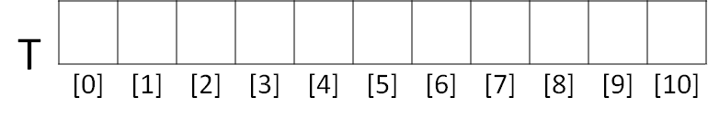  
  
  
  
**#2 [3 points]**

Sketch a hash table of size N=10, where the hash function is hash(key) = key mod N and *linear probing* is used to resolve collisions, after the following elements are inserted:  
20, 42, 45, 49, 62, 72, 95



**#3 [3 points]**

Sketch a hash table of size N=10, where the hash function is hash(key) = key mod N and *quadratic probing* is used to resolve collisions, after the following elements are inserted:  
20, 42, 45, 49, 62, 72, 95.

The probes are based on this equation: (H+c1∗i+c2∗i2)mod(N) and c1=1, c2=1.



**#4 [1 point]**

If *direct hashing* was used to store the same elements in the previous problems (20, 42, 45, 49, 62, 72, 95), what should be the minimum size of the hash table?