- With a message size of 1 we will see a larger effect of the alpha part of the alpha betta model. This is shown as the time per message is incredibly small at 263 microseconds, but the overall time is at just over one full second. As we add in the data from the message size of eight, we see that the time per message only increases by 2 microseconds and the overall message time reduces to just under a second. This shows the alpha part of the alpha beta model is about 250 microseconds or 250000 nanoseconds. Now as to the beta part of the model, the program kindly reports our gigabytes per second we just need to convert to the proper units which results in 17.016 bytes per nanosecond. One trend I noticed is that our largest message size is not the best performing one. This is because we achieve a better balance between the alpha and beta values as the larger message start requiring more time to fill the buffers then we save by sending less messages.
Message Size | 1 | 8 | 64 | 512 | 4096 | 32768 | 256K | 1M
Time in nanoseconds | 186,000,000 | 200,000,000 | 215,000,000 | 663,000,000 | 2,145,000,000 | 2,916,000,000 | 5,196,000,000 | 4,976,000,000
- The largest message that the default code runs at is 4096, as any message larger than that will result in a dead lock. The following table contains the time for full ring communication.
Note: The 1M time is smaller that the others but I believe that this is just variance between runs.

Number of processes | 1 | 2 | 4 | 8 | 16
GFLOPS | 2.25 | 4.48 | 8.15 | 11.42 | 13.62
Time in seconds | 0.010 | 0.005 | 0.003 | 0.002 | 0.002
% Speed up vs 1 | 0 | 200% | 333% | 500% | 600%
- Mat-Vec-Mul performance. Note that performance increases at a decreasing rate, I believe that this is because of the problem size and the cost of communication between each process.
Images of raw program output for ping pong and ring.
Ping Pong
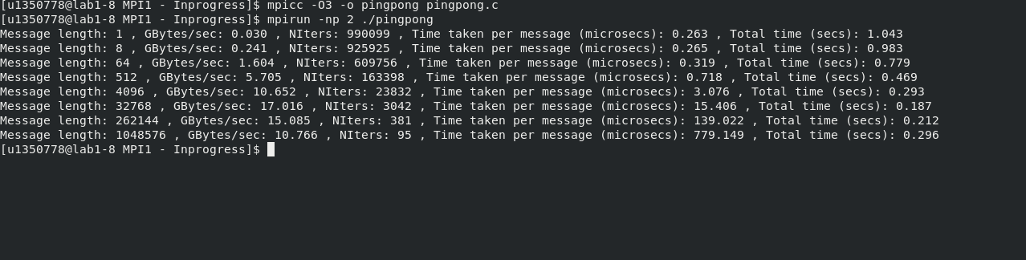
Ring
