**System Design Document**

**For**

**Microwave Tracking Ground Station**

Team members:  
Christian Ogburn

Jared O’Shea

Ian Wolfe

Clay Edwards

Jusefs Saade

Jordan West

| Version/Author | Date |
| --- | --- |
| 1.0/ CE, IW | 9/26/2023 |
| 2.0/ CE, IW | 10/28/2023 |
| 3.0/ CO, JO, IW, CE, JS, JW | 11/21/2023 |
|  |  |

TABLE OF CONTENT

1 INTRODUCTION 3

1.1 Purpose and Scope 3

1.2 Project Executive Summary 3

1.2.1 System Overview 3

1.2.2 Design Constraints 3

1.2.3 Future Contingencies 3

1.3 Document Organization 3

1.4 Project References 4

1.5 Glossary 4

2 SYSTEM ARCHITECTURE 4

2.1 System Hardware Architecture 4

2.2 System Software Architecture 4

2.3 Internal Communications Architecture 4

3 HUMAN-MACHINE INTERFACE 4

3.1 Inputs 5

3.2 Outputs 5

4 DETAILED DESIGN 5

4.1 Hardware Detailed Design 6

4.2 Software Detailed Design 6

4.3 Internal Communications Detailed Design 7

5 EXTERNAL INTERFACES 7

5.1 Interface Architecture 7

5.2 Interface Detailed Design 8

6 SYSTEM INTEGRITY CONTROLS 8

SYSTEM DESIGN DOCUMENT

*Overview*

*The System Design Document describes the system requirements, operating environment, system and subsystem architecture, files and database design, input formats, output layouts, human-machine interfaces, detailed design, processing logic, and external interfaces.*

# INTRODUCTION

## Purpose and Scope

The purpose of the Satellite-Tracking Microwave Ground Station (STMGS) is to design, functions as a prototype microwave ground station that tracks satellites and receives microwave communications. This will be done via microwave transmission around the frequencies within the K band or S band. The problem related to this project is the goal to be a compact ground station with enough power to move our satellite dish and have enough gain to receive transmission via antenna. The problems will be addressed in a multistep build with the positioner being the primary focus. The antenna will be designed to suit the needs of our frequency range and the ground base will be designed around established hardware components for stability. The project consists of spacecraft orbit tracking algorithms, integration of the positioning and receiver software, and the graphic user interface.

## Project Executive Summary

### System Overview

The system consists of an antenna, positioner, positioner controller, RF/RX, Tracking software and RF SDR Software as shown by Figure 1 below a high level systems diagram. The system will be able to actively track a satellite using the software on board and the positioner with the positioner controller. The antenna will facilitate the connection of RX signals between the satellite and system. Figure one below shows the general breakdown of the integrated system.

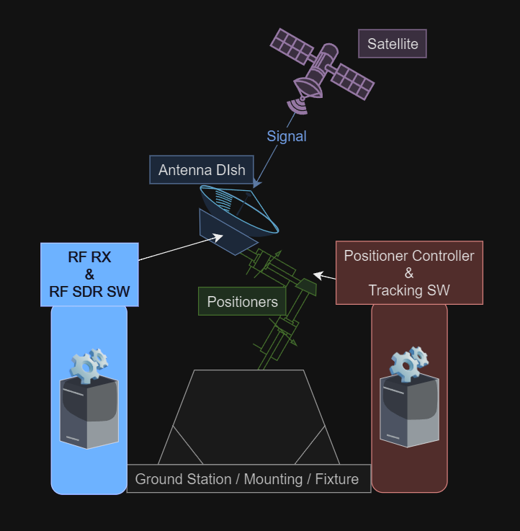

**Figure 1 (Satellite-Tracking Microwave Ground Station Systems diagram)**

### Design Constraints

* + - 1. Regulatory Compliance:
         1. The system must adhere to all relevant regulations and standards, which may include frequency usage, power emissions, and safety standards.
      2. Size and Deployability:
         1. The system must be compact, enabling deployment in a variety of locations. This necessitates a design that maximizes space efficiency.
      3. Signal Strength Compensation:
         1. Due to the compact size, the system may experience limitations in signal strength. To address this, enhancements such as amplified antenna gain will be implemented to ensure optimal performance.
      4. Power Requirement:
         1. The system's power supply must be both compact and capable of efficiently powering the entire system. It should conform to the United States standard of 120V at 60Hz.
      5. Keplerian Coordinate System Utilization:
         1. Keplerian coordinates will be the foundational elements in all positioning calculations, ensuring precision and consistency in tracking.
      6. Positioner Software Selection:
         1. The choice of positioner software remains undecided. The system is designed to be compatible with various positioners, many of which come with their own built-in software. The selected software will be adaptable to meet our specific requirements.
      7. Frequency Range Limitation of Software Defined Radio:
         1. Our system incorporates a Pluto software-defined radio, which inherently limits the operational frequency range. The maximum frequency capability of the Pluto SDR is a critical constraint in our design. This limitation necessitates careful consideration in the system's design and operation, ensuring that all functionalities and performance metrics are aligned with the achievable frequency range of the Pluto SDR. Strategies will be implemented to optimize performance within this frequency constraint, including the selection of compatible components and the development of software algorithms specifically tailored to operate efficiently within the defined frequency limits.
      8. Budgetary Limitations:
         1. Funding constraints necessitate careful selection of hardware components. The design will focus on optimizing the cost-efficiency of the system without compromising on essential functionalities.
      9. Compatibility with Existing Systems:
         1. The system must be compatible with existing infrastructure and technology, including communication protocols and data formats associated with the satellites that are emitting the microwaves we are trying to track.
      10. User Interface and Accessibility:
          1. The system should have a user-friendly interface, and be accessible and easy to operate, even for users with limited technical expertise.
      11. Adaptability to Diverse Weather Conditions:
          1. The system is engineered to function effectively across a range of environmental scenarios. However, it is important to note that certain extreme weather conditions, such as excessive moisture, high wind levels, or dense cloud cover, could potentially impact operational efficiency. This necessitates the implementation of robust design features and protective measures to mitigate the adverse effects of such environmental challenges, ensuring reliable performance even under less than optimal weather conditions. The system's resilience to these environmental factors is a key consideration in its design and operational planning.

### Future Contingencies

* + - 1. Antenna Modification for Future Adaptability:
         1. Size Adjustments for Signal Optimization:

In response to potential future scenarios, there may be a need to modify the dimensions of the dish or antenna. Such alterations could become essential to counteract unforeseen signal loss or to adapt to changes in transmission requirements. Proactive considerations will be made for adjusting the antenna size to ensure continuous optimization of signal strength and overall system efficiency.

* + - * 1. Adaptation to Frequency Constraints and Satellite Tracking:

Modifications to the antenna may also be necessitated by the limitations in frequency range imposed by the software-defined radio (SDR) and the specific satellites targeted for tracking. The antenna design will be evaluated and potentially revised to align with the frequency capabilities of the SDR and to optimize the tracking of available satellites. This will involve an assessment of both current and anticipated satellite constellations, ensuring the system's antenna remains effective and relevant in the evolving landscape of satellite communications.

* + - 1. Software Interface Overhaul:
         1. The system's software graphical user interface (GUI) may undergo significant revisions to maintain compatibility with evolving hardware components. These changes will aim to enhance user experience and interface efficiency, aligning with any new operational demands or technological advancements.
      2. Deployment Location Constraints:
         1. The geographical location and specific satellite targets may impose limitations on where the system can be effectively deployed. Future deployments will consider geographical and orbital factors to maximize operational effectiveness.
      3. Possible contingencies are having to change the size of the dish or antenna as to compensate for loss of signal. Software GUI may need to be significantly changed to operate with the components. Location and satellite may affect where the system can be deployed for operation. May need to adjust operations based on given laws and or approvals of the local area.

## Document Organization

This SDD is organized with headings and sections. The citations, figures, and references will be in American Psychological Association (APA) format or a link reference where applicable.

The major sections are:

* Introduction
  + This section contains the purpose, scope, executive summary, system overview, constraints, and contingencies .
* System Architecture
  + This section discusses the build of software, hardware, and integration of the system.
* Human-Machine Interface
  + This section discusses how users utilize the system via inputs and receive outputs from the system.
* Detailed Design
  + This section explains in detail the design of the software, hardware, and communication functions of the system.
* External Interfaces
  + This section explains the build and design of the external interfaces of the system.
* System Integrity Controls
  + This section shows how the integrity of this system is controlled.

## Project References

This section provides a bibliography of key project references and deliverables that have been produced before this point.

*1.8AEBP-1.8m elevation-over-azimuth antenna positioner - orbital systems*. MA 101-113 1.8AEBP-1.8m Positioner Data Sheet C.01 print. (n.d.). http://www.orbitalsystems.com/wp-content/uploads/2020/06/1.8AEBP-1.8m-Positioner-Data-Sheet-C.01.pdf

*AMSAT Satellite tracking for ISS*. AMSAT. (n.d.). https://www.amsat.org/track/satloc.php?lang=en&satellite=ISS

Barth et al. (2018). Critical Design Review - University of Colorado Boulder. https://www.colorado.edu/aerospace/sites/default/files/attached-files/argus_cdr_0.pdf

Bevelacqua, P. (n.d.-a). *Antenna types*. List of Antennas (Antenna Types). https://www.antenna-theory.com/antennas/main.php

Bevelacqua, P. (n.d.-b). *The parabolic reflector antenna (satellite dish) - 3*. Antenna. https://www.antenna-theory.com/antennas/reflectors/dish3.php

*Cassegrain reflector antennas: Antenna Design, gain & specs*. Millimeter Wave Products | Waveguide Products | MM Wave Components. (n.d.). https://www.miwv.com/cassegrain-reflector-antennas/

Chamberlin, A. B. (Ed.). (n.d.). *Small-body satellites*. NASA. https://ssd.jpl.nasa.gov/sb/sats.html

Comly, D. (n.d.). *Parabolic Antennas and their Feeds*. dl7qy. https://www.dl7qy.eu/broadbandfeed/N3AOGpattern.pdf

*Contact the ISS*. ARISS. (n.d.). https://www.ariss.org/contact-the-iss.html

Gilani, A. S. (2019, August 7). *Images from the ISS and listening to hams with the RTL-SDR: Toptal®*. Toptal Engineering Blog. https://www.toptal.com/software/software-defined-radio-tutorial-rtl-sdr

Keslo, T. S. (n.d.). *Search of SATCAT*. CelesTrak. https://celestrak.org/satcat/table-satcat.php?INTDES=2001-018A&MAX=10000

Keslo, T. S. (n.d.). *Search of SATCAT*. CelesTrak. https://celestrak.org/satcat/table-satcat.php?NAME=QuetzSat+1&PAYLOAD=1&MAX=500

Krebs, G. D. (n.d.). *XM 1, 2 (XM Rock, roll)*. Gunter’s Space Page. https://space.skyrocket.de/doc_sdat/xm-1.htm#:~:text=XM%201%20%5BBoeing%20BSS%5D%20Hughes%20Space%20and%20Communications,1%20and%20XM%202%20(nicknamed%20%22Rock%22%20and%20%22Roll%22)

Patel, S. (2023, October 26). *NASA Tech breathes life into potentially game-changing antenna design*. NASA. https://www.nasa.gov/directorates/stmd/nasa-tech-breathes-life-into-potentially-game-changing-antenna-design/

*Quetzsat 1 - Gunter’s Space Page*. Gunter’s Space Page. (n.d.). https://space.skyrocket.de/doc_sdat/quetzsat-1.htm

*RocketDish RD-2G24 Quick Start Guide*. Ubiquiti. (n.d.). https://dl.ubnt.com/guides/rocketdish/RocketDish_RD-2G24_QSG.pdf

*Satbeams - world of satellites at your fingertips*. Satbeams Web and Mobile. (n.d.-a). https://www.satbeams.com/satellites?norad=37826

*Satbeams - world of satellites at your fingertips*. Satbeams Web and Mobile. (n.d.-b). https://www.satbeams.com/channels?norad=37826

*Satellite finder*. USRadioguy.com. (2023, January 16). https://usradioguy.com/satellite-finder/

SPX-01 - RF hamdesign. (n.d.). https://www.rfhamdesign.com/downloads/spx-01-specifications.pdf

*SPX-01 azimuth & elevation rotor*. SPX Standard Rotators - RF HAMSTORE. (n.d.). https://www.rfhamstore.com/webshop/antenna-rotators/spx-standard-rotators/detail/77/spx-01-azimuth--elevation-rotor.html

*Technical details for satellite QUETZSAT 1*. N2YO.com - Real Time Satellite Tracking and Predictions. (n.d.-a). https://www.n2yo.com/satellite/?s=37826#results

*Technical details for satellite XM-2*. N2YO.com - Real Time Satellite Tracking and Predictions. (n.d.-b). https://www.n2yo.com/satellite/?s=26724#results

## Glossary

STMGS - Satellite-Tracking Microwave Ground Station

SDR - Software Defined Radio

LEO - Low Earth Orbit

GUI - Graphical User Interface

RX - Receiving/Receiver

RF - Radio Frequency

K Band - 18 - 27 GHz frequency band

Ku Band - 12 - 18 GHz

Ka Band - 27 - 40 GHz

S Band - 2 - 4 GHz

# SYSTEM ARCHITECTURE

The ground station consists of five main subsystems in order to successfully track and receive microwave signals from satellites, including: The positioner, motor controlling software, software defined radio, antenna, and tracking software. The tracking software determines where the desired satellite is and where it will be per GPS coordinates. The motor controlling software receives input from the tracking software and controls where the positioner aligns to. The positioner, consisting of an azimuth and elevation rotor, aligns the antenna to receive a signal from a satellite. The software defined radio receives and records the signals from our desired satellite.

## System Hardware Architecture

The structure of this system mainly includes the positioning system fixed on top of a rolling cart so that the system can be more easily deployed at a wide variety of locations. One end of the positioner has a counterweight and at the other end is a Ku band antenna. The signal from this antenna is passed through a coaxial cable which can be interfaced with the SDR receiver.

Antenna- currently: a Ku band dish antenna

Antenna- future: Designing a mesh dish with helix subreflector support

Positioner- two motors and supportive structure to position antenna

Positioner Controller- positioner motor controller (Yaesu Azimuth Dual Controller G-25)

Radio Receiver- an SDR receiver to interface between the antenna and a computer

## System Software Architecture

There are three main software components to this product. The tracking software accepts user input to determine which satellite to begin tracking. The tracking software then interfaces with the motor controlling software to maintain antenna alignment with the desired satellite. The tracking software user input includes Keplerian elements for the satellite and the location of the ground station when operating. The third software is the SDR receiver which will identify and record our desired signal, if possible. The SDR will display signals received by the antenna and may be adjusted by the user to monitor different frequencies.

## Internal Communications Architecture

There are two main lines of communication in this system: the antenna feed and the positioner control. The antenna feed comes straight from the dish antenna with distinct vertically polarized and horizontally polarized ports. These are combined into a circularly polarized signal which is run through a series of filters. This final signal is fed into the SDR where it is interpreted and displayed through the SDR software. The positioner control signal is sent from the control software to an accessory module of the motor controller. This accessory module is natively designed to interface with the motor controller to aid in computer control.

# HUMAN-MACHINE INTERFACE

This machine is mainly interfaced digitally through a computer, but there are a few physical considerations. To improve the transportability and maneuverability of this system, it could be easily moved to optimal locations on a mobile surface, greatly reducing the required work needed to move it. The digital interface is both the SDR software and the positioner control software; both are accessed with a computer. The softwares is designed with human usability as the primary focus.

## Inputs

The SDR software requires a variety of human inputs. The inputs related to this can/would be manual positioning of the dish via a manual positioner or machine input via GUI. The machine GUI would be fed Keplerian elements using software and equations based on acquired satellite data. These inputs are required for the functionality of the positioner. many reasons but mainly to set the frequency and interpret the signal.

The positioner control software needs Keplerian elements and the ground station’s location.

The system will be receiving transmitting frequencies within the K-band or S-band frequency range as an input to handle transmissions.

## Outputs

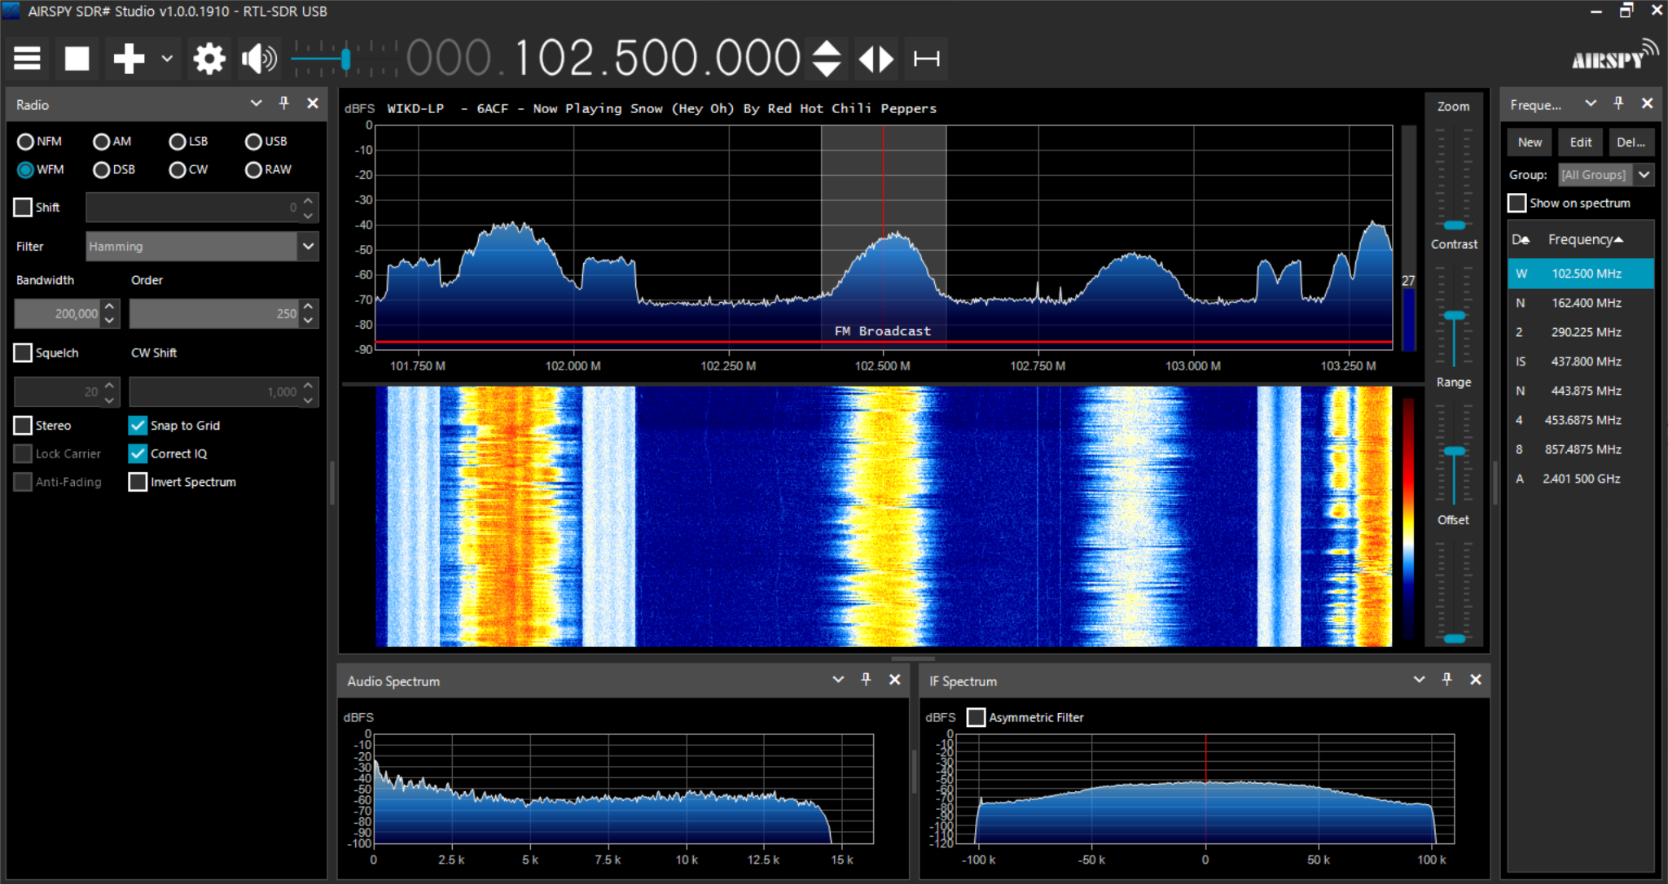

**Figure 2 (Screenshot of potential SDR Software)**

The system’s main output is the display of the SDR software as seen in Figure 2. This is how the signals are received and made into meaningful information. Another output of the system will be the results from the positions software that will move the positioner via the GUI into position actively tracking the satellite.

# DETAILED DESIGN

We are aiming to shrink the previous group's product. Making the ground station potentially lighter but definitely more compact and mobile. The biggest parts of the product are the cart and motors but also the dish attached to the motors. To use a smaller lighter motor type, we need to have a lighter antenna or the motors would not be able to orient the antenna according to satellite movement. One of our outcomes is to design a meshed dish antenna significantly reducing material mass paired with a helical feed as to use circular polarization to account for phase shift losses. The mesh can help us also use a bigger surface dish to help in receiving potentially weak signals from the satellite.

## Hardware Detailed Design

* + 1. Satellite Communication Module:
       1. The system includes a parabolic antenna dish designed for high-gain reception of microwave signals from satellites and operating at up to 6 GHz.
       2. Positioners are attached to the antenna dish to enable accurate orientation toward the satellite. These positioners are motorized and capable of azimuth and elevation adjustments.
    2. Ground Station Module:
       1. The ground station is equipped with an RF receiver (RF RX) and a software-defined radio (SDR) system. The RF RX is responsible for the initial reception of signals which are then processed by the SDR software for decoding.
       2. The ground station includes a mounting or fixture which securely holds the antenna dish and allows for stability during positioning adjustments.
    3. Positioner Controller and Tracking Module:
       1. A dedicated positioner controller and tracking software system (Tracking SW) are implemented.
       2. The tracking software is responsible for calculating the position, and sending commands to the positioners to track the satellite's movement.

We have not yet fully committed to any of the hardware currently being used, but we do have some of the technical specifications for the current or planned hardware.

| **Postioners** | **Angle Resolution** | **Rotation Speed** | **Weight (kg)** | **Dimensions**  **(mm)HxLxW** | **Max Load**  **(kg)** | **Software Included** | **Cost** |
| --- | --- | --- | --- | --- | --- | --- | --- |
| **SPX-01\*** | 0.5° | 3.5O/s | 12.8 | 487x174x174 | 11-30 | Yes | **$778.31** |
| **SPX-01/HR\*** | 0.1875° | 5.3O/s | 12.8 | 487x174x174 | 11-30 | Yes | **$1026.44** |
| **CURRENT  WIDE LAB  MODEL:  Yaesu G5500\*\*\*** | Not specified | AZ: 2.7O/s  EL:6.2O/s | 9 | Roughly the same | 200 | Yes | **Minimal** |
| **PTS06** | 0.005O | AZ: 60O/s  EL: 30O/s | 6 | 279x173x178 | 36 | Controlled via software on Windows 10 | **Not Specified** |

**Table 1 (Azimuth and Elevation Rotor/Positioners)**

Table 1 summarizes our current positioner options. Both SPX-01 and SPX-01/HR come equipped with a power supply, controller, and pole mounting bracket. SPX-01/HR shares the same physical and electrical composition but offers improved angle resolution, rotation speed, and features a TCP/IP module for wireless control. On the other hand, the Current WiDE Lab model from the previous group is available at no cost, requiring only the creation of a new mount.

| **Antennae** | **Weight** | **Diameter** | **Beamwidth** | **Gain** | **Band/Frequency** | **Cost** |
| --- | --- | --- | --- | --- | --- | --- |
| **Current Antenna** | 9.8 kg | 65 cm | 3.8° | 24 dB | 2.3-2.7 Ghz | **Minimal** |
| **223-18/**  **.XXX/419** | Not Specified | 46 cm | 3.0° | 33 dB | Ku-Band  12.4 to 18 GHz | **Not Specified** |
| **223-24/**  **.XXX/419** | Not Specified | 61 cm | 2.0° | 36.5 dB | Ku-Band  12.4 to 18 GHz | **Not Specified** |
| **223-36/**  **.XXX/419** | Not Specified | 92 cm | 1.5° | 40.5 dB | Ku-Band  12.4 to 18 GHz | **Not Specified** |
| **223-48/**  **.XXX/419** | Not Specified | 1220 cm | 1.0° | 43 dB | Ku-Band  12.4 to 18 GHz | **Not Specified** |

**Table 2 (S-band and K-band Dish Antennas)**

Table 2 summarizes our current antenna options. The previous team’s antenna would be available at no cost but would require additional mount design. The Millimeter Wave antennas are built to order; exact specifications can vary.

## Software Detailed Design

* + 1. RF SDR Software:
       1. The RF SDR software is responsible for tuning to different frequencies, demodulating received signals, and performing digital signal processing. It's likely to be Pluto with a maximum operating frequency of 3.8 GHz (max 6 GHz when amplified).
       2. The software will include a graphical user interface (GUI) for user interaction, allowing operators to select frequencies, track signal strength, and configure the SDR parameters.
    2. Positioner Controller and Tracking Software:
       1. The tracking software calculates the antenna's required position using Keplerian coordinates and real-time tracking algorithms. It sends control signals to the positioner motors to adjust the dish's orientation.
       2. Includes fault detection and diagnostics to ensure accurate tracking and to handle any errors or malfunctions in the positioner mechanism.

The project we are building off of has not developed any of the software yet. We plan to use a free open-source SDR software to interface with the SDR. However, we haven’t begun the design of the positioner control software as we are still learning how to interface with the motor controller.

## Internal Communications Detailed Design

* + 1. Control Signals:
       1. A control bus or communication system transmits commands from the positioner controller to the motor drivers within the positioners. This may use standard protocols such as Ethernet for reliable data transfer.
    2. Data Flow:
       1. The RF signal received by the antenna dish is converted to a digital format by the RF receiver and fed into the SDR software for processing.
    3. Monitoring and Feedback Loops:
       1. Sensor feedback from the positioners (such as encoders or potentiometers) is relayed back to the positioner controller to confirm that the dish has reached the commanded orientation.
       2. Monitoring systems are in place to check the health and status of the hardware components.

We still do not have a full list with description of parts.

# EXTERNAL INTERFACES

We will be running two programs via an external computer. The two software packages are not yet decided on, and we still do not have information on the satellite we are supposed to track, which is the only other external interface. There is potential for web access for the positioner depending on the model we purchase.

With multiple components in this project, they will have to interface with one another. Software on the user computer will determine the necessary angles to aim the antenna at the satellite, and send this information to the positioner software, which will then send signals to the physical positioner. The positioner will interpret these signals to the motors/servos and aim the antenna as needed. The second half of this process will begin with the satellite’s transmission which requires no user input. This transmission will be received by the antenna and processed as needed via filters and amplifiers, and ultimately sent to the SDR for digitization and demodulation. The SDR will interface with its accompanying software on the computer, and the desired outputs from this will be presented to the user via GUI.

## Interface Architecture

We are interfacing with the two softwares via a computer, and we are receiving signals from a satellite. Beyond this, the architecture is not yet decided.

If the PTS06 positioner is chosen, it will come with its own software to control the positioner directly. Further detail on this software is limited, however a separate program that performs calculations using the satellite’s position based on keplerian coordinates relative to the antenna may be needed to provide the positioner software with the angles needed to accurately track the satellite.

The other software will be focused on interpreting the RX data. Further details will depend on the SDR and whatever capabilities its accompanying software has.

## Interface Detailed Design

Until we get hardware, the software and related interfaces cannot be designed.

# SYSTEM INTEGRITY CONTROLS

The system incorporates a user authentication system to restrict access exclusively to authorized personnel. It's noteworthy that the information used to track satellites is publicly available and not deemed security-critical. Satellite signals, accessible to anyone with a capable ground station, contribute to the system's non security critical nature. Accurately tracking a satellite using its unique orbit data serves to help ensure that the received signal is from the desired source.

Access to the software is granted solely through the ground control station, following clearance by the user authentication system. Physical security measures entail secure storage practices for the system, accompanied by power-down procedures during periods of inactivity. Additionally, a pre-operation test is conducted to ensure proper motion functionality before initiating satellite tracking. The user operating the system will have access to a kill switch powering down the system hastily if any movement is perceived as unsafe.

Given the non-disruptive nature of the system, as it solely receives signals, primary emphasis is placed on limiting access to maintain full control in the hands of the product owner. This focus on controlled access ensures the system's operational integrity and aligns with the overall non-invasive character of its functionalities.