System Requirements Specification

for

Microwave Tracking Ground Station

**Version 3.0 approved**

**Prepared by <Jusefs Saade; Christian Ogburn; Jared O’Shea; Ian Wolfe; Clay Edwards; Jordan West>**

**<WiDE LAB>**

**11/21/2023**

**Table of Contents**

**Table of Contents ii**

**Revision History ii**

**1. Introduction 1**

1.1 Purpose 1

1.2 Document Conventions 1

1.3 Intended Audience and Reading Suggestions 1

1.4 Product Scope 1

1.5 References 1

**2. Overall Description 2**

2.1 Product Perspective 2

2.2 Product Functions 2

2.3 User Classes and Characteristics 2

2.4 Operating Environment 2

2.5 Design and Implementation Constraints 2

2.6 User Documentation 2

2.7 Assumptions and Dependencies 3

**3. External Interface Requirements 3**

3.1 User Interfaces 3

3.2 Hardware Interfaces 3

3.3 Software Interfaces 3

3.4 Communications Interfaces 3

**4. System Features 4**

4.1 System Feature 1 4

4.2 System Feature 2 (and so on) 4

**5. Other Nonfunctional Requirements 4**

5.1 Performance Requirements 4

5.2 Safety Requirements 5

5.3 Security Requirements 5

5.4 Software Quality Attributes 5

5.5 Business Rules 5

**6. Other Requirements 5**

**Appendix A: Glossary 5**

**Appendix B: Analysis Models 5**

**Appendix C: To Be Determined List 6**

**Revision History**

| **Name** | **Date** | **Reason For Changes** | **Version** |
| --- | --- | --- | --- |
| CO, JO, CE, IW, JS | 09/28/2023 | Document Creation | 1.0 |
| CO, CE, IW, JS | 10/28/2023 | Update for Sprint 2 | 2.0 |
| CO, JO, CE, IW, JS,JW | 11/21/2023 | Update for Sprint 3 | 3.0 |

# Introduction

## Purpose

The Microwave Tracking Ground Station is the software system designed to track satellites in orbit and receive data from them. This document specifies the software requirements for this system and each subsystem's requirements.

## Document Conventions

We will follow industry standard documentation and formatting. Each requirement is designed to have its own priority and may have sub requirements based on complexity.

## Intended Audience and Reading Suggestions

The Microwave Tracking Ground Station is intended for Dr. Eduardo Rojas, Director of the WiDE (Wireless Devices and Electronics) laboratory, and for future students involved in microwave tracking design projects.

## Product Scope

The final iteration of this product is expected to be able to track a satellite in orbit and receive data from said satellite. The product will have an antenna fixed to a positioning system, controlled via software to track a satellite as it orbits the Earth. There will also be a graphical interface element.

## References

*1.8AEBP-1.8m elevation-over-azimuth antenna positioner - orbital systems*. MA 101-113 1.8AEBP-1.8m Positioner Data Sheet C.01 print. (n.d.). http://www.orbitalsystems.com/wp-content/uploads/2020/06/1.8AEBP-1.8m-Positioner-Data-Sheet-C.01.pdf

*AMSAT Satellite tracking for ISS*. AMSAT. (n.d.). https://www.amsat.org/track/satloc.php?lang=en&satellite=ISS

Barth et al. (2018). Critical Design Review - University of Colorado Boulder. https://www.colorado.edu/aerospace/sites/default/files/attached-files/argus_cdr_0.pdf

Bevelacqua, P. (n.d.-a). *Antenna types*. List of Antennas (Antenna Types). https://www.antenna-theory.com/antennas/main.php

Bevelacqua, P. (n.d.-b). *The parabolic reflector antenna (satellite dish) - 3*. Antenna. https://www.antenna-theory.com/antennas/reflectors/dish3.php

*Cassegrain reflector antennas: Antenna Design, gain & specs*. Millimeter Wave Products | Waveguide Products | MM Wave Components. (n.d.). https://www.miwv.com/cassegrain-reflector-antennas/

Chamberlin, A. B. (Ed.). (n.d.). *Small-body satellites*. NASA. https://ssd.jpl.nasa.gov/sb/sats.html

Comly, D. (n.d.). *Parabolic Antennas and their Feeds*. dl7qy. https://www.dl7qy.eu/broadbandfeed/N3AOGpattern.pdf

*Contact the ISS*. ARISS. (n.d.). https://www.ariss.org/contact-the-iss.html

Gilani, A. S. (2019, August 7). *Images from the ISS and listening to hams with the RTL-SDR: Toptal®*. Toptal Engineering Blog. https://www.toptal.com/software/software-defined-radio-tutorial-rtl-sdr

Keslo, T. S. (n.d.). *Search of SATCAT*. CelesTrak. https://celestrak.org/satcat/table-satcat.php?INTDES=2001-018A&MAX=10000

Keslo, T. S. (n.d.). *Search of SATCAT*. CelesTrak. https://celestrak.org/satcat/table-satcat.php?NAME=QuetzSat+1&PAYLOAD=1&MAX=500

Krebs, G. D. (n.d.). *XM 1, 2 (XM Rock, roll)*. Gunter’s Space Page. https://space.skyrocket.de/doc_sdat/xm-1.htm#:~:text=XM%201%20%5BBoeing%20BSS%5D%20Hughes%20Space%20and%20Communications,1%20and%20XM%202%20(nicknamed%20%22Rock%22%20and%20%22Roll%22)

Patel, S. (2023, October 26). *NASA Tech breathes life into potentially game-changing antenna design*. NASA. https://www.nasa.gov/directorates/stmd/nasa-tech-breathes-life-into-potentially-game-changing-antenna-design/

*Quetzsat 1 - Gunter’s Space Page*. Gunter’s Space Page. (n.d.). https://space.skyrocket.de/doc_sdat/quetzsat-1.htm

*RocketDish RD-2G24 Quick Start Guide*. Ubiquiti. (n.d.). https://dl.ubnt.com/guides/rocketdish/RocketDish_RD-2G24_QSG.pdf

*Satbeams - world of satellites at your fingertips*. Satbeams Web and Mobile. (n.d.-a). https://www.satbeams.com/satellites?norad=37826

*Satbeams - world of satellites at your fingertips*. Satbeams Web and Mobile. (n.d.-b). https://www.satbeams.com/channels?norad=37826

*Satellite finder*. USRadioguy.com. (2023, January 16). https://usradioguy.com/satellite-finder/

SPX-01 - RF hamdesign. (n.d.). https://www.rfhamdesign.com/downloads/spx-01-specifications.pdf

*SPX-01 azimuth & elevation rotor*. SPX Standard Rotators - RF HAMSTORE. (n.d.). https://www.rfhamstore.com/webshop/antenna-rotators/spx-standard-rotators/detail/77/spx-01-azimuth--elevation-rotor.html

*Technical details for satellite QUETZSAT 1*. N2YO.com - Real Time Satellite Tracking and Predictions. (n.d.-a). https://www.n2yo.com/satellite/?s=37826#results

*Technical details for satellite XM-2*. N2YO.com - Real Time Satellite Tracking and Predictions. (n.d.-b). https://www.n2yo.com/satellite/?s=26724#results

# Overall Description

## Product Perspective

This product is intended to build up and eventually replace the product made by the originators of this project last year. The original design from the previous year was able to do basic movement function, but had too little gain, causing issues in receiving a signal from satellites in LEO. The new Microwave Ground Tracking Station is similar to the previously done one. Main differences are physical size, and operating frequency of the antenna. The system is composed of an antenna dish, a mounting bracket holding the antenna to 2 positioning motors controlling the antenna direction on azimuth and elevation coordinates. The positioners would be mounted to a ground plate or standing pole, depending on work cite and antenna visibility of the satellite. The positioners would be connected to a tracking system on a PC; and the signals received from the antenna would be demodulated by the SDR also on the PC.

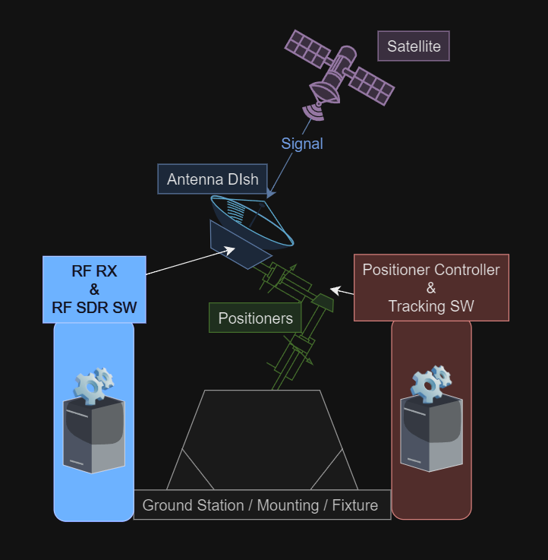

**Figure 1 (Satellite-Tracking Microwave Ground Station Systems diagram)**

## Product Functions

* The ground station shall be able to receive signals from a satellite
* The ground station shall be able to detect signals in the Ku-Band frequency range
* The ground station shall be portable and easy to move (smaller than existing prototype in WiDE lab)
* The ground station’s dish shall be able to turn in all directions in a hemispherical range of motion
* The ground station shall be able to be controlled by directly connected controls as well as remotely by computer software
* The ground station shall be able to track a specific satellite to receive constant signals

## User Classes and Characteristics

* Dr. Rojas & WiDE Lab Team - With Dr. Rojas being the product owner and the director of the WiDE Lab, he and his team are the most anticipated users of this ground station. They are extremely knowledgeable in the areas of satellite tracking and signals and continuously work on similar or related projects. Because they have so many projects in the field, they may not use our ground station a lot, but it may help them in future endeavors and they will certainly be the most frequent users.
* Requirements for this User Class:
* 2.3.1 - Dr. Rojas and the lab team shall have the following:
* deep understanding of satellite tracking
* deep understanding of RF signals
* deep understanding of electrical engineering
* basic understanding of connected software and programming for alterations
* access to WiDE lab and permission to use from Dr. Rojas if on team

* IEEE Community - We expect our ground station to be something that anyone in the IEEE field, including engineers, computer scientists, and mathematicians, is able to use as long as they have a basic understanding of satellite tracking and RF signals. The system is meant to function easily for any user, but understanding the outputs and results of the system, as well as detecting success and error, will require basic knowledge in those areas.
* Requirements for this User Class:
* 2.3.2 - IEEE Community members shall have the following:
* basic understanding of satellite tracking
* basic understanding of connected software
* access to WiDE lab and permission to use from Dr. Rojas and team
* 2.3.3 - No other users outside of the previous 2 user classes should be using or have access to the ground station of any connected parts. This is due to safety and security reasons.

## Operating Environment

The tracking ground station is intended to operate outdoors to minimize interference from transmissions such as WiFi and Bluetooth, which would be more prevalent indoors. Preferable operation locations may include the roof of the MicaPlex and the Lehman building. Additional design considerations will need to be given to mitigate any harm to the product from the elements, including but not limited to wind, humidity, uncontrolled climate (heat and cold), and direct sunlight/UV exposure. With this product being developed in Florida, rain is a major concern for outdoor operation, and ideally such exposure should be avoided at all costs rather than developing the product with water resistance in mind, as such exposure would likely result in catastrophic setbacks.

In terms of the softwares, along with their connections to some hardware, the softwares being used will not interact with each other a significant amount. The tracking software, which will be run on any laptop, all takes place in (*fill in tracking software name and version of IDE/Compiler etc.*) which will be feeding into the motor controller which moves the positioner to point the antenna. The (*fill in SDR software name and version*) is the SDR software that displays the received signals from the antenna that go from the antenna to the SDR Pluto module and then to the laptop. Note that testing will only be done with laptops running on Windows 10 and Windows 11.

## Design and Implementation Constraints

* + 1. Policies and Regulatory Compliance:
       1. Corporate Policies
          1. There are no specific corporate policies that need to be adhered to for this project.
       2. Regulatory Policies
          1. While not directly affected by regulatory policies, the system shall still operate within general industry and legal standards.
    2. Hardware Limitations
       1. Power Requirements
          1. The hardware is designed to be plugged into a 120V 60Hz power outlet, adhering to USA standard electrical requirements.
       2. Environmental Conditions
          1. The system is intended for outdoor use, but should be operated in dry conditions to ensure functionality and safety.
       3. Signal Reception
          1. Hardware design shall account for the capacity to receive signals from a broad range of bands under 6 GHz (amplified 3.8 GHz Pluto), ensuring versatile and effective satellite communication.
       4. Antenna Weight and Actuator Performance:
          1. The weight of the antenna is a critical factor as it impacts the speed and accuracy of the actuators in positioning the dish. This necessitates a balance between antenna robustness and agility.
    3. Timing Considerations
       1. The system's functionality heavily relies on precise timing. Users will input Keplerian coordinates of the target satellite and the ground station's current position, following which the actuators shall accurately and promptly orient the dish towards the satellite.
    4. Software Requirements:
       1. Memory Constraints:
          1. Given the primary function of receiving and interpreting satellite signals, the project does not require significant memory storage capabilities.
       2. Real-Time Processing:
          1. Software shall be capable of processing input data in real-time to allow for immediate actuator response and signal reception.
    5. Technology and Tools:
       1. Specific technologies and tools required for the development will be selected based on their compatibility with the above constraints and the overall project goals.
    6. Security Considerations:
       1. While not primarily a concern, basic security measures to protect the system from unauthorized access and interference should be implemented.
    7. Design and Programming Standards:
       1. The project will adhere to industry-standard design conventions and programming standards to facilitate future maintenance and potential upgrades.

## User Documentation

*We still are unable to complete this section, as we have not been given specifics by the product owner of certain hardware/software that is meant to be used in the design.*

User documentation for Pluto SDR:

<https://wiki.analog.com/university/tools/pluto>

2.6 User documentation will consist of …

2.6.1 The SDD will

2.6.2 The SRS will

2.6.2.1 The SRS will contain

2.6.3 The System Test plan will

2.6.3.1 The test plan will house the testing procedures

2.6.3.1.1 The test plan will contain all vital steps top confirm

Also reference our assembly plan documentation for the base station assembly.

We plan to add any user manuals or documentation associated with the hardware and software that we use.

## Assumptions and Dependencies

* + 1. Miniaturization Challenges:
       1. The project assumes the feasibility of miniaturizing certain components of the prototype. However, this may be challenging due to limitations in the availability and suitability of motors and other parts. The assumption is that existing technologies can be effectively downsized without compromising functionality.
    2. Timeline Constraints and Meeting Conflicts:
       1. The progress of the project is contingent on adherence to the proposed timeline. There is an inherent assumption that project milestones align with the availability of team members. Conflicts in scheduling and meeting times could adversely affect project progression and deadlines.
    3. Integration of Reused Software:
       1. The project depends on the integration of software components reused from a previous team's work. There are potential challenges in incorporating or redesigning this software to fit the new prototype, given its unique requirements and specifications. This assumption underlines the necessity for flexibility in software adaptation and potential redevelopment.
    4. Antenna Design and Part Availability:
       1. A critical dependency of the project is the design or acquisition of a new dish that meets the goals of this SRS. This process might face obstacles due to the availability of suitable parts or challenges in custom designing an antenna that aligns with our specific needs and constraints.
    5. Hardware Compatibility:
       1. The assumption that all selected hardware components, including SDRs, antennas, and positioning systems, will be compatible with each other. This includes both physical compatibility and the ability to communicate effectively through software interfaces.
    6. Software Licensing and Third-Party Tools:
       1. Dependence on third-party software tools or libraries, which might be subject to licensing terms and costs. This includes any software development kits (SDKs) or application programming interfaces (APIs) used in the project.
    7. Environmental Tolerance:
       1. The assumption that the hardware and software will perform reliably under various environmental conditions, such as temperature fluctuations, humidity, or electromagnetic interference, which might not have been fully tested.
    8. Regulatory Compliance:
       1. The project may be based on the assumption that it complies with all relevant regulations, such as those related to frequency use, power emissions, and operational safety. Changes in regulations or misunderstandings about compliance requirements could impact the project.
    9. Data Availability and Accuracy:
       1. Dependence on external data sources, such as satellite data or geographical information systems (GIS), assuming that this data will be available, accurate, and up-to-date.
    10. Stable Power Supply:
        1. Assuming a consistent and reliable power source that meets the system's requirements, especially if the system is intended for use in remote or varying locations.
    11. Network COnnectivity and Bandwidth:
        1. If the system requires internet or network connectivity, there's an assumption regarding the availability and consistency of these connections, including sufficient bandwidth for data transmission.
    12. Skilled Personnel Availability:
        1. The project might depend on the availability of skilled personnel, such as software developers, engineers, and technical support staff. Changes in team composition or skill levels could affect the project.
    13. Maintenance and Support:
        1. Assuming that maintenance and technical support will be available for both hardware and software components over the life of the system.
    14. Scalability and Future Upgrades:
        1. Assuming that the system can be scaled up or modified in the future to meet evolving requirements or to incorporate new technology.
    15. Budget Constraints and Funding Continuity:
        1. The project is dependent on the assumption of a consistent budget and ongoing funding. Financial constraints or changes in funding could significantly impact the project scope or timeline.

# External Interface Requirements

## User Interfaces

This device primarily connects to a computer digitally, although there are some physical aspects to consider. To enhance its portability and ease of maneuvering, it is affixed to a cart, significantly reducing the effort required for relocation. The digital interface encompasses both the SDR software and the positioner control software, both accessible via a computer. These software applications will be developed with a strong emphasis on user-friendly design.

## Hardware Interfaces

The hardware interface requirements for this system comprise two key communication pathways: the antenna feed and the positioner control. The antenna feed is sourced directly from the dish antenna, featuring separate vertical and horizontal polarization ports. These signals are amalgamated into a circularly polarized signal, which subsequently passes through a sequence of filters. The resultant signal is then directed into the Software-Defined Radio (SDR) for interpretation and visualization via the SDR software. Conversely, the positioner control signal is transmitted from the control software to an auxiliary module integrated with the motor controller. This specialized module is inherently designed to seamlessly interface with the motor controller, facilitating computer-based control. Both pathways require interfacing with an external computer that can run the software.

## Software Interfaces

The software interface requirements for this product revolve around two primary software components. The initial software component interacts with the positioner controller, ensuring precise alignment of the antenna with moving satellites. This software relies on input data, specifically the Keplerian elements of the satellite and the receiver's location, to regulate the positioner and achieve antenna alignment. The second software component is the SDR receiver software, which serves as the intermediary between the system's Software-Defined Radio (SDR) and a computer. This software is responsible for visualizing the signals received by the antenna and fine-tuning the frequencies monitored by the SDR.

## Communications Interfaces

The communication interface requirements for this system encompass three critical components. Firstly, the system shall support both vertical and horizontal polarization modes, combine them into a circularly polarized signal, and apply necessary signal processing filters before transmitting to the Software-Defined Radio (SDR) for further analysis. Secondly, a robust interface is needed to enable the positioner control software to communicate seamlessly with the motor controller's accessory module, ensuring real-time command and data transfer for precise antenna alignment with moving satellites. Lastly, the SDR software interface shall facilitate signal reception, interpretation, and frequency adjustments while offering a user-friendly display of received signals and data on a computer screen. These interface requirements are fundamental to the system's efficient and effective operation.

# System Features

## Antenna and Dish

4.1.1 Description and Priority

The Antenna and Dish are of High priority to the system. The Antenna and dish are critical to receiving satellite communications. Ratings are based on the priority, importance, and impact to the system. Benefit is a 9, penalty is a 2, cost is 6, and risk is 4.

4.1.2 Stimulus/Response Sequences

Sequence-4.1.3.1: User initiates satellite communication. System activates Antenna and Dish to establish communication.

Sequence-4.1.3.2: User adjusts Antenna direction. System reorients the Antenna accordingly for optimal signal reception.

Sequence-4.1.3.3: System detects signal interference. System adjusts Antenna parameters to minimize interference.

4.1.3 Functional Requirements

REQ-4.1.3.1: The system shall be capable of activating and deactivating the Antenna and Dish based on user initiation.

REQ-4.1.3.2: The Antenna shall be adjustable based on user input for direction and angle.

REQ-4.1.3.3: The system shall have built-in algorithms to automatically optimize the Antenna position for signal reception.

REQ-4.1.3.4: The system shall monitor signal quality in real-time and adjust Antenna parameters to mitigate interference.

REQ-4.1.3.5: In case of signal loss, the system shall provide feedback to the user and attempt to reconnect.

REQ-4.1.3.6: The Antenna and Dish shall be weather-resistant to ensure reliable operation under varying conditions.

REQ-4.1.3.7: The system shall log and report any issues related to the Antenna and Dish for maintenance purposes.

## Tracking Software

4.2.1 Description and Priority

The tracking software for the ground station is the software that will be controlling the positioner and giving it instructions on how to position the antenna to track a satellite as it moves through its orbit. This system is of high priority as without it, the product will not function. Receiving a signal from an orbiting satellite for an extended period of time is not possible without being able to track the satellite through the sky.

4.2.2 Stimulus/Response Sequences

Sequence-4.2.3.1: The User will input the Keplerian elements of the desired satellite to track into the Tracking Software for the software to calculate its orbit and where it needs to move the antenna to point toward the satellite.

Sequence-4.2.3.2: The Tracking Software will output azimuth and elevation along with voltage for the motors in the positioner to move the positioner.

Sequence-4.2.3.3: The User will input GPS coordinates of the location of the ground station into the Tracking Software that will be used to calculate azimuth and elevation.

4.2.3 Functional Requirements

REQ-4.2.3.1: The system shall use inputted Keplerian elements to calculate orbit along with azimuth and elevation.

REQ-4.2.3.2: The system shall send azimuth, elevation, and voltage to the positioner that are used for the positioner to move the antenna toward the desired satellite.

REQ-4.2.3.3: The system shall use inputted GPS coordinates to calculate azimuth and elevation relative to the current location of the ground station on Earth.

REQ-4.2.3.4: The software shall update the satellite's position in real-time based on the current date and time.

REQ-4.2.3.5: Employ algorithms to accurately predict the satellite's future positions over a specified time range.

REQ-4.2.3.6: Determine the voltage levels required for the antenna positioner motors to achieve the calculated azimuth and elevation angles.

REQ-4.2.3.7: Provide a user-friendly interface for users to input satellite data, view calculated positions, and configure system settings.

REQ-4.2.3.8: Display real-time information such as current satellite position, azimuth, elevation, and voltage.

REQ-4.2.3.9: Implement error detection and reporting mechanisms to alert users in case of invalid input data, calculation errors, or communication issues with external data sources.

## Rotor Positioning System

4.3.1 Description and Priority

The ground station positioner system features an Azimuth rotor and Elevation rotor. Controlled manually or via autonomous programming, the rotors may operate within 360 degrees of Azimuth and 180 degrees of Elevation. This system is of high priority as it is crucial to testing both tracking software and antenna design. Additionally, the specifications of the positioner shall be fast and accurate enough to maintain signal reception with tracked satellites.

4.3.2 Stimulus/Response Sequences

*these need to be added*

4.3.3 Functional Requirements

REQ-4.3.3.1: The system shall have an angle of resolution smaller than 1 degree.

REQ-4.3.3.2: The system shall have an accuracy greater than +/- 0.06 degrees within the set angle.

REQ-4.3.3.3: The system shall have an azimuth rotation speed greater than [TBD]

REQ-4.3.3.4: The system shall have an elevation rotation speed greater than [TBD]

REQ-4.3.3.5: The system shall be able to hold 30kg of vertical load at all angles of elevation between 0-1800.

REQ-4.3.3.6: The system shall be able to rotate 360 degrees of azimuth.

REQ-4.3.3.7: The system shall be able to rotate 180 degrees of elevation.

REQ-4.3.3.8: The system shall weigh less than 20kg.

REQ-4.3.3.9: The system shall remain still against 10lbs of horizontal force.

REQ-4.3.3.10: The system shall have a manual override for the Antenna in case of automated system failure.

# Other Nonfunctional Requirements

## Performance Requirements

* + 1. The system shall track the given satellite in real time
    2. The system shall adjust to moving position of the given satellite
    3. The system shall TX/RX at the given frequencies at all times of operation
    4. The system shall perform adjusting movements without interfering with communications
    5. The system shall only user the necessary power required

These requirements exist so that the system will perform satellite tracking efficiently and effectively. The goal is for the system to adjust to a satellite's ever changing position and perform the necessary actions to consistently track them. The system also needs to accurately transmit and receive data because otherwise the operations would not be possible.

## Safety Requirements

* + 1. The system shall cease operation in any event that’d cause damage to components
    2. The system shall cease operation if it interferes with local communications
    3. The system shall cease movement operations if the movement can not be performed(obstacles)
    4. The system shall perform consistent movements over time
    5. The system shall not meltdown during its operation
    6. The system shall not draw power while not in operation

## Security Requirements

* + 1. The system shall not interfere with local communications
    2. The system shall not interfere with local laws regarding communication equipment
    3. The system shall be accessible by only the user
    4. The system shall not interfere in local first responder operations
    5. The system shall not interfere with the satellites or other satellite operations
    6. The system shall have a passcode for the user interface

## Software Quality Attributes

* + 1. The software shall perform adjusting movements to more than 99.99% accuracy
    2. The software shall perform active tracking via the given frequencies and locations
    3. The software shall have reboot capabilities in the events of power cycling and or errors
    4. The software shall have adjustable operations in the event of loss communications

## Business Rules

* + 1. There will be one operator of the vehicle controlling the system via software and or a mechanical adjustor
    2. System use approval shall be given before the commencement of operations
    3. System use should be known to all parties involved

# Other Requirements

*We do not yet have other requirements for this product*

**Appendix A: Glossary**

TX: Transmit

RX: Receive

GPS: Global Positioning System

SDR: Software-Defined Radio

SDK: Software Development Kit

API: Application Programming Interface

**Appendix B: Analysis Models**

*To be added once design analysis has been completed*

**Use Case Diagram**

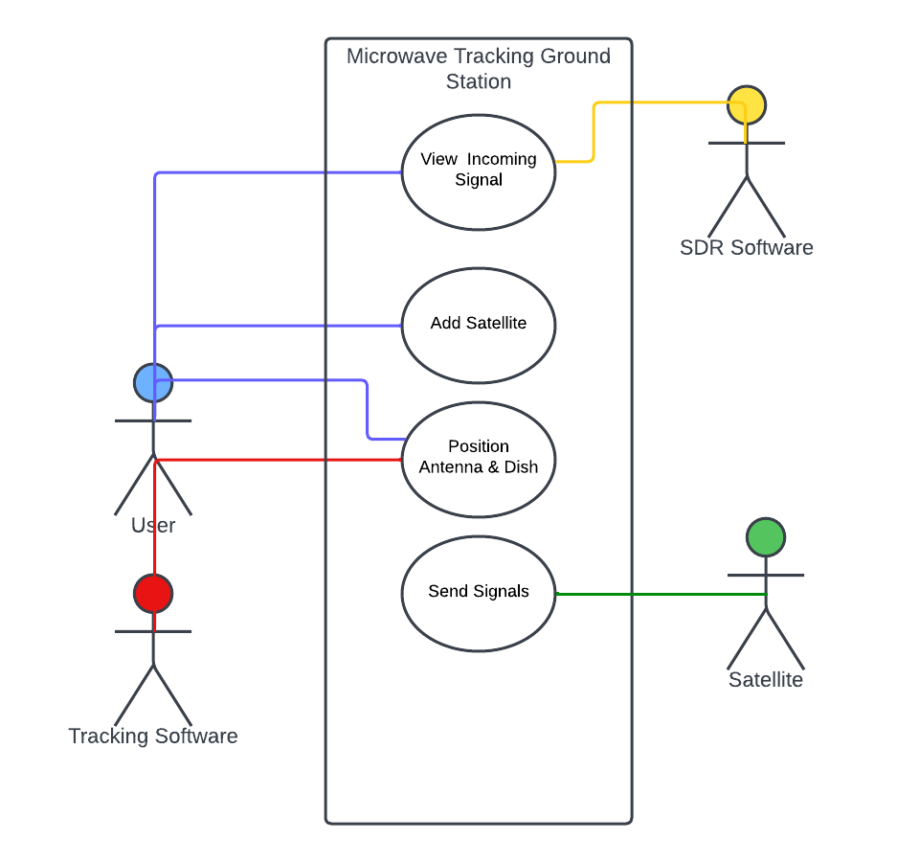

**Context Diagram**

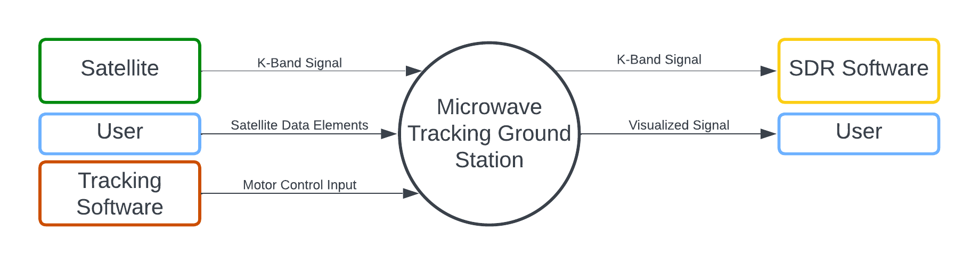

**Data Flow Diagram**

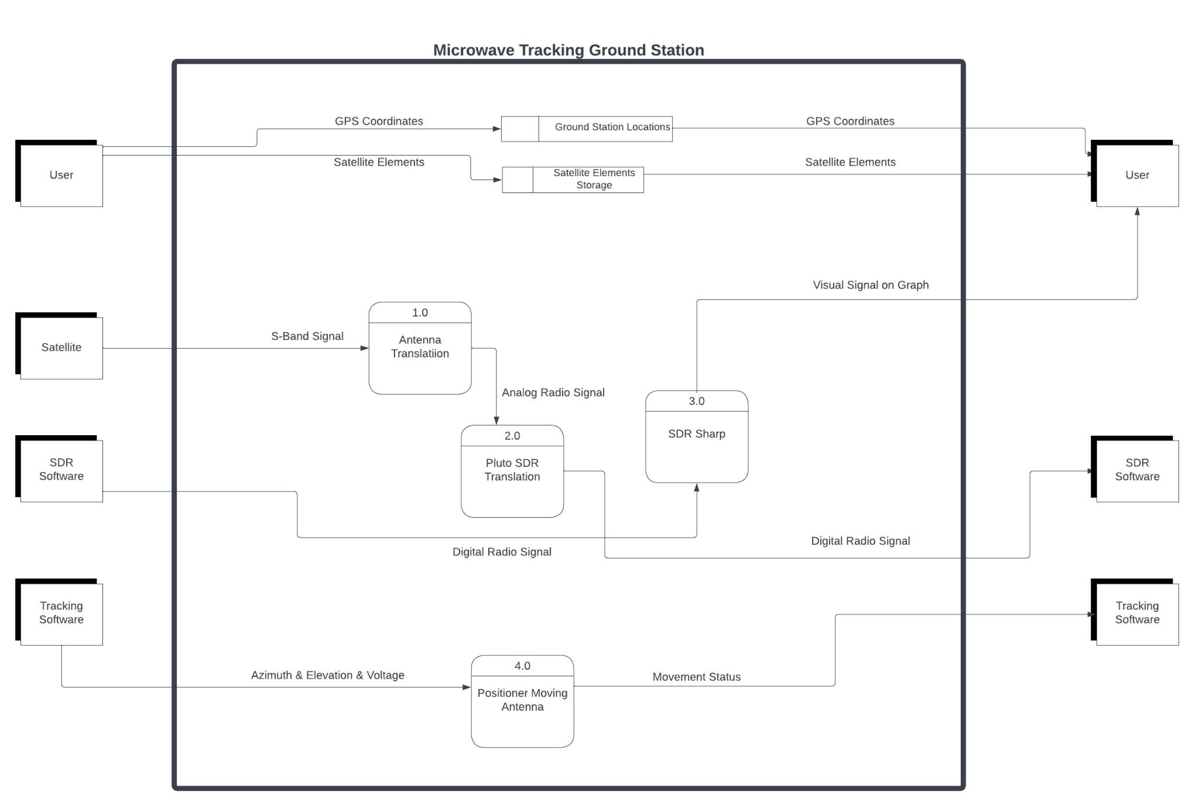

**Appendix C: To Be Determined List**

*<Collect a numbered list of the TBD (to be determined) references that remain in the SRS so they can be tracked to closure.>*