Networked Chat Application - Report

1. Introduction
This project aims to build a Peer-to-Peer chat application using TCP and UDP sockets in python. The application makes use of a rendevous server to facilitate the establishment of the peer-to-peer communications. Clients will be able to request a list of connected clients and their statuses to make a connection.

2. Features
- TCP Server-Client Communication: Enables communication between clients and the server using TCP.
- UDP Peer-to-Peer Communication: Facilitates peer-to-peer communication between clients using UDP.
- Client States: Differentiates between clients' states (listening, chatting, etc.) for effective communication handling.
- Client Disconnection: Gracefully handles client disconnection.
- Active Client List: Allows clients to request and receive a list of active clients.

3. Protocol Specification
The application protocol consists of a command followed by arguments if any. Any messages sent are prefaced with a 64 byte message header that will indicate the length of the incoming message. This is used to ensure that the messages are read correctly.

Message Types
- Change Status:
  - DISCONNECT: Disconnect cleanly from the server
  - LISTENING: Listening for new connections
  - CHATTING: Currently chatting
- GETC: Request a list of clients and their status from the server
- CONN <IP Addr> <Port>: Request connection to another client to initiate P2P communication
- STOP: Stop P2P communication with the client
- UDP <UDP Port> <Requesting client IP> <Requesting client port>: Send UDP details to the server
- SUCC <IP Addr> <UDP Port>: Sends a success message with UDP details to the client requesting a connection

Sequence Diagram(s)

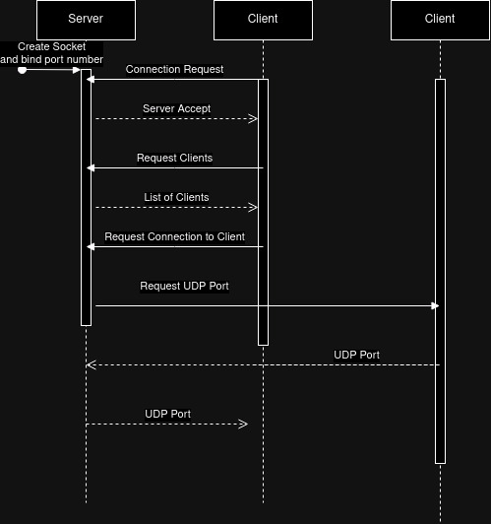Figure 1: Making a connection

Implementation Overview

- Server Setup: When the user runs the server, an IP and port will be allocated for clients to connect to. The socket will then listen for incoming connections.

- Client Handling: When the client application starts, it makes contact with the server, the server then accepts the connection, registers it to a list of connected clients and starts a new thread to handle incoming messages from the client.
- Client: Once connected the client can send commands to the server to perform various actions. Clients perform the following actions: request a list of connected clients and their statuses to make a connection, request to connect to other clients, and change their status. When a client requests to make a connection to another client, the server will send a message to the other client to request their UDP socket. If the client is currently listening, the server then sends the details back to the requesting client and a peer-to-peer connection is made. While connected the client states are set to chatting and can no longer receive connection requests unless they stop. Clients are able to message each other using the MESS command and close the connection using the STOP command.

