# **REPORT**

## CSC2001F: Assignment 4

## PTRJAR009

# Object Orientated Design

### User Class

The user class was created to store User details. It can store the users account name, account description, and a list of posts that is kept in a Binary Search Tree for efficiency.

### Posts Class

The post class was created to hold the post content of a user. It can store the post title, video file name, the number of likes the post has, and the date and time that the post was created. Is intended used along with the User class.

### Toktik Class

The Toktik class is the main body of the application. It contains the GUI which consists of a menu bar, text area box, and a panel with button. It implements the User and Posts class to allow the user to do the following tasks: Add new user, delete a user, list all users, add a post, list all posts, search for a user and give their account description.

### BinarySearchTree Class

The binary search tree class extends the BinaryTree Class and is used to store user accounts and their posts.

### BinaryTree Class

The BinaryTree class represents a binary tree and uses the BinaryTreeNode Class

### BinaryTreeNode Class

This class represents a node in a binary tree

BTQueueNode.java

This class represents a node in a queue used for implementing a breadth-first traversal of a binary tree.

# Testing

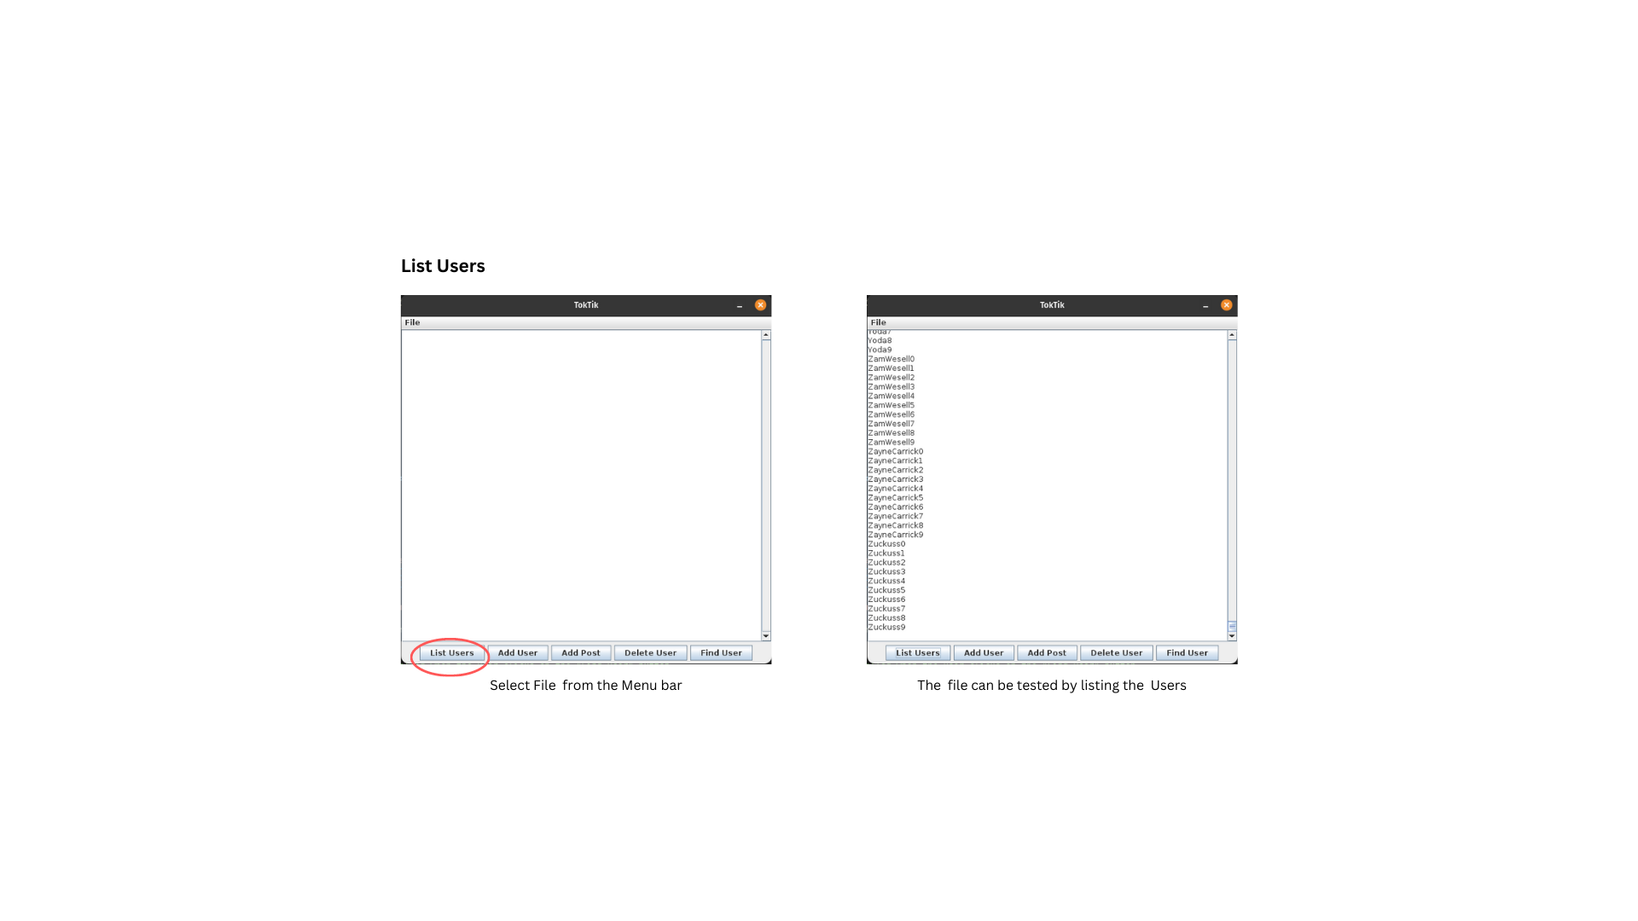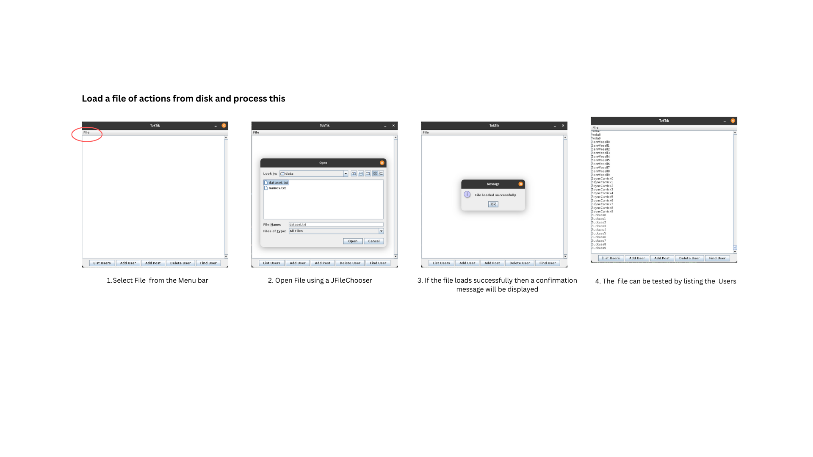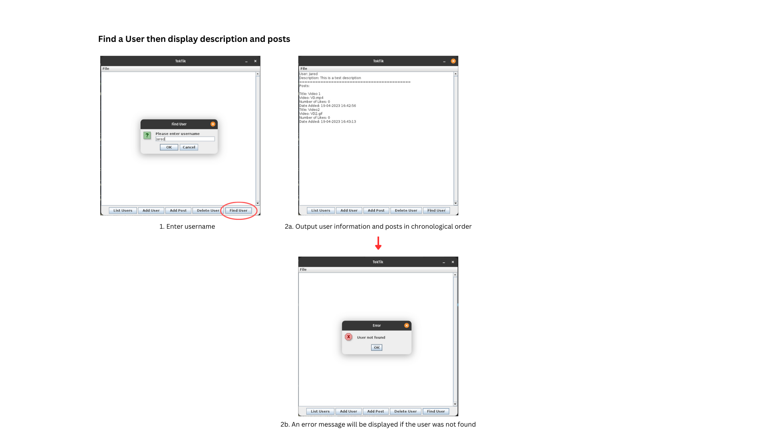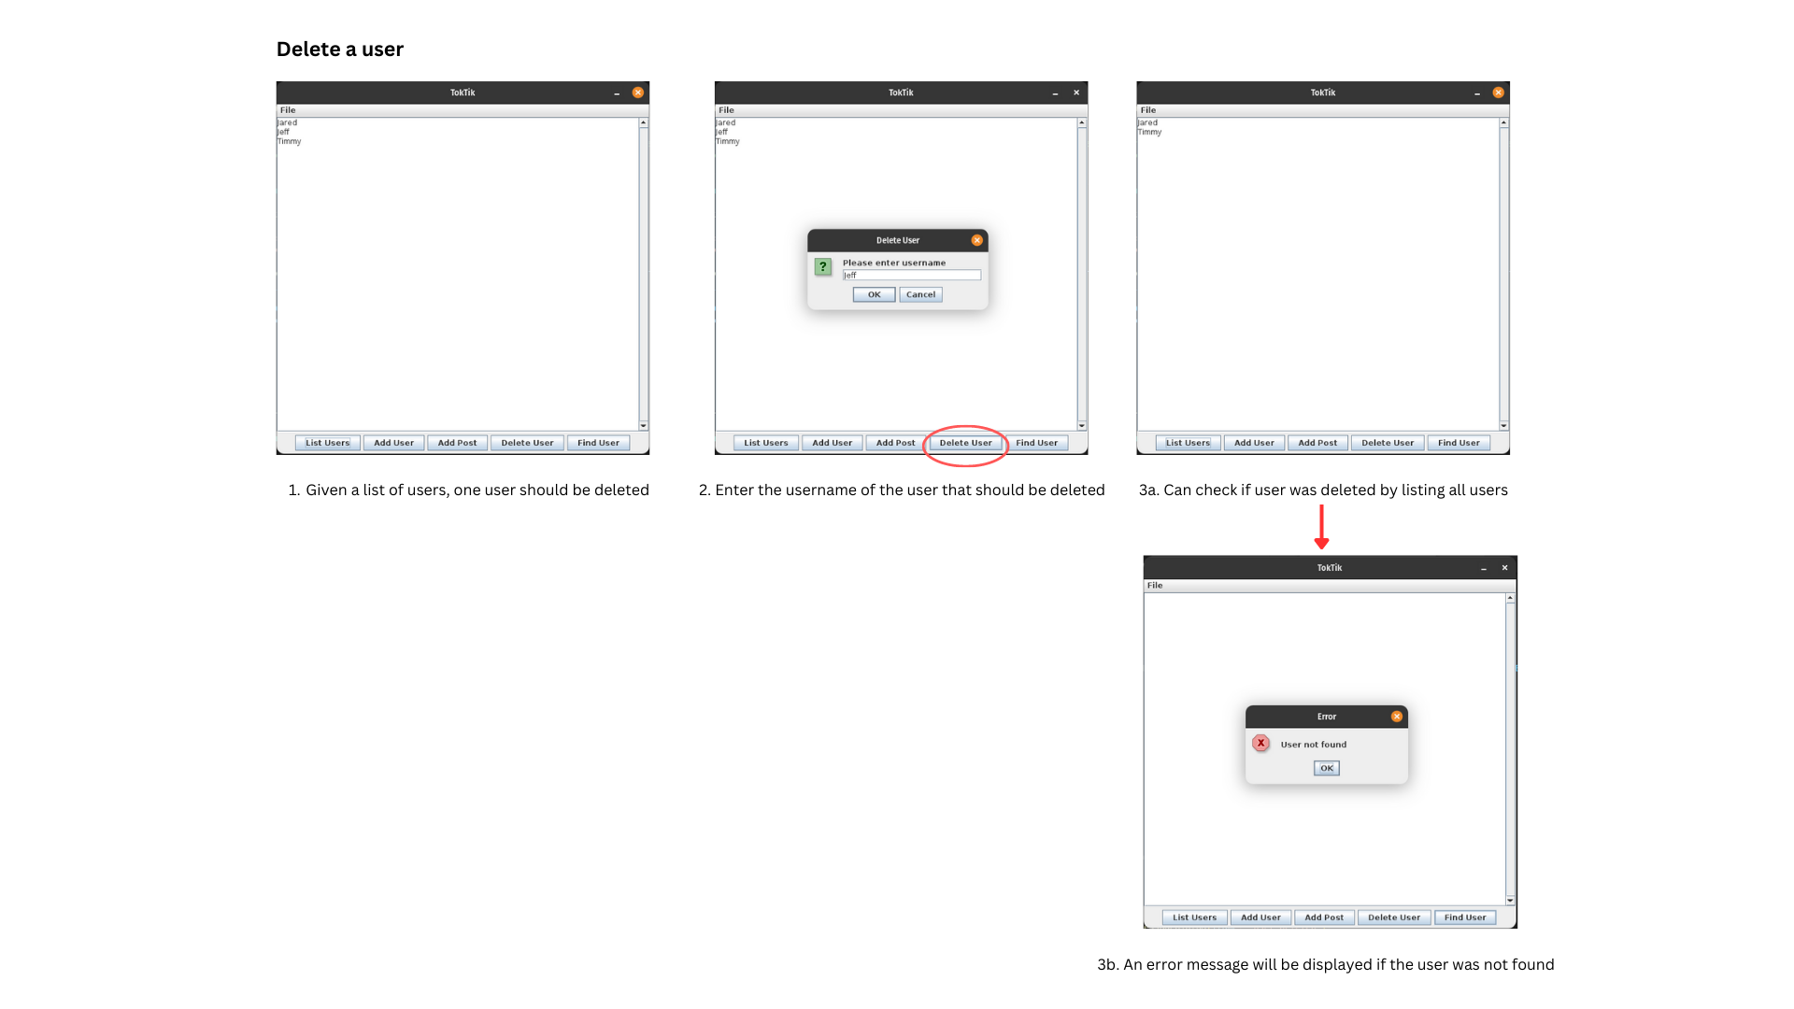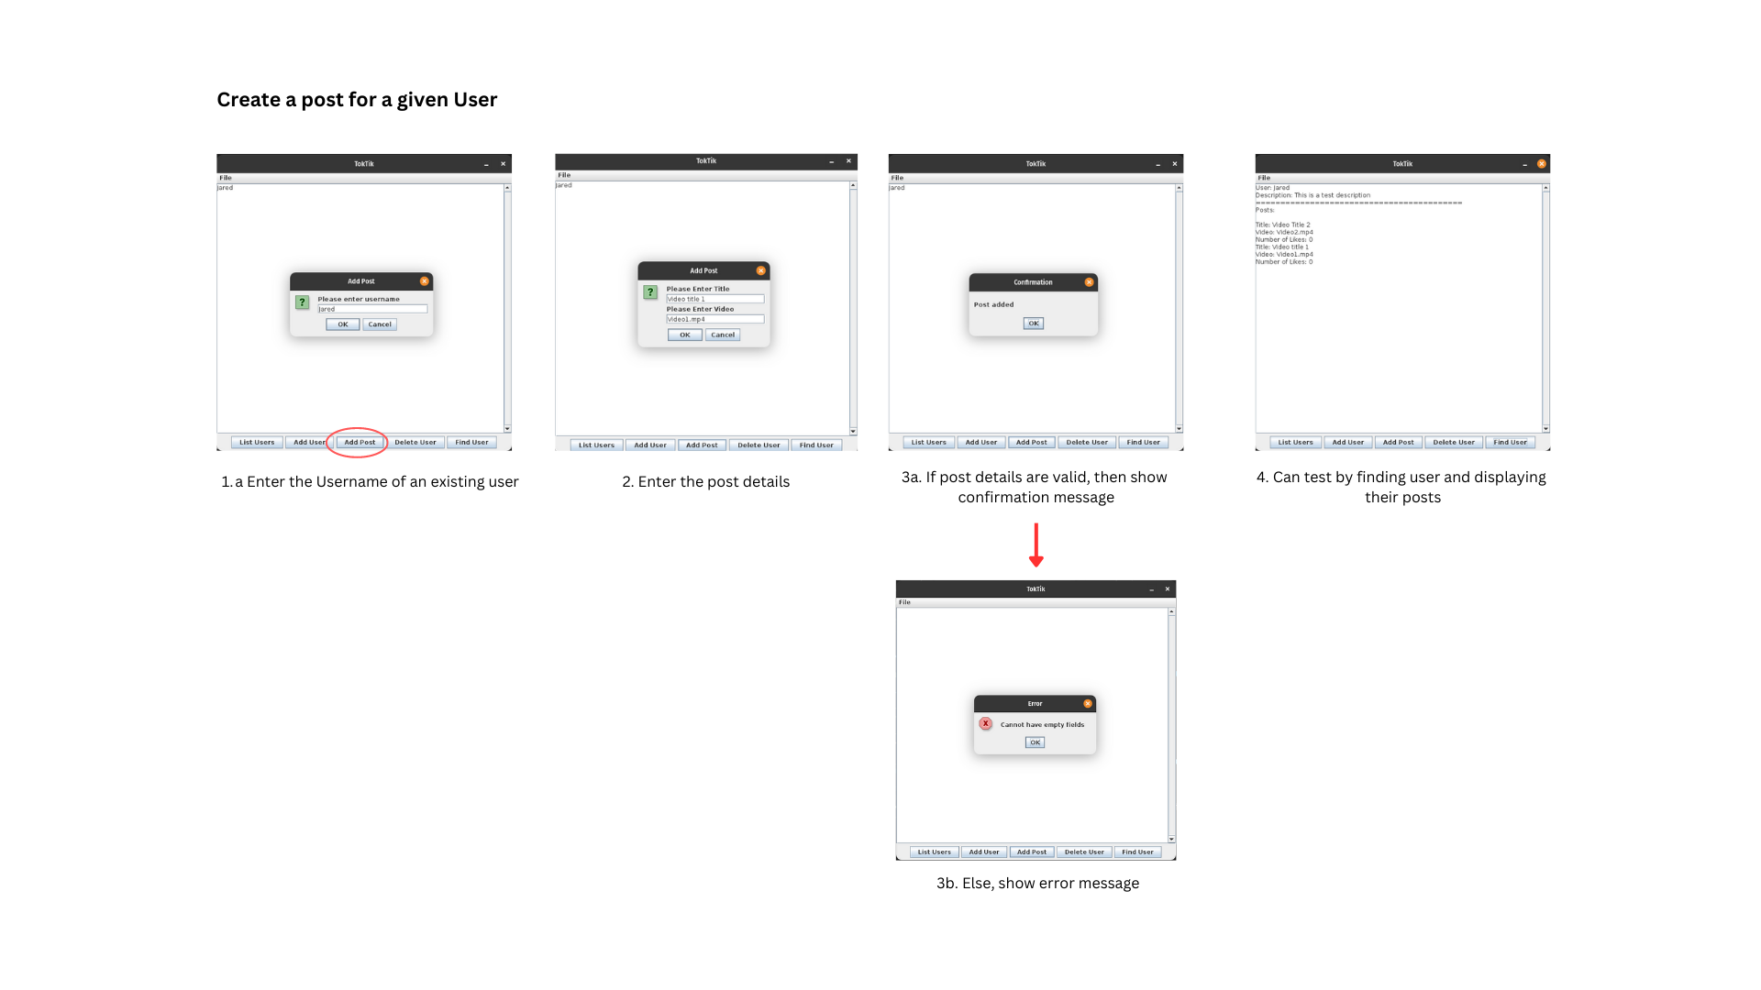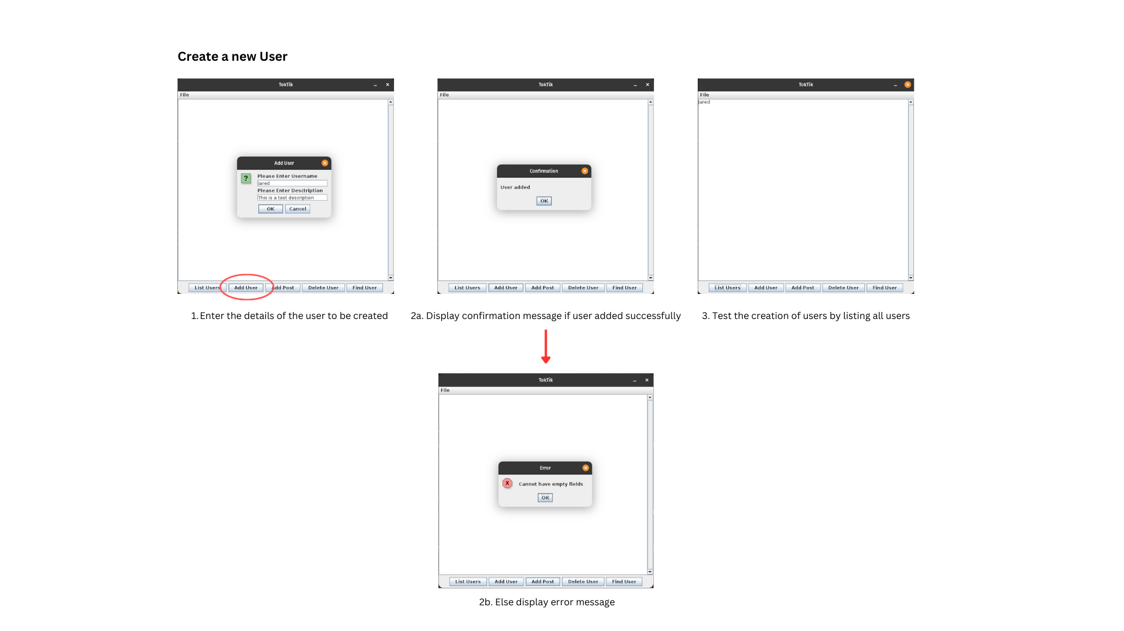

# Creativity

I demonstrated creativity by implementing a GUI to interact with the user. The GUI is built using the Java Swing framework

# Git usage

Git summary using the given command:

0: commit 74ccad924d7df3b3d16e079f75a6958a5a26d5c7

1: Merge: 9d5fda1 df66618

2: Author: JaredPetersen2003 <jared.petersen9@gmail.com>

3: Date: Tue Apr 18 11:22:26 2023 +0200

4:

5: Merge branch 'main' of https://github.com/JaredPetersen2003/tiktok-clone

6:

7: commit 9d5fda12817102b20da9be8821bdbf08ca32da67

8: Author: JaredPetersen2003 <jared.petersen9@gmail.com>

9: Date: Tue Apr 18 11:20:08 2023 +0200

...