Reflection Document 2:

Project Cost Overview:

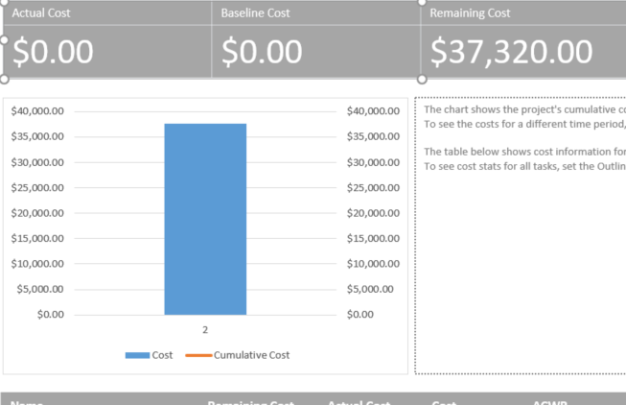

Based on the determined total cost of the project at roughly $40,000 with all costs included, for the given scenarios with 30 day, 60 day, and 90 day goals and scenarios we have some calculation to do. (CBC, CAC, CEV, CPI, CV, and FCAC)

a.

Relative to the schedule and budget this scenario shows that we are still on track and ahead of schedule. If we did maintain our 15% margin of error on the task specified, then it would be simple for us to correct this issue and get back on schedule since we are still early in the project. We did set aside a good chunk of money for unknown error calculations, so we can begin tapering off funds from that account to allocate the correct resource to veer us back onto schedule if need be.

b.

When we hit the 60-day marker the project was already completed but if we are only 25% on a project that should be at least 50% then we would have to make adjustments to our Gantt chart and ensure that the corrective actions do not push us over budget. To correct this issue, we might need to hire some better software engineers.

c.

Based on the performance measures of the project up to this point we can see that by day 90 we should be complete, but we still have parts of projects that are only 40% complete. In order to get these tasks done and keep the customer happy we might have to push back our deadline and hire a few extra engineers to take on extra tasks. Looking at the computations generated by Microsoft Project we can see that by forcing us to extend our deadline we are not going to severely impact our budget if we allocate some resources to the areas that need a little extra TLC. Our budget was designed to go over at least twice for this project so it seems that we are in good shape from a financial perspective, but we cannot do anything about the timeliness issue so much. Like I said the corrective action here is to do a cost-benefit analysis of our current situation and allocate as many free resources as we can to complete the remaining tasks.