Bootstrap

Wprowadzenie

You can add Bootstrap to any app by adding the following code to the top of your HTML:
<link rel="stylesheet" href="//maxcdn.bootstrapcdn.com/bootstrap/3.3.1/css/bootstrap.min.css"/>
In this case, we've already added it for you to this page behind the scenes.
To get started, we should nest all of our HTML in a div element with the class container-fluid.
Use .container-fluid for a full width container, spanning the entire width of your viewport.

Responsywne obrazki

Fortunately, with Bootstrap, all we need to do is add the img-responsive class to your image. Do this, and the image should perfectly fit the width of your page.

Now that we're using Bootstrap, we can center our heading element to make it look better. All we need to do is add the class text-center to our h2 element.
Remember that you can add several classes to the same element by separating each of them with a space, like this:
<h2 class="red-text text-center">your text</h2>

Przyciski

„btn” – podstawowa klasa przycisków

Normally, your button elements with a class of btn are only as wide as the text that they contain. By making them block elements with the additional class of btn-block, your button will stretch to fill your page's entire horizontal space and any elements following it will flow onto a "new line" below the block.

<button class="btn btn-block">Submit</button>
This button would take up 100% of the available width.
The btn-primary class is the main color you'll use in your app. It is useful for highlighting actions you want your user to take.
Bootstrap comes with several pre-defined colors for buttons:
- The btn-info class is used to call attention to optional actions that the user can take.
- The btn-danger class is the button color you'll use to notify users that the button performs a destructive action, such as deleting a cat photo.
- Bootstrap has another button class called btn-default.

Grid
Bootstrap uses a responsive grid system, which makes it easy to put elements into rows and specify each element's relative width. Most of Bootstrap's classes can be applied to a div element.
Here's a diagram of how Bootstrap's 12-column grid layout works:
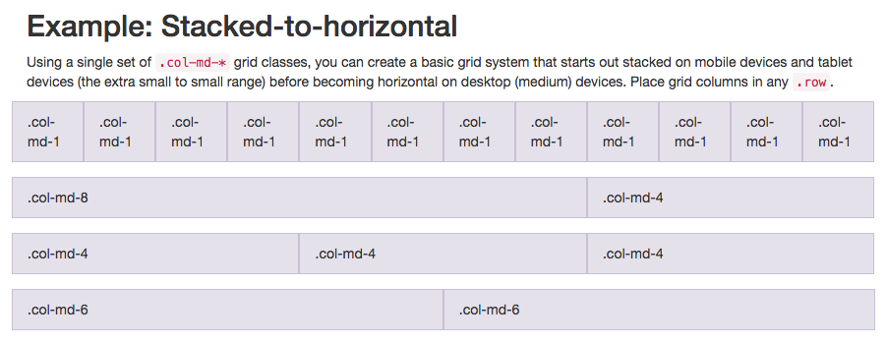
Note that in this illustration, the col-md-* class is being used. Here, md means medium, and * is a number specifying how many columns wide the element should be. In this case, the column width of an element on a medium-sized screen, such as a laptop, is being specified.
In the Cat Photo App that we're building, we'll use col-xs-*, where xs means extra small (like an extra-small mobile phone screen), and * is the number of columns specifying how many columns wide the element should be.
Wszystkie elementy zamknięte w divach z klasą typu col-*-* powinny być jeszcze zamknięte w nadrzędnym divie z klasą <div class="row">.

Używanie SPAN jako elementu inline
You can use spans to create inline elements. Remember when we used the btn-block class to make the button fill the entire row? By using the span element, you can put several elements together, and even style different parts of the same element differently.

Font Awesome
Font Awesome is a convenient library of icons. These icons are vector graphics, stored in the .svgfile format. These icons are treated just like fonts. You can specify their size using pixels, and they will assume the font size of their parent HTML elements.
You can add Font Awesome to any app just by including it by adding the following code to the top of your HTML:
<link rel="stylesheet" href="//maxcdn.bootstrapcdn.com/font-awesome/4.5.0/css/font-awesome.min.css"/>
In this case, we've already added it for you to this page behind the scenes.
The i element was originally used to make other elements italic, but is now commonly used for icons. You add the Font Awesome classes to the i element to turn it into an icon, for example:
<i class="fa fa-info-circle"></i>
„fa” to podstawowa klasa Font Awesome, po niej dopisuje się klasę bardziej szczegółową.
You can add the fa-paper-planeFont Awesome icon by adding <i class="fa fa-paper-plane"></i> within your submit buttonelement.

Bootstrap – inne
Bootstrap has a class called wellthat can create a visual sense of depth for your columns.

