**Wireframes**

View Articles page

View Page (Filters)

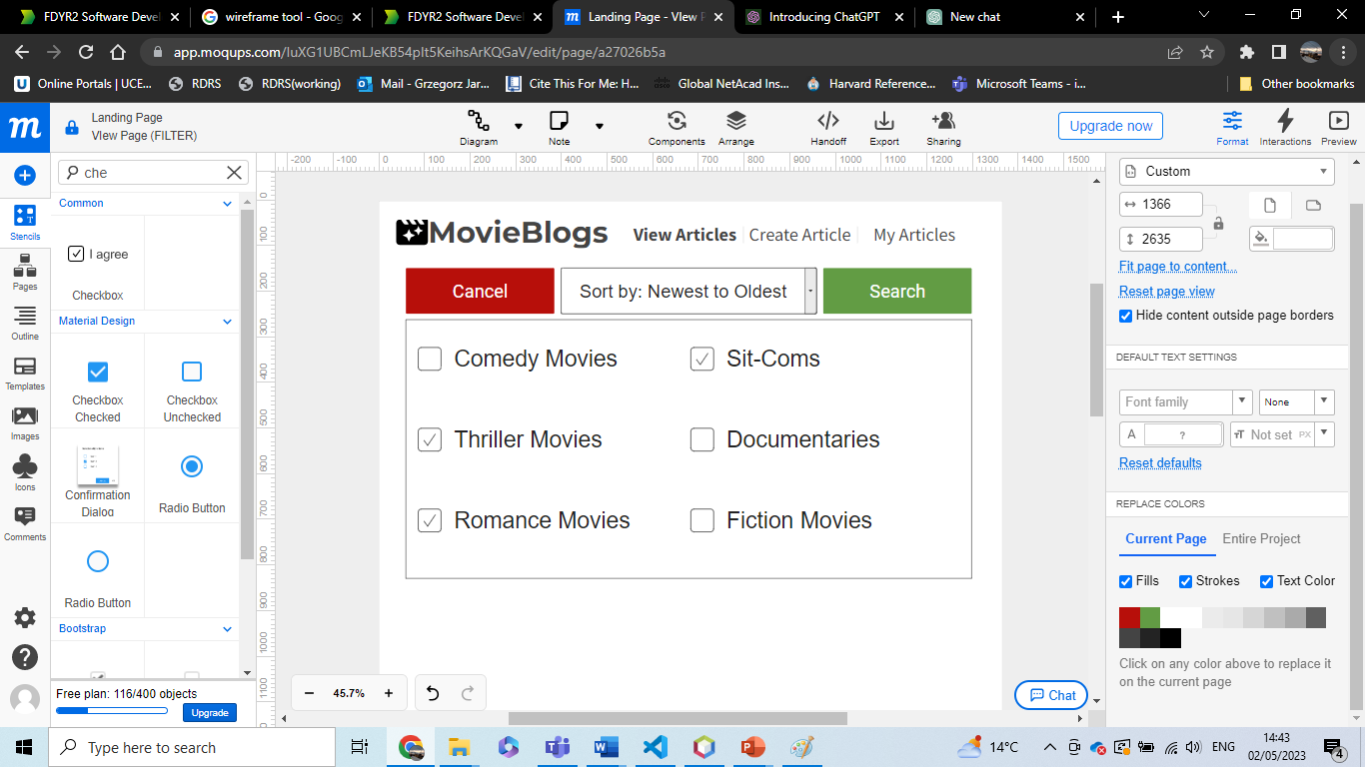

Create Article Page

Login Page

Register Page

Edit Page

