GREEK SCULPTURES

1. Phidias

Photo 1: <https://www.britannica.com/biography/Phidias>

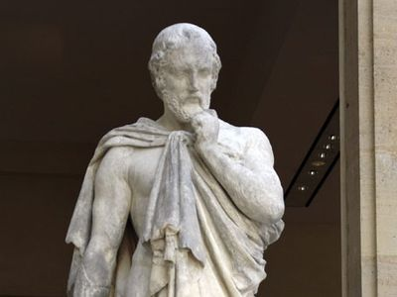

Photo 2: <https://en.wikipedia.org/wiki/Statue_of_Zeus_at_Olympia>

2. Praxiteles

Photo 1: <https://www.bridgemanimages.com/en/german-school-19th-century-after/praxiteles-of-athens-ancient-greek-sculptor-engraving/engraving/asset/8635104>

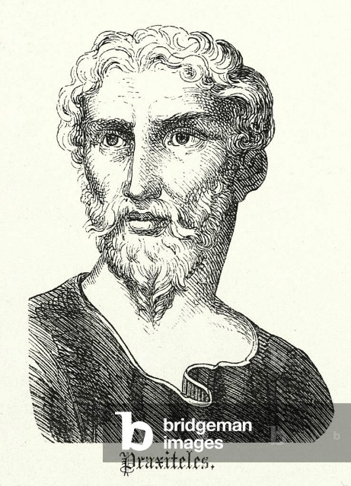

Photo 2: <https://greekreporter.com/2025/06/28/hermes-praxiteles-statue/>

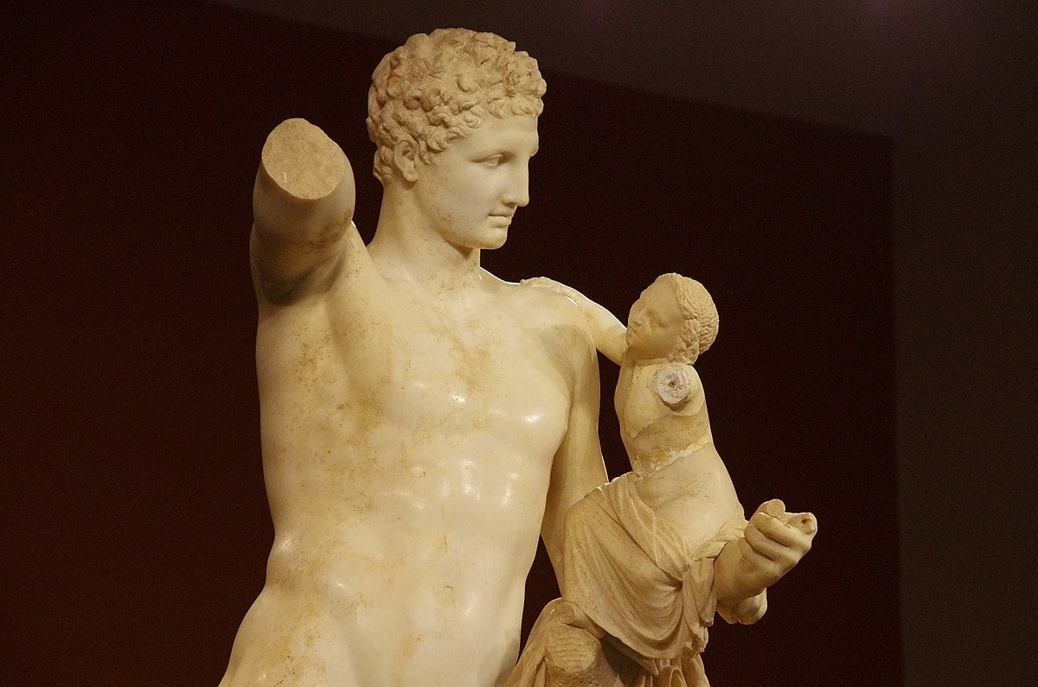

BYZANTINE SCULPTURES AND ARCHITECTURE

BYZANTINE EMPIRE

- Eastern half of the Roman Empire.

- Sole heir of the empire after the fall of western Rome.

- Border between Asia Minor and Europe.

- Recognized as Byzantine long after its fall.

BRIEF HISTORY

1. Founding & Early Years (330–527 CE)

Photo: <https://www.worldhistory.org/image/11818/western--eastern-roman-empire-395-ce/>

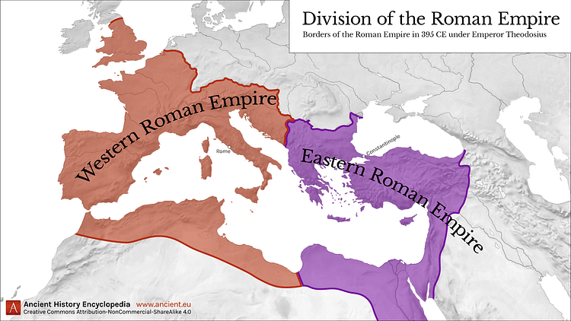

2. Golden Age (527–565 CE)

Photo: <https://www.freespeechhistory.com/timeline/527-565-justitian-i/>

3. Transition and Struggles (565–867 CE)

Photo: <https://www.britannica.com/place/Byzantine-Empire> (yung may map of the byzanine empire na may mga pula)

4. Decline and Western Conflicts (1056–1204 CE)

Photo: <https://en.wikipedia.org/wiki/Fourth_Crusade>

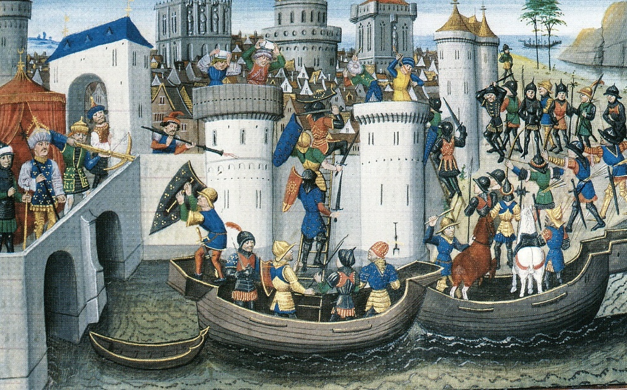

5. Restoration & Final Decline (1261–1453 CE)

Photo: <https://libapps.libraries.uc.edu/liblog/2019/05/on-may-29-the-classics-library-remembers-the-fall-of-constantinople-and-the-byzantine-empire/>

BYZANTINE ARCHITECTURE AND PROMINENT FIGURES

1. Isidore of Miletus and the Hagia Sophia

Photo 1: <https://en.wikipedia.org/wiki/Isidore_of_Miletus>

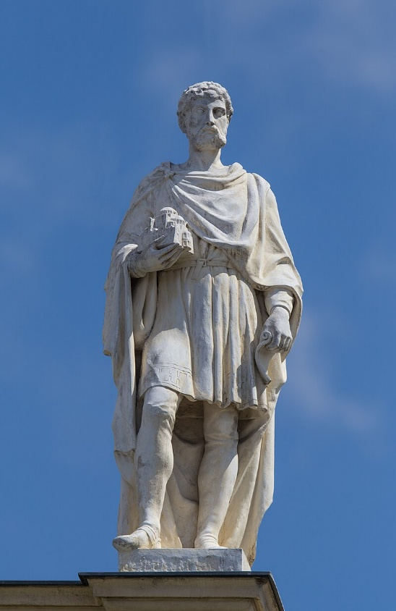

Photo 2: <https://www.britannica.com/topic/Hagia-Sophia> (First Picture you see)

2. Julianus Argentarius

Photo 1: <https://it.wikipedia.org/wiki/Giuliano_Argentario>

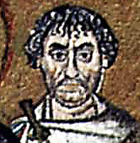

Photo 2: <https://www.tripadvisor.com/Attraction_Review-g187806-d246314-Reviews-Basilica_di_San_Vitale-Ravenna_Province_of_Ravenna_Emilia_Romagna.html>

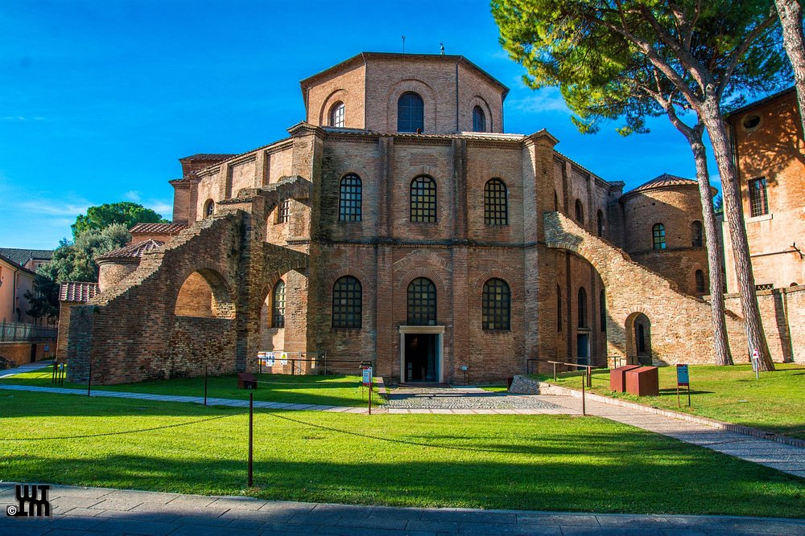

BYZANTINE SCULPTURES AND PROMINENT FIGURES

1. Theodosius I

Photo 1: <https://en.wikipedia.org/wiki/Theodosius_I>

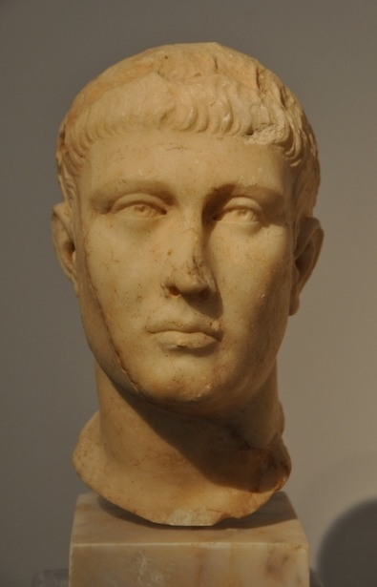

Photo 2: <https://en.m.wikipedia.org/wiki/File:The_Obelisk_of_Theodosius,_details_of_the_base_of_the_Obelisk_of_Thutmose_III,_Hippodrome,_Istanbul_%288370192180%29.jpg>

2. Theodora

Photo 1: <https://en.wikipedia.org/wiki/Theodora_%28wife_of_Justinian_I%29>

Photo 2: <https://smarthistory.org/theodora-rhetoric/>

3. Leo VI "the Wise"

Photo 1: <https://thehistoryofbyzantium.com/2016/07/05/episode-109-leo-the-wise/>

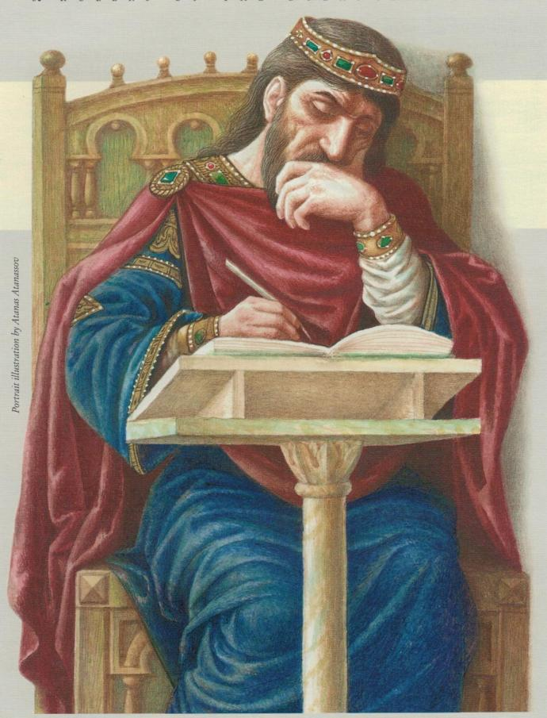

Photo 2: <https://en.wikipedia.org/wiki/Harbaville_Triptych>

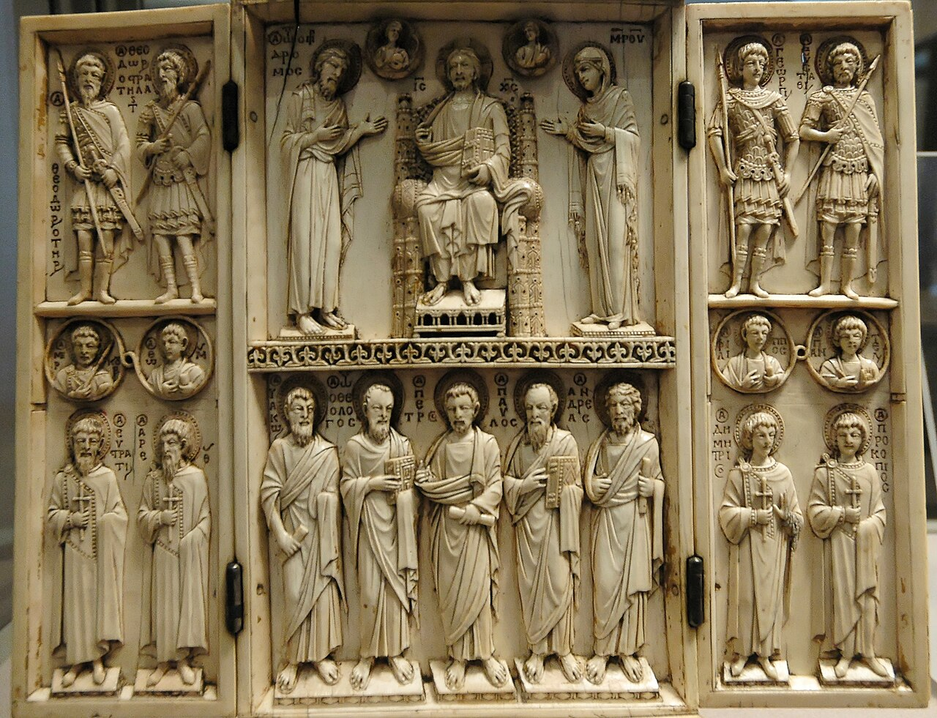

References:

- Jan van der Crabben. (2020, January 30). Western & eastern Roman Empire, 395 CE. World History Encyclopedia. <https://www.worldhistory.org/image/11818/western--eastern-roman-empire-395-ce/>

- Free Speech History. (2019, January 11). 527-65: Justitian I. <https://www.freespeechhistory.com/timeline/527-565-justitian-i/>

- Byzantine Empire. (2025, August 31). Encyclopedia Britannica. <https://www.britannica.com/place/Byzantine-Empire>

- Wikipedia. (2025, September 21). Fourth crusade. Retrieved September 23, 2025, from <https://en.wikipedia.org/wiki/Fourth_Crusade>

- On May 29, The Classics Library Remembers the Fall of Constantinople and the Byzantine Empire. (2019, May 19). University of Cincinnati Libraries. <https://libapps.libraries.uc.edu/liblog/2019/05/on-may-29-the-classics-library-remembers-the-fall-of-constantinople-and-the-byzantine-empire/>

- Wikipedia. (2025, August 10). Isidore of Miletus. Retrieved September 23, 2025, from <https://en.wikipedia.org/wiki/Isidore_of_Miletus>

- Wikipedia. (n.d.). Giuliano Argentario. Retrieved September 23, 2025, from <https://it.wikipedia.org/wiki/Giuliano_Argentario>

- TripAdvisor. (n.d.). Basilica di San Vitale. <https://www.tripadvisor.com/Attraction_Review-g187806-d246314-Reviews-Basilica_di_San_Vitale-Ravenna_Province_of_Ravenna_Emilia_Romagna.html>

- The History of Byzantium. (2018, January 2). Episode 109 – Leo the wise? <https://thehistoryofbyzantium.com/2016/07/05/episode-109-leo-the-wise/>

- Wikipedia. (2024, October 30). Harbaville triptych. Retrieved September 23, 2025, from <https://en.wikipedia.org/wiki/Harbaville_Triptych>

- Encyclopedia Britannica. (1998, July 20). Phidias. <https://www.britannica.com/biography/Phidias>

- Wikipedia. (2025, September 6). Statue of Zeus at Olympia. Retrieved September 23, 2025, from <https://en.wikipedia.org/wiki/Statue_of_Zeus_at_Olympia>

- Bridgeman Images. (n.d.). Image of Praxiteles of Athens. <https://www.bridgemanimages.com/en/german-school-19th-century-after/praxiteles-of-athens-ancient-greek-sculptor-engraving/engraving/asset/8635104>

- Wikipedia. (2025, September 17). Theodora (Wife of Justinian I). Retrieved September 23, 2025, from <https://en.wikipedia.org/wiki/Theodora_%28wife_of_Justinian_I%29>

- McClanan, A. (n.d.). Empress Theodora, rhetoric, and Byzantine primary sources. SmartHistory. <https://smarthistory.org/theodora-rhetoric/>