December 11, 2025
Odum School of Ecology

140 East Green Street,
Athens, GA 30602

tel 310-975-5309
Jordan.argrett@uga.edu

Dear Editor,

Please consider the enclosed manuscript, “Hemiparasitic Castilleja presence is correlated with increased plant diversity across montane plant communities” as a research article submission to the American Journal of Botany.
Parasitic plants represent a large and functionally diverse group that remains underexplored despite their prevalence across ecosystems. Root hemiparasites, such as Castilleja, are known to influence host physiology and nutrient cycling, often exerting effects that are disproportionate to their abundance. Building on this foundation, our study examined the relationship between three species of Castilleja and changes in plant community structure and host interactions across montane communities. Using paired presence–absence plots and both direct and indirect sampling methods, we quantified community diversity, composition, and host associations across two growing seasons.
We found that Castilleja presence was consistently associated with higher Shannon diversity and species richness in co-occurring plant communities, but not with consistent shifts in community composition. Direct and indirect host assessments further revealed that Castilleja species act as facultative generalist hemiparasites with broad host ranges. Together, these findings support the growing view that generalist hemiparasitic plants can function as keystone species, increasing local biodiversity in natural systems.
We believe this work will be of particular interest to readers of the American Journal of Botany because it advances our understanding of plant symbiosis, competitive dynamics, and plant-plant interactions. This study also highlights the ecological importance of parasitic plants, which could function as keystone species in natural communities. The manuscript has not been published elsewhere and is not under consideration by another journal. All authors have approved the manuscript and its submission to AJB.
Thank you for considering our work. We appreciate your time and look forward to the opportunity to contribute to the American Journal of Botany.
None of the authors have conflicts of interest to declare. This manuscript is not under consideration for publication elsewhere.

Sincerely (on behalf of all coauthors),
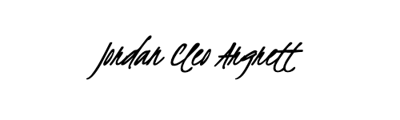

Jordan Argrett

