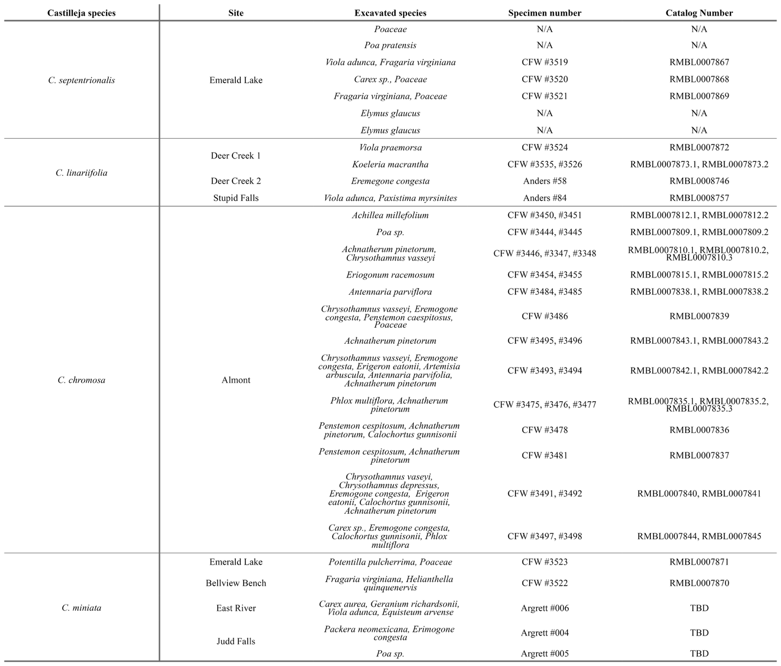
Supplement
Table SI. Putative host species for all excavation efforts. Collections that were not destroyed by the excavation effort were stored in the Rocky Mountain Biological Laboratory herbarium as an extended specimen for archiving and digitization.

