Technical Design:



Table of Contents

**Introduction2**

**Sytem Overview2**

Function & Intended Usage2

External Interfaces2

Characteristics3

**Plan Of Action**3

# 1 Introduction:

This file should provide an overview of the entire project and provide a description of the function of the system and its intended usage. This document should also describe external interfaces to the system, a brief overview of the ‘characteristics’ of the system and comment on aspects such as real-time use.

# 2 System Overview:

## 2.1 Function & Intended Usage:

After booting the game it will ask you what difficulty you want easy, normal or hard. After typing in your choice the game will ask you how many rounds there will be played. Once selected the game starts and the text “Choose an item” and “Rock / Paper / Scissors” appear after which you make a gesture to your webcam that got turned on. The code will process the gestures your making, after detecting one of the 3 options it will pick one of three values. And compare them to see who wins. After doing this it will increase the value of the players score or AI’s score and play a tune depending on if you won or lost. After hitting your selected score the game say if you won or lost and play another tune before shutting down.

## 2.2 External Interfaces

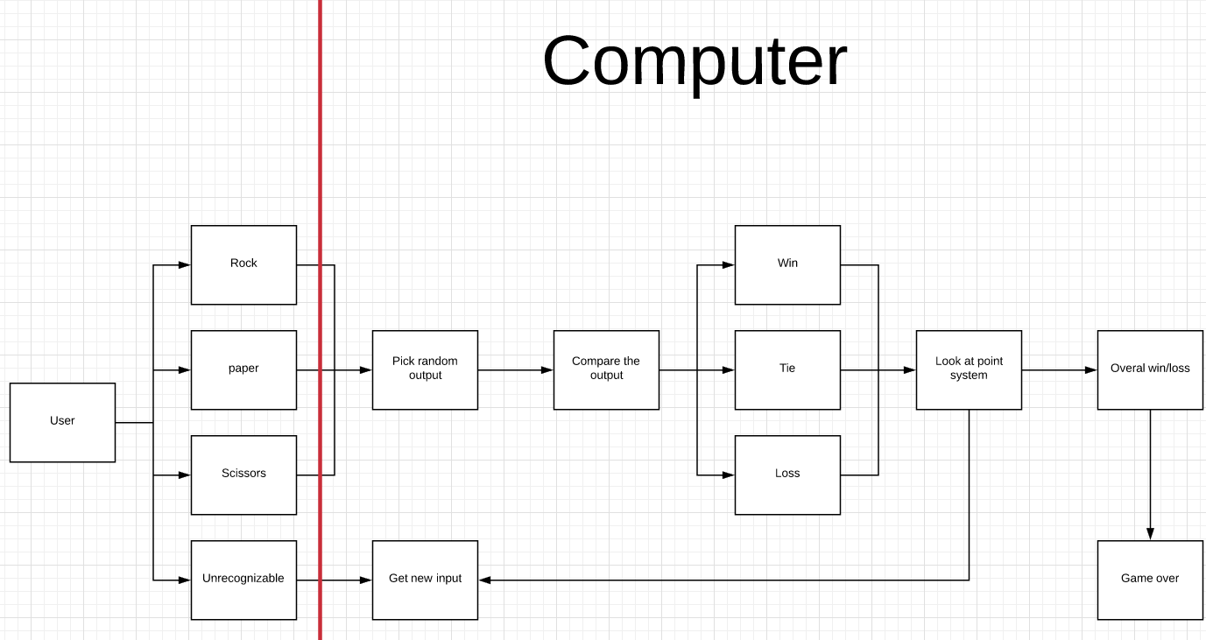

## 2.3 Characteristics

The system is made to be used by one player at the same time. This is because it runs on the local pc and because of the nature from the game. In principle everyone can play the game at the same time as long as it is running on a different pc. The program is very fool proof, it is almost impossible to get an error. If an error occurs it is asked to send the error to the creator team so that they can fix the error. Our files aren’t protected very well, this is because the game is made to show off what you can do with programming. So interested people should be able to see the code. If a new version comes out you only need to download it again which shouldn’t take too much effort since the game isn’t that large.

## Plan Of Action

# 