**Project Plan<Enter Company Name of Client.>**

**Project: rock-paper-code**

**Project Number: 1**

**Auteur: Jari van der Heijden/Amin Khachiche**

**Date: 7-5-2019**

**Version: 1.0**



**Client Project Manager**

***Initial Seen: Initial Seen:***

Date: <Enter Sign Date.> Date: 7-5-2019

Place: <Enter Sign Place.> Place: ROC-ter-aa, Helmond

Contents

Background 2

Project assignment 2

Project activities 2

Project boundaries 2

Requirements 2

Products 3

Quality assurances (optional) 3

Project organization 3

Planning 3

Costs and benefits (optional) 4

Risks 4

Appendices 4

# Background

This project will be made for school as we need to make something for the pro task. This document will be made so we have something to look back at if we don’t know what we should or shouldn’t implement into the program. The program that will be made is a rock paper scissors “AI” that will use the camera for input because. We picked that so people that don’t know how to use a mouse or keyboard will still be able to play. We are going to make this pro task using scrum and a lot of flow charts.

# Project assignment

The project will be made in Visual studio Code using a python plug in and a computer vision library. The goal of it is to make a working version of rock, paper, scissors.

# Project activities

We will achieve this by using a open source computer vision library and python code for our self to code. The end goal is making so you can play rock paper scissors using your camera

# Project boundaries

We will try to make a working bot that you can play rock paper scissors against with your webcam.

We won’t add in additional hand signs or different difficulty’s due to the given time frame

# Requirements

* Think about the following categories:
  + Preconditions
    - Program is ready to be played
    - The user can already interact with the program
    - The options are presented
  + Functional requirements
    - The program responds to the given image
    - The AI will check which sign has been detected through the webcam
    - A point is given to the winner of the match
    - When a user or the computer gets 3 wins, it will win the entire game
  + Operational requirements
    - Camera (webcam)
    - Laptop
    - Hands
    - Neutral Background
    - AI
  + [Moscow List](moscow_protask.xlsx)

# Products

When the project is finished and ready to be used, we have an application that you can interact with. This interaction goes as follows: the user’s hand is detected by using AI through a camera (webcam in this case). The AI reads the chosen sign (rock, paper or scissors) and it will respond with a random sign that’s chosen by the AI itself. The winner will get 1 point and first player to get 3 points wins the game.

# Quality assurances (optional)

The quality depends on the time we have and effort we’ve put into this project. When we have enough time and worked consistently, we should have produced a high-quality product.

# Planning

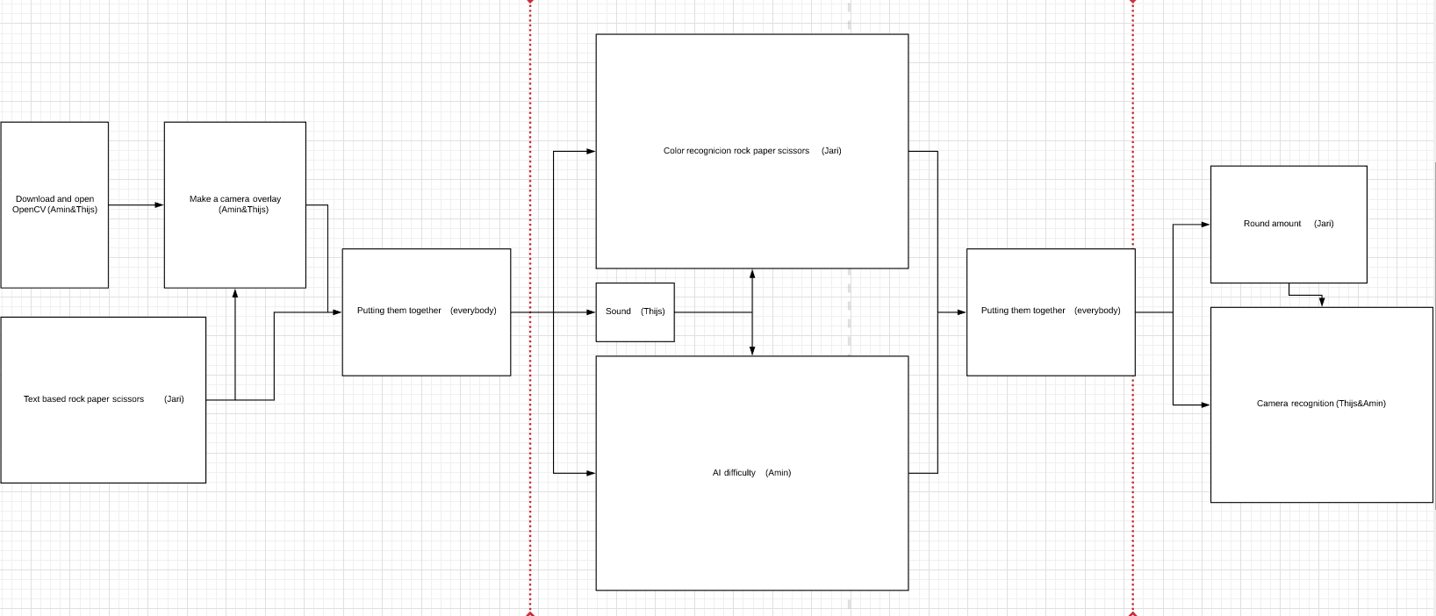

# Costs and benefits (optional)

The cost of the project is time. It’s a good idea to take advantage of the time we have especially during the extra lessons we get. The beneficial part of the project is that we get to know a new programming language (Python). This basic understanding will most likely be useful in the future.

# Risks

There are some risks that we might take. One of them could be that we might make it a little too hard for our self which could lead to a lack of time. In this case time is very valuable especially when we only have very minimum knowledge of Python. With this basic knowledge it might not get easy to get things done. And if we get in time trouble it could lead to an inadequate project formulation. The resources might be

# Appendices

None