Final Programming Assignment

*Stage 6*

Software Manual

ReboundScout



Jared Baribeau and Carson Ennis

ICS 4U1  
June 18th, 2012

Table of Contents

Table of Contents ………………………………………………………………………………. Page 1

Description, Installation, and Execution ……………………………………………… Page 2

Section 1. Welcome Screen ………………………………………………………………… Page 3

Section 2. Home Screen ……………………………………………………………………… Page 4, 5

Section 3. Scouter Screen ……………………………………………………………………. Page 5, 6

Section 4. Team Profile Screen …………………………………………………………….. Page 6, 7

*What is the ReboundScout?*

The ReboundScout program is a Java application that was designed to keep track of statistics related to the First Robotics competition of 2011-2012. The program does this by giving the user an interface in which they can easily increment various stat counters and adjust other values. The application then uses the collected data and displays it in an organized and sortable table for the user’s convenience.

While the software has many functions, a brief outline of important features of the application would include: the accurate recording of stats, writing them to a file, being able to open those files, organizing the data into a table, being able to manipulate the data through addition and deletion, and displaying a detailed description of each robot with its stats and specs.

*How to properly install the software:*

To ensure that the ReboundScout software works as it should, the user should check to make sure the following requirements have been met.

1. All Java files must be in the same folder, this includes

* Team.java
* Stats.java
* Main.java
* WelcomeScreen.java
* HomeScreen.java
* ScouterScreen.java
* TeamProfile.java
* Help.java
* GUIHelper.java

1. That Java JDK 1.6 or newer is the active JDK profile.
2. The “Images” and “Robot Photos” folders must be contained in the same location as all of the Java files.

*How to run the program:*

To properly run the program, the user should follow these steps:

1. Ensure all .class files have been deleted.
2. Open Main.java in a Java IDE.
3. Compile the program.
4. Run the program.

***Section 1. – Welcome Screen***

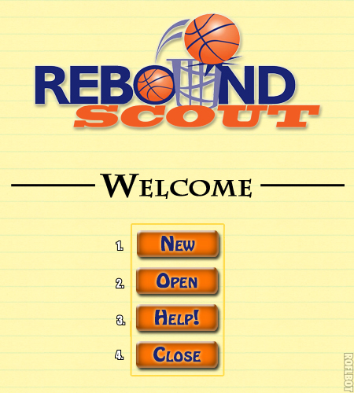

Functions of Welcome Screen:

*1. NEW*

Creates a new file for the user. This file is saved under a generic name, where the user can subsequently change the title.

The user is then directed to the Home screen.

2. OPEN

A file chooser prompts the user to select a text file to be read by the program.

The user is directed to the Home screen where the table is populated with all the data from the user's file.

3. HELP

Opens the help file.

4. CLOSE

Closes the program.

-------------------------------------------------------------------------------------------------------------

***Section 2. – Home Screen***

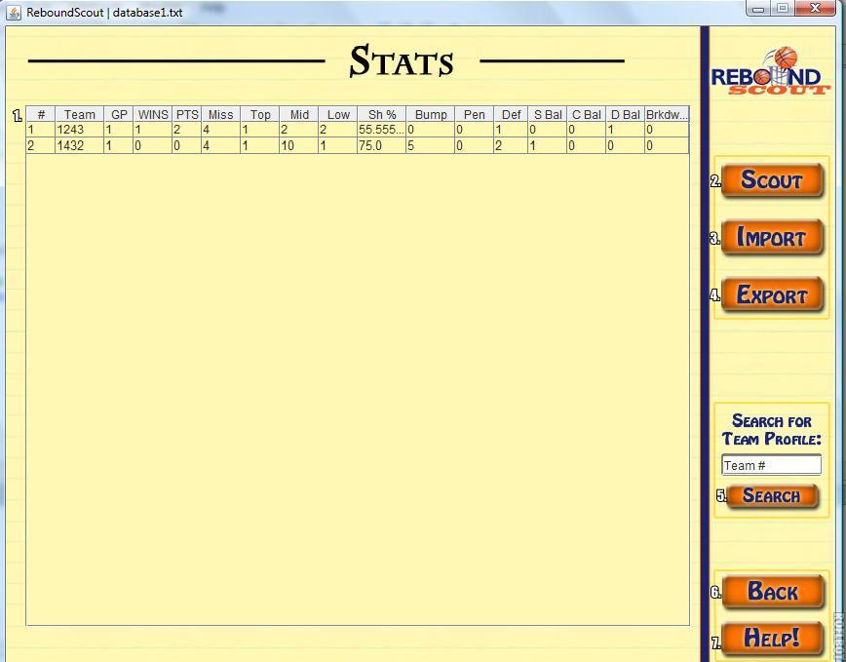

Functions of Home Screen

1. THE TABLE

The table in the centre of the Home screen will be automatically updated with the data from each of the robots as they are scouted by the user.

If there is nothing present, the user has no data in their text file. The table can be sorted by clicking any of the column headers.

Columns can also be rearranged to suit the user's preference.

2. SCOUT MATCH

The scout match button will redirect the user to the Scouter screen.

3. IMPORT

The import button will open a file chooser that prompts the user to select a file to open.

Data will be read from the file and populate the table appropriately.

4. EXPORT

A message will appear instructing the user on how to move files from computer to computer.

5. SEARCH FOR TEAM

To search for a team's profile by its number, the user must type in the team's number in the search bar, then click GO or hit the enter key on their keyboard.

If the team exists in the user's records, the user will be redirected to that team's profile.

If the team does not exist in the user's records, a message will tell the user that the team does not exist in the user's records.

6. BACK

Asks the user if they are sure they would like to return to the Welcome screen, closing their current file in the process.

7. HELP

Displays the help screen.

-------------------------------------------------------------------------------------------------------------

***Section 3. – Scouter Screen***

Functions of the Scouter

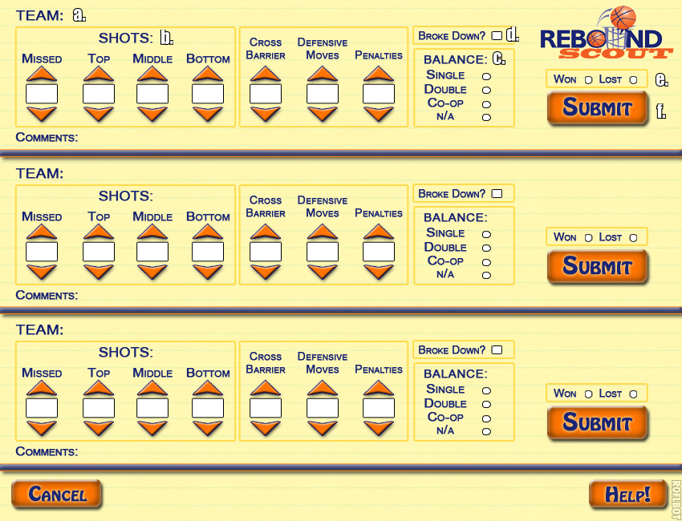

1. HOW TO USE THE SCOUTER SCREEN

The user should follow the following steps to properly use the Scouter screen.

a) Enter the team number for all three teams in the appropriate text boxes at the top of each scouting fields.

b) Increment stats as necessary during the match.

c) Select which kind of balance each robot achieved using the Balance option buttons.

d) Specify whether or not the robot became disabled during the match using the "Broke Down?" check box.

e) Specify whether or not the robot won using the Win/Loss option buttons.

f) Click the SUBMIT button to update all the stats for the robot.

2. HELP

Clicking the help button will open the help message.

3. BACK

Clicking the back button will return the user to the Home screen.

-------------------------------------------------------------------------------------------------------------

***Section 4. – Team Profile Screen***

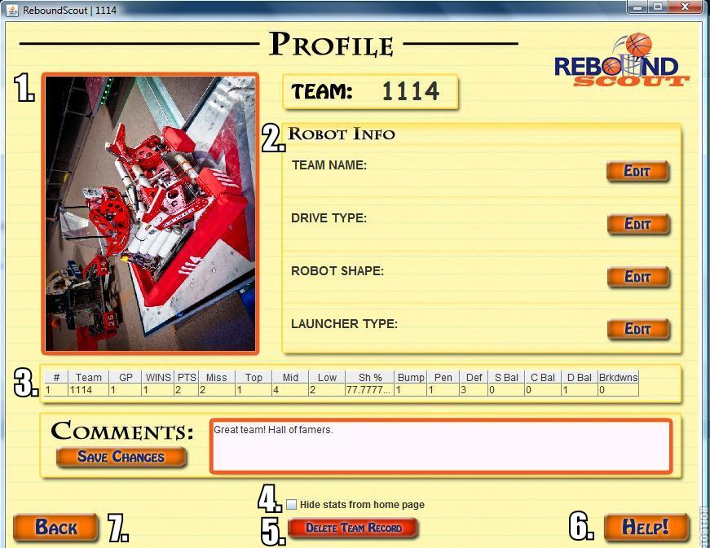

Functions of the TeamProfile screen

1. PICTURE

The program searches for a file with the corresponding team name (ex. 3756.jpg).

If no file can be found, a message instructing the user on how to save the picture properly will be displayed instead.

2. SPECIFICATIONS

The robot's build specifications including shape, launcher type, and drive type will be displayed on the screen.

Clicking the EDIT buttons will allow the user to change the description of the robot's components.

3. TABLE OF STATS

A table will display all of the robot's stats as recorded by the user. This table can be edited on the Scout screen.

4. SHOW IN TABLE

The show in table check box allows the user to specify whether or not they would like to omit the specified robot from the table of data.

If checked, the robot's stats will not be showed in the table. If unchecked, the robot's stats will be included in the table.

5. DELETE

The delete button allows the user to completely remove the active profile from the database.

6. HELP

Clicking the help button will open the help message.

7. BACK

Clicking the back button will return the user to the Home screen.