Task:1

Login as Boby. Sent a friend request to find the http request and the ID of Samy(59). ( <http://www.seed-server.com/action/friends/add?friend=59+ts+ts+token+token>)

To exclude samy from the spam, find his guid 🡪 Elgg object has a session class in it which contains user that contains guid(for samy it is 59). Compare the session’s guid with 59. If they are not equal then execute the code.

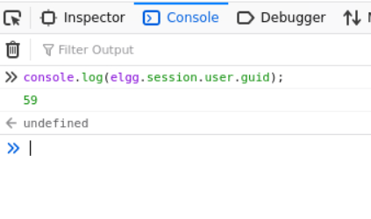

Task:2

Get the url format(seturl) 🡪 http://www.seed-server.com/action/profile/edit

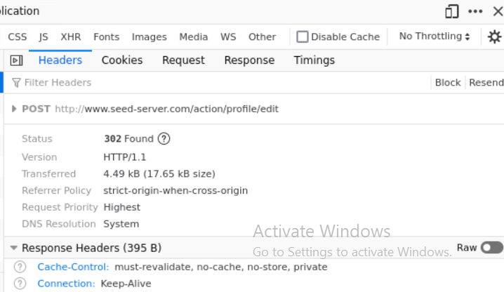

application/x-www-form-urlencoded: the keys and values are encoded in key-value tuples separated by '&', with a '=' between the key and the value.

Set the content 🡪 keys are in quotation(here keys are fields) and equal to value. “key=”+value+ “&key=” +value

Access value - Logged in user 🡪 value 1

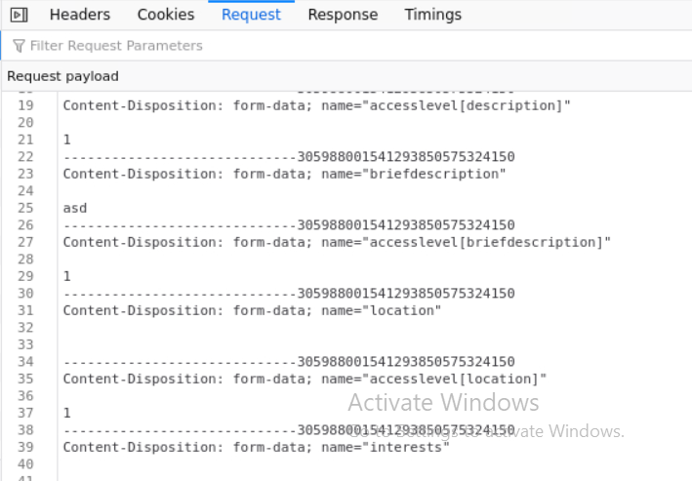

Ajax.setRequestHeader("Host", "www.seed-server.com"); // Host is denied

Newer versions of browsers don’t allow setting request header to host manually.

Task-3:

Posting on the Wire 🡪 a post request. url 🡪

The request body 🡪

So content of the wire should be the value of the field “body”.

The body contain does not allow new lines maybe

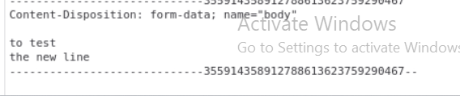

But the output

Task:4

Friend request sending part is same as task1

Profile update part is almost same as task2 but here the brief description is the script itself(got by DOM manipulation(from id worm))

Posting part is almost same as task3. Instead of posting samy’s profile link, here user will post his/her profile link